ES Lab3 optional problem A
R14942122 柯均儒
./examples/ble_scan/ble_scan
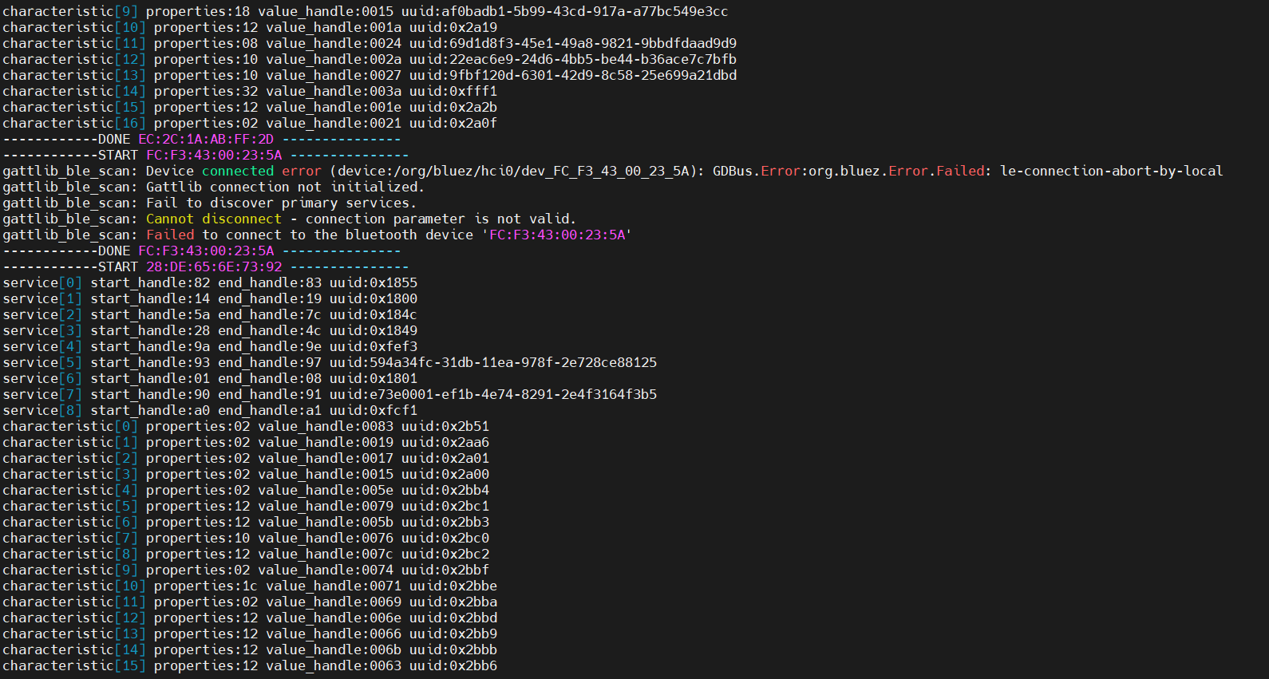
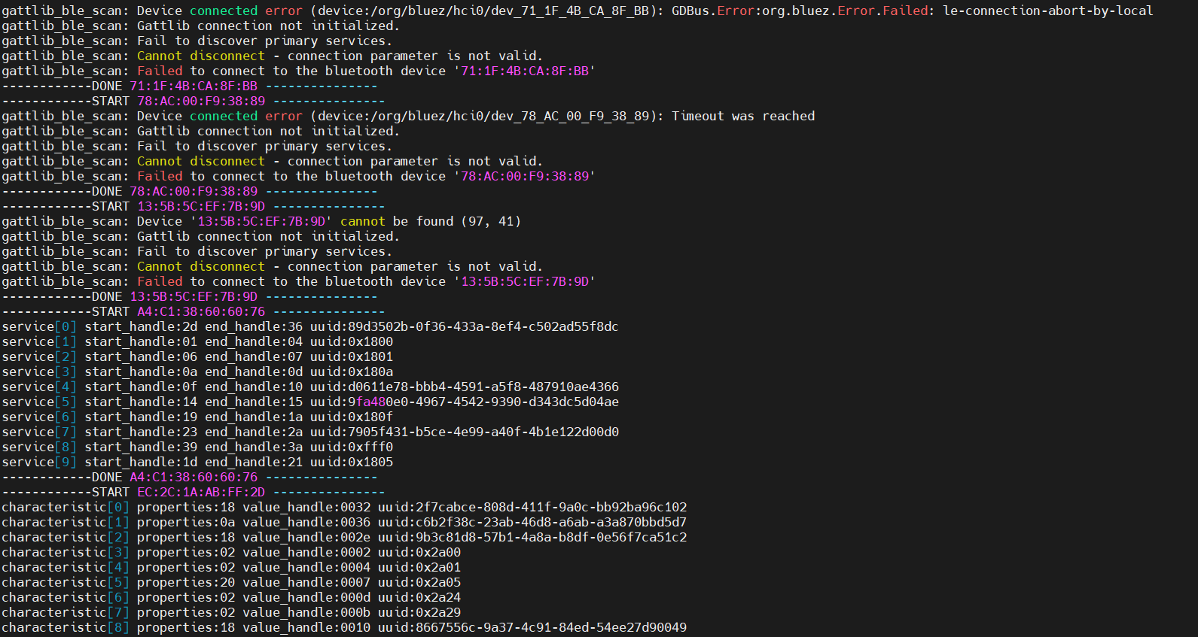
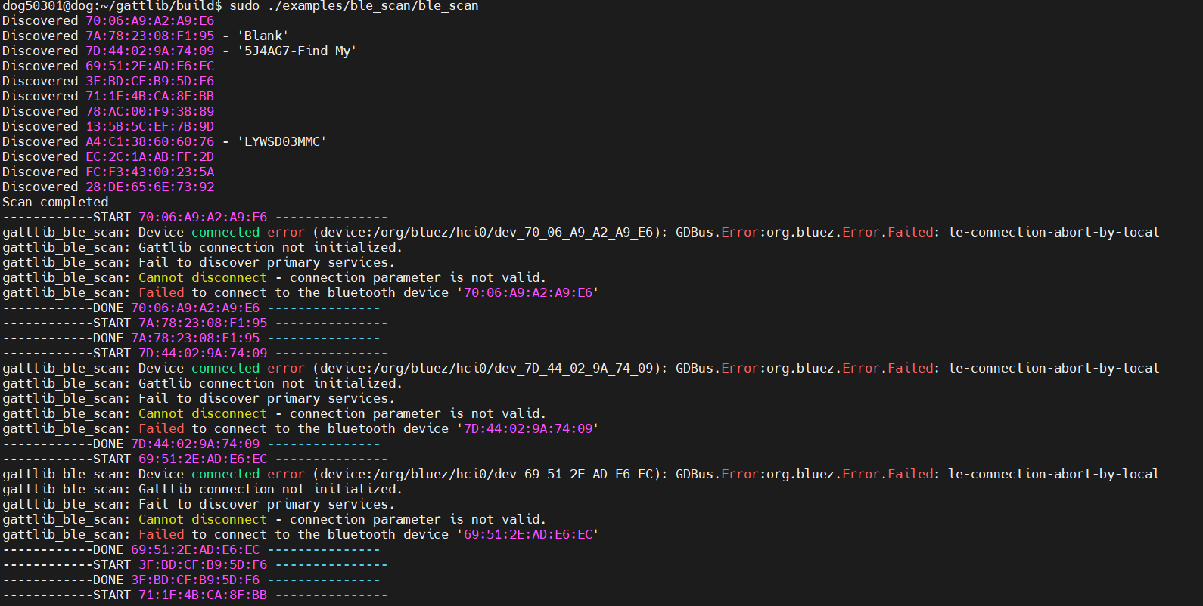

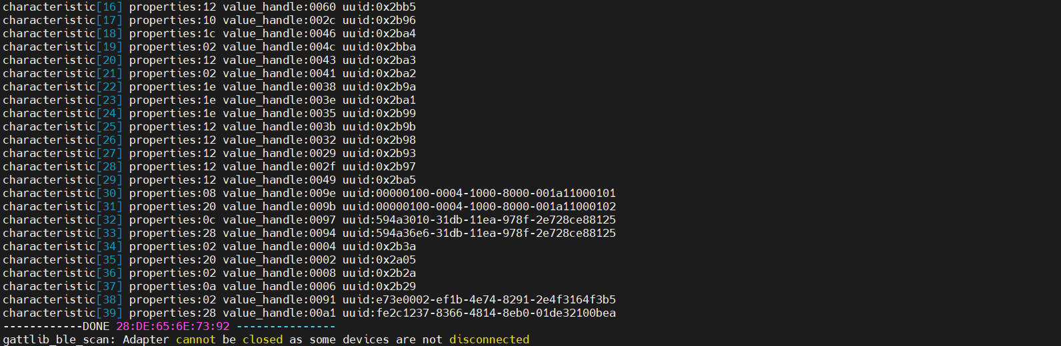

./examples/discover/discover 78:70:9B:A0:45:BD
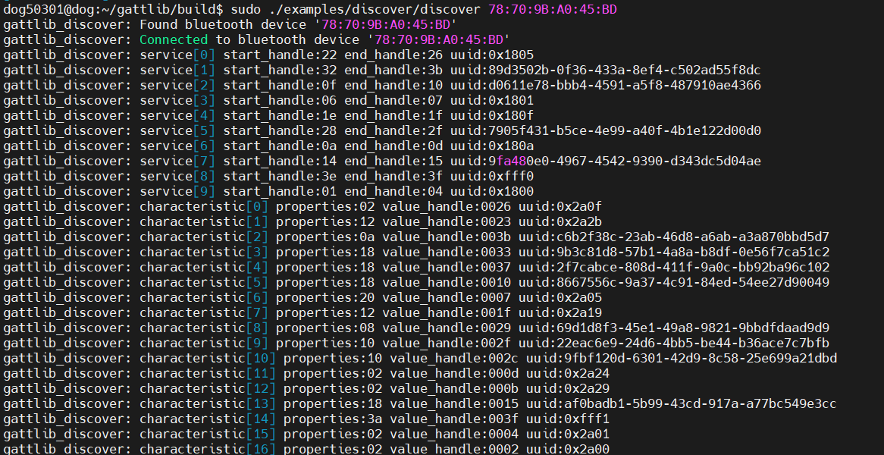

sudo ./examples/read_write/read_write 78:70:9B:A0:45:BD read 0000fff1-0000-1000-8000-00805f9b34fb

sudo ./examples/read_write/read_write 78:70:9B:A0:45:BD write 0000fff1-0000-1000-8000-00805f9b34fb 0x6767
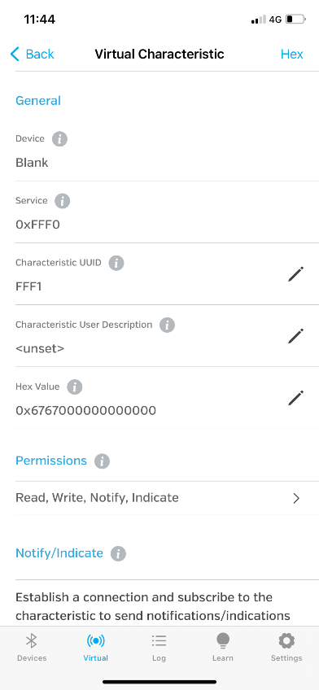

sudo ./examples/notification/notification
→sudo ./examples/notification/notification 78:70:9B:A0:45:BD 0000fff1-0000-1000-8000-00805f9b34fb

