Module 9: Building a RESTful API with Node.js and Express.js Assignment
CSC 820
03-29-26
Christie

API Screenshots:

- POST /orders: Create a new order.
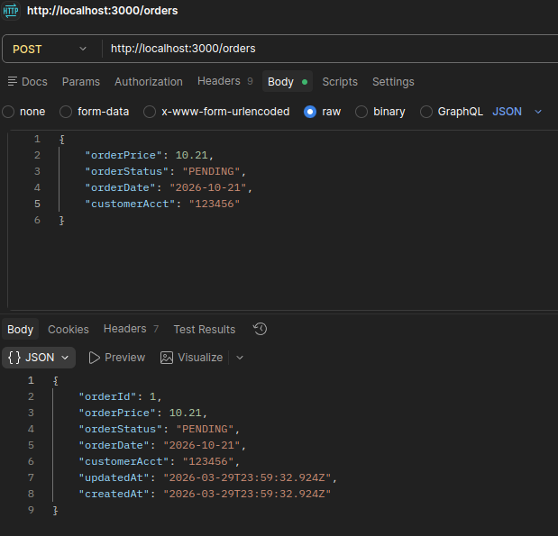
- GET /orders: Retrieve all orders.
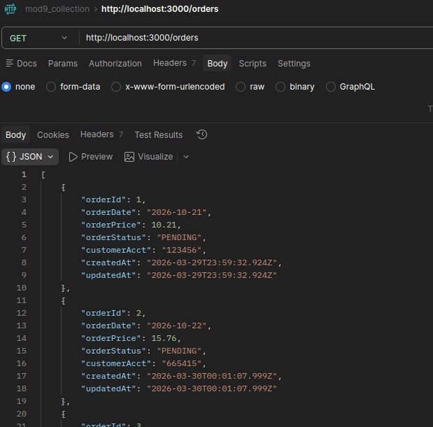
- GET /orders/:id: Retrieve a specific order by ID.
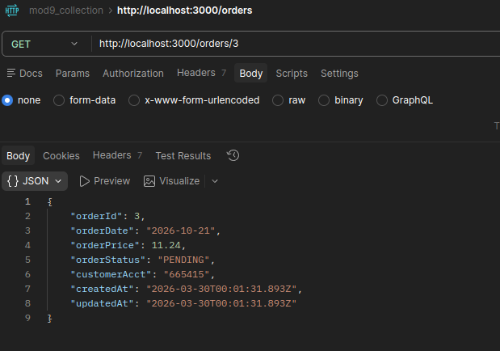
- PATCH /orders/:id: Update an order status (e.g., "Pending" to "Shipped").
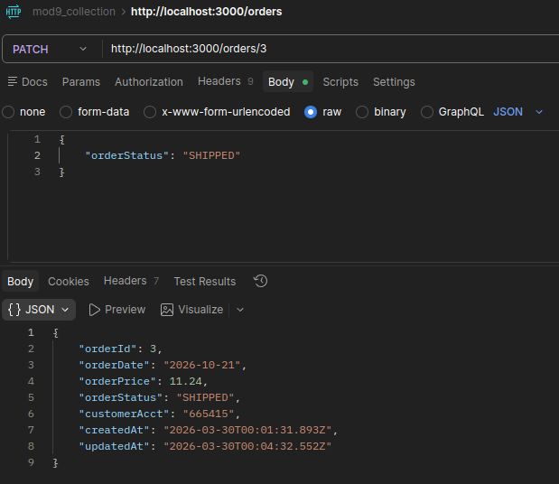
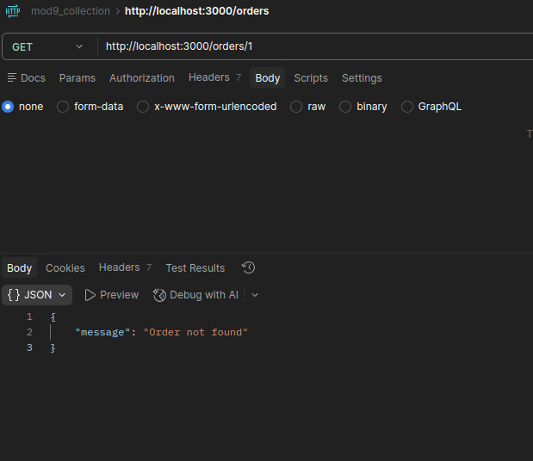
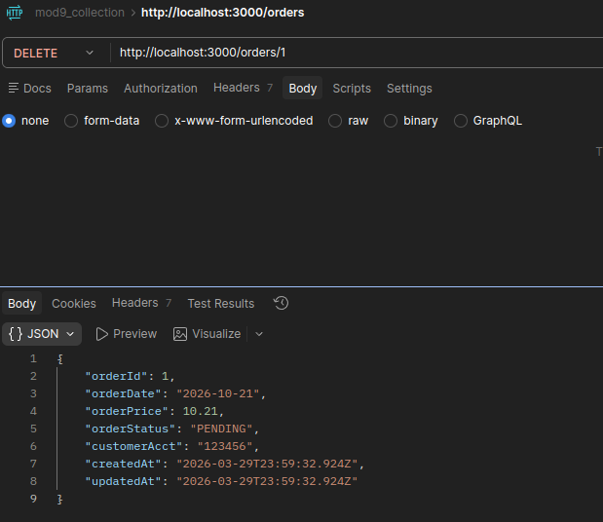
- DELETE /orders/:id: Cancel/remove an order.
- Passed Tests + Response Codes
