Module 11: Testing a REST API with Postman Assignment
Test Plan Document
CSC 820
Alex Christie
4/12/2026

Introduction
The following API is designed to simulate a basic e-commerce site’s backend. It serves basic CRUD functionality for ‘Order’ data; this includes things like order status, order price, order date, etc. Following REST principles, one can POST, GET, PATCH and DELETE orders through the API in order to add, update, read or delete orders.

Testing Scope
The size and complexity of the API allows for a comprehensive approach to testing in which each endpoint is tested. For each endpoint, multiple tests can be applied to determine if expected behavior is met for both standard and non-standard input.

Testing Approach
- Postman Testing
The goal of this testing phase is to ensure basic functionality before testing for correctness. Using postman, the tests evaluate basic requests for their expected response codes and data types. A failures at this stage indicate that either all or a portion of all tests within subsequent testing stages will fail automatically (e.g. failed to capture a response, improperly formatted response, etc.)
- Integration Testing
The goal of this phase of testing is largely to ensure the API’s CRUD functionality with respect to the database is working as expected. Changes in the database will be monitored following POST, PATCH and DELETE requests to assess the accuracy of these operations.
- Unit Testing
In this phase of testing, the goal is to test particular API endpoints within specific cases in order to verify that the API is complying with all validation rules. This might include ensuring that invalid prices are not accepted, the range of valid shipping statuses is respected, and more. This stage will largely focus on testing for incorrectly formatted payloads as proper requests will be covered in previous stages.

Test Environment
The API is hosted and tested locally. All the necessary resources (i.e the sqlite database) can be run locally, enabling quicker testing times.

Test Deliverables
- Test Cases
- Postman Collection
- Test Summary Report

Test Cases

Postman Test Cases
Test Case ID | Description | Input | Expected Output | Pass/Fail Criteria
pst_get_status | Test retrieving all orders when no records exist. | GET /orders | API returns 200 OK with an empty array []. | Pass if status code = 200 and response body includes [].
pst_post_status | Test creating a new order with valid input data. | POST /orders  { "orderPrice": 51.29, "orderStatus": "PENDING", "orderDate": "2026-12-13", "customerAcct": "908371" } | A new order is created. API returns 201 Created with orderId in response body. | Pass if status code = 201, response is JSON, and orderId is returned.
pst_patch_status | Test updating an existing order status. | PATCH /orders/{{orderId}}  { "orderStatus": "SHIPPED" } | Existing order is updated. API returns 200 OK with updated status SHIPPED. | Pass if status code = 200 and response contains SHIPPED.
pst_delete_status | Test deleting an existing order. | DELETE /orders/{{orderId}} | Order is deleted. API returns 204 No Content. | Pass if status code = 204.

Integration Test Cases Table
Test Case ID | Description | Input | Expected Output | Pass/Fail Criteria
int_post_status_1 | Create first test order. | POST /orders  { "orderPrice": 10.00, "orderStatus": "PENDING", "orderDate": "2026-12-14", "customerAcct": "908371" } | Order created with 201 and stored as orderA. | Pass if status code = 201 and orderId exists.
int_post_status_2 | Create second test order. | POST /orders  { "orderPrice": 21.20, "orderStatus": "SHIPPED", "orderDate": "2026-12-01", "customerAcct": "908371" } | Order created with 201 and stored as orderB. | Pass if status code = 201 and orderId exists.
int_post_status_3 | Create third test order. | POST /orders  { "orderPrice": 30.33, "orderStatus": "PENDING", "orderDate": "2026-12-15", "customerAcct": "908371" } | Order created with 201 and stored as orderC. | Pass if status code = 201 and orderId exists.
int_get_status_1 | Verify all 3 orders exist. | GET /orders | API returns 3 orders. | Pass if status code = 200 and response length = 3.
int_patch_status_1 | Update orderA price. | PATCH /orders/{{orderA}}  { "orderPrice": 11.11 } | OrderA price updated. | Pass if status code = 200.
int_patch_status_2 | Update orderB status. | PATCH /orders/{{orderB}}  { "orderStatus": "PENDING" } | OrderB status updated. | Pass if status code = 200.
int_patch_status_3 | Update orderC customer account. | PATCH /orders/{{orderC}}  { "customerAcct": "908372" } | OrderC account updated. | Pass if status code = 200.
int_get_status_2 | Verify updates persisted correctly. | GET /orders | OrderA price = 11.11, OrderB status = PENDING, OrderC acct = 908372. | Pass if all updated values match expected results.
int_delete_status_1 | Delete orderA. | DELETE /orders/{{orderA}} | Order removed. | Pass if status code = 204.
int_delete_status_2 | Delete orderB. | DELETE /orders/{{orderB}} | Order removed. | Pass if status code = 204.
int_delete_status_3 | Delete orderC. | DELETE /orders/{{orderC}} | Order removed. | Pass if status code = 204.
int_get_status_3 | Verify all orders deleted. | GET /orders | API returns empty array. | Pass if status code = 200 and response length = 0.

Unit Test Cases Table
Test Case ID | Description | Input | Expected Output | Pass/Fail Criteria
unt_post_status_date | Validate incorrect date format. | { "orderDate": "12-22-2026" } | API rejects request with "Invalid Input". | Pass if response message = "Invalid Input".
unt_post_status_price | Validate negative order price. | { "orderPrice": -51.29 } | API rejects request with "Invalid Input". | Pass if response message = "Invalid Input".
unt_post_status_status | Validate invalid order status. | { "orderStatus": "DELAYED" } | API rejects request with "Invalid Input". | Pass if response message = "Invalid Input".
unt_post_status_acct | Validate oversized customer account number. | { "customerAcct": "9083711111111" } | API rejects request with "Invalid Input". | Pass if response message = "Invalid Input".

Test Results
Selection | Description
Test Plan ID | 0001A
Test Plan Name | Initial Test
Version | V01
Date | 4-12-26
Author | Alex Christie
Objective | Initial testing to verify basic functionality
Scope | Cover all endpoints, connectivity, and errors
Test Criteria | Success → All tests passed, Failure → Any tests fail

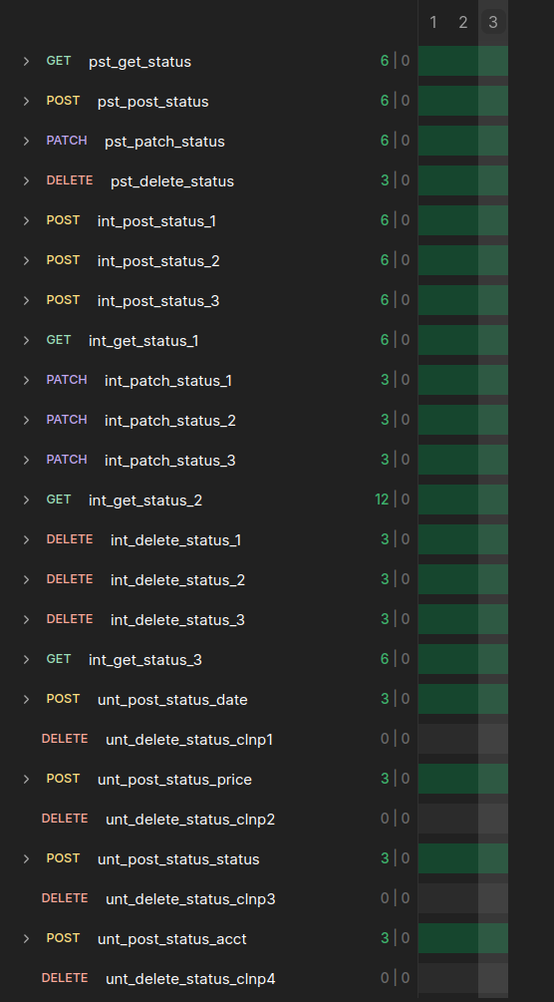
Postman Test Cases
Test Case ID | Pass/Fail
pst_get_status | PASS
pst_post_status | PASS
pst_patch_status | PASS
pst_delete_status | PASS

Integration Test Cases Table
Test Case ID | Pass/Fail
int_post_status_1 | PASS
int_post_status_2 | PASS
int_post_status_3 | PASS
int_get_status_1 | PASS
int_patch_status_1 | PASS
int_patch_status_2 | PASS
int_patch_status_3 | PASS
int_get_status_2 | PASS
int_delete_status_1 | PASS
int_delete_status_2 | PASS
int_delete_status_3 | PASS
int_get_status_3 | PASS

Unit Test Cases Table
Test Case ID | Pass/Fail
unt_post_status_date | PASS
unt_post_status_price | PASS
unt_post_status_status | PASS
unt_post_status_acct | PASS

Analysis
The postman collection test suite was successfully run across 3 iterations, with no failures at any point during the process. This demonstrates that the API achieves basic functionality reliably, with some coverage for outlier cases (i.e. common, but invalid, date formats). The consistency of the results indicate that the basic CRUD functions applied in this case are relatively stable with a simple, locally run and isolated database instance.

JEST Test Cases

Test Case ID | Description | Input | Expected Output | Pass/Fail Criteria
jst_post_valid | Create order with valid input | { validOrder } | 201 Created with order object | Pass if status = 201 and response contains validOrder
jst_post_invalid_types | Reject invalid data types and values | { orderDate: "not-a-date", orderPrice: -10, orderStatus: "INVALID", customerAcct: "abc" } | 422 Invalid Input | Pass if status = 422 and DB create not called
jst_post_boundary_price | Accept boundary value for price (0) | { orderPrice: 0, ...validOrder } | 201 Created | Pass if status = 201
jst_post_db_error | Handle database failure on create | validOrder | 400 Error creating order | Pass if status = 400 and error message returned
jst_post_boundary_customerAcct | Accept customerAcct at exact length (6) | { customerAcct: "999999", ...validOrder } | 201 Created | Pass if status = 201
jst_post_empty_body | Reject empty request body | {} | 422 Invalid Input | Pass if status = 422
jst_post_invalid_no_db_call | Reject invalid input without DB call | { bad: "data" } | 422 Invalid Input | Pass if status = 422 and create() not called
jst_get_all | Retrieve all orders | GET /orders | 200 OK with array of orders | Pass if status = 200 and response matches orders
jst_get_all_db_error | Handle DB failure when retrieving orders | GET /orders | 500 Error retrieving orders | Pass if response contains error message
jst_get_by_id_valid | Retrieve order by valid ID | /orders/1 | 200 OK with order object | Pass if status = 200 and response matches order
jst_get_by_id_not_found | Handle non-existent order ID | /orders/1 | 404 Order not found | Pass if status = 404
jst_get_by_id_db_error | Handle DB failure when retrieving order | /orders/1 | 500 Error retrieving order | Pass if response contains error message
jst_patch_valid | Update existing order | /orders/1 + validOrder | 200 OK with updated order | Pass if status = 200 and update() called with validOrder
jst_patch_invalid_input | Reject invalid update data | { orderPrice: -5 } | 422 Invalid Input | Pass if status = 422
jst_patch_not_found | Handle updating non-existent order | /orders/1 | 404 Order not found | Pass if status = 404
jst_patch_db_error | Handle DB failure during update | /orders/1 | 500 Error retrieving order | Pass if response contains error message
jst_patch_interaction | Verify correct DB interaction and response | /orders/1 + validOrder | 200 OK with updated order | Pass if findByPk called with ID and update called correctly
jst_delete_valid | Delete existing order | /orders/1 | 204 No Content | Pass if status = 204 and destroy() called
jst_delete_not_found | Handle deleting non-existent order | /orders/1 | 404 Order not found | Pass if status = 404
jst_delete_db_error | Handle DB failure during delete | /orders/1 | 500 Error retrieving order | Pass if response contains error message
Test Results
Selection | Description
Test Plan ID | 0002A
Test Plan Name | Jest Test
Version | V01
Date | 4-19-26
Author | Alex Christie
Objective | Initial testing of Jest Suite of Tests
Scope | Covers endpoints, connectivity, and errors
Test Criteria | Success → All tests passed, Failure → Any tests fail

Test Case ID | Pass/Fail Criteria
jst_post_valid | PASS
jst_post_invalid_types | PASS
jst_post_boundary_price | PASS
jst_post_db_error | PASS
jst_post_boundary_customerAcct | PASS
jst_post_empty_body | FAILURE
jst_post_invalid_no_db_call | PASS
jst_get_all | PASS
jst_get_all_db_error | PASS
jst_get_by_id_valid | PASS
jst_get_by_id_not_found | PASS
jst_get_by_id_db_error | PASS
jst_patch_valid | PASS
jst_patch_invalid_input | PASS
jst_patch_not_found | PASS
jst_patch_db_error | PASS
jst_patch_interaction | PASS
jst_delete_valid | PASS
jst_delete_not_found | PASS
jst_delete_db_error | PASS

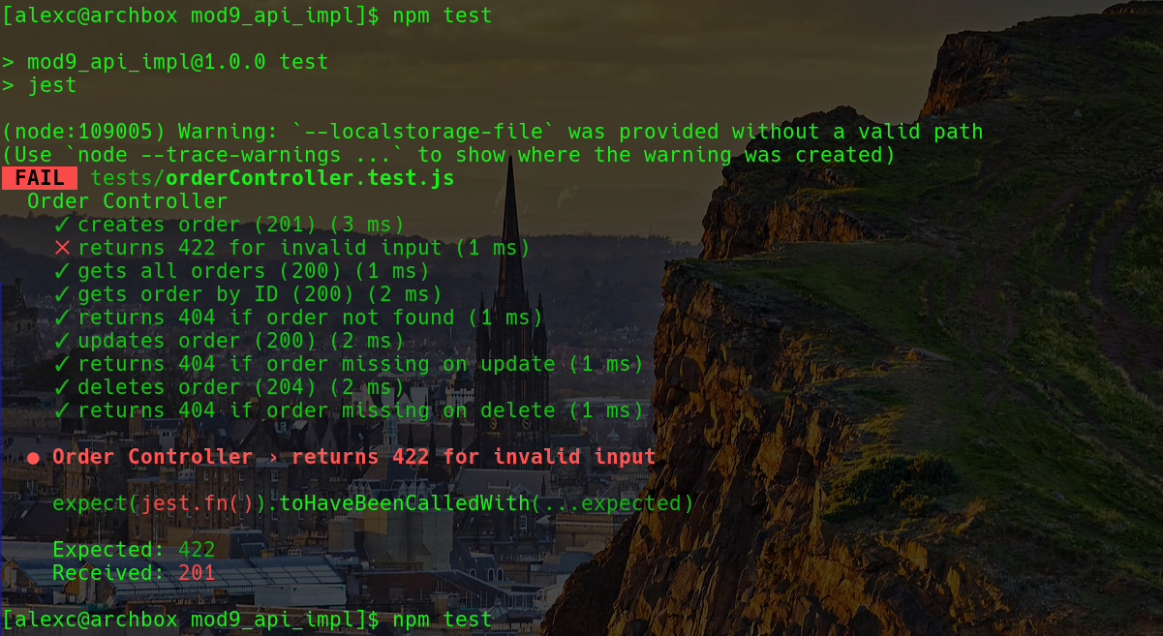

Selection | Description
Test Plan ID | 0003A
Test Plan Name | Jest Test
Version | V01
Date | 4-19-26
Author | Alex Christie
Objective | Initial testing of Jest Suite of Tests
Scope | Covers endpoints, connectivity, and errors
Test Criteria | Success → All tests passed, Failure → Any tests fail

Test Case ID | Pass/Fail Criteria
jst_post_valid | PASS
jst_post_invalid_types | PASS
jst_post_boundary_price | PASS
jst_post_db_error | PASS
jst_post_boundary_customerAcct | PASS
jst_post_empty_body | PASS
jst_post_invalid_no_db_call | PASS
jst_get_all | PASS
jst_get_all_db_error | PASS
jst_get_by_id_valid | PASS
jst_get_by_id_not_found | PASS
jst_get_by_id_db_error | PASS
jst_patch_valid | PASS
jst_patch_invalid_input | PASS
jst_patch_not_found | PASS
jst_patch_db_error | PASS
jst_patch_interaction | PASS
jst_delete_valid | PASS
jst_delete_not_found | PASS
jst_delete_db_error | PASS
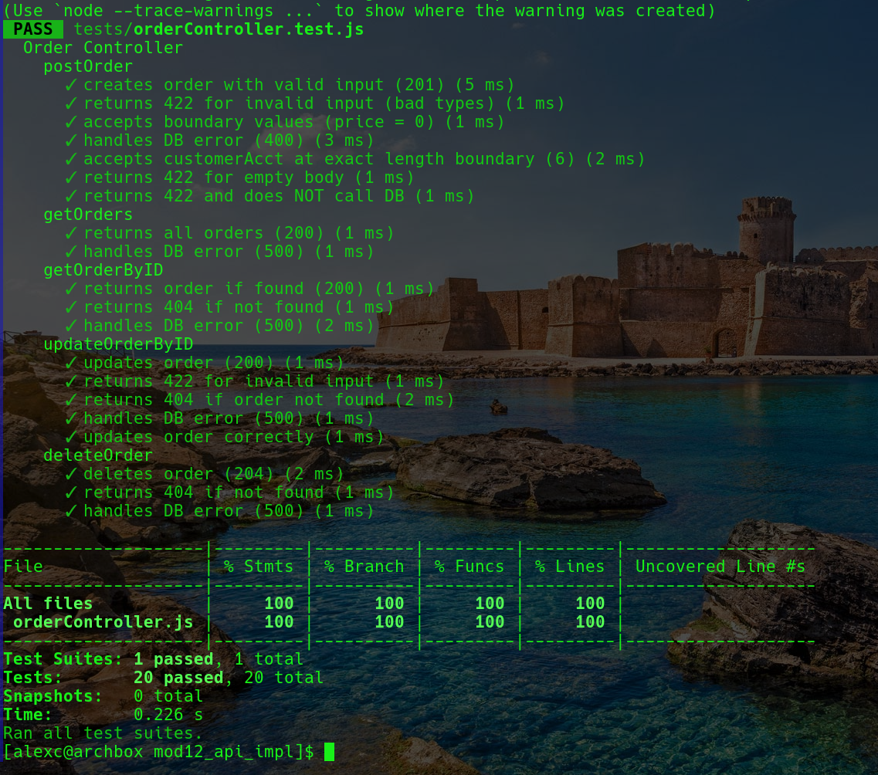
Analysis

The local suite of Jest tests was successfully run. Initially, there was a failure for test jst_post_empty_body; the validation checks in the order controller constrained the data within the data model’s fields, but it did not specify those fields as a requirement which lead to the error. A ‘required: ['orderDate', 'orderPrice', 'orderStatus', 'customerAcct']’ check was added to the schema and the subsequent tests ran without issue. These tests indicate the robustness of the API against a variety of situations and inputs. The suite reliably assesses the API’s capacity for handling adverse conditions like database errors, invalid input, and boundary conditions, in addition to normal operation.

