# Chapter 2: Financial Math

### Student Outcomes for this Chapter

Section 2.1: Introduction to Spreadsheets

Students will be able to:

* Perform basic calculations on a spreadsheet
* Use cell references and the fill-down feature

Section 2.2: Simple and Compound Interest

Students will be able to:

* Use spreadsheet functions and/or mathematical formulas to calculate simple, compound, and continuously compounded interest
* Understand the difference between simple and compound interest
* Use a spreadsheet to calculate the effective rate and compare accounts
* Use a spreadsheet and/or formula to calculate the present value needed to reach a desired future value

Section 2.3: Savings Plans

Students will be able to:

* Use a spreadsheet and/or formula to calculate the future value and interest earned on savings plans
* Use a spreadsheet and/or formula to calculate payment amounts for savings plans
* Analyze and compare lump sum and regular payment savings plans

Section 2.4: Loan Payments

Students will be able to:

* Use a spreadsheet and/or formula to calculate the payment amount for student loans, car loans, paying off credit cards and mortgage loans
* Calculate the total paid over the life of a loan, amount of interest paid, and the percentage of the total amount paid in interest
* Determine when to use each formula in the financial math chapter

Section 2.5: Income Taxes

Students will be able to:

* Calculate gross income and adjusted gross income (AGI)
* Determine the standard deduction according to filing status
* Determine whether to use the standard or itemized deductions and calculate taxable income
* Calculate income tax from tables
* Compare taxes owed to withholdings to determine whether a refund is due or a payment is required

## Section 2.1 Introduction to Spreadsheets

A spreadsheet such as Google Sheets or Microsoft Excel, is a very useful tool for doing calculations and making complex tables. You can type in your own custom calculations or use the built-in formulas.

The rectangles within a spreadsheet are called **cells**, and they can be referenced by their column letter and row number. The first cell in the upper left side highlighted below is A1. If we wanted to talk about the third column and the fifth row, that cell would be C5.

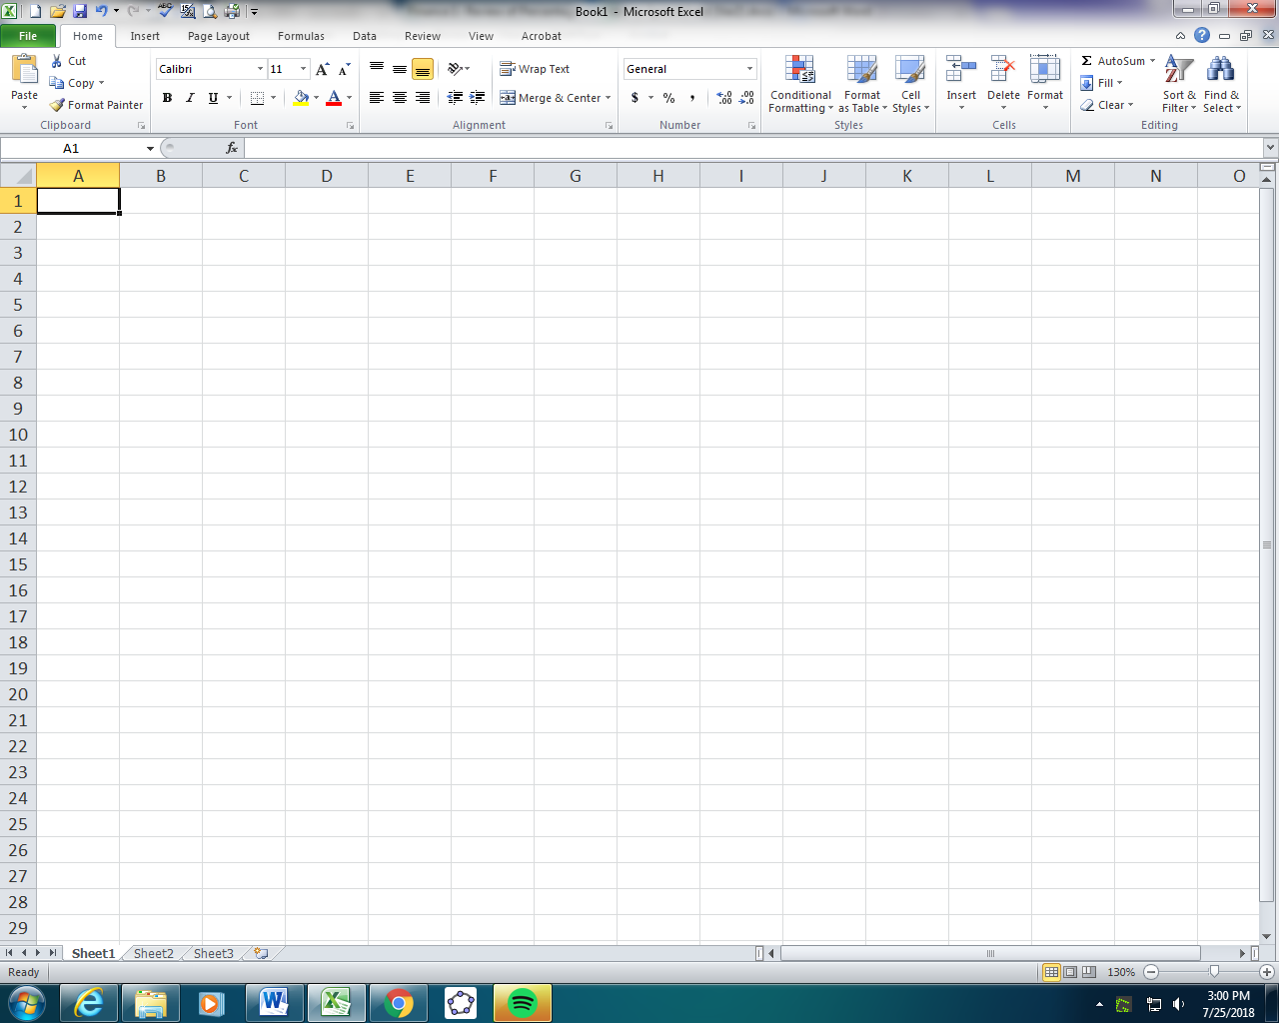

A spreadsheet file can contain many sheets. Look along the bottom to see if there is more than one sheet and make sure you are on the right sheet.



### Basic Calculations

To do a calculation on a spreadsheet, type an equal sign before the operation. This lets the program know that you want it to calculate the result. When you press enter, you will see the result.

Example 1:

1. To add 3 + 4 =3+4
2. To subtract 100-76 =100-76
3. 4 times 18 =4*18
4. 0.05 divided by 12 =0.05/12
5. To calculate 525 =5^25

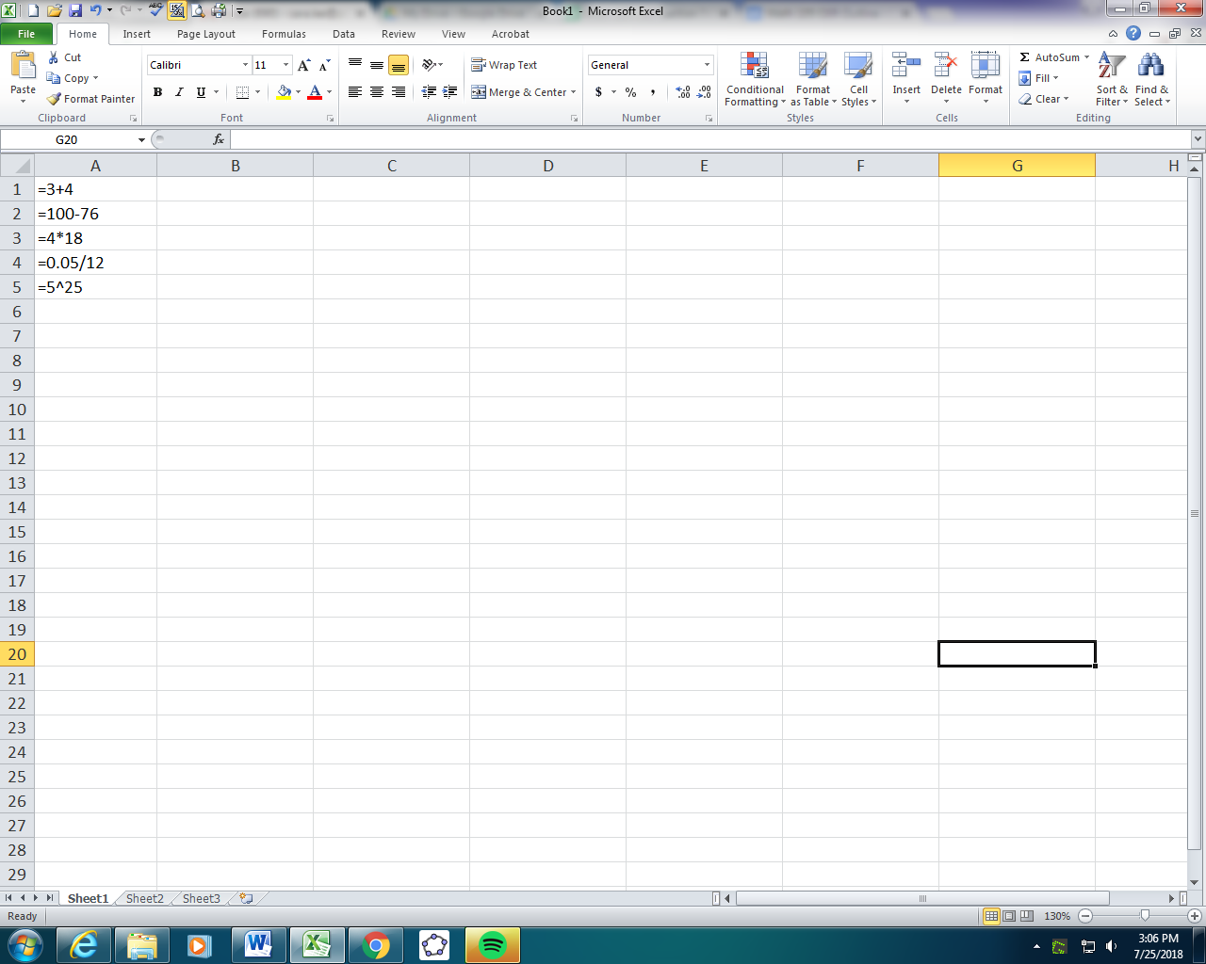

Note that the asterisk (*) is used for multiplication. Spreadsheets don’t recognize parentheses as indicators of multiplication like calculators do, so even if you have parentheses for the order of operations, the asterisk is also needed.

You can make more complicated mathematical expressions using parentheses and other operations. To **edit a cell**, click on the editing box at the top, or double click on the cell to edit it directly.

Example 2:

Your bill at a restaurant is $35.75 and you want to leave an 18% tip. How much would you add to the bill?

To work with a percentage, we need to convert it into a decimal first, and then multiply it by the base amount. In a spreadsheet we would type

=0.18*35.75

=$6.44, **rounded to the nearest cent**. You would leave a tip of $6.44.

### Cell References

One of the powerful things about spreadsheets is using a **cell reference**, such as C5 in a calculation. When you use a cell reference, the values will automatically update if any of the referenced values change.

Let’s make a spreadsheet for the percentage tip example above. We calculated an 18% tip on a bill of $35.75. We might want to tip 18% in general, but our bill will change values. We labeled the first column Bill Amount and the second column Tip. The amount of $35.75 is entered in cell A2. Then when we write our formula in B2, we want to calculate 18% of A2. That way if the number in A2 changes, our tip will automatically update.

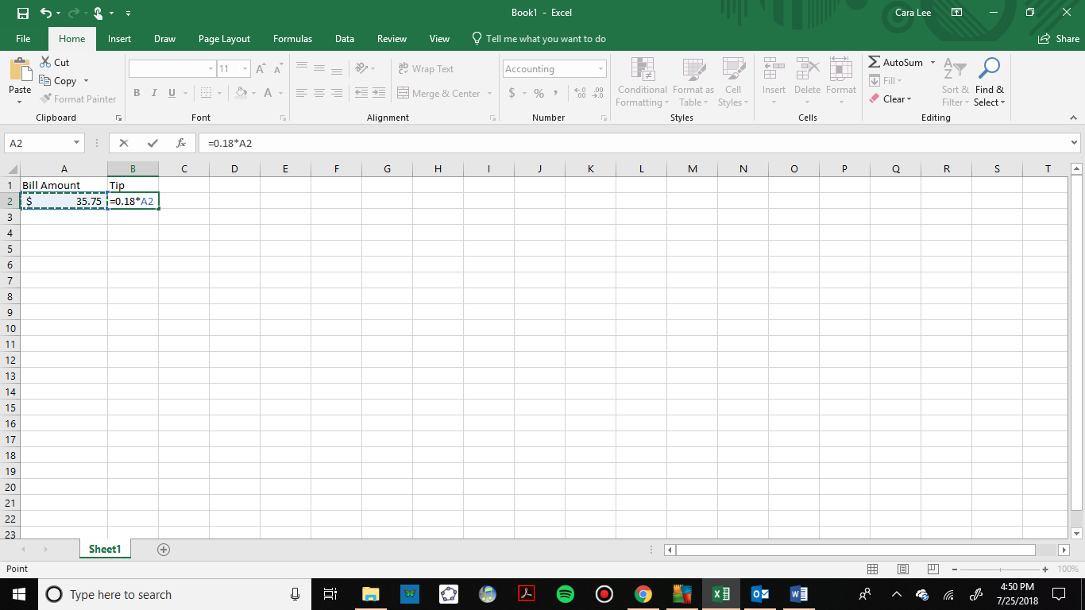

The formula =0.18*A2 is entered in B2 which gives a result of $6.44 when you hit enter.

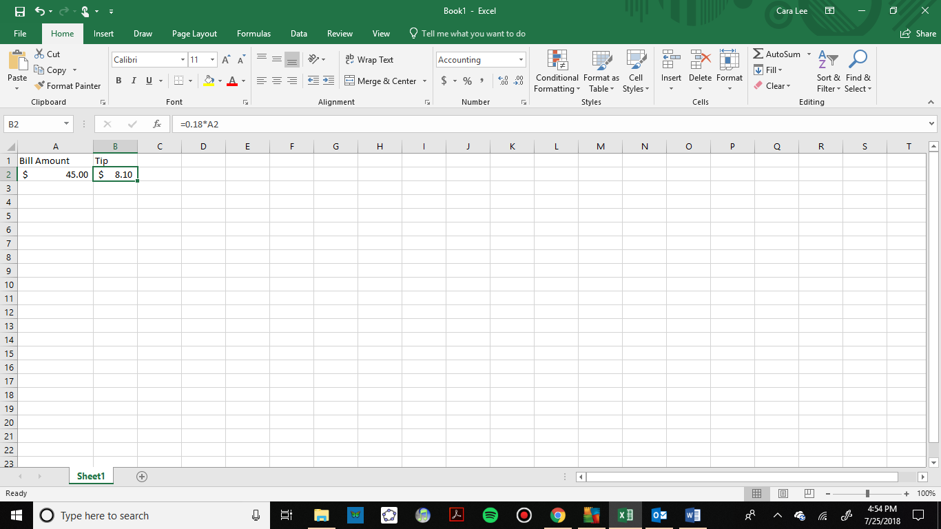

When the bill amount is changed, the tip is recalculated.

### Cell Formatting

We can also format cells A1 and B1 to show dollar signs by clicking on the dollar sign in the number formatting menu.

### Fill-Down Feature

The **fill-down feature** is very useful for making tables. This allows us to copy values or formulas to save time. Let’s make a tipping reference table with values from $10, to$100, in increments of $10. First, we will enter two values in column A to establish the pattern. Then select those two cells and you will see a small square in the lower right corner. Drag that square down until you get to $100.

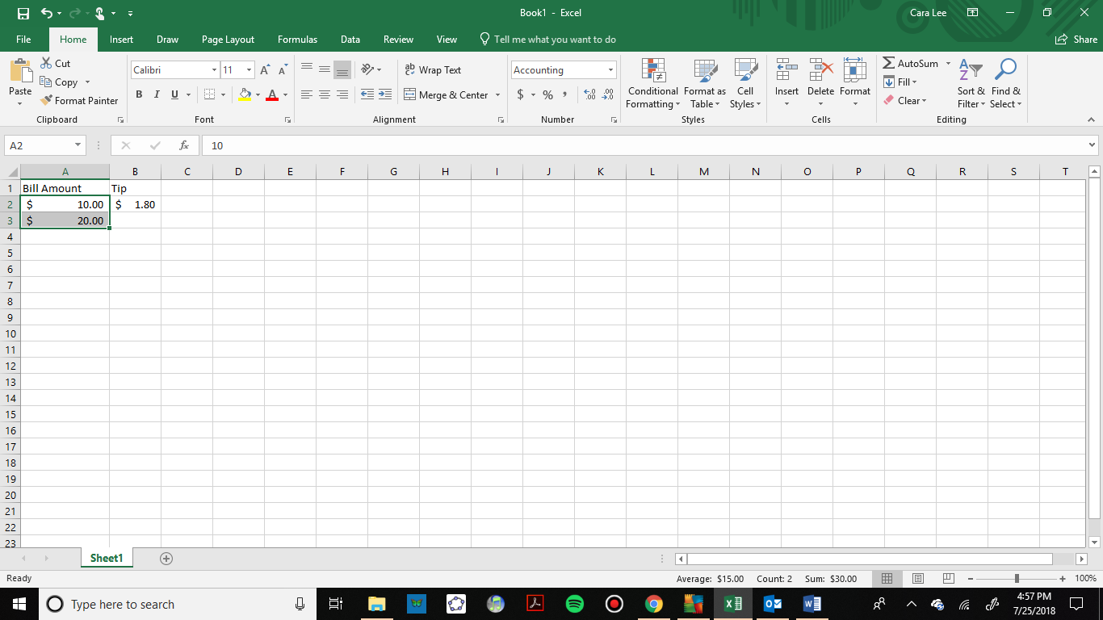

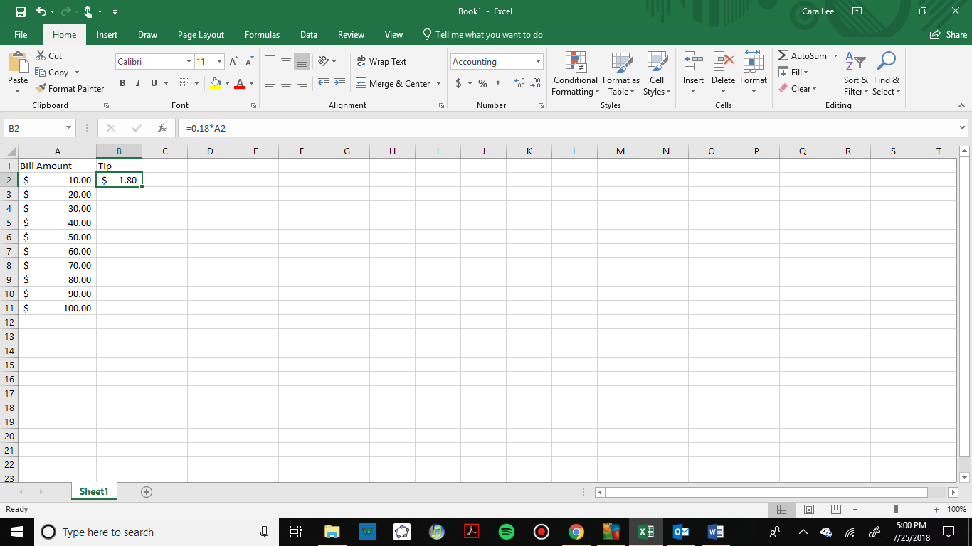

Next, we can drag our formula down and the cell reference will change to each row number automatically.

Here are the formulas with the row numbers updated:

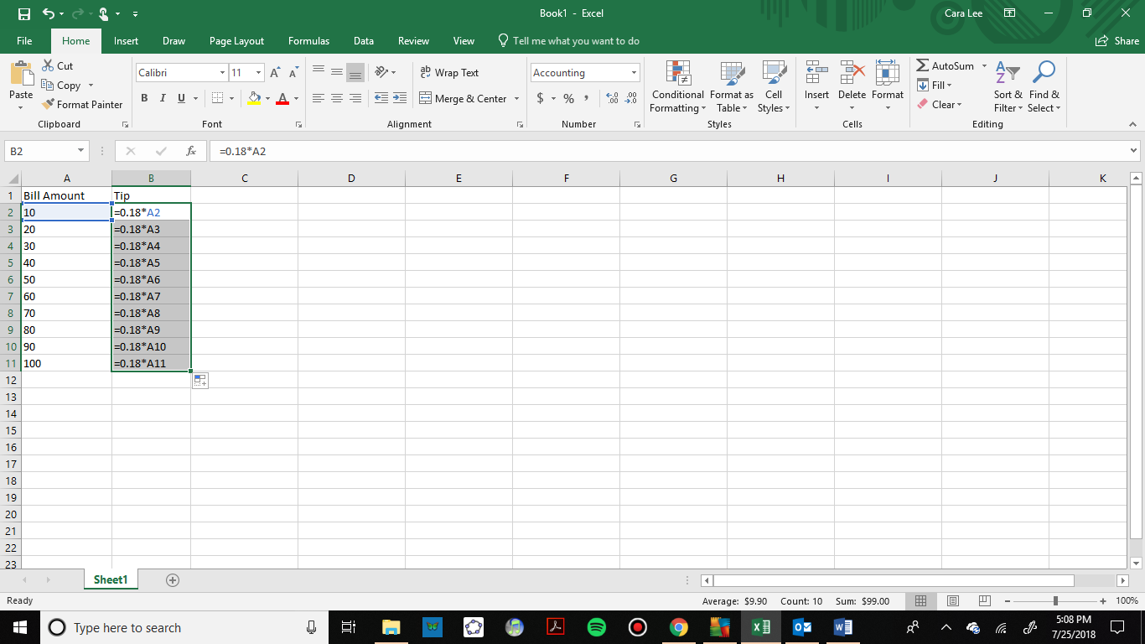

Here is our completed table with the calculations:

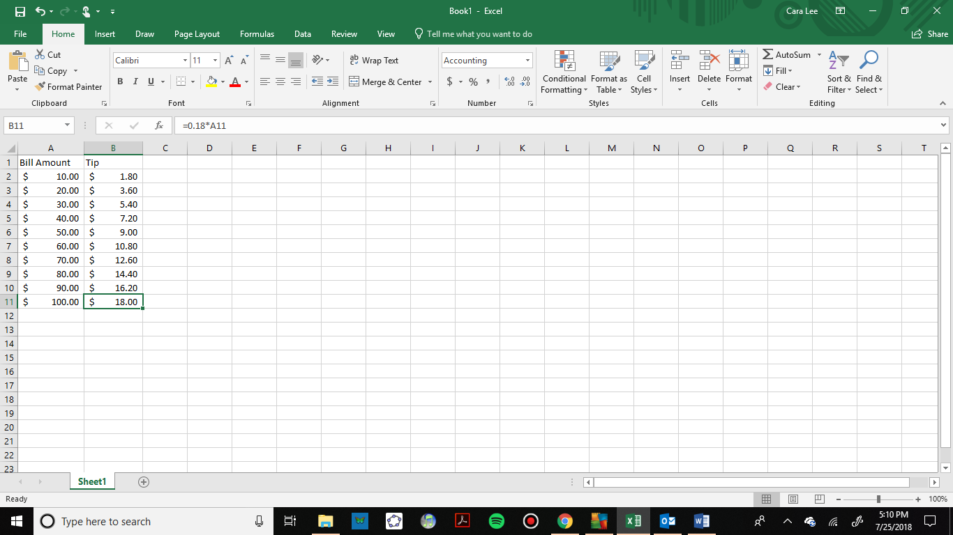

### Formulas

Spreadsheets have many useful built-in formulas. We will introduce some of the financial formulas in this chapter. Here are some of the formulas we will use:

=FV to calculate the future values of an investment

=PV to calculate the deposit needed for a desired future balance

=PMT to calculate a loan or savings plan payment

=EFFECT to calculate the effective rate of an account and compare accounts

In the rest of this chapter we will use spreadsheets and formulas to calculate the future values, interest paid or earned and monthly payments.

### Exercises 2.1

Use a spreadsheet to compute the following.

1. Convert 4/7 to a decimal
2. Convert 16% to a decimal
3. Add 8 and 19
4. Find the difference of 230 and 78
5. Multiple 12 and 9
6. Divide 0.09 by 52
7. Calculate 83
8. Your bill at a restaurant is $55.75 and you want to leave a 20% tip. How much would you add to the bill?
9. You leave a tip for $7.50 for a bill at a restaurant that is $44.50. What percent tip did you leave?
10. In Column A use the fill down feature to build a spreadsheet starting with $5 and ending at $125, in increments of $5. In Column B write a formula with a cell reference to calculate a 15.5% tip on the amount in Column A. Use the fill down feature to complete your table.

## Section 2.2 Simple and Compound Interest

*Note: Spreadsheets are emphasized in this chapter, but the formulas are also presented so you can understand what the spreadsheet is doing. Be sure to check with your instructor for which method to use.*

Working with money is a very important skill for everyday life. While balancing a checkbook or calculating our monthly expenditures on espresso requires only arithmetic, when we start saving money, planning for retirement, or need a loan, we need more mathematics and tools. In this section we will calculate and compare simple and compound interest.

### Simple Interest

Calculating interest starts with the **principal**, *P*,or the beginning amount in your account. This is also called the **present value**. This could be a starting investment, or the starting amount of a loan. The **interest**, *I*, in its most simple form, is a percentage of the principal.

For example, if you borrowed $100 from a friend and agree to repay it with 5% interest, then the amount of interest you would pay would be 5% of 100. It is very important to remember to change the interest **rate**, r, of 5% into a decimal by moving the decimal two places to the left.



The total amount you would repay is called the **future value** and would be $105, the original principal plus the interest.



Here are the formulas to represent the calculations we just did.

Simple One-time Interest



*I* is the interest

*P* is the principal, starting amount or **present value**

*r* is the interest rate in decimal form

*A* is the end amount: principal plus interest. This is also called the **future value**

Example 1:

A friend asks to borrow $300 and agrees to repay it in 30 days with 3% simple interest. How much interest will you earn?

*P* = $300 the principal or present value

*r* = 0.03 3% rate

Using the formula,

**

To calculate this in a spreadsheet, you would enter

=300*0.03

=$9. You will earn $9 in interest when your friend pays you back.

One-time simple interest is only common for extremely short-term or informal loans. For longer term loans or investments, it is common for interest to be paid on a daily, monthly, quarterly, or annual basis. In that case, interest would be earned regularly. Bonds are an example of this type of investment. Bonds are issued by the federal, state or local governments to cover their expenses.

Example 2:

Suppose your city is building a new park, and issues bonds to raise the money to build it. You buy a $1,000 bond that pays 5% simple interest annually and matures in 5 years. How much interest will you earn? What is the future value of the bond?

Each year, you would earn 5% interest so over the course of five years, you would earn:

**

When the bond matures, you would receive back the $1,000 you originally paid and the $250 in interest, so we could also put that into a single calculation:

**

Using a spreadsheet, you would enter

=1000+1000*0.05*5

=$1,250.

The future value of the bond is $1,250.

We can generalize this idea of simple interest over time.

Simple Interest over Time



*I* is the interest

*P* is the principal, starting amount, or present value

*r*  is the interest rate in decimal form

*t*  is time, where the increment of time (years, months, etc.) matches the time period for the interest rate

*A*  is the end amount, principal plus interest, or future value

### APR – Annual Percentage Rate

Interest rates are usually stated as an annual percentage rate (APR) – the total interest that will be paid in the year. If the interest is paid in smaller time increments, the APR will be divided by the number of time periods.

For example, a 6% APR paid monthly, would be divided by 12, because you would get one twelfth of the rate per month, which is half a percent per month.



A 4% annual rate paid quarterly, would be divided by 4 to get 1% per quarter.



Here is an example of a semi-annual rate.

Example 3:

Suppose you buy a $1,000 federal bond with a 4% annual simple interest rate, paid semi-annually, with a maturity in 4 years. How much interest will you earn? What will be the future value of the bond?

*P* = $1000 the principal

*r* = interest is being paid semi-annually (twice a year), so the 4% interest will be divided into two 2% payments.

*t* = 8 4 years, compounded twice a year so  half-years

**

You will earn $160 in interest over the four years. The future value of the loan is

**

We could also use a spreadsheet to do this calculation and enter:

=1000+1000*(0.04/2)*(4*2)

=$1,160

The future value of the bond is $1,160. Remember that spreadsheets don’t interpret parentheses as multiplication. We need the asterisks as well as the parentheses.

### Compound Interest

In a standard bank account, any interest we earn is automatically added to our balance, and we earn interest on that interest. This reinvestment of interest is called **compounding**. We will develop the mathematical formula for compound interest and then show the equivalent spreadsheet function.

Suppose that we deposit $1000 in a bank account offering 3% interest, compounded monthly. How will our money grow?

The 3% interest is an annual percentage rate (APR) – the total interest to be paid during the year. Since interest is being paid monthly, each month, we will earn  per month.

In the first month,

*P*= $1000

 (which is 0.25%)



**

In the first month, we will earn $2.50 in interest, raising our account balance to $1002.50.

In the second month,

*P* = $1002.50

 (rounded)



Notice that in the second month we earned more interest than we did in the first month. This is because we earned interest not only on the original $1000 we deposited, but we also earned interest on the $2.50 of interest we earned the first month. This is the key advantage that compounding gives us.

Calculating out a few more months in a table or a spreadsheet we have:

|  |  |  |  |
| --- | --- | --- | --- |
| Month | Starting balance | Interest earned | Ending Balance |
| 1 | 1000.00 | 2.50 | 1002.50 |
| 2 | 1002.50 | 2.51 | 1005.01 |
| 3 | 1005.01 | 2.51 | 1007.52 |
| 4 | 1007.52 | 2.52 | 1010.04 |
| 5 | 1010.04 | 2.53 | 1012.57 |
| 6 | 1012.57 | 2.53 | 1015.10 |
| 7 | 1015.10 | 2.54 | 1017.64 |
| 8 | 1017.64 | 2.54 | 1020.18 |
| 9 | 1020.18 | 2.55 | 1022.73 |
| 10 | 1022.73 | 2.56 | 1025.29 |
| 11 | 1025.29 | 2.56 | 1027.85 |
| 12 | 1027.85 | 2.57 | 1030.42 |

To find an equation to represent this, we will go through a few months to see the pattern:

Initial Amount: 

1st Month 

2nd Month 

3rd Month 

4th Month 

Observing a pattern, we could conclude

*n*th month 

Notice that the $1000 in the equation was *P*, the starting amount. We found 1.0025 by adding one to the interest rate divided by 12, since we were compounding 12 times per year. Generalizing our result, we could write

Compound Interest

 or 

*A* is the future value balance in the account after *n* years

*P* is the principal or present value

*r* is the annual interest rate in decimal form

*n* is the number of compounding periods in one year

*t* is the number of years

If the compounding is done annually (once a year), *n* = 1.

If the compounding is done quarterly, *n* = 4.

If the compounding is done monthly, *n* = 12.

If the compounding is done weekly, n = 52

If the compounding is done daily, *n* = 365.

The most important thing to remember about using this formula is that it assumes that we put money in the account **once** and let it sit there earning interest.

### The Future Value Spreadsheet Formula

The compound interest formula is built into spreadsheets and is called the future value formula.

Future Value Spreadsheet Formula

=FV(rate per period, number of periods, payment amount, present value)

*rate per period* is the interest rate per compounding period, *r/n*

*number of periods* is the total number of periods, *n*t*

*payment amount* is the amount of regular payments. If none, enter *0*

*present value* is the amount deposited or principal, *P*

We will use the payment amount in a future section, for now that will be 0. There is also an optional input at the end to specify making payments at the beginning or end of the period, but we will not use it in this book.

Now let’s look at an example and calculate the compound interest using the spreadsheet and the mathematical formula.

Example 4:

A certificate of deposit (CD) is a savings instrument that many banks offer. It usually gives a higher interest rate, but you cannot access your investment for a specified length of time. Suppose you deposit $3000 in a CD paying 6% interest, compounded monthly. How much will you have in the account after 20 years?

*P* = $3000 the initial deposit

*r* = 0.06 6% annual rate

*n* = 12 12 months in 1 year

*t* = 20 since we’re looking for how much we’ll have after 20 years

To use a spreadsheet, you would enter

=FV(rate per period, number of periods, payment amount, present value)

=FV(0.06/12, 12*20, 0, 3000)

=$9,930.61, rounded to the nearest cent.

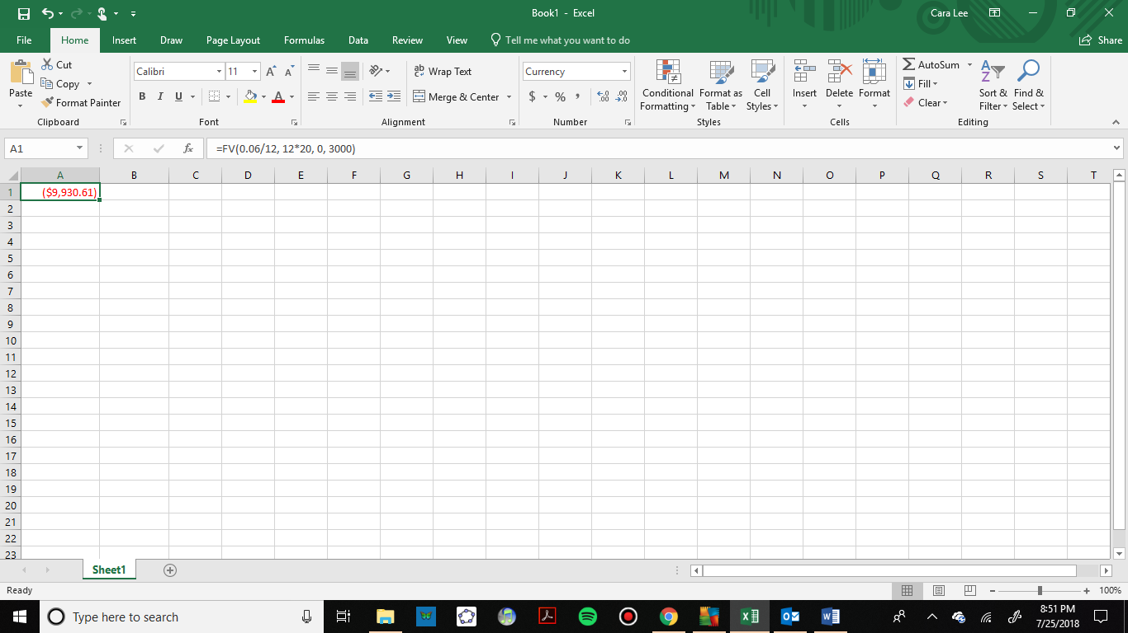

Note that the output of the formula gives the answer with the opposite sign as the principal and payments. A negative number may be denoted with a negative sign or with the color red or parentheses. The signs may be used in accounting, but we will ignore them in this book.

To use a formula, we are looking for the future value, so we use the formula solved for A:



To use a calculator, you would enter the formulas including parentheses around any inside operations. You would enter

.

### Comparing Simple and Compound Interest

Let us compare the amount of money earned from compounding in the previous example against the amount you would earn from simple interest. From the table and graph below we can see that over a long period of time, compounding makes a large difference in the account balance. You may recognize this as the difference between linear growth and exponential growth.

|  |  |  |
| --- | --- | --- |
| Years | Simple Interest ($15 per month) | Compound Interest  (6% compounded monthly or 0.5% each month) |
| 0 | $3000 | $3000 |
| 5 | $3900 | $4046.55 |
| 10 | $4800 | $5458.19 |
| 15 | $5700 | $7362.28 |
| 20 | $6600 | $9930.61 |
| 25 | $7500 | $13394.91 |
| 30 | $8400 | $18067.73 |
| 35 | $9300 | $24370.65 |

### Finding the Principal, or Present Value

When we know the amount of money we want to have in the future, we can use the formula that is solved for *P*. It requires a little algebra to divide both sides of the formula by the quantity that was multiplied by *P*. There is also a spreadsheet formula which we will introduce now, and then do an example using both methods.

### The Present Value Spreadsheet Formula

The present value spreadsheet formula will calculate how much you need to deposit in the present to get a specified future value.

Present Value Spreadsheet Formula

=PV(rate per period, number of periods, payment amount, future value)

*rate per period*  is the interest rate per compounding period, *r/n*

*number of periods* is the total number of periods, *n*t*

*payment amount* is the amount of regular payments. If none, enter *0*

*future value* is the amount desired in the future, *A*

Example 5:

You know that you will need $40,000 for your child’s education in 18 years. If your account earns 4% compounded quarterly, how much would you need to deposit now to reach your goal?

We are looking for what we need to deposit now so we will use the present value formula. We type the formula and inputs the same way we used the future value formula.

=PV(rate per period, number of periods, payment amount, future value)

=PV(0.04/4, 4*18, 0, 40000)

= $19,539.84

You would need to deposit $19,539.84 now and keep the same interest rate to have $40,000 in 18 years.

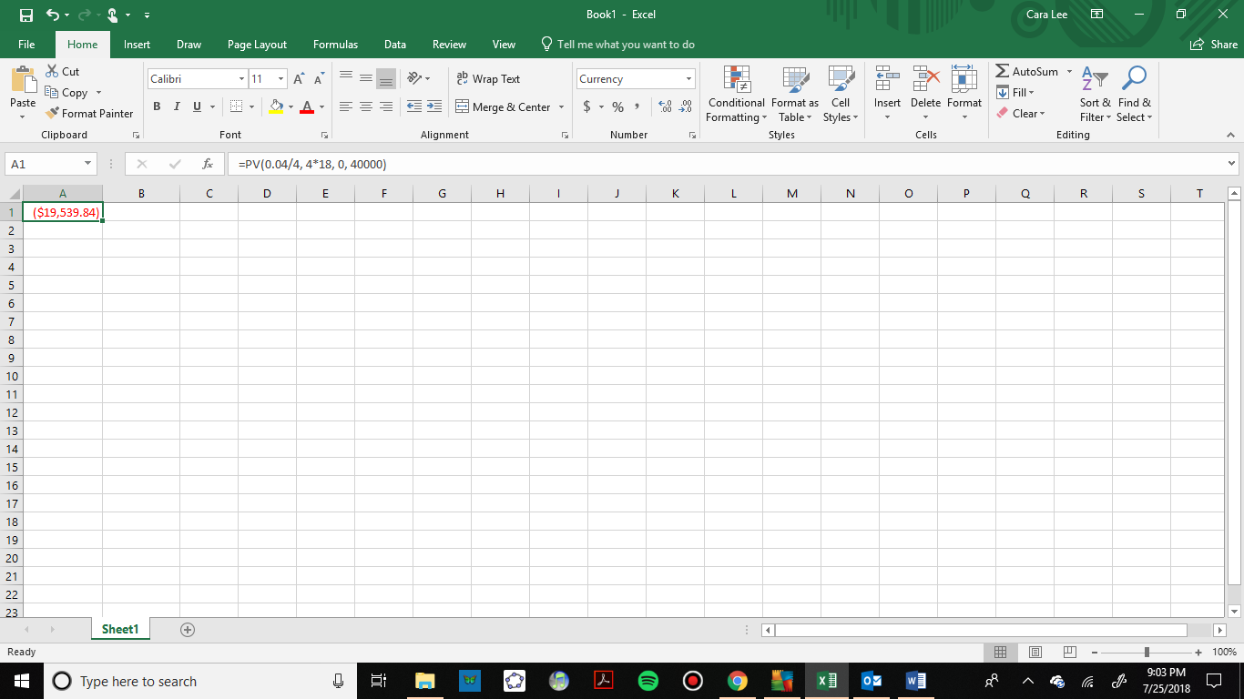

Note that we cannot enter commas in numbers in a spreadsheet. Commas are used to separate the input values, so we would not get the same answer if we put in $40,000 for an input.

To use the mathematical formula, we use the one that is solved for *P*.

*r* = 0.04 4%

*n* = 4 4 quarters in 1 year

*t* = 18 Since we know the balance in 18 years

*A* = $40,000 The amount we have in 18 years

In this case, we’re going to have to set up the equation, and solve for *P*.



You would need to deposit $19,539.84 now to have $40,000 in 18 years.

### Continuously Compounded Interest

In many bank accounts your interest is compounded continuously, or at each moment in time. The number of times per year, *n*, is infinite. As *n* approaches infinity the compound interest formula changes to the continuously compounded interest formula.

Continuously Compounded Interest

 or 

*A* is the future value or desired balance in the account

*P* is the principal or present value

*r* is the annual interest rate in decimal form

*t* is the number of years

*e* is an irrational number that is approximately2.718281828…

Find *e* on your calculator to use this formula

To calculate this on a spreadsheet we use the =EXP function. The spreadsheet formulas are

=Principal*EXP(r*t) or =A/EXP(r*t)

Example 6:

You deposit $4000 in an account that earns 2.75% interest compounded continuously. How much will you have after 7 years? How much interest did you earn? What percentage of the final balance is interest?

To use a spreadsheet, we look at the formula solved for A, the future value. We enter

=4000*EXP(0.0275*7)

=$4849.11.

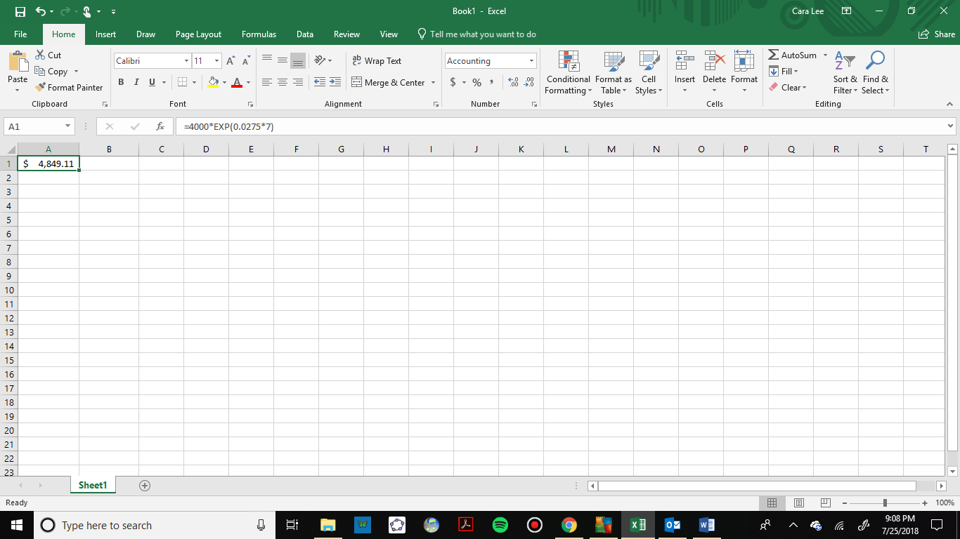

To use the formula, we have:



*P* = 4000 Amount invested

*r* = .0275 Interest rate

*t* = 7 Number of years



After 7 years your account would be worth $4,849.11. Next, we will calculate the amount of interest earned and the percentage.

### Finding the Amount of Interest Earned and the Percentage

In the previous example we also want to know how much interest was earned and what percentage of the final balance is from interest. The future value of the investment is $4,849.11. Now to figure out how much of that was interest, we need to subtract the amount initially deposited.

Example 6 Continued:

To find the total amount of interest earned, we subtract the principal from the total balance.



The spreadsheet calculation is

=4849.11 – 4000

=$849.11.

You would earn $849.11 in interest.

To find the percentage that is interest, divide the amount of interest by the total amount.



The spreadsheet calculation is the same:

=849.11/4849.11 =0.1751 or 17.5%.

This tells us that after 7 years, 17.5% of the account was earned as interest.

### Effective Rate

If you are shopping around for different investments, you might need to compare different rates that have different compounding periods. If the rate and period are different, it’s hard to know which account will give the better result. There is a spreadsheet formula called =EFFECT which will allow us to compare accounts. This is also sometimes called the annual percentage yield, or APY.

Effective Rate Formula

=EFFECT(stated rate, number of compounding periods)

*stated rate* is the interest rate given (APR)

*number of compounding periods* is the number of times the account is compounded per year, 

Example 7:

You are comparing an account that pays 5.25% interest compounded monthly, with an account that pays 5% compounded daily. Which account will earn you more interest?

It is hard to tell whether the higher interest rate will be better or the higher compounding rate in this case. We will find the effective rate of both accounts.

For the 5.25% APR account compounded monthly:

=EFFECT(0.0525,12)

=0.05378 or 5.38%

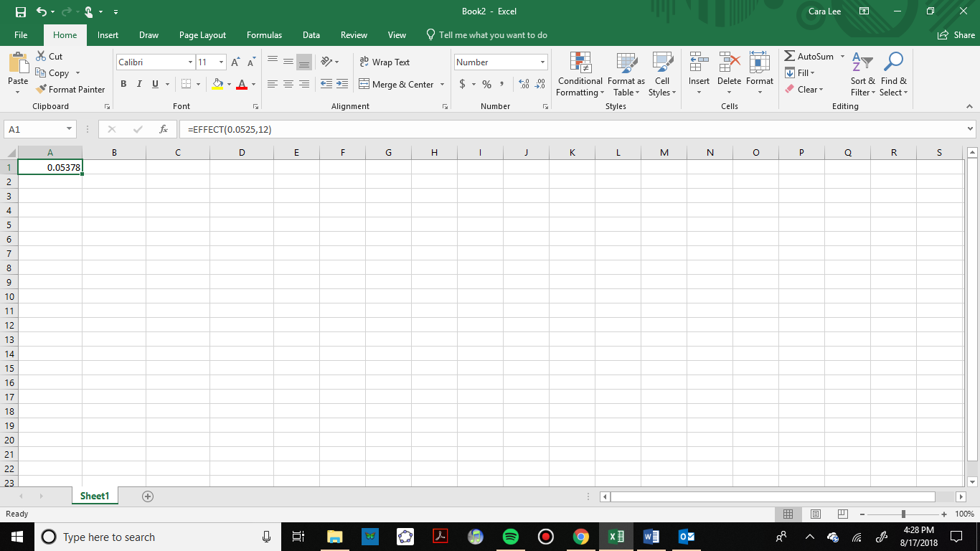

For the 5% APR account compounded daily:

=EFFECT(0.05,365)

=0.05127 or 5.13%

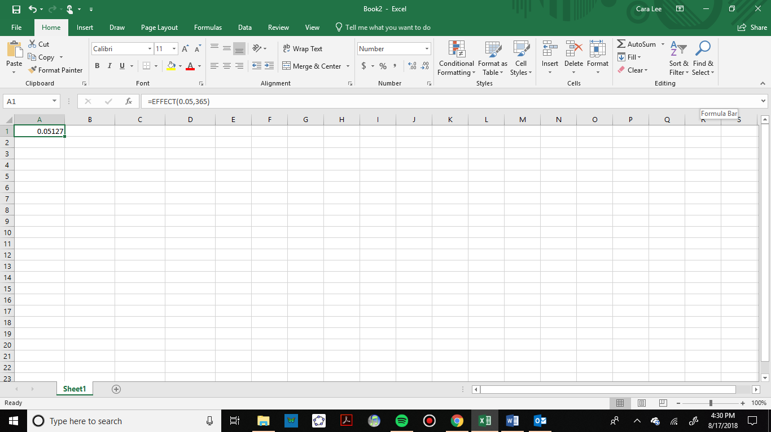

Now we can compare the effective rates of 5.38% and 5.13% and see that the account with the higher interest rate will earn more interest in this case. This is not always true, so we will show another example.

Example 8:

Find the effective rates to compare an account that earns 6% compounded quarterly with an account that earns 5.975% compounded daily. Which one would you choose?

Using the effective rate formula for each, we have:

For the 6% APR account compounded quarterly:

=EFFECT(0.06,4)

=0.06136 or 6.14%

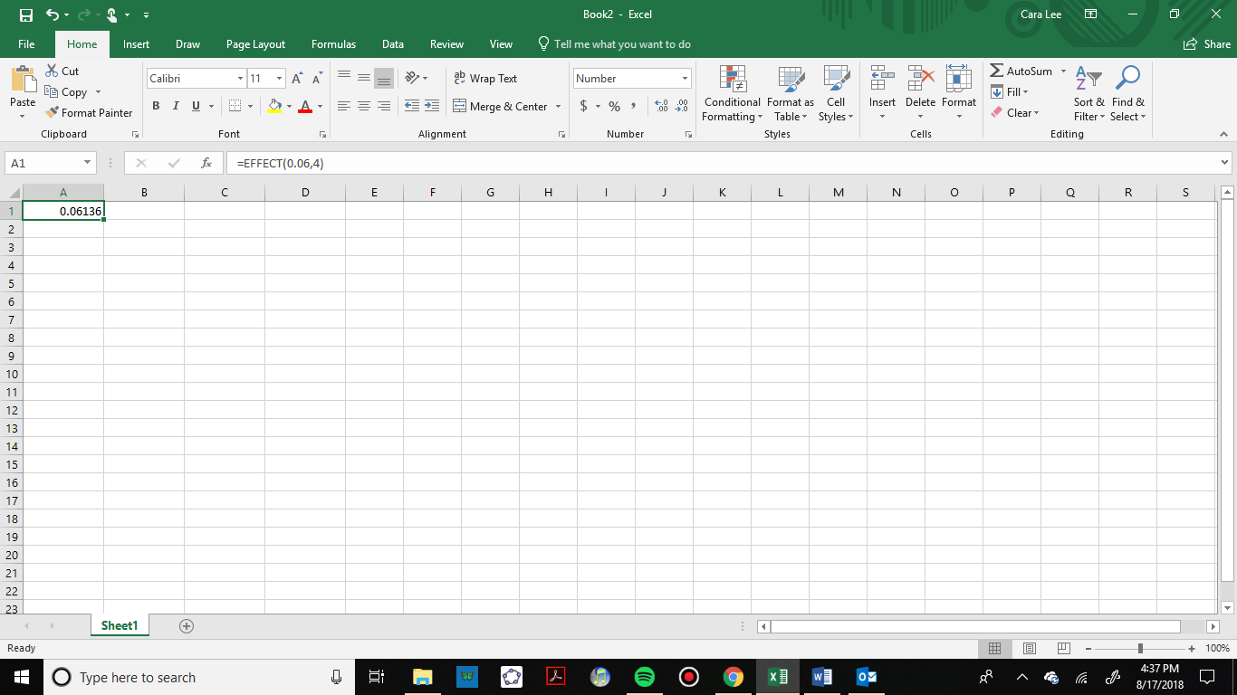

For the 5.975% APR account compounded daily:

=EFFECT(0.05975,365)

=0.06157 or 6.16%

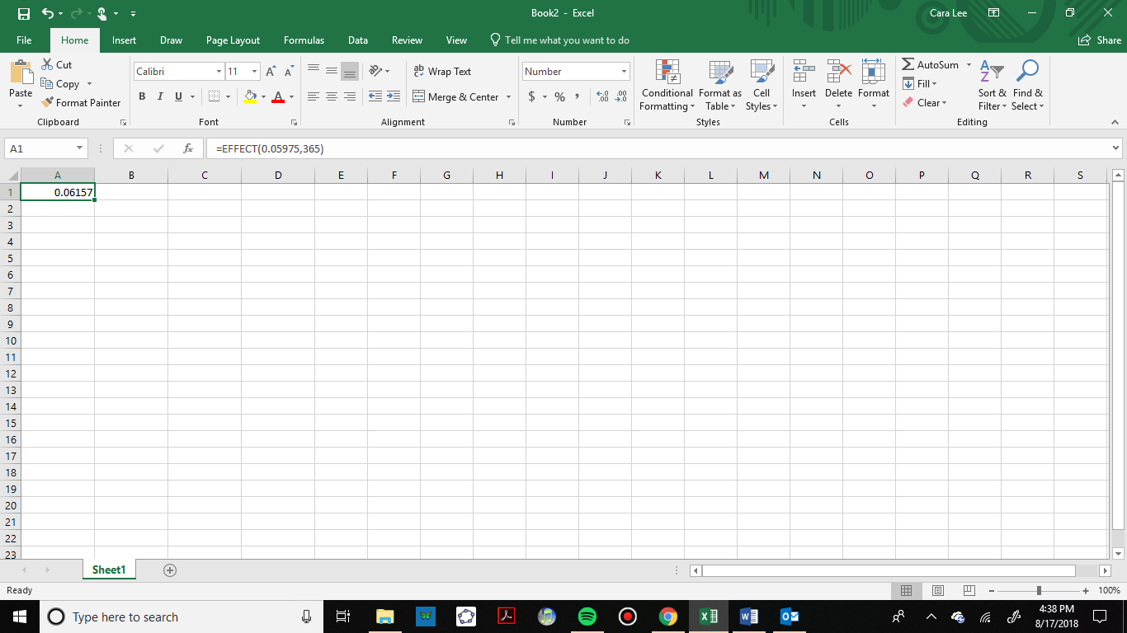

The account that was compounded more often has a slightly higher rate in this case.

### Exercises 2.2

1. A friend lends you $200 for a week, which you agree to repay with 5% one-time interest. How much will you have to repay?
2. You deposit $1,000 in an account that earns simple interest. The annual interest rate is 2.5%.
   1. How much interest will you earn in 5 years?
   2. How much will you have in the account in 5 years?
3. How much will $1,000 deposited in an account earning 7% interest compounded weekly be worth in 20 years?
4. Suppose you obtain a $3,000 Certificate of Deposit (CD) with a 3% annual rate, paid quarterly, with maturity in 5 years.
   1. What is the future value of the CD in 5 years?
   2. How much interest will you earn?
   3. What percent of the balance is interest?
5. You deposit $300 in an account earning 5% interest compounded annually. How much will you have in the account in 10 years?
   1. How much will you have in the account in 10 years?
   2. How much interest will you earn?
   3. What percent of the balance is interest?
6. You deposit $2,000 in an account earning 3% interest compounded monthly.
   1. How much will you have in the account in 20 years?
   2. How much interest will you earn?
   3. What percent of the balance is interest?
7. You deposit $10,000 in an account earning 4% interest compounded weekly.
   1. How much will you have in the account in 25 years?
   2. How much interest will you earn?
   3. What percent of the balance is interest?
8. How much would you need to deposit in an account now in order to have $6,000 in the account in 8 years? Assume the account earns 6% interest compounded monthly.
9. How much would you need to deposit in an account now in order to have $20,000 in the account in 4 years? Assume the account earns 5% interest compounded quarterly.
10. Breylan invests $1,200 in an account that earns 4.6% compounded quarterly and Angad invests the same amount in an account that earns 4.55% compounded weekly. 
    1. What will their balances be after 15 years?
    2. What will their balances be after 30 years?
    3. What is the effective rate for each account?
11. Bill invests $6,700 in a savings account that compounds interest monthly at a rate of 3.75%. Ted invests $6,500 in a savings account that compound interest annually at a rate of 3.8%.
    1. Find the effective rate for each account.
    2. Who will have the higher accumulated balance after 5 years?
12. Bassel is comparing two accounts where one pays 3.45% quarterly and the second pays 3.4% daily.
    1. What is the effect rate for each?
    2. If he has $5,000 to deposit how much will the balance be in 10 years?
13. You deposit $2,500 into an account earning 4% interest compounded continuously.
    1. How much will you have in the account in 10 years?
    2. How much total interest will you earn?
    3. What percent of the balance is interest?
14. You deposit $1,000 into an account earning 5.75% compounded continuously.
    1. How much will you have in the account in 15 years?
    2. How much total interest will you earn?
    3. What percent of the balance is interest?
15. You deposit $5,000 in an account earning 4.5% compounded continuously.
    1. How much will you have in the account in 5 years?
    2. How much total interest will you earn?
    3. What percent of the balance is interest?
16. You deposit $10,000 in an account that earns 5.5% compounded continuously and your friend deposits $10,000 in an account that earns 5.5% annually.
17. How much more will you have in the account in 10 years?
18. How much more interest did you earn in the 10 years?

## Section 2.3 Savings Plans

For most of us it is not practical to deposit a large sum of money in the bank. Instead, we save by depositing smaller amounts of money regularly. We might save in an IRA or 401-K for retirement. We might also save for a down payment on a car or house, or in a college savings plan for our children.

Just like the last section, we will emphasize spreadsheets but calculate each example with the formulas as well. Check with your instructor for which way you should do your problems.

### Savings Plan Formulas

To make calculations for savings plans using a spreadsheet, we can use the =FV formula we have already used. This time for regular payments will use the field for payment amount. If we are not making an initial deposit, the present value will be zero.

Here is the future value formula again:

Future Value Spreadsheet Formula

=FV(rate per period, number of periods, payment amount, present value)

*rate per period* is the interest rate per compounding period, *r/n*

*number of periods* is the total number of periods, *n*t*

*payment amount* is the amount of regular payments

*present value* is the initial principal. If none, enter 0

The mathematical formulas are shown below. If you want to know how we got the formula, it is derived at the end of the chapter.

Savings Plan Formulas

 or 

*A* is the balance in the account after *n* years (future value)

*d* is the regular deposit (or **payment amount** each month, quarter, year, etc.)

*r*  is the annual interest rate in decimal form

*n* is the number of compounding periods in one year

*t* is the number of years

If the compounding frequency is not explicitly stated, assume there are the same number of compounds in a year as there are deposits made in a year.

If you make your deposits every year, use yearly compounding, *n* = 1.

If you make your deposits every quarter, use quarterly compounding, *n*= 4.

If you make your deposits every month, use monthly compounding, *n* = 12, etc.

To see how both of these methods work, let’s look at an example.

Example 1:

A traditional individual retirement account (IRA) is a special type of retirement account in which the money you invest is exempt from income taxes until you withdraw it. If you deposit $100 each month into an IRA earning 6% interest, how much will you have in the account after 20 years? How much will you have earned in interest? What percentage of the balance is interest?

To use a spreadsheet, we will use =FV because we want to know the balance in the future. We enter 100 for the payment amount and 0 for the present value:

=FV(0.06/12, 12*20, 100, 0)

=$46,204.09

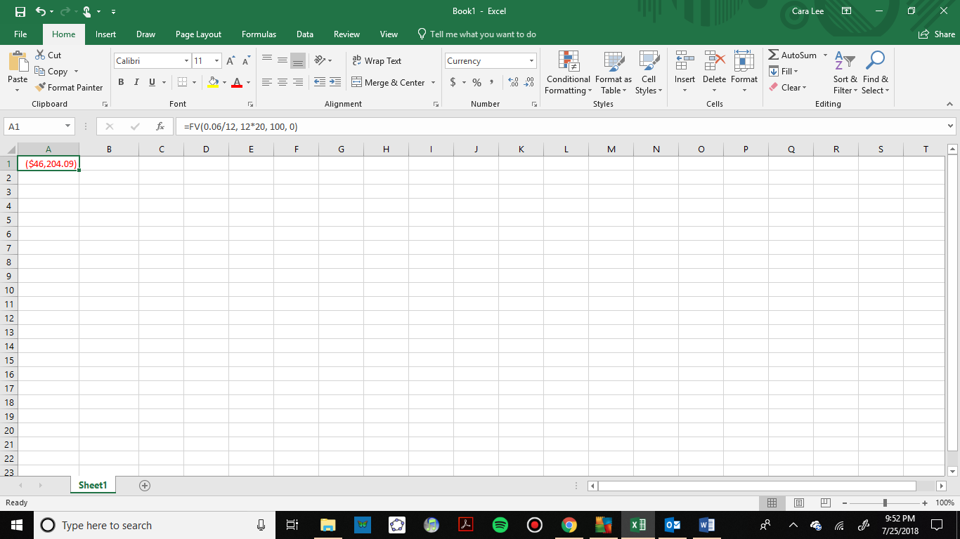

Remember that the output of the formula gives the answer with the opposite sign as the principal and payments. For our purposes we will ignore the signs.

To use the formula, we use the one solved for *A*, since we want to know the final amount.

*d* = $100 the monthly deposit

*r* = 0.06 6% annual rate

*n* = 12 since we’re doing monthly deposits, we’ll compound monthly

*t* = 20 we want the amount after 20 years

Putting this into the equation we have:



With U.S. dollars we round to the nearest cent. The account will grow to $46,204.09 after 20 years.

To find the **amount of interest earned**, calculate the total of all your deposits.



The difference between the total amount and the deposits is the interest earned.

.

The total amount of interest you earned was $22,204.09.

To find the **percentage of the balance that is interest** we will divide the interest by the total balance.

 or 48.1%

After 20 years 48.1% of the balance is from interest.

Now here’s an example with an initial deposit **and** monthly deposits. We can do this with the spreadsheet formula.

Example 2:

You want to jumpstart your saving by depositing $1500 from your tax return and then deposit $150 every month into an account that earns 5.5% compounded monthly. How much will you have in the account after 30 years?

Using the spreadsheet formula, we can enter an initial deposit and a monthly payment. We enter

=FV(0.055/12, 12*30, 150,1500)

=$144,822.87.

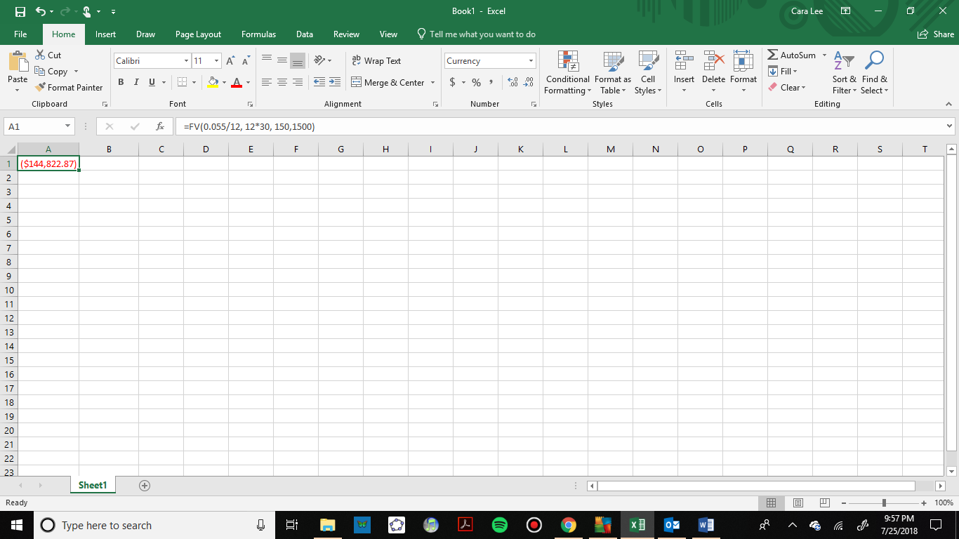

### Finding Payment Amounts Spreadsheets and the Formula

Another important thing we can calculate is how much we need to save in each period to have a specified amount in the future. Say you want to achieve a certain amount for retirement or for your kids’ college.

The mathematical formula for this is the one solved for *d*, the payment amount, above. There is a new spreadsheet formula to calculate payments, =PMT, that we will introduce now.

Payment Spreadsheet Formula

=PMT(rate per period, number of periods, present value, future value)

*rate per period* is the interest rate per compounding period, *r/n*

*number of periods* is the total number of periods, *n*t*

*present value* is the amount deposited or principal, *P*

*future value* is the amount you want in the future, *A*

Here is an example of a retirement goal calculated with a spreadsheet and the formula.

Example 2:

You want to have half a million dollars in your account when you retire in 30 years. Your retirement account earns 8% interest. How much do you need to deposit each month to meet your retirement goal?

To calculate this with a spreadsheet, we will use the =PMT function and enter 0 for the present value and $500,000 for the future value. We cannot enter commas within the numbers however, because spreadsheets use commas to separate the inputs. We enter:

=PMT(0.08/12, 12*30, 0, 500000)

=$335.49.

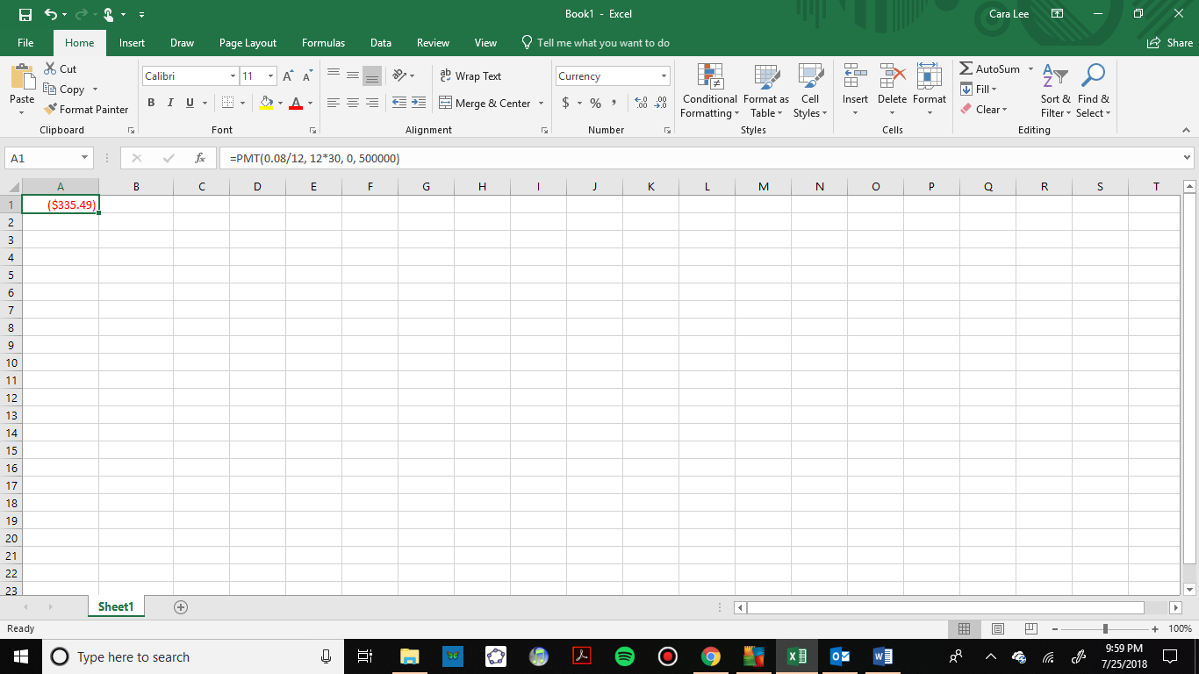

To see how this works with the formulas, we use the one solved for *d*, the regular deposit amount.

*r* = 0.08 8% annual rate

*n*= 12 since we’re depositing monthly

*t*= 30 30 years

*A* = $500,000 The amount we want to have in 30 years



So, you would need to deposit $335.49 each month to have $500,000 in 30 years if your account earns 8% interest.

A note about rounding

If you are using the formulas and round during intermediate steps you will probably have some roundoff error. For this reason, we enter the whole expression into the calculator and do not show the intermediate steps.

One of the challenges in this chapter is choosing the correct formula or spreadsheet function. Read this next example and see if you can determine which formula to use.

Example 3:

A more conservative investment account pays 3% interest. If you deposit $5 a day into this account, how much will you have after 10 years? What amount and percentage are from interest?

In this example we are given the regular deposit amount and we are looking for the future value. In a spreadsheet we use the =FV function and enter:

=FV(0.03/365, 365*10, 5,0)

=$21,282.07

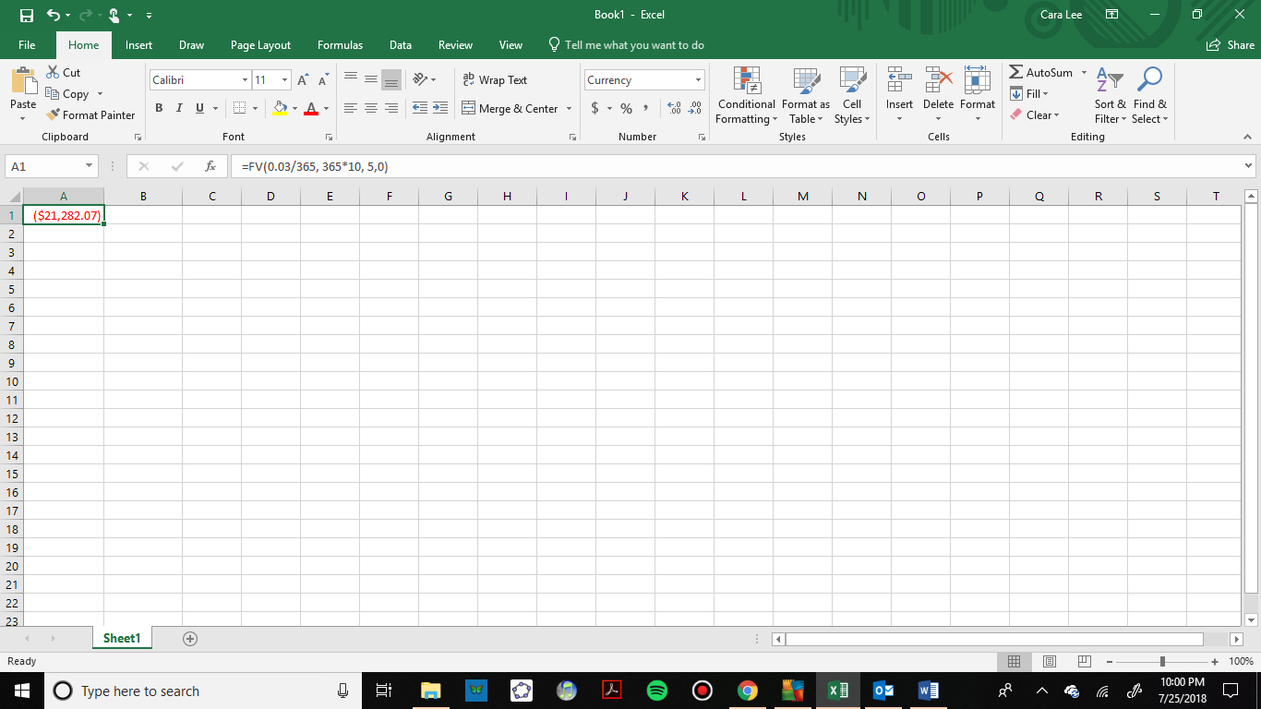

To use a mathematical formula, we choose the one solved for *A*:

*d* = $5 the daily deposit

*r* = 0.03 3% annual rate

*n* = 365 since we’re doing daily deposits, we’ll compound daily

*t* = 10 we want the amount after 10 years



To find the amount of interest, we will calculate how much was deposited in the account. Since you put in $5 a day for 10 years we get



The interest earned is



To find the percentage we divide by the total balance to get



After 10 years, about 14.2% of the account is interest.

### Comparing Lump Sum and Regular Savings Payments

Now let’s compare two scenarios to do some multistep problems and get a sense for the value of compounding over time.

Example 4:

Scenario 1: Suppose you invest $200 a month for 15 years into an account earning 10% compounded monthly. After 15 years, you leave the money, without making additional deposits, in the account for another 20 years. How much will you have in the end?

Scenario 2: Suppose instead you didn't invest anything for the first 15 years, then deposited $200 a month for 20 years into an account earning 10% compounded monthly. How much will you have in the end?

Before we calculate the balance for both scenarios, which one do you think will have a higher balance at the end?

For scenario 1, there are two steps involved. The first part is the monthly payments for 15 years. To calculate this with a spreadsheet we enter

=FV(0.10/12, 12*15, 200,0)

=$82,894.07.

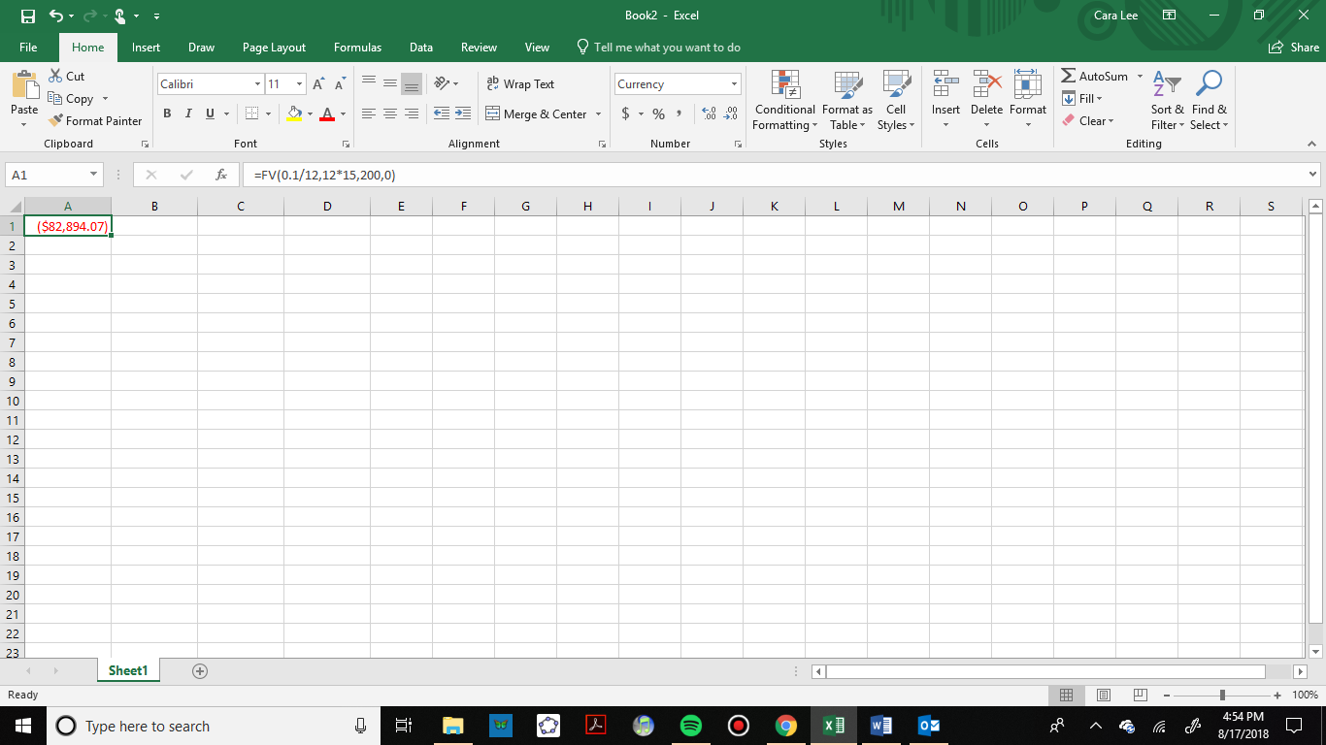

Now you will stop making payments and let the money sit and earn interest for 20 more years. With a spreadsheet we enter

=FV(0.10/12, 12*20, 0, 82894.07)

=$607,453.85.

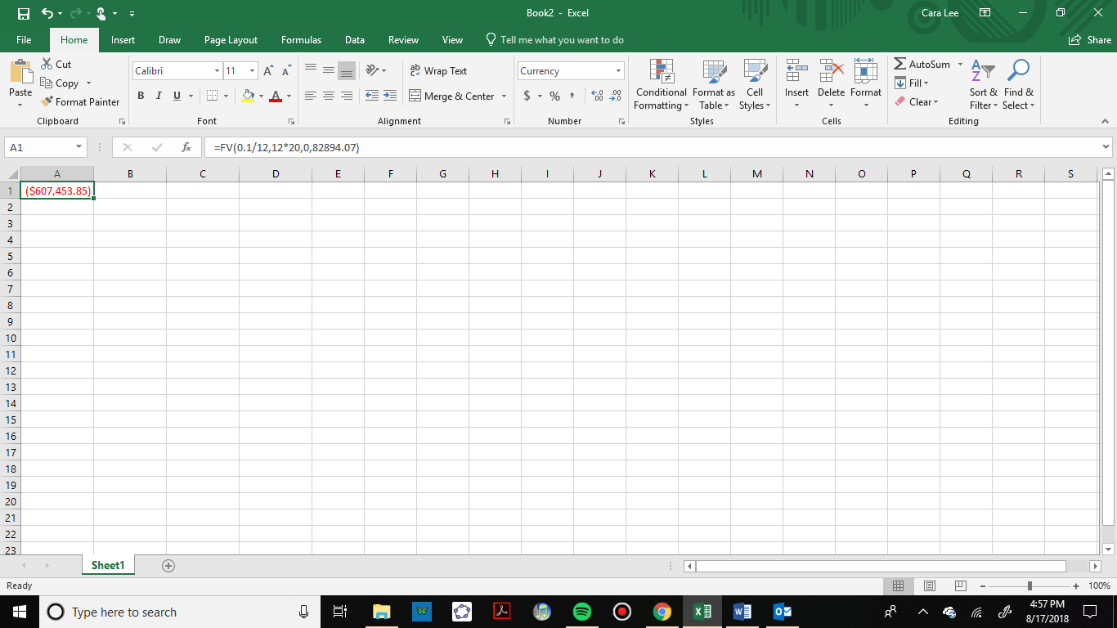

The process is similar with the formulas. For the first step we have:



And for the second step we use the compound interest formula from section 2.2.



Now for Scenario 2: Since we are not investing anything for the first 15 years there is nothing to calculate. This is a one-step problem. We will find the future value with the monthly payments of $200 for 20 years. With a spreadsheet we enter

=FV(0.10/12, 12*20, 200,0)

=$151,873.77.

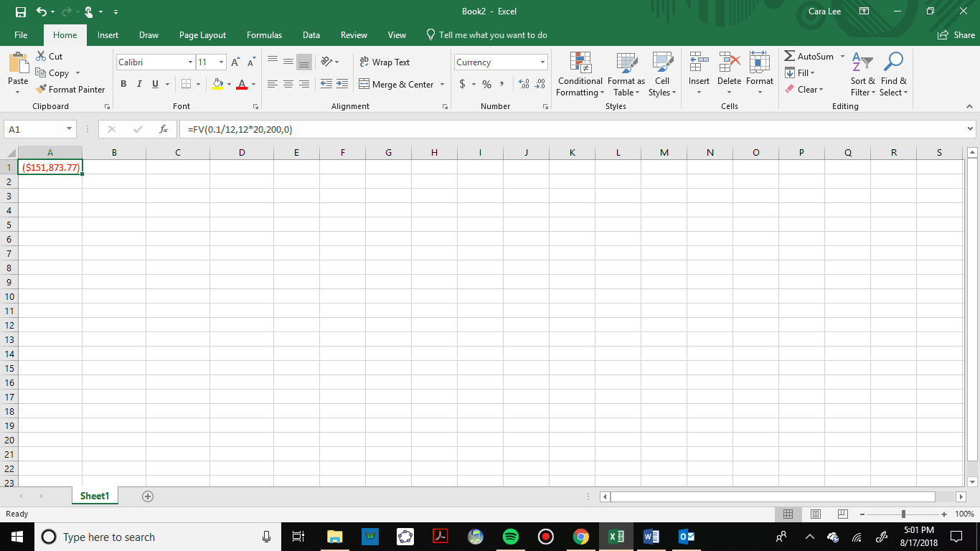

To check that with the formula we have:



Were you surprised by these numbers? You would put in less money in scenario 1 and end up with four times as much. The key to compounding interest is to start early. If you remember the graph of compound interest in section 2.2, we can see that as time goes on, the balance increases exponentially.

### Deriving the Savings Plan Formula (Optional)

If you are interested in where the savings plan formula came from, we will explain it here. A savings plan with regular payments can be described recursively. Recall that basic compound interest follows from the relationship for each compound period.



For a savings plan, we need to add a deposit, d, to the account with each compounding period:



Taking this equation from recursive form to explicit form is a bit trickier than with compound interest. It will be easiest to see by working with an example rather than working in general.

Suppose we will deposit $100 each month into an account paying 6% interest. We assume that the account is compounded with the same frequency as we make deposits unless stated otherwise.

In this example:

*r* = 0.06 6% interest

*n* = 12 12 compounds/deposits per year

*d* = $100 our deposit per month

Writing out the recursive equation gives where A is exchanged with  where *m* is the number of compounding periods.



Assuming we start with an empty account, we can begin using this relationship:



Continuing this pattern, after m deposits, we’d have saved:



In other words, after *m* months, the first deposit will have earned compound interest for m-1 months. The second deposit will have earned interest for months. Last month’s deposit would have earned only one month worth of interest. The most recent deposit will have earned no interest yet.

This equation leaves a lot to be desired, though – it doesn’t make calculating the ending balance any easier! To simplify things, multiply both sides of the equation by 1.005:



Distributing on the right side of the equation gives



Now we’ll line this up with like terms from our original equation, and subtract each side



Almost all the terms cancel on the right side when we subtract, leaving



Solving for 



Replacing with *A* (Future Value), *m* months with 12*t*, where *t* is measured in years, gives



Recall 0.005 was *r/n* and 100 was the deposit *d*. The value 12 was *n*, the number of deposits each year. Generalizing this result, we get the savings plan formula solved for *A*. The second formula uses algebra to rearrange the formula to be solved for *d*.

Savings Plan Formulas

 or 

*A*  is the balance in the account after *n* years (future value)

*d* is the regular deposit (the amount you deposit each year, each month, etc.)

*r*  is the annual interest rate in decimal form.

*n* is the number of compounding periods in one year

*t* is the number of years

**If the compounding frequency is not explicitly stated, assume there are the same number of compounds in a year as there are deposits made in a year**

### Exercises 2.3

1. You set up a savings plan for retirement in 35 years. You will deposit $250 each month for 35 years. The account will earn an average of 6.5% compounded monthly.
   1. How much will you have in your retirement plan in 35 years?
   2. How much interest did you earn.
   3. What percent of the balance is interest?
2. You set up a savings plan for retirement in 40 years.  You will deposit $75 each week for 40 years. The account will earn an average of 8.5% compounded weekly
   1. How much will you have in your retirement plan in 40 years?
   2. How much interest did you earn.
   3. What percent of the balance is interest?
3. You set up a savings plan for retirement in 30 years. You will deposit $750 each quarter for 30 years. The account will earn an average of 7.75% compounded quarterly.
   1. How much will you have in your retirement plan in 30 years?
   2. How much interest did you earn?
   3. What percent of the balance is interest?
4. Suppose you invest $130 a month for 5 years into an account earning 9% compounded monthly. After 5 years, you leave the money, without making additional deposits, in the account for another 25 years.
   1. How much will you have in the end?
   2. How much interest did you earn?
   3. What percent of balance is interest?
5. Suppose you have 30 months in which to save $3,500 for a cruise for your family. If you can earn an APR of 3.8%, compounded monthly, how much should you deposit each month?
6. You wish to have $3,000 in 2 years to buy a fancy new stereo system.  How much should you deposit each quarter into an account paying 6.5% compounded quarterly?
7. Jamie has determined they need to have $450,000 for retirement in 30 years. Their account earns 6% interest. How much would Jamie need to deposit in the account each month?
8. Lashonda already knows that she wants $500,000 when she retires. If she sets up a saving plan for 40 years in an account paying 10% interest, compounded quarterly how much should she deposit each quarter?
9. Jose’ inherits $55,000 and decides to put it in the bank for the next 25 years to save for his retirement. He will earn an average of 5.6% compounded monthly for the next 25 years. His partner deposits $375 a month in a separate savings plan that earns 5.6% interest compounded monthly for the next 25 years.
   1. How much will each have at the end of 25 years?
   2. How much interest did each person earn?
   3. What percent of balance is interest for each person?
10. Akiko inherits $45,000 and decides to put it in the bank for the next 30 years to save for her retirement. She will earn an average of 7.8% compounded monthly for the next 30 years. Her spouse deposits $200 a month in a separate savings plan that earns 7.8% interest compounded monthly for the next 30 years.
    1. How much will each have at the end of 30 years?
    2. How much interest did each person earn?
    3. What percent of balance is interest for each person?

## 

## Section 2.4 Loan Payments

In the last section, you learned about savings plans. In this section, you will learn about conventional loans (also called amortized loans or installment loans). Examples include student loans, car loans and home mortgages. These techniques do not apply to payday loans, add-on loans, or other loan types where the interest is calculated up front.

### Loan Formulas

In a savings plan, you start with nothing, put money into an account once or on a regular basis, and have a larger balance at the end. Loans work in reverse. You start with a balance owed, make payments and the future value is zero when the loan is paid off.

We will continue to use the same spreadsheet formulas. The ones that are most useful for loans are =PV and =PMT. We will look at how the inputs change for a loan.

Spreadsheet Formulas

=PV(rate per period, number of periods, payment amount, future value)

=PMT(rate per period, number of periods, present value, future value)

*rate per period* is the interest rate per compounding period, *r/n*

*number of periods* is the total number of periods, *n*t*

*payment amount* is the amount of regular payments, *d*

*present value* is the amount deposited or principal, *P*

*future value* is the amount you want in the future, *0 for a loan*

These two formulas correspond to the formulas below. The formula for loans is derived in a similar way that we did for savings plans, but notice they have negative exponents. The details are omitted here.

Loan Formulas

 or 

*P* is the balance in the account at the beginning (the principal, or amount of the loan).

*d* is your loan payment (your monthly payment, annual payment, etc.)

*r* is the annual interest rate in decimal form

*n* is the number of compounding periods in one year

*t* is the length of the loan, in years

Like before, the compounding frequency is not always explicitly given, but is determined by how often you make payments

Example 1:

Teresa wants to buy a car that costs $15,000. She has $3000 saved for the car and plans to finance the rest. She found a 3-year loan at 2.75% APR and a 5-year loan at 4%. How much will her monthly car payment be for each loan and how do these loans compare to each other.

To use a spreadsheet, we use the =PMT formula. For a loan, the loan amount is the present value and the future value is 0, indicating that the loan will be paid off. Teresa is making a down payment, so we also need to subtract that from the cost of the car to find the loan amount:

$15,000 – $3,000 = $12,000

Her loan amount is $12,000. For the 3-year loan at 2.75% APR, we enter:

=PMT(0.0275/12, 12*3, 12000, 0)

=$347.65

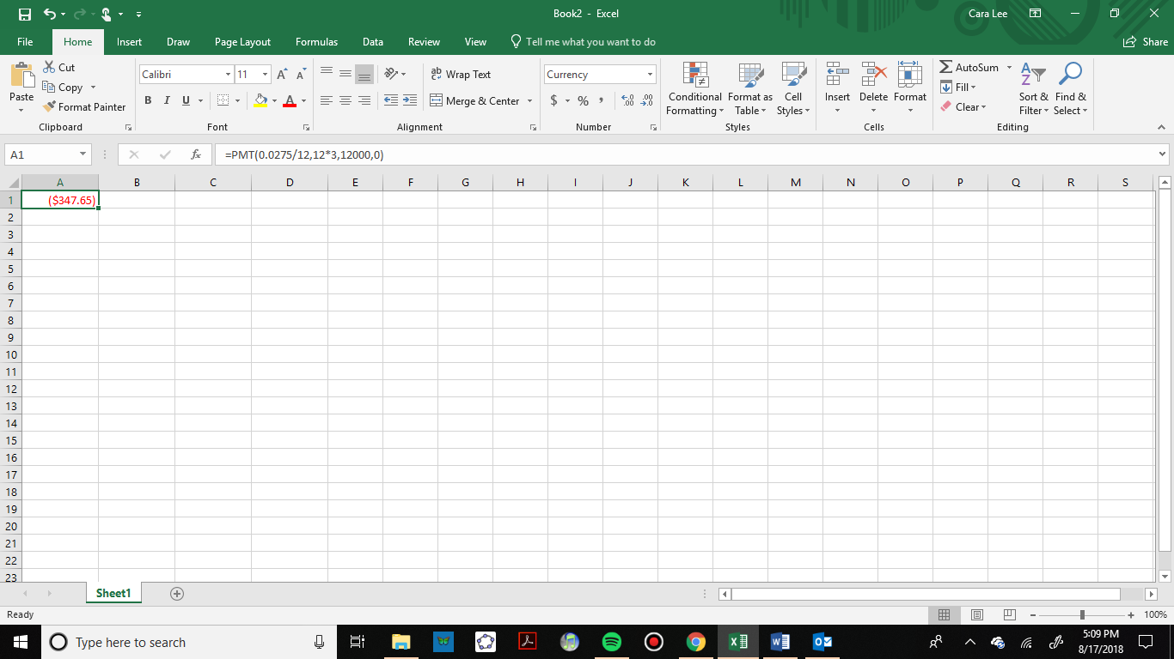

For the formula, we use the one solved for *d*:

*r* = .0275 2.75% annual rate  
*n* = 12 monthly payments

*t =* 3 3 years

*P* = 12000 Since she can pay $3,000 of the $15,000



Teresa’s car payment would be $347.65.

Now for the 5-year loan at 4% APR, we enter:

=PMT(0.04/12, 12*5, 12000, 0)

=$221.00

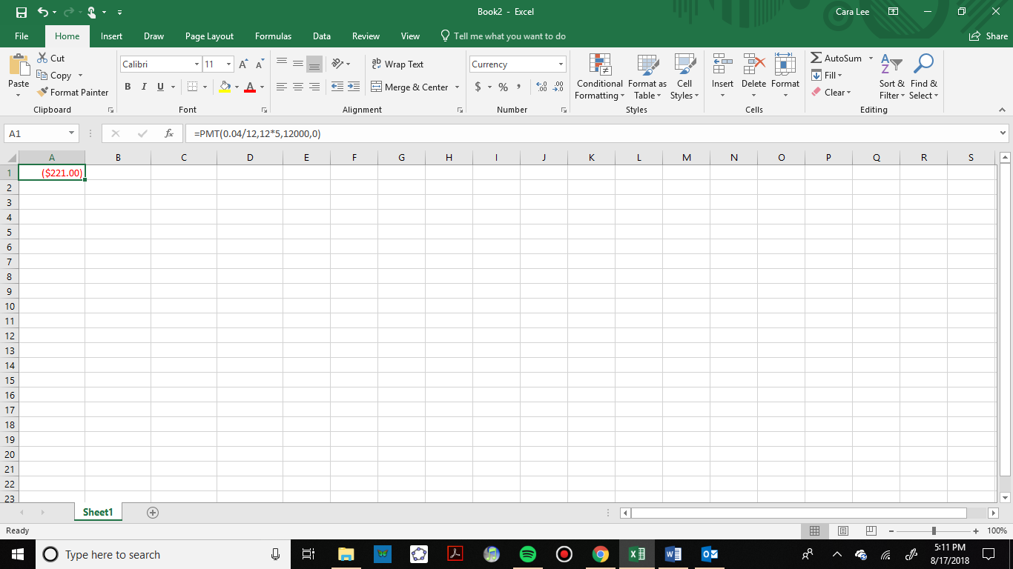

To use the formula, we have:

*r* = .04 4% annual rate  
*n* = 12 monthly payments

*t =* 5 5 years

*P* = 12000 the loan amount

  
Now let’s compare the loans by finding out how much Teresa would pay in interest for each loan.

For the 3-year loan at 2.75% APR, her payments would total:



Her interest would be $515.40.

For the 5-year loan at 4% APR, her payments would total:



Her interest would be $1,260.00.

There are two main differences between these two loans: the monthly payments and the total paid over the life of the loans. The first loan has a higher monthly payment by $126.65 per month. However, she would pay $744.60 less in interest.

In addition to loan payments, we can calculate the amount of loan we can afford given a monthly payment. Let’s look at that in the next example.

Example 2:

You can afford $200 per month as a car payment. If you can get an auto loan at 3% interest for 60 months (5 years), how expensive of a car can you afford? In other words, what amount loan can you pay off with $200 per month?

To use a spreadsheet for this problem, we use the =PV formula because we want to know the present value, which is the value of the loan right now. We enter

=PV(0.03/12, 12*5, 200,0)

=$11,130.47.

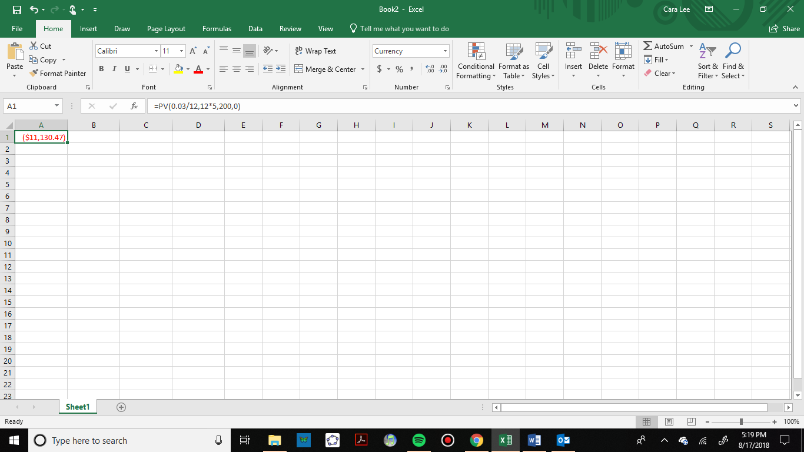

To use a formula, we are looking for *P*, the starting amount of the loan.

*d* = $200 the monthly loan payment

*r* = 0.03 3% annual rate

*n* = 12 since we’re doing monthly payments, we’ll compound monthly

*t* = 5 since we’re making monthly payments for 5 years



You can afford a maximum loan of $11,130.47. If you have a down payment you can add that to get the value of the car you can buy. If there are any closing costs for the loan you also need to take that into consideration.

To find the amount of interest you will pay for this loan, calculate the total of all your payments.



Then take the difference between the total payments and the loan amount.

.

In this case, you would be paying $869.53 in interest.

So far, we have looked at car loans. Student loans and home mortgages are calculated in the same way. Here is an example of a mortgage payment.

Example 3:

You want to take out a $140,000 mortgage (home loan). The interest rate on the loan is 6%, and the loan is for 30 years. How much will your monthly payments be? What percentage of your total payments will go towards interest?

To use a spreadsheet for this problem, we use the =PMT formula because we want to know the payment amount. The amount of the loan is the present value and to pay off the loan the future value is 0. We enter

=PMT(0.06/12, 12*30, 140000,0)

=$839.37.

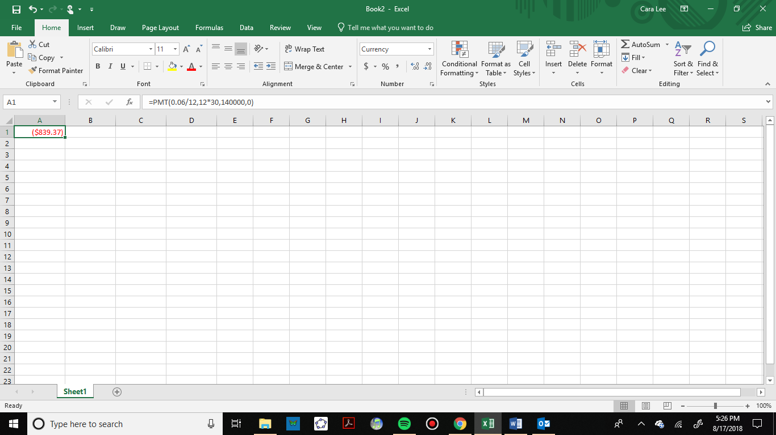

To use the formula, we have:

*r* = 0.06 6% annual rate

*n* = 12 since we’re paying monthly

*t* = 30 30 years

*P* = $140,000 the starting loan amount

In this case, we’re going to use the equation that is solved for *d.*



You would make payments of $839.37 per month for 30 years.

To find out what percentage of the total will go towards interest, we need to total up all of the payments.



Then take the difference between the total payments and the loan amount.

.

In this case, you would be paying $162,173.20 in interest over the life of the loan. To find the percentage, we divide the interest by the total amount paid.

or 53.7%

About 53.7% of the total is being paid towards interest.

### Remaining Loan Balance

With loans, it is often desirable to determine what the remaining loan balance will be after some number of years. For example, if you purchase a home and plan to sell it in five years, you might want to know how much of the loan balance you will have paid off and how much you will have to pay from the sale.

To determine the remaining loan balance after some number of years, we first need to calculate the payment amount, if we don’t already know it. Remember that only a portion of your loan payments go towards the loan balance; a portion is going to go towards interest. For example, if your payments were $1,000 a month, after a year you will *not* have paid off $12,000 of the loan balance.

To determine the remaining loan balance, we can think “how much loan will these loan payments be able to pay off in the remaining time on the loan?”

Example 4:

If a 30-year mortgage at a 6% interest rate has payments of $1,000 a month, what will the loan balance be in 5 years?

To determine this, we need to think backwards. We are looking for the amount of the loan that can be paid off by $1,000 per month in the remaining 25 years. In other words, we’re looking for *P* when:

*d* = $1,000 the monthly loan payment

*r* = 0.06 6% annual rate

*n* = 12 since we’re doing monthly payments, we’ll compound monthly

*t* = 25 since we’d be making monthly payments for 25 more years

To use a spreadsheet for this problem, we use the =PV formula because we want to know what the present value would be at the time you want to sell in 5 years. We enter:

=PV(0.06/12, 12*25, 1000,0)

=$155,206.86.

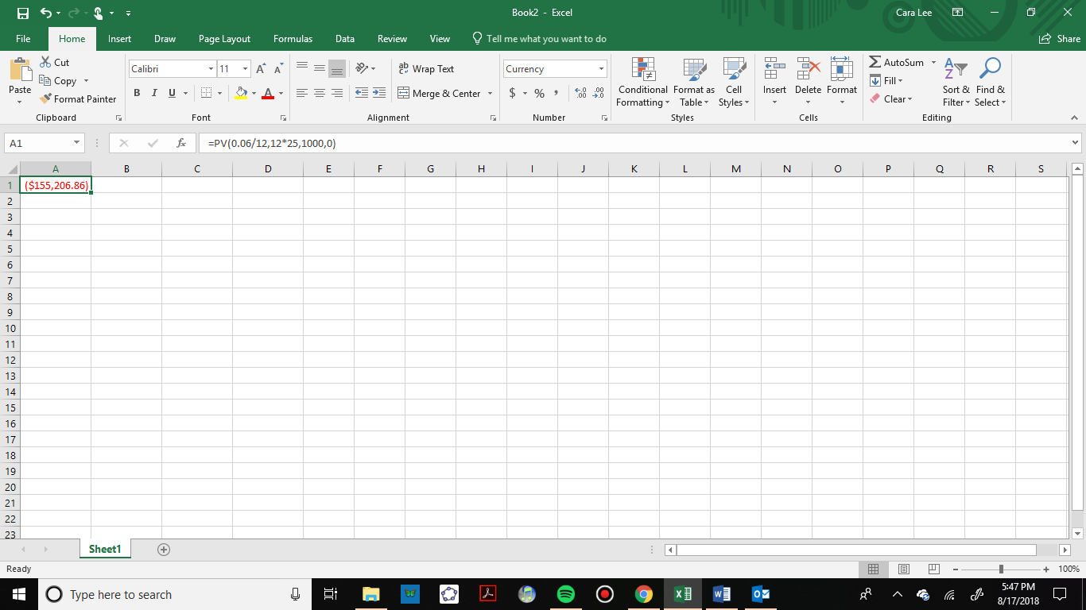

To check this with the formula we have:



The loan balance with 25 years remaining on the loan will be $155,206.86

Sometimes answering remaining balance questions requires two steps, both of which we have done in this section:

1. Calculate the monthly payment on the loan
2. Calculate the remaining loan balance based on the *remaining time* on the loan

On the next page we will give a summary of all the spreadsheet formulas we have used and when to use them.

### Summary of Spreadsheet Formulas

Here are all the spreadsheet formulas from this chapter so far together so you can see the similarities and differences.

Spreadsheet Formulas

=principal+principal*rate*time

=FV(rate per period, number of periods, payment amount, present value)

=principal*EXP(yearly rate*years)

=PV(rate per period, number of periods, payment amount, future value)

=PMT(rate per period, number of periods, present value, future value)

=EFFECT(stated rate, number of compounding periods per year)

*rate per period* is the interest rate per compounding period, *r/n*

*number of periods* is the total number of periods, *n*t*

*payment amount* is the amount of regular payments, *d*

*present value* is the amount deposited or principal, *P*

*future value* is the amount you want in the future, *0 for a loan*

#### When to use the formulas: What is the question asking?

* Find a payment: =PMT
* Find the effective rate or compare accounts: =EFFECT
* How much do you need to deposit now, what loan amount can you afford, or remaining loan balance: =PV
* What will the account balance be in the future?
  + Simple interest: =principal+principal*rate*time
  + Compound interest (except continuous): =FV
  + Continuously compounded interest: principal*EXP(rate*years)

### Summary of Mathematical Formulas

Mathematical Formulas

Simple Interest  

Compound Interest  or 

Continuously Compounded

 or 

Savings Plans  or 

Loans  or 

*P* is the principal, starting amount, or present value

*d* is your loan payment (your monthly payment, annual payment, etc.)

*r* is the annual interest rate in decimal form

*n* is the number of compounding periods in one year

*t* is the length of the loan, in years

*A* is theend amount or future value

If the compounding frequency is not always explicitly given, it is determined by how often you make payments

#### When to use the formulas: What is the question asking?

* Find a payment
  + Savings payment: savings plan equation (positive exponent) solved for *d*
  + Loan payment: loan equation (negative exponent) solved for *d*
* How much do you need to deposit now?
  + Compound interest (except continuous): compound interest formulas solved for *P*
  + Continuously compounded: the formula with *e* solved for *P*
* What loan amount can you afford, or remaining loan balance: loan formula solved for *P*
* What will the account balance be in the future?
  + One-time deposit:
    - Simple interest: simple interest formula
    - Compound interest (except continuous): compound interest formula solved for *A*
    - Continuously compounded interest: the formula with *e* in it, solved for *A*
  + Regular payments: Savings plan formula solved for *A*

Remember, the most important part of answering any kind of question, money or otherwise, is first to correctly identify what the question is really asking, and to determine what approach will best allow you to solve the problem. After practicing with the exercises from this section, you can test yourself with the cumulative chapter 2 exercises.

### Exercises 2.4

1. You can afford a $700 per month mortgage payment. You’ve found a 30-year loan at 5.5% interest.
   1. How big of a loan can you afford?
   2. How much total money will you pay the loan company?
   3. How much of that money is interest?
2. Marie can afford a $250 per month car payment. She’s found a 5-year loan at 7% interest.
   1. How expensive of a car can she afford?
   2. How much total money will she pay the loan company?
   3. How much of that money is interest?
3. You want to buy a $25,000 car. The company is offering a 2% interest rate for 48 months (4 years). What will your monthly payments be?
4. You decide to finance a $12,000 car at 3% compounded monthly for 4 years. What will your monthly payments be? How much interest will you pay over the life of the loan?
5. You want to buy a $200,000 home. You plan to pay 10% as a down payment and take out a 30-year loan for the rest.
   1. How much is the loan amount going to be?
   2. What will your monthly payments be if the interest rate is 5%?
   3. What will your monthly payments be if the interest rate is 6%?
6. Lynn bought a $300,000 house, paying 10% down, and financing the rest at 6.5% interest for 30 years.
   1. Find her monthly payments.
   2. How much interest will she pay over the life of the loan?
   3. What percentage of your total payment was interest?
7. Emile bought a car for $24,000 three years ago. The loan had a 5-year term at 3% interest rate. How much does he still owe on the car?
8. A friend bought a house 15 years ago, taking out a $120,000 mortgage at 6% for 30 years. How much does she still owe on the mortgage?

### Exploration 2.4

1. Pay day loans are short term loans that you take out against future paychecks: The company advances you money against a future paycheck. Either visit a pay day loan company or look one up online. Be forewarned that many companies do not make their fees obvious, so you might need to do some digging or look at several companies.
   1. Explain the general method by which the loan works.
   2. We will assume that we need to borrow $500 and that we will pay back the loan in 14 days. Determine the total amount that you would need to pay back and the effective loan rate. The effective loan rate is the percentage of the original loan amount that you pay back. It is not the same as the APR (annual rate) that is probably published.
   3. If you cannot pay back the loan after 14 days, you will need to get an extension for another 14 days. Determine the fees for an extension, determine the total amount you will be paying for the now 28-day loan, and compute the effective loan rate.
2. Suppose that 10 years ago you bought a home for $110,000, paying 10% as a down payment, and financing the rest at 9% interest for 30 years.
   1. Let's consider your existing mortgage:
      1. How much money did you pay as your down payment?
      2. How much money was your mortgage (loan) for?
      3. What is your current monthly payment?
      4. How much total interest will you pay over the life of the loan?
   2. This year, you check your loan balance. Only part of your payments have been going to pay down the loan; the rest has been going towards interest. You see that you still have $88,536 left to pay on your loan. Your house is now valued at $150,000.
      1. How much of the loan have you paid off? (i.e., how much have you reduced the loan balance by? Keep in mind that interest is charged each month - it's not part of the loan balance.)
      2. How much money have you paid to the loan company so far?
      3. How much interest have you paid so far?
      4. How much equity do you have in your home (equity is value minus remaining debt)?
   3. Since interest rates have dropped, you consider refinancing your mortgage at a lower 6% rate.
      1. If you took out a new 30-year mortgage at 6% for your remaining loan balance, what would your new monthly payments be?
      2. How much interest will you pay over the life of the new loan?
   4. Notice that if you refinance, you are going to be making payments on your home for another 30 years. In addition to the 10 years you've already been paying, that's 40 years total.
      1. How much will you save each month because of the lower monthly payment?
      2. How much total interest will you be paying?
      3. Does it make sense to refinance? (there isn't a correct answer to this question. Just give your opinion and your reason)

### Cumulative Chapter 2 Exercises

For each of the following scenarios, determine which formula to use and solve the problem.

* 1. Keisha received an inheritance of $20,000 and invested it at 6.9% interest, compounded continuously. How much will she have for college in 8 years?
  2. Paul wants to buy a new car. Rather than take out a loan, he decides to save $200 a month in an account earning 3.5% interest compounded monthly. How much will he have saved up after 3 years?
  3. Sol is managing investments for a non-profit company. They want to invest some money in an account earning 5% interest compounded annually with the goal to have $30,000 in the account in 6 years. How much should Sol deposit into the account?
  4. Miao is going to finance new office equipment at a 2.8% rate over a 4-year term. If she can afford monthly payments of $100, how much new equipment can she buy?
  5. How much would you need to save every month in an account earning 4.1% interest to have $5,000 saved up in two years.
  6. Terry and Jess are buying a house for $405,000 and they can afford to put 10% down. Their interest rate is 4.3% for 30 years. What will their monthly mortgage payment be?
  7. You loan your sister $500 for two years and she agrees to pay you back with 3% simple interest per year. How much will she pay you back
  8. Zahid starts saving $150 per month in an account that pays 4.8% compounded monthly. If he continues for 20 years, how much will he have? If he waited 10 years instead and put in $300 per month for 10 years with the same interest, how much would he have?

## Section 2.5 Income Taxes

### A Very Brief History of Taxes

Although Benjamin Franklin famously claimed in 1789 that “in this world nothing can be said to be certain, except death and taxes”, it wasn’t until 1913 that the 16th amendment was ratified, and income tax was legalized. Prior to this, taxes were primarily collected through tariffs on imported goods, poll taxes, and property taxes. A **poll tax**, also referred to as a head tax, was a fixed amount every liable individual had to pay. Payment of the poll tax was often required before a person could register to vote or be issued a hunting or fishing license.

Tax policy in the United States is a politically divisive issue. In general, Democrats seek to lower taxes for low and middle income earners and raise taxes for the wealthy, while Republicans support a variety of tax cuts and limiting the amount wealthy earners are taxed. There is even debate as to the current length of the tax code! Some claim that the code is over 70,000 pages while others insist it is just over 2,000. Nevertheless, there is at least one thing everyone can agree with - you don't want to be on the wrong side of the Internal Revenue Service (IRS)!

### **Types of Income Tax**

**Income tax** is a tax that is levied on earned income or profit. Income taxes are collected by the federal government, states, and even some municipalities. Income taxes are an important source of funding, and are used to finance social programs, maintain and expand infrastructure, and provide foreign aid, among other things.

#### Federal Income Tax

Anyone who earns income over a certain amount (approximately $10,000 for an individual) must file a federal tax return and have taxes collected on their behalf. The amount of federal tax owedis determined by your **filing status** and **taxable income**.

#### State Income Tax

Forty-one states and the District of Columbia collect taxes on income from wages and investment. Seven states - Washington, Nevada, South Dakota, Wyoming, Alaska, Texas, and Florida – do not collect tax on wage or investment income, and two states – New Hampshire and Tennessee – only collect tax on investment income. The amount of tax collected varies by state, with each state averaging between $500 and $3000 per person.

#### Municipal Income Tax

Some municipalities (urban districts) also collect income taxes. For example, business owners in Multnomah County pay a municipal tax on their business income, and workers in the Tri-met district (area served by Tri-met) have their wages taxed at 0.7537%.

### **Calculating Federal Income Tax**

Not all income is taxed, and not all income that gets taxed is taxed at the same rate. The general process of calculating the amount of federal income tax you owe is outlined in the chart below.

**Steps to Calculate Federal Income Tax**

**Calculate Adjusted Gross Income (AGI)**

Gross Income

–

Adjustments

=

Adjusted Gross Income

**Calculate Taxable Income**

AGI

–

Deductions (Standard or Itemized)

=

Taxable Income

**Calculate Tax Using Marginal Tax Table**

Calculate taxes from your taxable income using the tax table for your filing status

**Calculate Refund or Amount Owed**

Tax

–

Credits

–

Withholdings

=

Refund (if –)

Or

Owed (if +)

**Calculate Gross Income**

Sum together all earnings

### Gross Income

**Gross income** includes all wages, tips, earned interest, dividends, rents and royalties, alimony, property gains, income tax refunds, etc. Keep in mind that ALL income means ALL income. Even income earned from a crime must be reported!

### Adjusted Gross Income

**Adjustments** are eligible expenses used to reduce your gross income. Adjustments are tax-exempt and thus reduce the amount owed in taxes. Eligible expenses include contributions to tax deferred savings plans (401k, Individual Retirement Plan (IRA)), school tuition, student loan interest, moving expenses, business expenses, flexible spending accounts and health savings account contributions.

### Taxable Income

**Taxable income** is determined by subtracting your **deductions** from your adjusted gross income. You may choose to take *either* a **standard deduction**, which is determined by your filing status, or you may choose to **itemized** your deductions. Itemized deductions may include state and local income taxes, property taxes, medical expenses, mortgage interest, and charitable donations.

Prior to the 2018 tax year, you could also claim **personal exemptions**. Exemptions of $4,050 for each member of the household were subtracted from the adjusted gross income along with either the standard or itemized deduction to determine taxable income. Starting in 2018, however, the standard deduction was doubled, and personal exemptions were eliminated.

Let’s look at an example of how to calculate gross income and adjusted gross income (AGI).

Example 1: Sasha received $45,000 in wages and earned $1,300 in interest from his savings plan. He paid $1,400 in student loan interest, and put $4,000 into his Individual Retirement Account (IRA). Determine Sasha’s adjusted gross income.

To calculate Sasha’s adjusted gross income, we need to first determine his gross income. His gross income includes his wages and earned interest:

Gross Income = $45,000 + $1,300 = $46,300

To find his adjusted gross income, we need to subtract eligible adjustments from his gross income. His eligible adjustments include the interest paid on his student loans, and his contributions to his IRA:

Adjusted Gross Income = $46,300 - $1,400 - $4,000 = $40,900

### Filing Status

Your **filing status** is determined by your family situation. Are you married, widowed, divorced, caring for a family member? It is possible to fall into more than one category, but you may choose the one that is most beneficial for you.

**Single:** If you are unmarried, legally separated from your spouse, or divorced on the last day of the year.

**Married Filing Jointly:** If you are married and both you and your spouse agree to file a joint return. (On a joint return, you report your combined income and deduct your combined allowable expenses.)

**Married Filing Separately:** If you are married and you want to be responsible only for your own tax, or if this status results in less tax than a joint return.

**Head of Household (with qualifying person**): If you are 1) unmarried or considered unmarried on the last day of the year, 2) paid more than half the cost of keeping up a home for the year, and 3) have a qualifying dependent living with you for more than half the year (except temporary absences, such as school).

**Qualifying Widow/Widower (with dependent child):** This status is available for the two years following the death of your spouse.

Your filing status determines your standard deduction and tax liability. The standard deduction for each filing status for the tax year 2018 is given in the table below.

|  |  |
| --- | --- |
| **Filing Status** | **Standard Deduction for Tax Year 2018** |
| Single | $12,000 |
| Married Filing Jointly | $24,000 |
| Married Filing Separately | $12,000 |
| Head of Household | $18,000 |
| Qualifying Widower | $24,000 |

Here is an example where we calculate adjusted gross income and taxable income.

Example 2: Maria earned wages of $32,400 from her job as a server. She also earned $8,300 in tips, and received $95 in interest from a savings account. In trying to save for retirement, Maria has put $3,500 into a 401K tax deferred savings plan. She is unmarried and lives with her six year old daughter. Determine Maria’s gross income, adjusted gross income, and taxable income.

Maria’s gross income includes her wages, tips, and earned interest.

Gross Income = $32,400 + $8,300 + $95 = $40,795

Maria can use her 401k contribution as an adjustment.

Adjusted Gross Income = $40,795 - $3,500 = $37,295

Since Maria is unmarried and is the primary caregiver for her daughter, she can file as the head of household and take the standard deduction of $18,000.

Taxable Income = $37,295 - $18,000 = $19,295

### Tax Tables

The United States has a **progressive** federal income tax system which means the more income you have, the more you generally pay in taxes. There are **marginal tax rates** that go up according to our income, but we don’t pay the same rate on all of our income. The ranges of income are called **tax brackets** and the buckets in the illustration below can help us visualize the brackets.

The cutoff values in the figure are for a married couple filing jointly, but the percentages are the same for everyone as you’ll see in the table on the next page. We pay 10% of any taxable income in the first bucket. If the first bucket is full, we move to the second bucket and we pay 12% of that income. This couple is in the 22% tax bracket because the 3rd bucket is partially filled. They will pay 22% of the income in that bucket, but they are not paying 22% of their entire income.

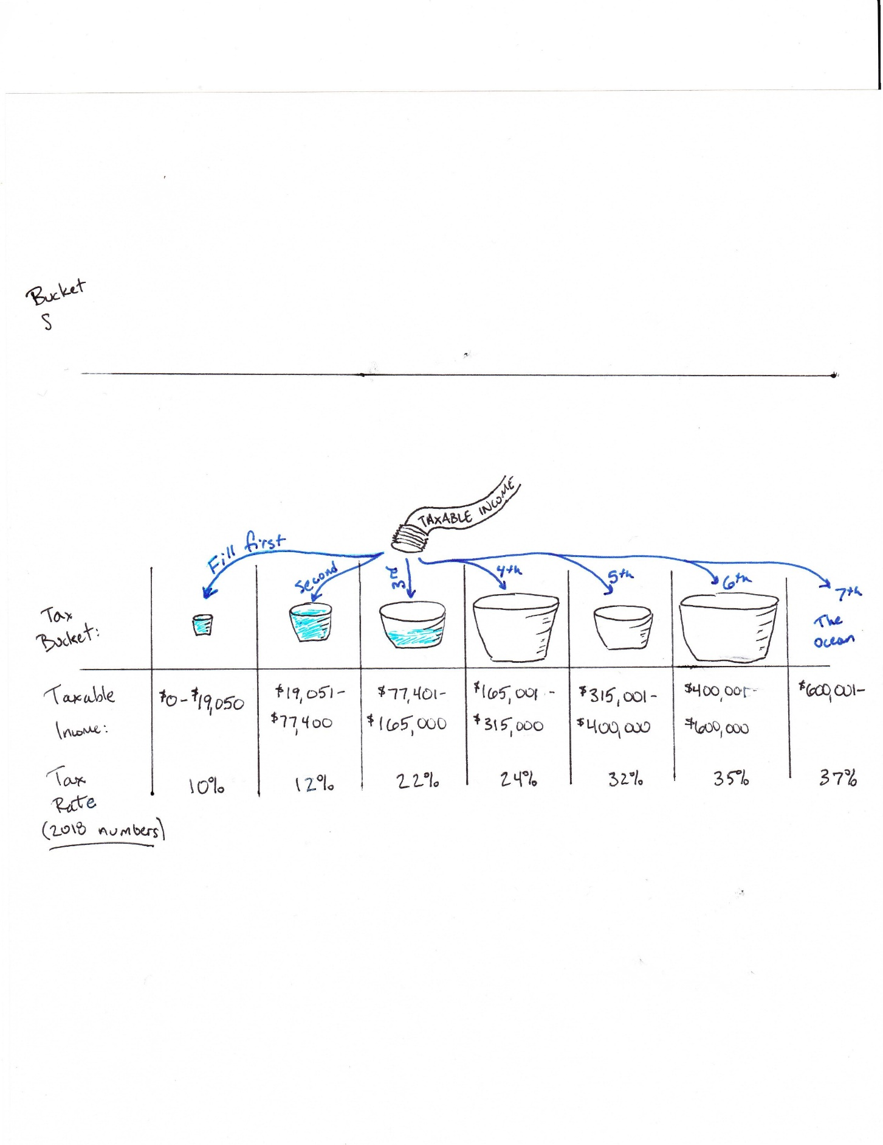

Figure 1. [Tax Buckets](https://www.trailfp.com/financial-planning/how-about-them-tax-apples/) by [John Chesbrough](https://www.trailfp.com/), licensed under [CC-BY-ND-NC 4.0](https://creativecommons.org/licenses/by-nc-nd/4.0/).

Here is a table with cutoff values for each filing status. Everyone pays a tax of 10% on any income in the first tax bracket. Then we all pay 12% of the next bracket of income, 22% of the next bracket, and so on. This keeps going up to the 37% tax bracket.

|  |  |  |  |  |
| --- | --- | --- | --- | --- |
| 2018 Tax Year | | | | |
| Marginal Tax Rate  On Taxable Income | Filing Single | Filing as Head of Household | Married filing Jointly | Married filing Separately |
| 10% | First $9,525 | First $13,600 | First $19,050 | First $9,525 |
| 12% | $9,525 – $38,700 | $13,600 – $51,800 | $19,050 – $77,400 | $9,525 – $38,700 |
| 22% | $38,700 – $82,500 | $51,800 – $82,500 | $77,400 – $165,000 | $38,700 – $82,500 |
| 24% | $82,500 – $157,500 | $82,500 – $157,500 | $165,000 – $315,000 | $82,500 – $157,500 |
| 32% | $157,500 – $200,000 | $157,500 – $200,000 | $315,000 – $400,000 | $157,500 – $200,000 |
| 35% | $200,000 – $500,000 | $200,000 – $500,000 | $400,000 – $600,000 | $200,000 – $300,000 |
| 37% | Over $500,000 | Over $500,000 | Over $600,000 | Over $300,000 |

Let’s see how to use this table to calculate taxes in an example.

Example 3:

If Avery is filing single and has $55,100 in taxable income, calculate their tax.

We begin with the lowest tax bracket and take 10% of $9,525. Since their income is higher than that, we add 12% of the next amount, found by subtracting the values in that bracket. Avery’s taxable income is in the 22% tax bracket, so we find the amount over $38,700 by subtracting. Here is the full calculation:



Avery would owe $8,043.50 in taxes. Note that their overall tax rate is somewhere between 10% and 22%. We can calculate the actual rate by dividing their tax owed by their taxable income:



We could calculate all taxes this way, but you might notice that the first few terms will be the same if the buckets are full. For this reason, we can simplify these tax tables. The tax tables below give the value for all of the lower tax buckets that are full. There is a tax table for each filing status and the cutoffs are regularly adjusted for inflation, so they usually vary from year to year.

2018 Federal Income Tax Tables

|  |  |
| --- | --- |
| Single (2018) | |
| If taxable income is: | The tax is: |
| Not over $9,525 | 10% of the taxable income |
| Over $9,525 but not over $38,700 | $952.50 plus 12% of the excess over $9,525 |
| Over $38,700 but not over $82,500 | $4,453.50 plus 22% of the excess over $38,700 |
| Over $82,500 but not over $157,500 | $14,089.50 plus 24% of the excess over $82,500 |
| Over $157,500 but not over $200,000 | $32,089.50 plus 32% of the excess over $157,500 |
| Over $200,000 but not over $500,000 | $45,689.50 plus 35% of the excess over $200,000 |
| Over $500,000 | $150,689.50 plus 37% of the excess over $500,000 |

|  |  |
| --- | --- |
| Head of Household (2018) | |
| If taxable income is: | The tax is: |
| Not over $13,600 | 10% of the taxable income |
| Over $13,600 but not over $51,800 | $1,360 plus 12% of the excess over $13,600 |
| Over $51,800 but not over $82,500 | $5,944 plus 22% of the excess over $51,800 |
| Over $82,500 but not over $157,500 | $12,698 plus 24% of the excess over $82,500 |
| Over $157,500 but not over $200,000 | $30,698 plus 32% of the excess over $157,500 |
| Over $200,000 but not over $500,000 | $44,298 plus 35% of the excess over $200,000 |
| Over $500,000 | $149,298 plus 37% of the excess over $500,000 |

|  |  |
| --- | --- |
| Married Filing Jointly (2018) | |
| If taxable income is: | The tax is: |
| Not over $19,050 | 10% of the taxable income |
| Over $19,050 but not over $77,400 | $1,905 plus 12% of the excess over $19,050 |
| Over $77,400 but not over $165,000 | $8,907 plus 22% of the excess over $77,400 |
| Over $165,000 but not over $315,000 | $28,179 plus 24% of the excess over $165,000 |
| Over $315,000 but not over $400,000 | $64,179 plus 32% of the excess over $315,000 |
| Over $400,000 but not over $600,000 | $91,379 plus 35% of the excess over $400,000 |
| Over $600,000 | $161,379 plus 37% of the excess over $600,000 |

|  |  |
| --- | --- |
| Married Filing Separately (2018) | |
| If taxable income is: | The tax is: |
| Not over $9,525 | 10% of the taxable income |
| Over $9,525 but not over $38,700 | $952.50 plus 12% of the excess over $9,525 |
| Over $38,700 but not over $82,500 | $4,453.50 plus 22% of the excess over $38,700 |
| Over $82,500 but not over $157,500 | $14,089.50 plus 24% of the excess over $82,500 |
| Over $157,500 but not over $200,000 | $32,089.50 plus 32% of the excess over $157,500 |
| Over $200,000 but not over $300,000 | $45,689.50 plus 35% of the excess over $200,000 |
| Over $300,000 | $80,689.50 plus 37% of the excess over $300,000 |

Example 4: Suppose Adira is filing as head of household and has a taxable income of $86,450. Calculate her taxes using the individual tax brackets and with the simplified table.

We will calculate Adira’s taxes first the long way:

Now, using the simplified tax table for single filing status, we see that Adira’s taxable income puts her in the 24% tax bracket. The simplified table tells us that her taxes will be equal to $12,698 plus 24% of the excess over $82,500. Notice the number $12,698 is the same value we got for all of the “full” tax brackets, so we only need to calculate the last one. To find the excess over $82,500, we subtract $82,500 from her taxable income. Thus, her taxes are:



We see that both methods result in the same value, $13,646, for Adira’s taxes.

Example 5: Phyllis and Gladys are married and filing jointly. Together their taxable income is $112,000. Use the simplified 2018 tax tables from this section to determine how much they owe in taxes.

Since Phyllis and Gladys are married and filing jointly, their taxable income puts them in the 22% tax bracket. Using the simplified 2018 tax table, their taxes are $8,907 plus 22% of the excess over $77,400:



Phyllis and Gladys owe $16,519 in taxes.

### Tax Credits

**Tax credits** are different from deductions in that they reduce the amount of tax you owe by the full amount of the credit, not just a percentage. This makes credits much more valuable than deductions.

Common tax credits include child tax credits, earned income credits, child and dependent care credits, American opportunity tax credits, lifetime learning credits, and various federal energy credits.

Example 6: Shiro is in the 22% tax bracket and itemizes his deductions. How much will his tax bill be reduced if he makes a $1,000 contribution to charity? How much will his bill be reduced if he gets a $1,000 tax credit?

The tax credit will reduce his tax bill by the full amount of the credit, so the $1,000 tax credit will reduce his tax bill by $1,000. As a deduction, however, his contribution to charity will only reduce his tax bill by 22% of the $1,000, or 0.22($1,000) = $220. Tax credits are always better than deductions.

### Calculating a Refund or Payment Due

Employers are required to take out an estimated amount for taxes from each of our paychecks. These **withholdings** are taken out, so we don’t all have huge tax bills at the end of the year, and so the government has the income it needs to run. When you file your taxes, you compare the amount of tax you actually owe, with the withholdings from your paycheck. If you had more withheld during the year than you owe, you will file for a refund. If your withholdings were less, though, you must pay the difference. Let’s look at a couple of examples with tax credits and withholdings.

Example 7: John’s taxes are $5,342.50. He can claim an American opportunity tax credit of $2,300 and he had $4,135 withheld from his paychecks. Determine if John will owe money or get a refund.

The first step is to reduce John’s taxes by the full amount of the tax credit.



Next we subtract the amount withheld from his paychecks by his employer. Since his withholdings are greater than the amount he owes after applying the tax credit, he will receive a refund equal to the difference.



John will receive a refund of $1,092.50. Notice that having a negative amount after subtracting credits and withholdings means you will receive a refund, while having a positive amount means you still owe money.

Example 8: As we discovered in earlier, Phyllis and Gladys owe $16,519 in taxes. Their employers withheld $8,980 and they received a $7,500 credit for their purchase of an electric car. Will they receive a refund, or will they need to make a payment?

To determine whether they will receive a refund or if they will still owe money, we will first subtract the full amount of the electric car credit.



We now subtract their withholdings:



Since the value is positive, Phyllis and Gladys still owe $39 in taxes.

### Exercises

1. Which decreases your tax bill more a credit or a deduction?
2. Can you take the standard deduction and itemize your deductions?
3. Can you make adjustments to your income and take the standard deduction?
4. If you decide to take the standard deduction what have you considered?
5. If you are married do you have to file your taxes together?
6. Fredrick is concerned about the effect of a raise on his taxes. He’s getting a raise of $3,000, putting him into a higher tax bracket by $1,000 dollars. He’s concerned about his entire income being taxed at 22% instead of 12%. Should he be concerned? Why or why not?
7. Using the simplified 2018 tax table, determine the income tax owed for a single person who has $80,000 of taxable income.
8. Determine the amount of taxes owed or the refund that would result in this situation:

* Filing Status: Married filing jointly
* Gross Income: $125,000
* Adjustments: $5,600
* Itemized Deductions: $11,400
* Credits: $15,000
  1. What is their adjusted gross income (AGI)?
  2. Should they itemize or take the standard deduction?
  3. Use the simplified 2018 tax tables to determine their taxes.
  4. What is their final tax refund or amount still owed?

1. Francis and Edward are planning to get married and they want to determine whether there is an advantage or disadvantage to marrying before the end of the year and filing their taxes jointly. Use the information below to calculate the amount they would owe or receive if they each filed as single, and the amount they would owe or receive if they filed jointly as a married couple. Which is the better choice?

* Filing Status: TBD
* Francis' Gross Income: $35,000
* Edward's Gross Income: $40,000
* Francis' Adjustments: $7000
* Edward's Adjustments: $3000
* Francis' Withholdings: $14000
* Edward's Withholdings: $5500
* Francis' Credits: $4000
* Edward's Credits: $5000

1. Janice is unmarried and has two kids. She earned $76,000 in wages last year, received $750 in interest from a savings account, and contributed $25,000 to a tax deferred savings account. Her itemized deductions are $19,600.
   1. Determine Janice’s gross income.
   2. Determine Janice’s adjusted gross income.
   3. Should Janice take the standard deduction or itemize? Explain.
   4. Determine Janice’s taxable income.
   5. If Janice has $4,200 in child tax credits and had $6,300 withheld for taxes from her wages, will Janice owe money, or will she receive a refund? Calculate the amount.