*Peter Baptist*

**On Going for a Walk with an Artist and a Famous Mathematician**

**Abstract**

Often people equate mathematics with arithmetic and focus on computational skills. But mathematics involves more than computation. It is a study of patterns and relationships, a way of thinking and a science that is characterized by order and internal consistency, a language that uses carefully defined terms and symbols, a tool that helps to explain the world. The famous British number theorist G.H. Hardy (1877 – 1947) pointed out: “A mathematician, like a painter or poet, is a maker of patterns. If his patterns are more permanent than theirs, it is because they are made with ideas.”

This article exemplarily provides ideas how to make students familiar with the above aspects. Such an orientation does not only give an adequate view of the nature of mathematics, it also is a prerequisite for an adequate understanding of mathematical concepts and relationships. We need more opportunities for students’ active engagement. They do not learn mathematics by memorizing formulas and rules or dull computations.

**1 Introduction**

“Mathematics is no spectator sport”, as George Polya (1887 – 1985) clearly said. “To understand mathematics means to be able to do mathematics. And what does it mean doing mathematics? In the first place, it means to be able to solve problems.” These problems should be viewed as a challenge for thinking. Therefore we have to create situations in which students (can) develop interest and try to go their own ways. To the characteristics of an experimental access to mathematics there belong

* open-ended problems that allow an active engagement by students,
* a vivid discourse among students about analyzing, solving, interpreting a problem,
* encouragement of students to generate questions and generalizations of their own,
* the insight that mathematics is a stimulating and challenging discipline.

**2 Seeing Mathematics through a Painter’s Spectacles**

The paintings of the Swiss artist Eugen Jost convince by their diversity. They contain elementary and more complex problems, they attract kids, students and adults with and without mathematical knowledge. They often stimulate to try an experimental access to the underlying mathematics that is more or less hidden. For Eugen Jost mathematics is a beautiful, lavishly landscaped, colourful garden with many paths, partly broad and even, partly narrow and winding, party fairly steep. Jost strolls through this garden, not as a botanist or a gardener but as a lover of flowers. On his way he goes from one flower to the next, picks a beautiful one from time to time and after a walk he has collected a magnificent bunch of flowers. In a lot of his paintings we can find such bouquets. This article is concerned with a painting that describes the beginning of a new mathematical field, the graph theory.

**3 Going back into the 18th Century**

This time Eugen Jost does not want to stroll in a garden but in a town and he chooses an outstanding companion. He goes for a walk with Leonhard Euler (1707 – 1783), one of the most prolific and one of the greatest mathematicians of all times. He wrote more than 800 research papers and a lot of books. Born in Basel (Switzerland) Euler made his academic career in Berlin (Prussia) and St. Petersburg (Russia).

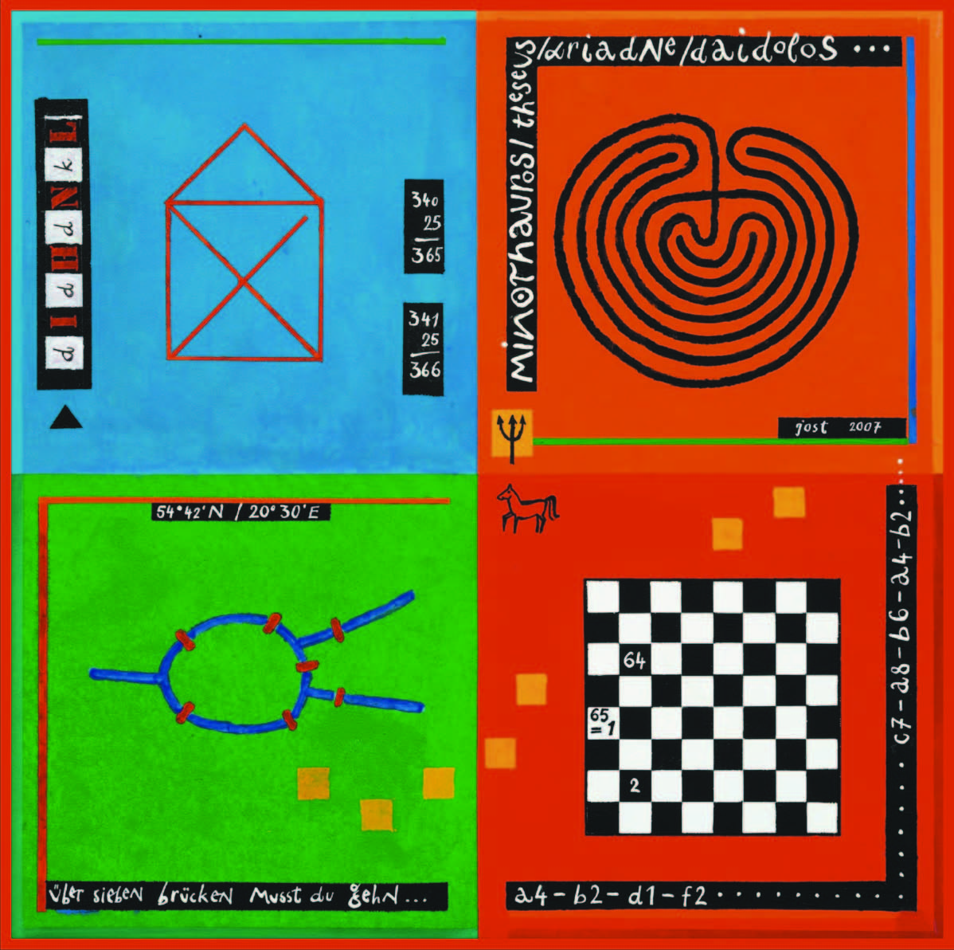

**Fig. 1: A Walk with Mr. Euler**

In the 18th century Königsberg (now Kaliningrad in Russia) was a well-known Prussian university town that was flown through by the river Pregel. The famous philosopher Immanuel Kant (1724 – 1804) lived and worked there. Let’s have a look at a map of the downtown area.

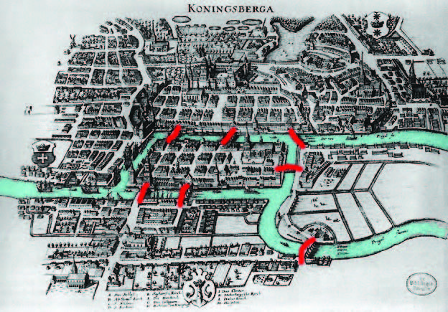

**Fig. 2: Historical map of Königsberg**

People in old Königsberg loved to take walks along the river, on the islands and over bridges. In the early 1700s they wondered if it was possible to take a journey across all seven bridges without having to cross any bridge more than once, and return to the starting location. Finding no solution the citizens asked the famous Euler. He proved that such a tour is impossible.

Euler pointed out that the choice of the route inside each land area is irrelevant. The only important feature of a route is the sequence of bridges crossed. Let’s have a look on Euler’s original diagram and the corresponding version by Eugen Jost:

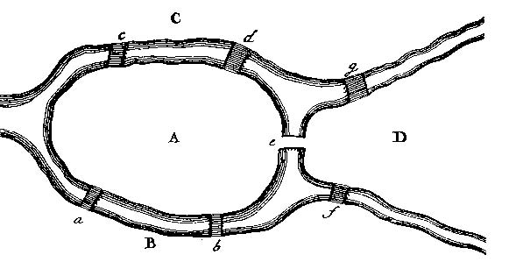

**Fig. 3: Leonhard Euler’s original diagram of Königsberg**

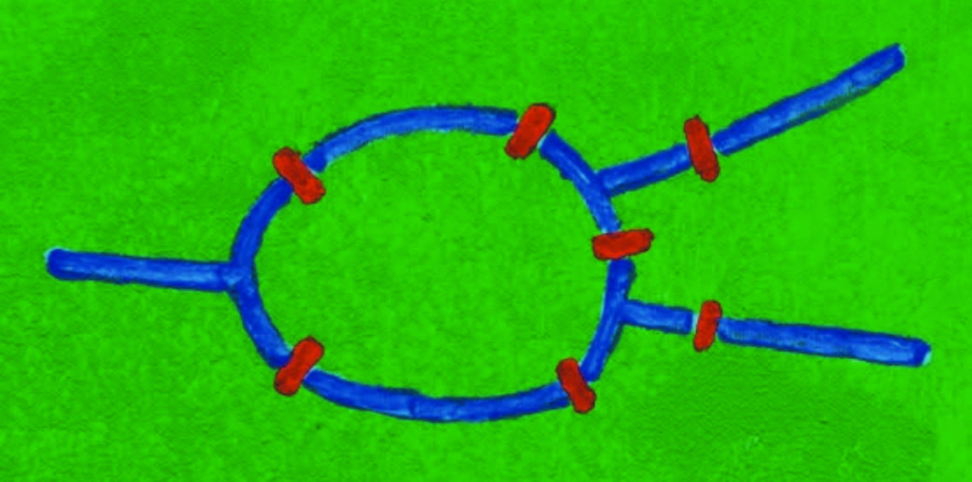

**Fig. 4: Eugen Jost’s paining of the situation in Königsberg**

What matters is how everything is connected. This finding allowed Euler to reformulate the problem in more abstract terms. Replacing each land area with a dot (or vertex) and each bridge with a line (or edge) Euler confines himself to the essential. The resulting mathematical structure is called a graph. Our problem is equivalent to asking if the graph on four vertices and seven edges has a so-called Eulerian cycle.

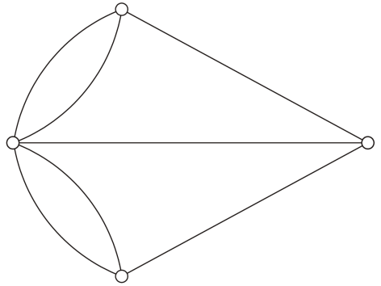

**Fig. 5: Eulerian cycle**

More generally Euler gave a criterion for any network of this kind. He showed that one could transverse such a graph by going through every edge just once only if the graph had fewer than three vertices of odd degree. By the degree of a vertex we understand the number of edges that start or end at the vertex. All the vertices in the above graph are of odd degree, therefore his answer was negative.

The English Canadian number theorist William Thomas Tutte (1917 – 2002) wrote a nice poem on the Königsberg bridges problem and Euler’s solution. Admittedly the following lines are not a masterpiece of 20th century poetry but they contain all the essential facts.

Some citizens of Koenigsberg

Were walking on the strand

Beside the river Pregel

With its seven bridges spanned.

O, Euler come and walk with us

Those burghers did beseech

We’ll walk the seven bridges o’er

And pass but once by each.

“It can’t be done” then Euler cried

“Here comes the Q. E. D.

Your islands are but vertices,

And all of odd degree.”

Since Euler generalized his result to journeys on any network of vertices and edges, the problem of the Königsberg bridges represents the beginning of graph theory. Today this part of mathematics is used in countless fields, from the study of car traffic flow, logistics in transportation to link structures of a website. Euler’s very simple representation of the situation with the bridges connecting the land areas (without regard of the specifics of the street map of Königsberg) also was the forerunner of the mathematical field of topology. We often use this simplification of a real situation for example to get a clear overview of the connections and stops of the public transportation in a city or region.

**4 Experimental Mathematics – Stimulating Acts**

The Königsberg bridges are an excellent example for a problem that can be solved by experimental methods. The situation can be investigated even with primary school kids. We encourage them to develop their own informal methods to solve the problem. Fig. 6 shows how.

Exploring, observing, discovering, assuming are the main activities in this kind of mathematics lesson. After that the kids are asked to try to explain their findings and to express their impressions. To get sustainability the activities together with the results have to be recorded in a study journal. By doing so the students are forced to work carefully and to think thoroughly.

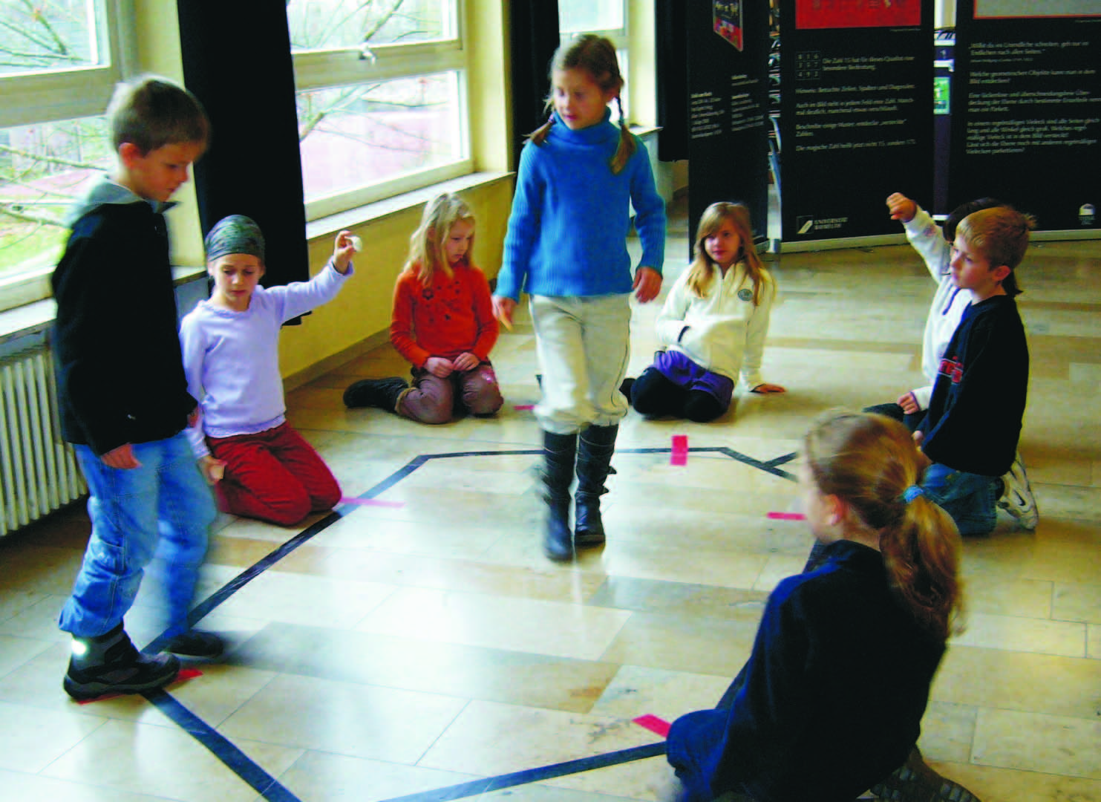

**Fig. 6: Children exploring the situation in Königsberg**

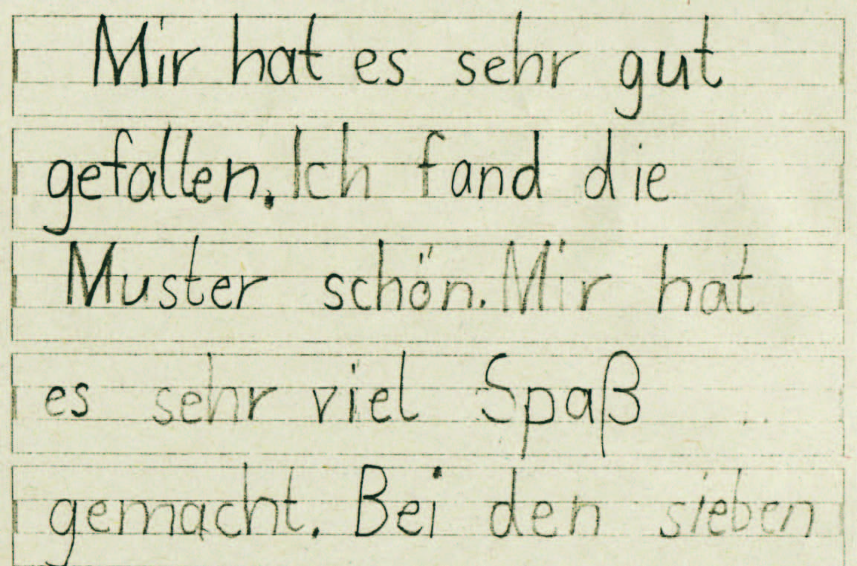

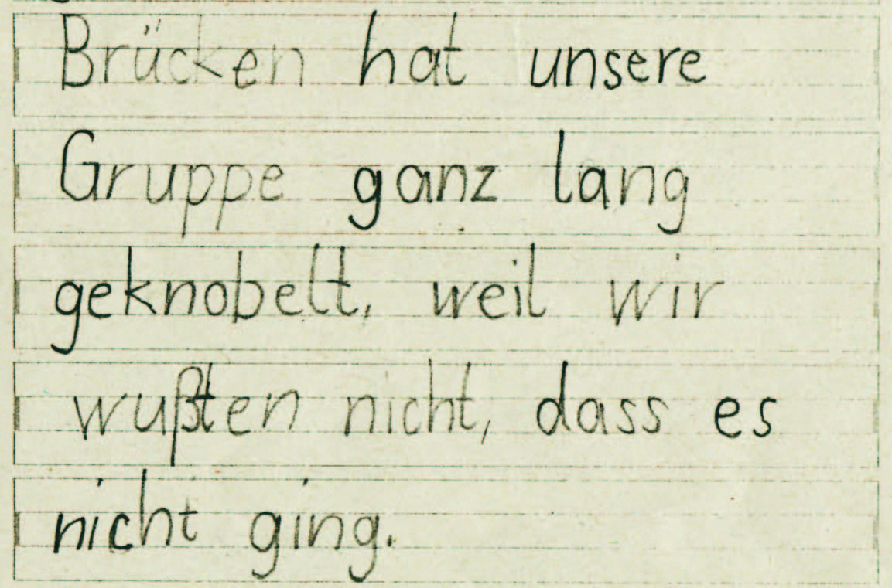

**Fig. 7: Written comments of a child**

The above notes show that the pupil is very astonished to be confronted with a problem that has no solution – apparently a new but very important experience.

**5 Variation: Königsberg nowadays**

Two of the seven original bridges were destroyed by bombs during World War II. Two others were later demolished and replaced by a modern highway. The three other original bridges have been preserved. Google allows us a view of Königsberg in the 21st century. We recognize the three remaining bridges and the two new highway bridges. And in the aerial photo we discover four additional bridges.

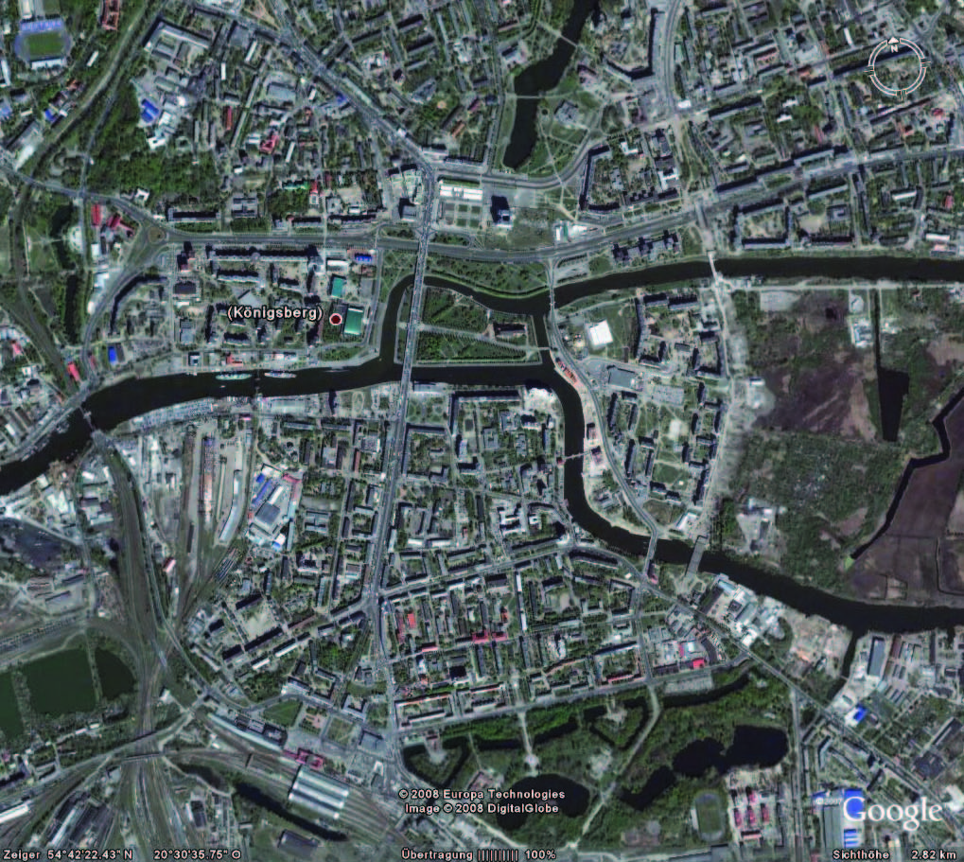

**Fig. 8: View of Königsberg nowadays**

We have a new situation and we have to check the degrees of the vertices. Do we get a round trip this time where we transverse each bridge only once?

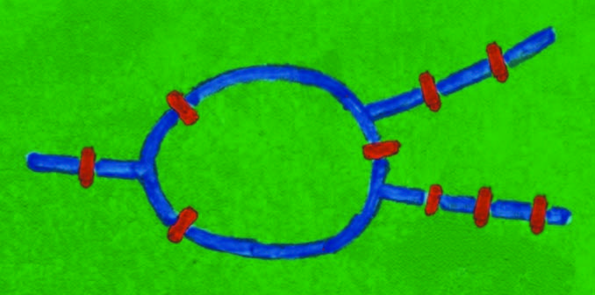

**Fig. 9: Variation of Jost’s painiting**

**6 Variation: The House of Santa Claus**

There is a close connection between the Königsberg bridges and an old children’s game. You have to draw a house, but you may not lift your pencil and you may not repeat a line. While drawing each line segment you have to pronounce a syllable of “This is the house of Santa Claus”.

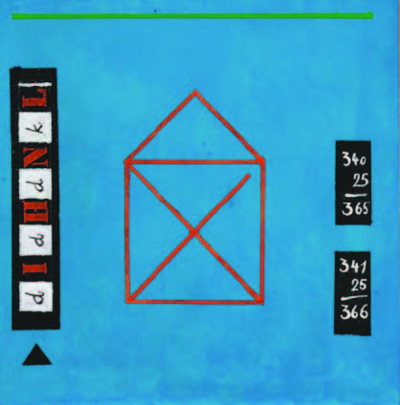

**Fig. 10: The House of Santa Claus**

This house is a graph, too, consisting of five vertices and eight edges. (Note: The diagonals in the square have no point of intersection and the artist was not accurate in drawing one diagonal!) Euler’s result helps to find out that there exists at least one solution. Altogether there are 88 solutions.

**7 Variation: Knight’s Tours**

At the beginning of a game of chess there are 32 pieces of six types (king, queen, rook, bishop, knight, pawn, each with its own style of moving) on the 8x8 chessboard. The knight has an unusual move. It can jump two squares horizontally or vertically, followed by a single square perpendicular to that, and it leaps over intermediate pieces.

Mathematicians use the chessboard for a special game, they only need one chess piece. To create a knight’s tour, a knight is required to make a series of moves, visiting each square on the chessboard exactly once. If the start and finish squares are one knight’s move apart we speak of a closed tour. Euler was the first to write a mathematical paper analyzing knight’s tours. The first algorithm for completing such a tour was described in 1823 by H. C. Warnsdorff.

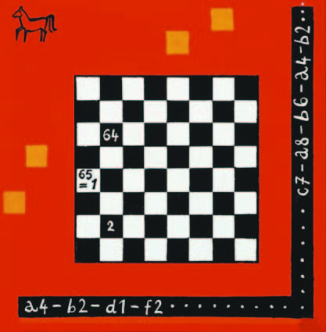

**Fig. 11: Chessboard and the problem of the knight’s tour**

It’s not so easy to find a closed tour on a chessboard by trial and error, although there are 13 267 364 410 532 solutions. Here is one of Euler’s examples:

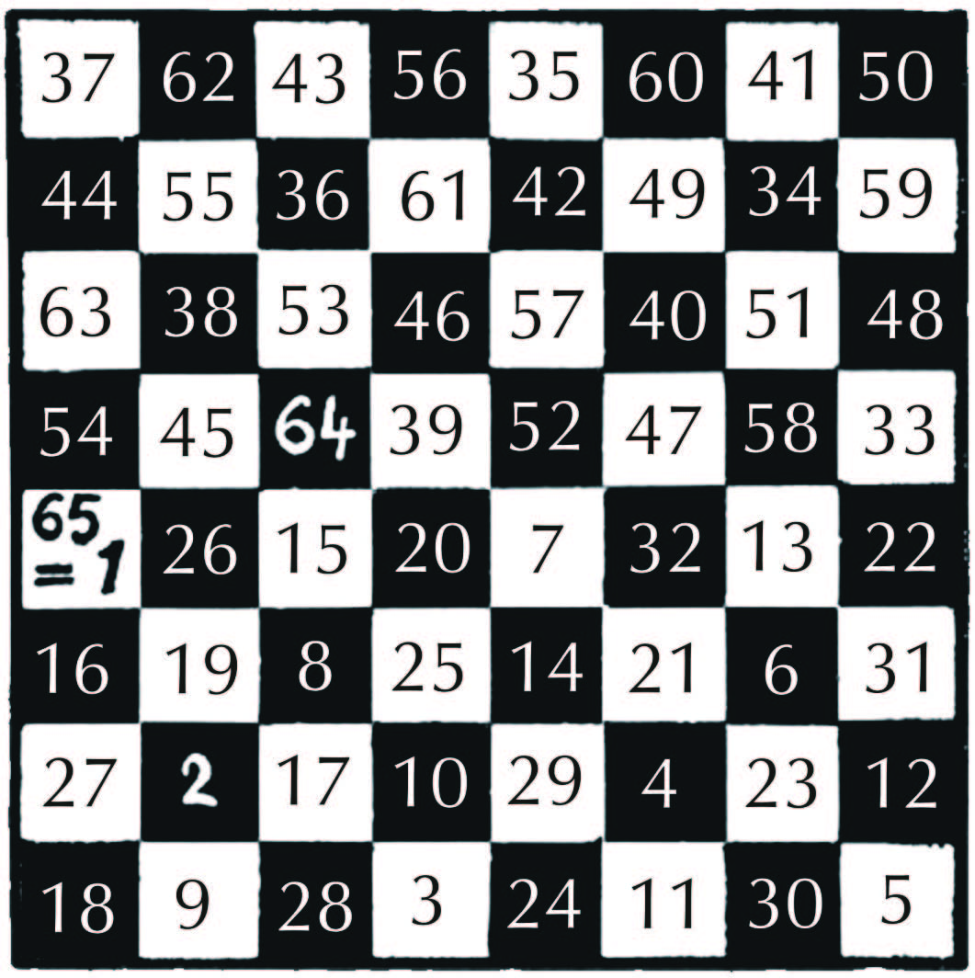

**Fig. 11: One of Euler’s solutions**

The following diagram clearly shows that the above tour visits two halves of the board in turn.

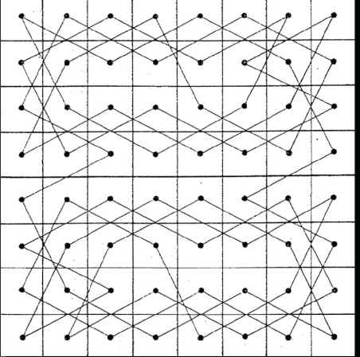

**Fig. 12: The knight’s tour**

By the way, the exact number of open tours is still open.

Now we reduce the number of rows and columns of the chessboard.

* Can you find a knight’s tour on a 4x4 board? If not, what is the largest number of squares that the knight can visit?
* Can you find an open and/or a closed tour on a 5x5 board?

Comparing the problem of finding a knight’s tour with the Königsberg bridges we notice an essential difference. On the “Königsberg” graph we want to pass each edge exactly once while during a knight’s tour we want to visit each vertex exactly once and no edge more than a single time.

* Find a tour along the edges of a dodecahedron such that every vertex is visited a single time, no edge is visited twice, and the ending point is the same as the starting point.

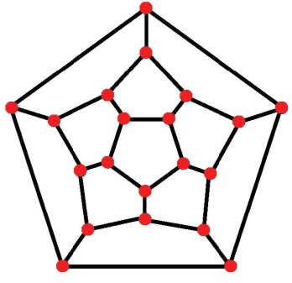

**Fig. 13: Diagram of the dodecahedron**

**8 An Excursion in Greek Mythology**

From Greek mythology we know the tale of Theseus and Ariadne. The location of this story is a labyrinth at Knossos on the island of Crete that was built for King Minos by the constructor Daidalus. He had made the labyrinth so cunningly that he himself could barely find the way out after building it.

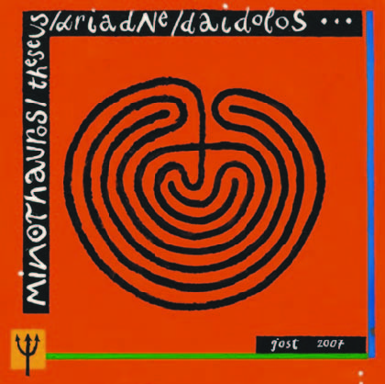

**Fig. 14: Labyrinth of minotaur**

In this labyrinth there lived the minotaur, a creature that was half man and half bull. It was fed with the bodies of young men and women who had yearly to be sent to Minos by the Athenians as a tribute. Theseus was among those who were sent from Athens as the third tribute to the minotaur. When he arrived, Ariadne, one of King Minos’ daughters, fell in love with him and offered him help if he agreed to marry her and take her with him to Athens. She gave Theseus a ball of thread, which he fastened to the door when he went in, so that, after killing the minotaur, he could make his way out by winding up the thread.

The design in the above detail of Eugen Jost’s painting became associated with the minotaur labyrinth. Having a closer look at it we definitely recognize: If this is really the design of minotaur’s housing, then Theseus had no need of Ariadne’s thread. There is no chance to get lost. Therefore we can be sure that the minotaur was trapped in a complex branching labyrinth, a so-called maze.

Often the notion *labyrinth* is synonymously used with *maze*, but there is a subtle distinction between the two. Maze refers to a complex branching puzzle with choices of path and direction. Such a maze can be described by a graph – and here we have the connection to Euler. A labyrinth by contrast has only a single, non-branching path, which leads to the centre. It has a clear route to the centre and back and is not designed to be difficult to navigate.

To construct the Knossos labyrinth we start by drawing a cross and four dots. The diagram shows what to do. Now it’s your turn.

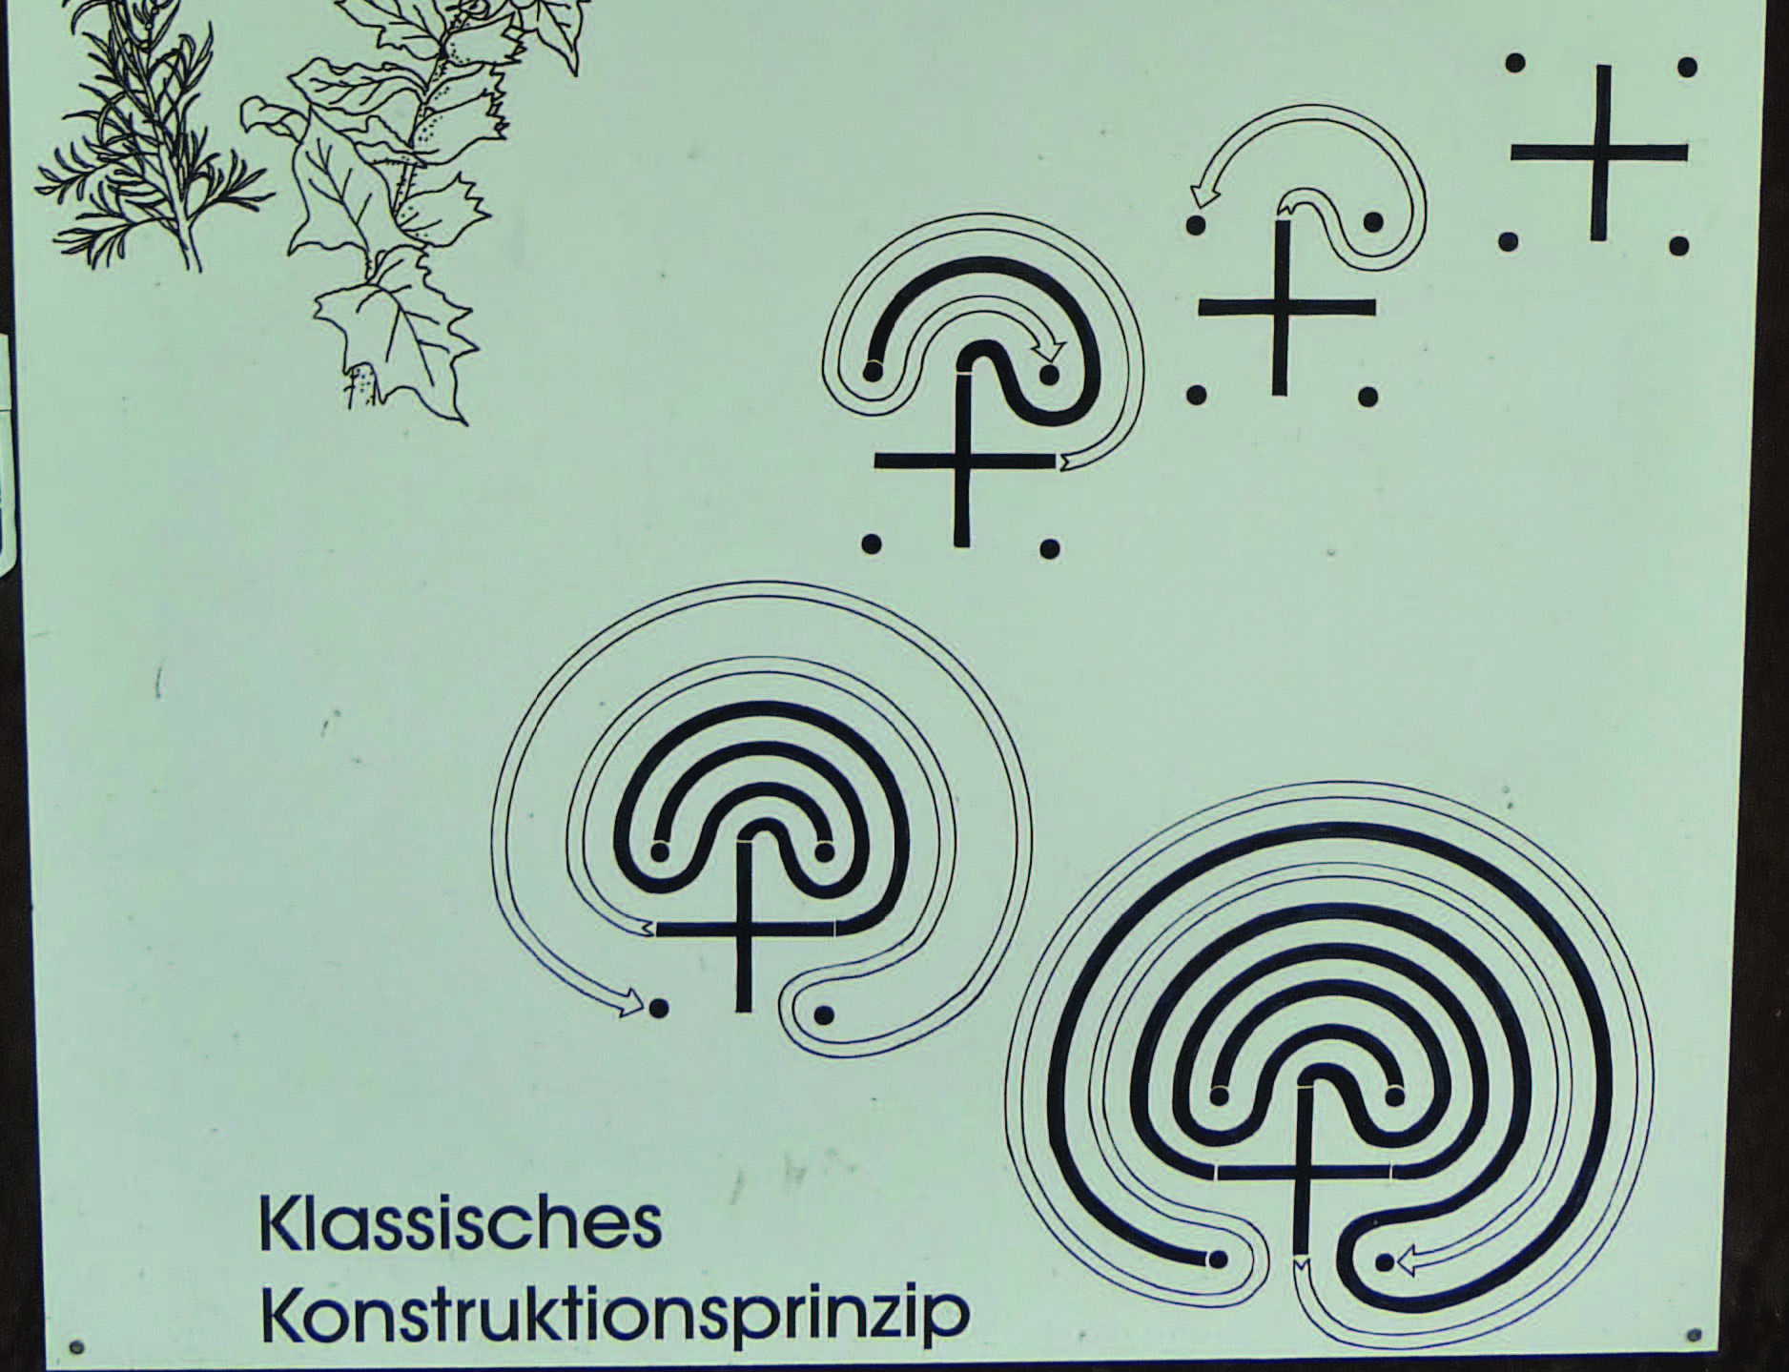

**Fig. 14: Way of constructing the labyrinth**

**9 Final Remark**

The walk with Leonhard Euler and Eugen Jost shows: Mathematics is much more than mere computing, mathematics is a part of our culture. Therefore historical aspects should be integrated in our teaching. Abe Shenitzer from York University (Toronto) underlines this aspect when saying: “One can invent mathematics without knowing much of its history. One can use mathematics without knowing much, if any, of its history. But one cannot have a mature appreciation of mathematics without a substantial knowledge of its history”.

Literature

Baptist, P. (2008). *Alles ist Zahl*, Kölner Universitätsverlag.

*Alfred Wassermann*

**The Challenge of a New Hardware Generation to Mathematics Education**

**Abstract**

JSXGraph is a library for displaying dynamic mathematics, e.g. dynamic geometry, function plotting, turtle graphics, in a web browser. It is written in JavaScript and runs on a broad variety of devices from desktop computers down to smart-phones and tablet PCs. JSXGraph is able to import various file formats like GEONEXT, GeoGebra, Intergeo, and – at least partially – Cinderella. At the moment, this seems to be the only possibility to display content from these sources on upcoming small computing devices, which makes them usable in classroom.

**1 Introduction**

In the late 1990s the availability of graphical web browsers that enabled easy access to the World Web Web brought many fresh ideas to the classroom and to mathematics education. The programming language Java became the dominant tool to raise interactivity in dynamic mathematics to a new level. Countless new Java applets came to existence to visualize many aspects of mathematics from kindergarten level to university level. Also, powerful software systems were developed that combined geometry and calculus under one graphical user interface. The most prominent examples are Cinderella[1], GEONEXT[2] and GeoGebra[3] to name a few of them.

But now a new hardware generation is on the horizon which appears to be better suited for the classroom than the old clumsy desktop PC. The revolution started with the success of small and cheap netbooks and the appearance of powerful smart-phones. Now, these two complementary worlds seem to melt together into tablet PCs. The success of the iPad made by Apple confirms this. Probably, very soon many other hardware manufacturer will follow and produce cheaper tablet PCs having more features than Apple’s iPad.

For use in classroom the advantages of these devices over the desktop PC are the long battery life and their small size and weight. Also, they offer much more possibilities than the still popular graphical, programmable pocket calculators. These features weigh out the difficulties in using these devices – especially typing – which is still easier on the desktop PC with a keyboard.

Now, mathematics education faces the challenge that most of the existing web-based software for dynamic mathematics is implemented in Java and embedded in web pages as so called Java applets. But there will be no Java plug-in available on most of these new machines.

Without good software the new hardware is useless for learning mathematics in the classroom.

With the project JSXGraph[4] at the University of Bayreuth we try to take up this challenge and offer first class dynamic mathematics software that runs on every device including smart-phones, netbooks, tablet PCs and desktop PCs. Moreover, the goal is to provide compatibility for existing resources for mathematics education.

**2 What is JSXGraph?**

JSXGraph is a software library implemented in the programming language JavaScript for dynamic mathematics. JSXGraph can be easily embedded into web pages, the download size for the library, when used on-line, is a mere 80 kByte. The software is open-source, released under the Lesser GNU General Public License (LGPL). The source code is hosted by Sourceforge[5].

For graphical output, JSXGraph uses the vector graphics format SVG (scalable vector graphics) on all web browsers supporting that format. This covers the popular web browsers firefox, chrome, safari and opera. The widely used web browser “internet explorer” does not support SVG, but instead uses the vector graphics format VML (vector markup language) – at least up to version number 8. The internet explorer version 9 supports SVG. Since JSXGraph is usable with SVG as well as VML, this means that JSXGraph still runs on older desktop PCs. In many cases, these outdated machines are restricted – for various reasons – to the use of Internet Explorer 6. With JSXGraph it is possible to access modern mathematical content even with these old machines.

Many smart-phones come with the operating system Android[6], also many already announced tablet PCs are expected to be Android based. The default web browser on Android does support neither SVG nor VML, but it allows to draw bitmap graphics with the new HTML element *canvas.* Starting with release 0.82, JSXGraph supports the canvas element, too.

Even on more powerful computers JSXGraph has the advantage over Java based software that the downloading time and the initialization time are much shorter than for comparable Java applets.

In summary, JSXGraph is usable on a huge amount of devices and should be able to take up the challenge and support dynamic mathematics on the upcoming hardware generation.

At the time of writing, there is no other software for dynamic mathematics that can be used on such a wide range of devices.

**3 How to use JSXGraph**

There are three possible scenarios:

**3.1 Display Existing Content**

JSXGraph is able to read the following file formats:

* GEONEXT
* Intergeo
* GeoGebra
* Cinderella

The support of the GEONEXT file format by JSXGraph is close to 100%. Only very few GEONEXT resources are misinterpreted by JSXGraph. In Fig. 1 the construction to the right is the GEONEXT Java applet, to the left is the same file displayed by JSXGraph.

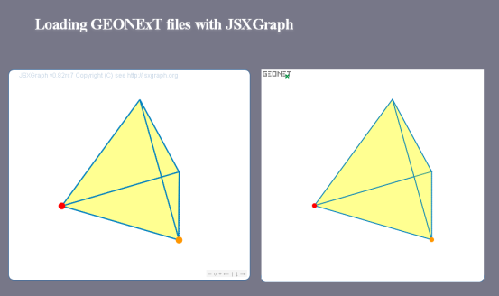

**Fig. 1: Importing GEONEXT**

The Intergeo[7] format is an upcoming common file format supported by the most European implementors of dynamic geometry systems. JSXGraph possesses one of the most complete implementations of the file format. But at the time of writing, the file format just starts to gain popularity.

The support for GeoGebra is not complete, but covers many of the most common features of GeoGebra. The support of the Cinderella file format by JSXGraph is in a very early development stage. At the moment it comprises most of the Euclidean Geometry part of Cinderella.

**3.2 Write Custom-made Applets**

JSXGraph provides an API (application programming interface) to build dynamic mathematics applications for the web browser. The differential equation plotter[8] on the JSXGraph home page is one example for using JSXGraph in mathematics education on the university level. Other applications are function plotters, turtle graphics, and support for various possibilities to create charts. This is especially interesting for publishers of e-books or providers of e-learning content. In this way, JSXGraph meanwhile is used in situations that are different from mathematics education, like medical information systems[9] or landslide prediction[10].

The JSXGraph wiki[11] contains more than 150 examples of dynamic mathematics, covering many areas like charts, function plotting, calculus, geometry, and turtle graphics, to name a few.

**3.3 Geometric Construction Language**

JSXGraph comes with a simple geometric construction language called JessieScript, which is closely related to the syntax students use in school to describe their constructions by compass and ruler. An example is shown in Fig. 2, the online version is available at http://jsxgraph.uni-bayreuth.de/jessie. The whole web page consists of three elements: the form for the text input of the construction, the display of the construction and a log window.

The most important commands are:

|  |  |
| --- | --- |
|  | Point with name '' at position |
|  | Point with name '' at position |
|  | straight line through points *A* and *B* |
|  | ray through points *A* and *B*, stopping at *A* |
|  | ray through points *A* and *B*, stopping at *B* |
|  | segment through points *A* and *B* |
|  | segment through points *A* and *B*, named by '*g*' |
|  | circle with midpoint *A* and radius 1 |
|  | circle with midpoint *A* through point *B* on the circle line |
|  | circle with midpoint *A* and radius defined by the length of the (not necessarily existing) segment |
|  | circle with midpoint *A* and radius 1, named by '*k*_1' |

The JSXGraph homepage contains the full description of the syntax.

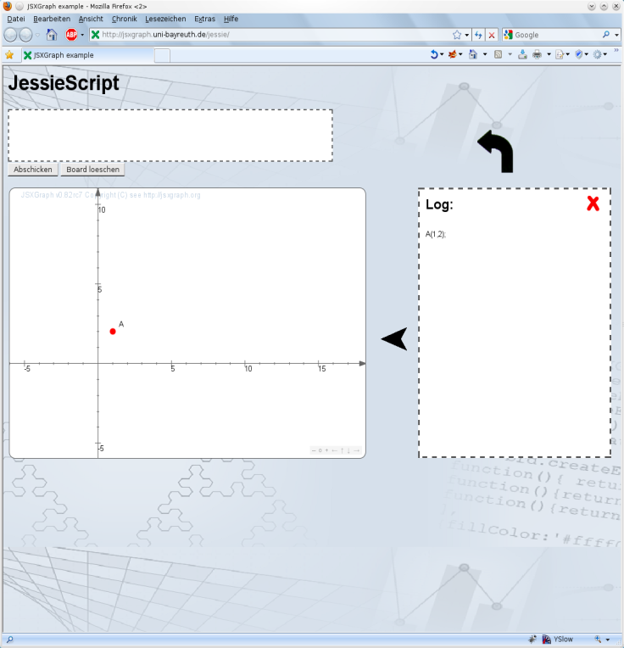

**Fig. 2: JessieScript**

**4 Conclusion**

JSXGraph enables the usability of existing mathematical resources on a broad variety of new, small computing devices. These devices seem to be very well suited for use in classroom, but up to now there is a lack of good mathematical software, since Java applets are not longer supported. The goal of JSXGraph is to change this situation.

**Literature**

Crockford D. (2008). *JavaScript: The good parts*. Sebastopol, CA: O'Reilly.

Ehmann, M. & Miller, C. (2003). Dynamic Mathematics with GEONExT. (Part I: The Interplay between Geometry, Algebra and Calculus). In: Triandafillidis, T. & Hatzikiriakou, K. (Eds.): *Technology in Mathematics Teaching*. Volos: University of Thessaly.

Ehmann, M., Miller, C. & Wassermann, A. (2008). Dynamic Mathematics with GEONExT: New Concepts. *Book of Abstracts*, 4th European Workshop on Mathematical & Scientific e-Contents.

Hohenwarter, M. & Fuchs, K. (2005). Combination of Dynamic Geometry, Algebra and Calculus in the Software System GeoGebra. In: *Computer Algebra Systems and Dynamic Geometry Systems in Mathematics Teaching Conference.* Pecs.

Kortenkamp, U., Dohrmann, Ch., Kreis, Y., Dording, C., Libbrecht, P. & Mercat, Ch. (2009). Intergeo – Using the Intergeo Platform for Teaching and Research. *Proceedings of ICTMT9 – The Ninth International Conference on Technology in Mathematics Teaching.* Metz.

Kortenkamp, U. & Richter-Gebert, J. (1999). Euklidische und Nicht-Euklidische Geometrie mit Cinderella. In: *Tagungsband zum Nürnberger Kolloquium zur Didaktik der Mathematik*. Nürnberg: Universität Erlangen-Nürnberg.

1. http://cinderella.de
2. http://geonext.de
3. http://geogebra.org
4. http://jsxgraph.org
5. http://sourceforge.net
6. http://www.android.com/
7. http://i2geo.net
8. See http://jsxgraph.uni-bayreuth.de/wiki/index.php/Differential_equations
9. http://swiftcaresolutions.com/index.html
10. http://www.rhok.org/2010/06/rhok-1-0-washington-d-c-winning-hack-chasm/
11. http://jsxgraph.uni-bayreuth.de/wiki