|  |  |  |
| --- | --- | --- |
|  | N=8, [3] |  |
| W=1, [4] | Cell | E=4, [2] |
|  | S=2, [1] |  |

1. Example

4 5

0

19

13 11 10 10 12 5 9 10 10 4 5 5 11 10 4 3 2 10 10 6

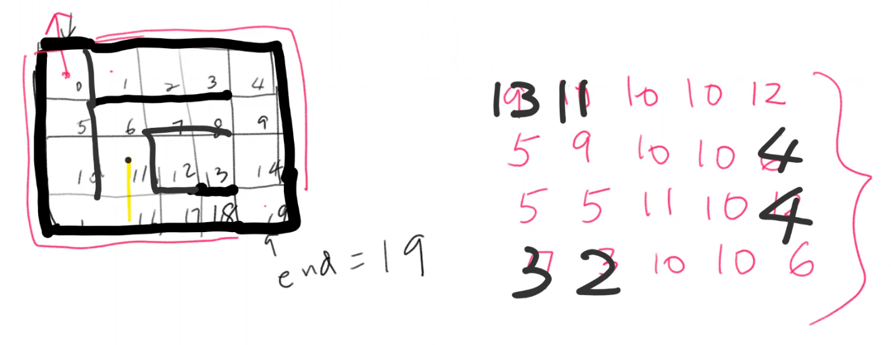

1. Circle and no solution

3 3

7

4

9 10 12 5 15 5 3 10 6

|  |  |  |
| --- | --- | --- |
| 0=9 | 1=10 | 2=12 |
| 3=5 | E, 4=15 | 5=5 |
| 6=3 | S, 7=10 | 8=6 |

1. Complex and BFS better solution

5 5

17

24

15 10 10 10 12 9 12 9 8 6 5 5 5 3 12 7 3 0 8 4 11 10 6 3 6

|  |  |  |  |  |
| --- | --- | --- | --- | --- |
| 0=15 | 1=10 | 2=10 | 3=10 | 4=12 |
| 5=9 | 6=12 | 7=9 | 8=8 | 9=6 |
| 10=5 | 11=5 | 12=5 | 13=3 | 14=12 |
| 15=7 | 16=3 | S, 17=0 | 18=8 | 19=4 |
| 20=11 | 21=10 | 22=6 | 23=3 | E, 24=6 |

1.

DFS_iterative Solutions:

19<-18<-17<-16<-15<-10<-5<-0

BFS Solutions:

19<-18<-17<-16<-15<-10<-5<-0

All Moves Using DFS_recursive:

0->5->10->15->16->11->6->7->8->9->14

DFS_recursive Solutions:

19<-14<-9<-8<-7<-6<-11<-16<-15<-10<-5<-0

2.

DFS_iterative Solutions:

No solution.

BFS Solutions:

No solution.

All Moves Using DFS_recursive:

7->6->3->0->1->2->5->8

DFS_recursive Solutions:

No solution.

3.

DFS_iterative Solutions:

24<-19<-18<-17

BFS Solutions:

24<-23<-18<-17

All Moves Using DFS_recursive:

17->22->21->20->16->11->6->5->10->15->12->7->8->13->14->19

DFS_recursive Solutions:

24<-19<-14<-13<-8<-7<-12<-17