SpiNNaker

Andrew Brown
Steve Furber
and a host of others...

V1.0 25 April 2008

Disclaimer/preamble

This document is an attempt to bring together both the diverse conversations held between various researchers over the months, and the 'big picture' of what SpiNNaker is about. The hardware details are outlined in the data sheet; this is intended to be a complementary document outlining the way the software will work.

It is necessary, because it has become clear that the researchers at Southampton and Manchester are in a dangerous relationship: we think we're talking the same language, but actually there are subtle and important differences in the way we think of things. Unfortunately we then go on to use the same words to describe them, and you can see where that goes..... This is primarily an attempt to translate 'Manchester-speak' (or more accurately 'SBF-think') into 'Southampton-speak', although it may find wider usefulness.

It is incomplete, partly because - quite deliberately - it started out along the lines of one of Galileo's Socratic dialogues between ADB and SBF, and these things never stop, and partly because there are still important issues for which no-one has yet got an answer. The identification of these holes is itself important. SpiNNaker is a big and complicated thing: If you don't know something, knowing you can look it up is good; and knowing that the information is needed but no-one has actually addressed the issue is also valuable, especially from the management perspective.

We will update this document, expand it and doubtless restructure it as we make progress. It's not formal - it's supposed to be useful.

If there's anything in this you don't understand, or you think is missing altogether, please say so. If you have a concern, there's a fighting chance a lot of other folk will be in the same boat, and you'll be doing everyone a favour if you get us to explain it better.

SBF: I haven't (necessarily) highlighted everything that you explicitly need to look at, 'cos a lot of it is brand new (from your perspective) so I'd end up highlighting the second half of the entire document, so I haven't. So it's up to you to spontaneously comment on things (a) I've obviously got wrong, (b) you think I may have got wrong, and (c) may or may not be wrong, but need commenting upon. Cast aside reticence! Chuck rocks! It's easy once you get into the swing of it.
I also think we might be approaching the point where we can open this up to a wider audience - I had in mind David and Luis, Peter and Mark - possibly Alex. What do you think? Open Pandoras box now, or do you and I need more iterations?
I've booked John Chad for the Plasticity Modelling Meeting at the end of the month; I'd like to be in a position to give this to him beforehand, and then talk him through any bits he doesn't understand. Is that a plan?

JC: I have made notes on the differences between the current model and “biological” neurones in the document I circulated before the plasticity meeting in Southampton in May’08 (Pre_QandA.doc).

Part I : Overview

1. Introduction
2. Principles of operation
3. Quantitative architecture drivers
4. Execution model
5. Machine operation
1. Introduction

This document is aimed primarily at the software end of the development spectrum associated with SpiNNaker. (The hardware is elegantly described by the datasheet [3].) It describes what we call the 'standard' spiking neurone execution model for which the SpiNNaker architecture design features have been optimised. SpiNNaker is a massively-parallel computer that employs message passing and does not support a coherent memory model (that is, each processor has its own independent memory and there is no hardware to maintain consistent views of memory across processors). As such it is capable of operating in a very wide number of ways, and there is no claim that the standard execution model is optimal or ideal; it is simply one reasonably complete view of how the machine might operate that can be used to assess architectural decisions.
2. Principles of operation

2.1 Spiking communication

Most biological neurones communicate predominantly through spikes. Each neurone has a single output, its axon, along which the neurone signals to its targets by sending a train of spikes, or impulses. The size and shape of the spike is largely invariant, being determined by local instabilities in the cell membrane current balance, so a spike can be viewed as a unit impulse that conveys information solely in the time at which it occurs. It costs the axon energy to transmit an event, but this is provided by a kind of electrochemical 'gain' distributed along the length of the fibre: the net effect is that - to a zeroth approximation - the axon can be viewed as a lossless dispersion free transmission line, although it has to have a rest just after a pulse has gone by to 'charge itself up' again. Think solitons.

2.2 Point neurone model

SpiNNaker is optimised for what is commonly known as the 'point neurone model', where the details of the dendritic structure of the neurone are ignored and all inputs are effectively applied - unordered - to the soma. The abstract synaptic inputs are summed to form a net input current that drives a system of simple differential equations that compute when an output spike should be issued. (The terminology is deliberately sloppy here; the terms 'potential', 'current' and so on are not those bound by Kirchoffs Laws.)

2.3 Synapses

A synapse is where a spike from one neurone couples into the input to another neurone. The spike has unit impulse, but the synapse has a variable efficiency which is often represented by a numerical 'weight'. If the weight is positive, the synapse is excitory. If the weight is negative, the synapse is inhibitory. When a spike arrives the weight may simply be added to the net input current of the local neurone. Alternatively, the weight may be viewed as a probabilistic indicator, but this view has not been developed within SpiNNaker yet.

The major long-term learning process in neural networks is through synaptic adaptation - that is, the synaptic weight changes over time. This is discussed further below, though has so far received little attention within the SpiNNaker project.

The modelling abstraction is summarised in figures I.1 and I.2. In the jargon of electronic circuits, it is a devices-on-devices graph. Biological neurones and their associated synaptic interconnectivity are vastly more complicated than this extreme abstraction. For a comprehensive explanation of the many types of real neurones and synapses, see [1,2].
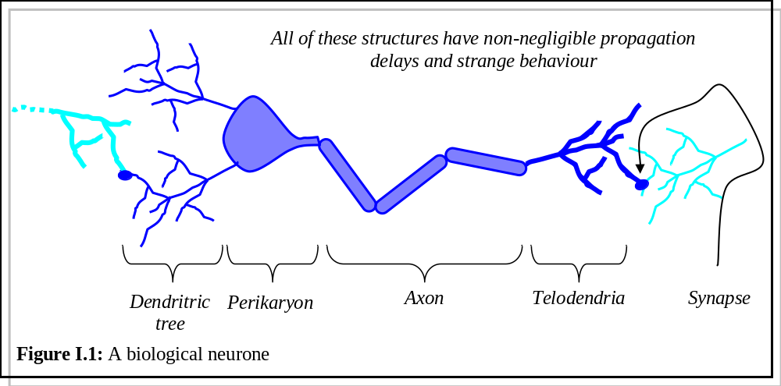
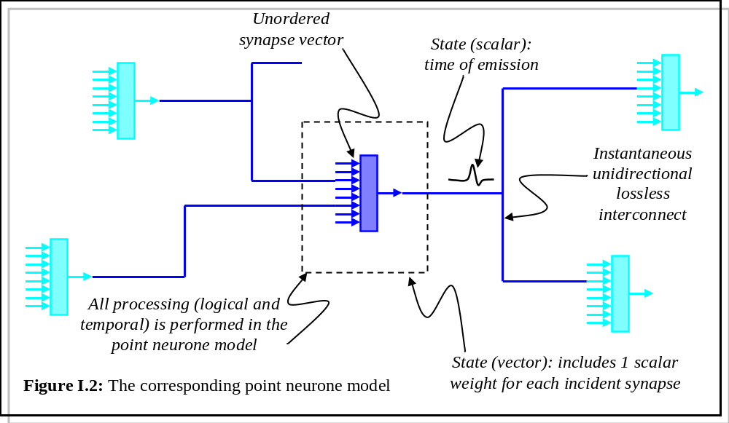

2.4 Address Event Representation

The central idea of the standard model is that of Address Event Representation (AER). The underlying principle of AER, which is well-established in the neuromorphic community, is that when a neurone spikes the spike is a pure asynchronous 'event'. All of the information is conveyed solely in the time of the spike and the identity of the neurone that emitted the spike. In a real-time system time models itself (possibly with a scaling factor, but we normally assume no scaling), so in an AER system the identity ('address') of a neurone that spikes is simply broadcast at the time that it spikes to all neurones to which the spiking neurone connects.

In SpiNNaker AER is implemented using packet-switched communication and multicast routing. Although the communication system introduces some temporal latency, provided this is small compared with biological time constants (which in practice means provided it is well under 1ms) then the error introduced by this latency is negligible (when modelling biological neural systems).

2.5 Topological virtualisation

Biological neural systems develop and operate in three dimensions, and their topologies are constrained by their physical structures. SpiNNaker employs a two-dimensional physical communication structure, but this in no way limits its capacity to model three- (or higher-) dimensional networks. Because electronic communication is effectively instantaneous on biological time-scales, every neurone in a SpiNNaker system can be connected to any other neurone with a time delay that equates to adjacency in the biological three-dimensional space. Thus the mapping of neurones from the biological 3-D space into the SpiNNaker 2-D network of processors can be arbitrary - any neurone can be mapped to any processor. In practice, the SpiNNaker model is likely to be more efficient if the mapping is chosen carefully, and this is likely to tend to mean mapping physically close neurones into physically close processors, but this is only a matter of efficiency and is in no way fundamentally constrained by the SpiNNaker implementation.
3. Quantitative architecture drivers

The SpiNNaker architecture is driven by the quantitative characteristics of the biological neural systems it is designed to model. The human brain comprises in the region of 10¹¹ neurones; the objective of the SpiNNaker work is to model 1% of this scale, which amounts to a billion neurones. Each neurone in the brain connects to thousands of other neurones. The mean firing rate of neurones is below 10 Hz, with the peak rate being 100s of Hz. These numerical points of reference can be summarized in the following deductions:

● 10⁹ neurones with a mean fan in/out 10³ ==> 10¹² synapses.
● 10¹² synapses with ~4 bytes/synapse ==> 4.10⁶ Mbytes total memory.
● 10¹² synapses switching at ~10Hz mean ==> 10¹³ connections/s.
● 10¹³ connections/s, 10 instr/connection ==> 10⁸ MIPS.
● 10⁸ MIPS using ~100MHz ARM ==> 10⁶ ARMs.

.... So 10⁹ neurones need 10⁶ ARMs, whence ....

● 1 ARM at ~100MHz ==> 10³ neurones.
● 1 node with 20 ARM968 + 80MB ==> 2.10⁴ neurones.
● 5.10⁴ nodes with 2.10⁴ neurones/node ==> 10⁹ neurones.

The above numbers all assume each neurone has 1,000 inputs. In practice this number will vary, and it is probably most useful to think of each ARM being able to model 1M synapses, so it can model 100 neurones each with 10,000 inputs, and so on.

The system will be inefficient unless there is some commonality across the inputs to the set of neurones modelled on a processor, so that each input event typically connects to tens or hundreds of neurones modelled by a processor. In biology connections tend to be sparse, so, for example, a processor could model 1,000 neurones each of which connects to a random 10% of the 10,000 inputs that are routed to the processor. The standard model assumes sparse connectivity.

3.1 Routing

With a billion neurones a 32-bit address is (more than) sufficient; moving to systems that break the 32-bit barrier has yet to be considered. The AER packets incur a small overhead for control purposes, which amounts to one byte in the current design. Since spike events are unit impulses, all the packet need carry is the control byte and the 32-bit ID of the neurone that fired. SpiNNaker packet formats support an optional 32-bit payload in addition, but that is not used for neural system modelling directly. The payload will be used for other applications and for debug and diagnostics. Thus the communication traffic generated by one node is:

● 2.10⁴ neurones/node x 10 Hz x 5 bytes ==> 1 MByte/s.
Each chip incorporates a Router that implements AER-based routing of neural spike-event packets. The total traffic from neurones modelled by the processors on the same chip as the Router averages 2.10⁵ packets/s, which is undemanding. However, the Router also handles incoming and passing traffic.
● Each link passes 4-bit symbols at 100MHz ==> 10⁷ packets/s.
● 6 incoming links ==> 6.10⁷ packets/s.

So, a Router operating at 100MHz processing one packet per clock cycle can easily handle all local, incoming and passing traffic.

3.2 Bisection bandwidth

If a 64K-node system is organized in such a way that all of the neurones in one half are connected to at least one neurone in the other half, the traffic across the border between the two halves is 32K x 200K = 6.4G packets/s. The border is 256 nodes long (assuming a square layout, not mapped to a toroid), so each node must carry 25M packets/s, which is within the Router's capacity.
4. Execution model

4.1 Terminology

A fascicle is the collective noun for a set of neurones. Other than to note that no neurone can be a member of more than one fascicle, the term defines nothing about any connectivity. There is an implication (and an efficiency assumption) that the neurones in a fascicle share common input fascicles (probably sparsely connected) and common output target fascicles (again, probably sparsely connected). There is no implication that they are interconnected with each other, though they can be (or not). However, none of this is required - it just makes the datastructure packing more efficient if it holds.

A Fascicle Processor is a single physical ARM core on a SpiNNaker chip. It may be host to zero, one or more fascicles in the simulation process. The intention is that of the n ARM cores on a chip, n-1 will be Fascicle Processors. It is also an ARM processor that is involved in the application layer of the modelling task. Sorry - I know I asked this, but what is this if it's not part of the simulation?

A Monitor Processor is also single physical ARM core on a SpiNNaker chip. On each node, one processor will be assigned (by a mechanism invoked at chip start-up, whereby all processors perform a self-test and then processors that pass the test compete for ownership of a token) to system management functions and is thereafter called the Monitor Processor.

The Monitor Processor is not involved in routine application-level neural processing, but is available for monitor and debug functions which it delivers using point-to-point communication with the Monitor Processors on other nodes, and it can communicate with local Fascicle Processors by various means, including interrupting them - by sending a packet - and exchanging data via on-chip memory.

It is possible that there may also be unassigned ARM cores on a chip (effectively a Fascicle Processor hosting zero fascicles), and that the designation of Monitor may change dynamically with time, although the details of how this may come to pass have yet to be decided.

4.2 Neural data structures

We assume that each neurone is a simple dynamical system (for example a leaky integrate-and-fire neurone, or an Izhikevich neurone) where the dynamics have a small amount of state and parameter data held in the processor's local memory. The input connections require far more data and are held in off-chip SDRAM (see part II). When an input fires, its connectivity data is loaded by DMA from the SDRAM into the local memory, where it is processed (modifying the state of each neurone modelled on this Fascicle Processor to which that input connects) and then later overwritten by a subsequent DMA of data corresponding to another input.

To summarize: the state of the neurones is held in local data memory and is modified as processing advances. The connection topology and synapse state is held in SDRAM. If needs be, the SDRAM can be written to either directly or via DMA to update the synapse state.

By far the most expensive aspect of the connectivity data is a result of its role in modelling axonal delays, which may be up to 20ms. One way to handle this (following Izhikevich) is that each neurone has a 'bin' for each of the next 20 milliseconds, and when a connection with non-zero delay is processed the connection weight is simply added into the appropriate bin to be processed the appropriate number of milliseconds later. This is a very crude form of event queue, but even so demands the lion's share of each neurone's state vector.

Data structures held in local memory are therefore:

● The dynamic state and parameters for each neurone (~12 bytes/neurone);
● The input delay bins for each neurone (~32 bytes/neurone);
● A binary tree used to compute the DMA address for each input (~160 bytes); this is explained in detail later
● One or more buffers for holding connection data loaded from SDRAM by DMA (~1Kbyte, assuming 4 bytes per connection and that each input connects to 10% of the local neurons).

Data structures held in off-chip SDRAM are:

● Connectivity information for each input (4 bytes/synapse - for example, 4 bits to specify a delay from 0 to 15ms to millisecond accuracy, 10 bits to indicate which local neuron this connection is to, and 18 bits to hold the numerical weight and/or learning parameters).

So, for example, a processor modelling 1,000 neurons each with 1,000 inputs sampled as 10% of 10,000 total inputs would require 45Kbytes of local memory and 4Mbytes of SDRAM.
(These details have been programmed up and simulated on an ARM emulation system.)

4.3 Event-driven processes

Fascicle processors execute processes in response to three interrupts. This can be viewed as an event-driven model with three threads:

● Arriving neural-event packet. When an input neural-event (multicast-type) packet arrives the Communications Controller raises an interrupt. The processor uses the identity of the neurone that spiked to compute the address range of the block of data in the SDRAM that contains the synaptic connectivity information for this input, and then initiates a DMA transfer of this block into its local data memory. This process is then complete.

● DMA completed. Once the block of connectivity information has been loaded into the local data memory the DMA controller raises an interrupt, and the processor uses this information to update the states of the neurones modelled locally that the firing input connects to. This process is then complete. (There is little the neural even handler can do whilst waiting for the DMA transfer to complete, but the option is there.)

● Timer interrupt. Every 1ms (nominal) the Timer/Counter raises an interrupt which causes the processor to update the dynamic state of each neurone that it models, possibly causing some of the neurones to fire. Once every neurone has been updated this process is complete.

These three processes are all that the Fascicle Processor does, and when all processes have completed the processor goes into a low-power wait state until a subsequent interrupt restarts one of the processes. Basic assembly-level models of these processes have been built and tested.

Clearly there will be a priority scheme to cope with an interrupt being raised when another process is active, and buffer schemes will be necessary, for example to queue input events when the DMA controller is busy.
[Details of this, peeking, and so on ? Whilst these capabilities might not be essential to the 'internal' operation, debug, congestion and fault handling will want to ask all sorts of question about the state of the queue.]
(This system has been programmed, though not yet in its final form.)

4.4 Learning

As the machine is running an application, synaptic connectivity data is repeatedly being loaded into processor local memory by DMA from the SDRAM. One of the most important mechanisms in a neural network is the adaptivity of the connections, but there is a plethora of models of how this works.

In the standard model we assume some form of Hebbian learning ('neurones that fire together wire together'), so changes to synaptic weights take place as a result of correlations between the firing patterns of the neurones either side of the synapse. In SpiNNaker we only have the synaptic weights 'to hand' for a short period after they have been loaded by DMA, so if we are going to change them we want to do it at that time, and then we must copy the modified value(s) back to the SDRAM (either by direct processor writes to SDRAM or by DMA of the whole block).
(We have only a few basic ideas about how to do this.)

4.5 Input, output and monitoring

The basic execution model is closed - neural events fly around, get processed, and generate other neural events. In order to interact with the outside world the system needs (sensory?) inputs and (actuator?) outputs.

The proposed mechanism for I/O exploits the 100 Mbit Ethernet interface built into every SpiNNaker chip. On most nodes this interface will be redundant, but on at least one node it will connect (via an off-chip physical-level interface chip (PHY)) to a Host processor. The Host processor can then send inputs into the system, receive outputs, and provide mechanisms for monitoring activity within the system.

● Inputs: the Host processor might, for example, be connected to a web cam. It could compress the video stream and send the compressed stream into the SpiNNaker node to which it is connected. Within the node the compressed video stream could be decompressed by one of the processors (possibly the Monitor) and converted into a neural spike code using a retinal model, effectively emulating the action of the retinal ganglion cells in issuing spikes down the optic nerve. The optic nerve spikes are issued into the AER fabric and processed like any other neural spikes. (Details of this have yet to be derived.)

● Outputs: in a dual process to that described above, virtual motor neurones receive spikes from multiple sources (defined by the routing tables) and recode these into motor commands that are passed via the Ethernet to the Host. As a simple example, the outputs could instruct stepper motors to move the position and direction of the web cam.

The above examples suggest how one might build a system demonstrating the ability to pay visual attention to items of interest. One could show things to the web cam and see if it could follow their movement, or decide to look at something more interesting, and so on.

● Monitoring: the same Ethernet connection is also used to provide visibility of the internal activities of the machine. The user might want to see a raster plot of the spiking activity in a bank of neurones, for example. This would be achieved by the Host sending a command to the Monitor Processor in the chip where the activity of interest is taking place. The Monitor Processor can instruct its local Router to include the Monitor Processor in the set of destinations for those spikes, and the Monitor Processor can then record the relevant spiking activity and send these records back to the Host for display to the user.

On small systems a single Host machine might be sufficient to handle all input, output and monitoring functions, and a single Ethernet interface would suffice. On large systems a single Host might connect to multiple Ethernet connections on SpiNNaker, and in very large systems multiple Hosts might be needed.

(None of this has been implemented or modelled in any detail.)

5. Machine operation

How is an application developed and loaded onto the machine for execution? In the simplest approach, which we will call the static model, a fixed network is loaded and executed. The allocation of hardware resources is fixed and determined externally to SpiNNaker. As the model executes, inputs arrive, outputs are generated, and synaptic weights may adapt, but that is all.

In what we call the dynamic model, operation is much more flexible (and much less well understood - this is speculation at the moment). Here an initial model may be loaded from outside, but there is enough information in the machine for it to develop new connections, adapt to systems failures, move functionality around, and generally evolve dynamically without reference to an external system.

5.1 Static model

Here is the static view of how an application runs:

1. The desired neural network is specified, perhaps statistically, perhaps from biological data, perhaps from a concept of an artificial network. This needs a suitable specification 'language', and perhaps a graphical input tool?

2. The specification is 'compiled', on an external machine, into a form suitable for loading into SpiNNaker. This means that each neurone is assigned to a processor on a node and an appropriate dynamical model (for example, an Izhikevich model, or a Leaky-Integrate-and-Fire model) identified for it. The routing tables are built for each node's Router. The synaptic weights are defined (although the resolution of statistical details may be deferred as below), and all associated tables are built.

3. The compiled model is loaded into SpiNNaker via the Host processor. Any remaining statistical details are resolved locally. The model is now ready to go.

4. The Host issues an 'execute' command, and the system starts running. The Host must maintain a real-time stream of sensory inputs, and act upon the output motor commands.

5. The User may, while the system is running, ask to look at some aspect of internal activity. This is handled via the Monitor Processor network as described above.

6. When the User has seen enough, the Host issues a 'halt' command. The system stops. The User may continue to inspect state, and may request a system state 'dump'.

In the initial stages, we will generate neural connectivity externally, (as a netlist), generate the appropriate SDRAM data externally, and load it directly. As our circuits become more ambitious, the manipulation of the circuit as a netlist will start to become cumbersome, so some kind of statistical definition may be necessary. (We have no idea how this might be achieved.)

None of the above is fully implemented, though we do have prototypes of some of the steps, most notably the routing table set-up.

The above very much has the feel of configuring an FPGA, except the units are neurones instead of logic gates, and the system is larger.

5.2 Dynamic model

If we don't know much about the static model, we know a lot less about the dynamic model! Here are some of the things that might be involved.

1. Basic fault-tolerance. Coping with a failed inter-chip link, or a failed processor. Start-up failures could be passed back to the external configuration engine, or could be handled locally. For example, the configuration algorithm could map a bunch of neurones to a processor on a node, but the decision as to which processor could be taken locally at load time. Any processor found to be dead at start-up just won't be used.

2. Run-time fault-tolerance. A link that fails during a run will cause emergency routing to be invoked for a quick fix, but re-routing should be used for a longer-term solution. This requires the Monitor Processors to have enough knowledge of the system to be able to design new routes and update the routing tables accordingly. (As a first step they could pass failure information back to the external configuration engine and ask it to sort things out?) A run-time processor failure is more fun - quickly move the neural models onto a spare processor, reconfigure the routing tables, and hope you haven't missed too much action.

3. Developmental networks. Here the connectivity of the network is allowed to develop as the system runs. The Monitor Processors must have extensive system knowledge, and be continually fiddling with tables and resource allocation as things proceed.

(We have very little idea how to do any of this!)

Part II: Datastructures, algorithms and models

1. General principles

2. Packets

3. The SDRAM structure

4. The Fascicle Processor local memory structure

5. The routing tables

6. The neurone model

7. The plasticity model

8. Automatic place and route (APR)

9. The Universal Interface Format (UIF)

1. General principles

Each SpiNNaker node consists of a SpiNNaker chip plus a bank of SDRAM (tightly bound to that chip alone). The chip contains, amongst other things, twenty ARM968 cores (nineteen Fascicle Processors and one Monitor Processor) and six fast links, intended to interface to neighbouring nodes by sending packets. These six links lend themselves naturally to a two-dimensional tiled hexagonal mesh, as in figure II.1. The intention is to identify the opposing edges of the mesh, so the whole structure is effectively wrapped around a virtual toroid.

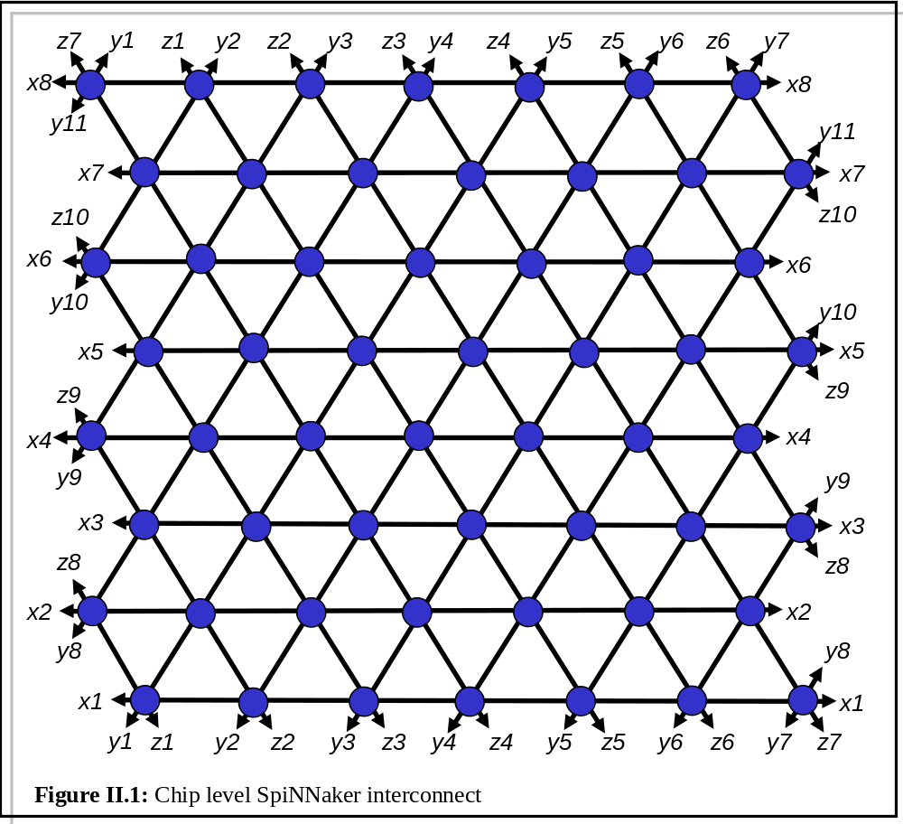An alternative way of looking at this is shown in figure II.2. There is no material difference in these representations; it's just that the latter figure is easier to draw. Both have the same degenerate three-axis non-orthogonal two-dimensional coordinate system.
Note the typo in figure II.2 (copied from datasheet): middle node, top row should be (1,2)

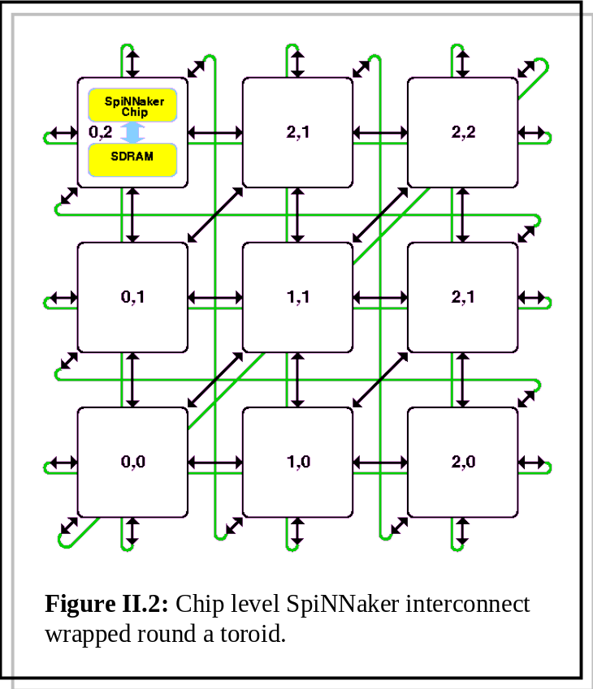
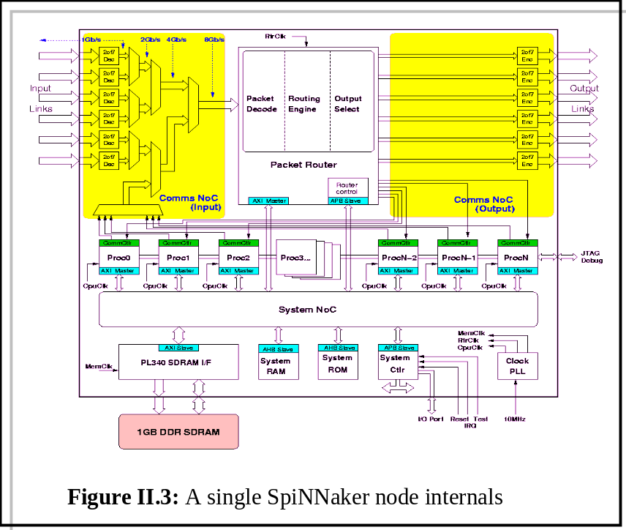The internal structure of the SpiNNaker node is outlined in figure II.3; (many) further levels of description are in the hardware data sheet [3].

This section is concerned with

● Describing the structure of the detailed data structures that reside in
○ The Fascicle Processor local memory
○ The node SDRAM
○ The node routing tables

● The low level design flow that bridges the conceptual gap between the neural structural description ('circuit diagram') and the binary patterns that occupy these structures.

In other words, firstly we describe what the binary patterns mean, then we describe how we get them.

2. Packets

Packets come in three types (0,1, and 2). The detailed internal structure is defined in the SpiNNaker datasheet; the segments of interest to the software developer are outlined here.

2.1 The naming hierarchy:

A billion neurones require a 30 bit identifier. For pragmatic reasons, we use 32 bits, which gives us four billion. Neurones are collected together into fascicles, fascicles are hosted by Fascicle Processors. The constraints of the identifier bit width require that neurone, fascicle and chip identifiers are not arbitrary, irrespective of whatever generated the original netlist. Neurones will be relabelled as processing progresses to conform to the bit layout in figure II.4. Within a fascicle, neurones are (re)labelled contiguously from 0 upwards. This is a hard constraint, dictated by packing efficiency concerns. Within a chip, fascicles are also numbered contiguously from 0: this is a whim, and may be overturned arbitrarily.

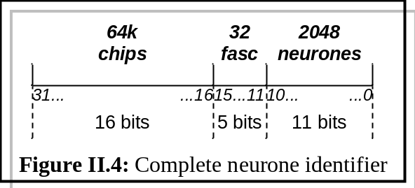
This labelling scheme places limits on the initial implementation: We can have no more than 64k chips, each containing a maximum of 32 fascicles (mapped onto the 19 Fascicle Processors), each fascicle containing no more than 2048 neurones. (In principle, we can trade-off neurone and fascicle identifier bit widths; for the initial implementation, these nibble sizes should be regarded as fixed constants.)

2.2 Neural event multicast (type 0) packets

This is the model of the neural spike; see figure II.5. It consists of a 32-bit source address (as in figure II.4), 8 bits of control, and an optional 32 bits of payload, which will not usually be present in neural simulations (except for debug and monitoring).
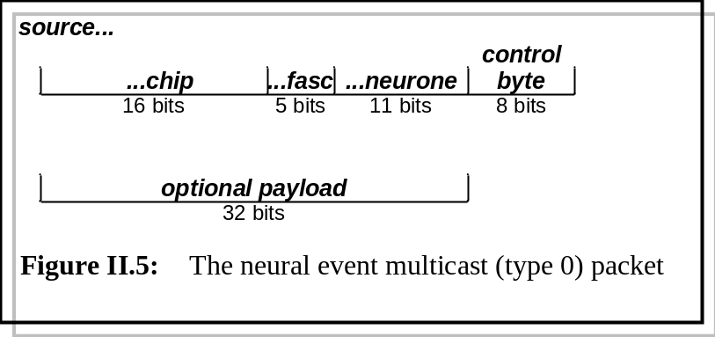

The packet may be duplicated and sent to multiple destinations by the hardware routing tables; there is no way (or need) to detect this in software.

This packet type is delivered to the target Fascicle Processor. It is the only packet type that is delivered to the Fascicle Processor. On arrival, it causes a hardware interrupt, and the 'arriving neural-event' handler is executed. The internal structure (data) of the packet that caused the interrupt handler to execute may be obtained within the handler by interrogating some fixed location in the local data memory map; the data must be there and valid otherwise the event handler would not have been launched. A relevant code fragment might look like:
const uint32 * pInKey = 0xaaaaaaaa;
const uchar8 * pInControl = 0xbbbbbbbb;
const uint32 * pInPayload = 0xcccccccc;
.
.
uint32 key = *pInKey;
uchar8 control = *pInControl;
uint32 payload = *pInPayload;
.
. // Do source-dependent stuff with packet
.

Packet type 0 is also the only packet type that may be launched from a Fascicle Processor. [SBF: uhh.. How can you make this stick? All the ARMS are identical....?]

Relevant code details are the addresses in the memory map, the 'launch' command, and a function that returns true if the packet has been sent. (This latter allows sending blocking/non-blocking behaviour to be emulated.)
const uint32 * pOutKey = 0xdddddddd;
const uint32 * pOutPayload = 0xeeeeeeee;
.
.
*pOutKey = myAddress;
*pOutPayload = LoadsaStuff;
.
SendPacket(); // Request launch
.
while (!HasItGone()); // Wait for it
.
.
The hardware will write the necessary control byte; it is not programmer-accessible. [SBF: Confirm/correct/comment - on all of the above]

2.3 Point-to-point (type 1) packets

This is a command/control packet; see figure II.6. It consists of a 16-bit source chip address, a 16-bit target chip address, 8 bits of control, and an optional 32 bits of payload. It is launched only by the Monitor Processor on the source chip (of which there can be only one), and will be delivered to the Monitor Processor on the target chip (of which there can only be one).

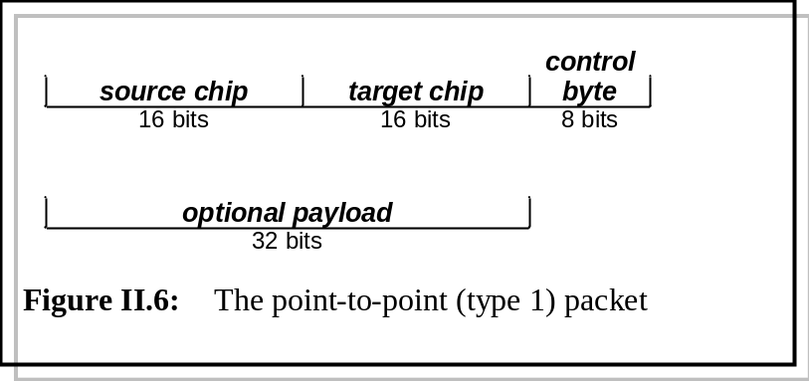
The progress of type 1 packets through the SpiNNaker fabric is entirely controlled by hardware. No entries are required in the routing tables. [SBF: Confirm/correct/comment. Is the Monitor code interrupt driven? If not, how does a Monitor know it's got a packet waiting? How does it send a packet? I assume the programmer can read the control byte but never sets it? There are a host of details needed here....]

2.4 Nearest neighbour (type 2) packets

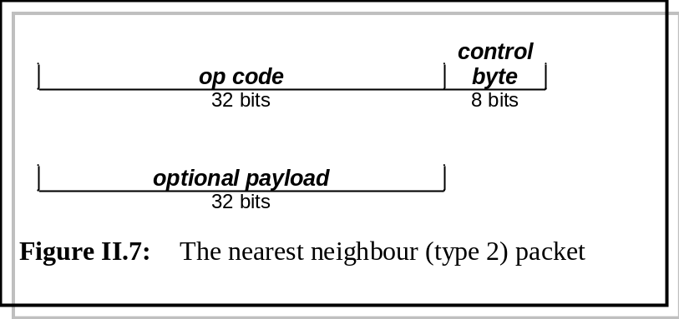This is a command/control packet; see figure II.7. It consists of a 32-bit op code, 8 bits of control, and an optional 32 bits of payload. And here I get confused. I thought it was a (Monitor Processor)-to-(Monitor Processor) packet, but the Datasheet (8.3->route) says "...They enable a packet to be directed to a particular neighbour (0-5), to all neighbours (6) or to the local Monitor Processor (7)..." which implies it can come from a Fascicle Processor, 'cos there's no-where else that would want to send a packet to the local monitor. Help?
What controls the movement of the packet? Hardware? (i.e. do I care?) Again, how does a Monitor know it's got a packet waiting? How does it send a packet? I assume the programmer can read the control byte but never sets it? Aargh....]

3. The SDRAM structure

In principle, the neural circuitry SpiNNaker is designed to simulate can have any arbitrary topology. However, the sheer size of the target systems require that certain assumptions are made - purely on the grounds of efficiency - about the statistics of the connectivity. This does not impose any restrictions on the input topology - arbitrary connectivity can be modelled; it is simply the case that, as a consequence of the design decisions, if the statistical assumptions made about the model hold, then the simulation will be more efficient, both in terms of packing and simulation speed.

(In fact, at a sharper level of focus, we note that the system is free-running and unsynchronised, so the departures from the statistical ideal may have second-order effects on the simulation results, because the neurone-to-processor mapping will effect the real-time interconnect delay slightly. Since real time is a constraint that must be satisfied for the above reasons, in practice an inefficient topology will have to result in fewer neurones/synapses being modelled per processor and/or ‘real time’ being scaled to 2x slower, for example. (These effects need to be investigated and qualified.)

3.1 A simple circuit

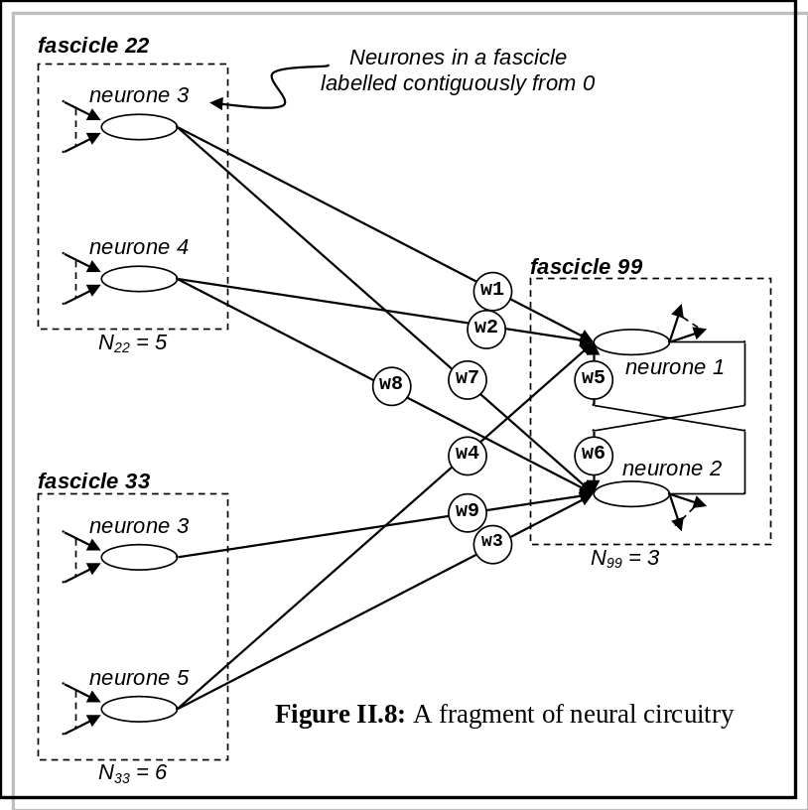Consider the fragment of neural circuit in figure II.8. Six neurones, mapped onto three fascicle processors, synapse weights as shown (w1..w9). The neurones on each fascicle are labelled contiguously from 0 to N_{f}-1; N_{f} may be different for each fascicle. (How these labels are derived is discussed later.) The corresponding data structure (which resides partly in the Fascicle Processor local memory and partly in the SDRAM is shown in figure II.9. Without loss of generality, assume they're all on the same chip for now.
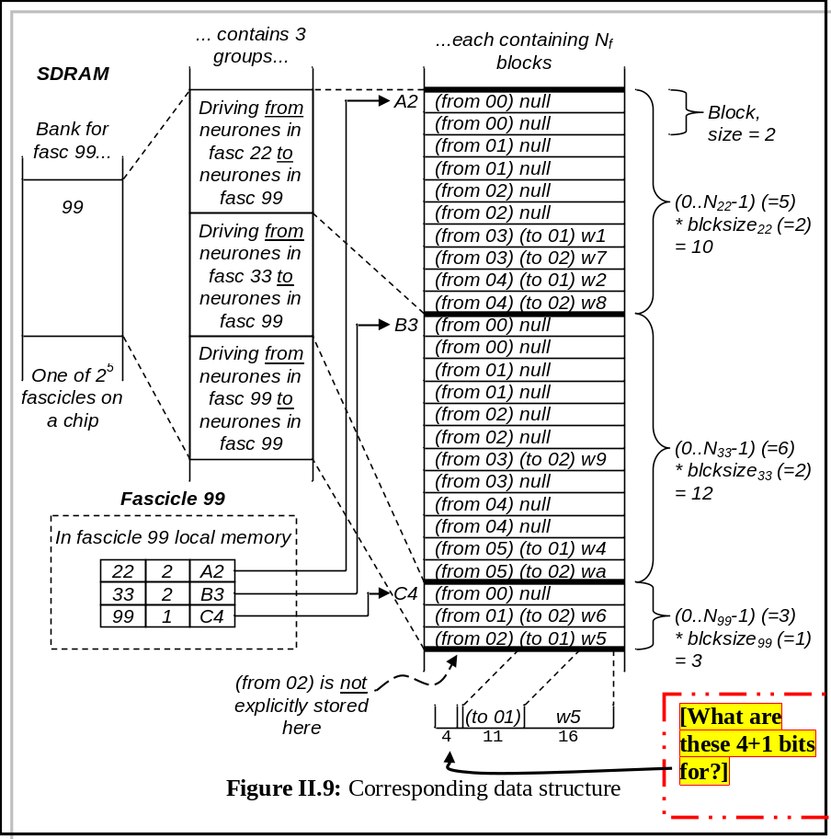

Let's say neurone 4, fascicle 22 fires. The event packet that is delivered is thus |(x*17)_{:17}|22_{:5}|4_{:10}|. (In other words, 17 bits-worth of chip identification - here we don't care, a 5 bit nibble containing decimal 22 and a 10 bit nibble containing decimal 4. By some magic we won't go into here, this event is delivered to fascicle 99. Fascicle 99 trawls through its local table and gets the row corresponding to SDRAM absolute address A2 - see figure II.10.

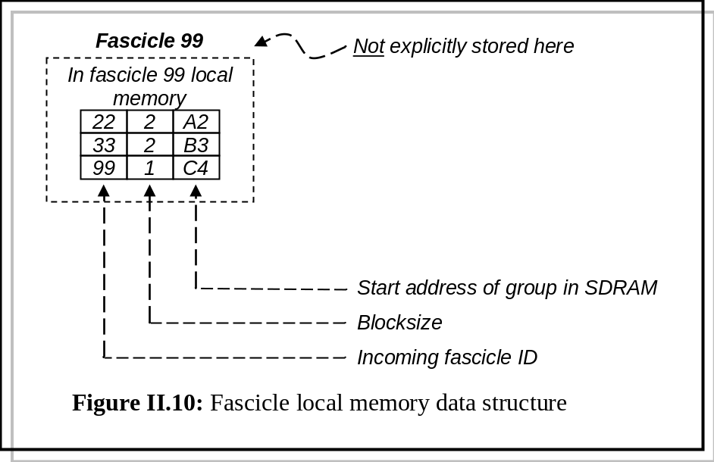
The synapse data relevant to the incoming event are stored in SDRAM addresses A2+(source neurone*blocksize) to A2+((source neurone+1)*blocksize)-1.

This needs to be copied to the Fascicle Processor local memory; the incoming key is a 32-bit packet (see figure II.4), and we want to search on the source fascicle ID (bits 11.15), so we need to mask out bits 0..10 and 16..21. This can be achieved with a bitmask:
key &= 0x0000f800 [check]

If, at a later date, we decide to exploit the flexibility of the nibble boundaries, the mask will become a variable and will need to be stored somewhere.

3.2 Mapping the neurones to fascicles

The connectivity of figure II.8 could be expressed in a sparse matrix form (figure II.11). Note this matrix is never actually explicitly instantiated anywhere; it is just an abstraction to help thinking.

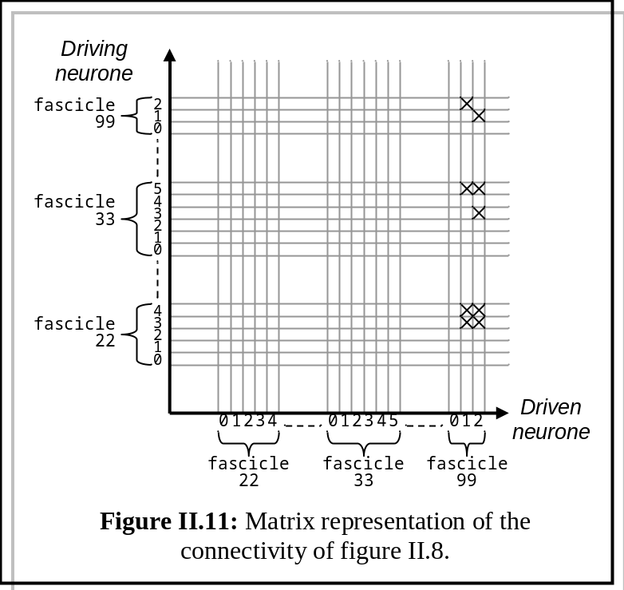
X indicates a driving connection (a synapse). This particular example is atypical and uninteresting, because

a) It is tiny (in terms of total neurone count).
b) It is sparse (in terms of total synapse count).
c) The axis calibration presumes a neurone-to-fascicle mapping that has already been determined (here for the sake of drawing a picture).

Some numbers just to indicate we're still in the Land of Feasibility:

● Single SpiNNaker chip:
20 Fascicle Processors
1 fascicle / Fascicle Processor
1000 neurones / fascicle
1000 synapses / neurone
Matrix will be 2.10⁴ x 2.10⁴
1000 synapses / neurone =>
Matrix density 10³.2.10⁴/(2.10⁴)² = 2%

● Brain
10¹¹ neurones
Matrix will be 10¹¹ x 10¹¹
10¹⁵ synapses
Matrix density = 10⁻⁵%

Bottom line: very big, very sparse, just about tractable.

The mapping problem becomes the identification of a set of rectangles that cover all the non-empty elements of the matrix. These rectangles will be

● Square on the diagonal (because fascicle in == fascicle out).
● Non-overlapping (obviously).
● Contiguous (i.e. abutting): non-abutting covers imply neurones with no inputs or no outputs.

And should be

● As dense and large as possible, subject to encapsulating < 10⁶ matrix elements: (10³ neurones x 10³ synapses) because of the physical limitations of the SDRAM.
● Mainly symmetric about the leading diagonal: Neurone IDs start from 0 in a fascicle, so blank upper sections (of any size) of a group need not be stored in the SDRAM

Note that the ordering of the matrix rows and columns is arbitrary. Rows and columns can be re-arranged (interchanged) at will to make the occupation density of the rectangular covers as high as possible (but the re-arrangement must be the same for the abscissa and ordinate, because of the neurone re-labelling).

Note it is only after the mapping of neurones to fascicles is complete that the neurone IDs (re-labelling) can be determined.

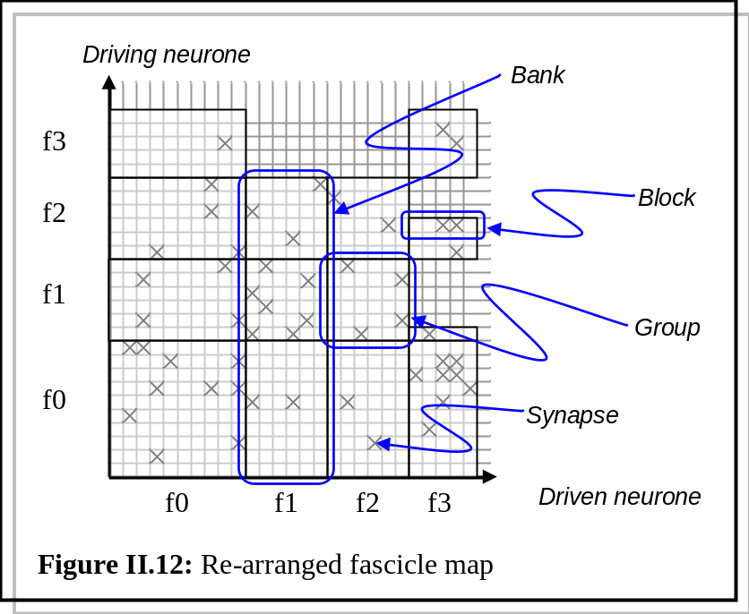Once the fascicle sizes are determined you can then draw complete horizontal and vertical lines at fascicle boundaries, and these define the covering rectangles. It is possible to send incomplete driving fascicles into a driven fascicle, as illustrated for f2-> f3 and f1-> f3 in figure II.12, though this may not often be useful in real networks. The driven fascicle must always accept all of the inputs for its neurones, so similar horizontal splits are not allowed. However, this 'compressed row representation' covers this fairly well, so here f2->f0 can have blocksize=2 and f0->f0 can have blocksize 3 (count the maximum number of crosses on any row in the rectangle).
Note that the synapse per processor constraint says that the total number of crosses in the matrix above any fascicle number must be <= a million. Hence a fascicle with around 10,000 inputs per neurone will include 100 neurones, and where this connects to a fascicle with around 1,000 inputs per neurone this will give a 100 x 1,000 rectangle (and 1,000 x 100, vice versa).

This example looks pretty inefficient. Despite row compression, f3->f0 [Typo - now fixed, I think - in original?] uses 5 words of synapse data to store 1 synapse (blocksize=1); f2->f0 uses 12 words of data to store 4; f1-> f0 uses 12 for 4 too; f0->f0 uses 30 for 10. Is this making sense? However the inefficiency is at least in part down to the statistics of small numbers – I believe (hope?) that larger, biologically-realistic networks will be much less inefficient.

Postponing briefly the discussion about how we move the rows and columns, the goal of the process is to get the number of synapses/block to be approximately the same.

● The storage space required in the SDRAM for a group is
(maximum number of synapses in a block) * number of blocks in the group.

● The wasted space / block is
(maximum number of synapses/block in that group) - number of synapses in that block

We end up with a structure looking something like figure II.12. Note the elegant mapping of the matrix onto the SDRAM layout of figure II.9.

3.3 Hierarchical description

Looking to the future, when we start playing with seriously large circuits, these will inevitably be hierarchically defined. Aside from just bashing them flat in pre-processor land - which will be challenging, given the sheer size - is there a sneaky way forward? This is a problem for the future.

3.4 The algorithm

(Inspired - loosely - by the min-cut partitioning algorithm described in [4]). [Please think about this - don't glaze over. The Mincut algorithm is well-established, has been studied to death and I have coded it up in a past life but the nature of the penalty function d() here is different. Traditionally, d() is simply the number of interconnects that cross a subgraph partition (i.e. cutline), and what you're trying to do is minimise this number, making the number of interconnects crossing the partition as low as possible. Here it is radically changed. The point is that it will take a lot of coding to get to the point of working out where the fundamental show-stopping flaw in the logic is, and I'd like the thing subjected to reasonable scrutiny before I invest this effort.]

Inputs: 1) The entire circuit, described as a devices-on-devices graph.
2) SDRAM size.
3) A number of heuristic fiddle factors (HFFn).

Outputs: 1) The SDRAM contents

1. The input graph G is bisected randomly (in terms of synapse count) into two subgraphs, A and B. (These are potential fascicles - we note that, in general, each will be far too big to fit into a single SDRAM, certainly for the first few recursion levels of the algorithm).

2. Define some size limit, h = 0.5 * number of synapses in G * HFF1.
(HFF1 is typically around 1.1).

3. label:
Find the neurone (an A or B) that (a) is unflagged, and (b) that would make the biggest improvement (which may, actually, be the smallest degradation) to the penalty function d() if it were to be moved to the opposite subgraph.
If Δd() is an improvement, and does not violate the fascicle size limit h, then {move it and flag it, goto label}
// Only here if the best Δd() is actually a degradation
If it was the first attempt (i.e. no neurones are flagged) then stop
Clear flags
Goto label

[I've got a better pseudocode version in my notes in Southampton, but they're (a) on paper, and (b) not here....]

4. Recursively apply step 3, replacing G with A and B at each level. The size of G will (approximately) halve at each recursion level; a recursive branch can terminate when h < SDRAM size (i.e. we have created a fascicle that will fit into a node SDRAM).

The core of the algorithm is expressed in figure II.13, which shows the behaviour of the loop of step 3. Note that the curve shown is idealised; in practice, it need not be as smooth as is shown, and you sometimes continue the iteration past the 'peak' shown , in case the noise gives us a better maximum.
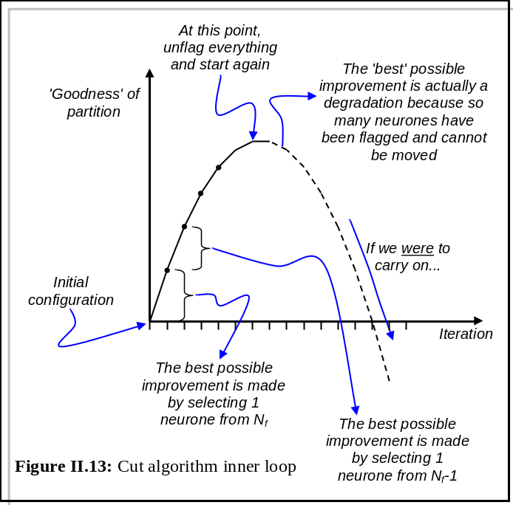
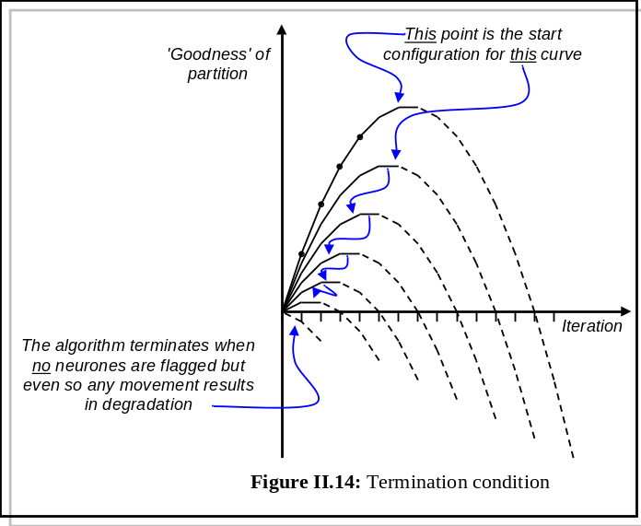This is a constrained optimisation problem; we need some notion of a penalty function, to give us a 'slope' in fascicle space that we can move down. Let's have a play:
Figure II.15 represents a fragment of neural circuitry, partitioned into two subgraphs A {1,2,3} and B {4..7}, which represent the 'starting' fascicles. Referring to figure II.16, we compute the blocksize, wasted space in group, average occupancy/group and standard deviation of occupancy in each group:

 | AA | AB | BA | BB
Blocksize (B) | 2 | 2 | 0 | 3
Waste (w₀) | 1+1+0 = 2 | 0+1+1 = 2 | 0 | 2+1+2+0 = 5
Average occupancy (f^) | 4/3 = 1.33 | 4/3 = 1.33 | 0 | 7/4 = 1.75
Std deviation (σ₀²) | .33²+.33²+.67²  = .67 | .67²+.33²+.33²  = .67 | 0 | .75²+.25²+.75²+1.25²  = 2.75

The total wasted space (Σw₀) = 2+2+0+5 = 9
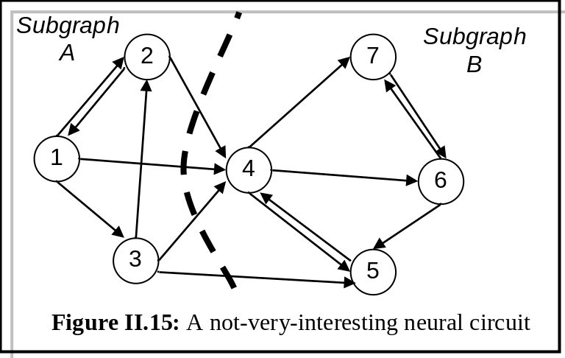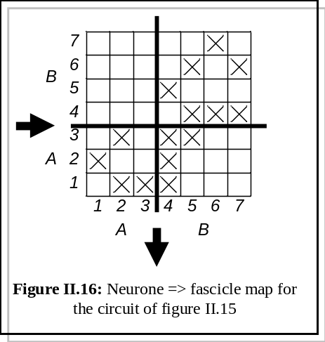The total standard deviation (Σσ₀²) = 0.67+0.67+0+2.75 = 4.09

Figure II.17 shows the effect on the neurone-to-fascicle map of moving each neurone to the opposite subgraph (A->B or B->A).

To keep life simple, throughout this section we'll ignore the possibility of placing partial fascicles in the SDRAM.
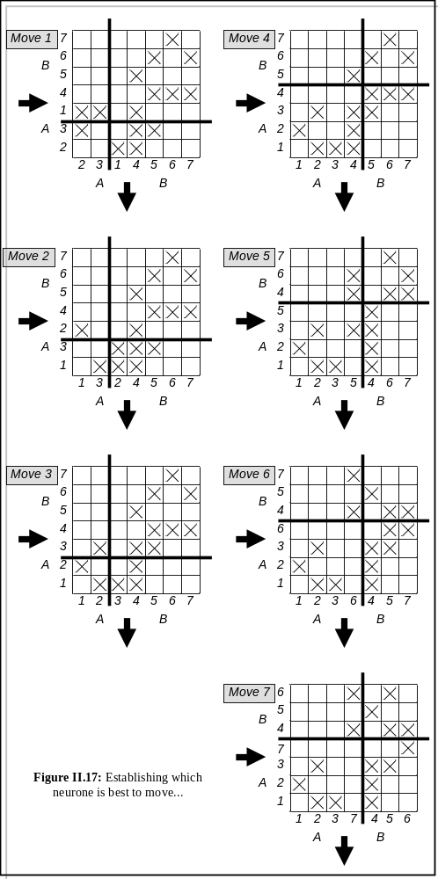
On the nature of d() - (1)

Maybe we can take the total wasted space as a driving function:

Move: | 1 | 2 | 3 | 4 | 5 | 6 | 7
B_{AA} | 1 | 1 | 1 | 3 | 2 | 2 | 2
w_{AA} | 1 | 1 | 0 | 5 | 3 | 4 | 4
B_{AB} | 2 | 3 | 2 | 3 | 1 | 2 | 2
w_{AB} | 0 | 1 | 1 | 8 | 0 | 2 | 3
B_{BA} | 2 | 1 | 1 | 16 | 1 | 3 | 1
w_{BA} | 8 | 4 | 4 | 2 | 1 | 6 | 1
B_{BB} | 3 | 3 | 3 | 2 | 2 | 2 | 2
w_{BB} | 7 | 6 | 6 | 3 | 2 | 3 | 2
Σw | 16 | 12 | 11 | 18 | 6 | 10 | 10
Σw₀ | 9 | 9 | 9 | 9 | 9 | 9 | 9
Σw-Σw₀ | +7 | +3 | +2 | +9 | -3 | +1 | +1

The table (derived from figure II.17) shows how the wasted space changes for whichever of the seven candidates neurones we choose to move. The only candidate here to reduce the space is neurone 5.

On the nature of d() - (2)

Let's see what happens if we use the total standard deviation of wasted space:

Move: | 1 | 2 | 3 | 4 | 5 | 6 | 7
f^_{AA} | 0.05 | 0.50 | 1.00 | 1.75 | 0.67 | 0.67 | 0.67
σ²_{AA} | 0.50 | 0.50 | 0.00 | 4.75 | 4.44 | 2.44 | 2.44
f^_{AB} | 2.00 | 2.50 | 1.50 | 1.00 | 1.00 | 1.50 | 1.25
σ²_{AB} | 0.00 | 0.13 | 0.13 | 6.00 | 0.00 | 1.00 | 0.75
f^_{BA} | 0.40 | 0.20 | 0.20 | 0.33 | 0.67 | 0.67 | 0.67
σ²_{BA} | 3.20 | 0.80 | 0.80 | 0.67 | 1.00 | 1.00 | 1.00
f^_{BB} | 1.60 | 1.60 | 1.80 | 1.00 | 1.33 | 1.00 | 1.33
σ²_{BB} | 3.20 | 3.20 | 2.80 | 2.00 | 0.67 | 2.00 | 0.67
Σσ² | 6.90 | 4.63 | 3.73 | 13.42 | 6.11 | 6.44 | 4.86

Hmm. This would have us choose neurone 3, but if we clamp HFF1 to 1.0, we effectively limit the choice to {4..7}, so we get neurone 7.

This is why I hate heuristics.

But this is trivial example, and it's the final solution we want, not the iteration trajectory, and I'm certainly not doing that by hand.

4. The Fascicle Processor local memory structure

Part of the local memory is given over to the state of each neurone; this is not discussed here.

4.1 Binary trees

The binary tree of figure II.18a (which was dreamed up randomly) can be represented as a linear structure as in figure II.19. Left children are implicit, right are explicit.
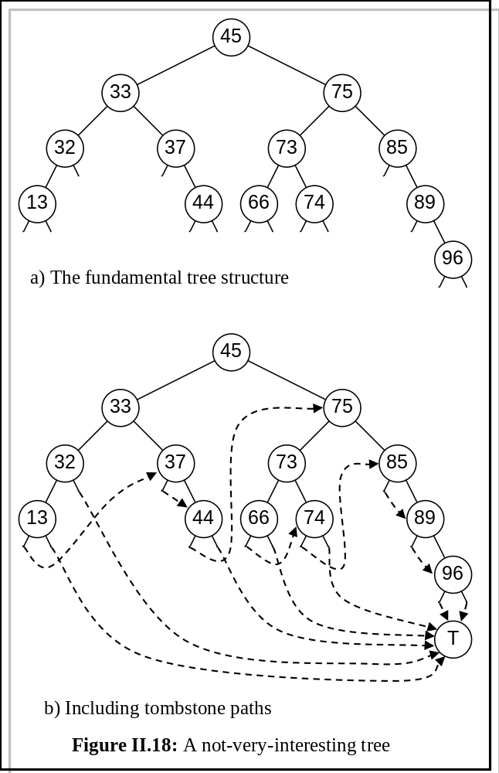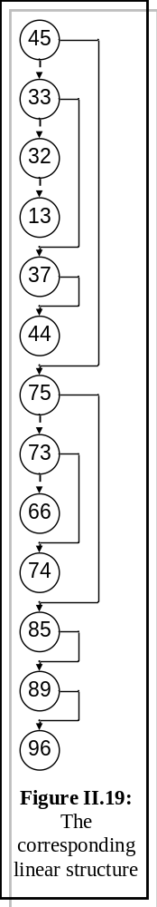

Searching the structure is safe if you know that what you're looking for is there. The structure can be made completely tolerant of a failed search by the addition of just one explicit tombstone: referring to figure II.19, allowing a failed left child search to drop through to the next record in the linear sequence, and tombstoning the failed right child searches, give the failure paths shown in figure II.19b - note that all the paths are non-cyclic and therefore everything will ultimately arrive at T. In view of the potential for difficulties from the routing tables, this is a wise thing to do (with very little cost).

4.2 Local data structures

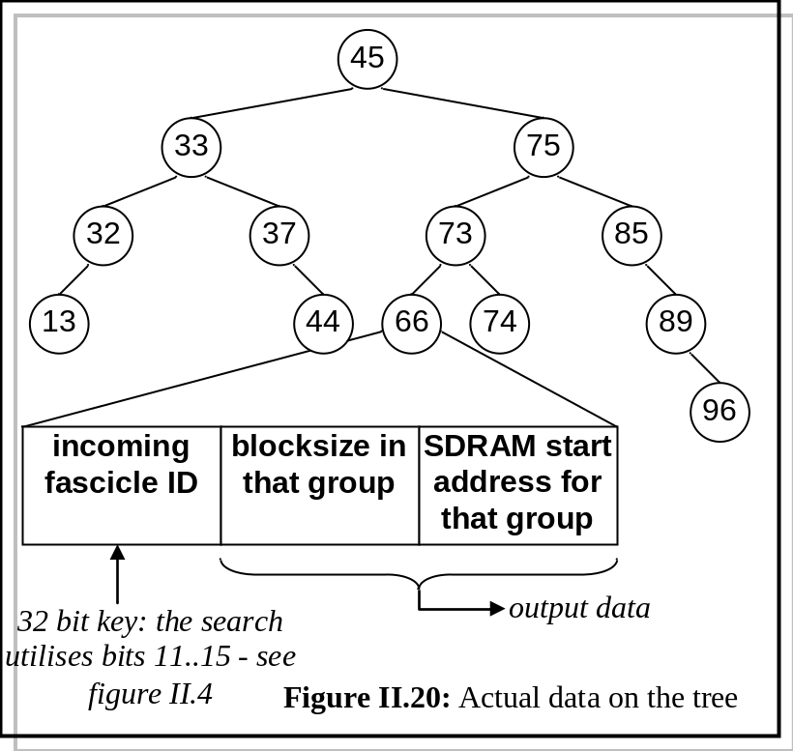

5. The routing tables

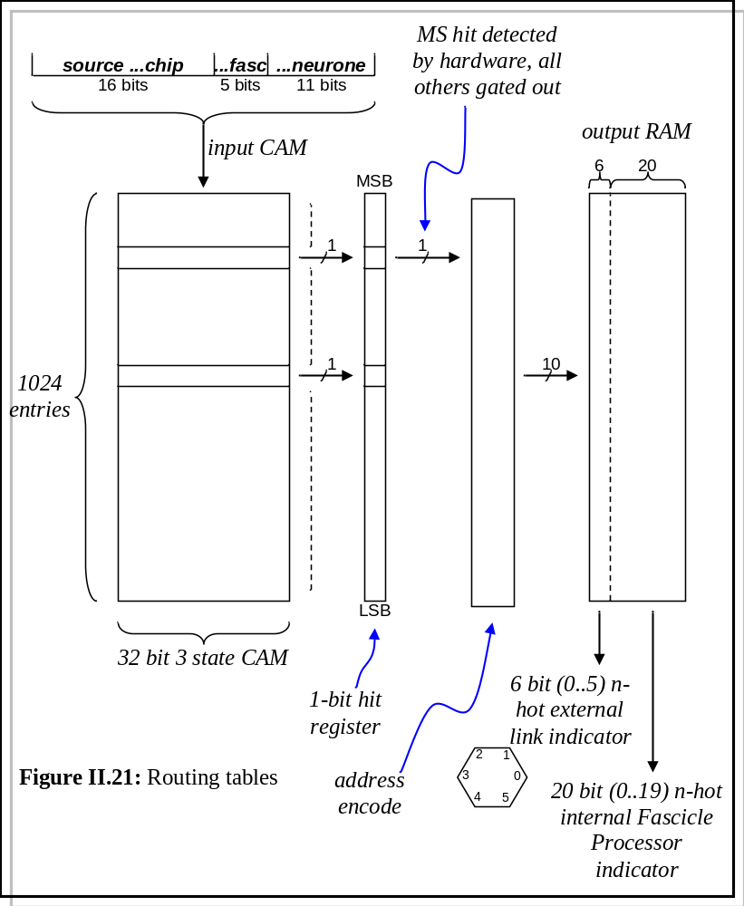The organisation of the neural (type 0) packet router is shown in figure II.21. Note packets of types 1 and 2 do not pass through this; they are handled by the hardware elsewhere, and are not of concern here.

The 32-bit source key is input to a 1024 x 32 bit tristate CAM. (The realisation details of this are described later.) As it is a tristate (0, 1, X) CAM, in general, multiple hits will be both possible and common. These hits are written to a 1024 x 1 bit hit register. All but the most significant single bit in this register are discarded, and this single remaining bit treated as a 1024 bit 1-hot and passed into an address encoder. This generates a 10 bit binary equivalent, which drives a 1024 x 26 bit lookup RAM (It's a RAM, not a ROM, because the ultimate intention is to be able to change it on the fly. Oh, look, there goes another flying mammal of artiodactyl ungulate persuasion.) The 26 bit word so generated consists of a 6-bit nibble and a 20-bit nibble. The 6-bit nibble represents an n-hot external link indicator (0-5) to which the packet is forwarded (for example 010110 would cause the packet to be routed to external links 1, 2 and 4). The 20-bit nibble represents an n-hot internal Fascicle Processor address (0-19) to which the packet will be forwarded, triggering an interrupt as it arrives. (For example, 00001000100100000000 will cause packets to go to Fascicle Processors 8, 11 and 15 on the current chip. It is easy to see how packets may be duplicated by this mechanism.

The 1024 x 32 bit tristate CAM is implemented as a 1024 x 32 bit binary CAM and a 1024 x 32 bit binary RAM, as depicted in figure II.22. The RAM simply holds a bit mask indicating the position of the "don't cares" in the CAM. The corresponding bits in the CAM (labelled '?' in the figure) will actually be '0' or '1', but will never be read.
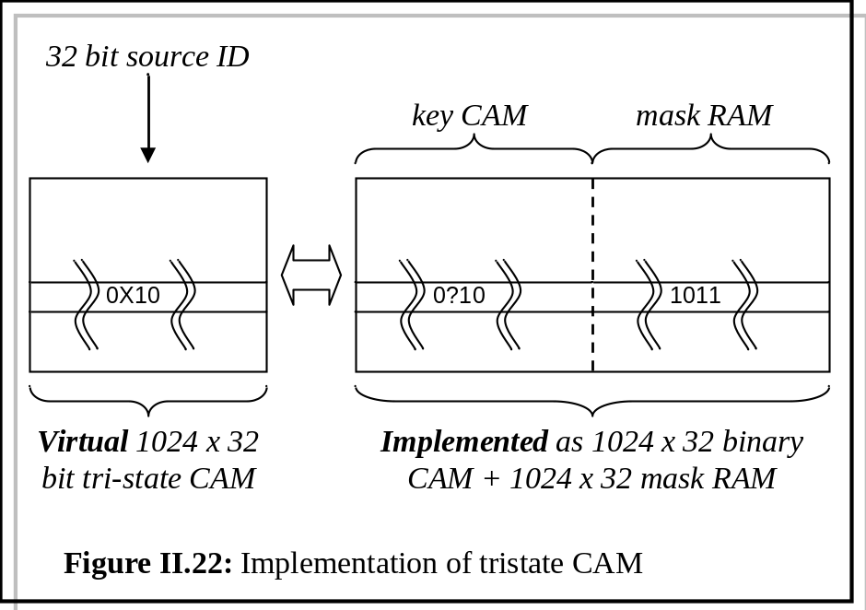
It is the responsibility of the APR software to generate the contents of the input CAM and output RAM from the neural netlist.

Here endeth the gospel according to St Lester and St Plana. I had to go and have a long lie-down after all this.

And then I got confused again. Referring to figure II.21, we get multiple hits out of the CAM, all bar one of which we throw away. The surviving bit is treated as a 1-hot row select, and encoded into a 10-bit bus, which enters a RAM where it is immediately decoded back into a 1-hot row select. Uhh... why?

And then I got even more confused: why chuck away all bar one CAM hit? Why not just feed them all into the output RAM and OR the results? Pretty much half of figure II.21 will reduce to a single plane of pull-down transistors?.

6. The neurone model

NMP - for the sake of completeness, I guess - although there is no urgency at the moment - we ought to fill this in......

7. The plasticity model

NMP, but I perceive that (a) this needs doing, and (b) no-one is doing it....
8. Automatic place and route (APR)

The overall structure is fairly conservative, and outlined in figure II.23. It is a heuristic; the size of the datasets makes iteration a very expensive operation, and so the design intention is that a neural circuit will pass through the design flow only once. Feedback of any kind is to be avoided, but if this is not possible, the feedback loops have been arranged in order of computational expense:

fb1: Should never be necessary anyway.
fb2: Is cheap and may never even be necessary - see later notes
fb3: Is cheap, but the usefulness is dubious
fb4: The Loop of Last Resort: expensive, but allows the system to expand onto unused SpiNNaker chip sites if any exist.
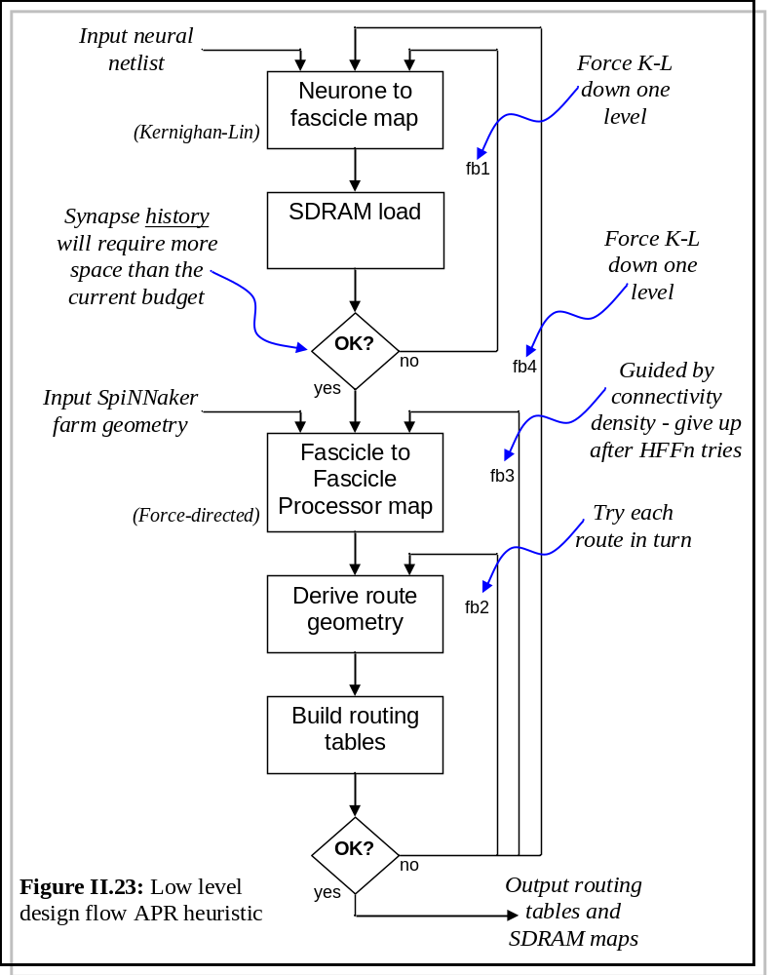
8.1 Neurone to fascicle map

This algorithm is described in sections II.3 and II.4. As the core algorithm applies a recursive bisection to the neural graph, and doesn't terminate until the fascicle maps are all small enough to fit into the SDRAM, it is hard to see how the first feedback loop should ever be necessary or executed.

8.2 Fascicle to Fascicle Processor map

Covered in the talk of 21/11/7; it is uncontentious (I think) and I want to get feedback on the difficult bits (i.e. the stuff here) asap. I'll write it up later or on demand.

8.3 The router

The goal of the router is to map the neural pathways required by the neural circuit onto the network of SpiNNaker chips. Prima facie a trivial problem, the constraint is the finite size of the routing tables (section II.5). Packets, once launched, will propagate in a straight line forever (unless killed by hardware-administered old age) until some Fascicle Processor claims them. The 'straight through' option is the default behaviour of the on-chip router and requires no entry into the routing table. Only turns, bifurcations and 'this is for me' entries require table space.

I don't exactly understand what Expresso is being asked to do here. I thought I did, but now I've thought about it, and now I think I don't. A discussion we haven't had (or if it's been had, I haven't been part of it) concerns the geometry of the chip farm?

If a source and target Fascicle Processor are collinear on whatever axis, the routing table will have one less entry. Mapping the chip farm onto a 2D toroidal surface, and using six links (i.e. a degenerate 2D coordinate system) means that collinearity can be achieved in a variety of ways - sometimes even simultaneously on two or three axes.
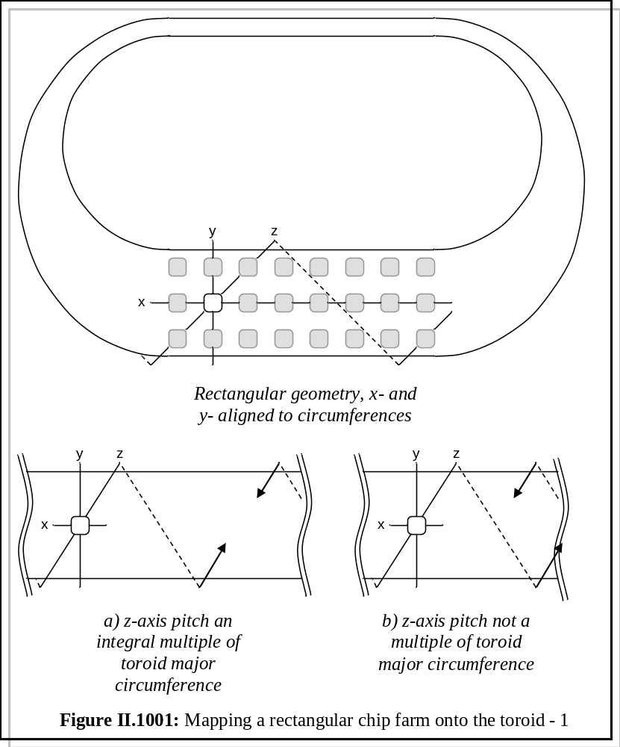Figure II.1001 shows a SpiNNaker farm mapped onto a toroidal surface, with the z-axis set at a pitch of 45 degrees. (Other arbitrary pitches are, of course, possible). The relative lengths of the x and y axes depend upon the aspect ratio of the toroid, and can be changed at will. Also, changing this ratio will alter the fraction of nodes the z-axis passes through (compare figures II.1001a and II.1001b).

Figure II.1002 depicts a different arrangement: z is now the shortest axis, and x and y are of equal length.

Figure II.1003 uses a hexagonal physical farm, with two possible orientations of chip mesh. Other permutations are, of course, possible.

Now, has this decision been taken / discussed / ignored? I can try to accommodate geometry as a variable in the router system, but it'll add complexity, and if it isn't necessary, I don't want t o burn the effort.....

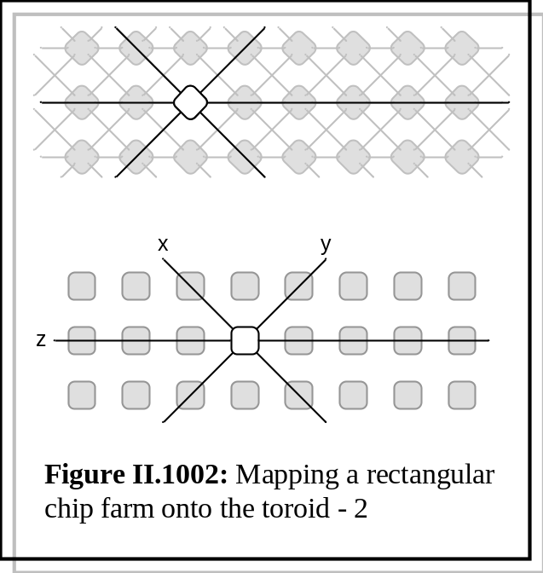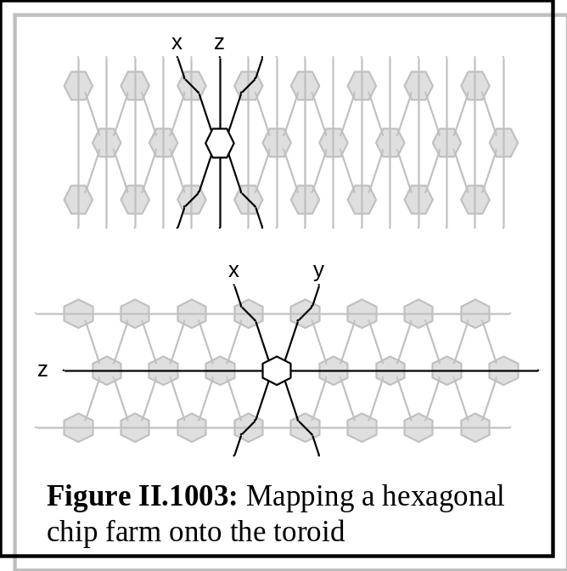

9. The Universal Interface Format (UIF)

The Universal Interface Format is nothing more than a very simply syntax I've been using in various forms for years. The original concept came from writing an object to encapsulate a u$soft .INI file. Everyone has one, but they're never quite what you want.... Rather than view the code as a parser for an .INI file, the mindset is that the file is simply the persistent form of the object. If you want to access the object, you do it through the encapsulating object methods, rather than fiddling with the file. Obviously, it has to be able to accept files from other sources, so it is effectively little more than a (very simple) parser with an easily burgleable datastructure.

With each project, the syntax has been extended, but it always stays backwards compatible with the u$oft .INI format.

It defines a syntax of symbols. It does not define any semantics - these are left to the user to decide upon and sort out. That's why it's so simple - it's just an ordered way of storing strings and symbols..

In the light of the last meeting, I've decided to extend it (once more). It seems to be morphing into a cross between XML, LISP and INI. Hey-ho. The following is written in as if it already takes this form; it's only vapour at the moment (but very easily and quickly condensed vapour).

9.1 UIF file structure

A .UIF file consists of an ordered set of optionally named sections.

Each section consists of a single section header, followed by an ordered set of records.

A section header is a comma* separated list of qualified names enclosed in square brackets.

Each record consists of an optional label field, followed by an optional variable field, followed by an optional value field, followed by an optional attribute list.

Each field consists of a comma∗ separated list of qualified names.

A qualified name consists of a qualified symbol, followed by parentheses containing a comma separated list of items, each of which can be a qualified symbol or a qualified name. (Spot the recursion - this is the new bit that pretty much allows synapse descriptions of arbitrary complexity.)

A qualified name is an optional operator followed by a string.

An operator (currently) is one of &, &&, =, @, ^, /, ==, >=, >, <=, |, <<, <, |\, |/, *, !=, ||, %, !, +, ?, >>, -, ~. Which is odd, because I was sure I'd put ++ and -- in there as well somewhere. A string is probably more than you'd expect - the idea is that the extraction of semantics is left to the user, so a string is pretty much anything that's not part of the UIF syntax. Specifically, UIF doesn't know about numeric literals, so 0.123e-88 is a string, and so is 0x.1_8e-8f. If you want spaces in it the whole thing must be enclosed in double quotes. If you want to turn a string into a value you have to do it yourself. This enables you to define hex, octal, binary, floating point (and so on) formats to suit. A handful of helper functions are provided.

An attribute list is a semicolon-separated list of attributes, enclosed in braces {}.

An attribute is an optional label field (see above), and optional variable field (see above) and an optional expression.

An expression is what you expect an expression to be (there is no operator precedence, because it's up to you the user to decide what the operators mean), and it understands parentheses, function calls and inline conditionals.

The language has no notion of numeric literals or keywords - the file is parsed and the symbols shoved into an easily-traversed datastructure. It is up to the user of the object to extract the symbols and strings and overlay what semantics they require onto the data.

A semicolon before the EOR allows the insertion of comments. These are stored as strings in the object.

A rudimentary filemap is provided, giving the originating file location (in terms of (row,column)) of every item in the datastructure, to allow for rudimentary error reporting.

Callback hooks are provided for records, sections and errors.

Error recovery is to reject the erroneous record/section header and skip to the next EOR. If you haven't provided an error callback you'll never know it's happened.

I have a vague idea that virtual records can extend beyond physical records by placing a '\' character as the last non-blank on a physical line, but it's been so long since I've used it the capability has probably decayed away by now. Software does that, I find...

It does other stuff too, but that's enough for now.

The bit of nonsense at the end is one of my test files.

Returning to neural netlists, we could have

["post fascicle map"] ; Mapping all done
fasc_1(7856) : N34 = N35(model1), N986(a(1),b(2),c(3)), N234(22)
fasc_2(7346) : N44 = N35(model1), N294(b(1),b(2),c(3)), N234(22)
fasc_1(1256) : N64 = N35(model1), N938(a(1),b(2),c(3)), N234(stuff)

[models] ; Parameter model library
model1: {a=1;b=45-tan(a);c=(a==1)?5!7}

{other_stuff=(2.0^_in) < _in ? (2.0^_in) ! (_out+lg2(_in)*lg2(_out))/2.0}
{f:3.4e-10}
{q=3.4e-10+3.2e-11}
{b(c)=cos(sin(a,b),3,tan(7))}
{x:y=-sin(cos(y))-*tan(+x)}
{q:h(k:y)=-(a)*(-b+--3)}
[section(tooth)] ; five,six*seven
[V,e,r,s,i,o,n,Info]
IncludeVerInfo=0

s{a:j=8;b=3*7-(7+sin(97)+(22/9-j+(y==7)?9!6)-tan(76+98/(8+9^cos(66.5)*y)))}
*a(+b:-2),f(:&k),-k2(uy:),SS(:),%jj:q(w:4),g(:c),*k3(3:),s3(:)=87,-9.2,1e4
{j=((9)+(-a--b))}
{k=p- - - - q}
{x=a+b/c}
d{k=(-8)}
{icky=(x)/(y^z)}
{thnoop=((a+b))/((c))}
d{k=((((((((9)-(-8))/(6^7))+(((-6)+a)*tt)-(p))+ooo)~5)*33.6)*77.3e5)-1}
{E=((1*h)-8)/(5~2)}
{Q=a+b/c}
{A=a}
{B=gg*jj/99|\543}
{C=-5* (-t)}
{D=(h*j)-(a/w)}

"gnome" ; heh heh heh
zblart ; "hah hah hah"

A(B:C):D(E:F)=G(H:I)
a(b:2),f(:k),-k2(uy:),SS(:),jj : q(w:4),g(:c),*k3(3:),s3(:) = 87,-99.2,1e4
l1 : dd = d87,23,-8 {h:hg=sdkj}
d{k=9}
;s{a:j=((((((6.5
[GonkGargler]
Item0="E:\Grants\Brobdingnagian\ZeDoiude;$(BCB)\include\vcl"
["HistoryLists\hlIncludePath"]
plop = 1.0.0.9

-k2 : *k3(3:),s3(:)
-l1 : dd = d87,23,-8 {h:hg=sdkj}
[section(the:wunth)] ; two,three,four

References and bibliography

[1] Neuroscience, ed. D. Purves et al (4th edition), Sinauer Associates 2008, ISBN 978-0-87893-697-7

[2] Elements of Molecular Neurobiology, C.U.M. Smith (3rd edition), Wiley 2002, ISBN 0-471-56038-3

[3] SpiNNaker datasheet

[4] K-L min-cut algorithm. Reference in Southampton somewhere.

 I might make this comma- or colon-separated, for the sake of backwards compatibility....

