**CONSULTAS A LA BASE DE DATOS DE UNA UNIVERSIDAD**

**2025-2 G01 Bases de Datos I 11:00**

**Parra Ochoa Alex**



**CONSULTA 1**

**π ID,name (student)**

**CONSULTA 2**

**π name,ID (σ tot_cred>59(student))**

**CONSULTA 3**

**π name, ID (σ dept_name = 'Comp. Sci.' ∧ tot_cred ≥ 50 ∧ tot_cred ≤ 100 (student))**

**CONSULTA 4**

**σ dept_name = 'Biology' (course)**

**CONSULTA 5**

**π course_id, title (σ credits = 4 (course))**

**CONSULTA 6**

**π course_id, title ( σ dept_name='Biology' ∨ dept_name='History' (course) )**

**CONSULTA 7**

**π dept_name ( σ credits=4 ∨ credits=3 (course) )**

**CONSULTA 8**

**π dept_name ( σ credits=4 (course) ) ∩ π dept_name ( σ credits=3 (course) )**

**CONSULTA 9**

**π name, course_id (instructor ⨝ instructor.ID = teaches.ID teaches)**

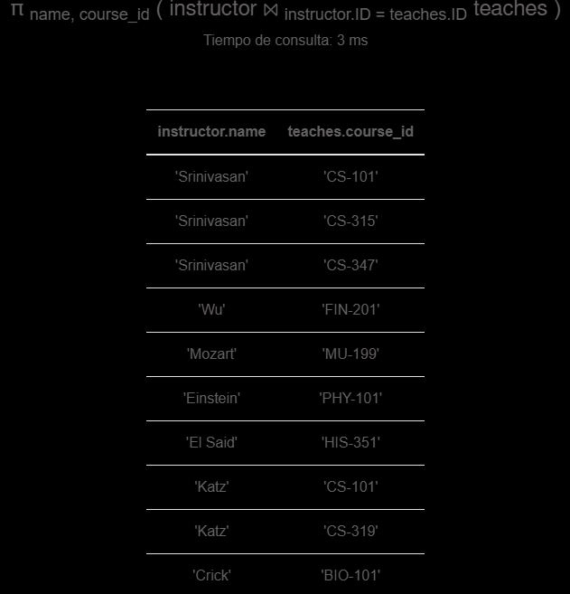

**CONSULTA 10**

**π name, course_id ( σ semester='Fall' ( instructor ⨝ instructor.ID = teaches.ID teaches ) )**

**CONSULTA 11**

**πsalary,name,course_id,title(σsalary<=80000∧section.semester='Summer'(instructor⨝course⨝section))**

**CONSULTA 13**

**πname,title,dept_name,year(σdept_name='Comp. Sci.'∧year=2009(student⨝course⨝section))**

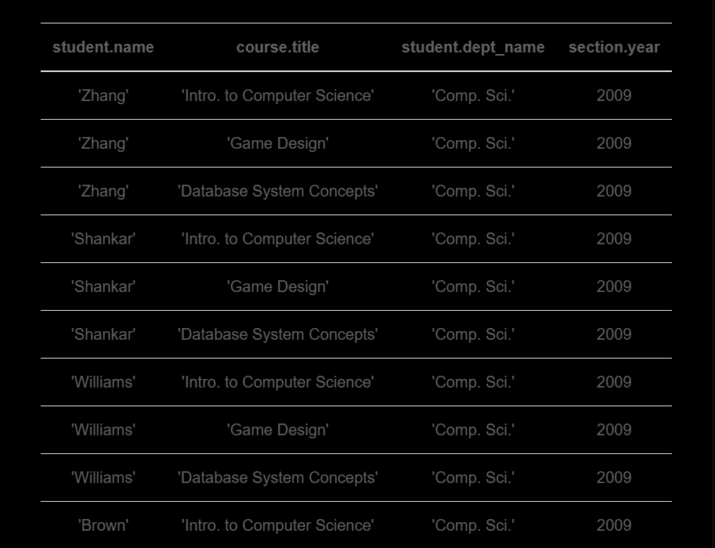  
**CONSULTA 14**

**π course.title, takes.grade (σ student.name='Chavez' ∧ grade<>'F' (student⨝takes⨝course))**

**CONSULTA 15**

**π course_id course - (π course_id prereq ∪ π prereq_id prereq)**

**CONSULTA 16**

**π name (student ⨝ ID = s_id advisor)**

**CONSULTA 17**

**π name (student) - π name (student ⨝ ID = s_id advisor)**

**CONSULTA 18**

**π name (σ dept_name = 'Biology' student ⨝ ID = s_id advisor)**

**CONSULTA 19**

**π building (σ dept_name = 'Biology' department)**

**CONSULTA 20**

**γ dept_name; COUNT(title)→course_count(course)**

**CONSULTA 21**

**γ dept_name; avg(num_courses) -> avg_num_courses (γ dept_name, year;** **count(course.course_id) -> num_courses (π course_id, dept_name (course) ⨝ π course_id,** **year (section)))**

**CONSULTA 22**

**π dept_name, budget (department) - pi d1.dept_name, d1.budget ( sigma d1.budget <** **d2.budget ( (rho d1 (department)) × (rho d2 (department)) ) )**

**CONSULTA 23**

**γ course_id; count(ID)→num_students (takes) -π t1.course_id, t1.num_students (  σ** **t1.num_students < t2.num_students ( ρ t1 (γ course_id; count(ID)→num_students (takes))  x ρ** **t2 (γ course_id; count(ID)→num_students (takes)))**

**CONSULTA 24**

**γ avg(salary)->avg_salary (instructor)**

**CONSULTA 25**

**σ instructor.salary > avg_sal (instructor x (γ avg(salary) → avg_sal (instructor)))**

