**CONSULTAS A LA BASE DE DATOS DE PIZZERIAS**

**2025-2 G01 Bases de Datos I 11:00**

**Parra Ochoa Alex**



**CONSULTA 1**

π name, age (Person)

**CONSULTA 2**

σ age ≥ 18 (Person)

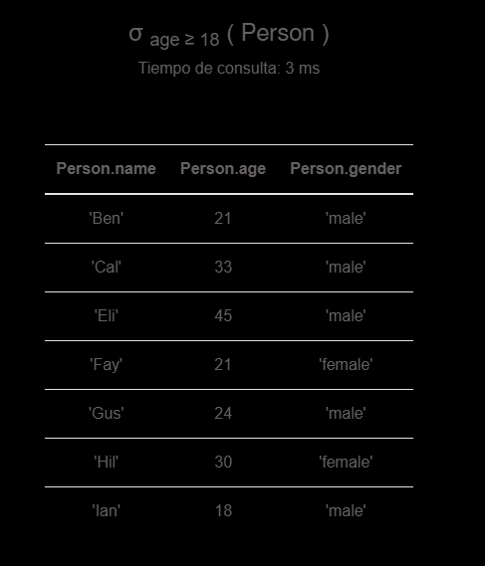

**CONSULTA 3**

π pizza (σ name = 'Gus' (Eats))

**CONSULTA 4**

 name, age (σ age ≤ 18(Person))

**CONSULTA 5**

π name, age(σ gender = ''female' and age ≥ 18 (Person))

**CONSULTA 6**

π pizzeria, price (σ pizza = 'pepperoni'(Serves))

**CONSULTA 7**

π pizza, pizzeria (σ pizza = 'pepperoni' ∨ pizza = 'supreme' Serves)

**CONSULTA 8**

π pizzeria (σ pizza = 'pepperoni' Serves) ∩ π pizzeria (σ pizza = 'supreme' Serves)

**CONSULTA 9**

π pizza, pizzeria (σ pizzeria = 'Pizza Hut' ∨ pizzeria = 'Little Caesars' Serves)

**CONSULTA 10**

**π pizza (σ pizzeria = 'Little Caesars' Serves) ∩ π pizza (σ pizzeria = 'Pizza Hut' Serves)**

**CONSULTA 11**

π pizza, pizzeria (σ pizzeria ≠ 'Pizza Hut' Serves)

**CONSULTA 12**

π pizza (σ pizzeria = 'Pizza Hut' Serves) - π pizza (σ pizzeria = 'Little Caesars' Serves)

**CONSULTA 13**

π name, pizzeria,pizza (Eats ⨝ Serves ⨝ Frequents)

**CONSULTA 14**

π Eats.name, Serves.pizzeria, Serves.pizza (σ (Eats.name = 'Amy' ∧ Eats.pizza = Serves.pizza)(Eats ⨯ Serves))

**CONSULTA 15**

πname,pizzeria,pizza(σpizzeria='Chicago Pizza'(Frequents⨝Eats))

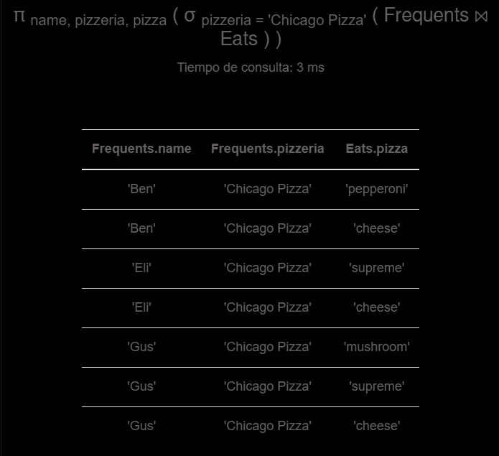

**CONSULTA 16**

(((π name, pizza (Eats)) ÷ (π pizza (σ pizzeria = 'Chicago Pizza' (Serves))))∩(π name (σ pizzeria = 'Chicago Pizza' (Frequents))))⨯(π pizzeria (σ pizzeria = 'Chicago Pizza' (Serves)))

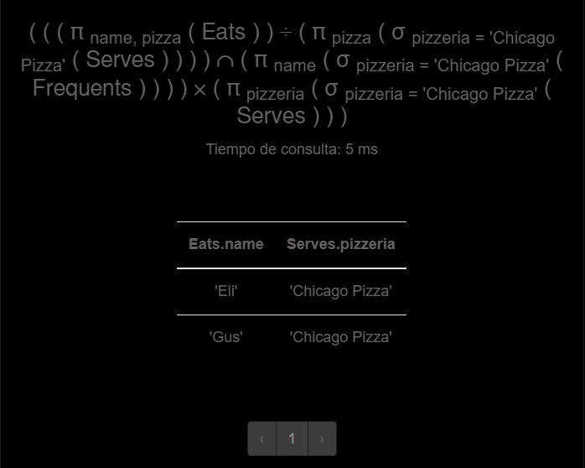

**CONSULTA 17**

πname,pizzeria(σage<18(Person⨝Frequents))

**CONSULTA 18**

πname,pizza(σ(gender='female'∧(pizza='mushroom'∨pizza='pepperoni'))(Person⨝Eats))

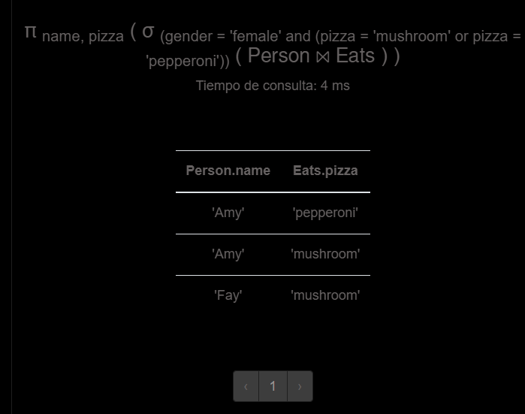

**CONSULTA 19**

π name ((σ gender='female' (Person)) ⨝ ρ E1(σ pizza='mushroom'  (Eats)) ⨝ ρ E2(σ pizza='pepperoni' (Eats)))

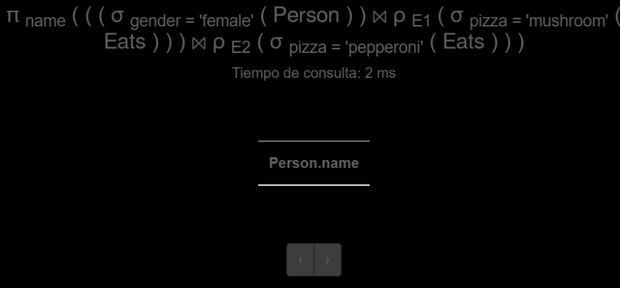

**CONSULTA 20**

π pizzeria ((σ name='Amy' (Eats)) ⨝ Eats.pizza=Serves.pizza (σ price<10 (Serves)))

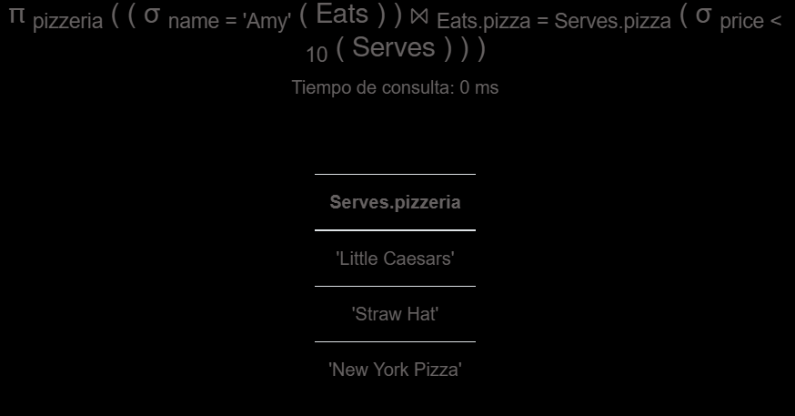

**CONSULTA 21**

π pizzeria (Frequents ⨝ Person.name=Frequents.name Person)- π pizzeria (σ gender='male' (Frequents ⨝ Person)) ∩ π pizzeria (Frequents ⨝ Person) - π pizzeria (σ gender='female' (Frequents ⨝ Person))

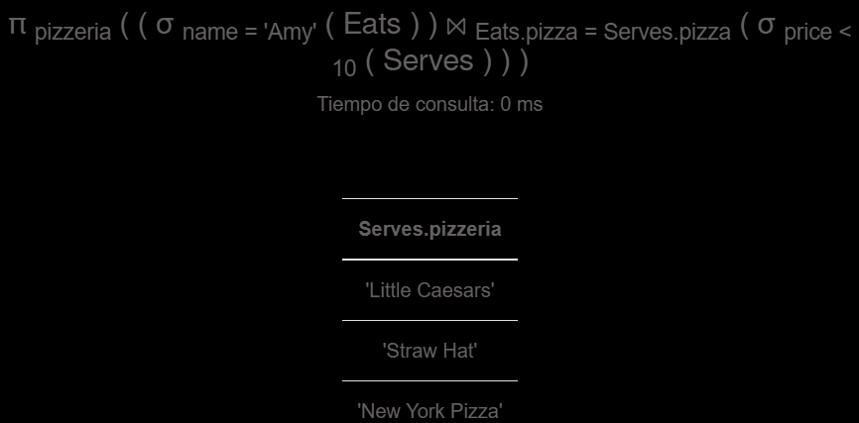

**CONSULTA 22**

π name,pizza (Eats)- π name,pizza (Frequents ⨝ Serves)

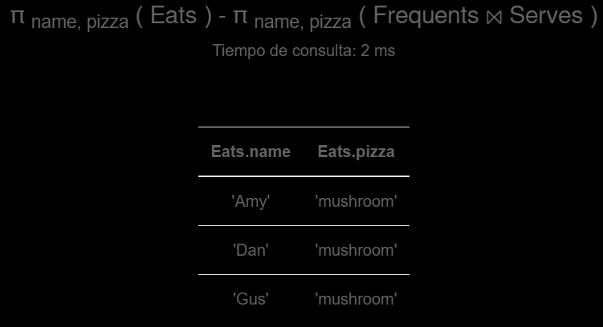

**CONSULTA 23**

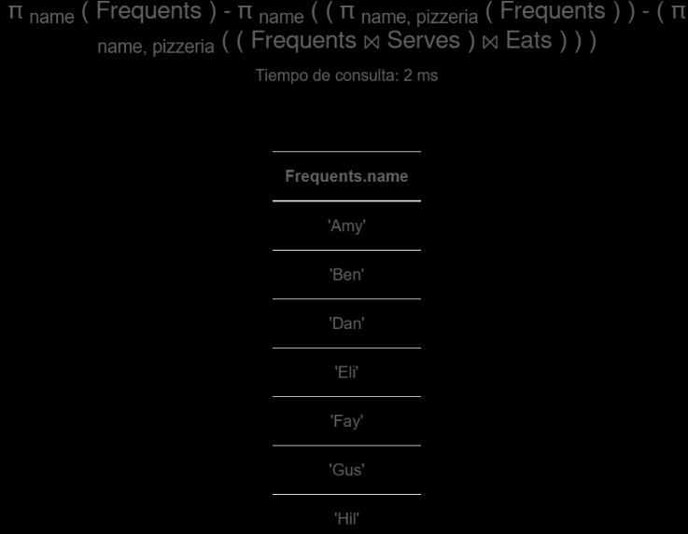π name (Frequents)− π name ( (π name,pizzeria (Frequents)) − (π name,pizzeria (Frequents ⨝ Serves ⨝ Eats)) )

**CONSULTA 24**

π name ( π name,pizzeria (Eats ⨝ Serves))-π name ((π name,pizzeria (Eats ⨝ Serves)) - π name,pizzeria (Frequents))

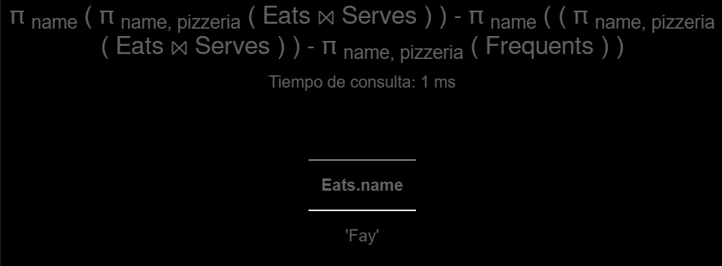

**CONSULTA 25**

pi pizzeria (sigma price = minprice ((sigma pizza='pepperoni' (Serves))     ⋈

    (gamma ; min(price)->minprice (sigma pizza='pepperoni' (Serves)))))

