Deployment Portfolio Task1
Student Name: Alex Phan
Student ID: 105334704
Unit Code & Title: SWE40006 Software Deployment and Evolution
Semester & Submission Date
Declared Target Level: 1.3

Execution Evidence:

Deployment Task 1:
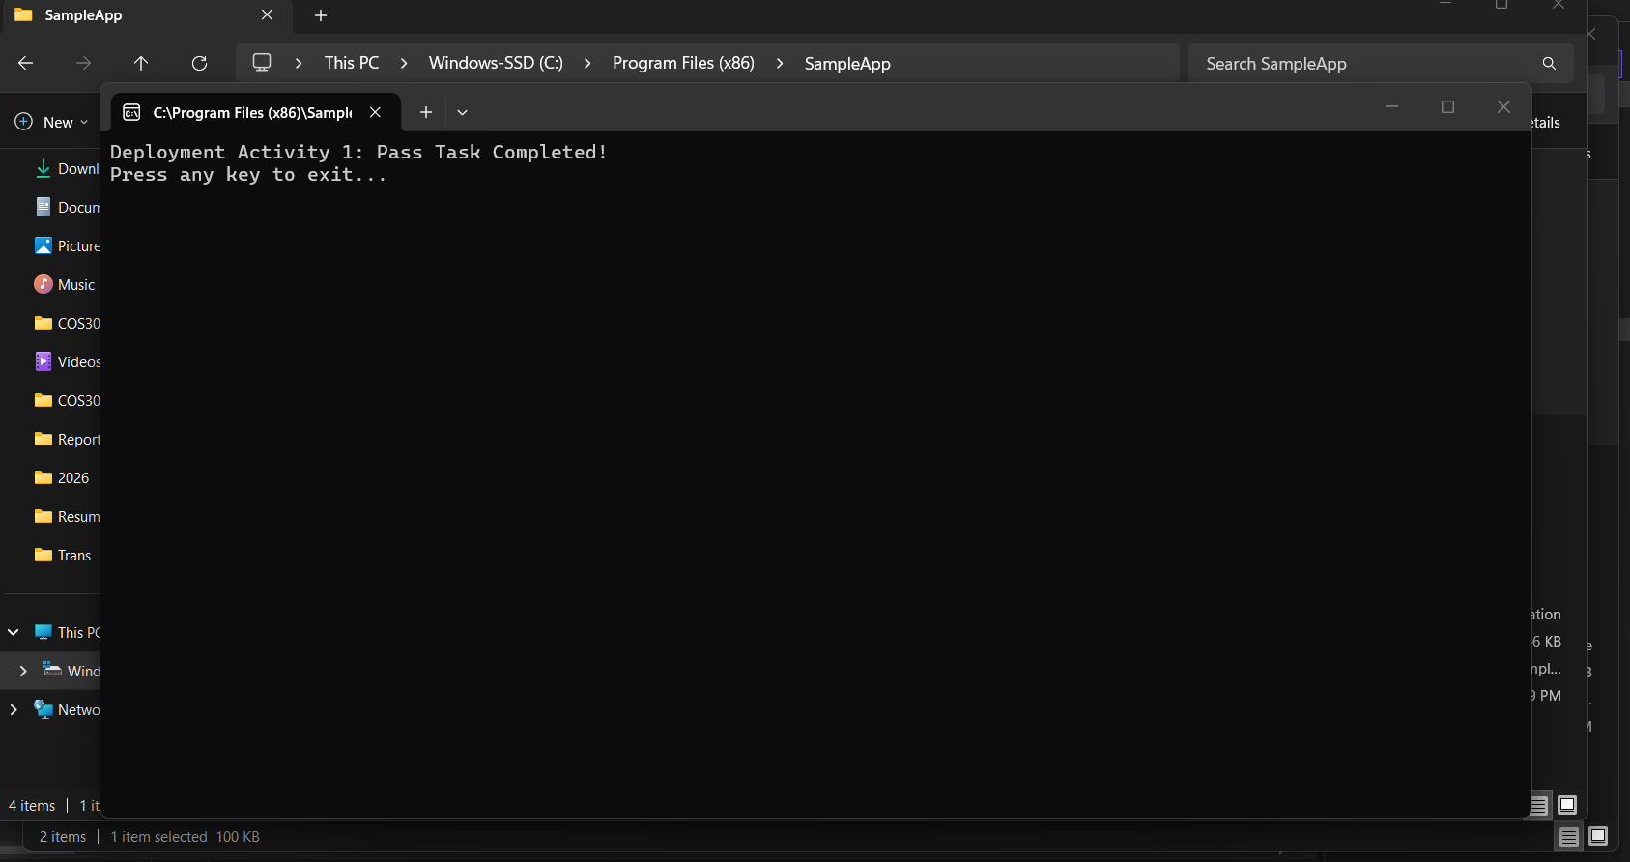
Figure 1, Deployed program
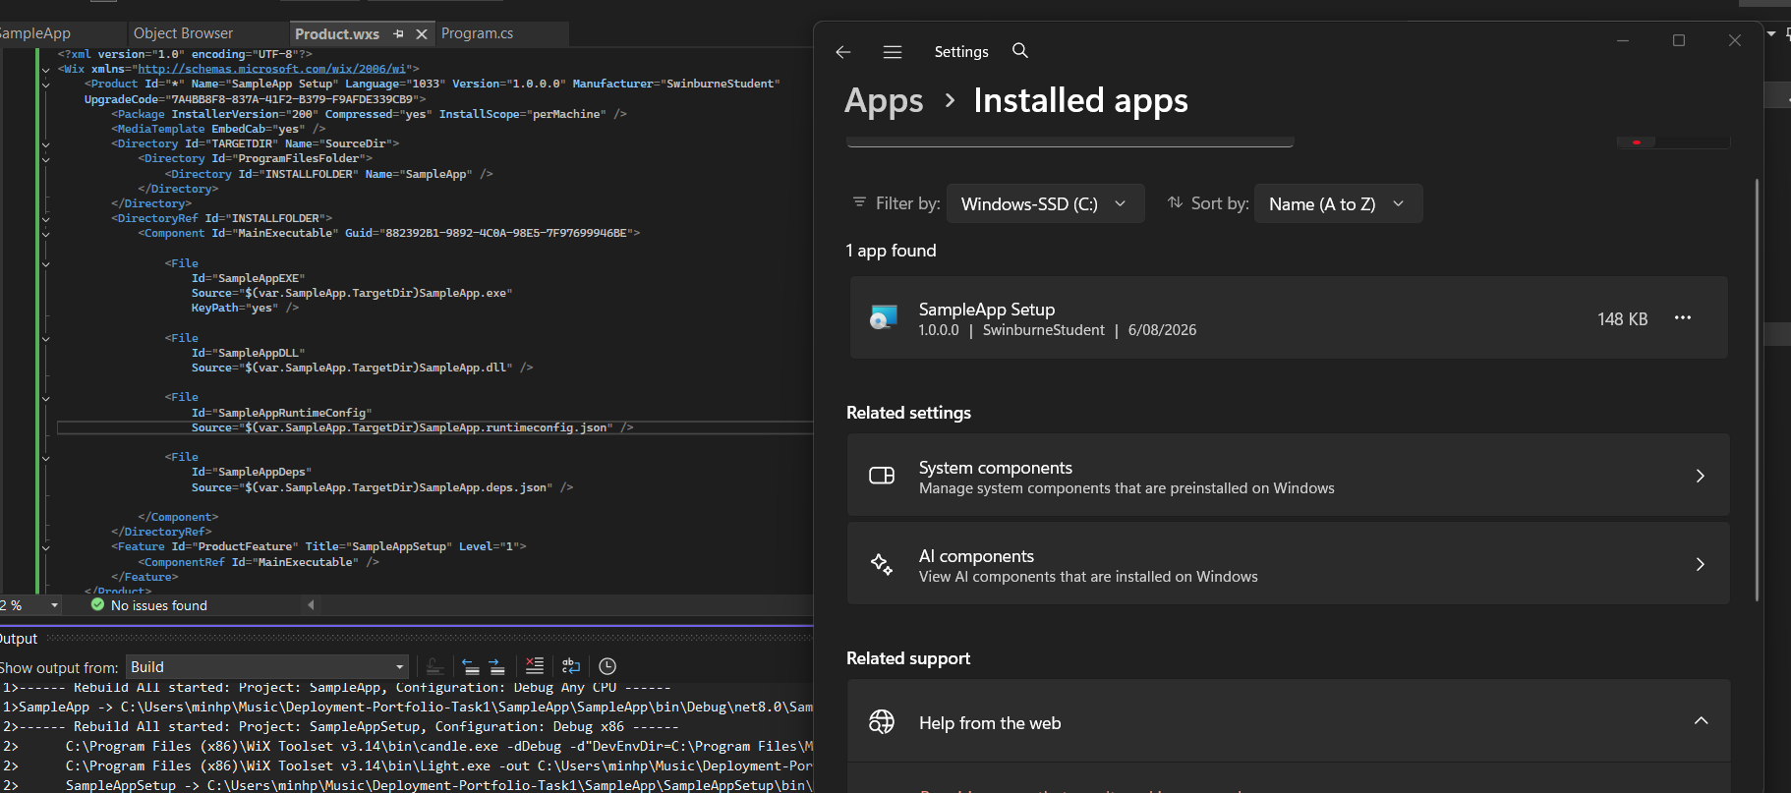
Figure 2, SampleApp found in Apps

External Code & Script Repository

