Deployment Portfolio Task 4
Student Name: Alex Phan
Student ID: 105334704
Unit Code & Title: SWE40006 Software Deployment and Evolution
Semester & Submission Date: Semester 2,
Declared Target Level: Distinction (4.3)

Execution Evidence:

Pass Level Task:

WSL installation
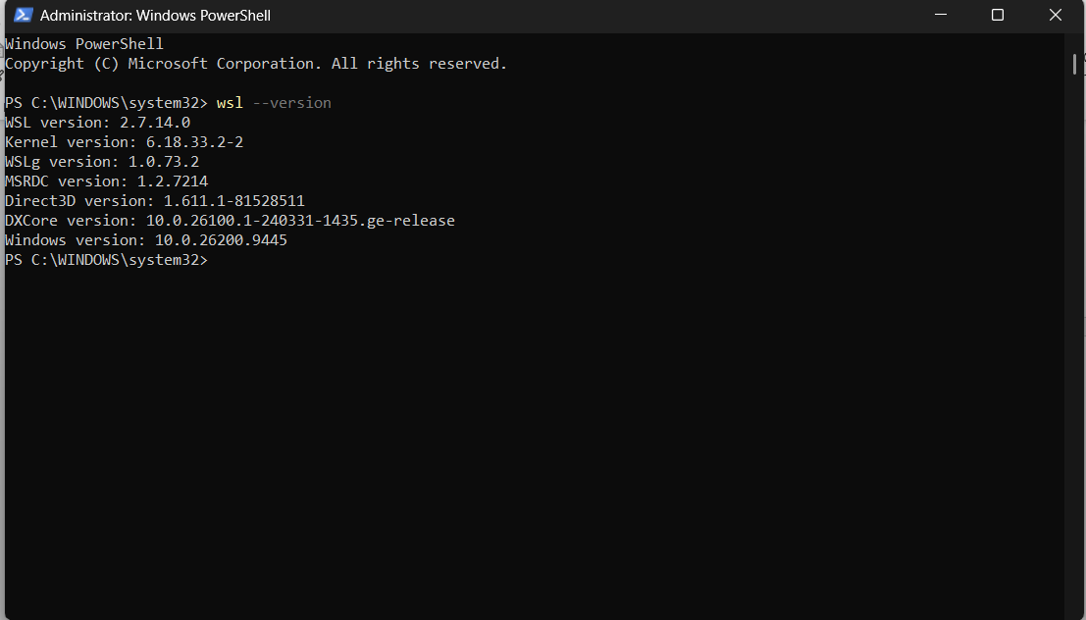
Figure 1, wsl installation

The figure shows that wsl is installed and the version is newer than 2.1.5

Docker desktop installation
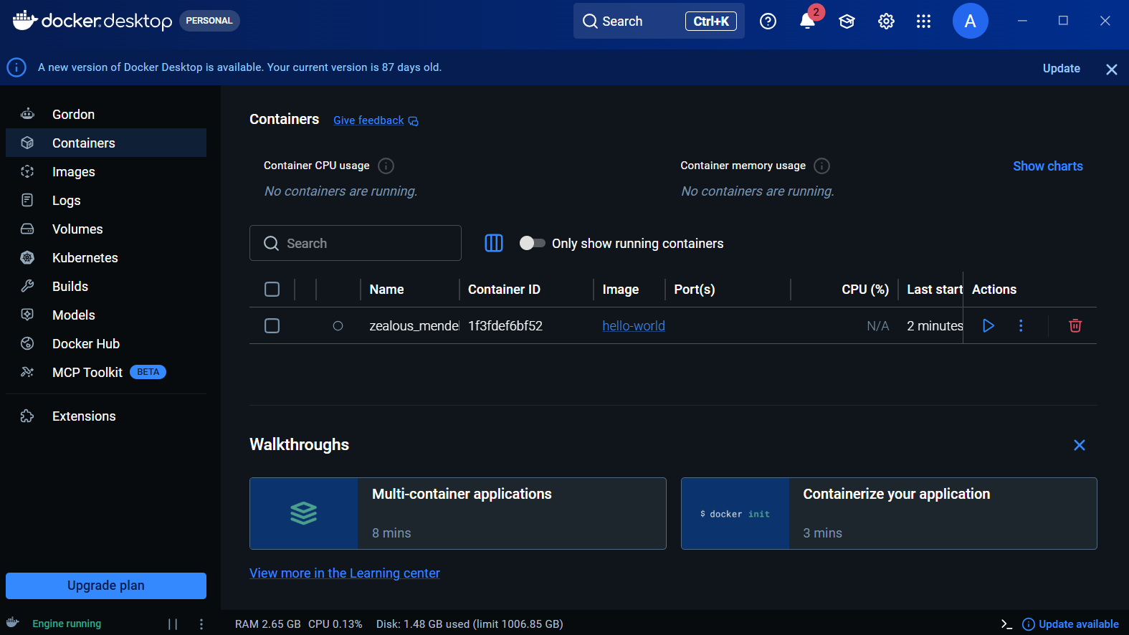
Figure 2, Docker desktop
Figure 2 shows the docker desktop installation being completed and is running the test container hello-world downloaded from docker desktop.

Docker test image
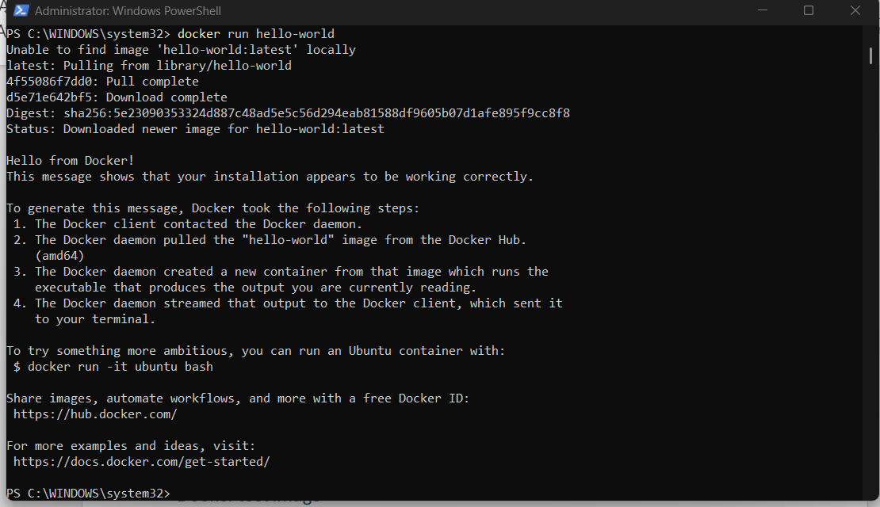
Figure 3, test image
Figure 3 shows that I have pulled an official hello-world container image from docker hub, additionally figure 2 also shows that the container has been registered within docker desktop.

Credit Level Task:

Sample Flask Application
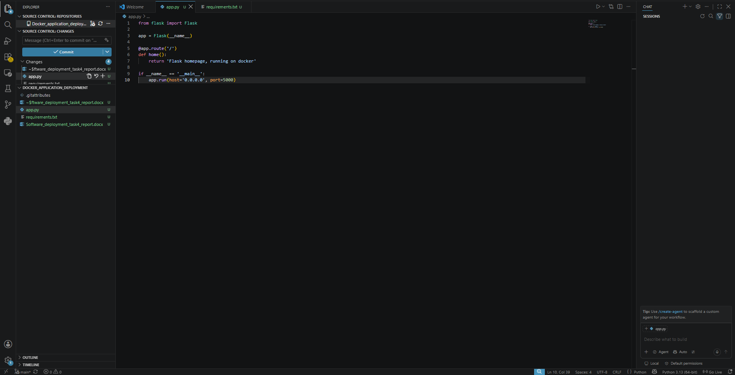Figure 4, Flask App
First, I have created the app.py file and defined the standard flask routing code which prints a welcome statement on a webpage running on flask, the flask allows connection on any interface.

Requirements file
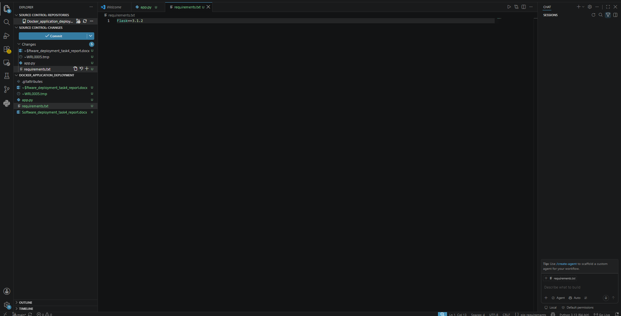
Figure 5, Requirements file
Created the requirements.txt file which contains the flask version needed to run the web app. This is for docker when the container spun up it will check the requirements file and makes sure to install all dependencies needed to run the application.

Docker File
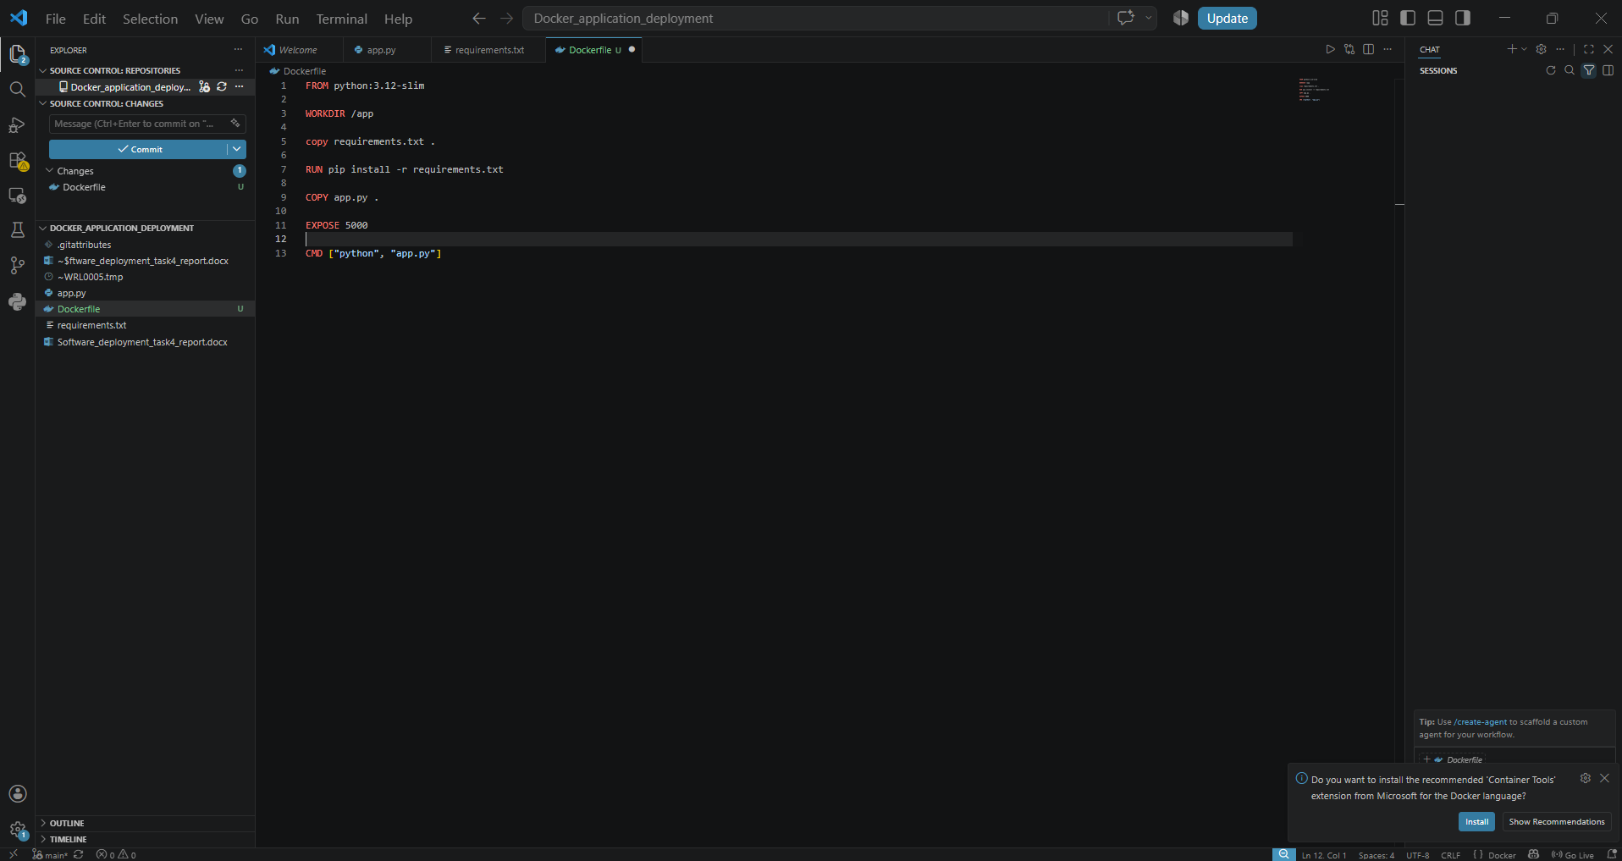
Figure 6, Docker file
Figure 6 shows the specifications for the Dockerfile defined in the working directory, where it will use a standard python image, create a working directory, download requirements, let docker know which port to listen for and run the python flask application after spinning up the container.

Docker Image of flask application
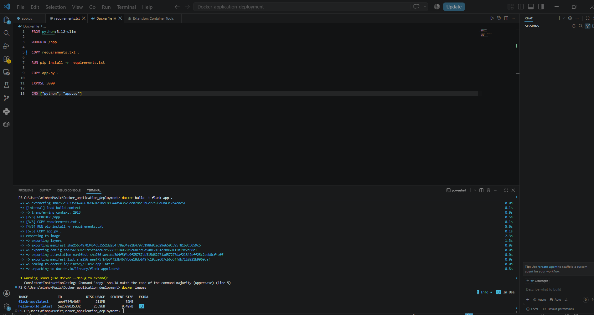
Figure 7, Docker Flask Image
Figure 7 portrays the docker flask image stored in the docker desktop virtualized storage after running the build command to build the template of the flask application, so that when docker spins up containers and use this template to correctly build and configure the application.

Docker Container creation
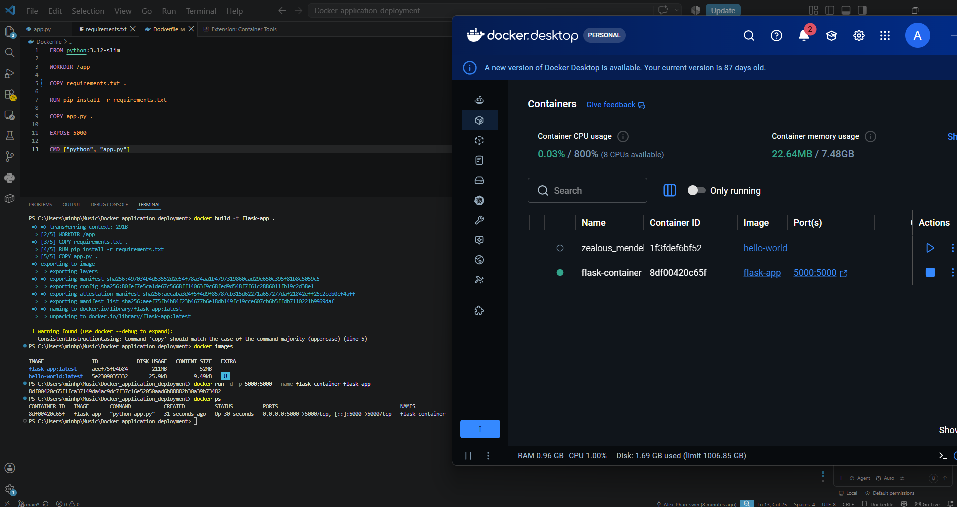
Figure 8, Docker Container
The docker container was then created with the application image illustrated in figure 7, I have also mapped the ports so that to access the container I would access through the same port the flask web server is running on to simplify the accessibility.

Flask App on docker
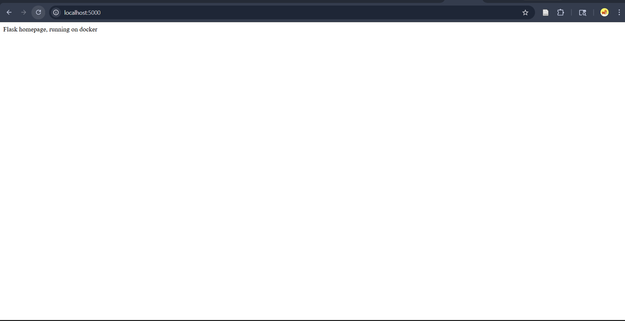
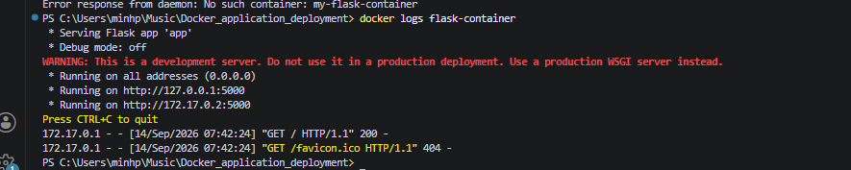
Figure 9, Containerized Flask app
Figure 9 shows that the flask app is accessible but also the docker logs highlight that the web is app is successfully running on a docker container.

Docker repo
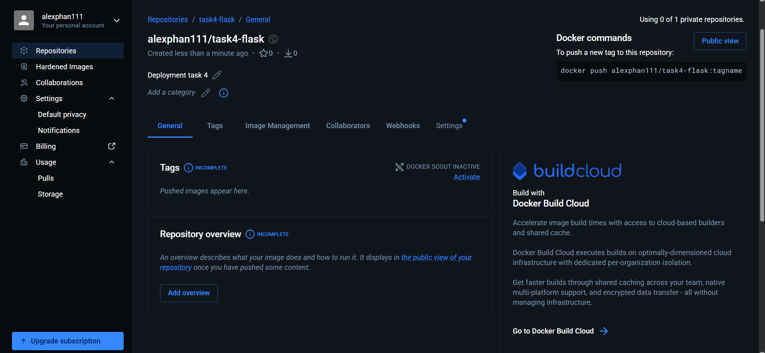
Figure 10, Repo
Create a repo on docker hub to be able to push the image to.

Push image

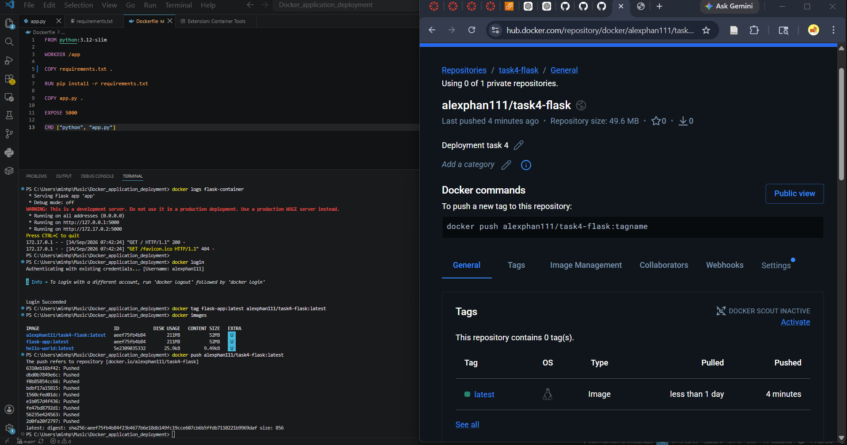
Figure 11, Pushed image
Figure 10 shows the repo now storing the flask image, this can now be used for a secondary docker host

Login on docker on new environment
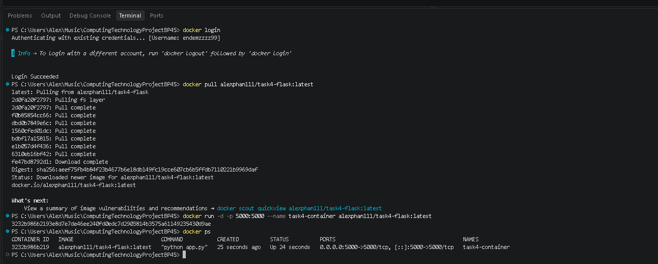
Figure 12, New environment
Figure 12 shows logging into a new docker account and then pulling the image from the public repo

Running Docker container on different environments
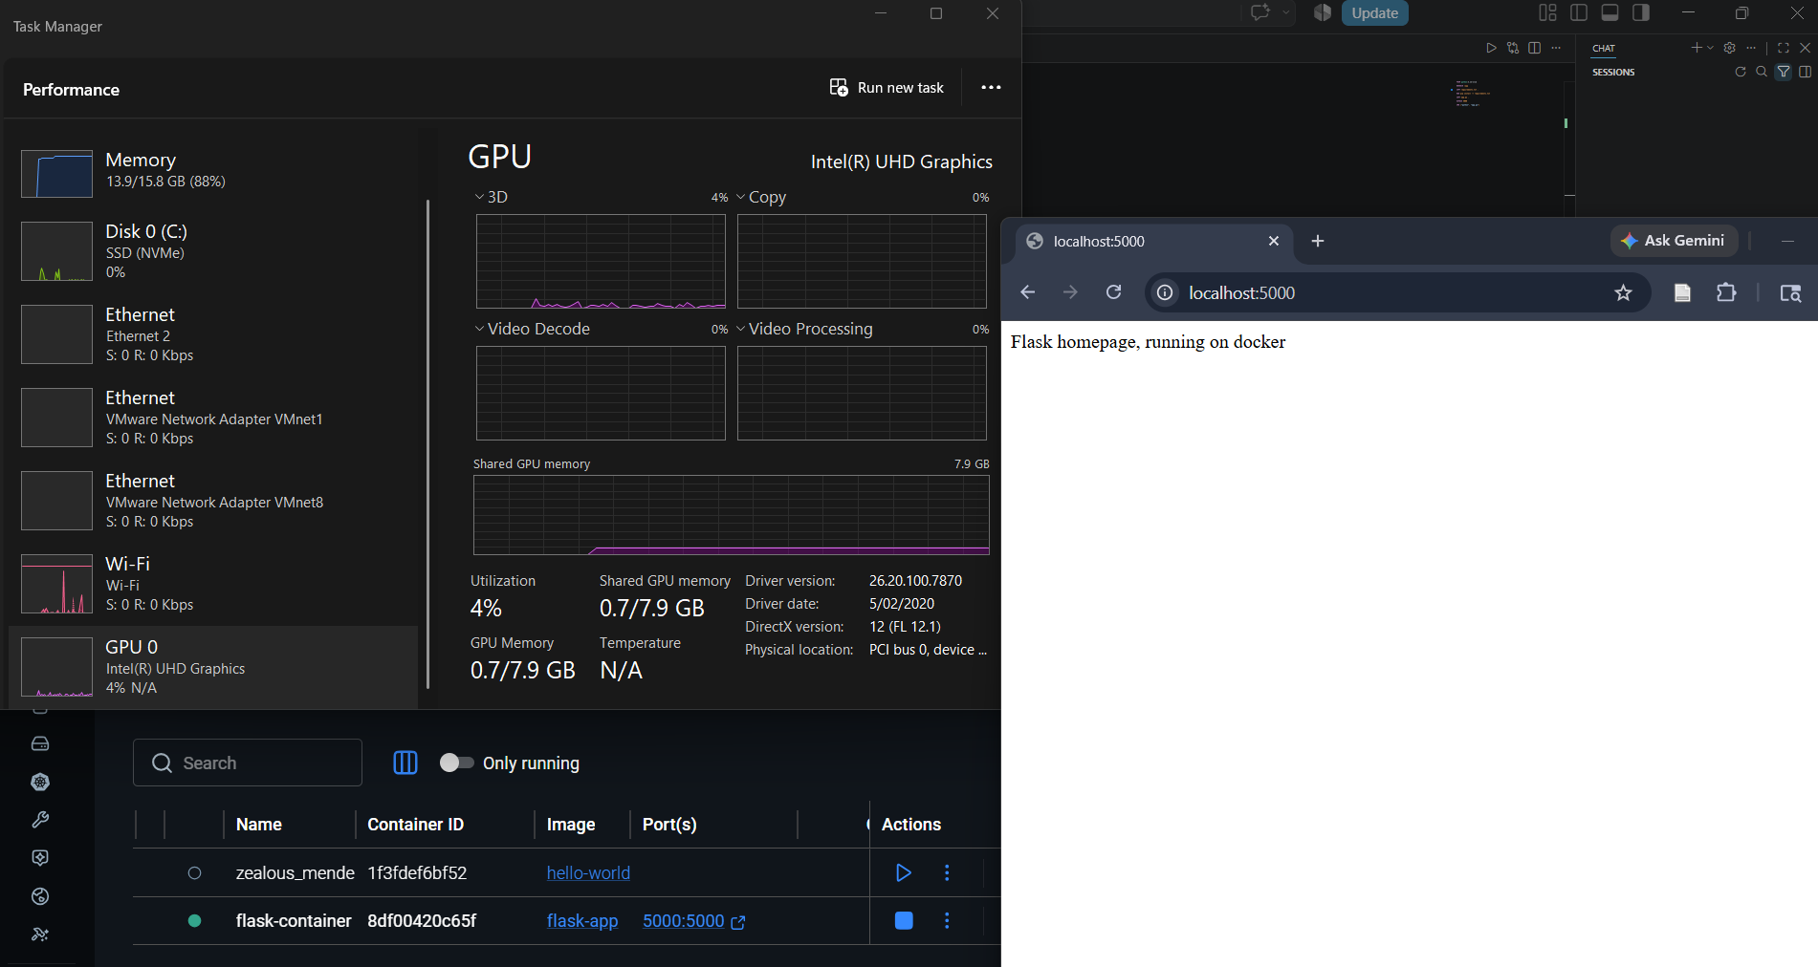
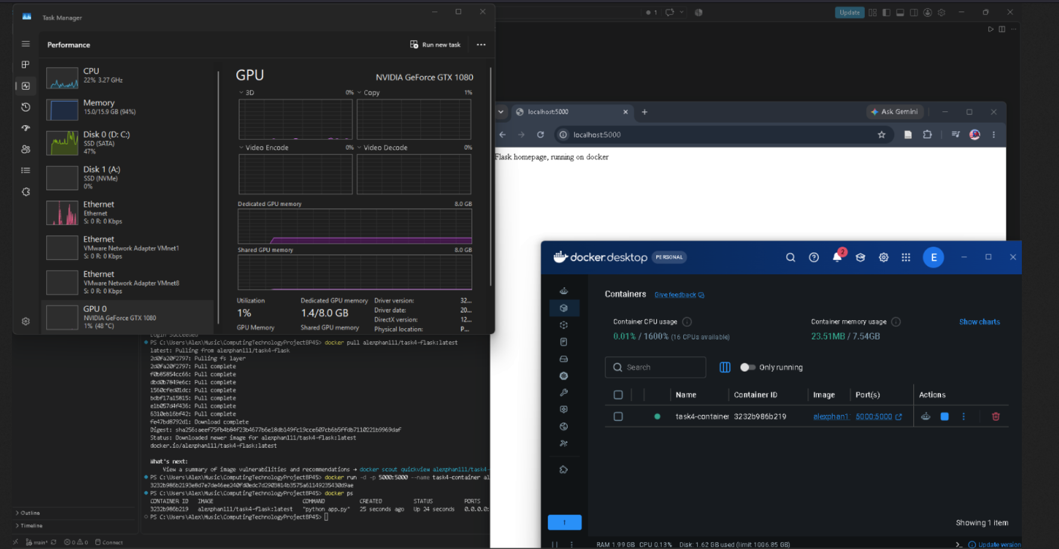
Figure 13, Different environments
Figure 13 highlights the containers being able to run on different environments after demonstrating that the image of the flask web app can be pulled from the public docker repository online and used to spin up a container. Furthermore, this is shown through the different computing specifications shown in task manager which is evidence of multi environment.

Distinction Level Task:

Grade calculation front page
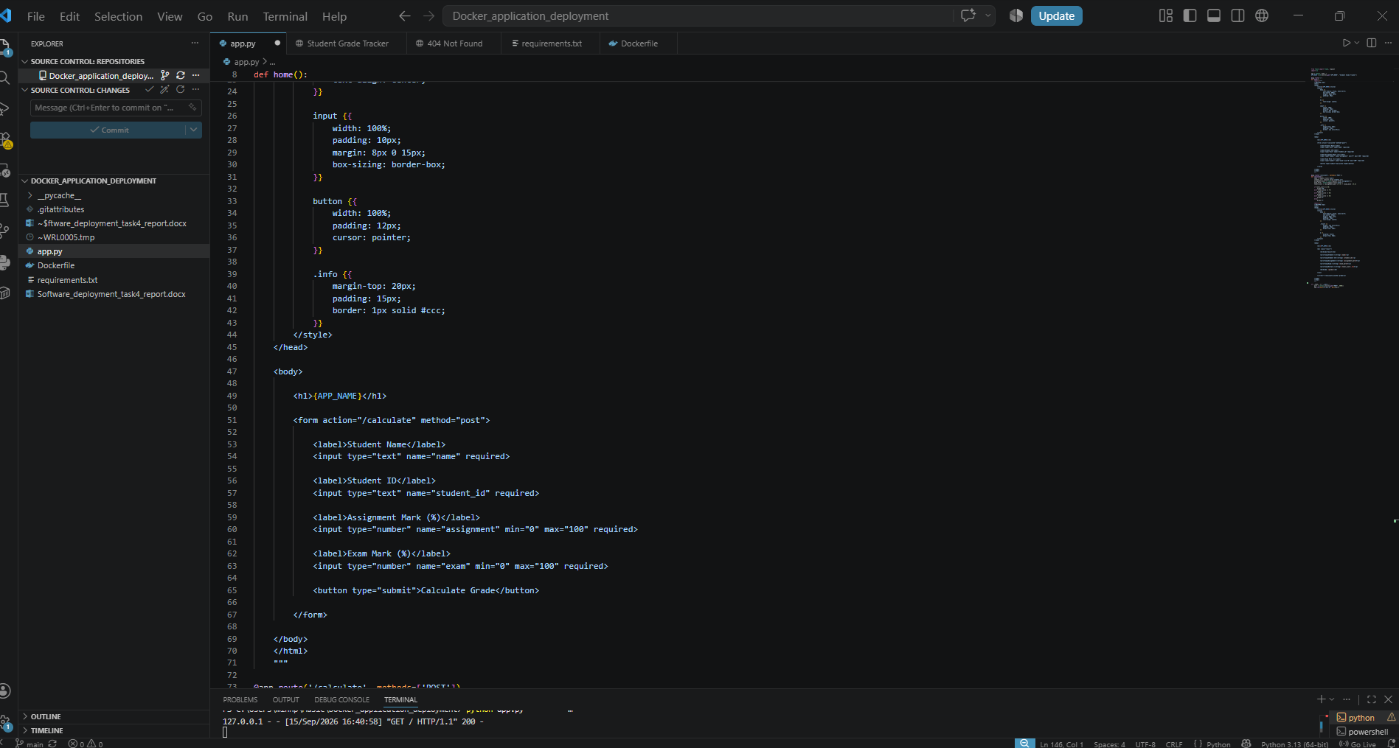
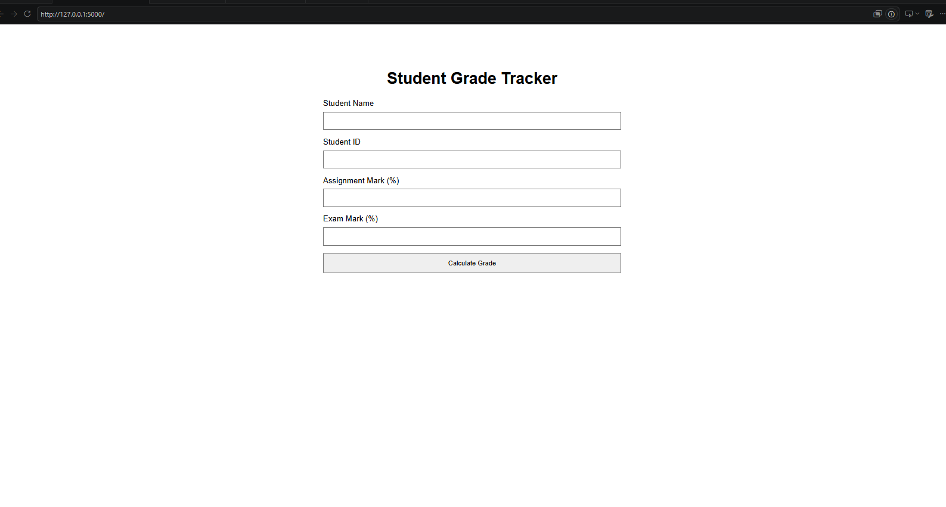
Figure 14, Front page
For the beginning of the distinction task, I have decided to create a simple student grade tracker app, figure 14 shows the use of a html form tag to create the grade calculation form which will send a post request to the backend. Additionally, I have configured environment variables for the title of the page so that Docker can configure them.

Grade calculated page
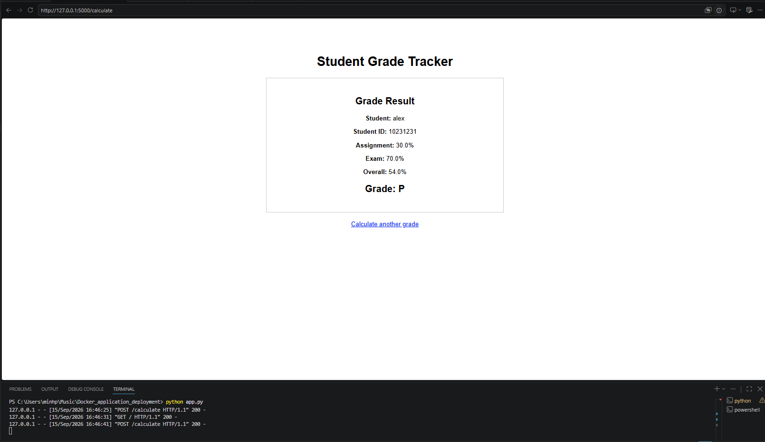
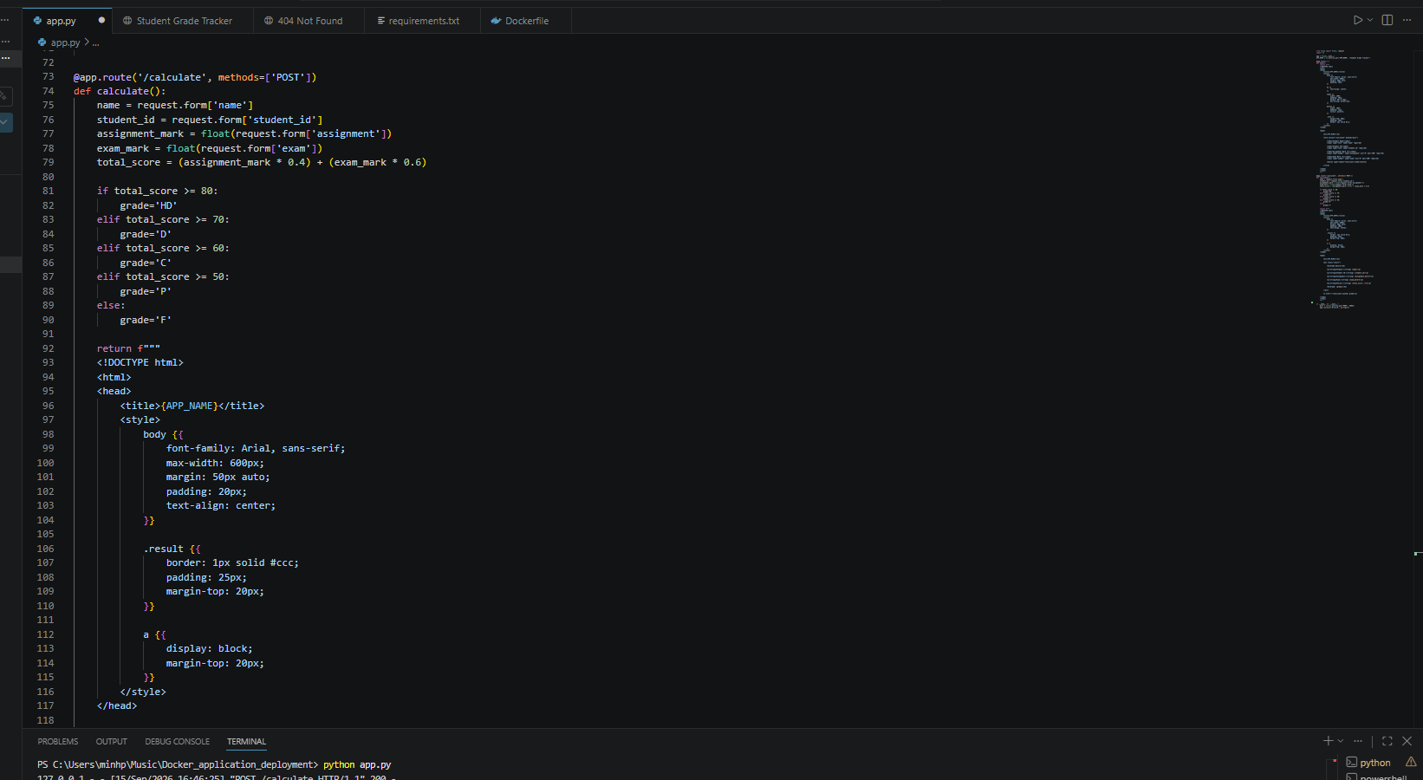
Figure 15, Grade calculated page
Figure 15 shows the route code where the flask server listens for the POST request on /calculate page, after receiving POST request it will then calculate the grades entered in the forms using the names of the tags within the form html in the front page.

Update Docker file
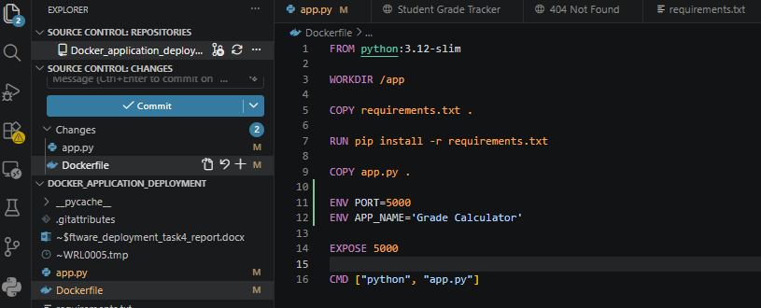
Figure 16, Update Docker file
I then updated the docker file so that it would set the environment variables instead of me having to change the program in the code every time, I can now change it in the Docker file.

Build Image
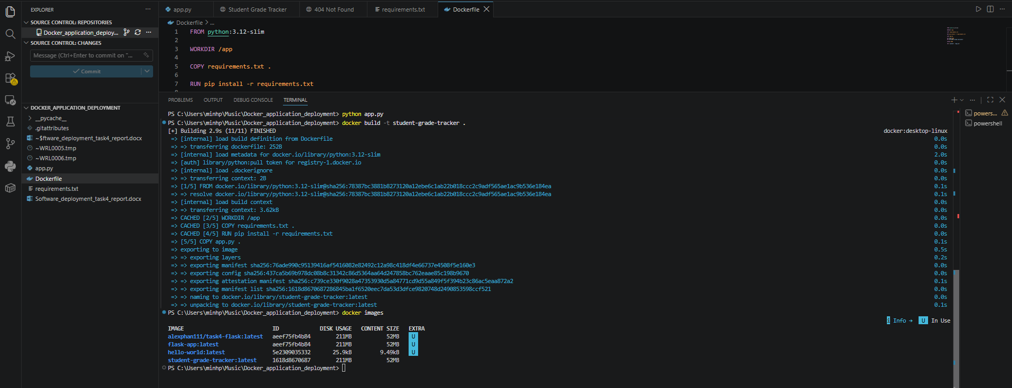
Figure 17, Build image
After developing the main program, I then used docker built to create the docker image which I will then use to recreate my application within a docker container.

Docker Container
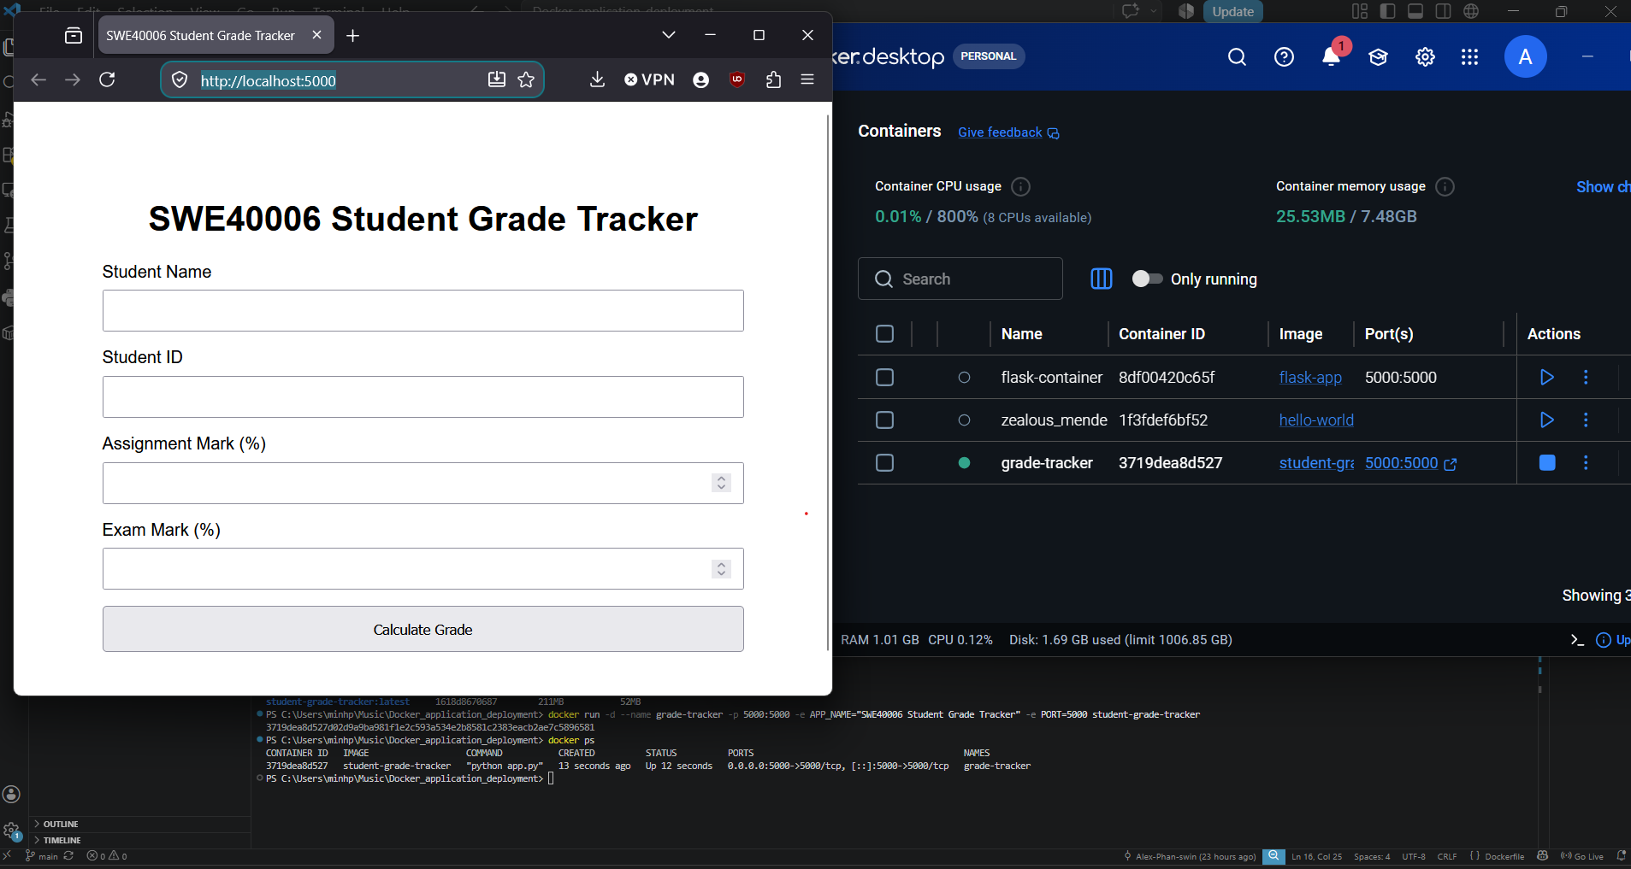
Figure 18, Container
Figure 18 shows the application running on the registered docker container named grade-tracker which was created based on the applications image shown in figure 17.

External Code & Script Repository

GitHub repository: https://github.com/Alex-Phan-swin/Docker_application_deployment

