Ideas to avoid time consuming and annoying merges:

-More frequent commits

-Using the Stash/Pop feature

-Checking if the commits between the time you started your local branch and now are touching any of the same files you’ve edited

-If your merge could be risky, take a preserved local branch of develop and don’t delete your local feature branch, to reference if needed during the merge

-Adopting git-friendly syntax styles:

* Using appended block starts:  
  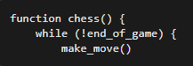
* And comments to ends of functions

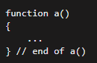

* With the side effect of avoiding this annoyance:

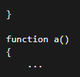

-Using a good merge tool