The Summer Job Portal

by Alexander Rybak (20312525)

I created this summer job portal using Python and HTML as my main programming languages. It uses the Django software for website development.

The repository linked features three files: this document (in .pages and .word), a requirements file, and the env_site directory. env_site is a virtual environment, which is used to launch Django projects. I previously tried creating the software in another folder and committing just the directory with the actual project, but I ran into some issues during the final stages so I had to create a new virtual environment and project from scratch and copy and paste my code there, and ran into issues launching it as well for a while.

To launch this software you need to have pip on your computer. If you don't, you can launch it by going to terminal and typing in:

python3 -m pip install -U pip

After that you need to install virtualenv. This can be done by:

pip install virtualenv

After that, navigate to the directory where you will have cloned this repository and open env_site in Terminal, and type in:

source bin/activate

Then go to the directory where the project is saved:

cd summerjobportal

and launch the server

python3 manage.py runserver

To open it, copy and paste <http://127.0.0.1:8000/> into your browser window.

My project uses crispyforms in order to create a form into which the user inputs data (for example, a recruiter making a vacancy or a jobseeker creating their resume) and saves it into a Model data structure, and from there onto the db.sqlite3 database which comes with Django.

Now a few snapshots of it in action:

First here is a picture of the landing page for jobseekers.

And here is the landing page bu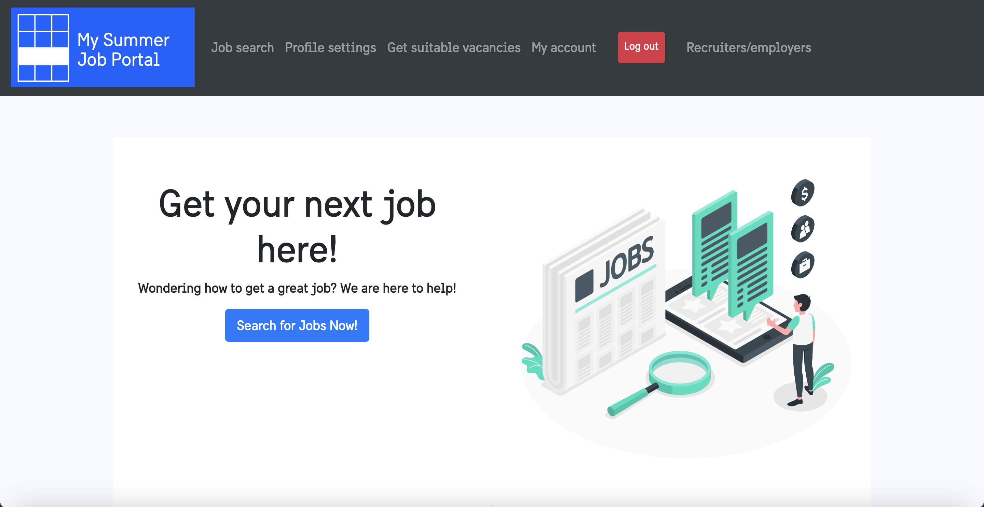t oriented towards recruiters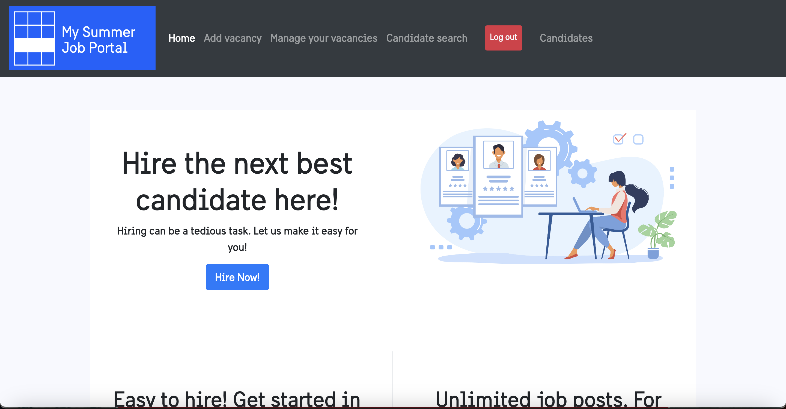

Here is a picture of the page that is used to create vacancies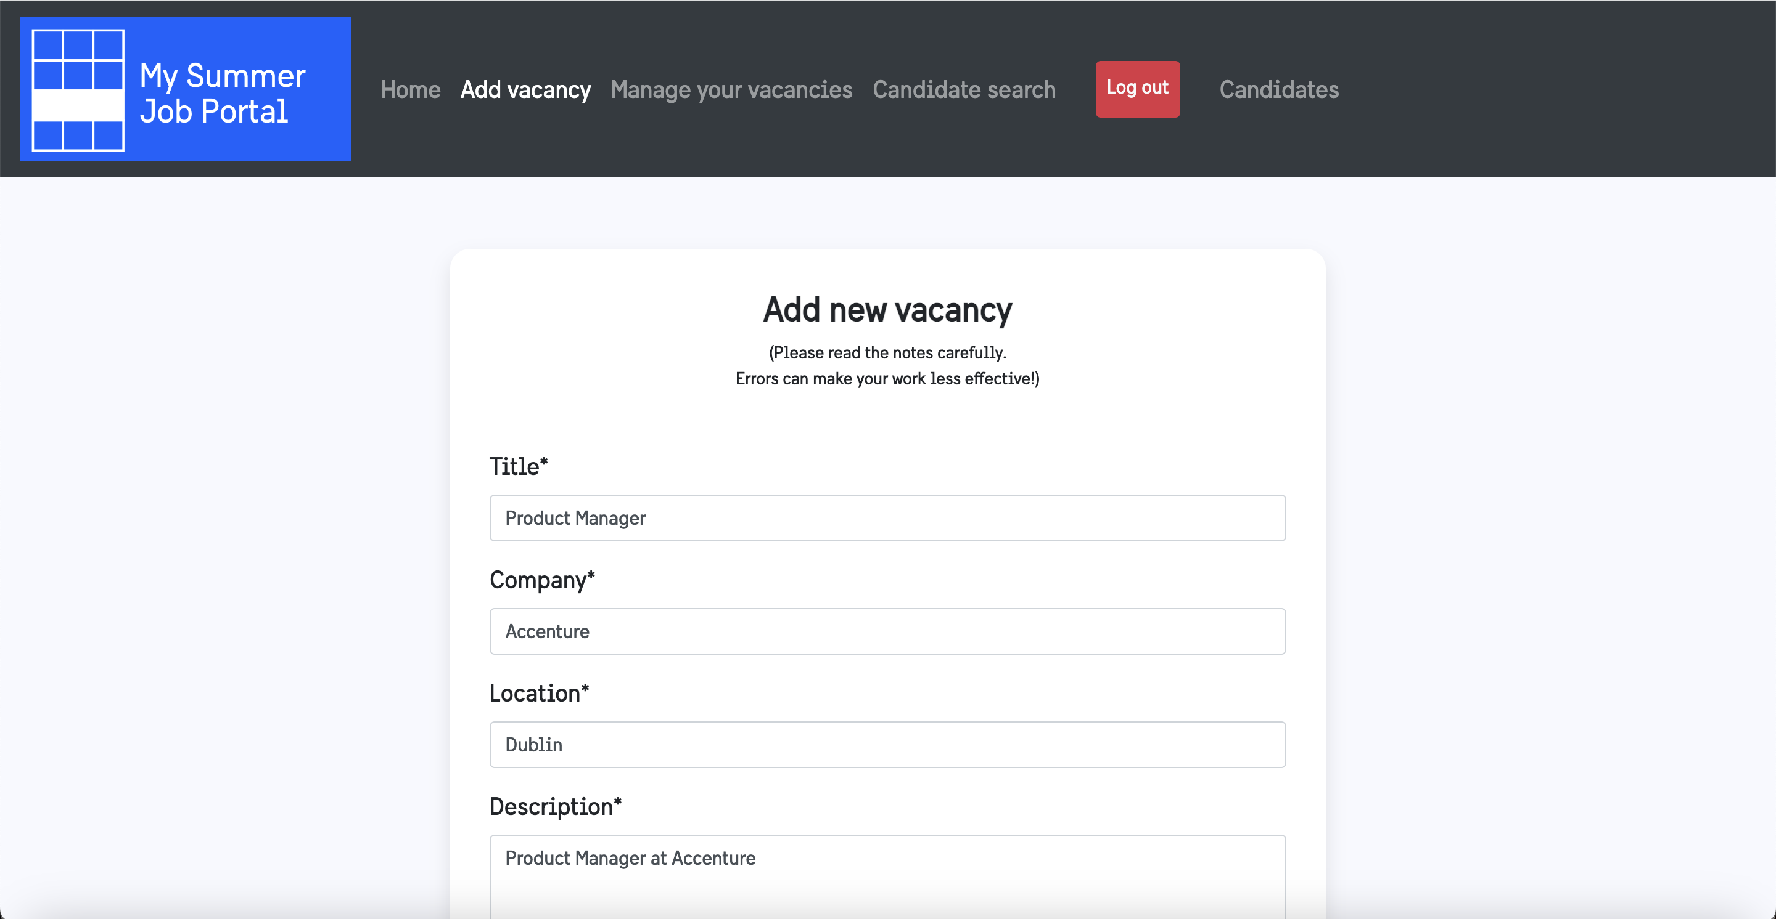

And here is the result of it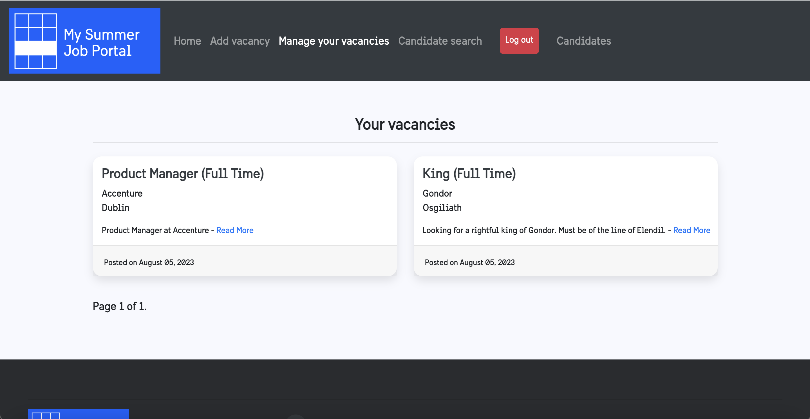

As a camdidate you can search for jobs, but the most popular searches are in there already prepared, one click and you can search them!

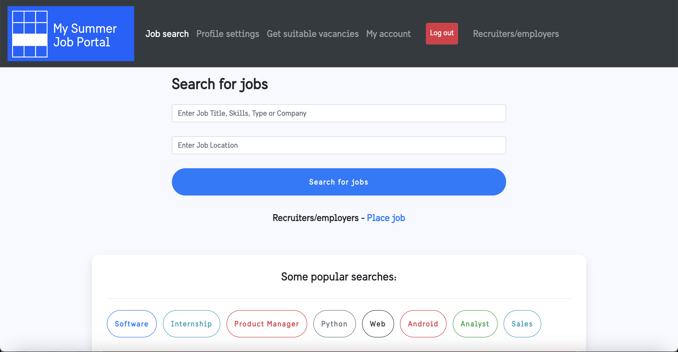

And here the listing shows up. Yay, you applied there!

Other features include resumes that an applicant can fill, a way to save vacancies, and a feature tha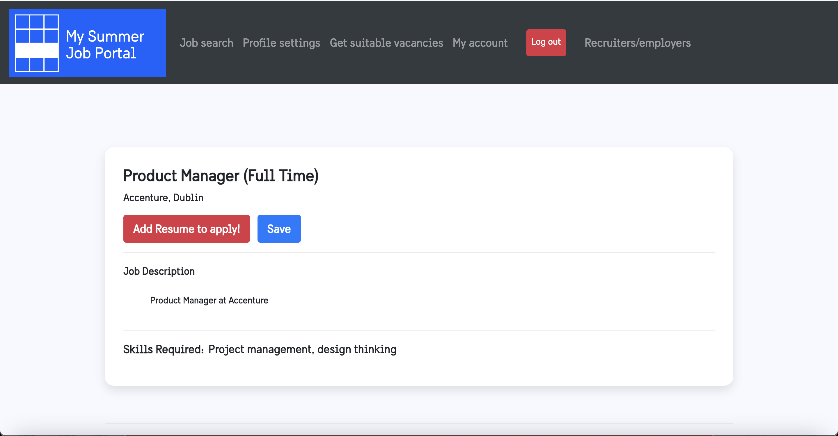t suggests you jobs right for your skillset.

Login through Google, LinkedIn and Github was originally intended, but not implemented due to time constratints.