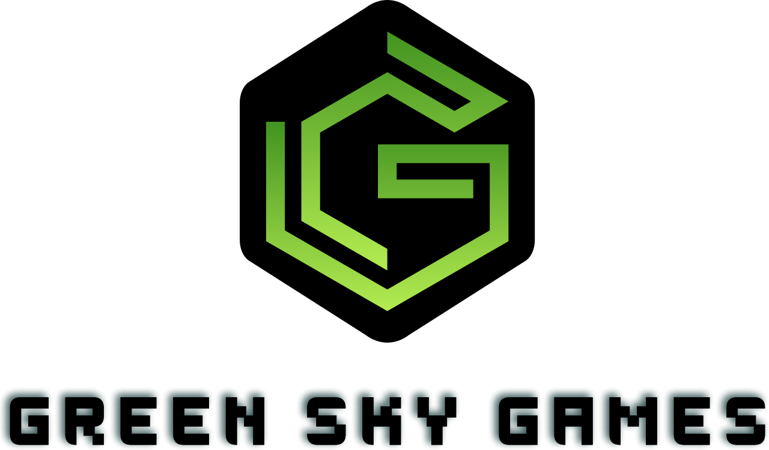

**Breaking Red**

**Request for Proposal**Version 4.0

Document History

|  |  |  |  |
| --- | --- | --- | --- |
| Version | When | Who | What |
| 1.0 | 2/3/2025 | Todd Carter | Initial Drafting |
| 2.0 | 2/4/2025 | Todd Carter | Edits to Product Features |
| 3.0 | 2/4/2025 | Alex Senst | Updated Product Features, Problem Description, and Current Systems |
| 4.0 | 2/4/2025 | Hengyi Tian | Updated Logo and Refine Format  Updated Intended users, interaction with the system and with the other systems |
| 5.0 | 2/5/2025 | Liz Beltran | Updated Known constraints to development, how to submit proposals and Dates. |
| 6.0 | 2/6/2025 | Shan Peck | Updated Project Schedule |
| 7.0 | 2/7/2025 | Shan Peck | Updated Project Schedule |

Table of Contents

1. Problem description
2. Project Features
3. Current System(s) – if any or similar systems
4. Intended users and their interaction with the system
5. Known interactions with other systems inside/outside the client organization
6. Known constraints to development
7. Project Schedule
8. How to Submit Proposals
9. Dates
10. Glossary of terms
11. Game Opportunity

*What is the need for improvement of the existing *system, or the need for the new system? Hints in the template, Deleted at the end*

Video games of all kinds have seen a surge in popularity over the past decade, growing over a billion new users of varying ages over the course of just 8 years. People enjoy video games as a simple form of entertainment and a distraction from reality that allows them to immerse themselves in a world completely unlike their own. In recent years, a trend has begun showing an increase in service games and particularly first person shooters that care most about monetization and numbers of users as compared to classic 2D exploration-based games like Pokémon or Zelda which dominated the field in the 1990s and before. We here at Green Sky Gaming feel that this trend, along with the sharp increase in new video game users, allows a golden opportunity to reintroduce the public to single person, narrative-based 2D games which are currently lacking in industry.

Green Sky Games would like to design a game that shakes up the market and puts our company on the map as one dedicated to designing engaging storytelling games with unique characters and a classic feel. We want this game to be a customizable, interactive 2D game with a top-down perspective that mimics old free-exploration video games to capture the attention of new and old gamers alike. The game should act as a revitalized version of a classic genre and should answer the question: “How can one make an original video game in a classic genre that engages a large, diverse audience while still maintaining enough game elements to be challenging and engaging.”

Since most classic video games using the 2D top-down view were made in the 1980s and 90’s, we are looking to develop a fresh look combined with a new storyline never before seen in past games. We believe that this free-movement game should focus on unique storylines, character interactions, and dynamic maps/environments. The game should stand out as a novel idea that allows a dynamic experience distinct for each user who plays the game.

1. Project Features

Specify the main objectives in detail. Include rational as to why each objective is important to your group. *Hints in the template, Deleted at the end*

Green Sky Games is seeking a team or contractor to make a story-based game with lots of non-playable characters and enemies along with an interesting environment that leads to a multitude of different conclusions to a central storyline.

Game features that should be included:

1. Levels
   1. Unique maps/environments players can traverse between to explore the world
   2. Basic obstacles or challenges affecting player navigation
2. Non-Playable Characters
   1. Generate in each level and can interact with players to progress the storyline
   2. Capable of attacking and damaging a player
   3. Trigger dialogue boxes and interactions which influence the story
3. Menus/UI
   1. Display base health and current inventory of player
   2. Open a game menu at start of game controlling loading games or starting of new games
   3. Allow for a pause/help menu within the game to modify settings or save progress
4. Power-Ups / Collectibles
   1. Distributed throughout levels to help or affect player abilities
   2. Objects the player can interact with or add to inventory
5. Background and Sound Design
   1. Background music for specific screens or levels
   2. Sound effects for specific movements, actions, or events
   3. Changing/moving background images and scenes
6. Main Character Customization
   1. Screen where users can customize features of the character to influence gameplay
   2. Tracks stats of player through combat and object interactions
7. Save points
   1. Game progress can be saved and returned/respawned from previous progress spot
   2. User choices are saved to influence game progression
8. Current system(s) – if any / similar systems

Current system(s) used by your group (if any). If none, are there any systems that are similar to the one you would like to build? *Hints in the template, Deleted at the end*

There are games in existence that loosely can act as a template for this one. These games include *Zelda: A Link to the Past, Undertale,* and *Final Fantasy I*. Each of these are an action adventure Role Playing Game that tells a story across an explorable, two dimensional map in a variety of art styles.

**Zelda: A Link to the Past**

Released by Nintendo in 1991, this action-adventure game follows protagonist Link on his question to rescue Princess Zelda and defeat the dark forces threatening Hyrule. Players get to explore a vast world with intricate dungeons, puzzles, enemies, and collectibles along with two parallel worlds.

**Undertale**

An RPG game released in 2015, Undertale allows players to control a human who has fallen into a realm of monsters. The game uses a battle system allowing players to fight, spare, or befriend enemies through turn-based combat where each decision influences the story and changes the ending. It is best known for its unique combat options, memorable characters, and unique dialogue and conclusions.

**Final Fantasy I**

Fian Fantasy I, released by Square in 1987, was a turn-based RPG where players controlled the Warriors of Light on their quest to defeat the Four Fiends and restore balance to the world. The game allowed players to explore towns, dungeons, and various elements of an overworld while battling enemies in a classic turn-based system. The game was most focused on leveling up and managing resources with a non-linear story and specific playable classes.

1. Intended users and their basic interaction with the system

Users could be in the client (your) organization or outside. *Hints in the template, Deleted at the end*

**Intended Users:**

The target audience will be game players interested in an immersive RPG-style game and will be attracted to exploration and strategic combat. The game is designed for casual and dedicated players of all skill levels, with no gaming experience required. Due to the elements of violence, the age of the target audience should be included and above 12.

**Basic interactions with the game will include:**

1. Starting the new game or selecting an existing save.
2. Exploring the map using keyboard controls.
3. Tutorial guiding operations of combat.
4. Fighting/speaking to NPCs may get feedback.
5. Fighting to final boss to end the game
6. Opening/closing the pause menu.
7. Observing the HUD for details about their gameplay.
8. Closing the game.
9. Known interactions with other systems within or outside of the client organization.

List up to three. Hints in the template, Deleted at the end THIS PART SHOULD BE MODIFIED!

The completed game should be self-contained and not have interactions outside of downloading and running on a typical Windows environment.

**Inside Interactions:**

1. Game Engine Integration
2. Save and Load System
3. Combat System

**Outside Interactions:**

1. Apple App Store
2. Microsoft Store
3. Steam
4. Known constraints to development

List up to three. *Hints in the template, Deleted at the end*

Known constraints to development:

1. Time constraints for development
2. Feature and code complexity
3. Budget

1. Project Schedule

Broad overview. Must agree with the course schedule. Can include some of the potential meeting dates with milestones included. *Hints in the template, Deleted at the end*

|  |  |
| --- | --- |
| Date | Description |
| February 7, 2025 | Request For Proposal Due |
| February 8, 2025 | Have Individual Champions, Class Diagrams, and Sequence Diagrams done |
| February 18, 2025 | Systems Analysis Presentation (Present Features + Storyboard) |
| February 25, 2025 | Present Minimum Viable Product |
| March 20, 2025 | Game should be 80% done, ready to test |
| April 12, 2025 | Game complete |
| April 13-15, 2025 | Oral Exam Week |
| May 1, 2025 | Final Demo |

|  |  |
| --- | --- |
| 8.0 | How To Submit Proposals |
|  | Instructions for submitting proposals (i.e. electronically, etc.) *Hints in the template, Deleted at the end*  *Submissions may be sent via mail or electronically by the submission deadline.*  Project Name/Description: 2D RPG-style Story-based game  Company Name: Green Sky Games  Address: 875 Perimeter Dr, Moscow, ID 83844  Contact Person: Bidhan Ratna  Telephone number: (208) 123- 4567  Email Address: fakeemail@greensky.com  **Submission Criteria**  A submission must, at a minimum, include the following elements:   * Description of the firm, including a general overview, names and credentials of the creative team. * One-page narrative outlining the firm’s strengths, distinguishing skills and capabilities as they relate to the 2D story-based game.   **Selection Criteria**   * Relevant Experience (--)   Demonstrated experience in developing a 2D RPG-Style or story-based games.   * Technical Experience (--)   Proficiency in game development tools, programming languages, and platforms relevant to the project.   * Creative Approach (--)   Innovation, storytelling quality, and artistic vision as demonstrated in the submission.   * Project Plan and Timeline (--)   Feasibility of the proposed development timeline, milestones, and overall project management approach.   * Budget and Cost Efficiency (--)   Clear, reasonable cost estimates with a breakdown of expenses and value for investment.   * Compliance with Submission Requirements (--)   Adherence to formatting and completeness of the proposal. |
| 9.0 | Dates |
|  | Deadline for submission and when respondents will be notified that a winner is chosen. *Hints in the template, Deleted at the end*  **Submission Timeline**   * Proposal Deadline: February 7, 2025, by 5pm (PST). * Contract Award Date: ----. The contract will be granted no later than this date. * Final Delivery Deadline: ----. The completed project must be delivered by this date. |
| 10.0 Glossary of terms | |

Terms that are meaningful to your client group but might not be understood by someone outside your group. *Hints in the template, Deleted at the end*

*Note: Remember that “system” means product, service, and/or system your group would like to see created, built, upgraded, and/or changed. It is a broad term.