深 圳 大 学 实 验 报 告

课程名称： Python程序设计

实验项目名称： 作业2

学院： 计算机与软件学院

专业： 计算机科学与技术

指导教师： 潘浩源

报告人：沈晨玙 学号：2019092121 班级： 19计科国际

实验时间： 2021.6.11

实验报告提交时间： 2021.6.11

教务部制
实验目的与要求：
（1） 实验报告提交截止日期：2021.04.15， 23:59pm，迟交扣 20%，缺交 0 分。
（2） 实验报告内容包括：解决问题的思路与方法（如代码的解释）、遇到的问
题以及收获（简单描述即可）、代码运行结果的展示。
- 实验报告提交方法：blackboard。
- 提交要求：实验报告+源代码，打包上传，命名：学号_姓名_实验报告_5。
（5） 禁止抄袭，一经发现 0 分处理（包括抄袭者和提供代码或实验报告者）！
方法、步骤、实验过程及内容：
Problem 1:
思路：
- 基类实现
  - 状态转移
def transition_fn(self, s, x):
raise NotImplementedError
  - 状态输出
def output_fn(self, s):
raise NotImplementedError
  - 转换
def transduce(self, input_seq):
ans = []
for input in input_seq:
self.start_state = self.transition_fn(
self.start_state, input)
ans.append(self.output_fn(self.start_state))
return ans
对于输入列表，对当前状态进行更新，并且将更新后的状态添加到ans列表之中。

- 累加器
  - 状态转移
def transition_fn(self, s, x):
return s+x
累加器的作用是将当前值与先前状态值累加。
  - 状态输出
def output_fn(self, s):
return s
- 二进制相加
  - 状态转移
def transition_fn(self, s, x):
return ((x[0]+x[1]+s[0]) // 2, (x[0]+x[1]+s[0]) % 2)
当前状态中包含了两个数据（carry/digit），输入状态中包含了两个digit
二进制累加，将输入状态中的digit与当前状态carry相加
返回（进位符，累加结果）
  - 状态输出
def output_fn(self, s):
return s[1]
返回状态第二个参数（digit）

- 反向器
  - 部分定义
start_state = []
end = False
Start_state为一个栈，存储了需要输出的文字
End为布尔值，false说明未开始反转输出，true说明开始反转输出

  - 状态转移
def transition_fn(self, s, x):
if x == 'end':
self.end = True
if self.end:
return s
else:
s.append(x)
return s
如果输入状态为end，更改状态布尔值
如果开始反转输出，则直接返回当前状态，不更新状态
如果未开始反转输出，则将新字符串加入栈中，并更新状态

  - 状态输出
def output_fn(self, s):
if not self.end:
return None
else:
if s:
return s.pop()
else:
return None
如果未开始反转输出，返回none
如果栈为空，则返回none，否则返回pop元素

数据测试：
output = Accumulator().transduce([-1, 2, 3, -2, 5, 6])

output = Binary_Addition().transduce([(1, 1), (1, 0), (0, 0)])

output = Reverser().transduce(
['foo', ' ', 'bar'] + ['end'] + ['end']*3 + list(range(2)))

output = Reverser().transduce(list('the') + ['end'] + list(range(3)))

output = Reverser().transduce([] + ['end'] + list(range(5)))

output = Reverser().transduce(list('nehznehS evol I') + ['end'] +
list(range(15)))
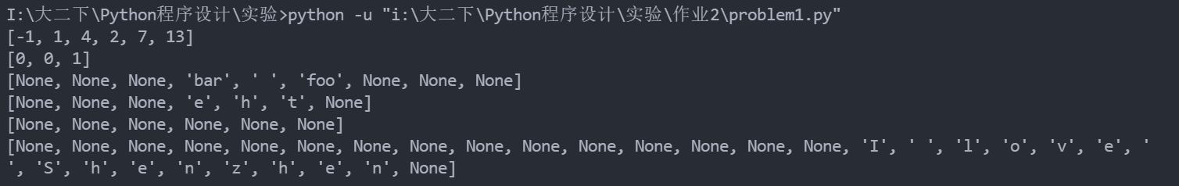

Problem 2:
思路：
- Card类
class Card():
def __init__(self, rank, suit):
assert suit in {'S', 'H', 'C', 'D'}
assert rank in range(2, 15)
self.rank = rank
self.suit = suit
suit_str = {'S': "\u2660", 'H': "\u2661", 'C': "\u2663", 'D': "\u2662"}
rank_str = {n: str(n) for n in range(2, 11)}
rank_str[11] = 'J'
rank_str[12] = 'Q'
rank_str[13] = 'K'
rank_str[14] = 'A'
def __str__(self): # 输出，如'2♡'
return f"{self.rank_str[self.rank]}{self.suit_str[self.suit]}"
def __repr__(self): # Card(2,'H')
return f"Card({self.rank},'{self.suit}')"
def __gt__(self, other):
return self.rank > other.rank
def __lt__(self, other):
return self.rank < other.rank
def __eq__(self, other):
return self.rank == other.rank
根据扑克牌大小定义，重写运算符定义。

- Hand类
class Hand():
def __init__(self, cards=[]):
self.cards = []
self.receive_cards(cards)
def receive_cards(self, cards):
self.cards.extend(cards)
def receive_card(self, card):
self.cards.append(card)
def shuffle(self):
if self.cards:
random.shuffle(self.cards)
def give_card(self):
if not self.cards:
return None
temp = self.cards[0]
del self.cards[0]
return temp
def give_cards(self):
if not self.cards:
return None
temp = self.cards.copy()
self.cards.clear()
return temp
def __iter__(self):
yield from self.cards
def __repr__(self):
return f"Hand({self.cards})"
def __str__(self):
return str([str(card) for card in self.cards])
@property # 设置属性，这样可以使用 对象.num_cards 访问，而不是 对象.num_cards()
def num_cards(self):
return len(self.cards)
Give card方法就是将列表的第一个元素删除并返回。
Givescards方法要利用copy方法，否则会导致由于浅拷贝而引起的错误。

- Deck类
class Deck(Hand):
def __init__(self):
self.cards = []
for i in Card.rank_str:
for j in Card.suit_str:
self.cards.append(Card(i, j))
self.size = self.num_cards
self.shuffle()
根据花色/点数生成所有52张卡牌

- Player类
class Player(Hand):
def __init__(self, name, cards=[]):
self.name = name
self.cards = cards.copy()
def __repr__(self):
return f"Player({repr(self.name)}, {[c for c in self]})"
def __str__(self):
return f"<{repr(self.name)} has {[str(c) for c in self]}>"
Cards的赋值方法要利用copy方法，否则会导致由于浅拷贝而引起的错误。

- Game类
class Game():
def __init__(self, players):
self.players = players
self.deck = Deck()

def deal(self):
# 补充代码：给两个玩家发牌。每个玩家轮流从牌堆Deck中取出一张牌，每人26张。
while self.deck.cards:
self.players[0].receive_card(self.deck.give_card())
self.players[1].receive_card(self.deck.give_card())

def turn(self):
h = Hand()
while True:
card1 = self.players[0].give_card()
card2 = self.players[1].give_card()
h.receive_cards([card1, card2])
if card1 != card2:
break
if not self.players[0].cards and not self.players[1].cards:
print(h,'=> Tie')
return 'Tie'
if not self.players[0].cards:
print(h, '=>', self.players[1].name)
return self.players[1]
if not self.players[1].cards:
print(h, '=>',self.players[0].name)
return self.players[0]
if card1 < card2:
print(h, '=>', self.players[1].name)
self.players[1].receive_cards(h.give_cards())
self.players[1].shuffle()
return self.players[1]
else:
print(h, '=>', self.players[0].name)
self.players[0].receive_cards(h.give_cards())
self.players[0].shuffle()
return self.players[0]
def play(self):
self.deal() # 发牌
cnt = 0
while True:
cnt += 1
winner = self.turn()
if winner == 'Tie' or not self.players[0].cards or not self.players[1].cards:
break
print(cnt)
return winner.name if winner !='Tie' else 'No Winner'
Deal方法代表了发牌的动作，当牌库非空，轮流给两位玩家发牌
Turn方法代表了大牌的过程。其中h是建立了一个临时牌堆，用于存放两位原价的出牌。两位玩家轮流出一张排放入h中，直到两张牌分出胜负 / 一方手牌为空 / 同时手牌为空（平局），出牌过程结束。通过比较最后一轮的出牌结果，决出两位玩家的胜负，并将牌堆中的所有牌给到获胜玩家。每一轮结束后，将玩家手牌打乱重排（否则容易死循环）
Play方法，首先进行发牌，然后进行打牌的动作，直到平局 / 一方手牌为空，游戏结束。

数据测试：
test_Card()
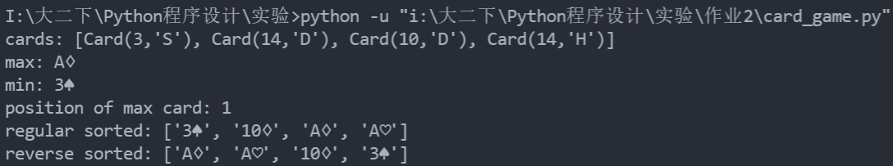
test_Deck()
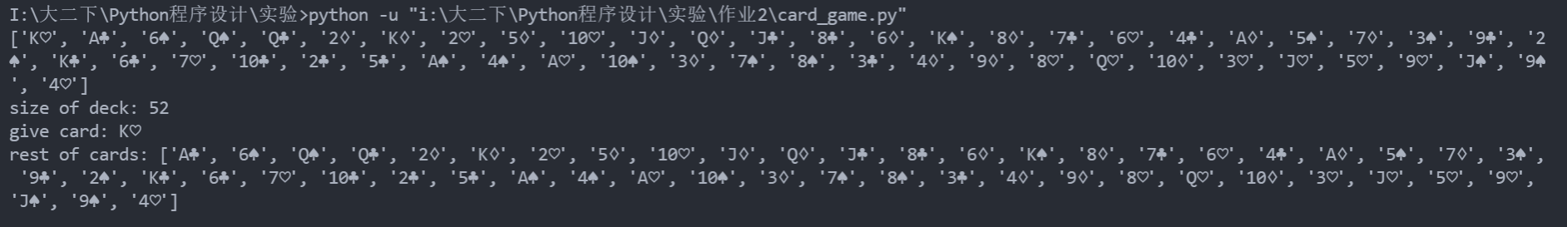
test_Hand()
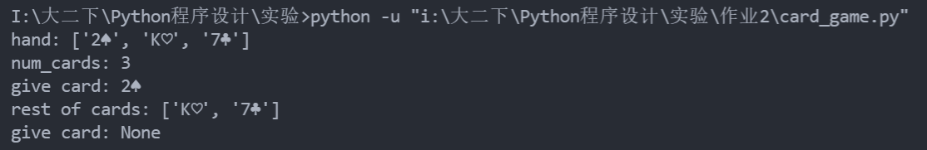
test_Player()
test_Game()
- 52张牌随机分发
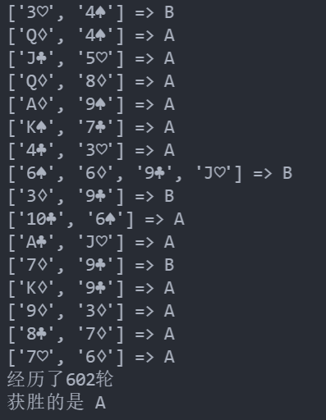
- 特定牌堆
self.players[0].cards = [Card(2, 'H'), Card(3, 'C')]
self.players[1].cards = [Card(2, 'H'), Card(3, 'C')]
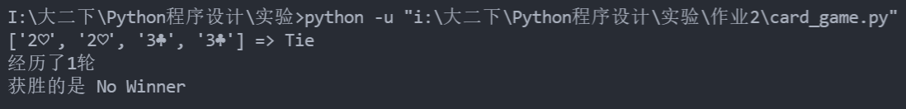
self.players[0].cards = [Card(2, 'H'), Card(3, 'C')]
self.players[1].cards = [Card(3, 'H'), Card(3, 'C')]
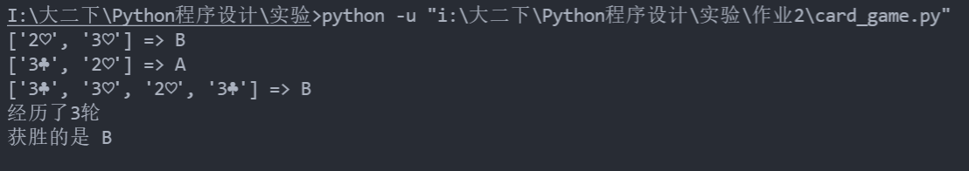

数据处理分析：
Problem 1:
代码:
class SM:
start_state = None

def transition_fn(self, s, x):
raise NotImplementedError

def output_fn(self, s):
raise NotImplementedError

def transduce(self, input_seq):
ans = []
for input in input_seq:
self.start_state = self.transition_fn(
self.start_state, input)
ans.append(self.output_fn(self.start_state))
return ans

class Accumulator(SM):
start_state = 0

def transition_fn(self, s, x):
return s+x

def output_fn(self, s):
return s

class Binary_Addition(SM):
start_state = (0, 0)

def transition_fn(self, s, x):
return ((x[0]+x[1]+s[0]) // 2, (x[0]+x[1]+s[0]) % 2)

def output_fn(self, s):
return s[1]

class Reverser(SM):
start_state = []
end = False

def transition_fn(self, s, x):
if x == 'end':
self.end = True
if self.end:
return s
else:
s.append(x)
return s

def output_fn(self, s):
if not self.end:
return None
else:
if s:
return s.pop()
else:
return None

output = Accumulator().transduce([-1, 2, 3, -2, 5, 6])
print(output)

output = Binary_Addition().transduce([(1, 1), (1, 0), (0, 0)])
print(output)

output = Binary_Addition().transduce(
[(1, 1), (1, 0), (0, 0), (1, 1), (0, 1), (1, 0)])
print(output)

output = Reverser().transduce(
['foo', ' ', 'bar'] + ['end'] + ['end']*3 + list(range(2)))
print(output)

output = Reverser().transduce(list('the') + ['end'] + list(range(3)))
print(output)

output = Reverser().transduce([] + ['end'] + list(range(5)))
print(output)

output = Reverser().transduce(list('nehznehS evol I') + ['end'] +
list(range(15)))
print(output)
Problem 2:
代码:
import itertools
import random

class Card():
def __init__(self, rank, suit):
assert suit in {'S', 'H', 'C', 'D'}
assert rank in range(2, 15)

self.rank = rank
self.suit = suit

suit_str = {'S': "\u2660", 'H': "\u2661", 'C': "\u2663", 'D': "\u2662"}
rank_str = {n: str(n) for n in range(2, 11)}
rank_str[11] = 'J'
rank_str[12] = 'Q'
rank_str[13] = 'K'
rank_str[14] = 'A'

def __str__(self): # 输出，如'2♡'
return f"{self.rank_str[self.rank]}{self.suit_str[self.suit]}"

def __repr__(self): # Card(2,'H')
return f"Card({self.rank},'{self.suit}')"

def __gt__(self, other):
return self.rank > other.rank

def __lt__(self, other):
return self.rank < other.rank

def __eq__(self, other):
return self.rank == other.rank

class Hand():
def __init__(self, cards=[]):
self.cards = []
self.receive_cards(cards)

def receive_cards(self, cards):
self.cards.extend(cards)

def receive_card(self, card):
self.cards.append(card)

def shuffle(self):
if self.cards:
random.shuffle(self.cards)

def give_card(self):
if not self.cards:
return None
temp = self.cards[0]
del self.cards[0]
return temp

def give_cards(self):
if not self.cards:
return None
temp = self.cards.copy()
self.cards.clear()
return temp

def __iter__(self):
yield from self.cards

def __repr__(self):
return f"Hand({self.cards})"

def __str__(self):
return str([str(card) for card in self.cards])

@property # 设置属性，这样可以使用 对象.num_cards 访问，而不是 对象.num_cards()
def num_cards(self):
return len(self.cards)

class Deck(Hand):
def __init__(self):
self.cards = []
for i in Card.rank_str:
for j in Card.suit_str:
self.cards.append(Card(i, j))
# 补充代码: 52张牌
# self.cards = [Card(2, "H"), Card(2, "S"), Card(
# 3, "D"), Card(3, "S")] # 仅供测试用，补充上句后可注释
self.size = self.num_cards
self.shuffle()

class Player(Hand):
def __init__(self, name, cards=[]):
self.name = name
self.cards = cards.copy()

def __repr__(self):
return f"Player({repr(self.name)}, {[c for c in self]})"

def __str__(self):
return f"<{repr(self.name)} has {[str(c) for c in self]}>"

class Game():
def __init__(self, players):
self.players = players
self.deck = Deck()

def deal(self):
# 补充代码：给两个玩家发牌。每个玩家轮流从牌堆Deck中取出一张牌，每人26张。
# while self.deck.cards:
# self.players[0].receive_card(self.deck.give_card())
# self.players[1].receive_card(self.deck.give_card())

# self.players[0].cards = self.deck.cards[:26]
# self.players[1].cards = self.deck.cards[26:]
self.players[0].cards = [Card(2, 'H'), Card(3, 'C')]
self.players[1].cards = [Card(3, 'H'), Card(3, 'C')]

def turn(self):
h = Hand()
while True:
card1 = self.players[0].give_card()
card2 = self.players[1].give_card()
h.receive_cards([card1, card2])
if card1 != card2:
break
if not self.players[0].cards and not self.players[1].cards:
print(h, '=> Tie')
return 'Tie'
if not self.players[0].cards:
print(h, '=>', self.players[1].name)
return self.players[1]
if not self.players[1].cards:
print(h, '=>', self.players[0].name)
return self.players[0]
if card1 < card2:
print(h, '=>', self.players[1].name)
self.players[1].receive_cards(h.give_cards())
self.players[1].shuffle()
return self.players[1]
else:
print(h, '=>', self.players[0].name)
self.players[0].receive_cards(h.give_cards())
self.players[0].shuffle()
return self.players[0]

def play(self):
self.deal() # 发牌
cnt = 0
while True:
cnt += 1
winner = self.turn()
if winner == 'Tie' or not self.players[0].cards or not self.players[1].cards:
Break

print("经历了{}轮".format(cnt))
return winner.name if winner != 'Tie' else 'No Winner'

def test_Card():
cards = [Card(3, 'S'), Card(14, 'D'), Card(10, 'D'), Card(14, 'H')]
# cards: [Card(3,'S'), Card(14,'D'), Card(10,'D'), Card(14,'H')]
print("cards:", cards)
print("max:", max(cards)) # max: A♢
print("min:", min(cards)) # min: 3♠
print("position of max card:", cards.index(
max(cards))) # position of max card: 1
# regular sorted: ['3♠', '10♢', 'A♢', 'A♡']
print("regular sorted:", [str(c) for c in sorted(cards)])
# reverse sorted: ['A♢', 'A♡', '10♢', '3♠']
print("reverse sorted:", [str(c) for c in sorted(cards, reverse=True)])

def test_Hand():
h = Hand()
h.receive_card(Card(2, 'S'))
h.receive_cards([Card(13, 'H'), Card(7, 'C')])
print("hand:", h) # hand: ['2♠', 'K♡', '7♣']
print("num_cards:", h.num_cards) # num_cards: 3
print("give card:", h.give_card()) # give card: 2♠
# rest of cards: ['K♡', '7♣']
print("rest of cards:", [str(c) for c in h.give_cards()])
print("give card:", h.give_card()) # None

def test_Deck():
d = Deck()
print(d) # ['3♢', '3♠', '2♠', '2♡']
print("size of deck:", d.size) # size of deck: 4
print("give card:", d.give_card()) # give card: 3♢
# rest of cards: ['3♠', '2♠', '2♡']
print("rest of cards:", [str(c) for c in d.give_cards()])

def test_Player():
p = Player('Pam')
p.receive_card(Card(10, 'H'))
print(p) # <'Pam' has ['10♡']>

def test_Game():
game = Game([Player("A"), Player("B")])
winner = game.play()
print("获胜的是", winner)

test_Game()
# test_Card()
# test_Deck()
# test_Hand()
# test_Player()

# """
# 例子1:
# at start <'A' has ['2♡', '3♢']>
# at start <'B' has ['2♠', '3♠']>
# ['2♡', '2♠'] => Tie
# ['3♢', '3♠', '2♡', '2♠'] => Tie
# No Winner

# 例子2:
# at start <'A' has ['2♡', '2♠']>
# at start <'B' has ['3♠', '3♢']>
# ['2♡', '3♠'] => B
# ['2♠', '3♠'] => B
# B wins!

深圳大学学生实验报告用纸

实验结论：

完成了两道题的作业要求。

指导教师批阅意见：

成绩评定：

指导教师签字：
年 月 日
备注：
注：1、报告内的项目或内容设置，可根据实际情况加以调整和补充。
2、教师批改学生实验报告时间应在学生提交实验报告时间后10日内。

