深 圳 大 学 实 验 报 告

课程名称： Database System

实验项目名称： Advanced SQL LAB

学院： Computer Science and Software Engineering

专业： Computer Science

指导教师： Basker George

报告人__沈晨玙__学号：2019092121_班级：_19计科国际 _

实验时间： 1th November, 2019

实验报告提交时间： 2th November, 2019

教务部制
实验目的与要求：(Purpose of Experiment purpose and Requirements)
* Please show all work for these problems.
Just writing down the answer will not get full credit.

Answers to the following questions must include:
- SQL Query command ( 60 Points)
- Screenshot of your SQL command result (30 Points)
Note: Oral Question in LAB ( 10 points)

EXERCISES 2 JOINS
1. Find the name and salary of employees in Luton.
2. Join the DEPT table to the EMP table and show in department number order.
3. List the names of all salesmen who work in SALES
4. List all departments that do not have any employees.
5 For each employee whose salary exceeds his manager's salary, list the employee's name and salary and the manager's name and salary.
6. List the employees who have BLAKE as their manager.
7. List all the employee Name and his Manager’s name, even if that employee doesn’t have a manager

EXERCISES 3 FUNCTIONS
1 Find how many employees have a title of manager without listing them.
2 Compute the average annual salary plus commission for all salesmen
3 Find the highest and lowest salaries and the difference between them (single SELECT statement)
4 Find the number of characters in the longest department name
5 Count the number of people in department 30 who receive a salary and the number of people who receive a commission (single statement).
6 List the average commission of employees who receive a commission, and the average commission of all employees (assume employees who do not receive a commission attract zero commission)
7 List the average salary of employees that receive a salary, the average commission of employees that receive a commission, the average salary plus commission of only those employees that receive a commission and the average salary plus commission of all employees including those that do not receive a commission. (single statement)
8 Compute the daily and hourly salary for employees in department 30, round to the nearest penny. Assume there are 22 working days in a month and 8 working hours in a day.
9 Issue the same query as the previous one except that this time truncate (TRUNC) to the nearest penny rather than round.

EXERCISES 4 DATES
1 Select the name, job, and date of hire of the employees in department 20. (Format the hiredate column using a picture MM/DD/YY)
- Use a picture to format hiredate as DAY(day of the week), MONTH (name of the month, ) DD (day of the month) and YYYY(year)
- Which employees were hired in March?
- Which employees were hired on a Tuesday?
- Are there any employees who have worked more than 16 years for the company?
- Show the weekday of the first day of the month in which each employee was hired. (plus their names)
- Show details of employee hiredates and the date of their first payday. (Paydays occur on the last Friday of each month) (plus their names)
- Refine your answer to 7 such that it works even if an employee is hired after the last Friday of the month (cf Martin)

EXERCISES 5 GROUP BY & HAVING

1 List the department number and average salary of each department.
2 Divide all employees into groups by department and by job within department. Count the employees in each group and compute each group's average annual salary.
3 Issue the same query as above except list the department name rather than the department number.
4 List the average annual salary for all job groups having more than 2 employees in the group.
5 Find all departments with an average commission greater than 25% of average salary.
6 Find each department's average annual salary for all its employees except the managers and the president.
7A. List the Department ID and Name where there are at least one Manager and two clerk
7. List the Department ID and Name where there are at least one Manager and two clerk and whose average salary is greater that the company’s average salary.
8. List the name of the Manager who manages most employee
9. List the name of all the Manager who manages atleast 2 employees

EXERCISES 6 SUB QUERIES.

1 List the name and job of employees who have the same job as Jones.

2 Find all the employees in Department 10 that have a job that is the same as anyone in department 30.

3 List the name, job, and department of employees who have the same job as Jones or a salary greater than or equal to Ford.

4 Find all employees in department 10 that have a job that is the same as anyone in the Sales department

5 Find the employees located in Liverpool who have the same job as Allen. Return the results in alphabetical order by employee name.

6 Find all the employees that earn more than the average salary of employees in their department.

7 Find all the employees that earn more than JONES, using temporary labels to abbreviate table names.

8. List the Name of all employees who earn Highest salary and Second Highest salary.

EXERCISES 7 Data Manipulation
1 Create a new table called loans with columns named LNO NUMBER (3), EMPNO NUMBER (4), TYPE CHAR(1), AMNT NUMBER (8,2), Create all constraints, such as Primary Key, Foreign Key, Check

2 Insert the following data

LNO EMPNO TYPE AMNT
23 7499 M 20000.00
42 7499 C 2000.00
65 7844 M 3564.00

3 Check that you have created 3 new records in Loans

4 The Loans table must be altered to include another column OUTST NUMBER(8,2)

5 Add 10% interest to all M type loans

6 Remove all loans less than £3000.00

7 Change the name of loans table to accounts

8 Change the name of column LNO to LOANNO

9 Create a view for use by personnel in department 30 showing employee name, number, job and hiredate

10 Use the view to show employees in department 30 having jobs which are not salesman

11 Create a view which shows summary information for each department.

实验过程及内容：(Methods and steps)
EXERCISES 2 JOINS
- Find the name and salary of employees in Luton.
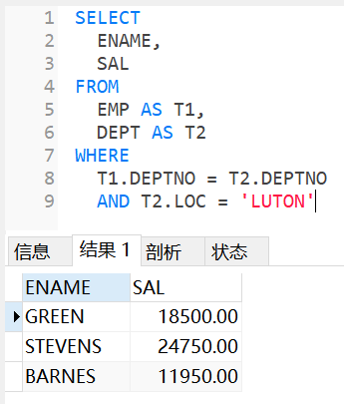

- Join the DEPT table to the EMP table and show in department number order.
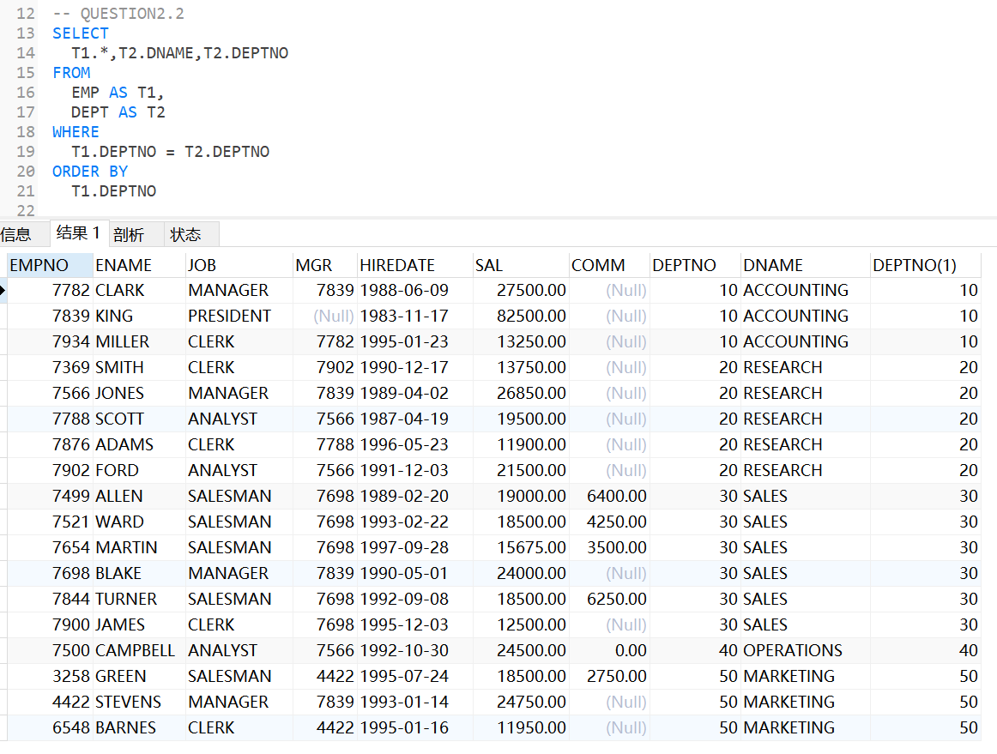
- List the names of all salesmen who work in SALES
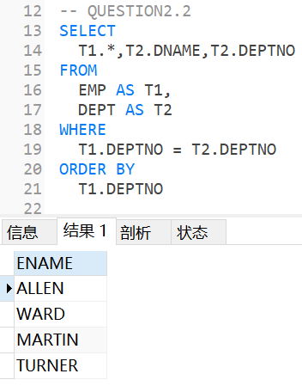
- List all departments that do not have any employees.
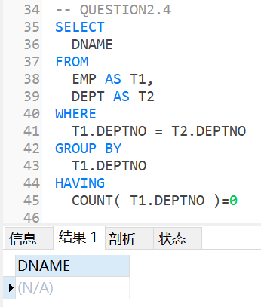
- For each employee whose salary exceeds his manager's salary, list the employee's name and salary and the manager's name and salary.
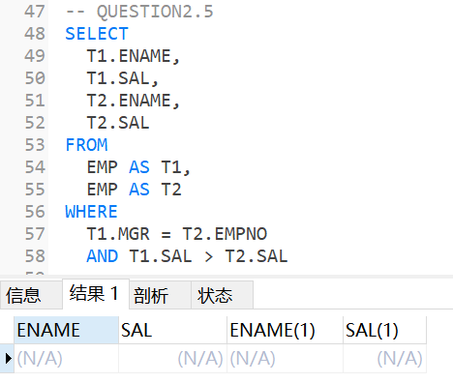

- List the employees who have BLAKE as their manager.
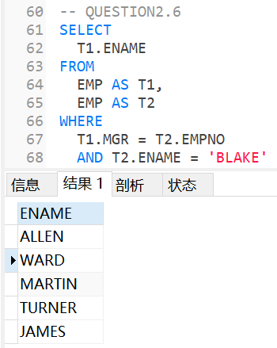

- List all the employee Name and his Manager’s name, even if that employee doesn’t have a manager
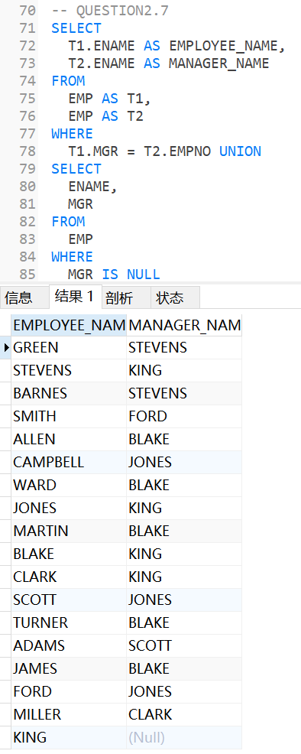
EXERCISES 3 FUNCTIONS
- Find how many employees have a title of manager without listing them.
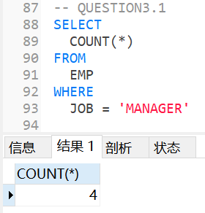
- Compute the average annual salary plus commission for all salesmen
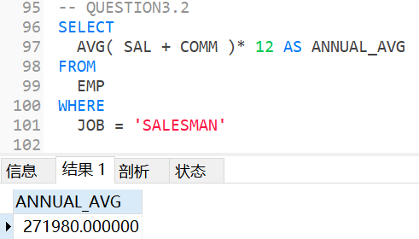

- Find the highest and lowest salaries and the difference between them (single SELECT statement)
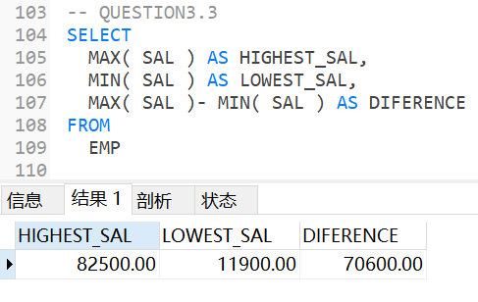

- Find the number of characters in the longest department name
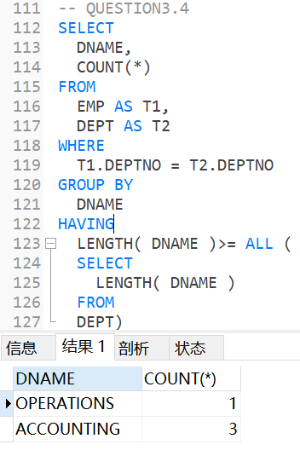
- Count the number of people in department 30 who receive a salary and the number of people who receive a commission (single statement).
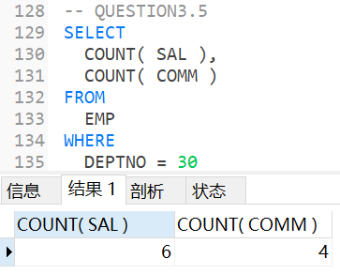

- List the average commission of employees who receive a commission, and the average commission of all employees (assume employees who do not receive a commission attract zero commission)
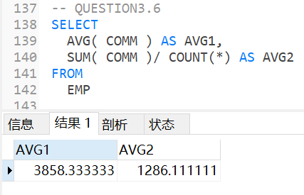

- List the average salary of employees that receive a salary, the average commission of employees that receive a commission, the average salary plus commission of only those employees that receive a commission and the average salary plus commission of all employees including those that do not receive a commission. (single statement)
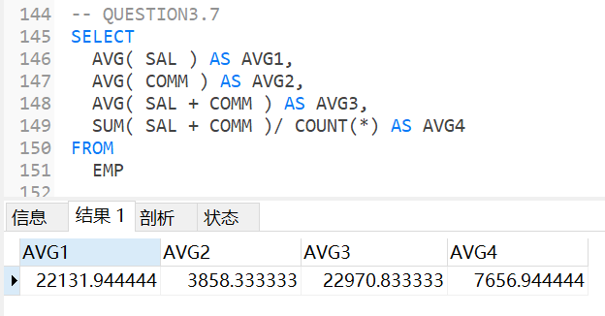

- Compute the daily and hourly salary for employees in department 30, round to the nearest penny. Assume there are 22 working days in a month and 8 working hours in a day.
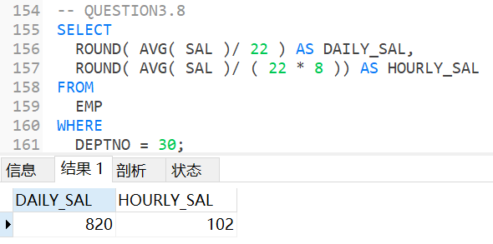

- Issue the same query as the previous one except that this time truncate (TRUNC) to the nearest penny rather than round.
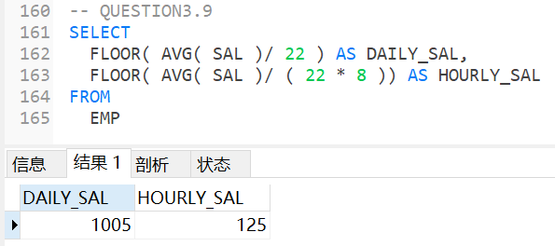
EXERCISES 4 DATES
- Select the name, job, and date of hire of the employees in department 20. (Format the hiredate column using a picture MM/DD/YY)
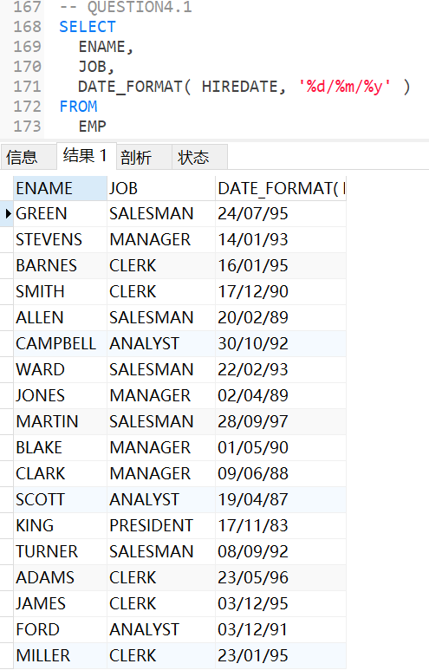
2 Use a picture to format hiredate as DAY(day of the week), MONTH (name of the month, ) DD (day of the month) and YYYY(year)
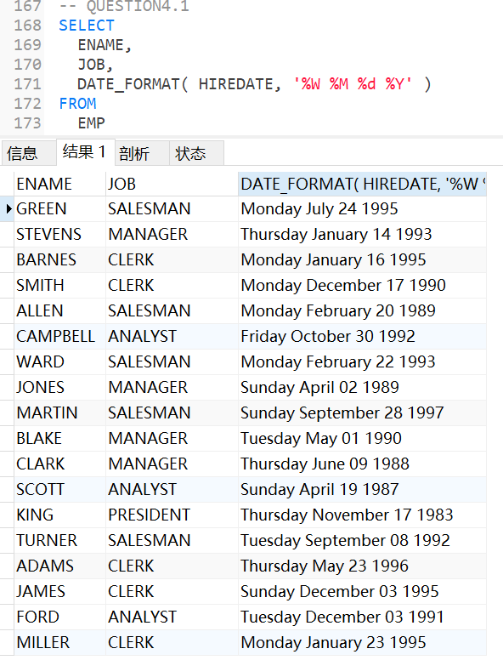

3 Which employees were hired in March?
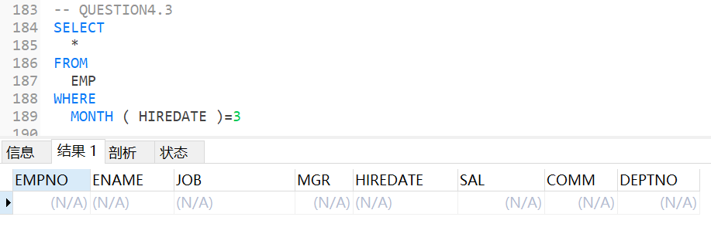
4 Which employees were hired on a Tuesday?
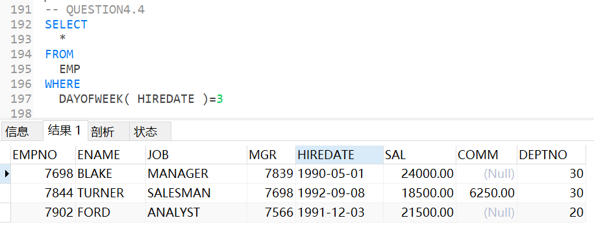
5 Are there any employees who have worked more than 16 years for the company?
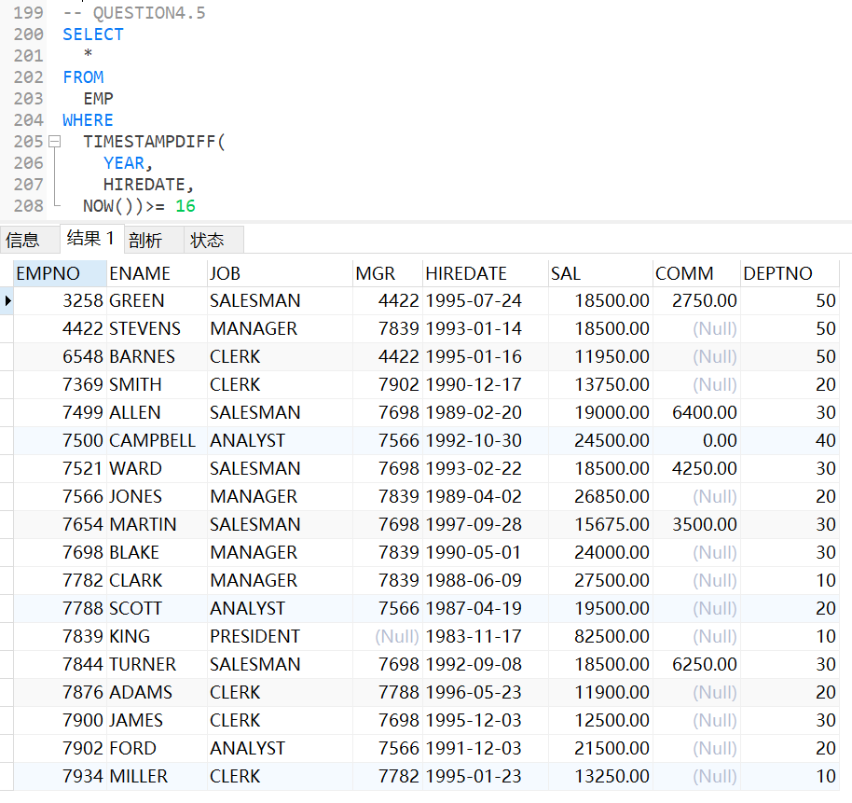
6 Show the weekday of the first day of the month in which each employee was hired. (plus their names)
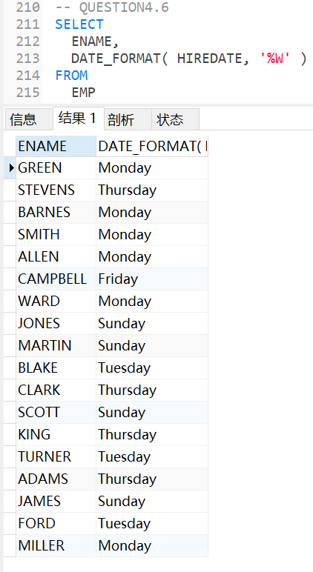
7 Show details of employee hiredates and the date of their first payday. (Paydays occur on the last Friday of each month) (plus their names)

8 Refine your answer to 7 such that it works even if an employee is hired after the last Friday of the month (cf Martin)

EXERCISES 5 GROUP BY & HAVING

- List the department number and average salary of each department.
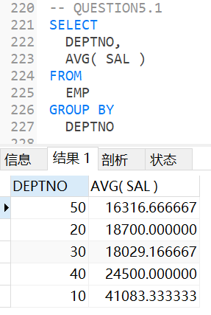
- Divide all employees into groups by department and by job within department. Count the employees in each group and compute each group's average annual salary.
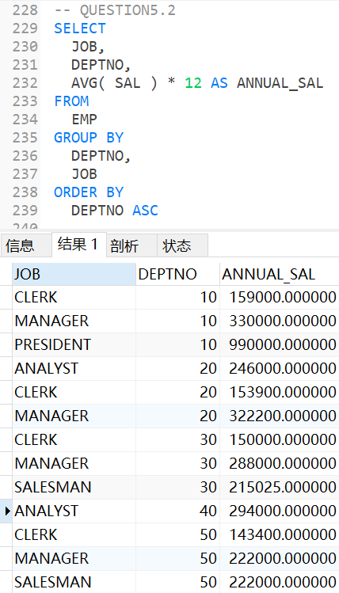
- Issue the same query as above except list the department name rather than the department number.
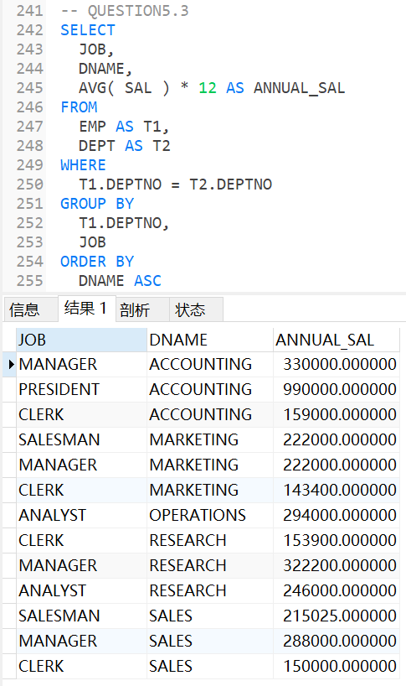

- List the average annual salary for all job groups having more than 2 employees in the group.
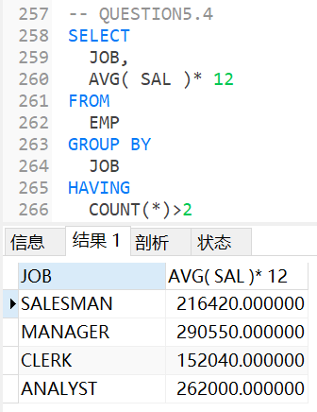
- Find all departments with an average commission greater than 25% of average salary.
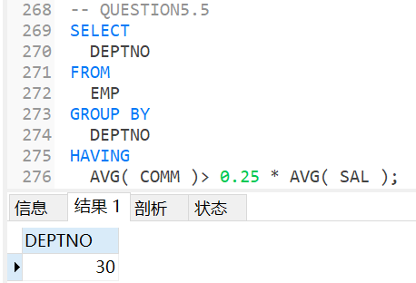

- Find each department's average annual salary for all its employees except the managers and the president.
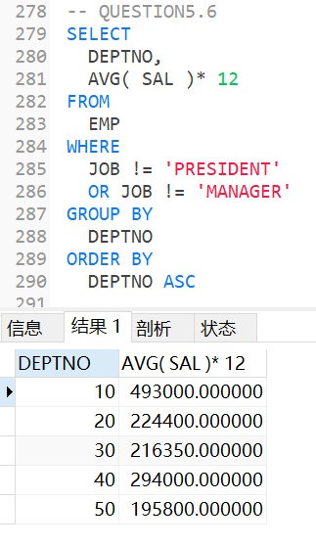
7A. List the Department ID and Name where there are at least one Manager and two clerk
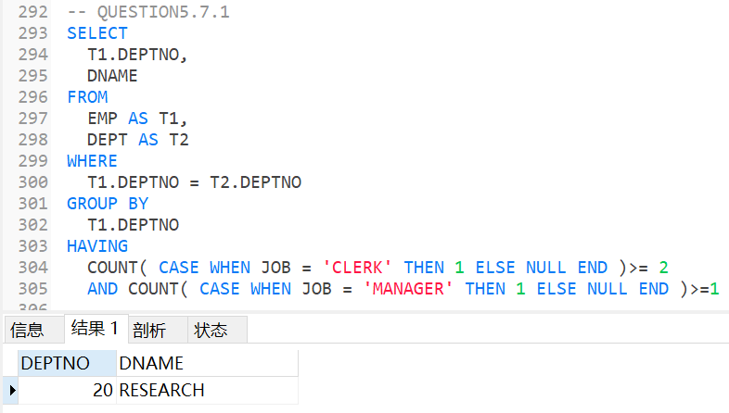
7B. List the Department ID and Name where there are at least one Manager and two clerk and whose average salary is greater that the company’s average salary.
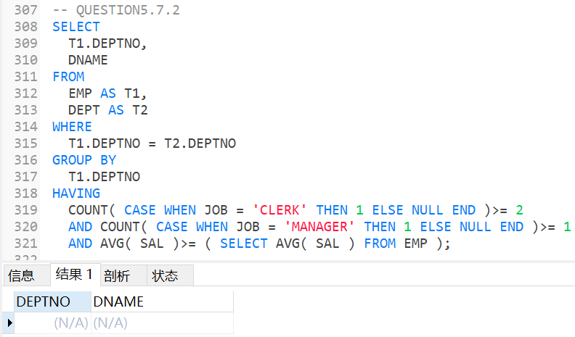
8. List the name of the Manager who manages most employee
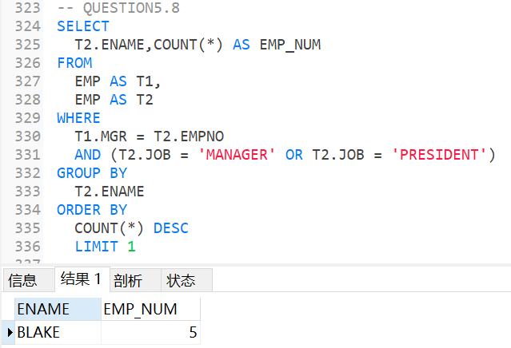
9. List the name of all the Manager who manages at least 2 employees
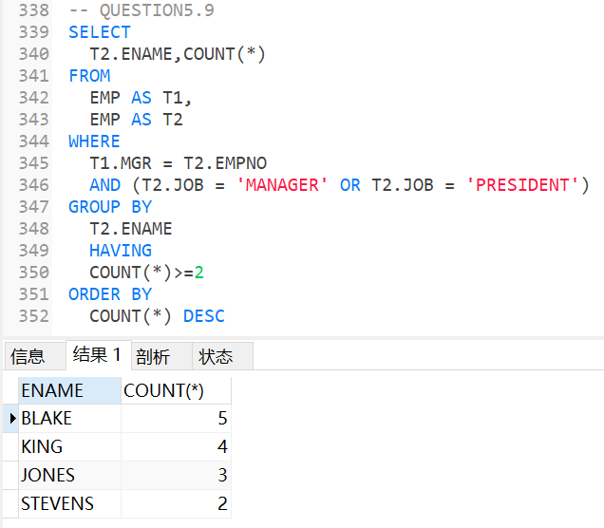
EXERCISES 6 SUB QUERIES.

- List the name and job of employees who have the same job as Jones.
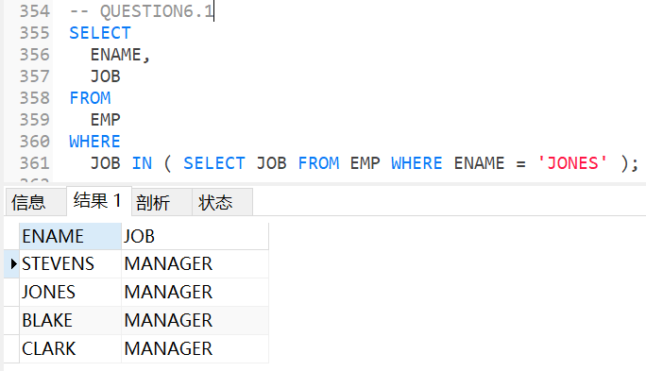
- Find all the employees in Department 10 that have a job that is the same as anyone in department 30.
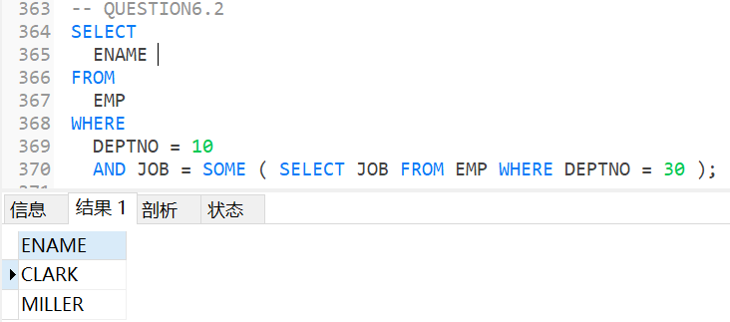
- List the name, job, and department of employees who have the same job as Jones or a salary greater than or equal to Ford.
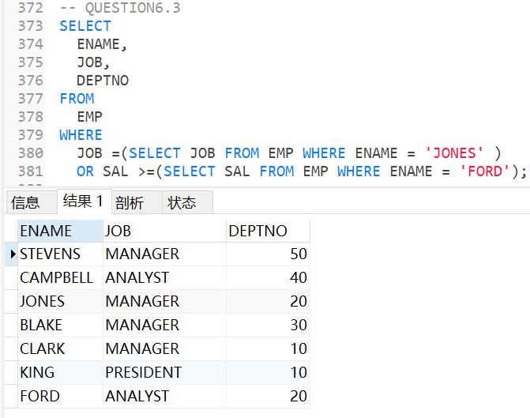
- Find all employees in department 10 that have a job that is the same as anyone in the Sales department
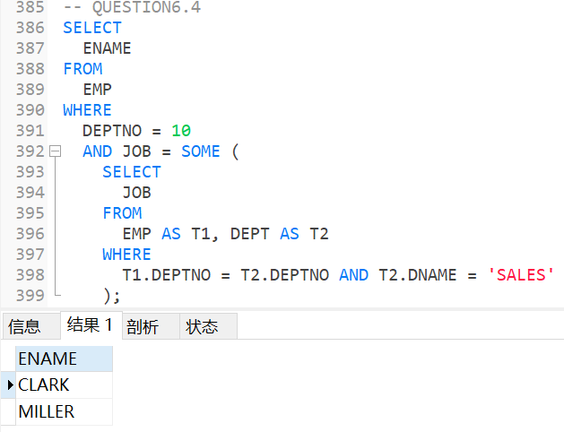
- Find the employees located in Liverpool who have the same job as Allen. Return the results in alphabetical order by employee name.
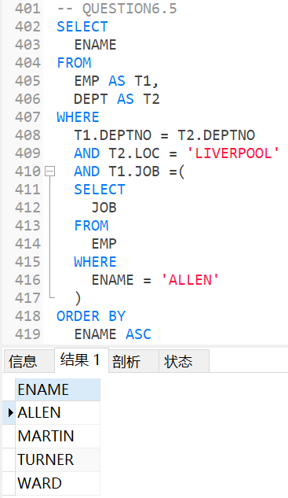

- Find all the employees that earn more than the average salary of employees in their department.
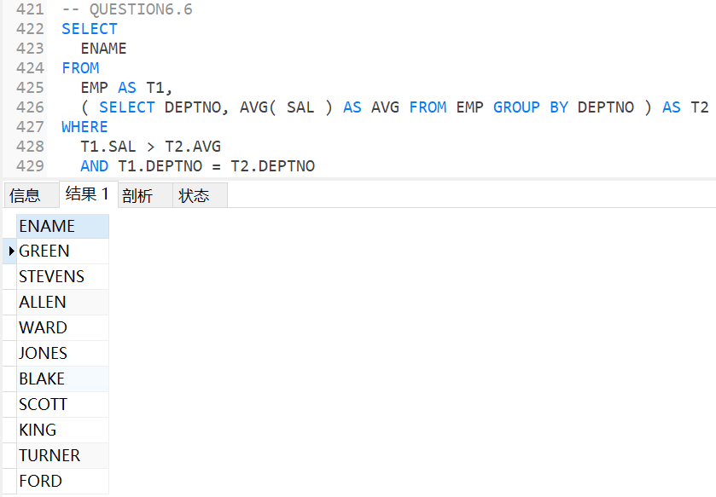
- Find all the employees that earn more than JONES, using temporary labels to abbreviate table names.
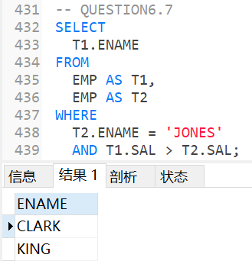
8.List the Name of all employees who earn Highest salary and Second Highest salary.
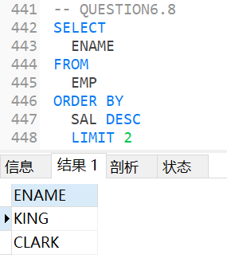
EXERCISES 7 Data Manipulation
- Create a new table called loans with columns named LNO NUMBER (3), EMPNO NUMBER (4), TYPE CHAR(1), AMNT NUMBER (8,2), Create all constraints, such as Primary Key, Foreign Key, Check
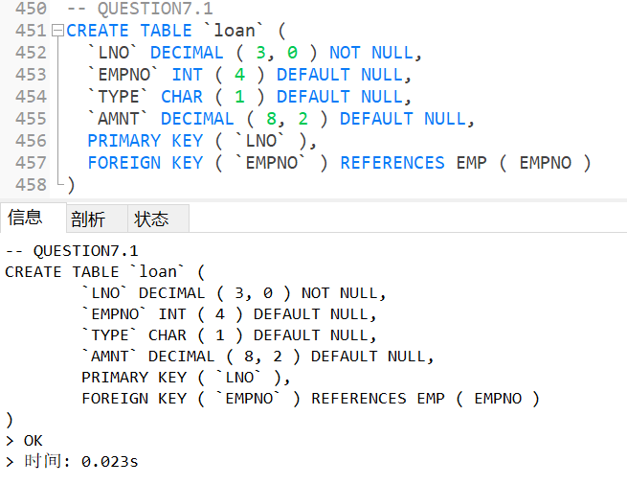
2 Insert the following data

LNO EMPNO TYPE AMNT
23 7499 M 20000.00
42 7499 C 2000.00
65 7844 M 3564.00

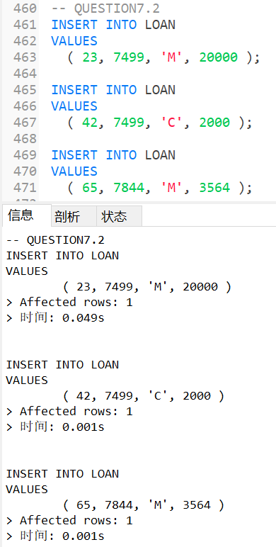
3 Check that you have created 3 new records in Loans
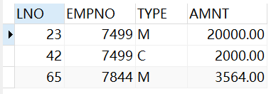
- The Loans table must be altered to include another column OUTST NUMBER(8,2)
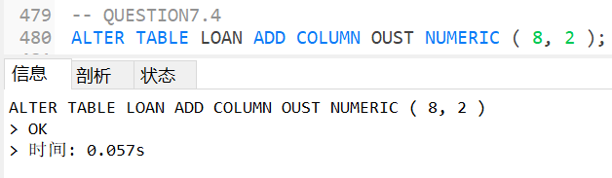

Results:
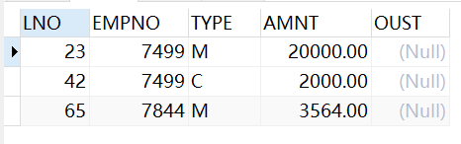

- Add 10% interest to all M type loans
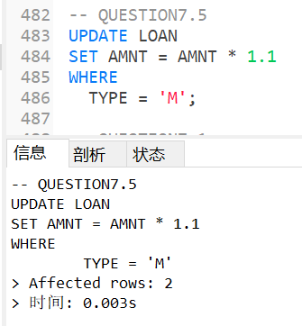

Results:

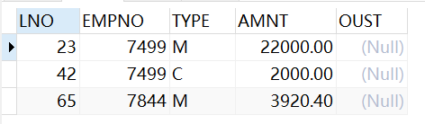

- Remove all loans less than £3000.00
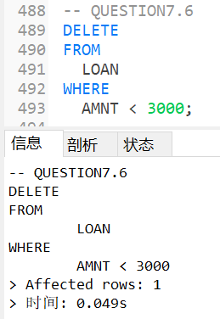

Results:
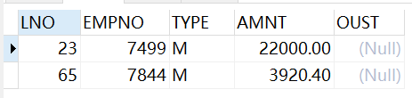

- Change the name of loans table to accounts
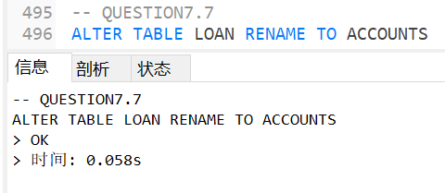

Results:
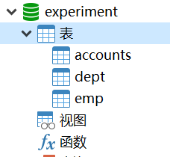

- Change the name of column LNO to LOANNO
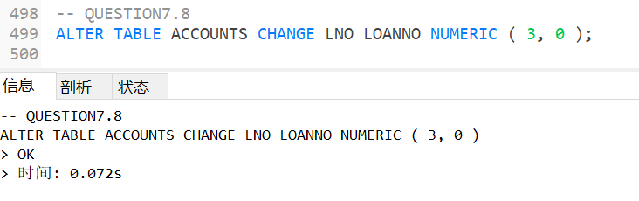
Results:
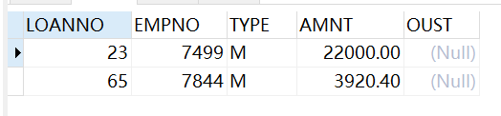

- Create a view for use by personnel in department 30 showing employee name, number, job and hiredate
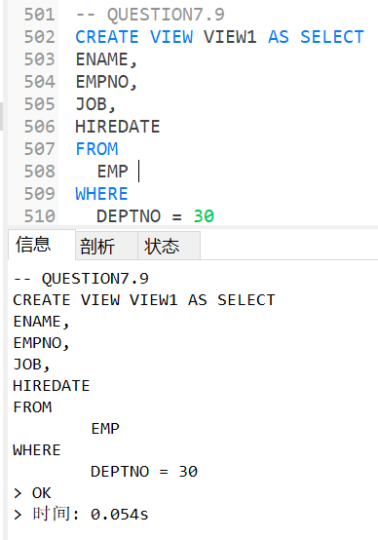
Results:
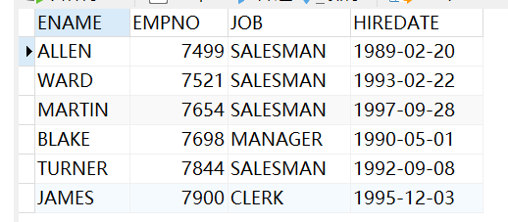
- Use the view to show employees in department 30 having jobs which are not salesman
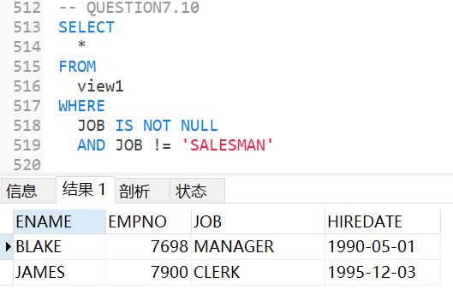

- Create a view which shows summary information for each department.
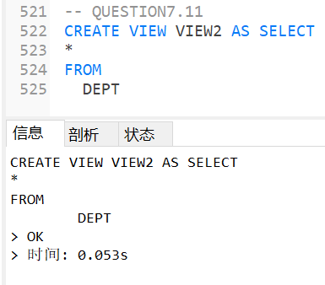
Results:
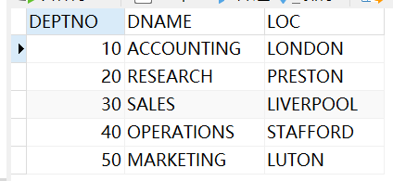

数据处理分析：(Experiment process and content)
SQL知识点整理
- UNION
在表后连接一个新的表
- COUNT/MAX/MIN/...
聚合函数，不能用于where中，若要作为分组条件，只能用户having中
- THETA ALL/SOME
运算符+all/some ===> 大于/小于/... + 部分/全部数据
- ROUND
四舍五入函数
- FLOOR
去尾法函数
- DATE_FORMAT
日期格式定义函数，具体格式见下
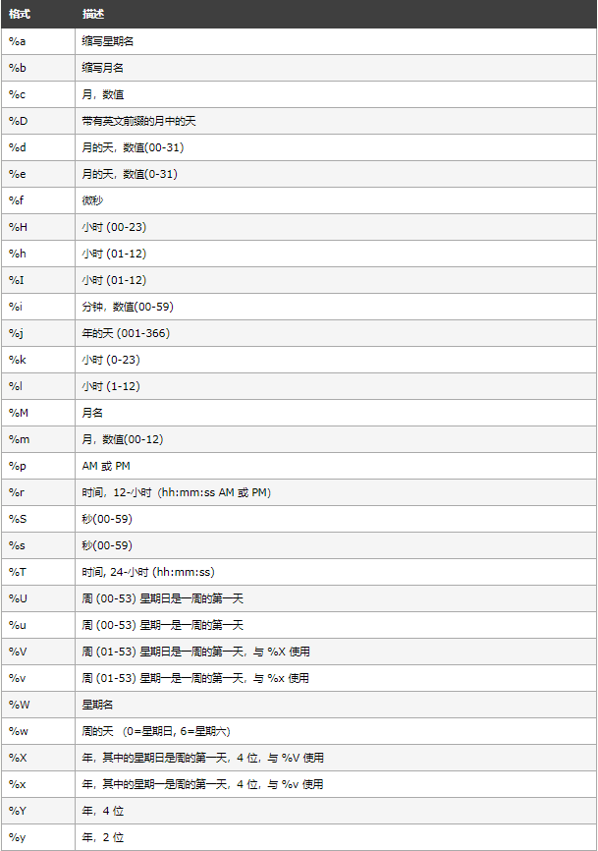
- TIMESTAMPDIFF函数
TIMESTAMPDIFF(interval,datetime_expr1,datetime_expr2)
返回日期或日期时间表达式datetime_expr1 和datetime_expr2the 之间的整数差。
- NOW()函数
获取系统当前时间
- COUNT聚合函数+判断条件
Count(case when XXXX then 1 else NULL end)
返回值为1，计数+1，返回值为NULL，不计数
- 取数据前n行
Order By
XXXX DESC/ASC
Limit n

深圳大学学生实验报告用纸

指导教师批阅意见：
The following problems was identified from the students answer:

成绩评定：

Final Grade of Student is:

指导教师签字：Baker George
2019年11月06 日
备注：
注：1、报告内的项目或内容设置，可根据实际情况加以调整和补充。
2、教师批改学生实验报告时间应在学生提交实验报告时间后10日内。

