**深 圳 大 学 实 验 报 告**

**课程名称： 移动设备交互应用**

**实验项目名称： 课堂作业1**

**学院： 计算机与软件学院**

**专业： 计算机科学与技术**

**指导教师： 解为成**

**报告人： 沈晨玙 学号：2019092121 班级： 19计科国际**

**实验时间： 2020.10.19**

**实验报告提交时间： 2020.10.21**

**教务处制**

一、实验目的与内容：

1. 尝试使用Intent结合Bundle一起传递数据（80分）；

2. 怎样模拟活动被回收，使得 onRestart() 方法被替换成 onCreate方法（书本P62-P63，建议采用手机模拟器，20分）。

二、实验过程和代码与结果

**实验1：**

**Layout界面：**

**Activity1:**

<?xml version="1.0" encoding="utf-8"?>

<LinearLayout xmlns:android="http://schemas.android.com/apk/res/android"

android:layout_width="match_parent"

android:layout_height="match_parent"

android:orientation="vertical">

<TextView

android:layout_width="wrap_content"

android:layout_height="wrap_content"

android:text="This is Activity 1"

android:textSize="30dp"/>

<EditText

android:layout_width="match_parent"

android:layout_height="wrap_content"

android:id="@+id/editText"/>

<Button

android:layout_width="wrap_content"

android:layout_height="wrap_content"

android:text="输入文本,跳转到Activity 2"

android:id="@+id/button1"/>

</LinearLayout>

Activity 2:

<?xml version="1.0" encoding="utf-8"?>

<LinearLayout xmlns:android="http://schemas.android.com/apk/res/android"

android:layout_width="match_parent"

android:layout_height="match_parent"

android:orientation="vertical">

<TextView

android:layout_width="wrap_content"

android:layout_height="wrap_content"

android:text="This is Activity 2"

android:textSize="30dp"/>

<TextView

android:layout_width="match_parent"

android:layout_height="wrap_content"

android:textSize="20dp"

android:id="@+id/textView2"/>

<Button

android:layout_width="wrap_content"

android:layout_height="wrap_content"

android:text="返回main activity"

android:id="@+id/button2"/>

</LinearLayout>

**代码部分：**

Activity 1:

package com.example.classtest1

import android.content.Intent

import android.os.Bundle

import androidx.appcompat.app.AppCompatActivity

import kotlinx.android.synthetic.main.activity_main.*

class MainActivity : AppCompatActivity() {

override fun onCreate(savedInstanceState: Bundle?) {

super.onCreate(savedInstanceState)

setContentView(R.layout.activity_main)

button1.setOnClickListener(){

val intent = Intent(this@MainActivity, second_activity::class.java)

val bundle = Bundle()

bundle.putString("edit", editText.text.toString())

intent.putExtras(bundle)

startActivity(intent)

}

}

}

val intent = Intent(this@MainActivity, second_activity::class.java)

val bundle = Bundle()

bundle.putString("edit", editText.text.toString())

intent.putExtras(bundle)

startActivity(intent)

}

}

}

Activity 2:

package com.example.classtest1

import android.content.Intent

import android.os.Bundle

import androidx.appcompat.app.AppCompatActivity

import kotlinx.android.synthetic.main.activity_second_activity.*

class second_activity : AppCompatActivity() {

override fun onCreate(savedInstanceState: Bundle?) {

super.onCreate(savedInstanceState)

setContentView(R.layout.activity_second_activity)

val bb = this.intent.extras;

val str = bb!!.getString("edit")

textView2.text = str

button2.setOnClickListener(){

val intent2 = Intent(this, MainActivity::class.java)

startActivity(intent2)

}

}

}

**结果：从Activity1中输入文字，通过bundle传递数据给Activity2，通过intent，Button实现Activity之间跳转。**

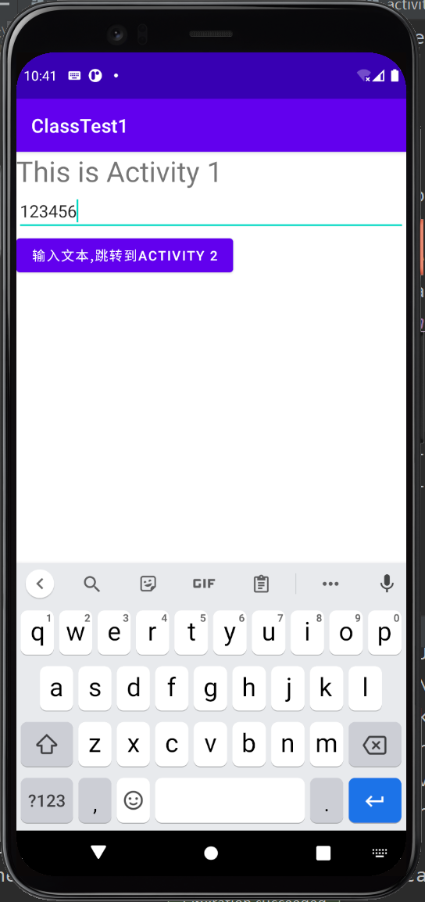 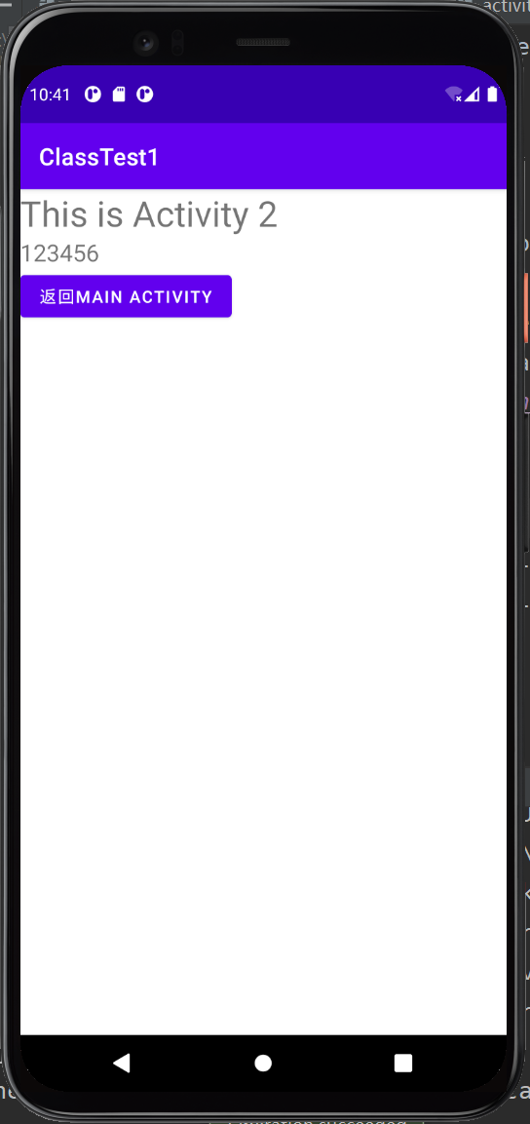

**实验1：**

**Layout界面：**

**Activity1:**

<?xml version="1.0" encoding="utf-8"?>

<RelativeLayout xmlns:android="http://schemas.android.com/apk/res/android"

xmlns:tools="http://schemas.android.com/tools"

android:id="@+id/activity_main"

android:layout_width="match_parent"

android:layout_height="match_parent"

android:paddingBottom="@dimen/activity_vertical_margin"

android:paddingLeft="@dimen/activity_horizontal_margin"

android:paddingRight="@dimen/activity_horizontal_margin"

android:paddingTop="@dimen/activity_vertical_margin"

tools:context="com.example.activityrecycle.MainActivity">

<TextView

android:layout_width="wrap_content"

android:layout_height="wrap_content"

android:text="Hello World!"

android:id="@+id/textView" />

<Button

android:text="Button"

android:layout_width="wrap_content"

android:layout_height="wrap_content"

android:id="@+id/button"

android:layout_below="@+id/textView"

android:layout_toEndOf="@+id/textView"

android:layout_marginStart="18dp"

android:layout_marginTop="63dp" />

</RelativeLayout>

android:paddingTop="@dimen/activity_vertical_margin"

tools:context="com.example.activityrecycle.MainActivity">

<TextView

android:layout_width="wrap_content"

android:layout_height="wrap_content"

android:text="Hello World!"

android:id="@+id/textView" />

<Button

android:text="Button"

android:layout_width="wrap_content"

android:layout_height="wrap_content"

android:id="@+id/button"

android:layout_below="@+id/textView"

android:layout_toEndOf="@+id/textView"

android:layout_marginStart="18dp"

android:layout_marginTop="63dp" />

</RelativeLayout>

**Activity2:**

<?xml version="1.0" encoding="utf-8"?>

<RelativeLayout xmlns:android="http://schemas.android.com/apk/res/android"

xmlns:tools="http://schemas.android.com/tools"

android:id="@+id/activity_second"

android:layout_width="match_parent"

android:layout_height="match_parent"

android:paddingBottom="@dimen/activity_vertical_margin"

android:paddingLeft="@dimen/activity_horizontal_margin"

android:paddingRight="@dimen/activity_horizontal_margin"

android:paddingTop="@dimen/activity_vertical_margin"

tools:context="com.example.activityrecycle.SecondActivity">

</RelativeLayout>

**代码部分：**

Activity 1:

package com.example.activityrecycle;

import android.content.Intent;

import androidx.appcompat.app.AppCompatActivity;

import android.os.Bundle;

import android.util.Log;

import android.view.View;

import android.widget.Button;

public class MainActivity extends AppCompatActivity {

private static final String TAG = "MainActivity";

@Override

protected void onCreate(Bundle savedInstanceState) {

super.onCreate(savedInstanceState);

Log.d(TAG, "onCreate Begin");

setContentView(R.layout.activity_main);

Button button1 = (Button) findViewById(R.id.button);

button1.setOnClickListener(new View.OnClickListener() {

@Override

public void onClick(View view) {

Intent intent = new Intent(MainActivity.this, SecondActivity.class);

startActivity(intent);

}

});

Log.d(TAG, "Show savedInstanceState");

if (savedInstanceState != null){

Log.d(TAG, "Hello First Activity");

String tempData=savedInstanceState.getString("data_key");

Log.d(TAG, tempData);

}

}

@Override

protected void onRestart() {

super.onRestart();

Log.d(TAG, "onRestart is executed!");

}

@Override

protected void onSaveInstanceState(Bundle outState) {

Log.d(TAG, "onSaveInstanceState");

String tempData="Something you just typed";

outState.putString("data_key", tempData);

super.onSaveInstanceState(outState);

}

@Override

protected void onRestoreInstanceState(Bundle savedInstanceState) {

Log.d(TAG, "onRestoreInstanceState");

super.onRestoreInstanceState(savedInstanceState);

String tempData = savedInstanceState.getString("data_;key");

Log.d(TAG, tempData);

}

//static final String STATE_USER = "user";

//private String mUser;

//@Override

//protected void onCreate(Bundle savedInstanceState) {

// super.onCreate(savedInstanceState);

// // Check whether we're recreating a previously destroyed instance

// if (savedInstanceState != null) {

// // Restore value of members from saved state

// mUser = savedInstanceState.getString(STATE_USER);

// } else {

// // Probably initialize members with default values for a new instance

// mUser = "NewUser";

// }

//}

//

//@Override

//public void onSaveInstanceState(Bundle savedInstanceState) {

// savedInstanceState.putString(STATE_USER, mUser);

// // Always call the superclass so it can save the view hierarchy state

// super.onSaveInstanceState(savedInstanceState);

//}

}

}

@Override

protected void onSaveInstanceState(Bundle outState) {

Log.d(TAG, "onSaveInstanceState");

String tempData="Something you just typed";

outState.putString("data_key", tempData);

super.onSaveInstanceState(outState);

}

@Override

protected void onRestoreInstanceState(Bundle savedInstanceState) {

Log.d(TAG, "onRestoreInstanceState");

super.onRestoreInstanceState(savedInstanceState);

String tempData = savedInstanceState.getString("data_;key");

Log.d(TAG, tempData);

}

//static final String STATE_USER = "user";

//private String mUser;

//@Override

//protected void onCreate(Bundle savedInstanceState) {

// super.onCreate(savedInstanceState);

// // Check whether we're recreating a previously destroyed instance

// if (savedInstanceState != null) {

// // Restore value of members from saved state

// mUser = savedInstanceState.getString(STATE_USER);

// } else {

// // Probably initialize members with default values for a new instance

// mUser = "NewUser";

// }

//}

//

//@Override

//public void onSaveInstanceState(Bundle savedInstanceState) {

// savedInstanceState.putString(STATE_USER, mUser);

// // Always call the superclass so it can save the view hierarchy state

// super.onSaveInstanceState(savedInstanceState);

//}

}

**Acticity 2：**

package com.example.activityrecycle;

import androidx.appcompat.app.AppCompatActivity;

import android.os.Bundle;

public class SecondActivity extends AppCompatActivity {

@Override

protected void onCreate(Bundle savedInstanceState) {

super.onCreate(savedInstanceState);

setContentView(R.layout.activity_second);

}

}

**结果：重写Activity 1的onCreate（），onRestart（）方法，模拟活动被回收**

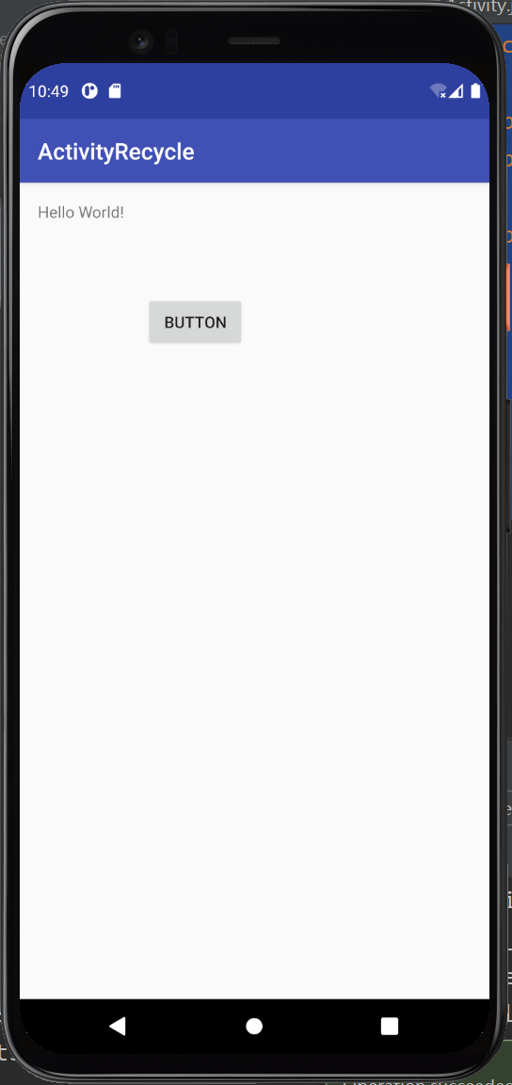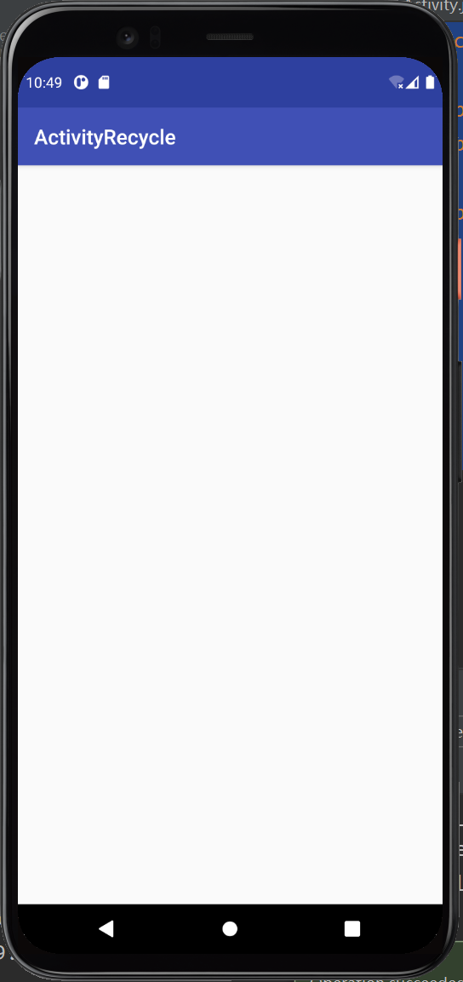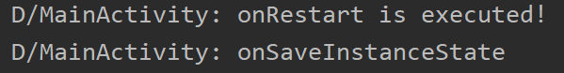

1. 实验总结

体验了运用使用Intent结合Bundle一起传递数据的方法，以及模拟了活动被回收的过程，进一步了解了安卓应用的实现机制与原理。期间没有遇到什么问题。

|  |
| --- |
| 指导教师批阅意见：  成绩评定：  指导教师签字：解为成  年 月 日 |
| 备注： |

注：1、报告内的项目或内容设置，可根据实际情况加以调整和补充。

2、教师批改学生实验报告时间应在学生提交实验报告时间后10日内。