Q1

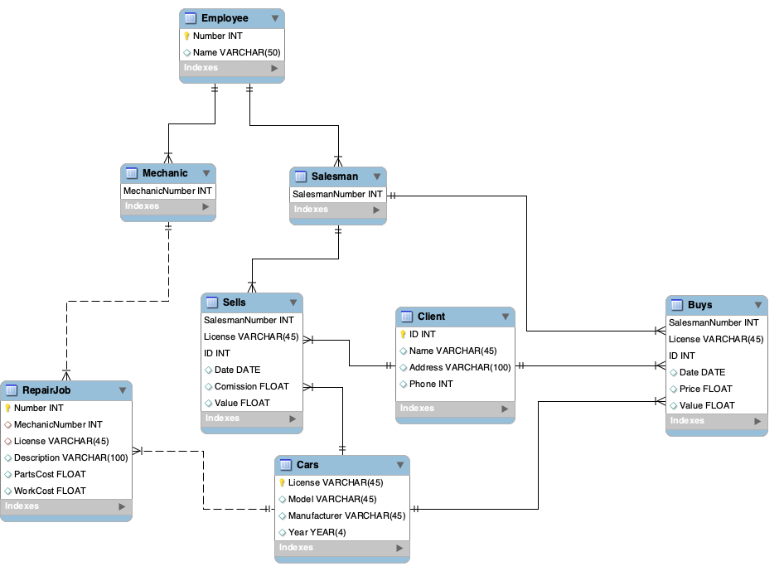

-- -----------------------------------------------------

-- Schema CarSales

-- -----------------------------------------------------

CREATE SCHEMA IF NOT EXISTS `CarSales` DEFAULT CHARACTER SET utf8 ;

USE `CarSales` ;

-- -----------------------------------------------------

-- Table `CarSales`.`Employee`

-- -----------------------------------------------------

CREATE TABLE IF NOT EXISTS `CarSales`.`Employee` (

`Number` INT NOT NULL,

`Name` VARCHAR(50) NULL,

PRIMARY KEY (`Number`))

ENGINE = InnoDB;

-- -----------------------------------------------------

-- Table `CarSales`.`Mechanic`

-- -----------------------------------------------------

CREATE TABLE IF NOT EXISTS `CarSales`.`Mechanic` (

`MechanicNumber` INT NOT NULL,

PRIMARY KEY (`MechanicNumber`),

CONSTRAINT `fk_Mechanic_Employee`

FOREIGN KEY (`MechanicNumber`)

REFERENCES `CarSales`.`Employee` (`Number`))

;

-- -----------------------------------------------------

-- Table `CarSales`.`Salesman`

-- -----------------------------------------------------

CREATE TABLE IF NOT EXISTS `CarSales`.`Salesman` (

`SalesmanNumber` INT NOT NULL,

PRIMARY KEY (`SalesmanNumber`),

CONSTRAINT `fk_Salesman_Employee1`

FOREIGN KEY (`SalesmanNumber`)

REFERENCES `CarSales`.`Employee` (`Number`));

-- -----------------------------------------------------

-- Table `CarSales`.`Cars`

-- -----------------------------------------------------

CREATE TABLE IF NOT EXISTS `CarSales`.`Cars` (

`License` VARCHAR(45) NOT NULL,

`Model` VARCHAR(45) NULL,

`Manufacturer` VARCHAR(45) NULL,

`Year` YEAR(4) NULL,

PRIMARY KEY (`License`));

-- -----------------------------------------------------

-- Table `CarSales`.`RepairJob`

-- -----------------------------------------------------

CREATE TABLE IF NOT EXISTS `CarSales`.`RepairJob` (

`Number` INT NOT NULL,

`MechanicNumber` INT NULL,

`License` VARCHAR(45) NULL,

`Description` VARCHAR(100) NULL,

`PartsCost` FLOAT NULL,

`WorkCost` FLOAT NULL,

PRIMARY KEY (`Number`),

INDEX `fk_RepairJob_Mechanic1_idx` (`MechanicNumber` ASC) VISIBLE,

INDEX `fk_RepairJob_Cars1_idx` (`License` ASC) VISIBLE,

CONSTRAINT `fk_RepairJob_Mechanic1`

FOREIGN KEY (`MechanicNumber`)

REFERENCES `CarSales`.`Mechanic` (`MechanicNumber`),

CONSTRAINT `fk_RepairJob_Cars1`

FOREIGN KEY (`License`)

REFERENCES `CarSales`.`Cars` (`License`));

-- -----------------------------------------------------

-- Table `CarSales`.`Client`

-- -----------------------------------------------------

CREATE TABLE IF NOT EXISTS `CarSales`.`Client` (

`ID` INT NOT NULL,

`Name` VARCHAR(45) NULL,

`Address` VARCHAR(100) NULL,

`Phone` INT NULL,

PRIMARY KEY (`ID`));

-- -----------------------------------------------------

-- Table `CarSales`.`Buys`

-- -----------------------------------------------------

CREATE TABLE IF NOT EXISTS `CarSales`.`Buys` (

`SalesmanNumber` INT NOT NULL,

`License` VARCHAR(45) NOT NULL,

`ID` INT NOT NULL,

`Date` DATE NULL,

`Price` FLOAT NULL,

`Value` FLOAT NULL,

PRIMARY KEY (`SalesmanNumber`, `License`, `ID`),

INDEX `fk_Buys_Cars1_idx` (`License` ASC) VISIBLE,

INDEX `fk_Buys_Client1_idx` (`ID` ASC) VISIBLE,

CONSTRAINT `fk_Buys_Salesman1`

FOREIGN KEY (`SalesmanNumber`)

REFERENCES `CarSales`.`Salesman` (`SalesmanNumber`),

CONSTRAINT `fk_Buys_Cars1`

FOREIGN KEY (`License`)

REFERENCES `CarSales`.`Cars` (`License`),

CONSTRAINT `fk_Buys_Client1`

FOREIGN KEY (`ID`)

REFERENCES `CarSales`.`Client` (`ID`));

-- -----------------------------------------------------

-- Table `CarSales`.`Sells`

-- -----------------------------------------------------

CREATE TABLE IF NOT EXISTS `CarSales`.`Sells` (

`SalesmanNumber` INT NOT NULL,

`License` VARCHAR(45) NOT NULL,

`ID` INT NOT NULL,

`Date` DATE NULL,

`Comission` FLOAT NULL,

`Value` FLOAT NULL,

PRIMARY KEY (`SalesmanNumber`, `License`, `ID`),

INDEX `fk_Sells_Cars1_idx` (`License` ASC) VISIBLE,

INDEX `fk_Sells_Client1_idx` (`ID` ASC) VISIBLE,

CONSTRAINT `fk_Sells_Salesman1`

FOREIGN KEY (`SalesmanNumber`)

REFERENCES `CarSales`.`Salesman` (`SalesmanNumber`),

CONSTRAINT `fk_Sells_Cars1`

FOREIGN KEY (`License`)

REFERENCES `CarSales`.`Cars` (`License`),

CONSTRAINT `fk_Sells_Client1`

FOREIGN KEY (`ID`)

REFERENCES `CarSales`.`Client` (`ID`));

Q2

