CC –Certified in Cybersecurity

*Diagrams*

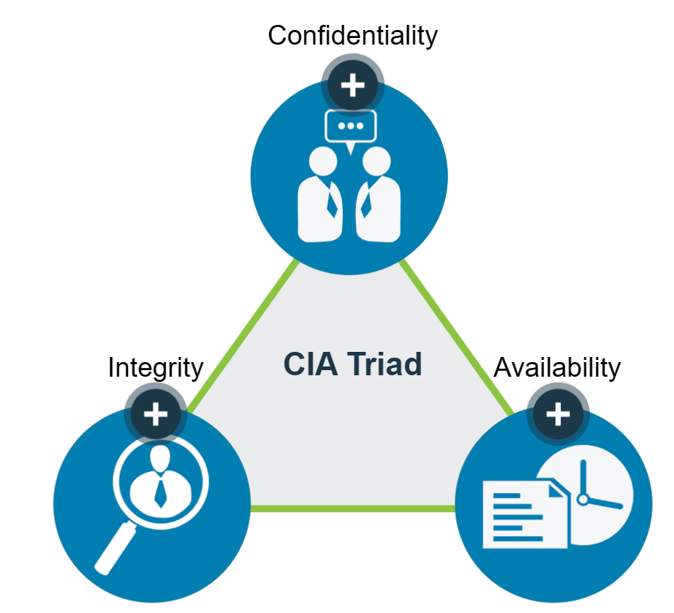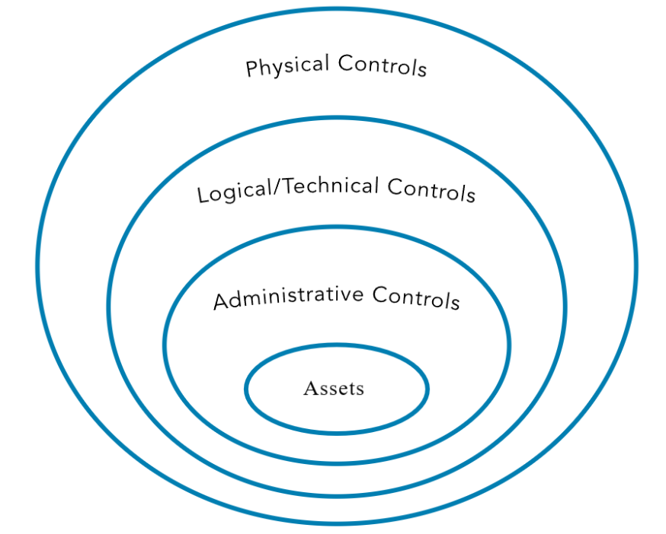

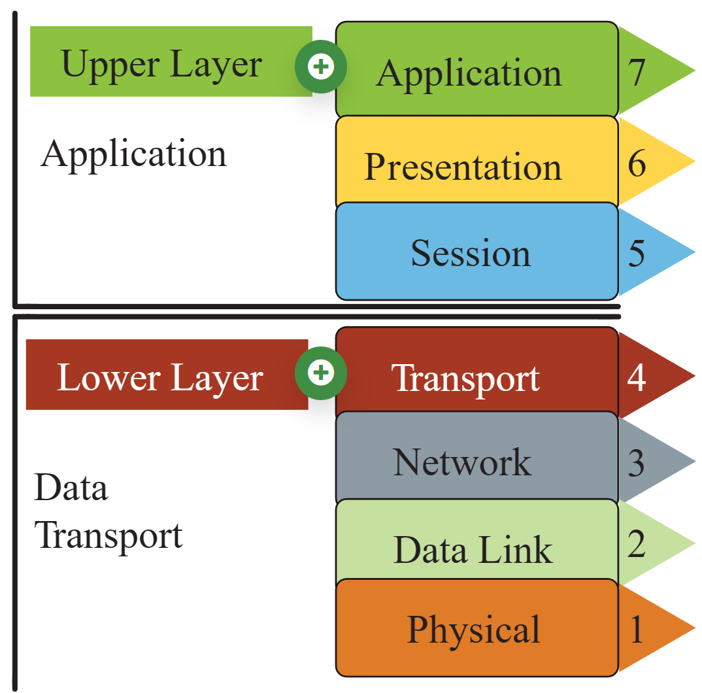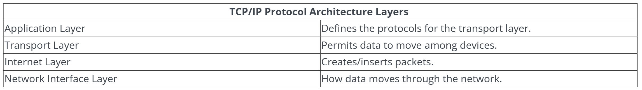

The following are the glossary terms for studying provided by <https://learn.isc2.org/> for preparation for CC exam.

* **Adequate Security** - Security commensurate with the risk and the magnitude of harm resulting from the loss, misuse or unauthorized access to or modification of information. Source: OMB Circular A-130
* **Administrative Controls -**Controls implemented through policy and procedures. Examples include access control processes and requiring multiple personnel to conduct a specific operation. Administrative controls in modern environments are often enforced in conjunction with physical and/or technical controls, such as an access-granting policy for new users that requires login and approval by the hiring manager.
* **Artificial Intelligence** - The ability of computers and robots to simulate human intelligence and behavior.
* **Asset**- Anything of value that is owned by an organization. Assets include both tangible items such as information systems and physical property and intangible assets such as intellectual property.
* **Authentication** - Access control process validating that the identity being claimed by a user or entity is known to the system, by comparing one (single factor or SFA) or more (multi-factor authentication or MFA) factors of identification.
* **Authorization -**The right or a permission that is granted to a system entity to access a system resource. NIST 800-82 Rev.2
* **Availability** - Ensuring timely and reliable access to and use of information by authorized users.
* **Baseline** - A documented, lowest level of security configuration allowed by a standard or organization.
* **Bot**- Malicious code that acts like a remotely controlled “robot” for an attacker, with other Trojan and worm capabilities.
* **Classified or Sensitive Information** - Information that has been determined to require protection against unauthorized disclosure and is marked to indicate its classified status and classification level when in documentary form.
* **Confidentiality** - The characteristic of data or information when it is not made available or disclosed to unauthorized persons or processes. NIST 800-66
* **Criticality** - A measure of the degree to which an organization depends on the information or information system for the success of a mission or of a business function. NIST SP 800-60 Vol. 1, Rev. 1
* **Data Integrity**- The property that data has not been altered in an unauthorized manner. Data integrity covers data in storage, during processing and while in transit. Source: NIST SP 800-27 Rev A
* **Encryption** - The process and act of converting the message from its plaintext to ciphertext. Sometimes it is also referred to as enciphering. The two terms are sometimes used interchangeably in literature and have similar meanings.
* **General Data Protection Regulation (GDPR)** - In 2016, the European Union passed comprehensive legislation that addresses personal privacy, deeming it an individual human right.
* **Governance -**The process of how an organization is managed; usually includes all aspects of how decisions are made for that organization, such as policies, roles, and procedures the organization uses to make those decisions.
* **Health Insurance Portability and Accountability Act (HIPAA)** - This U.S. federal law is the most important healthcare information regulation in the United States. It directs the adoption of national standards for electronic healthcare transactions while protecting the privacy of individual's health information. Other provisions address fraud reduction, protections for individuals with health insurance and a wide range of other healthcare-related activities. Est. 1996.
* **Impact**- The magnitude of harm that could be caused by a threat’s exercise of a vulnerability.
* **Information Security Risk** - The potential adverse impacts to an organization’s operations (including its mission, functions and image and reputation), assets, individuals, other organizations, and even the nation, which results from the possibility of unauthorized access, use, disclosure, disruption, modification or destruction of information and/or information systems.
* **Institute of Electrical and Electronics Engineers** - IEEE is a professional organization that sets standards for telecommunications, computer engineering and similar disciplines.
* **Integrity** - The property of information whereby it is recorded, used and maintained in a way that ensures its completeness, accuracy, internal consistency and usefulness for a stated purpose.
* **International Organization of Standards (ISO)**- The ISO develops voluntary international standards in collaboration with its partners in international standardization, the International Electro-technical Commission (IEC) and the International Telecommunication Union (ITU), particularly in the field of information and communication technologies.
* **Internet Engineering Task Force (IETF)**- The internet standards organization, made up of network designers, operators, vendors and researchers, that defines protocol standards (e.g., IP, TCP, DNS) through a process of collaboration and consensus. Source: NIST SP 1800-16B
* **Likelihood**- The probability that a potential vulnerability may be exercised within the construct of the associated threat environment.
* **Likelihood of Occurrence**- A weighted factor based on a subjective analysis of the probability that a given threat is capable of exploiting a given vulnerability or set of vulnerabilities.
* **Multi-Factor Authentication** - Using two or more distinct instances of the three factors of authentication (something you know, something you have, something you are) for identity verification.
* **National Institutes of Standards and Technology (NIST)**- The NIST is part of the U.S. Department of Commerce and addresses the measurement infrastructure within science and technology efforts within the U.S. federal government. NIST sets standards in a number of areas, including information security within the Computer Security Resource Center of the Computer Security Divisions.
* **Non-repudiation** - The inability to deny taking an action such as creating information, approving information and sending or receiving a message.
* **Personally Identifiable Information (PII)** - The National Institute of Standards and Technology, known as NIST, in its Special Publication 800-122 defines PII as “any information about an individual maintained by an agency, including (1) any information that can be used to distinguish or trace an individual’s identity, such as name, Social Security number, date and place of birth, mother’s maiden name, or biometric records; and (2) any other information that is linked or linkable to an individual, such as medical, educational, financial and employment information.”
* **Physical Controls** - Controls implemented through a tangible mechanism. Examples include walls, fences, guards, locks, etc. In modern organizations, many physical control systems are linked to technical/logical systems, such as badge readers connected to door locks.
* **Privacy** - The right of an individual to control the distribution of information about themselves.
* **Probability** - The chances, or likelihood, that a given threat is capable of exploiting a given vulnerability or a set of vulnerabilities. Source: NIST SP 800-30 Rev. 1
* **Protected Health Information (PHI)**- Information regarding health status, the provision of healthcare or payment for healthcare as defined in HIPAA (Health Insurance Portability and Accountability Act).
* **Qualitative Risk Analysis** - A method for risk analysis that is based on the assignment of a descriptor such as low, medium or high. Source: NISTIR 8286
* **Quantitative Risk Analysis**- A method for risk analysis where numerical values are assigned to both impact and likelihood based on statistical probabilities and monetarized valuation of loss or gain. Source: NISTIR 8286
* **Risk** - A possible event which can have a negative impact upon the organization.
* **Risk Acceptance** - Determining that the potential benefits of a business function outweigh the possible risk impact/likelihood and performing that business function with no other action.
* **Risk Assessment**- The process of identifying and analyzing risks to organizational operations (including mission, functions, image, or reputation), organizational assets, individuals and other organizations. The analysis performed as part of risk management which incorporates threat and vulnerability analyses and considers mitigations provided by security controls planned or in place.
* **Risk Avoidance**- Determining that the impact and/or likelihood of a specific risk is too great to be offset by the potential benefits and not performing a certain business function because of that determination.
* **Risk Management** - The process of identifying, evaluating and controlling threats, including all the phases of risk context (or frame), risk assessment, risk treatment and risk monitoring.
* **Risk Management Framework** - A structured approach used to oversee and manage risk for an enterprise. Source: CNSSI 4009
* **Risk Mitigation** - Putting security controls in place to reduce the possible impact and/or likelihood of a specific risk.
* **Risk Tolerance** - The level of risk an entity is willing to assume in order to achieve a potential desired result. Source: NIST SP 800-32. Risk threshold, risk appetite and acceptable risk are also terms used synonymously with risk tolerance.
* **Risk Transference**- Paying an external party to accept the financial impact of a given risk.
* **Risk Treatment**- The determination of the best way to address an identified risk.
* **Security Controls** - The management, operational and technical controls (i.e., safeguards or countermeasures) prescribed for an information system to protect the confidentiality, integrity and availability of the system and its information. Source: FIPS PUB 199
* **Sensitivity**- A measure of the importance assigned to information by its owner, for the purpose of denoting its need for protection. Source: NIST SP 800-60 Vol 1 Rev 1
* **Single-Factor Authentication** - Use of just one of the three available factors (something you know, something you have, something you are) to carry out the authentication process being requested.
* **State**- The condition an entity is in at a point in time.
* **System Integrity**- The quality that a system has when it performs its intended function in an unimpaired manner, free from unauthorized manipulation of the system, whether intentional or accidental. Source: NIST SP 800-27 Rev. A
* **Technical Controls** - Security controls (i.e., safeguards or countermeasures) for an information system that are primarily implemented and executed by the information system through mechanisms contained in the hardware, software or firmware components of the system.
* **Threat**- Any circumstance or event with the potential to adversely impact organizational operations (including mission, functions, image or reputation), organizational assets, individuals, other organizations or the nation through an information system via unauthorized access, destruction, disclosure, modification of information and/or denial of service.
* **Threat Actor**- An individual or a group that attempts to exploit vulnerabilities to cause or force a threat to occur.
* **Threat Vector** - The means by which a threat actor carries out their objectives.
* **Token**- A physical object a user possesses and controls that is used to authenticate the user’s identity. Source: NISTIR 7711
* **Vulnerability** - Weakness in an information system, system security procedures, internal controls or implementation that could be exploited by a threat source. Source: NIST SP 800-30 Rev 1
* **Adverse Events** - Events with a negative consequence, such as system crashes, network packet floods, unauthorized use of system privileges, defacement of a web page or execution of malicious code that destroys data.
* **Breach** - The loss of control, compromise, unauthorized disclosure, unauthorized acquisition or any similar occurrence where: a person other than an authorized user accesses or potentially accesses personally identifiable information; or an authorized user accesses personally identifiable information for other than an authorized purpose. Source: NIST SP 800-53 Rev. 5
* **Business Continuity (BC)** - Actions, processes and tools for ensuring an organization can continue critical operations during a contingency.
* **Business Continuity Plan (BCP)** - The documentation of a predetermined set of instructions or procedures that describe how an organization’s mission/business processes will be sustained during and after a significant disruption.
* **Business Impact Analysis (BIA)**- An analysis of an information system’s requirements, functions, and interdependencies used to characterize system contingency requirements and priorities in the event of a significant disruption. Reference: https://csrc.nist.gov/glossary/term/business-impact-analysis
* **Disaster Recovery (DR)** - In information systems terms, the activities necessary to restore IT and communications services to an organization during and after an outage, disruption or disturbance of any kind or scale.
* **Disaster Recovery Plan (DRP)** - The processes, policies and procedures related to preparing for recovery or continuation of an organization's critical business functions, technology infrastructure, systems and applications after the organization experiences a disaster. A disaster is when an organization’s critical business function(s) cannot be performed at an acceptable level within a predetermined period following a disruption.
* **Event** - Any observable occurrence in a network or system. Source: NIST SP 800-61 Rev 2
* **Exploit**- A particular attack. It is named this way because these attacks exploit system vulnerabilities.
* **Incident** - An event that actually or potentially jeopardizes the confidentiality, integrity or availability of an information system or the information the system processes, stores or transmits.
* **Incident Handling** - The mitigation of violations of security policies and recommended practices. Source: NIST SP 800-61 Rev 2
* **Incident Response (IR)** - The mitigation of violations of security policies and recommended practices. Source: NIST SP 800-61 Rev 2
* **Incident Response Plan (IRP)** - The documentation of a predetermined set of instructions or procedures to detect, respond to and limit consequences of a malicious cyberattack against an organization’s information systems(s). Source: NIST SP 800-34 Rev 1
* **Intrusion**- A security event, or combination of security events, that constitutes a security incident in which an intruder gains, or attempts to gain, access to a system or system resource without authorization. Source: IETF RFC 4949 Ver 2
* **Security Operations Center**- A centralized organizational function fulfilled by an information security team that monitors, detects and analyzes events on the network or system to prevent and resolve issues before they result in business disruptions.
* **Vulnerability** - Weakness in an information system, system security procedures, internal controls or implementation that could be exploited or triggered by a threat source. Source: NIST SP 800-128.
* **Zero Day** - A previously unknown system vulnerability with the potential of exploitation without risk of detection or prevention because it does not, in general, fit recognized patterns, signatures or methods.
* **Audit** - Independent review and examination of records and activities to assess the adequacy of system controls, to ensure compliance with established policies and operational procedures. NIST SP 1800-15B
* **Crime Prevention through Environmental Design (CPTED)**- An architectural approach to the design of buildings and spaces which emphasizes passive features to reduce the likelihood of criminal activity.
* **Defense in Depth** - Information security strategy integrating people, technology, and operations capabilities to establish variable barriers across multiple layers and missions of the organization. Source: NIST SP 800-53 Rev 4
* **Discretionary Access Control (DAC)**- A certain amount of access control is left to the discretion of the object’s owner, or anyone else who is authorized to control the object’s access. The owner can determine who should have access rights to an object and what those rights should be. NIST SP 800-192
* **Encrypt** - To protect private information by putting it into a form that can only be read by people who have permission to do so.
* **Firewalls**- Devices that enforce administrative security policies by filtering incoming traffic based on a set of rules.
* **Insider Threat** - An entity with authorized access that has the potential to harm an information system through destruction, disclosure, modification of data, and/or denial of service. NIST SP 800-32
* **iOS**- An operating system manufactured by Apple Inc. Used for mobile devices.
* **Layered Defense** - The use of multiple controls arranged in series to provide several consecutive controls to protect an asset; also called defense in depth.
* **Linux** - An operating system that is open source, making its source code legally available to end users.
* **Log Anomaly** - A system irregularity that is identified when studying log entries which could represent events of interest for further surveillance.
* **Logging** - Collecting and storing user activities in a log, which is a record of the events occurring within an organization’s systems and networks. NIST SP 1800-25B.
* **Logical Access Control Systems**- An automated system that controls an individual’s ability to access one or more computer system resources, such as a workstation, network, application or database. A logical access control system requires the validation of an individual’s identity through some mechanism, such as a PIN, card, biometric or other token. It has the capability to assign different access privileges to different individuals depending on their roles and responsibilities in an organization. NIST SP 800-53 Rev.5.
* **Mandatory Access Control** - Access control that requires the system itself to manage access controls in accordance with the organization’s security policies.
* **Mantrap** - An entrance to a building or an area that requires people to pass through two doors with only one door opened at a time.
* **Object** - Passive information system-related entity (e.g., devices, files, records, tables, processes, programs, domains) containing or receiving information. Access to an object (by a subject) implies access to the information it contains. See subject. Source: NIST SP 800-53 Rev 4
* **Physical Access Controls**- Controls implemented through a tangible mechanism. Examples include walls, fences, guards, locks, etc. In modern organizations, many physical control systems are linked to technical/logical systems, such as badge readers connected to door locks.
* **Principle of Least Privilege** - The principle that users and programs should have only the minimum privileges necessary to complete their tasks. NIST SP 800-179
* **Privileged Account** - An information system account with approved authorizations of a privileged user. NIST SP 800-53 Rev. 4
* **Ransomware** - A type of malicious software that locks the computer screen or files, thus preventing or limiting a user from accessing their system and data until money is paid.
* **Role-based access control (RBAC)** - An access control system that sets up user permissions based on roles.
* **Rule** - An instruction developed to allow or deny access to a system by comparing the validated identity of the subject to an access control list.
* **Segregation of Duties** - The practice of ensuring that an organizational process cannot be completed by a single person; forces collusion as a means to reduce insider threats. Also commonly known as Separation of Duties.
* **Subject** - Generally an individual, process or device causing information to flow among objects or change to the system state. Source: NIST SP800-53 R4
* **Technical Controls** - The security controls (i.e., safeguards or countermeasures) for an information system that are primarily implemented and executed by the information system through mechanisms contained in the hardware, software or firmware components of the system.
* **Turnstile** - A one-way spinning door or barrier that allows only one person at a time to enter a building or pass through an area.
* **Unix** - An operating system used in software development.
* **User Provisioning** - The process of creating, maintaining and deactivating user identities on a system.
* **Application programming interface (API)** - A set of routines, standards, protocols, and tools for building software applications to access a web-based software application or web tool.
* **Bit** - The most essential representation of data (zero or one) at Layer 1 of the Open Systems Interconnection (OSI) model.
* **Broadcast** - Broadcast transmission is a one-to-many (one-to-everyone) form of sending internet traffic.
* **Byte** - The byte is a unit of digital information that most commonly consists of eight bits.
* **Cloud computing** - A model for enabling ubiquitous, convenient, on-demand network access to a shared pool of configurable computing resources (e.g., networks, servers, storage, applications, and services) that can be rapidly provisioned and released with minimal management effort or service provider interaction. NIST 800-145
* **Community cloud**- A system in which the cloud infrastructure is provisioned for exclusive use by a specific community of consumers from organizations that have shared concerns (e.g., mission, security requirements, policy and compliance considerations). It may be owned, managed and operated by one or more of the organizations in the community, a third party or some combination of them, and it may exist on or off premises. NIST 800-145
* **De-encapsulation**- The opposite process of encapsulation, in which bundles of data are unpacked or revealed.
* **Denial-of-Service (DoS)** - The prevention of authorized access to resources or the delaying of time-critical operations. (Time-critical may be milliseconds or it may be hours, depending upon the service provided.) Source: NIST SP 800-27 Rev A
* **Domain Name Service (DNS)** - This acronym can be applied to three interrelated elements: a service, a physical server and a network protocol.
* **Encapsulation** - Enforcement of data hiding and code hiding during all phases of software development and operational use. Bundling together data and methods is the process of encapsulation; its opposite process may be called unpacking, revealing, or using other terms. Also used to refer to taking any set of data and packaging it or hiding it in another data structure, as is common in network protocols and encryption.
* **Encryption** - The process and act of converting the message from its plaintext to ciphertext. Sometimes it is also referred to as enciphering. The two terms are sometimes used interchangeably in literature and have similar meanings.
* **File Transfer Protocol (FTP)**- The internet protocol (and program) used to transfer files between hosts.
* **Fragment attack**- In a fragment attack, an attacker fragments traffic in such a way that a system is unable to put data packets back together.
* **De-encapsulation**- The opposite process of encapsulation, in which bundles of data are unpacked or revealed.
* **Denial-of-Service (DoS)** - The prevention of authorized access to resources or the delaying of time-critical operations. (Time-critical may be milliseconds or it may be hours, depending upon the service provided.) Source: NIST SP 800-27 Rev A
* **Domain Name Service (DNS)** - This acronym can be applied to three interrelated elements: a service, a physical server and a network protocol.
* **Encapsulation** - Enforcement of data hiding and code hiding during all phases of software development and operational use. Bundling together data and methods is the process of encapsulation; its opposite process may be called unpacking, revealing, or using other terms. Also used to refer to taking any set of data and packaging it or hiding it in another data structure, as is common in network protocols and encryption.
* **Encryption** - The process and act of converting the message from its plaintext to ciphertext. Sometimes it is also referred to as enciphering. The two terms are sometimes used interchangeably in literature and have similar meanings.
* **File Transfer Protocol (FTP)**- The internet protocol (and program) used to transfer files between hosts.
* **Fragment attack**- In a fragment attack, an attacker fragments traffic in such a way that a system is unable to put data packets back together.
* **Packet**- Representation of data at Layer 3 of the Open Systems Interconnection (OSI) model.
* **Payload**- The primary action of a malicious code attack.
* **Payment Card Industry Data Security Standard (PCI DSS)** - An information security standard administered by the Payment Card Industry Security Standards Council that applies to merchants and service providers who process credit or debit card transactions.
* **Platform as a Service (PaaS)** - The web-authoring or application development middleware environment that allows applications to be built in the cloud before they’re deployed as SaaS assets.
* **Private cloud** - The phrase used to describe a cloud computing platform that is implemented within the corporate firewall, under the control of the IT department. A private cloud is designed to offer the same features and benefits of cloud systems, but removes a number of objections to the cloud computing model, including control over enterprise and customer data, worries about security, and issues connected to regulatory compliance.
* **Protocols** - A set of rules (formats and procedures) to implement and control some type of association (that is, communication) between systems. NIST SP 800-82 Rev. 2
* **Public cloud** - The cloud infrastructure is provisioned for open use by the general public. It may be owned, managed, and operated by a business, academic, or government organization, or some combination of them. It exists on the premises of the cloud provider. NIST SP 800-145
* **Simple Mail Transport Protocol (SMTP)** - The standard communication protocol for sending and receiving emails between senders and receivers.
* **Software** - Computer programs and associated data that may be dynamically written or modified during execution. NIST SP 80-37 Rev. 2
* **Software as a Service (SaaS)** - The cloud customer uses the cloud provider’s applications running within a cloud infrastructure. The applications are accessible from various client devices through either a thin client interface, such as a web browser or a program interface. The consumer does not manage or control the underlying cloud infrastructure including network, servers, operating systems, storage, or even individual application capabilities, with the possible exception of limited user-specific application configuration settings. Derived from NIST 800-145
* **Spoofing** - Faking the sending address of a transmission to gain illegal entry into a secure system. CNSSI 4009-2015
* **Transport Control Protocol/Internet Protocol (TCP/IP) Model**- Internetworking protocol model created by the IETF, which specifies four layers of functionality: Link layer (physical communications), Internet Layer (network-to-network communication), Transport Layer (basic channels for connections and connectionless exchange of data between hosts), and Application Layer, where other protocols and user applications programs make use of network services.
* **Virtual Local Area Network (VLAN)** - A logical group of workstations, servers, and network devices that appear to be on the same LAN despite their geographical distribution.
* **VPN**- A virtual private network (VPN), built on top of existing networks, that can provide a secure communications mechanism for transmission between networks.
* **Wireless Area Network (WLAN)** - A group of computers and devices that are located in the same vicinity, forming a network based on radio transmissions rather than wired connections. A Wi-Fi is network is a type of WLAN.
* **Zenmap** - The graphical user interface (GUI) for the Nmap Security Scanner, an open-source application that scans networks to determine everything that is connected as well as other information.
* **Zero Trust** - Removing the design belief that the network has any trusted space. Security is managed at each possible level, representing the most granular asset. Microsegmentation of workloads is a tool of the model.

* **Application Server** - A computer responsible for hosting applications to user workstations. NIST SP 800-82 Rev.2
* **Asymmetric Encryption** - An algorithm that uses one key to encrypt and a different key to decrypt the input plaintext.
* **Checksum** - A digit representing the sum of the correct digits in a piece of stored or transmitted digital data, against which later comparisons can be made to detect errors in the data.
* **Ciphertext** - The altered form of a plaintext message so it is unreadable for anyone except the intended recipients. In other words, it has been turned into a secret.
* **Classification** - Classification identifies the degree of harm to the organization, its stakeholders or others that might result if an information asset is divulged to an unauthorized person, process or organization. In short, classification is focused first and foremost on maintaining the confidentiality of the data, based on the data sensitivity.
* **Configuration management** - A process and discipline used to ensure that the only changes made to a system are those that have been authorized and validated.
* **Cryptanalyst** - One who performs cryptanalysis which is the study of mathematical techniques for attempting to defeat cryptographic techniques and/or information systems security. This includes the process of looking for errors or weaknesses in the implementation of an algorithm or of the algorithm itself.
* **Cryptography** - The study or applications of methods to secure or protect the meaning and content of messages, files, or other information, usually by disguise, obscuration, or other transformations of that content and meaning.
* **Data Loss Prevention (DLP)** - System capabilities designed to detect and prevent the unauthorized use and transmission of information.
* **Decryption** - The reverse process from encryption. It is the process of converting a ciphertext message back into plaintext through the use of the cryptographic algorithm and the appropriate key for decryption (which is the same for symmetric encryption, but different for asymmetric encryption). This term is also used interchangeably with the “deciphering.”
* **Degaussing** - A technique of erasing data on disk or tape (including video tapes) that, when performed properly, ensures that there is insufficient magnetic remanence to reconstruct data.
* **Digital Signature** - The result of a cryptographic transformation of data which, when properly implemented, provides the services of origin authentication, data integrity, and signer non-repudiation. NIST SP 800-12 Rev. 1
* **Egress Monitoring** - Monitoring of outgoing network traffic.
* **Encryption**- The process and act of converting the message from its plaintext to ciphertext. Sometimes it is also referred to as enciphering. The two terms are sometimes used interchangeably in literature and have similar meanings.
* **Encryption System** - The total set of algorithms, processes, hardware, software, and procedures that taken together provide an encryption and decryption capability.
* **Hardening**- A reference to the process of applying secure configurations (to reduce the attack surface) and locking down various hardware, communications systems, and software, including operating system, web server, application server, application, etc. Hardening is normally performed based on industry guidelines and benchmarks, such as those provided by the Center for Internet Security (CIS).
* **Hash Function** - An algorithm that computes a numerical value (called the hash value) on a data file or electronic message that is used to represent that file or message and depends on the entire contents of the file or message. A hash function can be considered to be a fingerprint of the file or message. NIST SP 800-152
* **Hashing**- The process of using a mathematical algorithm against data to produce a numeric value that is representative of that data. Source CNSSI 4009-2015
* **Ingress Monitoring** - Monitoring of incoming network traffic.
* **Message Digest** - A digital signature that uniquely identifies data and has the property such that changing a single bit in the data will cause a completely different message digest to be generated. NISTIR-8011 Vol.3
* **Operating System** - The software “master control application” that runs the computer. It is the first program loaded when the computer is turned on, and its main component, the kernel, resides in memory at all times. The operating system sets the standards for all application programs (such as the Web server) that run in the computer. The applications communicate with the operating system for most user interface and file management operations. NIST SP 800-44 Version 2
* **Patch** - A software component that, when installed, directly modifies files or device settings related to a different software component without changing the version number or release details for the related software component. Source: ISO/IEC 19770-2
* **Patch Management** - The systematic notification, identification, deployment, installation and verification of operating system and application software code revisions. These revisions are known as patches, hot fixes, and service packs. Source: CNSSI 4009
* **Plaintext**- A message or data in its natural format and in readable form; extremely vulnerable from a confidentiality perspective.
* **Records** - The recordings (automated and/or manual) of evidence of activities performed or results achieved (e.g., forms, reports, test results), which serve as a basis for verifying that the organization and the information system are performing as intended. Also used to refer to units of related data fields (i.e., groups of data fields that can be accessed by a program and that contain the complete set of information on particular items). NIST SP 800-53 Rev. 4
* **Records Retention** - A practice based on the records life cycle, according to which records are retained as long as necessary, and then are destroyed after the appropriate time interval has elapsed.
* **Remanence** - Residual information remaining on storage media after clearing. NIST SP 800-88 Rev. 1
* **Request for change (RFC)**- The first stage of change management, wherein a change in procedure or product is sought by a stakeholder.
* **Security Governance** - The entirety of the policies, roles, and processes the organization uses to make security decisions in an organization.
* **Social engineering**- Tactics to infiltrate systems via email, phone, text, or social media, often impersonating a person or agency in authority or offering a gift. A low-tech method would be simply following someone into a secure building.
* **Symmetric encryption** - An algorithm that uses the same key in both the encryption and the decryption processes.
* **Web Server** - A computer that provides World Wide Web (WWW) services on the Internet. It includes the hardware, operating system, Web server software, and Web site content (Web pages). If the Web server is used internally and not by the public, it may be known as an “intranet server.” NIST SP 800-44 Version 2
* **Whaling Attack** - Phishing attacks that attempt to trick highly placed officials or private individuals with sizable assets into authorizing large fund wire transfers to previously unknown entities.