VisionWeb
AI-Powered Object Detection Web Application

Technical Design & Implementation Document

Version 1.1 | Production Release

Prepared for personal project documentation purposes
Accessibility-first web application for real-time object and scene identification

Version History

Version | Date | Author | Summary of Changes
1.0 | March 2026 | Alex Loo | Initial document — MVP1 architecture with TF.js, COCO-SSD, Google Vision API
1.1 | April 2026 | Alex Loo | Production update — full migration to Claude Haiku API, serverless architecture, Supabase scan limiting, bilingual audio, consent screen, device tracking, issue reporting, iOS fixes

1. Project Overview

VisionWeb is an accessibility-first web application that uses AI to identify objects and scenes through a device camera in real time. Inspired by the object detection concept from the Netflix K-drama series Start-Up, VisionWeb delivers spoken bilingual audio feedback (English and Malay) describing what the camera sees — making it particularly useful for visually impaired users.
The application runs entirely in a web browser with no mobile app installation required. As of v1.1, VisionWeb uses a serverless architecture where all AI inference is handled by Anthropic's Claude Haiku model via a secure Vercel serverless proxy — eliminating browser-side ML model loading entirely.

1.1 Project Goals
- Provide real-time object and scene identification via browser camera
- Deliver spoken bilingual audio feedback (English and Malay) for every detection result
- Support visually impaired users through audio-first interaction design
- Run entirely in the browser with no app installation required
- Use Claude Haiku API via a secure serverless proxy for all AI inference
- Enforce a weekly scan limit (10 scans/browser) via Supabase session tracking
- Allow authorised users unlimited access via email-based token unlock

1.2 Project Information
Project Name | VisionWeb
Project Type | Web Application (Single Page Application)
Primary Users | General public, visually impaired users
Platform | Web browser — mobile and desktop (iOS Safari, Chrome, Edge, Firefox)
Hosting | Vercel (free tier) with serverless functions
Current Phase | Production v1.1 — Claude Haiku API + Supabase + Access Control
Version | v3.13.0 (application) | v1.1 (document)

2. Requirements

2.1 Functional Requirements
ID | Requirement | Priority
FR-01 | Show PDPA consent screen on first visit and once per week; audio reads full notice; only accept button advances the flow | High
FR-02 | Display bilingual audio and visual prompt: 'Hold the screen to scan' (English and Malay) | High
FR-03 | Activate camera stream when user taps and holds screen | High
FR-04 | Require a steady 3.5-second hold before triggering detection; reset if released early | High
FR-05 | Capture a single frame from camera at detection trigger; cap resolution at 800x600 for iOS compatibility | High
FR-06 | Send captured frame to Claude Haiku API via secure serverless proxy (/api/detect); receive mode, English description, Malay description, and confidence score | High
FR-07 | Speak detection result aloud in English then Malay using Web Speech API | High
FR-08 | Enforce a weekly limit of 10 scans per browser session tracked via Supabase; display remaining scan count on result screen | High
FR-09 | Allow unlimited access for authorised emails via /api/unlock endpoint; verified email shown with green border; token stored in localStorage | High
FR-10 | Collect browser, OS, device type, brand and model via UA parsing and High Entropy API; store with scan session | Medium
FR-11 | Provide 'Report an Issue' button (top-left); form captures email, title (50 char max), description (500 char max); all fields mandatory; auto-attaches device info | Medium
FR-12 | Tick sound feedback active only on camera and result screens; silent on all other screens (consent, report, error, limit) | Medium
FR-13 | Show weekly limit screen with bilingual audio when scan limit is reached; direct user to use the email unlock | High

2.2 Non-Functional Requirements
ID | Requirement | Priority
NFR-01 | Must work on modern mobile and desktop browsers: Chrome, Safari, Edge, Firefox | High
NFR-02 | Camera must be accessed over HTTPS only — enforced by Vercel hosting | High
NFR-03 | API key must never be exposed to the browser; all Claude and Supabase calls must route through Vercel serverless functions | High
NFR-04 | Audio feedback must play within 1 second of detection completing | Medium
NFR-05 | Interface must be minimal and accessibility-first with high contrast; tap-and-hold as sole primary interaction | High
NFR-06 | Fetch timeout of 20 seconds on all API calls; AbortController used to prevent infinite spinner on iOS | High
NFR-07 | Image capture must be capped at 800x600 at 80% JPEG quality to prevent iOS payload oversize failures | High
NFR-08 | PDPA compliance: consent screen displayed weekly; data collection disclosed before use | High
NFR-09 | Session keys must be SHA-256 hashed before database storage; no raw device identifiers stored | High

3. Technical Flow

The following describes the complete user journey and system flow from page load to audio feedback delivery in the current production architecture.

3.1 Step-by-Step Technical Flow
Step | Description
1 — Page Load | User visits the VisionWeb URL. The page loads instantly — no ML model loading required. Device information is collected in the background via UA parsing and the High Entropy API (Chrome/Android shows permission prompt for brand/model).
2 — Consent Screen | If the user has not accepted consent this week, the consent screen is shown. The Web Speech API reads the full PDPA notice aloud. The Accept button remains disabled until audio completes. Only the button advances the flow — tapping elsewhere has no effect.
3 — Prompt Screen | The screen displays 'Hold the screen to scan' in large text. Web Speech API reads the prompt in English then Malay. A tick sound fires on the first touch as audio context initialisation.
4 — Hold Detection | User places finger on screen. Camera stream activates immediately. A circular progress ring counts up to 3.5 seconds. A rhythmic tick sound plays every 500ms during hold. If released early, the timer resets and camera deactivates.
5 — Frame Capture | At the 3.5-second mark, a single frame is captured from the live camera stream. Resolution is capped at 800x600 pixels at 80% JPEG quality — enforced to prevent iOS payload size failures. Camera stream is stopped immediately after capture.
6 — API Dispatch | The base64 image, browser session UUID, device info, and optional unlock token are sent via POST to /api/detect (Vercel serverless function). A 20-second AbortController timeout is armed. Audio speaks 'Analysing now' without awaiting — keeping the fetch call within the iOS gesture context.
7 — Scan Limit Check | The serverless function hashes the session UUID with SHA-256 and looks up the scan_sessions table in Supabase. If the user has reached 10 scans this week and holds no valid unlock token, an HTTP 429 (Too Many Requests) response is returned immediately — this is the standard web status code indicating a usage limit has been exceeded. Otherwise the count is incremented.
8 — Claude Haiku | The serverless function forwards the base64 image to Anthropic Claude Haiku (claude-haiku-4-5-20251001). A structured JSON response is requested containing mode (portrait/scene), English description, Malay description, and a confidence score.
9 — Result Display | The result is displayed on the result screen showing the detection mode badge, English sentence, Malay sentence, confidence percentage, and remaining weekly scans. Unlimited access users see 'Unlimited access' instead of a scan count.
10 — Audio Feedback | Web Speech API speaks the English result then the Malay result sequentially. After both complete, the app prompts 'Hold anywhere to scan again' in both languages. A hold on the result screen restarts the camera for the next scan.

3.2 System Flow Diagram

PAGE LOAD → Collect Device Info (background)
↓
CONSENT SCREEN — Audio reads PDPA notice → Accept button enables → User taps Accept
↓ (skipped if consented this week)
PROMPT SCREEN — Audio: 'Hold the screen to scan' (EN + MY)
↓
USER HOLDS SCREEN → Camera activates + 3.5s progress ring + tick sound
↓
Released before 3.5s? → YES → Reset, camera deactivates
↓ NO
FRAME CAPTURED — 800×600px max, JPEG 80% quality
↓
POST /api/detect {image, sessionId, deviceInfo, token?}
↓ (20s AbortController timeout)
SUPABASE — scan_sessions: check count / increment
Count ≥ 10 AND no valid token? → HTTP 429 (Too Many Requests) → LIMIT SCREEN (audio EN + MY)
↓ Allowed
CLAUDE HAIKU API — returns {mode, description, descriptionMY, score}
↓
RESULT SCREEN — Display EN + MY text, confidence, scans remaining
↓
AUDIO FEEDBACK — Speak EN result → Speak MY result → 'Hold again to scan'

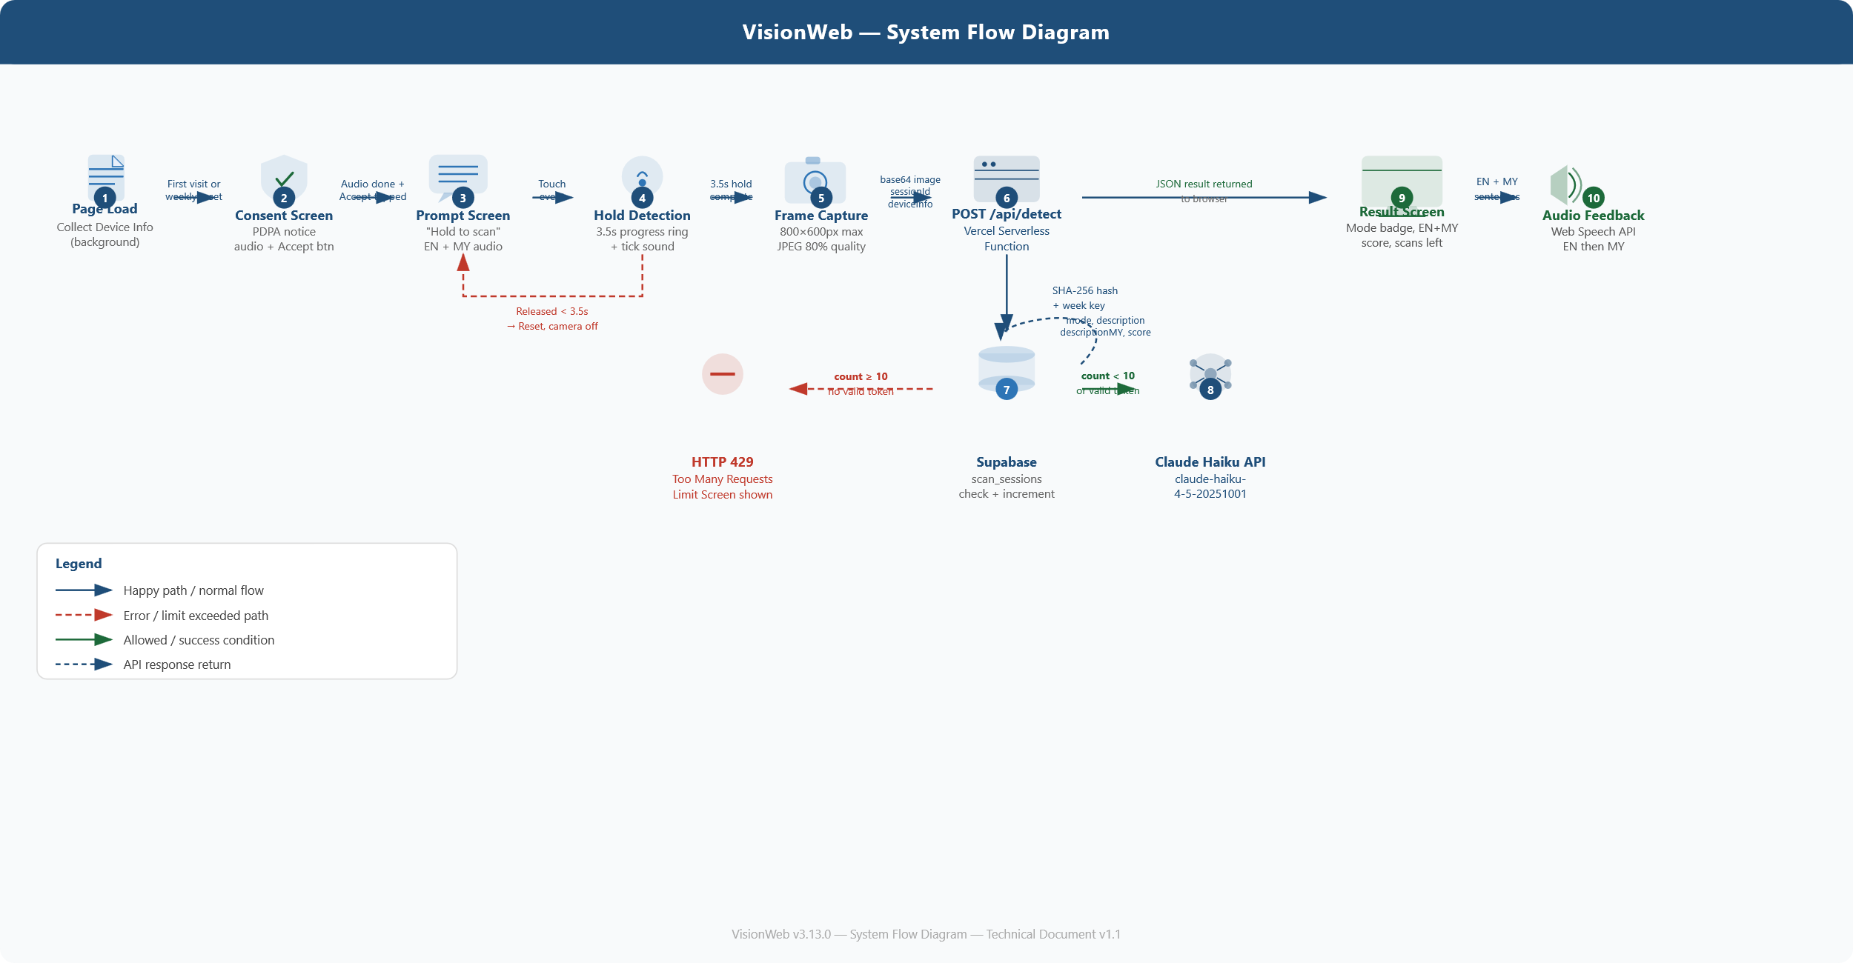

4. Component Architecture

VisionWeb is built using a fully modular architecture split across two layers: a browser-side JavaScript application and a set of Vercel serverless functions. No ML models are loaded in the browser. All AI inference and data persistence is handled server-side.

4.1 Module Overview — Browser Layer
Module | Responsibility | Technology
ScreenManager | Controls which of the 8 screens is visible at any time | Vanilla JS / CSS
ConsentManager | Shows PDPA notice weekly; disables accept button until audio completes; stores weekly acceptance in localStorage | localStorage, Web Speech API
SessionID | Generates and persists a UUID in localStorage on first visit; sent with every /api/detect call for per-browser scan tracking | crypto.randomUUID(), localStorage
DeviceInfo | Parses User-Agent for browser/OS/device type; requests brand and model via High Entropy API on Chrome/Android | navigator.userAgentData, UA string
TickSound | Plays accessibility beep on camera and result screens only; rhythmic tick during hold; screen-aware — silent on all other screens | Web Audio API (AudioContext)
Camera | Accesses device camera; streams live video; captures single frame at detection trigger; resolution capped at 800x600 | getUserMedia(), HTML Canvas API
HoldDetection | Detects 3.5-second steady hold; drives circular progress ring; manages tick sound start/stop; enforces 3-second cooldown between scans | Touch/mouse event listeners, rAF
Detector | Sends image + sessionId + deviceInfo + token to /api/detect; arms 20s AbortController timeout; handles HTTP 429 (Too Many Requests) limit responses | fetch() + AbortController
ResultBuilder | Wraps Claude's noun phrase response into natural EN and MY sentences for audio delivery | Vanilla JS
ResultDisplay | Renders mode badge, confidence score, English and Malay detection text, and remaining scan count on the result screen | DOM manipulation
Audio | Manages bilingual sequential speech (EN then MY); wraps Web Speech API with promise-based queuing | Web Speech API (SpeechSynthesis)
UnlockManager | Manages the sliding email unlock bar; sends email to /api/unlock; stores HMAC token; shows green border on verified email; suppresses tick sound during workflow | fetch(), localStorage
ReportManager | Manages the Report an Issue screen; validates all fields; submits to /api/report with device info attached; returns user to main flow via App.showPrompt() | fetch(), DOM manipulation
App | Top-level state machine coordinating all modules; manages screen transitions; exposes showPrompt() for external module use | Vanilla JS

4.2 Module Overview — Serverless Layer (Vercel Functions)
Function | Responsibility | Dependencies
api/detect.js | Validates session UUID; hashes UUID with SHA-256; checks/increments scan count in Supabase; verifies unlock token via HMAC; forwards image to Claude Haiku; returns detection result | Anthropic API, Supabase
api/unlock.js | Validates email format; looks up email in Supabase allowed_emails (case-insensitive); returns HMAC-signed token if found | Supabase
api/report.js | Validates all required fields server-side (email, title ≤50 chars, description ≤500 chars); inserts issue report with device info into Supabase issue_reports | Supabase

4.3 Module Interaction Diagram

BROWSER — index.html
ConsentManager → ScreenManager → App (state machine)
SessionID | DeviceInfo | TickSound | Audio (Web Speech API)
Camera → HoldDetection → Detector → ResultBuilder → ResultDisplay
UnlockManager | ReportManager
↓ fetch (HTTPS POST) ↑ JSON response
VERCEL SERVERLESS FUNCTIONS
/api/detect → SHA-256 hash session → Supabase scan check → Claude Haiku API
/api/unlock → Supabase allowed_emails lookup → HMAC token
/api/report → Validate fields → Supabase issue_reports insert
SUPABASE DATABASE
scan_sessions | allowed_emails | issue_reports
↓ HTTPS API call ↑ JSON inference result
ANTHROPIC — Claude Haiku (claude-haiku-4-5-20251001)

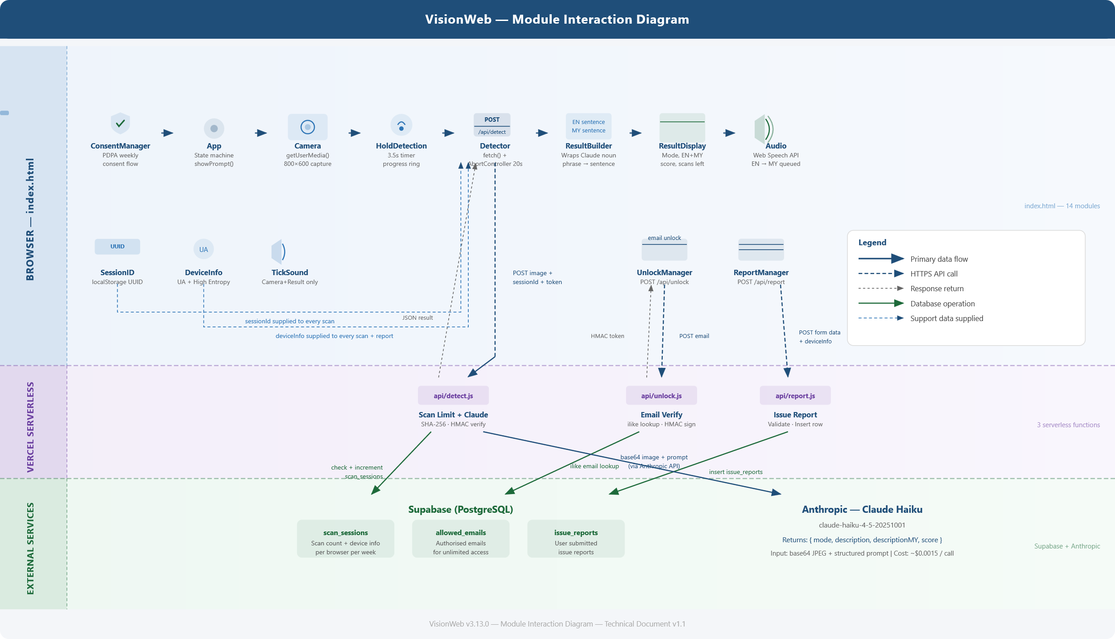

5. Database Schema (Supabase)

VisionWeb uses Supabase (PostgreSQL) for three tables. All tables have Row Level Security (RLS) enabled — only the service role key used in Vercel serverless functions can read or write these tables. No browser-side Supabase access is permitted.

5.1 scan_sessions
Tracks scan usage per browser per week for rate limiting purposes. The session_key is a SHA-256 hash of the browser's localStorage UUID — the raw UUID is never stored.
Column | Type | Description
id | uuid | Primary key — auto-generated
session_key | text | SHA-256 hash (first 32 chars) of browser UUID — unique per browser instance
week_key | text | ISO week identifier e.g. '2026-W14' — resets scan count each Monday
scan_count | integer | Number of scans made this week; limit enforced at 10
browser | text | Browser name and version e.g. 'Chrome 120' — from UA parsing
os | text | Operating system e.g. 'Android', 'iOS', 'Windows 10/11'
device_type | text | 'mobile' or 'desktop'
brand | text | Device brand e.g. 'Samsung' — from High Entropy API; null if unavailable
model | text | Device model e.g. 'SM-S901B' — from High Entropy API; null if unavailable
created_at | timestamptz | First scan timestamp this week (Asia/Kuala_Lumpur timezone)
updated_at | timestamptz | Most recent scan timestamp — auto-updated via trigger

5.2 allowed_emails
Stores email addresses authorised for unlimited scan access. When a matching email is found, an HMAC-signed token is returned to the browser and stored in localStorage.
Column | Type | Description
id | uuid | Primary key — auto-generated
email | text | Authorised email address — unique, case-insensitive lookup via ilike
created_at | timestamptz | Date email was added

5.3 issue_reports
Stores user-submitted issue reports. All device fields are automatically attached at submission time. Fields have CHECK constraints enforcing the character limits.
Column | Type | Description
id | uuid | Primary key — auto-generated
email | text | Reporter's email address — mandatory
title | text | Issue title — mandatory, max 50 characters (CHECK constraint)
description | text | Issue description — mandatory, max 500 characters (CHECK constraint)
browser | text | Reporter's browser — auto-attached from DeviceInfo
os | text | Reporter's OS — auto-attached
device_type | text | 'mobile' or 'desktop' — auto-attached
brand | text | Device brand — auto-attached; null if unavailable
model | text | Device model — auto-attached; null if unavailable
created_at | timestamptz | Submission timestamp (Asia/Kuala_Lumpur timezone)

6. Technology Stack

6.1 Frontend Technologies
Technology | Purpose | Cost | Notes
HTML5 | Page structure, screens, camera video element | Free | Standard browser API
CSS3 | Accessibility-first styling, 8 screen layout, high contrast UI | Free | No framework needed
JavaScript (ES6+) | All 14 browser modules, state machine, event handling | Free | No build tools required
Web Speech API | Bilingual TTS — English then Malay sequential delivery | Free | Built-in to modern browsers
Web Audio API | Tick sound generation via AudioContext oscillator | Free | Screen-aware — camera/result only
getUserMedia() API | Camera stream access and live viewfinder | Free | Requires HTTPS
HTML Canvas API | Frame capture and resolution capping (800x600 max) | Free | Built-in to all modern browsers
crypto.randomUUID() | Browser UUID generation for session tracking | Free | Falls back to manual UUID v4
AbortController | 20-second fetch timeout to prevent iOS infinite spinner | Free | Critical for iOS reliability

6.2 Backend & API Layer
Technology | Purpose | Cost | Notes
Vercel Serverless | Hosts api/detect.js, api/unlock.js, api/report.js — acts as secure proxy keeping API keys server-side | Free tier | 3 functions deployed
Claude Haiku API | AI vision inference — identifies objects and scenes, returns bilingual description as structured JSON | ~$0.0015/call | claude-haiku-4-5-20251001
Supabase (PostgreSQL) | Scan session tracking, authorised emails, issue reports — all tables behind RLS | Free tier | 3 tables, KL timezone
Node.js crypto | SHA-256 session hashing and HMAC-256 token signing/verification | Free | Built-in Node.js module

6.3 Infrastructure & Tooling
Tool | Purpose | Cost
Vercel | Hosting, HTTPS enforcement, serverless function runtime, environment variable management | Free tier
GitHub | Version control and automatic Vercel deployment trigger on push | Free
Supabase Dashboard | Database management, SQL editor for migrations, table viewer for issue reports and scan sessions | Free tier
VS Code | Code editor for local development | Free
Node.js (LTS) | Local development server | Free

7. Security Architecture

Security is implemented across four layers: API key isolation, session hashing, token signing, and database access control.

7.1 Security Controls
Control | Implementation | Purpose
API Key Isolation | All API keys (Anthropic, Supabase service role, TOKEN_SECRET) stored as Vercel environment variables; never sent to browser | Prevents credential theft from client-side inspection
Serverless Proxy | Browser never calls Anthropic or Supabase directly; all requests route through Vercel functions that validate and authenticate first | Single control point for rate limiting and auth
SHA-256 Session Hash | localStorage UUID hashed with SHA-256 before storing in scan_sessions; only the first 32 hex chars stored | No raw client identifiers in database
HMAC Token Signing | Unlock tokens are base64(email) + '.' + HMAC-SHA256(email:unlimited, TOKEN_SECRET); verified server-side on every /api/detect call | Unforgeable tokens; email encoded but not plaintext
UUID Format Validation | Server validates sessionId matches /^[a-f0-9-]{36}$/ before processing; rejects malformed inputs with 400 | Prevents session key injection attacks
Supabase RLS | Row Level Security enabled on all 3 tables; service role key bypasses RLS by design; anon key has zero access | Database inaccessible from browser even if Supabase URL is known
CSP Headers | Content Security Policy set in vercel.json restricting script sources, connect-src to api.anthropic.com and Supabase URL only | Prevents XSS and unauthorised external connections
Image Size Limit | Server rejects base64 image payloads exceeding 600,000 characters; client also caps at 800x600px before sending | Prevents payload abuse and excessive API cost

7.2 Environment Variables Required
Variable | Used By | Description
ANTHROPIC_API_KEY | api/detect.js | Claude Haiku API key — never sent to browser
SUPABASE_URL | All 3 functions | Supabase project URL (https://xxx.supabase.co)
SUPABASE_SERVICE_KEY | All 3 functions | Supabase service role key — bypasses RLS; never sent to browser
TOKEN_SECRET | api/detect.js, api/unlock.js | Random 32+ char string used to sign and verify HMAC unlock tokens

8. iOS Compatibility

Several iOS-specific behaviours required targeted fixes. These are documented here for reference as they represent non-obvious platform constraints.

Issue | Root Cause | Fix Applied
Infinite spinner on scan | iOS drops fetch() responses after ~10s when browser goes to background; also caused by oversized base64 image exceeding 600KB server limit | (1) Image capped at 800x600, 80% JPEG quality (~80-150KB). (2) AbortController with 20s timeout — throws 'Scan timed out' instead of hanging
Audio blocking fetch | iOS deprioritises network requests initiated after async audio context; awaiting Audio.speak() before fetch() caused the request to be throttled or dropped | Audio.speak('Analysing now') called without await; fetch() fires immediately in the same gesture microtask context
Consent button fires early | iOS fires touchstart before disabled attribute is evaluated; user could advance before audio completed | JS boolean gate (audioComplete) checked in handler; touchend used instead of touchstart; disabled attribute retained as visual cue only
Volume control not working | Apple deliberately blocks HTMLMediaElement.volume from web pages on iOS — volume property always returns 1.0 regardless of what is set; affects all browsers on iOS (all use WebKit) | No workaround available. User must use hardware volume buttons. Documented in Apple's Safari HTML5 Audio and Video Guide (developer.apple.com)

9. Known Risks & Mitigations

Risk | Likelihood | Impact | Mitigation
iOS Safari camera restrictions | Medium | High | Resolution cap and AbortController timeout applied; tested and confirmed working
Claude API cost overrun | Low | High | 10 scans/week/browser limit enforced via Supabase; unlimited users are known authorised individuals only
Scan limit bypass via cache clear | Medium | Low | Clearing localStorage resets UUID — user gets fresh 10 scans; cost per extra scan is ~$0.0015; acceptable risk for an accessibility tool
Web Speech API voice unavailable | Low | High | Text result displayed on screen as visual fallback; API support checked on load
Supabase service degradation | Low | Medium | If Supabase is unreachable, scan limit check fails and returns 500; user sees error screen; Claude API is not called
TOKEN_SECRET exposure | Low | High | Stored only as Vercel env var; never in source code or browser; if compromised, rotate the secret — all existing tokens become invalid and users re-verify email
Claude API response latency | Medium | Medium | AbortController fires at 20s; user receives clear timeout message rather than infinite spinner; prompt to try again

10. Production Scope Summary (v3.13.0)

Feature | Status | Notes
Audio prompt on page load (EN + MY) | Shipped | Bilingual — English then Malay
PDPA consent screen (weekly) | Shipped | Audio-first, button-only advancement
Tap-and-hold camera activation (3.5s) | Shipped | 3s cooldown between scans
Claude Haiku AI detection (portrait + scene) | Shipped | Replaces TF.js + COCO-SSD + Google Vision
Bilingual audio result (EN + MY) | Shipped | Web Speech API sequential delivery
Weekly scan limit (10/browser) | Shipped | Supabase scan_sessions, UUID-based
Email unlock (unlimited access) | Shipped | HMAC token, green border on verify
Device and browser tracking | Shipped | UA parsing + High Entropy API
Report an Issue form | Shipped | Email + title + desc; stored in Supabase
iOS image resolution cap + fetch timeout | Shipped | 800x600 cap; 20s AbortController
Version badge (top-right) | Shipped | v3.13.0 visible on all screens
Admin panel for issue management | Planned | Separate Vercel project; Supabase Auth
Real-time navigation mode | Under evaluation | Hybrid on-device + Claude architecture
Multiple language support beyond EN + MY | Future | —
Detection history / session log | Future | —

