***Untold Stories of Barcelona  
Poverty and*** [***Hope***](http://esperancabarcelona.com/)

Alex Minkin

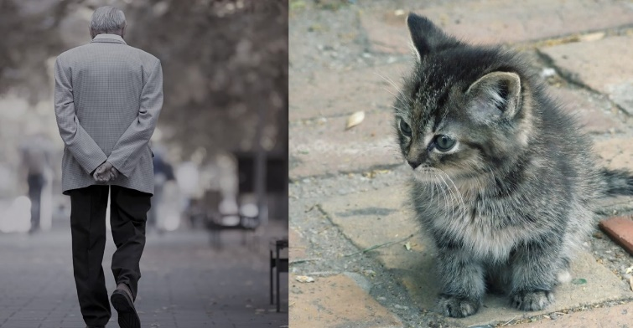

My name is Misha. I'm 71 years old. I was born, raised, and also studied and worked in the city of Moscow. Since childhood, I have liked cranes that lift massive loads after graduating from school, so I graduated from school with a degree in "Truck Crane Driver." The school I studied sent me to practice in my specialty. After school, I stayed there to work. After working for 32 years there, I I was fired.

They didn't take me to another job because I'm old, and they want young people to work. Having lived on the accumulated money for 2.5 years, I began to get into significant debts for utility bills, and as a result, my home was taken away from me, and I ended up on the street.

Then there was an opportunity to move to Spain, where a my friend ha s a construction project, and they need a specialist with experience. With my last money, I bought the cheapest one-way ticket and flew to Barcelona.

I worked for a friend for several months and managed to earn about 3000 €. But after a couple of months in a rented apartment, the money ran out, and I did not find a job so hard because of problems with documents and language.

Therefore, when I am on the streets of warm Barcelona, kind people bring me warm blankets and even personal hygiene items. There are also many charity events where you can eat a lot and tasty food. I live on Raval Street nearby with Caixa Bank; there is a corner in which I settled.

Now I am saving up for all the paperwork, and I plan to go to Spanish langugage courses, and I also want to pass my license. I heard that taxi drivers are paid well here. The most challenging thing for me now is to find any job, I am an elderly person, so I cannot carry tremendous loads or engaged in any work that requires physical labor.

I was amazed at what kind and smiling people here. On the contrary in Moscow everyone is furious and gloomy. I am happy because soon I will live well, find a job, get documents, learn the language, and live an ordinary person's life!

**BIBLIOGRAPHY**

Crowley, T. (2020, 15 enero). How to help the homeless in Barcelona. ShBarcelona.

<https://www.shbarcelona.com/blog/en/help-homeless/>