# Lab 02-01: Laptop and VirtualBox Setup

By Peter Hung, Nick Wang, Allen Ou,Tim, Tony last modified on 07/26, 2018.

The objective of the tutorial is to have your working environments: Ubuntu 16.04 system and ROS Kinetic. The content is aimed for beginners who have little knowledge about basic commands in Ubuntu and Vim. We assume the users have some knowledge about programming in C++ and (a bit) Python.

*1.Any sentence behind “$” means those are commands that typed in the terminal  
 $ 代表terminal的指令*

* *laptop: do the command after $ on the laptop/PC side  
  laptop: 代表在筆電上打指令*

## Hardware and Software Setup

**Lab 02-01: Laptop and VirtualBox Setup** **1**

Hardware and Software Setup 1

Overview 1

Topic/Activity (TA will go through this step by step) 2

Activity 1: Get your Ubuntu 2

Activity 2: What are included in the provided image? 2

Assignment Tasks (DIY, either during the class or at home) 3

Task 1 Ubuntu Installation 3

Task 2 Use Ubuntu and Vim 8

Task 3 Change hostname 10

Check point (檢查點): 12

## Overview

Estimated Time to Finish: 0.5 hours

After completing this tutorial you should

* understand how to install ubuntu system on your laptop
* be able to use vim to modify the text file
* develop the common sense of ubuntu system

## Topic/Activity (TA will go through this step by step)

### Activity 1: Get your Ubuntu

The tutorial requires Ubuntu 16.04 system and ROS Kinetic installed in the following :

此文件建立在Ubuntu16.04 和 ROS Kinetic上

* First option, use the provided Virtualbox ([image](https://drive.google.com/file/d/1s7hrbEZxCGpu0Z5pojQHenVKGD9ywEsI/view?usp=sharing), 8 GB).  
  第一步，下載VirtualBox Image
* **Second option, use the provided USB Virtualbox image from our Teaching Assistant.** Ask TA and get a USB drive with the VirtualBox image.
* For advanced users who wish to have native system, take a look at our shell scripts. You only want to do this when you have a GPU machine. Not suggested for first-time Ubuntu users.

### Activity 2: What are included in the provided image?

Ubuntu 16.04 system and ROS Kinetic

Caffe/Tensorflow

Realsense

docker

An overview of the shell scripts

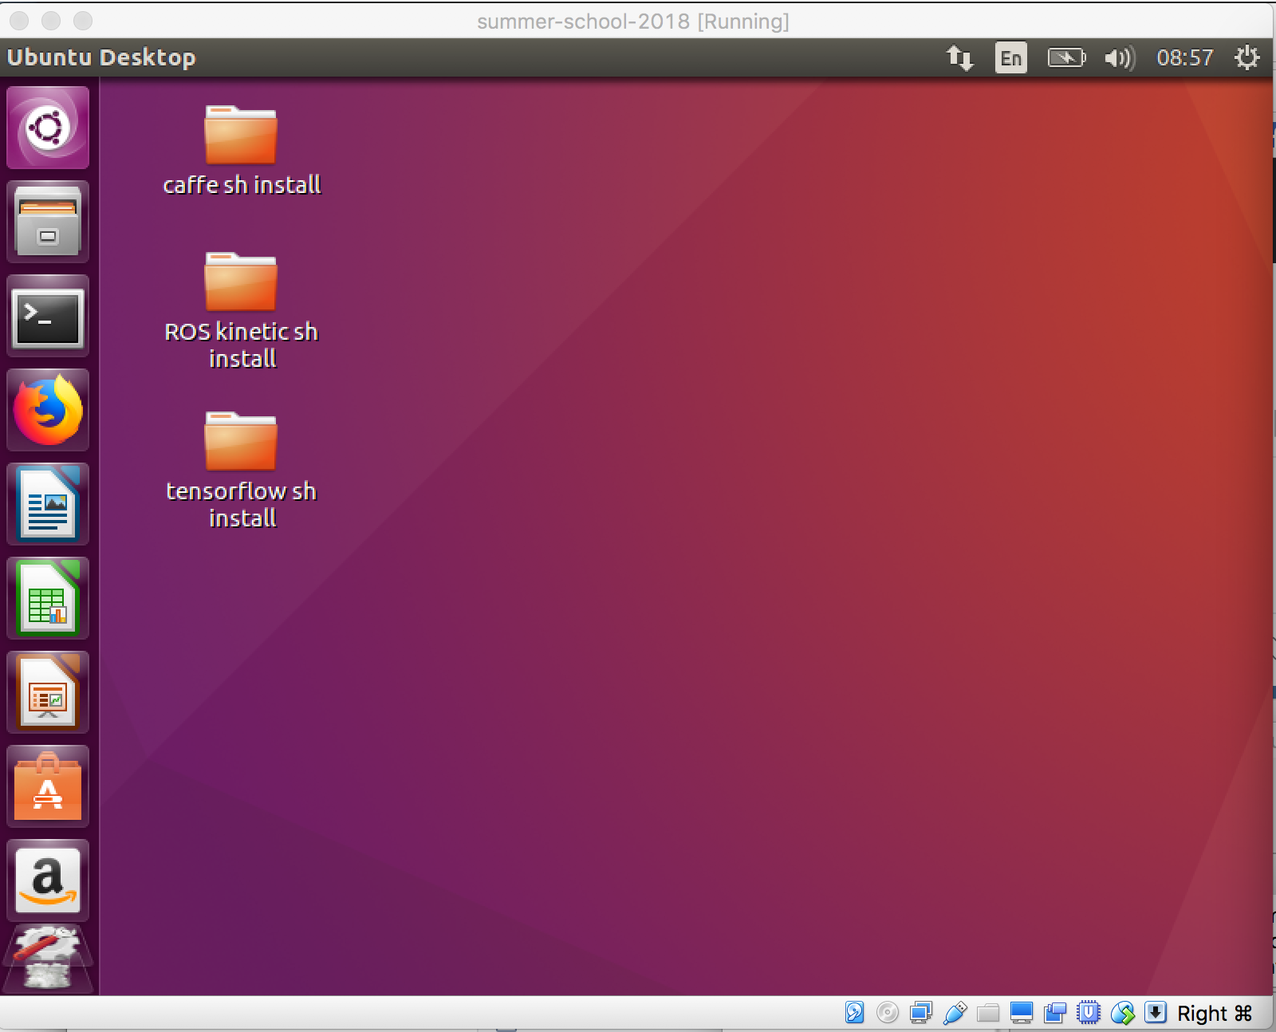

## Assignment Tasks (DIY, either during the class or at home)

### Task 1 Ubuntu Installation

**Download and install Virtualbox on your machine  
MAKE SURE YOUR VIRTUALBOX IS THE LATEST VERSION**

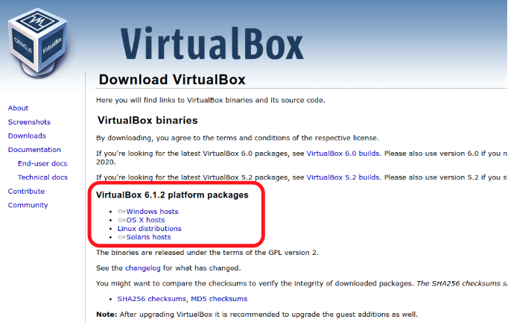<https://www.virtualbox.org/wiki/Downloads>

**Start Virtualbox**

**New(新增)** -> Linux -> 64bit -> Memory 2G -> select the .vdi file.

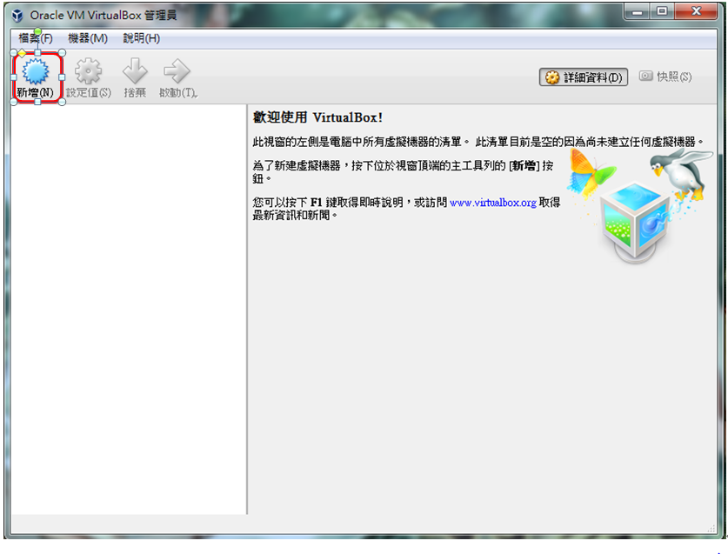

New-> **Linux -> 64bit -> Memory 2G** -> select the .vdi file.

you can change the name of this virtual machine as you want

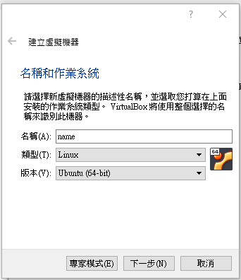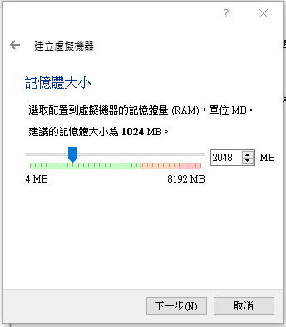

New-> Linux -> 64bit -> Memory 2G -> **select the .vdi file.**  
使用現有虛擬硬體檔案  
選擇下載好的VirtualBox Image (.vdi檔案)

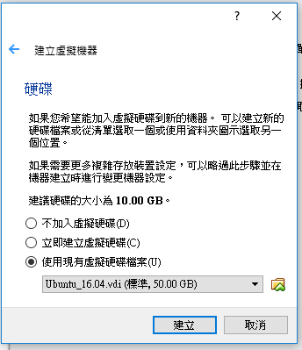

Please go to [here](https://www.virtualbox.org/wiki/Downloads), download the **extension pack**, install it and enable USB3.0.



**Installation: 檔案 -> 喜好設定 -> 擴充功能 -> 加入新的功能包 -> 點選剛下載的檔案(Oracle_VM_VirtualBox_Extension_Pack-6.1.2.vbox-extpack) -> 我同意**

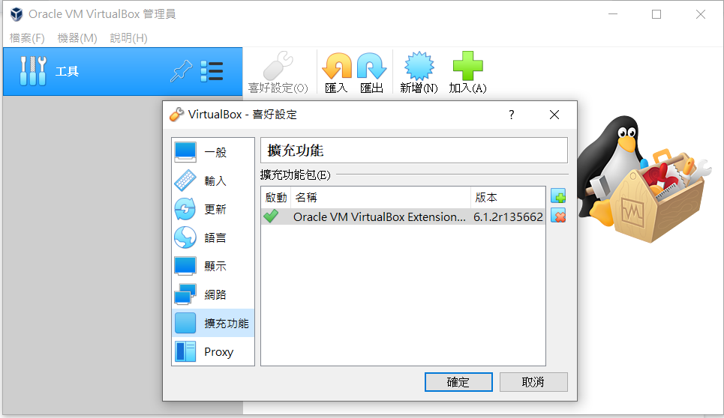

**Enable USB3.0:** open the setting terminal from 裝置 -> USB -> 選擇USB3.0

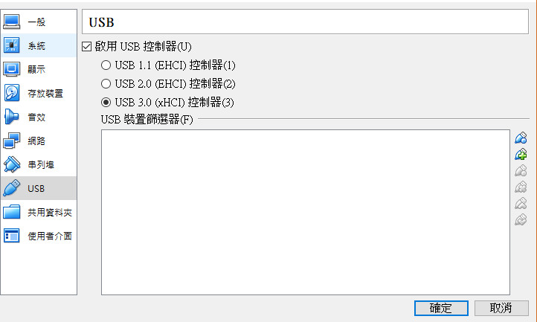

press the “activate” to activate your virtual machine

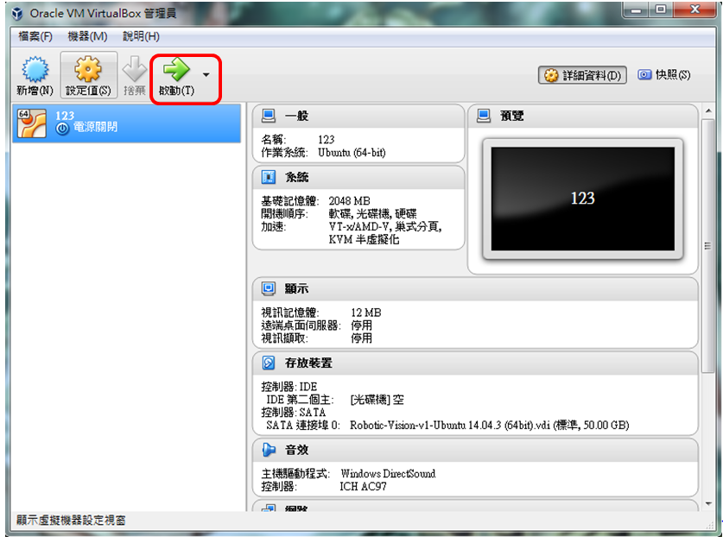

The password is **bocelli2015  
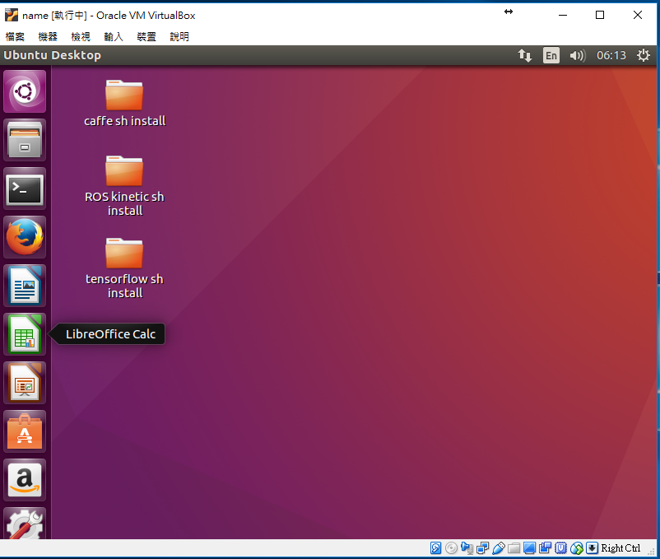**

**Network Setup**

open the setting terminal from 裝置 -> 網路 -> 網路設定

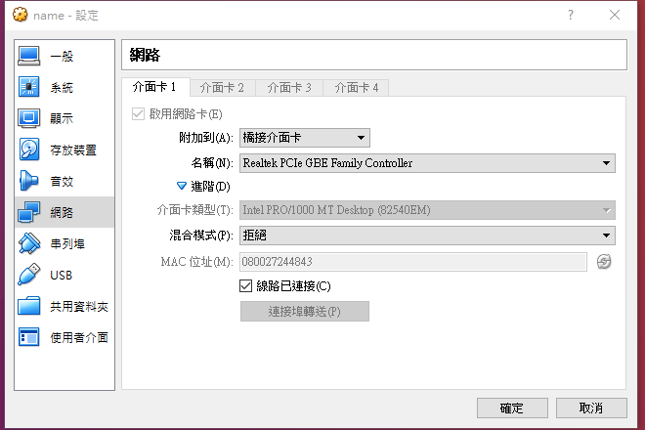

Change the first thing to bridged adapter (橋接介面卡)

**Scrapbook Setup**

共用剪貼簿

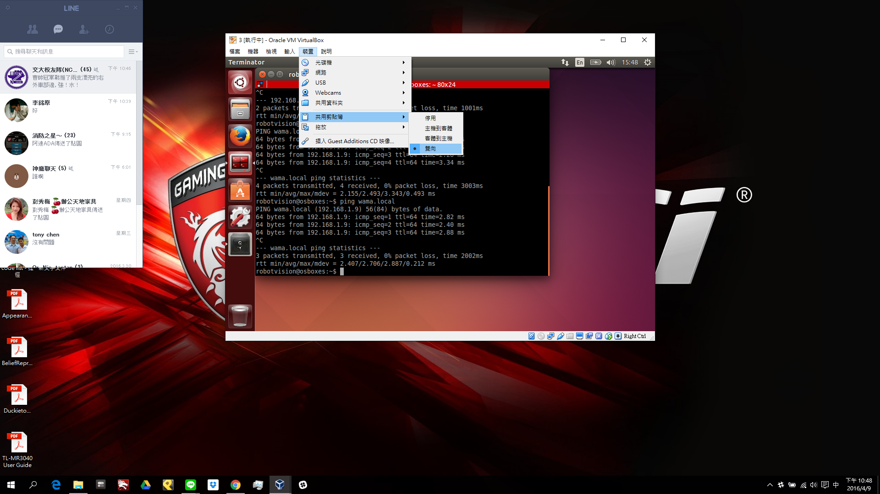

**Drag and Drop**

托放  
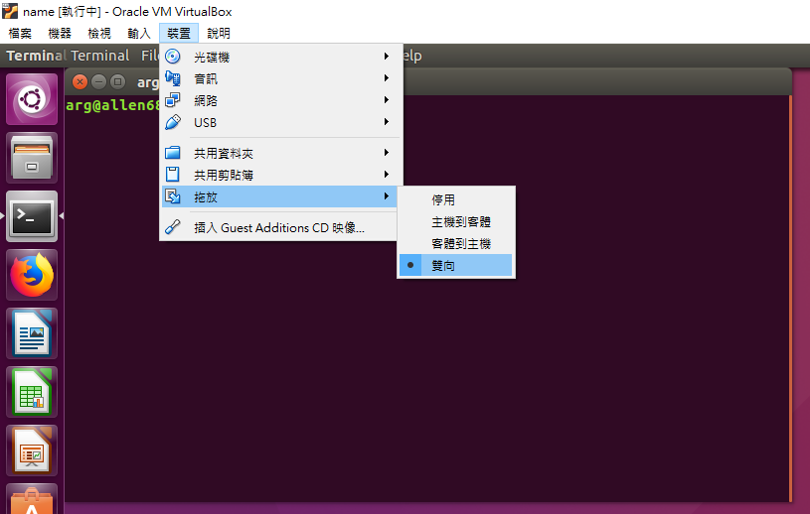

### Task 2 Use Ubuntu and Vim

You should know the basic commands in Ubuntu.

**cd： enter a folder (進入資料夾)**

**ls： list all files and folders (列出所有檔案)**

**sudo： act as root before other commands (最高權限進行指令)**

**mkdir： create a folder (創新資料夾)**

**cp ： copy files (複製檔案)**

**rm： delete files (刪除檔案)**

**apt-get update： update packages (取得遠端更新伺服器的套件檔案清單)**

**apt-get install： install packages (安裝套件)**

Exercise: Create a folder and use vim to edit a file.

練習: 創造一個新資料夾，並用vim去修改檔案

**laptop$ ls**



**laptop$ mkdir csp2017**

**laptop$ ls**



**laptop$ cd ~/**TODO**csp2017**

**laptop$ vim test**

**press “i” to enter “Insert mode**

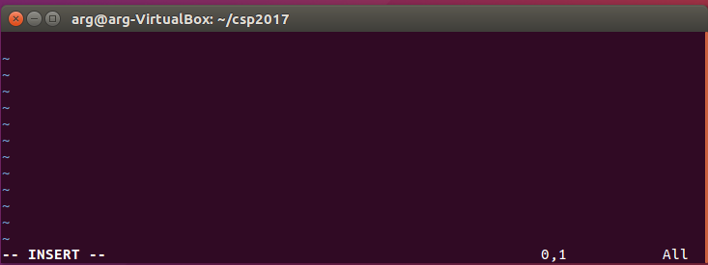

**please type “hello world” as shown below**

**(打一行”hello world”在檔案裡)**

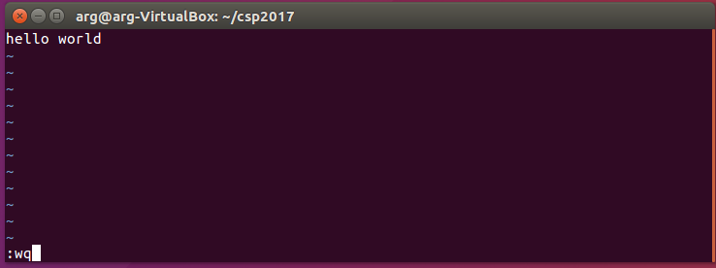

**press “esc” and type :wq and press “enter”**

**w: write**

**q: quit**

**laptop$ ls**



**laptop$ cp test test2**

**laptop$ ls**



**laptop$ rm test**

**laptop$ ls**



### Task 3 Change hostname

Due to our fleet setting, we wish that all laptops and jetson tx2 will have unique hostname. [ID] stands for the number of the jetson tx2 you picked up. We suggest to use:

* sstop[ID][Name] for your laptop, ex: sstop01allen
* ss[ID] for your jetsontx2 ex:ss01
* The ID is the number on jetsontx2

**NO jetsontx2 / LAPTOP name are allowed using uppercase, symbols, punctuation, space (e.g. %^#@!_,;:” ) since the Internet Standard Protocols for hostname label only contain lowercase ASCII letters (‘a’ to ‘z’), and numbers (‘0’ to ‘9’)**

**在更改筆電以及TX2的hostname時，請不要使用特殊字元 (e.g. %^#@!_,;:” )，只用數字以及小寫英文字母**

Open a terminal (press this button):

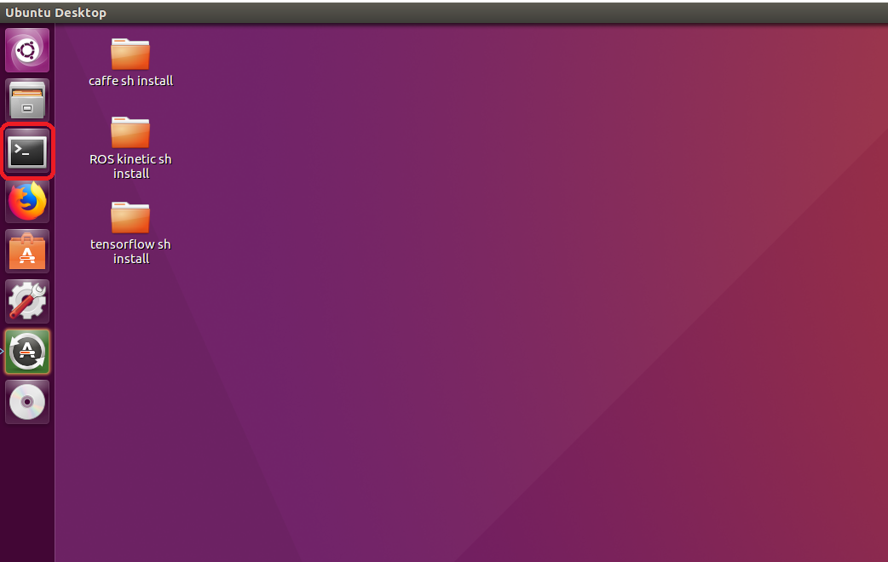

type in the command below:

記得打sudo, 沒有sudo會無法更改此檔案

**laptop$ sudo vim /etc/hostname**[sudo] password for arg: bocelli2015

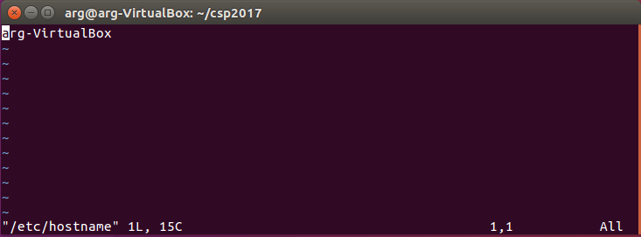

若不小心忘了打sudo卻已經更改檔案，請打”**:q!**”強制退出後再加上sudo進去一次  
Change "hostname" to your own hostname. For example: allen

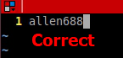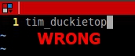

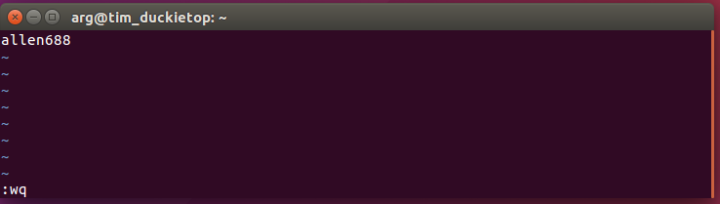

For information about vim & how to use it,   
check <http://linux.vbird.org/linux_basic/0310vi.php>

After exiting vim editing and go back to terminal, type in the command below:

記得打sudo, 若沒有sudo會無法更改此檔案

**laptop$ sudo vim /etc/hosts**

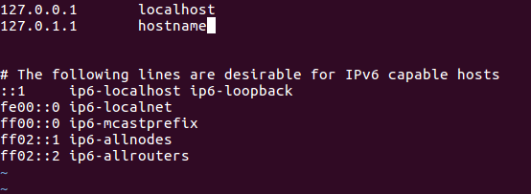

change "hostname" to the one you typed in the /etc/hostname file, don’t forget to save it (:wq) after modification.

將hostname改的跟剛剛在/etc/hostname一樣的名字，並儲存

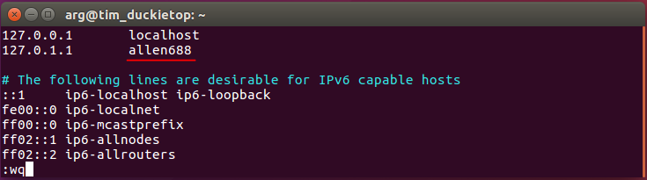

Then reboot   
重開機

**laptop $ sudo reboot**

Double check if hostname is changed.  
確認hostname改變了

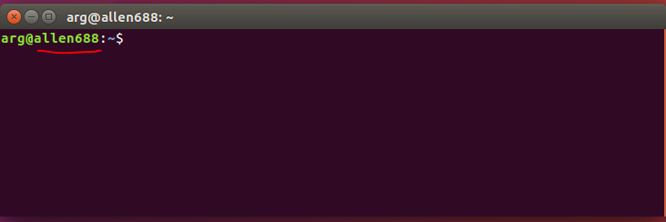

#### Check point (檢查點):

you should have a virtual machine called arg@**[HostName]**   
確認你的虛擬裝置, hostname叫做 arg@**[HostName]**   
