

CEP restaurant’s website
UI Style Guide

Colors scheme

Navigation h1 #f07339

Header h1
#333333
f07339

Body Text
#000000

Navigation elements #f0c52c

Body h1
#c19e1f

Text Shadow & Hovered nav bar elements #f15d0e
Body Background #e5f0ec

Pressed Navigation Elements #9acd32

Body h2
#8f13ef

Navigation Background#f4f1ee

Typography
Aa

Verdana
Regular

Aa
Oswald
Regular

Heading Styles
Font Family: Oswald Regular
Font size: 39px
<H1> Header

Font Family: Oswald Regular
Font size: 20px

<H1> Nav Bar

<H1> Main

Font Family: Oswald Regular
Font size: 40px

<H2> Main

Font Family: Oswald Regular
Font size: 28px

Font Family: Oswald Regular
Font size: 25px

<H3> Main

Body text Style
Font Family: Verdana Regular
Font size: 23px

Navigation Bar Text

Font Family: Oswald Regular
Font size: 19px

Body Text

Imagery
Social Icons






Search Icon

Restaurant Icon

Website Background

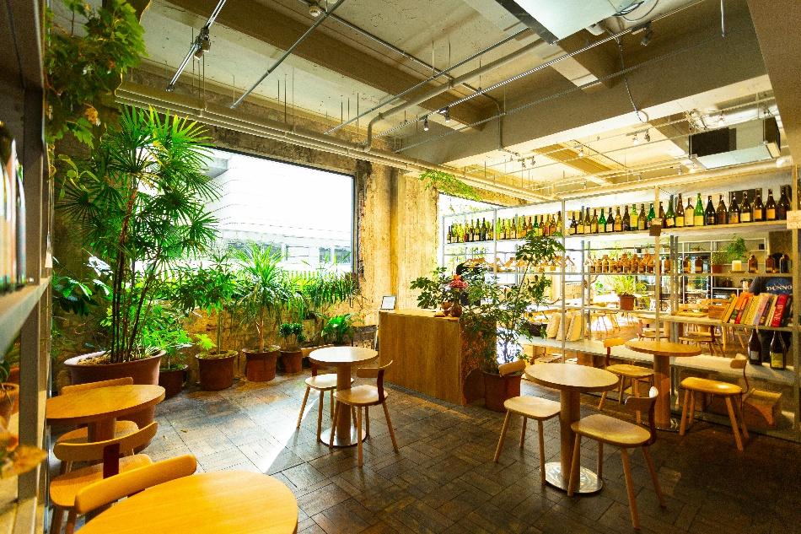

Home Page Introduction Images
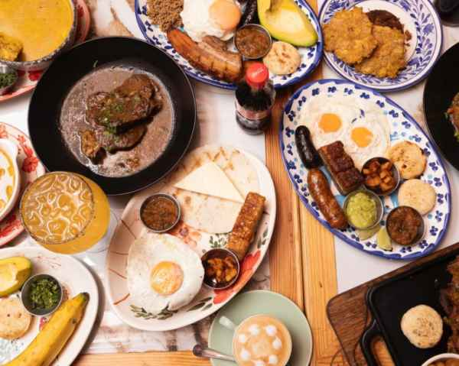

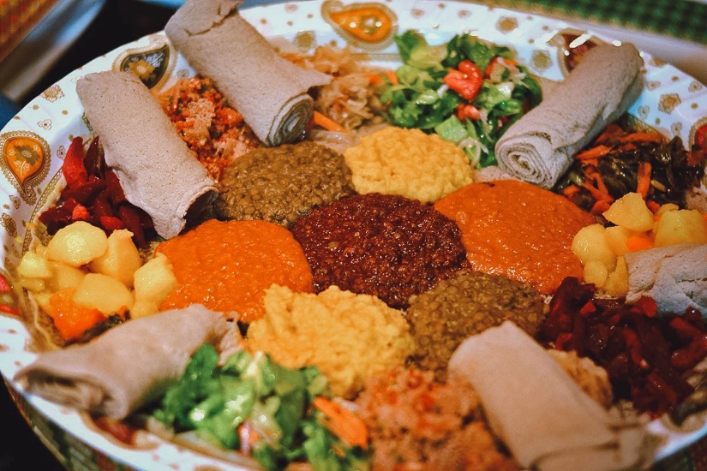

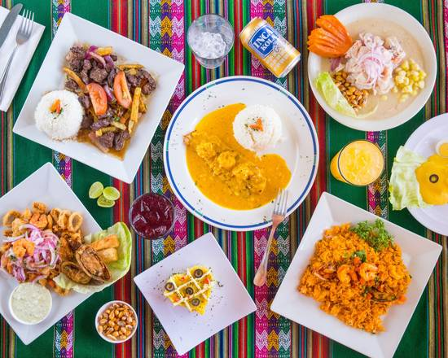

Menu Dishes Images
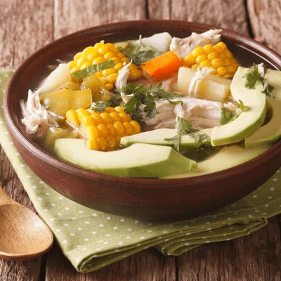
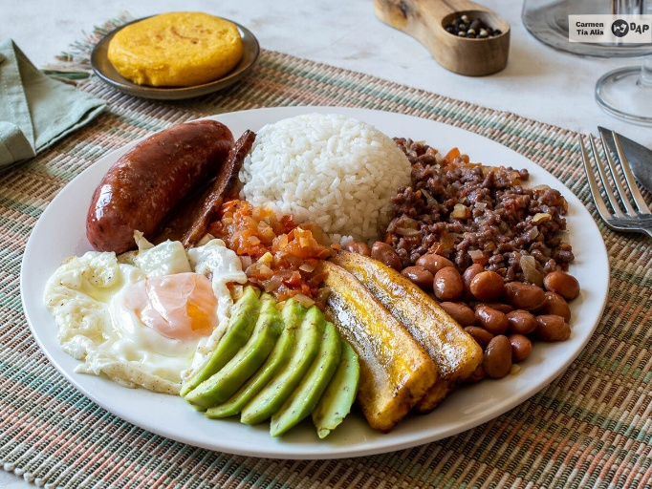

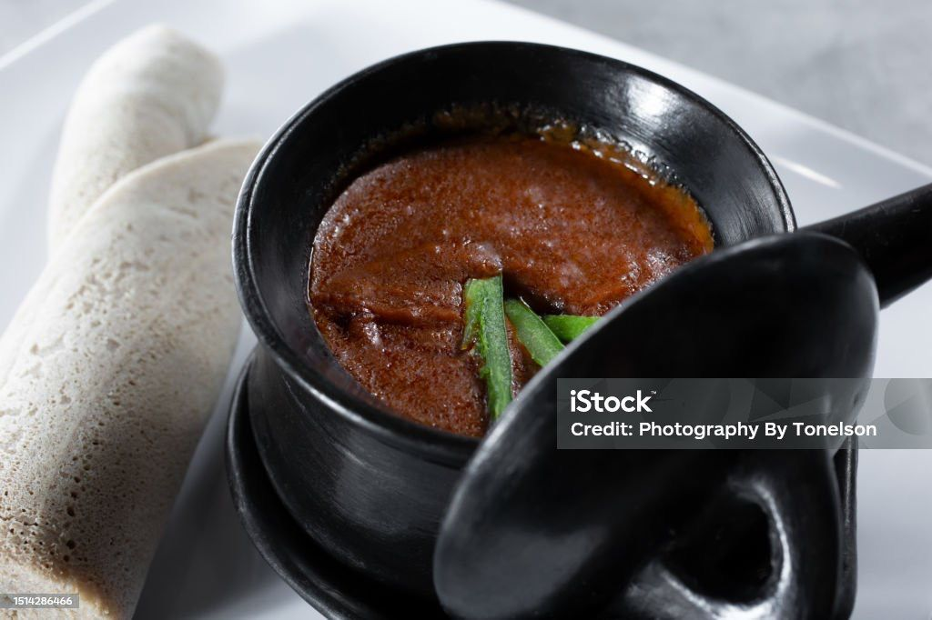
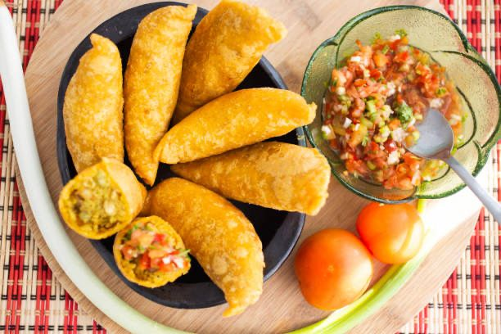
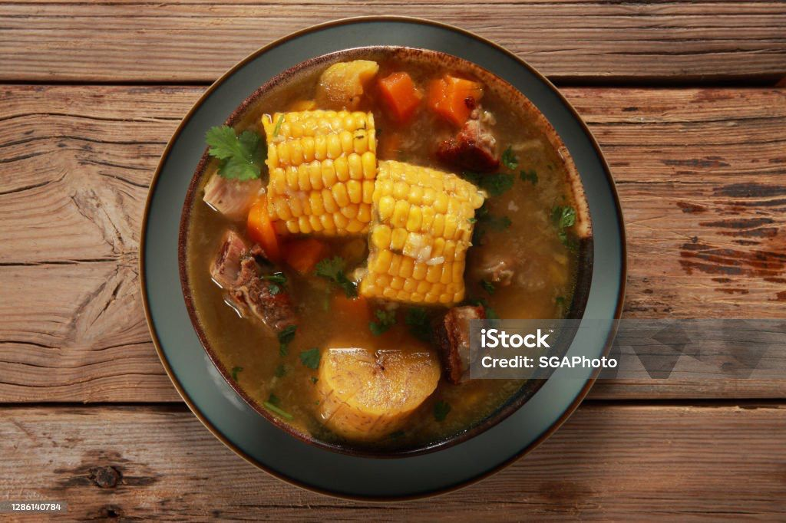

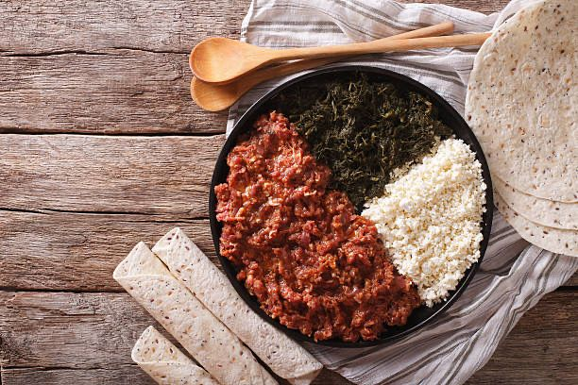
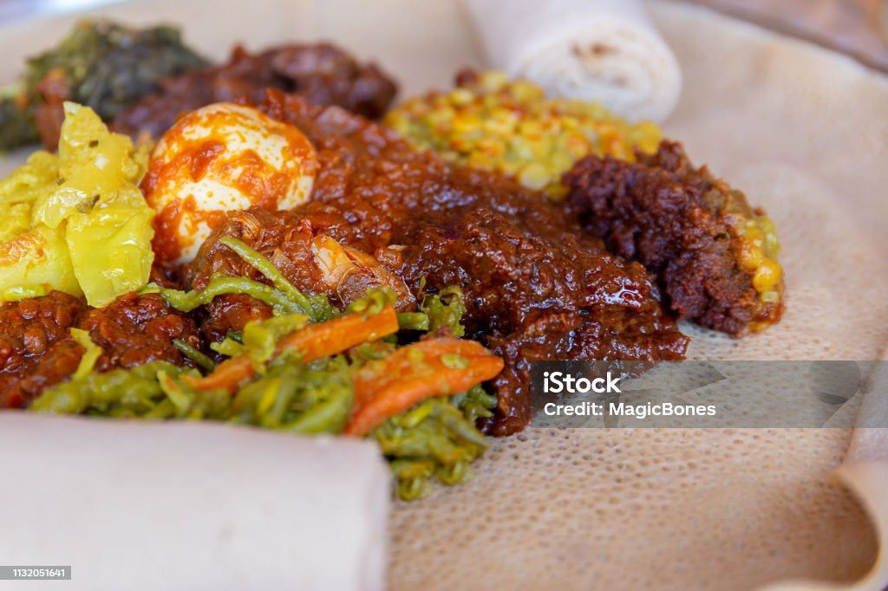
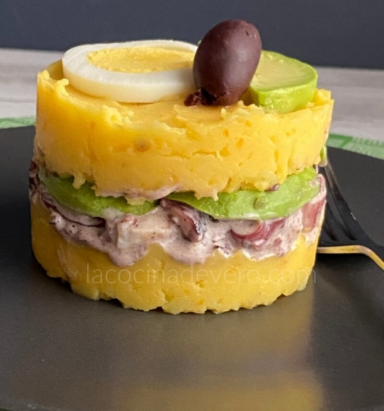
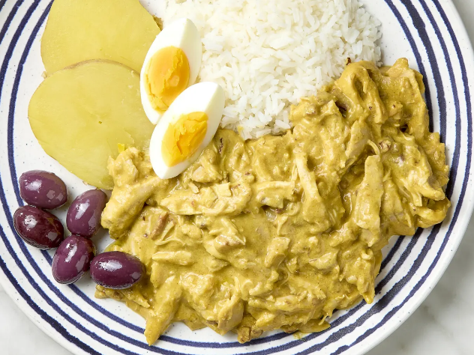

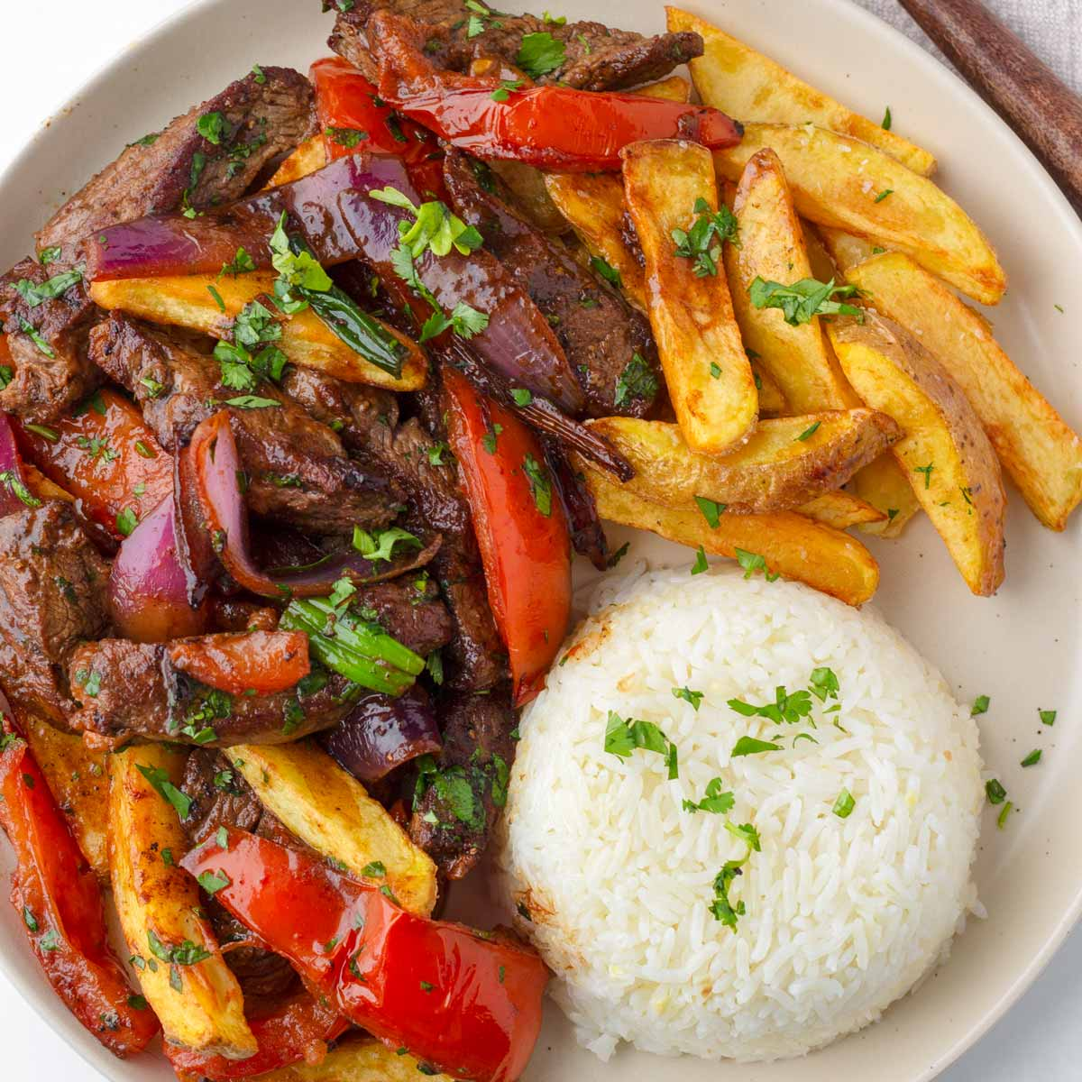
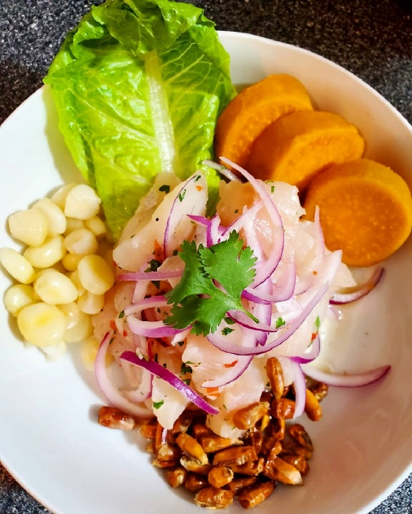

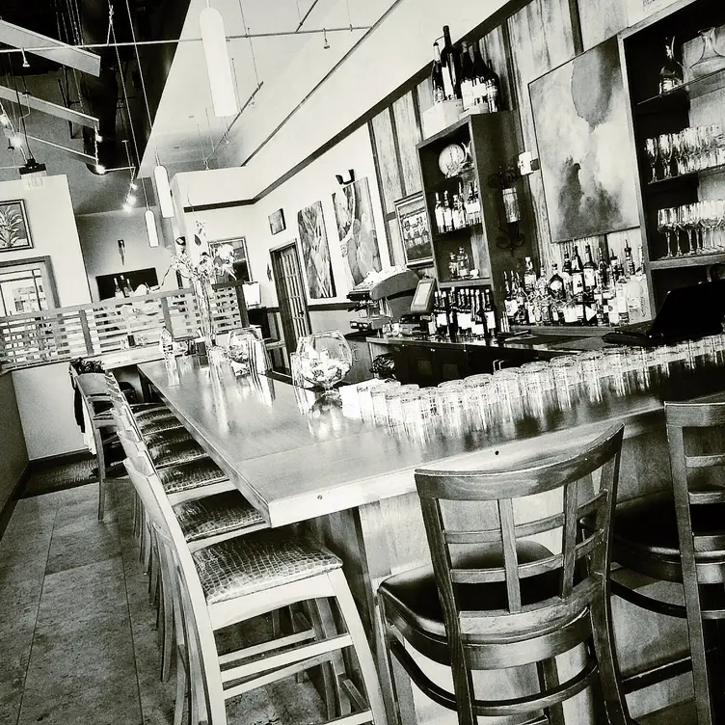
About Us Image

