Alex Vo

June 19, 2022

Module 3.3 - PyBookCo

ORD:

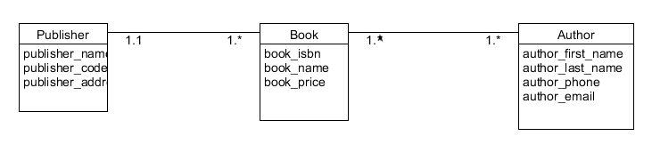

NoSQL Document Diagram

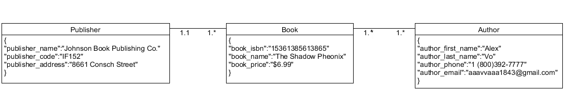

Business Rules:

A publisher can publish many books

Books can only be assigned to one publisher at a time

A book can have multiple authors

Authors can be an author of multiple books

NoSQL Data Structure:

