

**Azure Pipelines**

Continuously build, test, and deploy to any platform and cloud

[**Start free with Pipelines**](https://go.microsoft.com/fwlink/?LinkId=2014579&campaign=acom~azure~devops~pipelines~main~hero&projectVisibility=Everyone&githubsi=true&clcid=0x1009&WebUserId=03F3F09FE99965071F5AFC34ED9963FE) [**Start Pipelines free with GitHub**](https://go.microsoft.com/fwlink/?LinkId=2014676&provider=github.com&clcid=0x1009&WebUserId=03F3F09FE99965071F5AFC34ED9963FE)

Already have an account?

[**Sign in to Azure DevOps**](https://go.microsoft.com/fwlink/?LinkId=2014676&githubsi=true&clcid=0x1009&WebUserId=03F3F09FE99965071F5AFC34ED9963FE)

Explore Azure Pipelines:

* [Documentation](https://docs.microsoft.com/en-ca/azure/devops/pipelines/index/)
* [Support](https://azure.microsoft.com/en-ca/support/devops/)
* [Pricing](https://azure.microsoft.com/en-ca/pricing/details/devops/azure-pipelines/)
* [Blog](https://devblogs.microsoft.com/devops/)

**Get cloud-hosted pipelines for Linux, macOS, and Windows. Build web, desktop and mobile applications. Deploy to any cloud or on-premises.**

**Automate your builds and deployments with Pipelines so you spend less time with the nuts and bolts and more time being creative.**

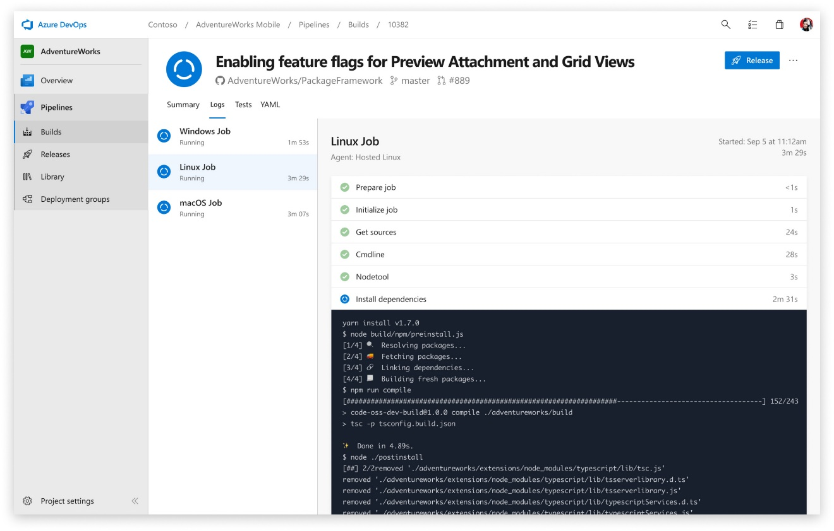

**Any language, any platform**

**Build, test, and deploy Node.js, Python, Java, PHP, Ruby, C/C++, .NET, Android, and iOS apps. Run in parallel on Linux, macOS, and Windows.**

**Containers and Kubernetes**

**Easily build and push images to container registries like Docker Hub and Azure Container Registry. Deploy containers to individual hosts or**[**Kubernetes.**](https://azure.microsoft.com/en-ca/topic/kubernetes/)

**Extensible**

**Explore and implement a wide range of community-built build, test, and deployment tasks, along with hundreds of extensions from Slack to SonarCloud.**

**Deploy to any cloud**

**Implement continuous delivery (CD) of your software to any cloud, including Azure, AWS, and GCP. Visualize deployment to any number of interdependent stages.**

**Best-in-class for open source**

**Ensure fast continuous integration/continuous delivery (CI/CD) pipelines for every open source project. Get 10 free parallel jobs with unlimited build minutes for all open source projects.**

**Advanced workflows and features**

**Take advantage of easy build chaining and multi-phased builds. Support for YAML, test integration, release gates, reporting—and more.**

**Build and deploy faster with Pipelines**

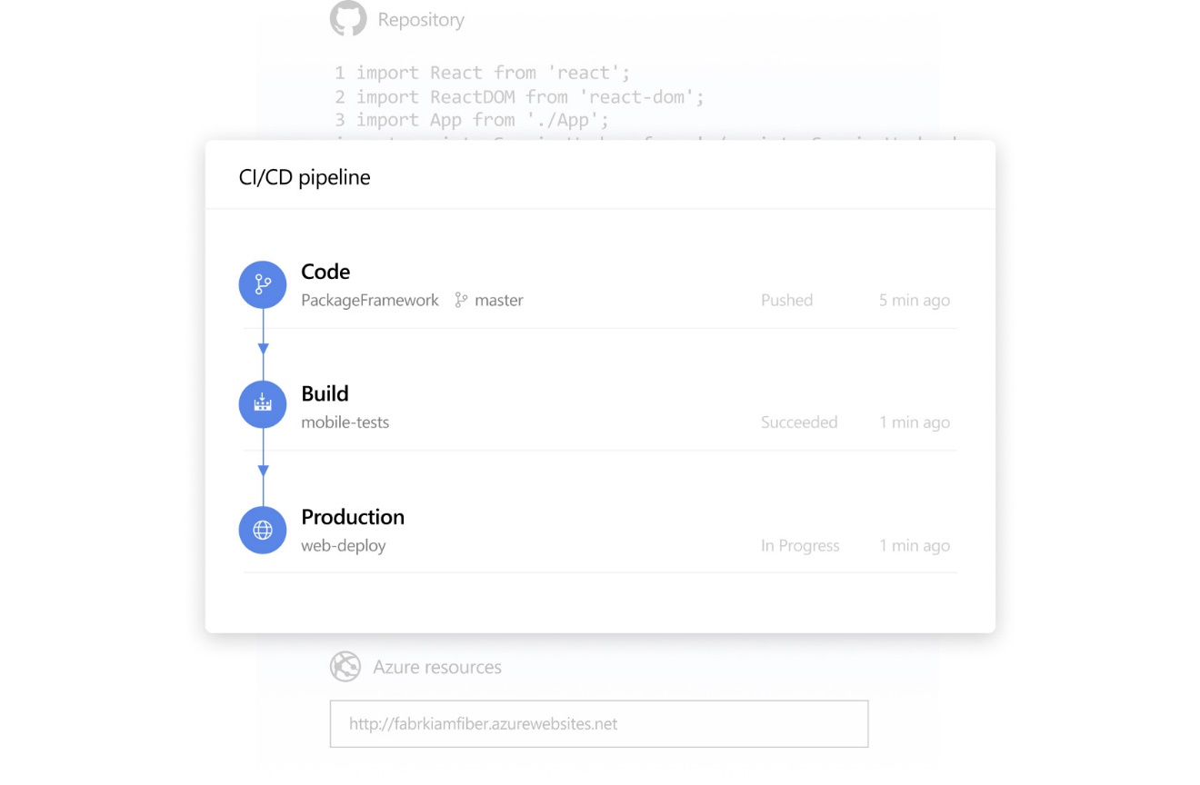

**Powerful workflows with native container support**

**Get lightning fast builds with parallel jobs and test execution. Use container jobs to create consistent and reliable builds with the exact tools you need. Create new containers with ease and push them to any registry.**

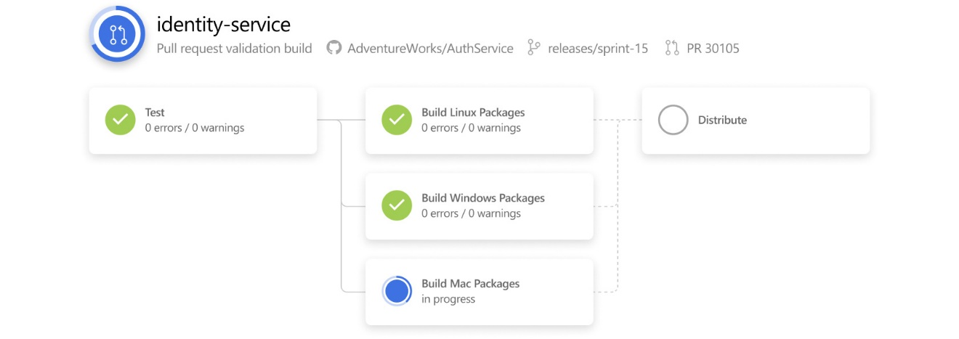

**Linux, macOS, and Windows agents—hosted by Microsoft**

**Simplify managing hardware and VMs by using Microsoft cloud-hosted agents. Get full CI/CD pipeline support for every major platform and tool.**

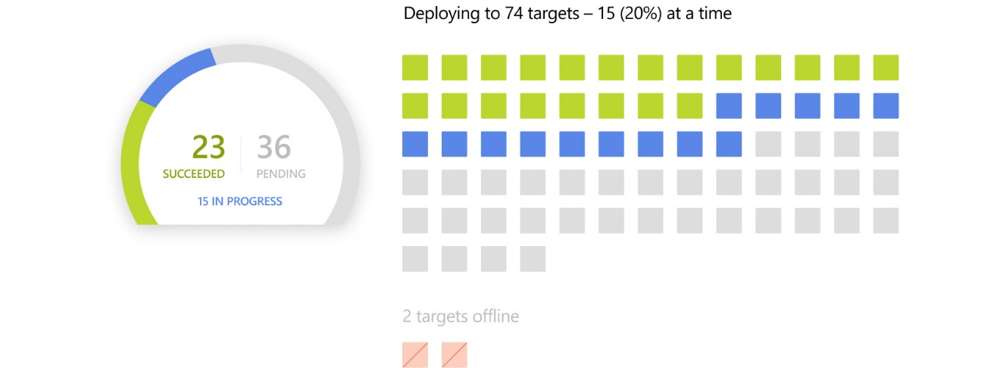

**Flexible deployments to Kubernetes, serverless, or VMs**

**Deploy to Kubernetes, VMs, Azure Functions, Azure Web Apps, or any cloud. Use stages, gates, and approvals to create a deployment strategy that’s right for you and ensures quality at every step. Even deploy from other CI systems, like Jenkins.**

**Build on Linux, macOS, and Windows with Pipelines**

**Open source projects**

**10 Free**

**Parallel jobs with unlimited minutes per month**

[**Start free**](https://go.microsoft.com/fwlink/?LinkId=2014579&campaign=acom~azure~devops~pipelines~mid~hero&projectVisibility=Everyone&githubsi=true&clcid=0x1009&WebUserId=03F3F09FE99965071F5AFC34ED9963FE)

**Microsoft-hosted CI/CD**

**1 Free**

**Parallel job with up to 1,800 minutes per month**

Then $51.20 per extra parallel job

[**Start free**](https://go.microsoft.com/fwlink/?LinkId=2014579&campaign=acom~azure~devops~pipelines~mid~hero&projectVisibility=TeamMembers&githubsi=true&clcid=0x1009&WebUserId=03F3F09FE99965071F5AFC34ED9963FE)

**Self-hosted CI/CD**

**1 Free**

**Parallel job with unlimited minutes per month**

Then $19.20 per extra parallel job

[**Start free**](https://go.microsoft.com/fwlink/?LinkId=2014579&campaign=acom~azure~devops~pipelines~mid~hero&projectVisibility=TeamMembers&githubsi=true&clcid=0x1009&WebUserId=03F3F09FE99965071F5AFC34ED9963FE)

Need more?

[**Learn about pricing**](https://azure.microsoft.com/en-ca/pricing/details/devops/azure-pipelines/)

**GitHub user? You’re covered.**



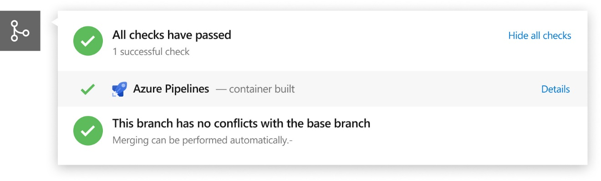

Build, test, and deploy everything you create on GitHub. Get fast, reliable builds on all platforms through deep integration with GitHub pull requests, checks, and statuses.

[**GitHub Marketplace**](https://github.com/marketplace/azure-pipelines/)

**Explore more of Azure DevOps**

**There’s more to Azure DevOps than just Pipelines. Learn how the full set of integrated, end-to-end tools can empower your team to ship software faster.**

[**Learn more about Azure DevOps**](https://azure.microsoft.com/en-ca/services/devops/)

*We were previously using three different CI services to build Atom releases for Windows, macOS, and Linux. Moving to Azure DevOps enabled us to produce release builds for those platforms and automate our nightly release process, all in a single CI job.*

**David Wilson  
Senior Application Engineer, GitHub, Atom Editor**

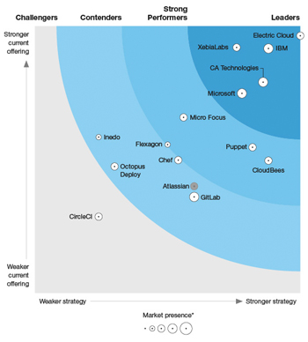

**The 15 CDRA providers that matter most**

Read The Forrester Wave™: Continuous Delivery and Release  
Automation, Q4 2018, to see why Azure DevOps ranks as a leader  
among 15 significant providers.

[**Get the report**](https://azure.microsoft.com/en-ca/resources/continuous-delivery-and-release-automation/)

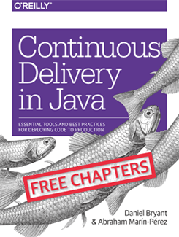

**Continuous Delivery in Java**

Essential Tools and Best Practices for Deploying Code to Production

[**Download the e-book**](https://azure.microsoft.com/en-ca/resources/continuous-delivery-in-java/)

**Get started with Pipelines**

**Easily set up pipelines to build, test, and deploy your code to any platform.**

[**Start free with Pipelines**](https://go.microsoft.com/fwlink/?LinkId=2014579&campaign=acom~azure~devops~pipelines~footer~hero&projectVisibility=Everyone&githubsi=true&clcid=0x1009&WebUserId=03F3F09FE99965071F5AFC34ED9963FE)

[**Learn about pricing**](https://azure.microsoft.com/en-ca/pricing/details/devops/azure-pipelines/)

**Go Social**

* [Facebook](https://www.facebook.com/microsoftazure)
* [Twitter](https://twitter.com/azure)
* [YouTube](https://www.youtube.com/user/windowsazure)
* [LinkedIn](https://www.linkedin.com/company/16188386)
* [Rss](https://azurecomcdn.azureedge.net/en-ca/blog/feed/)

[**Microsoft Azure**](https://azure.microsoft.com/en-ca/)

* [Solutions](https://azure.microsoft.com/en-ca/solutions/)
* [Products](https://azure.microsoft.com/en-ca/services/)
* [Regions](https://azure.microsoft.com/en-ca/global-infrastructure/regions/)
* [Case Studies](https://azure.microsoft.com/en-ca/case-studies/)
* [Pricing](https://azure.microsoft.com/en-ca/pricing/)
* [Member Offers](https://azure.microsoft.com/en-ca/pricing/member-offers/)
* [Calculator](https://azure.microsoft.com/en-ca/pricing/calculator/)
* [Documentation](https://docs.microsoft.com/en-ca/azure/)
* [Downloads](https://azure.microsoft.com/en-ca/downloads/?sdk=net)
* [Samples](https://azure.microsoft.com/en-ca/resources/samples/)
* [Marketplace](https://azuremarketplace.microsoft.com/en-ca/marketplace/)
* [Datacenters](https://azure.microsoft.com/en-ca/global-infrastructure/)

[**Community**](https://azure.microsoft.com/en-ca/blog/)

* [Blog](https://azure.microsoft.com/en-ca/blog/)
* [Azure Updates](https://azure.microsoft.com/en-ca/updates/)
* [Tech Community](https://techcommunity.microsoft.com/t5/Azure/ct-p/Azure)
* [Events](https://azure.microsoft.com/en-ca/community/events/)
* [Careers](https://news.microsoft.com/features/azure/?wt.mc_id=azuremktg_hp_careers)
* [Education](https://azure.microsoft.com/en-ca/education/)
* [Students](https://azure.microsoft.com/en-ca/free/students/)
* [Startups](https://startups.microsoft.com/)

[**Support**](https://azure.microsoft.com/en-ca/support/options/)

* [Forums](https://azure.microsoft.com/en-ca/support/community/)
* [Azure Status Dashboard](https://azure.microsoft.com/en-ca/status/)
* [Support](https://azure.microsoft.com/en-ca/support/options/)

[**Account**](https://azure.microsoft.com/en-ca/account/)

* [Microsoft Azure portal](https://portal.azure.com/)
* [Preview Features](https://azure.microsoft.com/en-ca/updates/?status=inpreview)
* [Privacy data management](https://azure.microsoft.com/en-ca/privacy-data-management/)

[**Trusted**](https://azure.microsoft.com/en-ca/overview/trusted-cloud/)

* [Security](https://go.microsoft.com/fwlink/?LinkId=717954&clcid=0x1009)
* [Privacy](https://go.microsoft.com/fwlink/?LinkId=717953&clcid=0x1009)
* [Compliance](https://go.microsoft.com/fwlink/?LinkId=837787&clcid=0x1009)

Hello from Seattle.





* [Contact Us](https://azure.microsoft.com/en-ca/overview/sales-number/)
* [Feedback](https://feedback.azure.com/forums/34192--general-feedback)
* [Trademarks](https://www.microsoft.com/en-us/legal/intellectualproperty/Trademarks/)
* [Privacy & Cookies](https://go.microsoft.com/fwlink/?LinkId=248681&clcid=0x1009)

© 2019 Microsoft