**BALOTARIO DE EJERCICIOS**

**SUMA:**

1. **010 + 101 =**
2. **001101 + 100101 =**
3. **1011011 + 1011010 =**
4. **110111011 + 100111011 =**

**RESTA:**

1. **111 – 101 =**
2. **10001 – 01010 =**
3. **11011001 – 10101011 =**
4. **111101001 – 101101101 =**

**MULTIPLICACION:**

1. **10110101000101 x 1011 =**
2. **10100001111011 x 10011 =**

**DIVISION:**

1. **10110101000101 / 1011 =**
2. **10100001111011 / 10011 =**

**DESARROLLO**

**SUMA:**

1. **010 + 101 =**
2. **001101 + 100101 =**
3. **1011011 + 1011010 =**
4. **110111011 + 100111011 =**

**RESTA:**

1. **111 – 101 =**
2. **10001 – 01010 =**
3. **11011001 – 10101011 =**
4. **111101001 – 101101101 =**

**MULTIPLICACION:**

1. **10110101000101 x 1011 =**
2. **10100001111011 x 10011 =**

**DIVISION:**

1. **10110101000101 / 111 =**

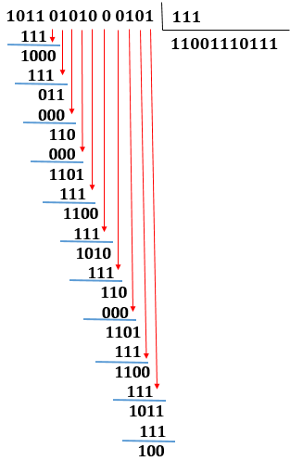

1. **10100001111011 / 1011 =**