Gold mine Python game
  - An assignment for Applied distributed systems (COIT13229)


Name: Alex Hall
Student Number: 12331263
Tutor: Tony Sahama
Unit: COIT13229
Campus: Brisbane
Date: 13/05/2026
Table of Contents
1. Introduction 3
2. Requirements analysis 4
2.1 Functional and Non-Functional requirements 4
2.2 Use case diagram 5
3. Architectural design 6
3.1 Architecture overview 6
3.2 Component diagram 7
3.3 Design rationale 7
3.4 Consistency model 8
3.5 High-level class diagram 9
3.6 Sequence diagram 10
4. Redesign 11
5. Test plan 12
5.1 Test plan overview 12
5.2 Fault tests 12
5.3 Testing approach 12
5.4 Client disconnect – sequence diagram 13
5.5 Communication delay – sequence diagram 14
6. Test results 15

Introduction
For this assignment, I will develop a distributed system using ZeroMQ and Python. The game is called Gold Miner and allows multiple players to connect to a distributed game system where they can compete for who collects the most points; in this case ‘gold’.
This report discusses the functional requirements, design, implementation of a prototype, and testing of a multiplayer game called ‘Gold Miner’. The project focuses on a distributed system using Python to let players interact across a Local Area Network. For demo purposes, the prototype will just be one player and a number of bots. A prototype will be included, but the main objective is abstractly explaining how such a system could be constructed and how it would operate.
The purpose of the assignment is to demonstrate practical understanding of distributed systems, consistency management, concurrency, fault tolerance, and testing. In addition to the abstract analysis of system requirements and design, the project also focuses on the actual implementation of this into a prototype.
Another important part of the project is the testing of distributed-system behaviours and failures as these usually only occur in very specific situations.
In short, this report provides a requirements analysis, architectural design, testing approach, implementation overview, supporting design documentation and a short manual for the distributed system game.

Requirements analysis

2.1 Functional and Non-Functional requirements
I derived the functional and non-functional requirements below, from the objective and goals provided in the task overview on Moodle.
Number | Functional (FR) or Non-Functional (NFR) Requirements.
FR1 | The system shall allow a human player to join a game session.
FR2 | The system shall allow automated bots to participate in a game session.
FR3 | The system shall maintain a shared game environment containing an active player, bots and collectible gold.
FR4 | The system shall allow participants to move within the game.
FR5 | The system shall detect collisions between participants and the collectible gold.
FR6 | The system shall update participants’ scores when gold is collected.
FR7 | The system shall distribute updated game-state information to all connected participants.
FR8 | The system shall prevent invalid movement outside the game boundaries.
FR9 | The system shall support multiple distributed clients connected simultaneously.
NFR1 | The system should maintain a consistent shared game state between connected participants.
NFR2 | The system should tolerate temporary communication delays without corrupting game-state information.
NFR3 | The system should continue operating when individual clients unexpectedly disconnect.
NFR4 | The system architecture should be able to support 100 participants within a single organisation.
NFR5 | The system should support increasing numbers of participants without requiring changes in the architectural design.
NFR6 | The model should support distributed participants across a Local Area Network.

The requirements above have been created with the assumptions below, also derived from the task overview on Moodle.
- Participants communicate through a Local Area Network
- At least one human player and bots may interact concurrently
- Temporary communication delays may occur

2.2 Use case diagram
Below is a picture of the use case diagram based on the task on Moodle and the above-stated requirements.
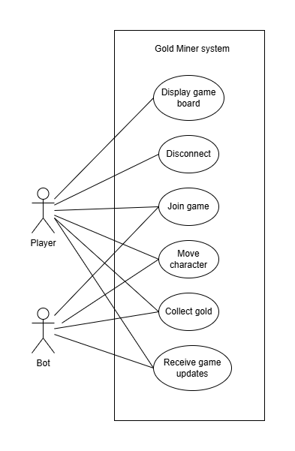

Architectural design

Architecture overview
The gold miner game uses a central client-server with a distributed architecture. The architecture consists of a single authoritative game server and multiple distributed clients. Clients should represent human players, but for demo purposes, one will represent a human player and the others will represent automated bots.
The game server is responsible for the shared game state. This includes processing movement requests, validating actions such as joining, tracking player scores by detecting collision with the collectible gold and distributing the updated information to all connected clients.
Player and bot clients act as distributed nodes that communicate with the server asynchronously. Clients send movement requests to the server and receive updated game-state information in return. The clients are responsible for local rendering and (player) interaction. The server is responsible for maintaining all game state data and distributing updated data to all clients.
The chosen architecture separates the actual gameplay logic from rendering and client interactions. This improves both maintainability and scalability as the clients can use the same scripts, regardless of the amount of players.

Component diagram
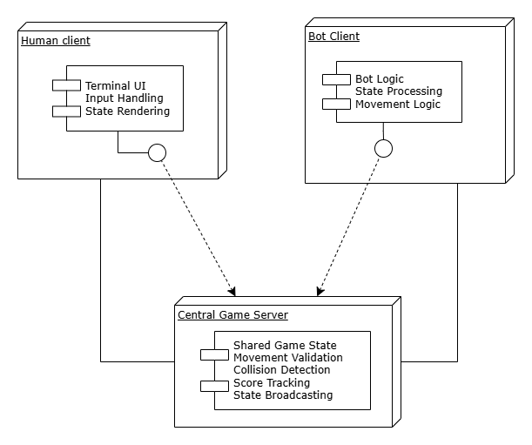
Above a picture can be seen of the component diagram

Design rationale
A centralised client-server architecture was selected because it simplifies consistency management and coordination between the clients. By maintain a single authoritative central server, the system avoids conflicting updates between clients and ensures that all clients receive a consistent representation of the game. Besides that, it also takes away the opportunity to cheat the game from a client, as the server keeps all authoritative data.
Alternative architectures such as ZooKeeper and Amazon SQS were considered, but as this is a simple game with only one authoritative server on a local area network, ZeroMQ was chosen for its simplicity.
This also improves maintainability as the system is not complex. However, in case more players join, it might be necessary to scale up the system by moving the server to a better pc, but as the server does not require too much computing and processing power for input up to a 100 players, this probably will not be necessary for the goal of this project.

Consistency model
The game server maintains the single authoritative version of the shared game state, while clients submit (movement) requests to alter the game state without modifying the state directly themselves. Under this model, all game-state changes are processed by the server before updated information is distributed to the other clients. This ensures that there is only one game state and all clients receive that same, correct, game-state data.
The consistency model is implemented through the following behaviours:
- All game-state change requests made by clients are validated by the server.
- Gold collection and score updates are processed and stored centrally as well.
- Clients receive updated game-state information from the server instead of calculating their own state individually.
- The server distributes updated game-state information to all connected clients after processing.
The main advantage of this consistency model is that coordination between distributed clients is simplified and there is a less likely chance of inconsistent game states.
However, there are some downsides to this design as well which include, but are not limited to:
- Communication delays may happen depending on connections, causing clients to temporarily having or displaying outdated game-state information.
- The server may become a bottleneck as the number of participants / bots increases.
- Unexpected server failure will terminate the active game session, i.e. there is no redundant second server handling requests.

High-level class diagram

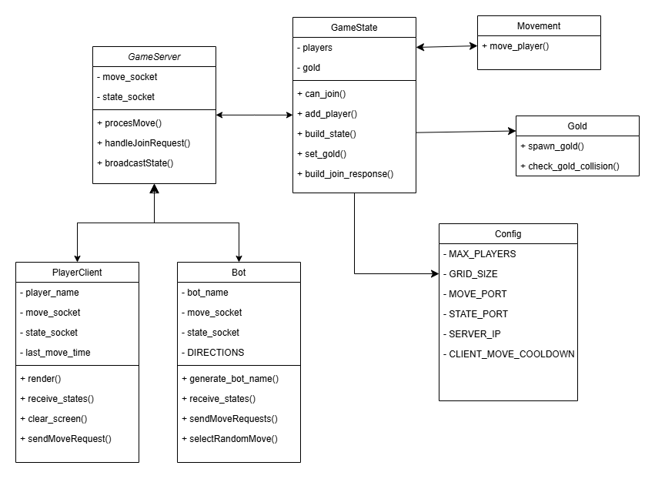
Above a high-level class diagram of the project can be seen.

Sequence diagram
Below, the sequence diagram for this project can be seen
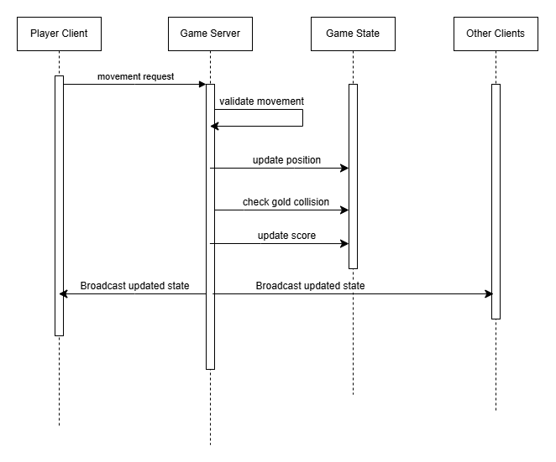

Redesign
As the prototype of this game completely follows the architecture, a redesign was not necessary. This chapter does remain in the report so it is clear there was no redesign necessary for the design.

Test plan

Test plan overview
The purpose of the test plan is to evaluate the behaviour, reliability and fault tolerance of the distributed system prototype. The testing process focuses mostly on the distributed-system faults and communication instead of standard unit tests common done in software engineering.
The tests below are designed to test the system mostly on client disconnects, keeping multiple concurrent client connections and concurrent player interactions. As the game is just a prototype, some tests are expected to partially fail and point out limitations and future improvements for the current design.

Fault tests
The table below shows all tests set up for this project
Test ID | Test Name | Description | Expected result
T1 | Multiple client connection | Connect multiple player and bots simultaneously to the server | All participants should successfully join and receive continuous game-state updates
T2 | Concurrent movement | Multiple clients attempt to move simultaneously | The server should process movement consistently without corrupting shared game-state
T3 | Client disconnection | A client disconnects unexpectedly during gameplay. | The server continues operating as normal, but the clients name will remain visible and inactive for other players
T4 | High number of participants | A large number of bots are connected simultaneously | The server should continue operating as normal without slowing down significantly
T5 | Consistency validation | Multiple clients connect and compare received game-state information after gameplay updates. | Clients should maintain a consistent render / view of the shared game state.
T6 | Communication delay | A delay between client and server will be placed | The server should continue operating while tolerating delayed updates

Testing approach
The distributed system fault tests mentioned above will be tested through manual testing. Unexpected node failures will be tested by manually terminating clients while the game is in session. The behaviour of the server and remaining clients will be observed.
Consistency validation tests will be performed by comparing received game-state information from different clients.
Other tests such as T4 or T2 will be tested by manual performing them and checking the terminal.

Client disconnect – sequence diagram
Below a sequence diagram can be seen showing a client disconnect and how the system should and does respond to this.
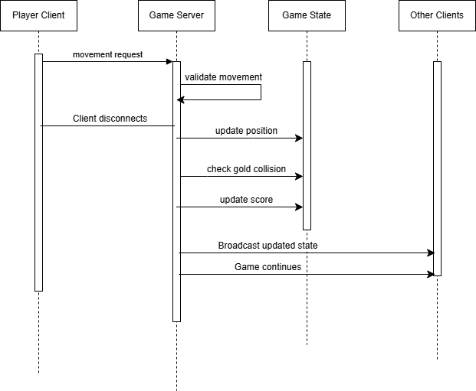

Communication delay – sequence diagram
A sequence diagram of a communication delay test can be seen below. A clear communication delay, caused by an artificial ‘processing delay’ will be placed between a client and the server to see how it responds.
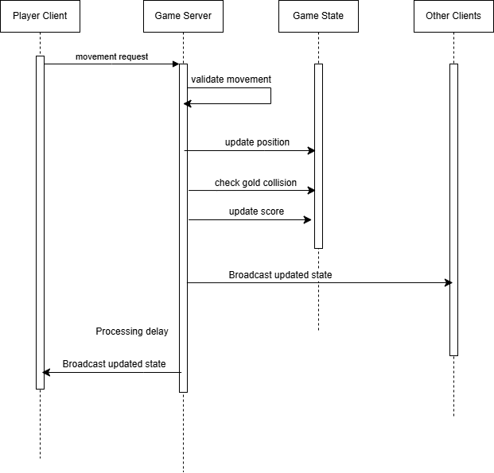

Test results
All test results will be shown below, per test ID. For reference what each test ID entails, refer to the following paragraph: 5.2 Fault tests.

  - Test result T1
For this test I have used one player connection to get a graphical interface of the game and three bots. The result is quite clear. All the clients can connect and the game operates as expected. Everyone received the same continues game updates.
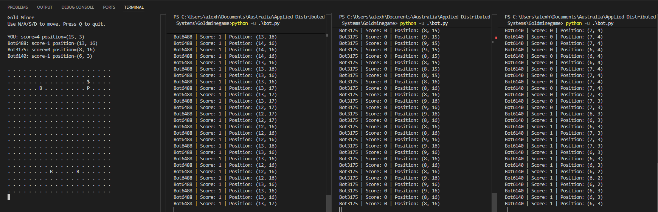
  - Test result T2
For this test, I used two actual players, to have two graphical interfaces and two bots. This worked as expected as well, all clients can move simultaneously without any issues arising.
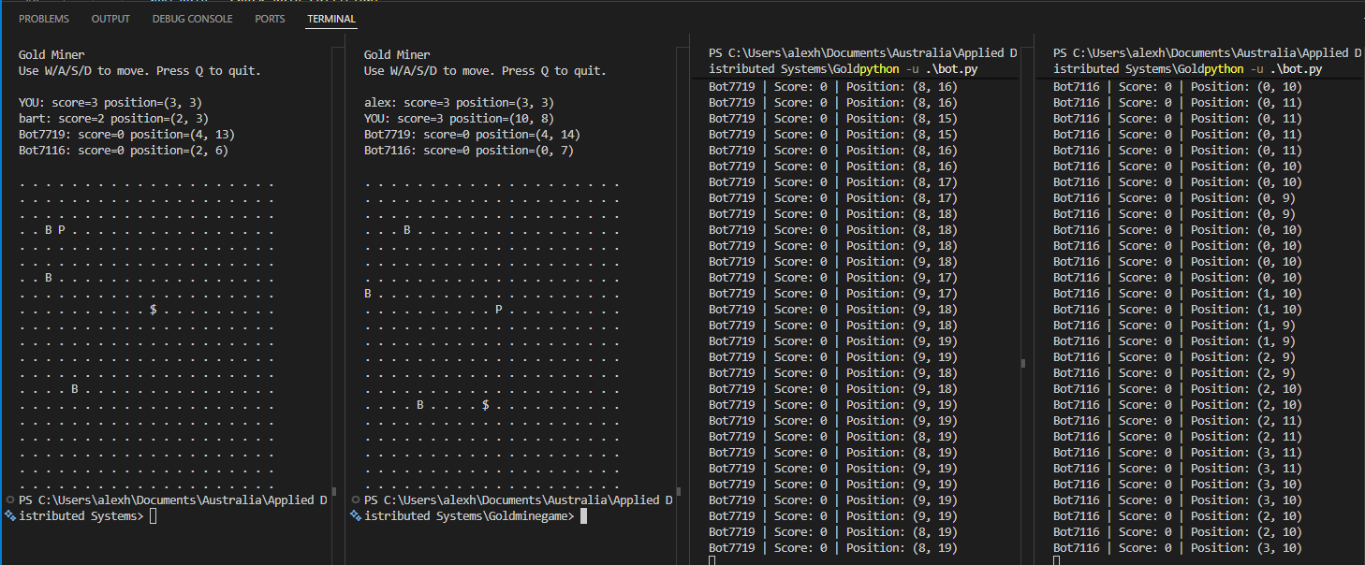

  - Test result T3
For this test I used the same names as during previous test. You can see that when player Bart (second player from left to right) left and his screen is no longer updated. Player Alex (first player) has gathered more gold in the meanwhile and has gotten a higher score as can be seen than when Bart was still active. The result is as expected and the game continues when a client suddenly disconnects.
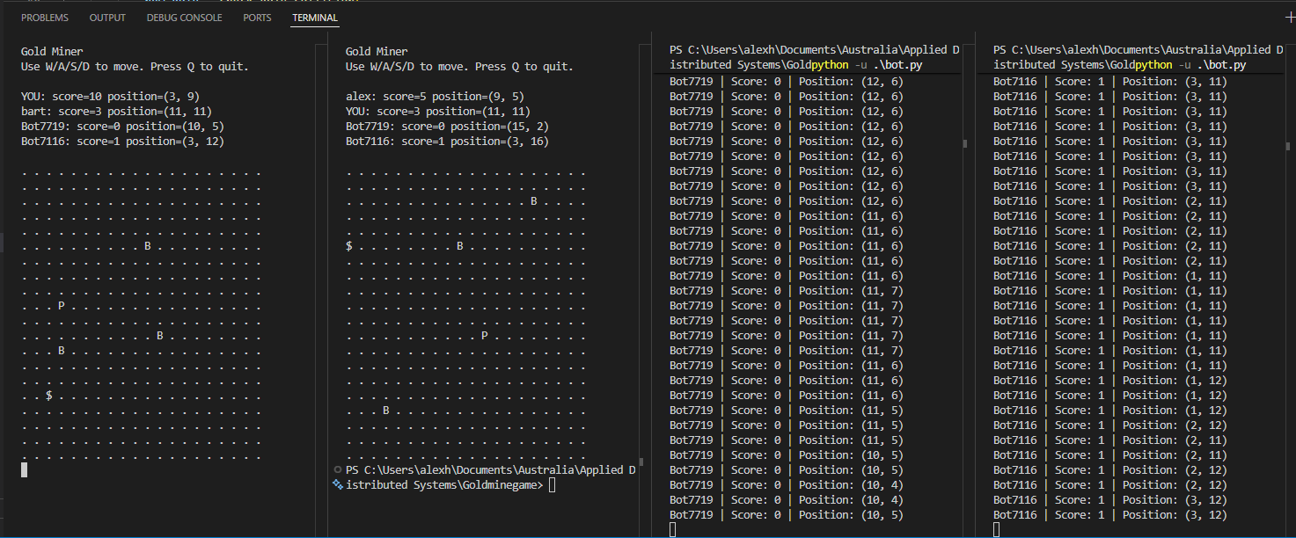

  - Test result T4
For this test, I connected 11 bots and one player (12 clients) to one game. The game ran without any issues and operated as expected. The only issue that arose was that of a graphical issue, because the playing field get’s more clustered by Bs (Bots), it becomes less clear who is a bot, which one you are and where the gold is.
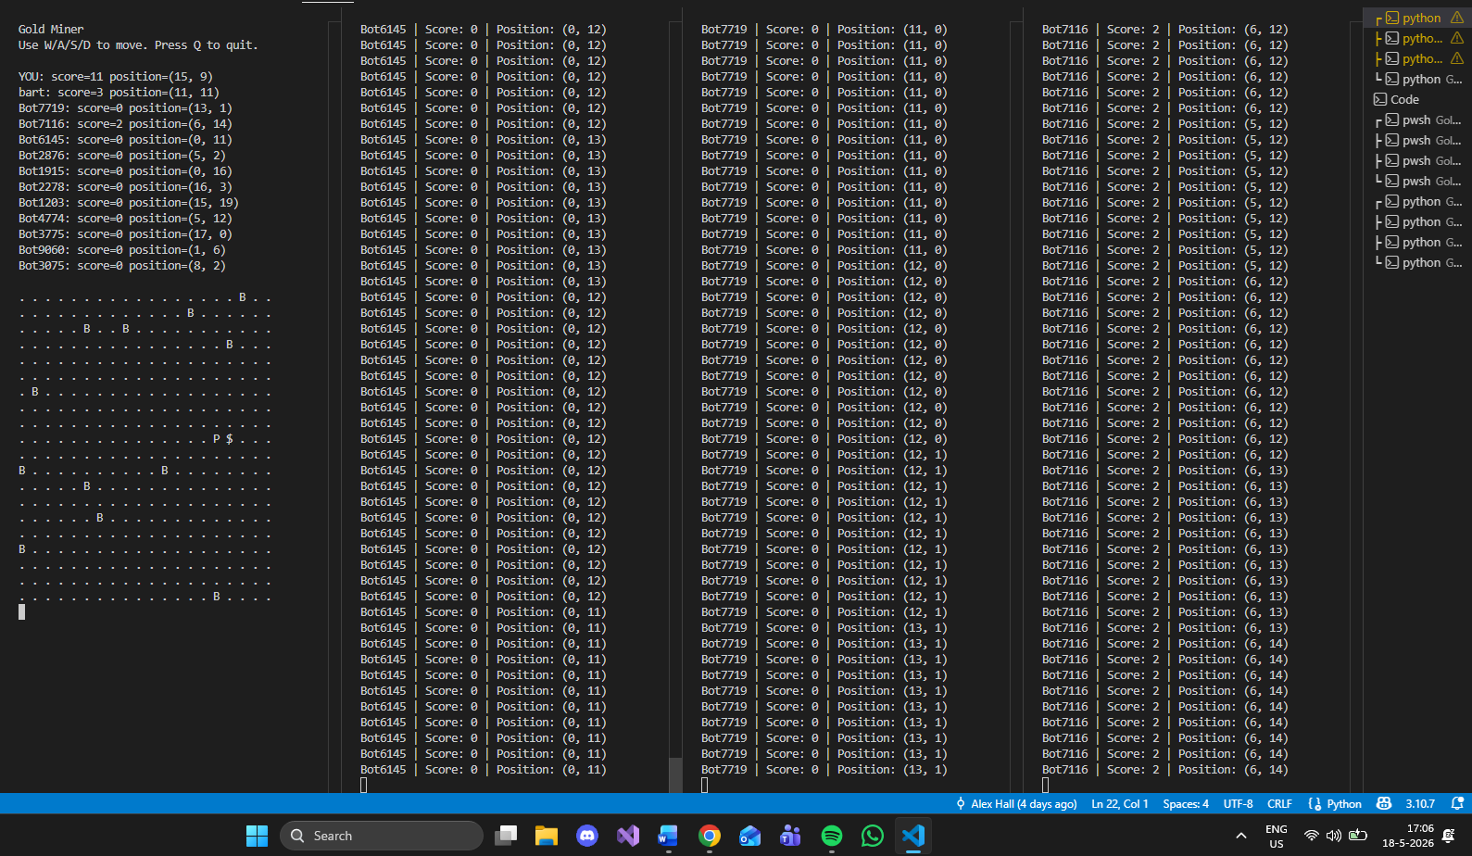

  - Test result T5
For this test I have connected two players and one bot. At all times are the game-state updates received the same. Proof can be seen below in different screenshots taken throughout the gameplay.
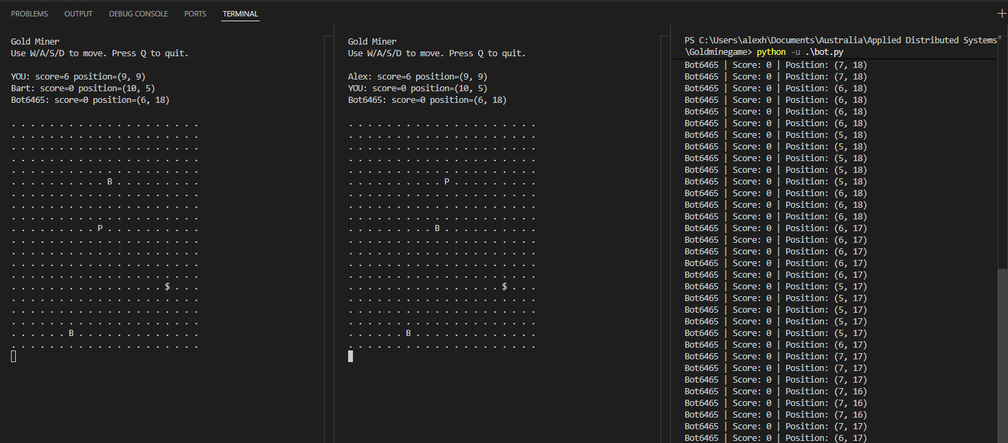
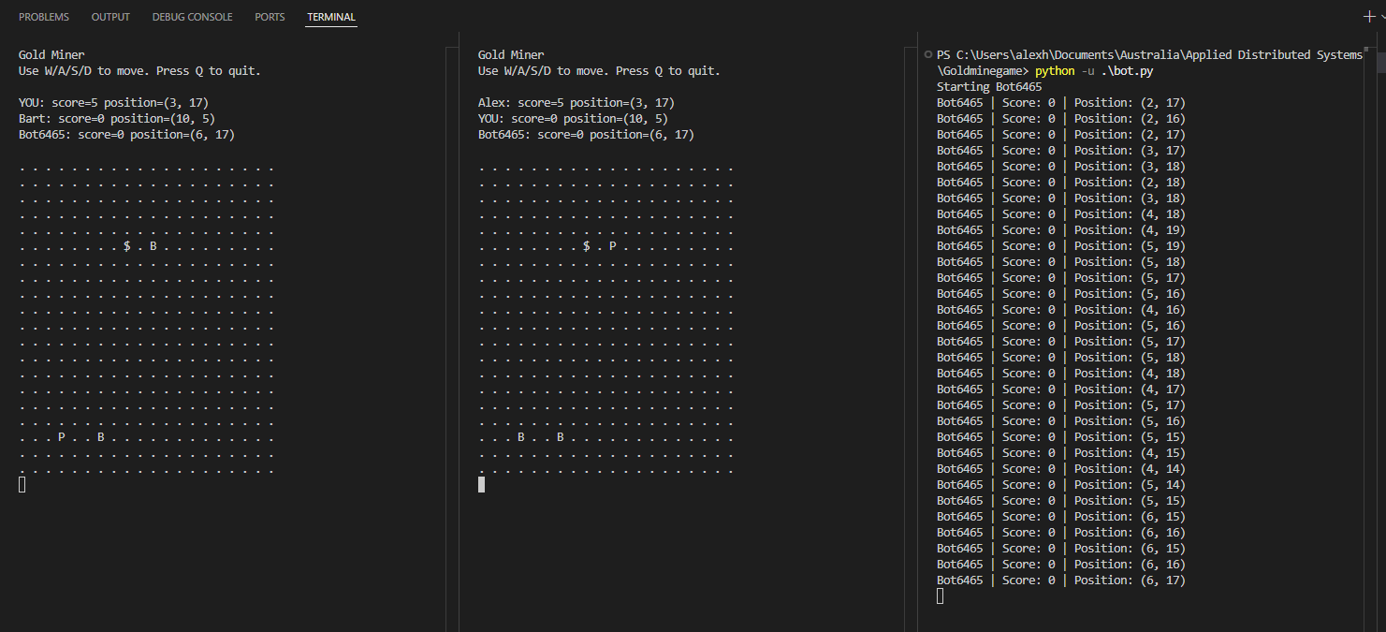
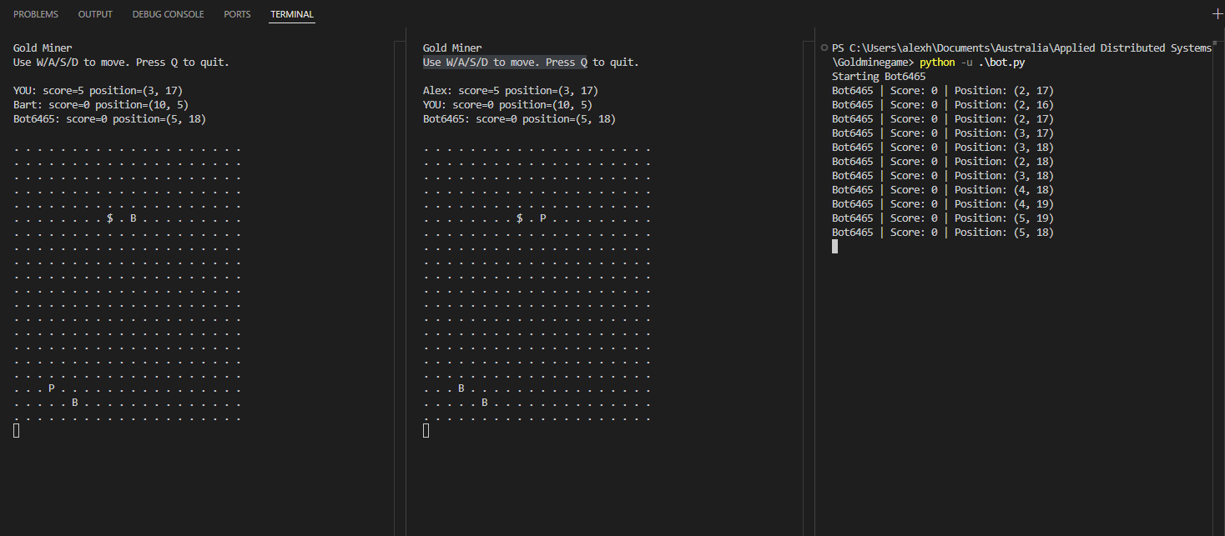
  - Test result T6
For this test, I used a delayed send by one client, in this case I created an extra script (duplicate of player_client, called delayed_player_client). To emulate a slow network connection, I added a time.sleep before movements were sent. The system still picks it up and the delayed client still sees his movements. However, the client does see the delay happening on screen and the other players see that specific client moving at the same time as the client does itself.
