Review First Week Deliverables

* <https://docs.google.com/document/d/1zfaoEBkzUoN0spfYByzJ20PpE9otDsfvSG-iEDlA0jw/edit?usp=sharing>

Roles:

* Project Manager = Rebecca Gruenberg
  + Primary communication with customer
  + Iteration planning, task assignment/division
* Technical Manager = Alex Gray
  + Manages task board technology
  + Architectural design/technology solution
  + Includes some coding
* Daya Layer Person/Tester = Juliette Amorati
  + Organizes UML models, SQL schemas
  + Includes some coding, but less so
  + Testing of current software
* Developers = Jack Del Vecchio, Linh Nguyen
  + Bulk of the coding and documentation work

Team’s Meeting Schedule:

* Wednesdays at 5:00pm on Google Hangouts
* Alternate time added based on conflict or workload is Tuesdays at 6:30pm

Requirements to be validated:

1. The repository must be accessible through an online interface
2. Each entry should contain at least the movie name and description
3. Without logging in, users should be able to view all the movies in the repository
4. Without logging in, users should be able to sort and filter all the movies in the repository
5. Users should be able to search for movies whose information contains the strings specified in the search bar
6. Users should be able to submit a request form (with an external link) to add an entry to the repository
7. Administrators must be able to verify or deny user requests and include a related comment
8. Administrators should have access to a request page where they can see submitted application requests
9. Users can create an account with a unique username and password
10. Users are able to leave comments in a comment section for each entry
11. Moderators have the ability to moderate a comment section by deleting posts for each entry

Current Requirement Questions:

* What things should each entry contain?
  + Actors, ratings, comment section, genre
* Where should the external link go for verification? IMDB?
  + IMDB
* Do users need to log in to request adding a movie?
  + Yes
* What criteria should the users be able to sort and filter the movies by (Requirement 4)?
  + Sort alphabetically, filter by genre
* When the users create an account, what fields are required? (for example, first + last name, email, phone number?)
  + first/last name, username, password
* Should the users be able to change the information of a movie already on the page? (if the info is wrong, maybe the users can submit a request form to change the info?)
  + No
* Is there a limit for the number of words/characters in the comments?
  + 250 char
* Which of these requirements are your highest priority?
  + GUI with dummy data, sorting sample functionality
* Other questions that come up

Initial UML Class Diagram

* <https://drive.google.com/file/d/1Dnhlaid6Vj6jXiPmAq5y0cgyZyBPe0ec/view?usp=sharing>

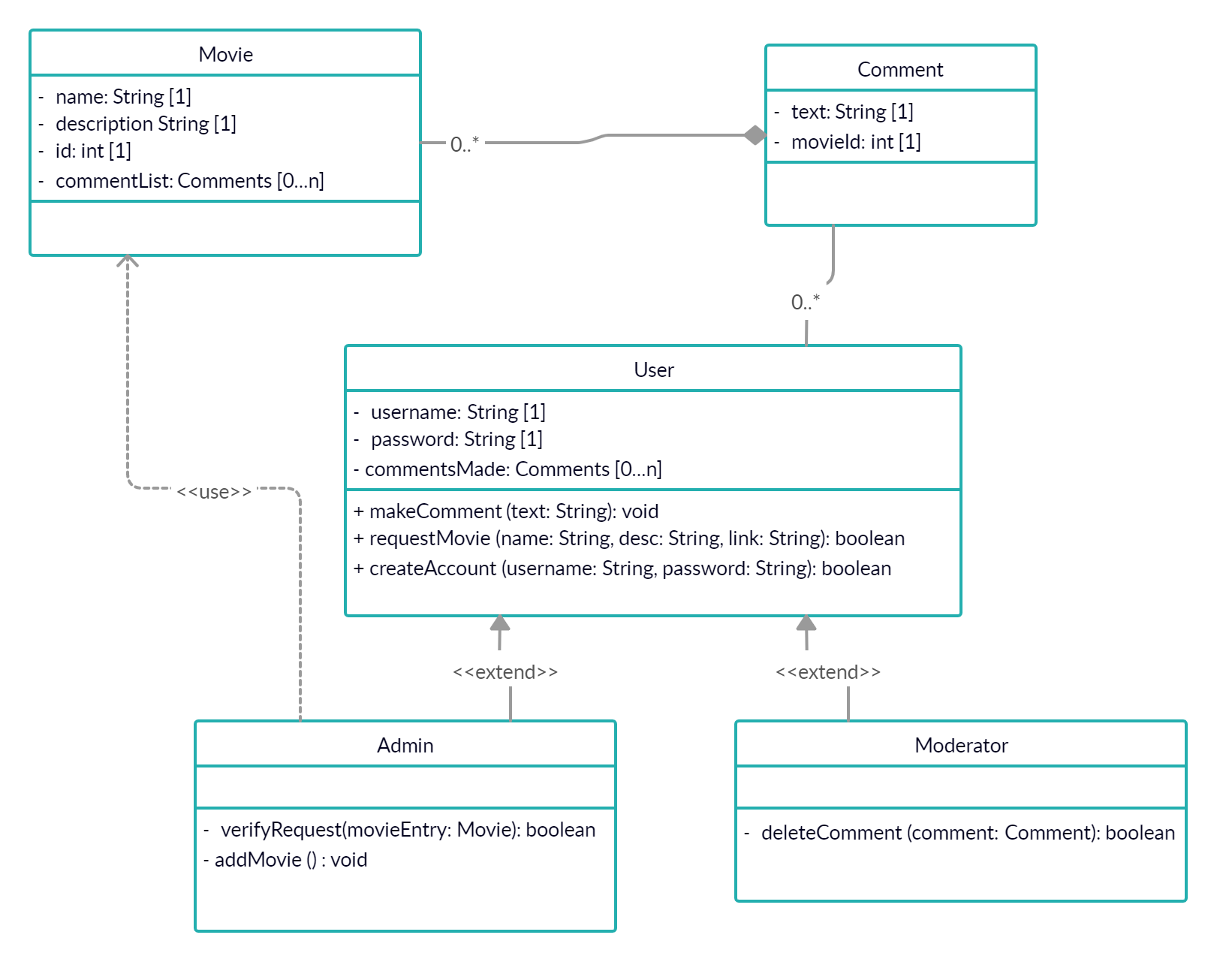

Bluesky Requirements Session:

* What would your perfect site do?
* What would your perfect site look like?
* What do you want the users to get out of the site?
* How big are you imagining this repository being?
* Other questions that come up

Display Trello Board

* <https://trello.com/b/DUoWwEH1/the-reel-world>
* Tasks for Iteration 1 -- Still assigning estimates, but tentative stories in backlog
* Tentative team member assignment on board

Show Code Repository

* Github
* <https://github.com/Alex4008/CSE201-The-Reel-World>