Display running program with skeleton objects

* <http://ceclnx01.cec.miamioh.edu/~gruenbrc/CSE201-The-Reel-World/>
* Last pull 4/1/2020 4:40 p.m.

Display trello board with finalized tasks, assignments, task effort value, and iteration 1 division

* <https://trello.com/b/DUoWwEH1/the-reel-world>
  + Task effort value is within the task checklist in each requirement (in hours)
  + Iteration 1 task division is also within the requirement checklist

Requirements Not Worked On In Iteration 1

* Split up on trello board but further enumerated here:
  + Users should be able to search for movies whose information contains the strings specified in the search bar
  + Users should be able to submit a request form (with an external link) to add an entry to the repository
  + Administrators must be able to verify or deny user requests and include a related comment
  + Administrators should have access to a request page where they can see submitted application requests
  + Users can create an account with a unique username and password
  + Users are able to leave comments in a comment section for each entry
  + Moderators have the ability to moderate a comment section by deleting posts for each entry

Burn-down chart

* Task estimates and chart calculated through Burndown for Trello
  + <https://www.burndownfortrello.com/index.php>
  + Below picture is as of 4/1/2020

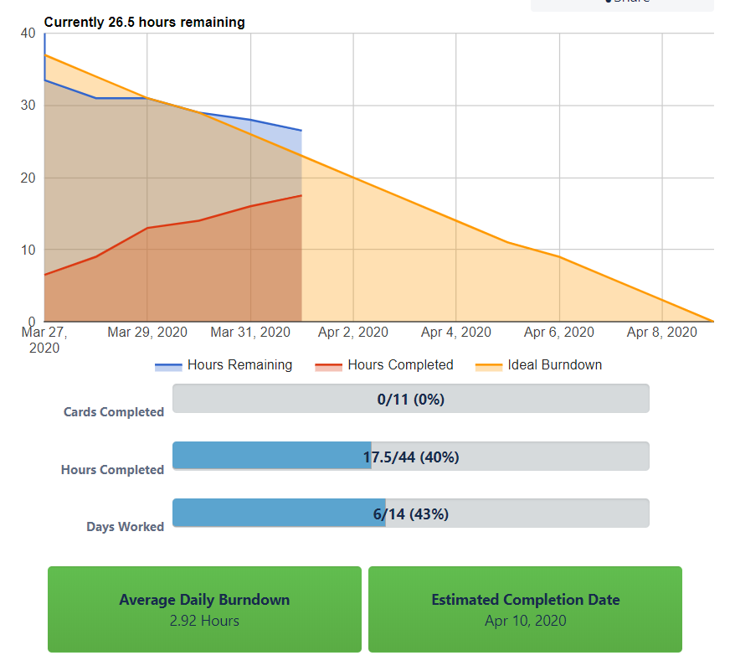

State Diagram Chart for User Class

* Done by Juliette (Data Layer Person)
* Made for Movie objects

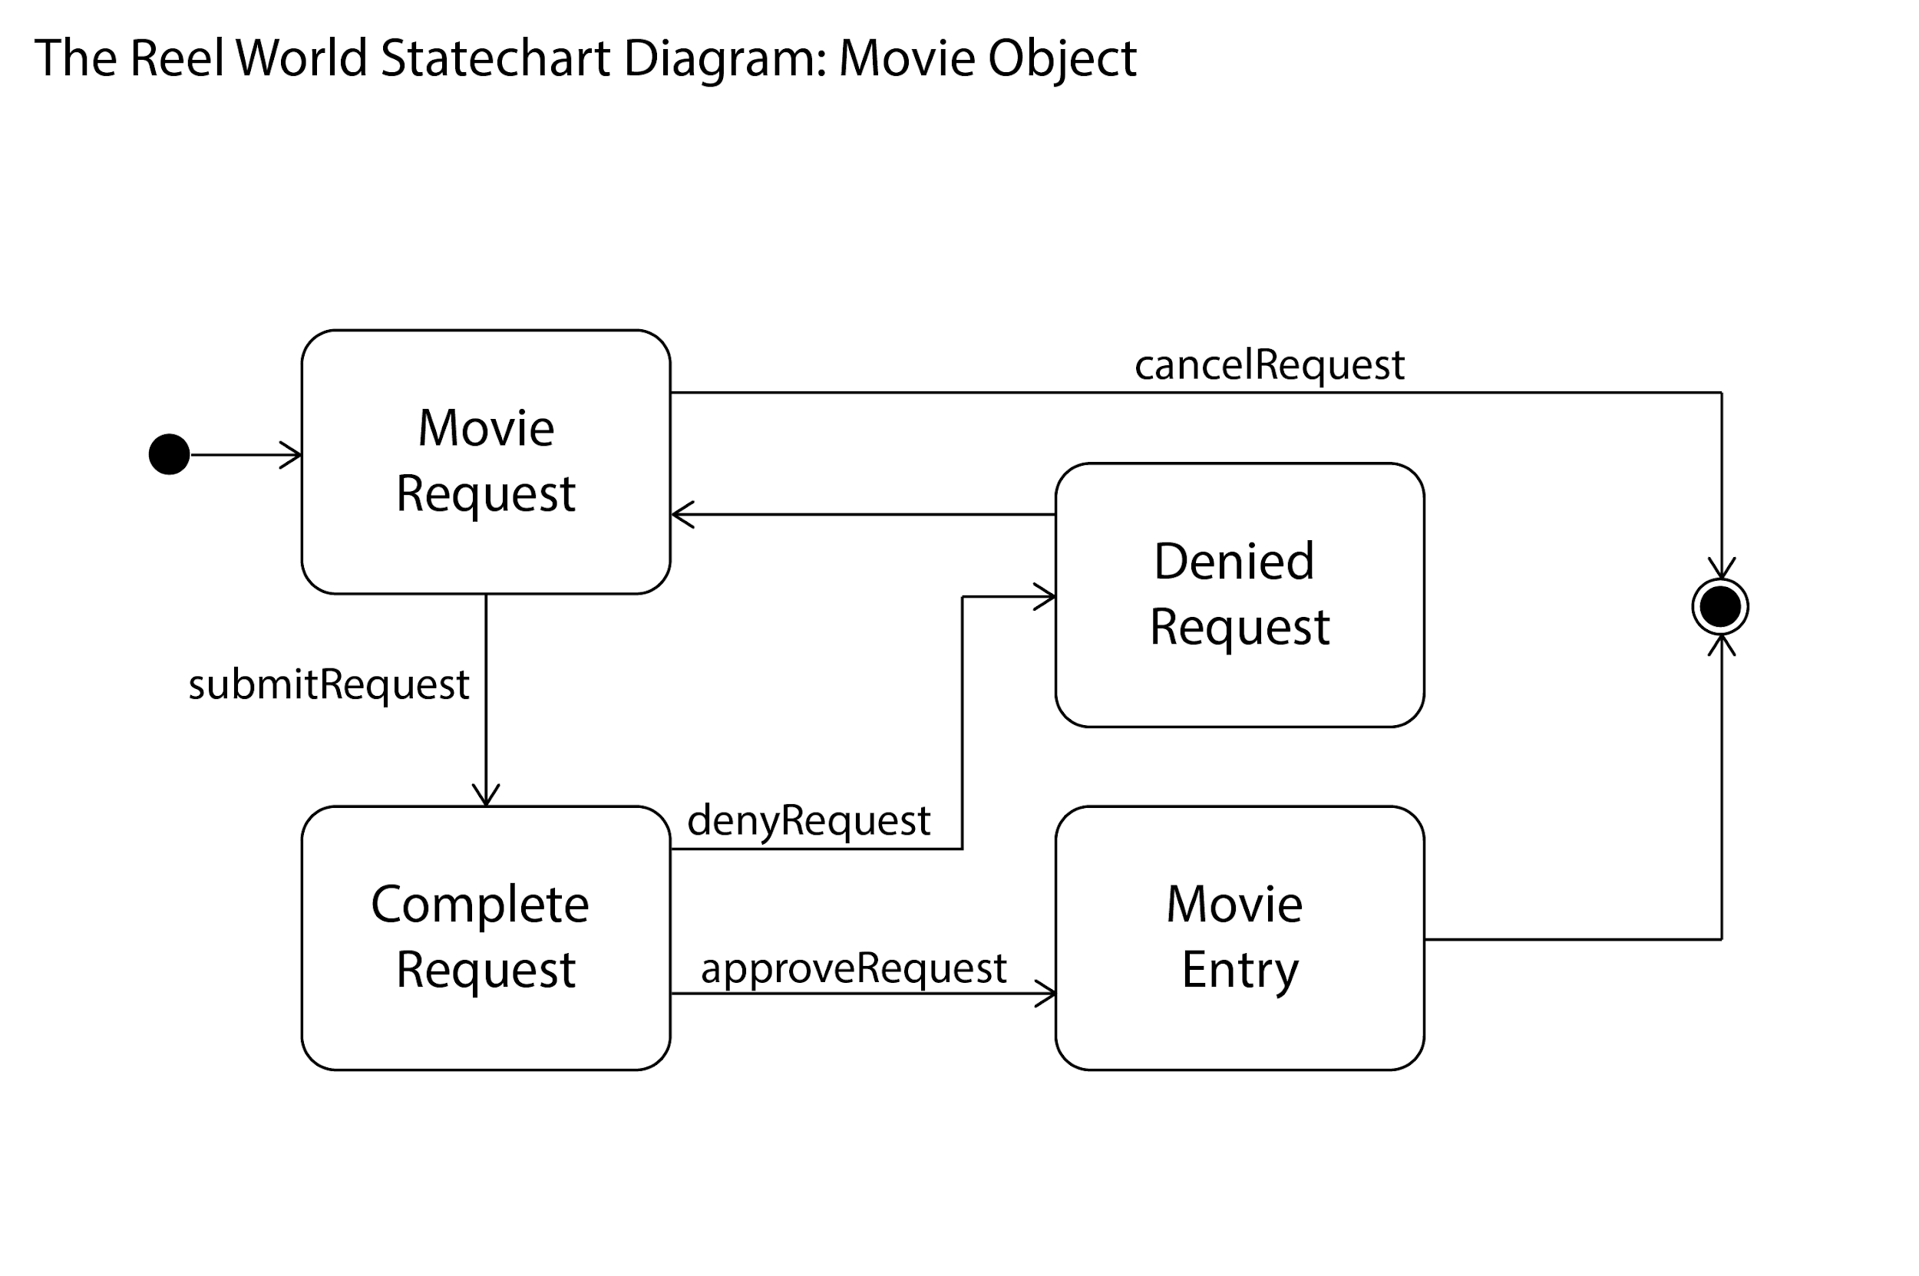

GitHub Repository

* <https://github.com/Alex4008/CSE201-The-Reel-World>

Agenda for 4/9/2020 Meeting

* <https://docs.google.com/document/d/1sGawydsbw_SV4iPi5NGE14kOqNNdnTmQKAJOkhuErns/edit>