**Open Source Ventilator**

**Passive Valves**

V1.0; Robert Benedict, March 25, 2020; Kent, Ohio, USA

Assumptions:

* Passive valves for Anti-Asphyxia, Over-Pressure and PEEP
* 1” PVC air flow pipe
* Passive valves 3D printed
* Passive valves and sensor mounted on 1” PVC T bodies

Notes: The designs are done in OpenSCAD which is freely available and completely parametric. My prototype devices are printed in PETG on a Prusa Research MK3s.

Design choice – gravity loaded poppets

+ easily controlled and reproducible, should not require individual calibration

- requires orientation, AA point down, Op and PEEP point up

Version 1

Using poppet valves with 45 degree seats that have a rubber O-ring embedded. The 1 1/16" OD x 3/32" diameter O-ring is a common hardware store item for faucet valve repair. Tested by mounting in a T and breathing through it. Open at a very low pressure and I can breath easily. Does not seal completely., I can detect a leak when I blow hard into it.

V1 AA valve parts

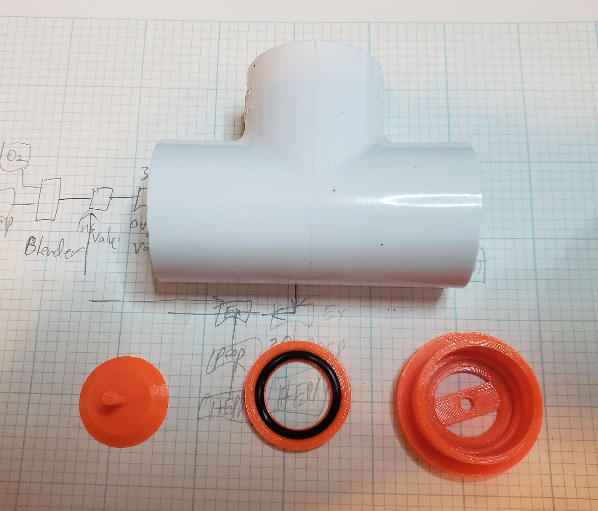

V1 AA valve assembly

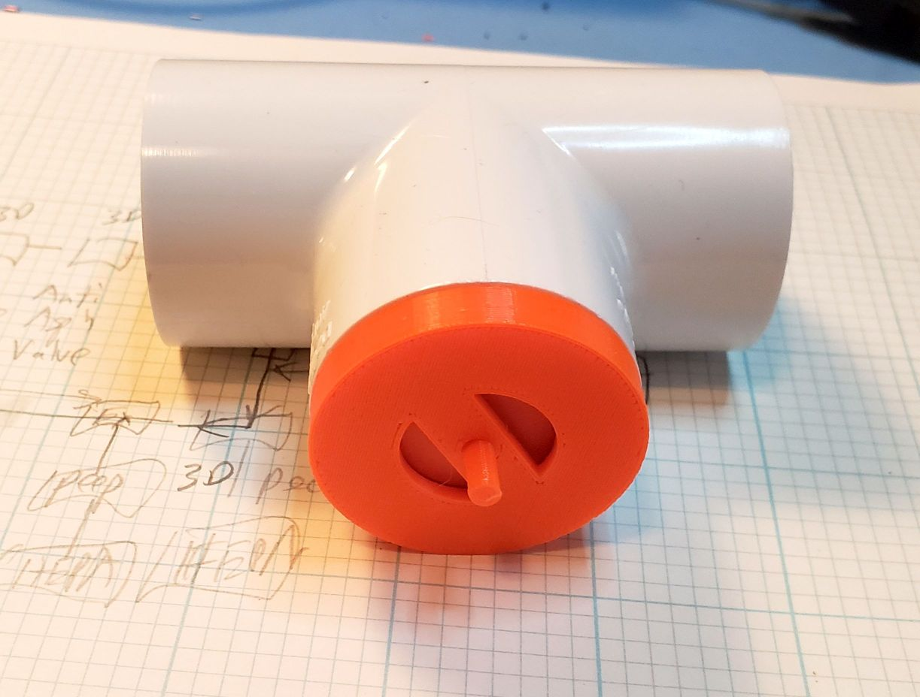

Version 2 is also a poppet valve but flat acting against a soft garden hose washer. In subjective breathing test it also opens easily and seals very well.

V2 AA parts

