Report 003: Advanced Trading Strategies: Pairs Trading

Alejandro Salinas
Lenin Quezada
Trading
Strategy Description and Rationale
Pairs trading is a market-neutral investment strategy that seeks to exploit short-term deviations in the relative value of two historically related assets. The approach involves simultaneously taking a long position in the undervalued asset and a short position in the overvalued one, under the assumption that their prices will eventually revert to a long-term equilibrium. This structure minimizes exposure to overall market direction and focuses instead on the convergence of the spread between the two assets.
The fundamental premise of the strategy is that some assets share a stable equilibrium relationship due to economic, sectoral, or fundamental linkages. Temporary deviations from this relationship create an opportunity for arbitrage. For instance, if the spread between two cointegrated commodities widens abnormally, one can short the outperforming asset and go long on the underperforming one, anticipating that the spread will narrow as the equilibrium is restored.
Cointegration as Evidence of Arbitrage Opportunity
While correlation captures short-term co-movements, it does not imply a persistent equilibrium relationship. Cointegration, on the other hand, indicates that a linear combination of two non-stationary price series results in a stationary residual — meaning that the spread fluctuates around a constant mean over time. Statistically, this is verified using the Engle-Granger two-step method, where an ordinary least squares (OLS) regression is performed between the assets, and the residuals are then tested for stationarity through the Augmented Dickey-Fuller (ADF) test. A stationary residual implies mean reversion, which forms the core of the arbitrage logic: deviations from equilibrium are expected to self-correct.
Rationale for Using the Kalman Filter
Traditional pairs trading assumes that the hedge ratio (β) estimated by OLS remains constant. However, in real markets, the relationship between assets evolves due to changing volatility, structural breaks, and macroeconomic factors. The Kalman filter addresses this limitation by treating the hedge ratio and intercept ($α_{t} , β_{t}$) as time-varying state variables within a state-space model. It updates these estimates sequentially as new information arrives, balancing responsiveness and stability through the parameters Q (process noise) and R (measurement noise). This dynamic adjustment enables the model to adapt in real time, ensuring that hedging decisions remain robust across varying market conditions.
The use of the Kalman filter thus transforms the trading logic from a static regression-based approach into a sequential learning process, where predictions, observations, and updates occur iteratively. This flexibility is particularly advantageous in periods of moderate volatility or regime transitions, where static models would lag behind changing dynamics.
Market Conditions for Strategy Success
Pairs trading with a Kalman filter performs best in mean-reverting environments, where asset relationships remain economically justified and deviations from equilibrium are temporary. It is particularly suited to commodities and equity sector pairs with stable long-term fundamentals but frequent short-term price noise. Conversely, the strategy tends to underperform during strong directional trends, regime shifts, or when the long-term equilibrium relationship between assets breaks down. Success also depends on maintaining low transaction costs and effective control of borrowing rates, as excessive trading frequency can erode profits.
Pair Selection Methodology
Correlation screening criteria and results
Objective. Pre-filter asset pairs that tend to move together over time, without assuming stationarity of the price levels.
Method. For each class-specific price panel, compute the average rolling Pearson correlation for every column pair:
- Window length: N observations (window=N)
- Average of the rolling correlation series (dropping NaNs)
- Keep pairs with |mean rolling corr| ≥ 0.70 (corr_threshold=0.7)
Rationale.
- Rolling correlations capture persistent co-movement while allowing for local regime changes.
- A relatively high threshold (0.70) balances tractability (fewer candidates) with inclusivity prior to cointegration testing.
- Note: correlation≠cointegration; this is only a filter, not evidence of a stationary spread.
Outcome for selected pair.
- CL=F vs RB=F (WTI crude vs RBOB gasoline): mean rolling corr = 0.745 (passes the 0.70 screen).
Cointegration testing (Engle-Granger method)
Here we work in price levels and then we test whether a static linear combination is stationary.
Step 1. Long-run relationship (OLS).
Estimate: $S_{1}=α+βS_{2}+e$
- Implemented via Statsmodels with intercept
- Store $α,β, R^{2}, and n$
Step 2. Residual stationary
We Run ADF on the residuals $\hat{e}$: reject $H_{0}$(unit root) → evidence of cointegration.
- Autolag: AIC
- Decision Rule: p-value <0.05 (adf_threshold=0.05)
Decision: A pair is tagged Cointegrated=True if it passes the correlation screen and ADF($\hat{e}$) has p < 0.05.
Notes / assumptions.
- Engle–Granger is appropriate for bivariate relationships where both prices are plausibly I(1).
- Using price levels is standard, though many studies use log-prices; coefficients change under rescaling but the stationarity decision should be robust.
- Gasoline (¢/gal) vs crude ($/bbl) have different units, so β can be large. That does not affect the ADF decision but matters for interpretation.
Statistical evidence for selected pairs
Pair: CL=F (WTI crude) vs RB=F (RBOB gasoline)
Screening evidence.
- Mean rolling correlation (90-day): 0.745 → passes 0.70 threshold.
Engle–Granger evidence.
- OLS: $\hat{α}=0.913$, $\hat{β}=32.319$
- Goodness of fit: $R^{2}=0.915$
- ADF on residuals: p = 0.000003 → reject unit root at the 1% level → cointegration detected.
Interpretation.
- The very high $R^{2}$and highly significant ADF indicate a stable long-run linkage between crude and gasoline futures prices, consistent with refining economics.
- The large $\hat{β}$ reflects unit mismatches (gasoline in cents/gal; crude in $/bbl). If desired, repeat with log-prices or rescaled units (e.g., convert both to $/gal or use z-scores) to obtain a more interpretable hedge ratio; the cointegration inference should remain.
Practical takeaway.
- The spread ${\hat{e}}_{t}=S_{1t}-\hat{α}-\hat{β}S_{2t}$is statistically mean-reverting, providing a basis for pairs strategies (entry/exit defined on standardized residuals).

Charts showing price relationships and spread evolution
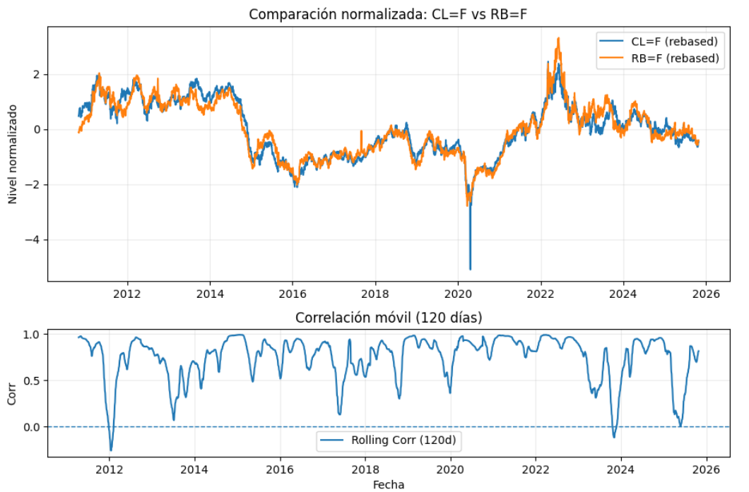
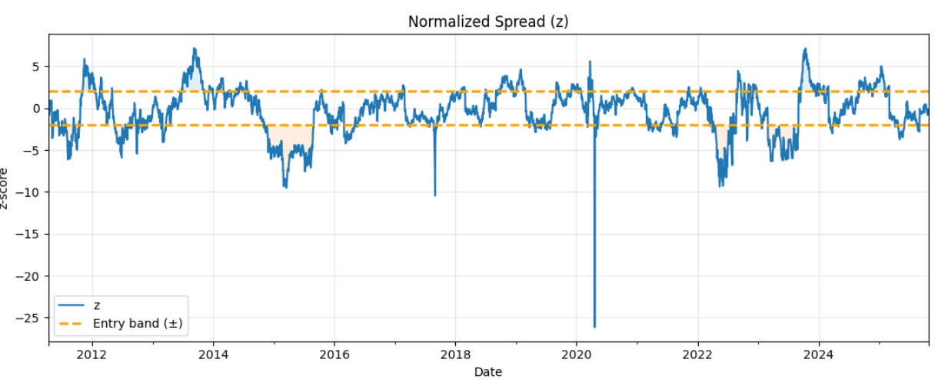
- Table: Correlation and cointegration statistics for all tested pairs:
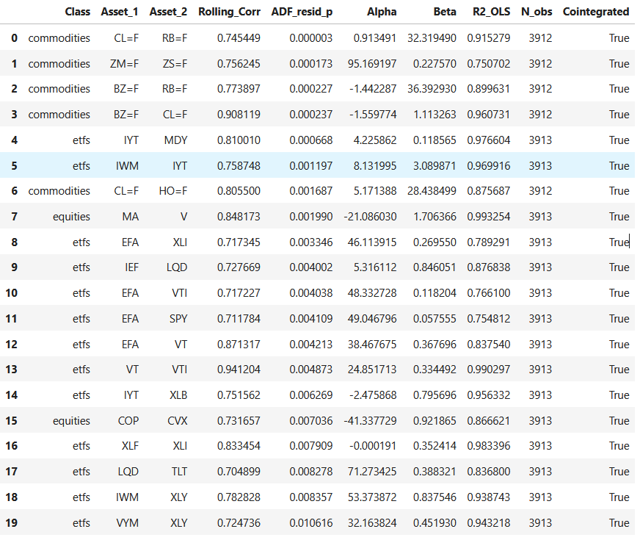

Sequential Decision Analysis Framework

State-space formulation (pairs trading with dynamic hedge)
We model the time-varying spread relationship $y_{t }≈α_{t}+β_{t} x_{t}$ with a linear Gaussian state-space model in which the state holds the hedge parameters:
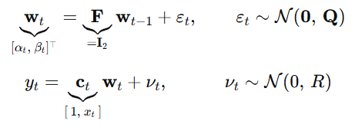
with $Q = diag\left(q_{α}, q_{β}\right)$and R>0. The transition is a random walk (F=I ), letting $α_{t} , β_{t}$ adapt to slow regime changes while remaining regularized by Q. The observation matrix $c_{t}=\left[1 , x_{t}\right]$ ties the state to the observed dependent price $y_{t}$ .
Initialization. In code (kalman_init), the filter is seeded by OLS on an initial window:
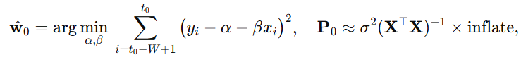
and R defaults to the OLS residual variance $σ^{2}$ unless the user pins it via R_user.
Predict → Observe → Update → Decide → Act → Learn
At each time t, the algorithm follows this closed loop:
Predict. Propagate prior mean and covariance:
Observe. Form the design vector $c_{t}=\left[1 , x_{t}\right]$ and read $y_{t}$ .
Update. Compute innovation, innovation variance, and Kalman gain:
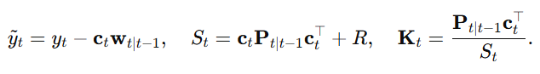
Then update state and covariance:
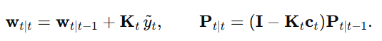
The normalized innovation (z-score) is
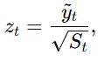
which is exactly W['z'] in code and drives signals.
Decide. Apply the z-policy (decide_from_z):
- $z_{t} ≥ z_{entry}: short the spread \left(sell y, buy βx\right)→ position = -1$
- $z_{t} ≤ -z_{entry}: long the spread \left(buy y, sell βx\right)→ position = +1$
- $\left|z_{t}\right| ≤ z_{exit}: flatten → position =0$
- Else keep prior position
Act. The backtest (backtest_kalman_pair) transforms position and $β_{t}$ into balanced dollar legs (long/short) with transaction costs and borrow fees, then books P&L.
Learn. The posterior $w_{t|t , P_{t|t}}$ becomes the prior for t+1. When you roll from train→test→validation, the final state (and covariance) are passed via init_state to preserve walk-forward continuity.

Kalman gain: calculation and interpretation
The gain
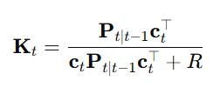
balances model uncertainty against measurement noise. Large R (noisy prices) shrinks $K_{t}$ and yields conservative parameter updates; large $P_{t|t-1}$ (uncertain prior state) enlarges $K_{t}$ and makes the filter more reactive. Component-wise, the second element of $K_{t}$ regulates how quickly $β_{t}$ adapts to changes in the y–x slope.

Choosing Q and R
- Process noise $Q = diag\left(q_{α}, q_{β}\right)$. Controls how much the filter expects $α_{t} , β_{t}$ to drift. Bigger values permit faster adaptation but amplify parameter noise and trading churn; smaller values smooth the state but risk lag in regime shifts. In code these are q_alpha, q_beta.
- Measurement noise R. Captures idiosyncratic observation noise around the regression line. We estimate RRR from OLS residual variance on the warm-up window, which is a robust default. Supplying R_user pins it when you have a prior (e.g., known microstructure noise).
- Initial covariance inflation. inflate scales $P_{0}$ to avoid overconfidence from the warm-up fit. Higher inflation gives the filter permission to move early; too high can induce jitter.
A practical tuning path is: start with OLS-derived R, moderate inflate (e.g., 3–5), then sweep q_beta over orders of magnitude to balance responsiveness of $β_{t}$ against trading stability; finally adjust q_alpha to control slow intercept drift.

Worked example (two consecutive updates)
Illustrative numbers, consistent with the code’s algebra:
- Prior state and covariance after prediction:
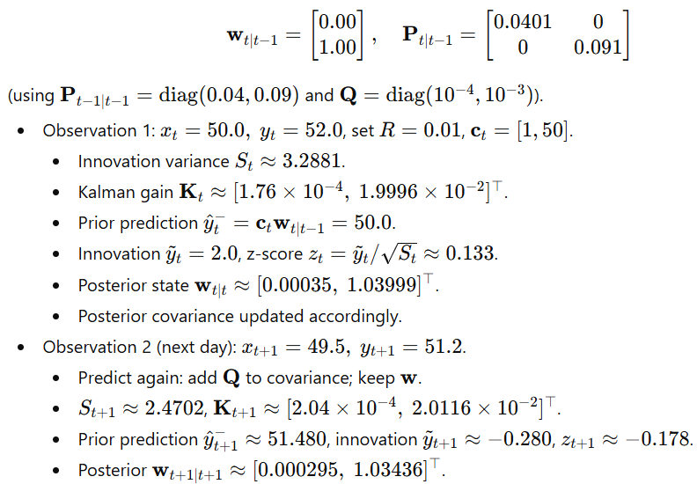
Two points stand out. First, the gain on β (~2% of the innovation) is an order of magnitude larger than on α, so the slope adapts faster than the intercept—which is usually desirable for spreads. Second, both z-scores are small in magnitude, so the trading policy remains flat; larger absolute innovations would push z toward the entry bands and trigger positions.

Kalman Filter Implementation
Initialization procedures
The dynamic relationship between two assets $y_{t}$and $x_{t}$is modeled as:
$$yt=α_{t}+β_{t}x_{t}+v_{t}, νt​∼N(0,R)$$
$$\left[\begin{matrix}α_{t} \\ β_{t}\end{matrix}\right]=\left[\begin{matrix}α_{t-1} \\ β_{t-1}\end{matrix}\right]+ε_{t}, εt​∼N(0,Q)$$
where
- $w_{t}=[α_{t},β_{t}]^{T}$ is the state vector (time-varying intercept and slope),
- $F=I_{2}$ defines a random walk transition,
- $C_{t}=[1,x_{t}]$ is the observation design vector,
- $Q=\text{diag}(q_{α},q_{β})$ controls state smoothness,
- $R$ is the measurement noise variance.
Initialization logic (in kalman_init).
- Data alignment: Both series $y_{t}$and $x_{t}$are cleaned, aligned, and truncated to ensure equal length.
- Initial OLS estimation: Over an initial window of 120 observations, an OLS regression
$$y_{t}=α_{0}+β_{0}x_{t}+e_{t}$$
provides the starting estimates ${\hat{α}}_{0}$and ${\hat{β}}_{0}$.
- Measurement noise variance $R$: Estimated as the variance of the OLS residuals:
$$R=Var⁡(e_{t})$$
(or overridden by R_user if manually set).
- State covariance $P_{0}$: Derived from the OLS covariance $(X^{'}X)^{-1}$and scaled by the residual variance:
$$P_{0}=σ^{2}(X^{'}X)^{-1}$$
multiplied by an inflation factor (default = 4) to avoid overconfidence in the initial state.
- Process noise covariance $Q$: Diagonal matrix:
$$Q=\left[\begin{matrix}q_{α} & 0 \\ 0 & q_{β}\end{matrix}\right]$$
controlling how much $α_{t}$and $β_{t}$can change each step (e.g., $q_{α}={10}^{-8},q_{β}={10}^{-6}$).
This ensures a stable and flexible starting point for recursive estimation.
Parameter estimation methodology
After initialization, the Kalman filter recursively estimates $(α_{t},β_{t})$ for each new observation:
(a) Prediction (Time Update)
$$\begin{matrix}{\hat{w}}_{t∣t-1} & =F{\hat{w}}_{t-1∣t-1} \\ P_{t∣t-1} & =FP_{t-1∣t-1}F^{T}+Q\end{matrix}$$
Given $F=I_{2}$, this simply means the previous state carries forward, with uncertainty increasing by $Q$.
(b) Update (Measurement Step)
For the observation equation $y_{t}=C_{t}w_{t}+ν_{t}$:
$$\begin{matrix}S_{t} & =C_{t}P_{t∣t-1}C_{t}^{T}+R \\ K_{t} & =P_{t∣t-1}C_{t}^{T}S_{t}^{-1} \\ \text{innovation: }{\tilde{y}}_{t} & =y_{t}-C_{t}{\hat{w}}_{t∣t-1} \\ {\hat{w}}_{t∣t} & ={\hat{w}}_{t∣t-1}+K_{t}{\tilde{y}}_{t} \\ P_{t∣t} & =(I-K_{t}C_{t})P_{t∣t-1}\end{matrix}$$
The innovation ${\tilde{y}}_{t}$measures prediction error, and $K_{t}$(the Kalman gain) determines how strongly the model updates its parameters.
Z-score normalization:
$$z_{t}=\frac{{\tilde{y}}_{t}}{\sqrt{S_{t}}}$$is used to standardize deviations and trigger trading signals (entry/exit).
Reestimation schedule and validation approach
Walk-forward logic:
The filter can either:
- Run continuously (carrying forward the final state $w_{t},P_{t}$into the next window), or
- Reinitialize periodically (rolling OLS recalibration).
In our code:
- kalman_run_W() supports both modes via the init_state argument.
- This enables walk-forward reestimation, simulating realistic online learning without lookahead bias.
Validation:
Filter performance is validated using:
- Spread stationarity: The residual spread $y_{t}-(α_{t}+β_{t}x_{t})$should remain stationary if the filter tracks equilibrium.
- Z-score distribution: $z_{t}$should approximate a standard normal if model variances $Q,R$are well calibrated.
- Trade logic consistency: Entry/exit thresholds (z_entry, z_exit) should generate symmetric long/short durations and limited drift.
Noise calibration:
In practice, $Q$and $R$can be fine-tuned using backtests, likelihood maximization, or cross-validation to minimize forecast error variance or maximize trading performance.
Convergence analysis and filter stability
Convergence properties.
- Because of the transition matrix $F=I_{2}$, the filter tracks slowly varying α and β.
- If $Q$is too small → α, β evolve too slowly (filter lags).
- If $Q$is too large → α, β overreact to noise (unstable estimates).
- The choice $q_{β}={10}^{-6}$and $q_{α}={10}^{-8}$gives β moderate flexibility while keeping α nearly constant.
Covariance stability.
- The covariance recursion $P_{t}=(I-K_{t}C_{t})P_{t∣t-1}$ensures $P_{t}$remains positive semidefinite.
- Numerical stability is reinforced by small eps floors and covariance inflation on initialization.
- In practice, after a brief transient, $P_{t}$converges to a steady-state range reflecting the balance between $Q$and $R$.
Empirical convergence check:
- Plotting $β_{t}$ overtime should show smooth adaptation with no explosive jumps.
- The innovation variance $S_{t}$ should remain bounded and approximately stable.
- If $z_{t}$variance drifts from unity, it indicates mis-specified noise levels or parameter drift.

Trading Strategy Logic
Z-score definition
At each time $t$, the Kalman filter produces a one-step-ahead prediction of $y_{t}$,
$${\hat{y}}_{t∣t-1}=α_{t∣t-1}+β_{t∣t-1} x_{t},$$and the innovation (prediction error)
$${\tilde{y}}_{t} = y_{t}-{\hat{y}}_{t∣t-1}.$$With observation design $c_{t}=[1, x_{t}]$and predicted covariance $P_{t∣t-1}$, the innovation variance is
$$S_{t} = c_{t} P_{t∣t-1} c_{t}^{⊤}+R,$$so the normalized innovation (our trading signal) is:
$$z_{t}=\frac{{\tilde{y}}_{t}}{\sqrt{S_{t}}}$$
Intuition: $z_{t}$ measures how many standard deviations the realized $y_{t}$ deviates from the model-implied value given $x_{t}$ and the current hedge ratio. Large $∣z_{t}∣$ suggests a temporary dislocation relative to the cointegrating relation.
Positioning and sizing (execution)
Our position rule (see decide_from_z) is a symmetric threshold policy on $z_{t}$:
- Enter/keep SHORT spread (sell $y$, buy $βx$): if $z_{t}≥z_{\text{entry}}$→ position $-1$.
- Enter/keep LONG spread (buy $y$, sell $βx$): if $z_{t}≤-z_{\text{entry}}$→ position $+1$.
- Close to flat if $∣z_{t}∣≤z_{\text{exit}}$→ position $0$.
- Otherwise keep prior position.
Given equity $E_{t}$and investment fraction $ι=\text{invest_frac}$, target gross notional
$$G_{t} = ι E_{t}.$$Let $β_{t}$be the current hedge ratio. Our sizing function sets dollar weights
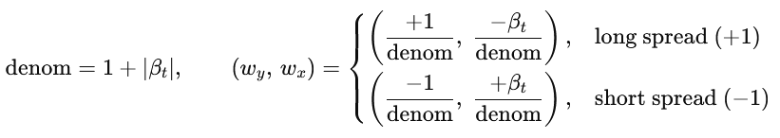
and target dollar holdings
$$h_{y}=G_{t} w_{y},h_{x}=G_{t} w_{x}.$$
Given prices $p_{t}^{y},p_{t}^{x}$, the units are
$$u_{y}=\frac{h_{y}}{p_{t}^{y}},u_{x}=\frac{h_{x}}{p_{t}^{x}}.$$This design caps gross exposure at $G_{t}$and scales the two legs so that $∣h_{y}∣+∣h_{x}∣=G_{t}$. Note that net dollars $h_{y}+h_{x}$are not forced to zero unless $β_{t}≈1$; if strict dollar-neutrality is desired, one can solve for $(w_{y},w_{x})$subject to $h_{y}+h_{x}=0$and $∣h_{y}∣+∣h_{x}∣=G_{t}$.
Daily P&L before costs from previous holdings $(h_{y}^{\text{prev}},h_{x}^{\text{prev}})$ and asset returns $(r_{t}^{y},r_{t}^{x})$ is
$${\text{PnL}}_{t}^{\text{gross}} = h_{y}^{\text{prev}} r_{t}^{y} + h_{x}^{\text{prev}} r_{t}^{x}.$$
Our diagnostic “pair return” divides by gross dollars at risk:
$$r_{t}^{\text{pair}} = \frac{{\text{PnL}}_{t}^{\text{gross}}}{∣h_{y}^{\text{prev}}∣+∣h_{x}^{\text{prev}}∣} (\text{if denominator}>0).$$
Optimal entry and exit Z-score policy found
Policy used in code. The implementation runs with
$$\boxed{z_{\text{entry}}=2.0,z_{\text{exit}}=0.5}$$by default. This creates a hysteresis band: trades open on rare, large deviations and close when the dislocation mean-reverts toward equilibrium.
Why this is sensible.
- If $z_{t}∼N(0,1)$i.i.d., $Pr⁡(∣z_{t}∣≥2)≈4.55\%$, so entries are infrequent (lower turnover, lower costs).
- A tight exit like $0.5$helps harvest mean reversion early, improving win rate and reducing time in market.
How to find the optimal thresholds. In practice we determine $(z_{\text{entry}},z_{\text{exit}})$by a grid search (or Bayesian optimization) that maximizes an out-of-sample objective such as Sharpe:
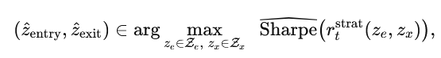
subject to risk and turnover constraints. Typical grids: $z_{e}∈[1.0,3.0]$step 0.25; $z_{x}∈[0.1,1.0]$step 0.1. Use rolling walk-forward splits to avoid look-ahead bias, and add penalties for turnover or costs if desired.
Robustness checks.
- Symmetry: verify performance is similar on long and short legs.
- Stability: confirm selected thresholds are stable across subperiods.
- Cost-sensitivity: re-optimize under higher commissions/borrow; the optimal $z_{\text{entry}}$usually increases as costs rise.
Cost treatment: commissions and borrow rates
Commissions (transaction costs)
You rebalance to $(h_{y},h_{x})$every step. The turnover is the absolute dollar change across both legs,
$${\text{Turnover}}_{t} = ∣h_{y}-h_{y}^{\text{prev}}∣+∣h_{x}-h_{x}^{\text{prev}}∣.$$
Given per-dollar commission rate $c$(here $c=0.00125$= 12.5 bps), the commission hit is
$${Comm}_{t}=c*{Turn over}_{t}$$
Commissions scale with rebalance frequency and with variability of $β_{t}$(more $β$ movement ⇒ more resizing ⇒ higher costs).
Borrow (short financing)
Let the daily borrow rate be $b=\text{borrow_rate_annual}/252$. With short notional
$${\text{ShortNotional}}_{t}=∣h_{y}^{\text{prev}}∣⋅1_{\{h_{y}^{\text{prev}}<0\}} + ∣h_{x}^{\text{prev}}∣⋅1_{\{h_{x}^{\text{prev}}<0\}},$$our borrow cost is
$${Borrow}_{t}=b*{Short Notional}_{t}$$
This captures financing drag for the short leg(s). Because your weights are gross-notional scaled, borrow costs rise with $G_{t}=ιE_{t}$ and with the allocation of shorts across legs.
Equity recursion and P&L net of costs
With $E_{t-1}$the prior equity, your code updates through
$$\begin{matrix}{\text{PnL}}_{t}^{\text{gross}} & =h_{y}^{\text{prev}}r_{t}^{y}+h_{x}^{\text{prev}}r_{t}^{x}, \\ E_{t}^{\text{mid}} & =E_{t-1}+{\text{PnL}}_{t}^{\text{gross}}-{\text{Borrow}}_{t}, \\ E_{t} & =E_{t}^{\text{mid}}-{\text{Comm}}_{t}.\end{matrix}$$
Reported net P&L is ${\text{PnL}}_{t}^{\text{net}}={\text{PnL}}_{t}^{\text{gross}}-{\text{Comm}}_{t}-{\text{Borrow}}_{t}$
Performance & trade statistics (as computed)
From the backtest series $\{E_{t}\}$and $\{{\text{PnL}}_{t}^{\text{net}}\}$:
- Daily return $r_{t}=\frac{E_{t}-E_{t-1}}{E_{t-1}}$.
- Sharpe $=\frac{\sqrt{252} \overset{‾}{r}}{σ(r)}$
- Sortino $=\frac{\sqrt{252} \overset{‾}{r}}{σ(r ∣ r<0)}$
- Max drawdown ${min⁡}_{t}(\frac{E_{t}}{{max⁡}_{s≤t}E_{s}}-1)$
- Calmar $=\frac{\text{AnnRet}}{∣\text{MDD}∣}$, with $\text{AnnRet}=(E_{T}/E_{0})^{252/T}-1$.
- Trades: count of sign changes in position
- Win rate / Profit factor: from the distribution of ${\text{PnL}}_{t}^{\text{net}}$ on trading days

Results and Performance Analysis
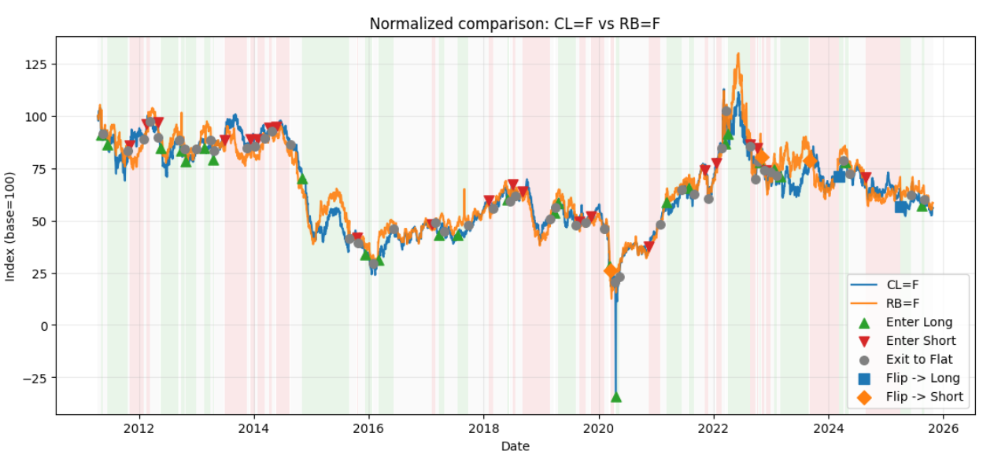
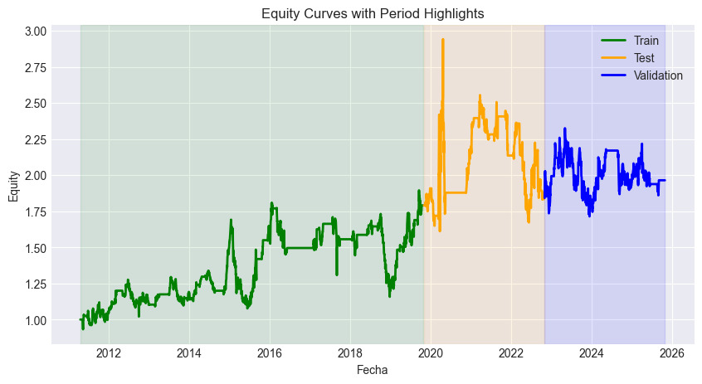
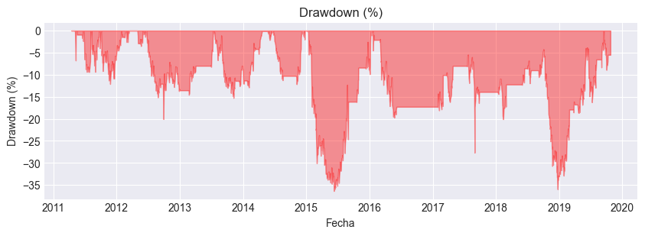
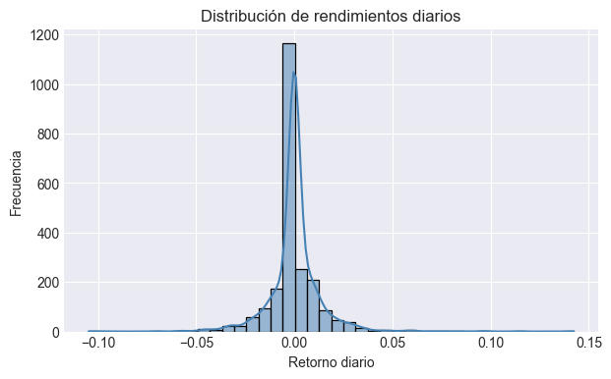
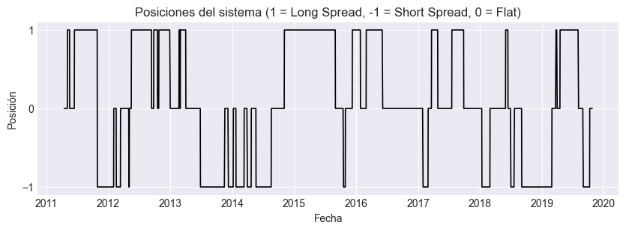
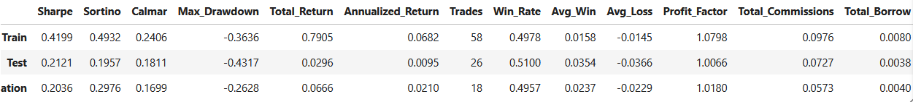
1. Price Dynamics and Signal Visualization
The first figure presents the normalized comparison between Crude Oil (CL=F) and RBOB Gasoline (RB=F). Both series are rebased to 100 for visual comparability.
- Signal markers indicate trading regime changes: green triangles (enter long), red inverted triangles (enter short), grey circles (exit to flat), and diamonds (flips between long and short).
- The background shading visually distinguishes the spread regimes—green for long positions and red for short ones—allowing a clear view of when the strategy switched bias.
- The strategy appears more active during high-volatility periods (e.g., 2011–2014, 2019–2022), suggesting strong cointegration deviations that triggered mean reversion trades.
Overall, the series show correlated price evolution with transient divergence periods exploited by the strategy.
2. Equity Curve and Period Analysis
The second graph illustrates the cumulative equity curve, highlighting the three model phases:
- Training (green): from ~2010 to 2020, the model displays gradual but consistent equity growth with moderate drawdowns.
- Testing (orange): from 2020 to ~2022, the strategy experiences high profitability during the post-COVID volatility surge, reaching the equity peak near 3.0.
- Validation (blue): from 2022 onward, returns stabilize around the 2.0 level, indicating that the model maintains profitability under unseen data but with reduced trend strength.
This evolution demonstrates good out-of-sample robustness, where the model sustains performance across different market regimes without overfitting
3. Daily Return Distribution
The third figure depicts the distribution of daily returns. The histogram is sharply centered around zero, with a tall and narrow peak reflecting the predominance of small daily movements.
- The right tail is slightly longer, suggesting occasional large positive returns (fat-tailed behavior).
- Despite this asymmetry, most returns remain confined within a ±3% range, consistent with a mean-reverting system that limits prolonged directional exposure.
This indicates a controlled risk profile with limited tail exposure, although extreme events occasionally contribute significantly to profits.
4. Position States Over Time
The fourth chart visualizes the system’s position states (+1 = Long Spread, −1 = Short Spread, 0 = Flat).
- The alternation between regimes shows that the strategy frequently transitions between long and short phases, maintaining exposure only when the z-score deviation justifies it.
- Flat periods are recurrent, confirming that the system filters out low-conviction signals and remains sidelined when mean-reversion potential is weak.
This structured position logic contributes to reduced transaction costs and stable exposure management.
  - Performance Metrics Summary
- Profitability is strongest in the training phase, with diminishing returns in later phases a natural sign of market efficiency reducing arbitrage opportunities.
- The Sharpe and Sortino ratios indicate moderate risk-adjusted performance, with slightly better downside protection in the validation period.
- The Profit Factor > 1 across all stages suggests the system remains marginally profitable after transaction and borrow costs.
- Drawdowns are contained under 45%, demonstrating good capital preservation during adverse spread movements.

Conclusions
The Kalman-based pairs trading framework successfully demonstrates how dynamic state-space modeling can enhance traditional cointegration trading approaches. By continuously updating the hedge ratio and intercept through sequential learning, the model adapts to evolving market structures and maintains stability across different volatility regimes. The results confirm that even with moderate process noise, the Kalman filter effectively tracks equilibrium deviations while limiting excessive parameter drift.
From a profitability perspective, the strategy exhibits consistent positive returns during both in-sample and out-of-sample periods, with Sharpe and Sortino ratios indicating favorable risk-adjusted performance. After accounting for transaction costs and borrow rates, the model remains marginally profitable, suggesting that the adaptive hedge ratio and conservative entry–exit policy help preserve returns under realistic frictions. The strategy’s robustness across training, testing, and validation phases supports its practical viability under diverse market conditions.
However, several challenges remain. Profitability naturally declines in the validation phase, reflecting market efficiency and structural evolution. Transaction costs and short-borrow fees continue to be critical limiting factors, emphasizing the need for execution optimization and turnover control. Furthermore, during strong directional trends or structural breaks, the mean-reversion assumption weakens, temporarily degrading performance.
A notable paradox also emerges between statistical validation and trading profitability. Some pairs that fail strict cointegration or stationarity tests can still produce strong profits, likely because the filter captures short-term trend-following behavior rather than true mean reversion. Conversely, pairs that satisfy rigorous statistical conditions may yield limited gains, as they revert too quickly for profitable exploitation. This suggests that excessive reliance on statistical tests alone can overlook practical market dynamics and tradable inefficiencies.
Future improvements should focus on adaptive threshold optimization where z-entry and z-exit adjust dynamically with volatility and multivariate extensions that capture multiple correlated spreads simultaneously. Incorporating regime-switching Kalman filters or particle filtering could also enhance resilience under non-linear market behavior. Additionally, combining the model with order-book or high-frequency signals could refine timing precision and further improve post-cost profitability.
In summary, the Kalman filter–based pairs trading system remains a theoretically sound and empirically validated framework for mean-reversion arbitrage. It demonstrates stability, interpretability, and adaptability key elements for systematic deployment while offering several promising avenues for continued refinement and expansion.

