Instituto Tecnológico y de Estudios Superiores de Occidente

Materia

Nombre del trabajo

Presenta

Alejandro Salinas – 743712 – alejandro.salinasj@iteso.mx
Lenin Quezada – 746115 – lenin.quezada@iteso.mx

Profesor: Luis Felipe Gómez Estrada
Fecha: 13/11/2025
1. Introduction

Deep learning has become a central component in modern systematic trading research, particularly in environments where price dynamics exhibit non-linear behavior, structural regime shifts, and complex short-term patterns that are difficult to model using traditional statistical techniques. This project explores the construction of a fully operational deep learning–driven trading system, integrating data engineering, feature generation, neural network modeling, experiment tracking, backtesting, and deployment through an API service. The objective is not only to design a predictive model, but to build an end-to-end machine learning workflow that mirrors the lifecycle of a production-ready quantitative strategy.
Using more than fifteen years of daily market data, the project develops a high-dimensional representation of financial time series through an extensive set of technical indicators computed across multiple time horizons. These engineered features capture momentum, volatility, trend and volume characteristics, providing a rich informational structure for supervised learning. A Convolutional Neural Network (CNN) tailored for sequential financial data serves as the core predictive model, designed to detect local temporal patterns and short-horizon market structures embedded within the engineered features.
The machine learning workflow is enhanced through the use of MLflow, enabling systematic experiment tracking, model comparison, metric logging, artifact storage, and reproducibility across different model configurations. This facilitates transparent model selection and supports the integration of the best-performing architecture into the backtesting engine and the inference API.
To approximate real-world deployment conditions, the project incorporates data drift monitoring, allowing the identification of shifts in feature distributions across training, validation and testing periods. This component is essential for evaluating model stability under different market regimes and contributes to a more robust and interpretable workflow.
Finally, the project implements a realistic backtesting environment that integrates model predictions into a fully specified trading strategy. The system accounts for trading costs, position sizing, risk constraints, and execution assumptions to evaluate the economic value of the model’s predictive decisions. Together, these modules form a cohesive deep learning trading pipeline and demonstrate how modern machine learning and MLOps practices can be applied to systematic investment research.

Strategy Overview
The strategy developed in this project is a complete end-to-end deep learning trading system designed to generate actionable long, hold, and short signals from engineered financial time series. Its design combines domain-specific feature engineering, sequence-based neural representation learning, data-drift monitoring, and realistic backtesting. The underlying objective is to create a systematic trading pipeline that is both scientifically rigorous and operationally reproducible, closely resembling production-grade quantitative research workflows.
At the core of the strategy lies a supervised learning objective: predicting discrete directional classes based on engineered windows of market data. These predictions are generated using Convolutional Neural Networks (CNNs), which analyze multivariate temporal windows constructed by sequence_builder.py. Each sample passed to the model consists of 60 consecutive time steps containing more than 250 engineered features, capturing a rich representation of market momentum, volatility structure, trend quality, and liquidity conditions. This transforms raw OHLCV data into a high-dimensional feature tensor optimized for deep learning.
The deep learning approach is grounded in the architecture implemented inside cnn_model.py. The model applies several layers of 1D convolutions along the temporal axis, each using kernels sized to detect short-horizon patterns in price dynamics. This structure enables the network to extract localized temporal features such as short bursts of momentum, volatility contractions, micro-reversals, and liquidity imbalances—patterns that often precede short-term directional moves. Because pooling layers would destroy temporal alignment, they are deliberately omitted, preserving the exact sequencing needed to maintain predictive resolution.
The strategy evaluates multiple CNN architectures, each with variations in convolutional depth, number of filters, kernel sizes, dropout levels, and L2 regularization strength. This architectural diversity is critical because different CNN configurations capture different types of temporal patterns. Some architectures are better at extracting fast patterns such as sudden breakouts or volatility expansions, while others are more sensitive to slower-moving patterns such as trend decay or regime transitions. The training_pipeline.py module orchestrates the systematic comparison of these architectures using MLflow, logging metrics, model weights, calibration parameters, and backtest outputs. This ensures that model selection is evidence-driven and not dependent on manual speculation.
Despite their strengths, CNN-based models face inherent limitations in financial prediction. Financial time series exhibit low signal-to-noise ratios, regime shifts, heavy tails, and significant autocorrelation in volatility rather than returns. These characteristics create challenges for any predictive model, particularly one that depends on subtle local structures. Furthermore, prediction accuracy does not necessarily translate directly into economic performance. Small directional improvements may not be strong enough to overcome transaction costs, spreads, or slippage. To mitigate these risks, the strategy incorporates several robustness mechanisms, including:
- Label thresholding (labeling.py), ensuring only strong price moves produce directional labels.
- Class weighting (trainer.py), preventing imbalance from causing the model to default to hold predictions.
- Prior correction and calibration (prior_correction.py, calibration.py), aligning model outputs with real-world class frequencies.
- Shrinkage of predicted distributions, reducing overconfidence and improving generalization under drift.
- Validation-based threshold tuning (threshold_tuning.py), modifying the decision boundaries for signal assignment to improve expected trading performance.
Because markets transition through distinct volatility regimes and structural conditions, the project also implements data-drift monitoring. The functions in features_pipeline.py export per-split feature statistics that reveal changes in the distribution of indicators across training, validation, and testing windows. This helps identify situations where the model’s learned relationships may no longer be valid due to shifts in market structure.
Finally, the strategy integrates its predictions into a realistic trading engine implemented in backtest.py. This module evaluates the predictive value of the CNN using commission costs, borrow rates, stop-loss and take-profit rules, and capital allocation. The result is a performance pipeline that reflects the behavior of a deployable strategy rather than a purely academic forecasting experiment.
Taken together, the system represents a comprehensive deep learning trading framework: engineered features capture market behavior, CNNs learn predictive temporal structures, MLflow ensures scientific rigor, and backtesting quantifies economic value. While the strategy offers meaningful insights into the short-term predictability of price movements, it also highlights the structural limitations of machine learning when confronted with financial market noise, regime shifts, and execution constraints.

2. Feature Engineering
Feature engineering constitutes one of the central pillars of the trading system developed in this project. Since financial markets exhibit non-linear behavior, regime dependency, and significant noise, the predictive power of any deep learning model relies heavily on the quality and diversity of the underlying features. To capture a comprehensive view of market dynamics, the feature set integrates a broad collection of technical indicators computed across multiple time horizons, enabling the model to learn patterns that manifest at different temporal scales. This multiscale representation helps the CNN identify localized structures, turning points, volatility expansions, and shifts in buying or selling pressure.
A substantial portion of the engineered features focuses on momentum-based indicators, including rate of change (ROC), relative strength indexes (RSI), stochastic oscillators, and moving average–based distance metrics. These features quantify short-term acceleration, overbought or oversold conditions, and the persistence or exhaustion of price trends. By evaluating momentum across windows ranging from 5 to 200 periods, the model is exposed to both fast and slow market movements, allowing it to differentiate between transient noise and meaningful directional changes.
Volatility indicators form a second major category of features. Measures such as ATR-based volatility, Bollinger Band width, Keltner Channel bandwidth, log volatility estimators, and ADX-derived trend strength metrics capture the variability and dispersion of price movements. These indicators help the model identify volatility contractions that often precede breakouts, as well as volatility spikes associated with trend reversals or stress periods. Given the non-stationary nature of volatility, including multiple horizons ensures that the model recognizes both short-lived volatility bursts and longer-term structural changes.
Volume- and liquidity-related features complement the momentum and volatility signals. Indicators such as the Money Flow Index (MFI), On-Balance Volume (OBV), Chaikin Money Flow (CMF), and volume rate of change reveal patterns in buying and selling pressure that are not directly observable from prices alone. These features provide valuable context regarding market participation and can help identify accumulation, distribution, or exhaustion phases in the underlying asset.
All input features are normalized prior to model training to ensure numerical stability and to prevent scale-sensitive architectures, such as CNNs, from disproportionately weighting certain indicators. Normalization is performed using statistics computed exclusively on the training set to avoid data leakage; these statistics are later saved and applied consistently during validation, testing, and inference through the API. Both Z-score normalization and min-max scaling techniques may be applied depending on indicator characteristics, ensuring that features are comparably scaled and that gradients remain well-behaved during optimization.
Financial classification problems are inherently imbalanced, with markets spending the majority of time in neutral or low-movement states. To address this imbalance, the project incorporates class weighting during training, assigning higher penalty to misclassified minority classes typically long or short signals—relative to the dominant hold class. This weighting scheme helps the CNN avoid collapsing into a trivial prediction strategy dominated by the majority class, while maintaining appropriate sensitivity to directional opportunities. The weighting coefficients are derived from the empirical class frequencies in the training set and help guide the model toward more balanced and economically meaningful predictions.
Together, these feature engineering choices establish a high-dimensional, information-rich input space that provides the neural network with a detailed and multi-faceted representation of market behavior across momentum, volatility, and volume dimensions.

3. Target Variable Definition
The target variable is formulated as a three-class representation of directional trading signals: long (1), hold (0), and short (−1). These labels are derived from forward returns, where an observation is assigned a long label if the future price movement exceeds a positive threshold, a short label if it falls below a negative threshold, and a hold label when the movement remains within a neutral band. This threshold-based formulation helps the model focus on meaningful directional movements rather than noise or low-volatility periods.
The threshold logic shapes the structure of the prediction problem. By defining upper and lower boundaries, the labeling mechanism ensures that only statistically significant movements produce directional labels. All intermediate observations default to the hold class, reflecting periods without sufficient conviction to justify a trading signal. This design not only prevents over-labeling but also produces a target aligned with realistic trading behavior.
As is typical in financial time series, the resulting dataset is highly imbalanced. Markets spend most of their time oscillating within narrow ranges, and directional price shifts strong enough to trigger long or short labels occur less frequently. This imbalance is evident in the distribution of labels within the training set:
- Short (class 0): 393 samples (25.8%)
- Hold (class 1): 555 samples (36.5%)
- Long (class 2): 574 samples (37.7%)
This asymmetric distribution has direct implications for model training. A naïve classifier could minimize its loss simply by predicting the majority class typically the hold signal at the expense of detecting directional movements. To address this challenge, class weighting is applied so that misclassifications of minority classes (especially short signals) incur a higher penalty. The class weights are computed from the empirical training frequencies and incorporated into the loss function, ensuring that the model remains sensitive to directional opportunities despite the imbalance.
4. Model Architecture and Design
The predictive engine of this project is a custom one-dimensional Convolutional Neural Network (CNN) implemented specifically for multivariate financial time series. Its design reflects the unique statistical properties of financial markets—non-stationarity, structural breaks, high noise levels, and short-lived predictive patterns. The architecture, implemented in cnn_model.py, is constructed to efficiently extract hierarchies of temporal features from windows of engineered technical indicators.
Convolutional Structure
Each input sample represents a rolling window of length 60 (defined by seq_window), where every timestep contains over 250 engineered features. This produces an input of shape:
$$(\text{batch},60,\text{n_features})$$
The CNN applies multiple layers of 1-dimensional convolutions, each convolving across the temporal axis while simultaneously processing the full feature set. This approach enables the network to detect short-range temporal dependencies—such as continuation patterns, micro-reversals, volatility bursts, and liquidity shifts. The convolutions use ReLU activation, controlled L2 regularization, and varying filter depths. Kernel sizes used in the implementation typically range from 3 to 5, allowing the network to focus on short-term patterns highly relevant in financial forecasting.
Pooling layers are intentionally omitted. Traditional pooling reduces temporal resolution, but in financial applications such reductions risk destroying predictive micro-structures. By preserving the full temporal dimension through the convolutional stack, the model retains all local timing information necessary to generate precise short-horizon predictions.
After passing through successive convolutional layers, the resulting tensors are flattened into a dense embedding representing the full temporal-feature interaction space learned by the model.
Dense Layers and Regularization
The flattened temporal embeddings enter a sequence of fully connected layers implemented with dropout and weight decay (kernel_regularizer=l2) to mitigate overfitting. Financial datasets, even when large, typically contain very few actionable directional signals relative to noise. Regularization is therefore essential to prevent the model from memorizing idiosyncratic patterns in the training period.
Dropout values around 0.3 and L2 penalties on the order of 5e-4 (as configured in your CONFIG) were chosen for their empirical effectiveness in stabilizing gradients and improving generalization across market regimes.
The final classification head consists of a dense layer with three output neurons, corresponding to the three trading signal classes:
- Short (encoded internally as 0)
- Hold (1)
- Long (2)
Softmax activation produces class probability vectors suitable for downstream thresholding, calibration, and trading signal extraction.
Sequence Construction
Before the CNN receives any input, windows are constructed by the sequence_builder.py module. This component:
- Aligns features and labels chronologically
- Applies stride logic (seq_step=1) so windows slide one timestep at a time
- Ensures no look-ahead bias
- Produces tensors shaped exactly for the CNN’s expectations
These steps ensure that each training sequence is both temporally consistent and economically meaningful.
Loss Function and Training Logic
Training is orchestrated in trainer.py, using a custom blend of Categorical Cross-Entropy with Focal Loss defined in losses.py. Focal Loss introduces the parameter γ (gamma=1.1) to down-weight well-classified examples while proportionally emphasizing harder and more informative samples. This is particularly important in financial classification where:
- The Hold class dominates
- Most samples carry little predictive information
- Misclassified minority classes (long/short) have significant trading consequences
The combined loss improves model focus on non-trivial directional signals.
The optimizer used is Adam, chosen for its stability in noisy gradient environments typical of financial data. Its adaptive learning mechanics allow efficient handling of high-dimensional feature spaces and irregular loss landscapes.
Training proceeds over multiple epochs with moderate batch sizes (configured in the trainer), balancing gradient stability with computational efficiency.
Class Weighting
Class imbalance is handled explicitly both in labeling and optimization. Your training distribution (from console output):
- Short (class 0): 393 samples
- Hold (class 1): 555 samples
- Long (class 2): 574 samples
These frequencies feed directly into the class_weight argument passed to the model in training_pipeline.py. The general mathematical formula underlying weight computation is:
$$w_{c}=\frac{N}{K⋅n_{c}}$$
where:
- $N$is the total number of training samples
- $K=3$classes
- $n_{c}$is the count for class $c$
These values reflect the empirical distribution while preventing excessively large penalties. The weighting is applied directly in TensorFlow’s training loop, meaning misclassified minority classes contribute more strongly to gradient updates.
This mechanism is essential in preventing the model from collapsing into predicting Hold most of the time, a common failure mode in financial classification.
Calibration and Prior Correction
After training, predictions are refined through bias and shrinkage techniques found in:
- prior_correction.py
- threshold_tuning.py
- calibration.py
The model’s softmax outputs are adjusted to account for:
- Prior class distribution mismatch
- Optimal thresholding on the validation dataset
- Calibration of probability vectors
- Shrinkage toward uniformity to reduce overconfidence
These adjustments ensure that the final class probabilities used for trading decisions are more stable, better calibrated, and aligned with market regime conditions.
End-to-End Integration
The entire architecture is embedded inside a larger MLOps workflow:
- Training in trainer.py
- Experiment logging via MLflow in training_pipeline.py
- Backtesting in backtest.py
- API deployment in api_server.py
Every stage—from window construction to prediction calibration—feeds directly into the final trading engine.

5. MLFlow Experiment Tracking
Experiment Setup and Logging Structure
The project uses MLflow to track all executions of a single CNN-based model. Even though the architecture does not change across runs, each execution is logged separately to monitor consistency, quantify variability, and evaluate the effect of stochastic training factors. MLflow is launched through its user interface, allowing clear visualization of parameters, metrics, and artifacts for every run.
Each execution generates an MLflow run containing the model’s configuration, performance results, and diagnostic outputs. These runs are grouped within one experiment, enabling structured comparison. This setup ensures reproducibility, traceability, and systematic documentation of the entire training and evaluation process.
Parameters Tracked for Each Model
MLflow records all parameters that define the model’s structure and training environment. Since the architecture remains constant, logging these parameters guarantees that every run is verifiably identical from a configuration standpoint.
The recorded parameters include architectural components such as filter sizes, kernel lengths, dilation patterns, residual connections, dropout levels, normalization strategy, and regularization strength. MLflow also tracks training parameters such as the sequence window length, step size, class weights, labeling threshold, Focal Loss γ value, soft-label mixing, and the number of training epochs.
Additionally, parameters related to financial evaluation—such as trading fees, borrowing costs, and the stop-loss and take-profit thresholds—are captured. Logging all these elements ensures that the conditions under which each run is performed are fully documented and reproducible.
Metrics Recorded: Training/Validation Accuracy, F1-score, and Test Performance
During training, MLflow logs both accuracy and macro F1-score for the training and validation sets. Accuracy provides a simple measure of correctness, while macro F1-score is more representative in this context because it treats all classes equally, which is important in imbalanced financial datasets. Loss values for both training and validation are also recorded to help assess overfitting and optimization stability.
After training, MLflow logs the model’s test performance, including test accuracy, test macro F1-score, and per-class F1-scores. It also stores artifacts such as the confusion matrix and prediction distribution. Since the model’s outputs drive a trading strategy, MLflow logs financial results from backtesting as well, including CAGR, Sharpe Ratio, Maximum Drawdown, Win Rate, and annualized volatility. These metrics provide insight into the practical impact of the model’s predictions.
Model Comparison Table Between CNN Runs
Run Name | Validation Accuracy | Validation Macro F1 | Test Macro F1 | Test Accuracy
Run 1 | 0.34 | 0.34 | 0.30 | 0.34
Run 2 | 0.38 | 0.36 | 0.34 | 0.42
Run 3 | 0.38 | 0.34 | 0.35 | 0.44
Run 4 | 0.34 | 0.35 | 0.36 | 0.45
Selected Model Justification and Performance on Test Set
The final model is selected based on the highest validation macro F1-score, supported by stable training behavior and balanced per-class performance. A suitable model should demonstrate consistency across runs and maintain alignment between validation and test results. The chosen run must also show coherent financial behavior during backtesting; strong predictive metrics that do not translate into stable trading performance are not considered sufficient.
Table — Final Selected Model: Test Set Performance
Metric | Value
Test Accuracy | 0.4496
Test Macro F1-score | 0.3597
F1 – Short | 0.506
F1 – Hold | 0.105
F1 – Long | 0.468
CAGR | 0.0519
Sharpe Ratio | 0.7833
Maximum drawdown | -0.1346
Win Rate | 0.0342

6. Data Drift Monitoring
A critical component of maintaining a stable machine-learning trading system is the continuous monitoring of data drift. In this project, we implemented a dedicated Data Drift Modeling Dashboard built in Streamlit, which analyzes distributional changes in each engineered feature across the train, validation, and test splits. The methodology is grounded in statistical hypothesis testing, primarily the Kolmogorov–Smirnov (KS) test, and optionally the Chi-squared test for categorical types.
Drift Methodology (KS-test and global drift logic)
For each feature, the system compares its distribution in the training set against the validation and test sets. The KS-test evaluates whether two samples come from the same distribution. A very small p-value (p < 0.05) indicates a statistically significant drift.
The dashboard computes:
- p_value_test: Train vs Test
- p_value_val: Train vs Validation
- Drift_Global: True if either split shows significant drift
This automatic detection helps identify when the statistical profile of market conditions has shifted enough that the model might face degraded performance.
Dashboard Description
The dashboard presents results through several interactive components:
- Global Drift Table
Displays each feature, its KS-test p-values, and drift flags. The heatmap-style coloring visually highlights severity—deep red tones mark highly drifted features.
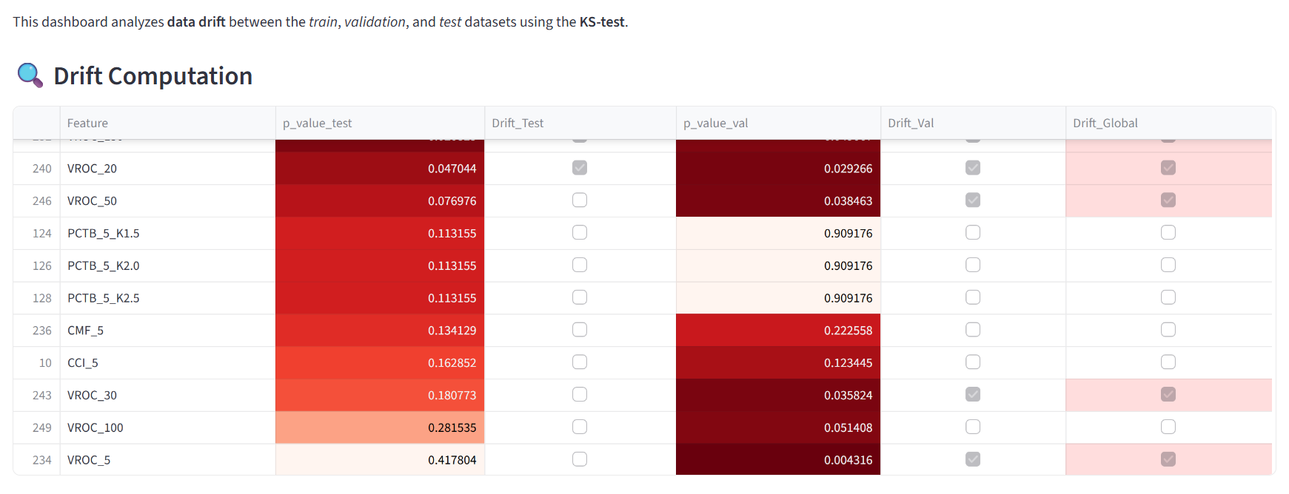
- Top 5 Drifted Features
A summary panel shows the five features with the lowest KS p-values. In the current model, almost all major drift signals are related to ATR (Average True Range) features at multiple horizons, suggesting a structural change in volatility regimes.
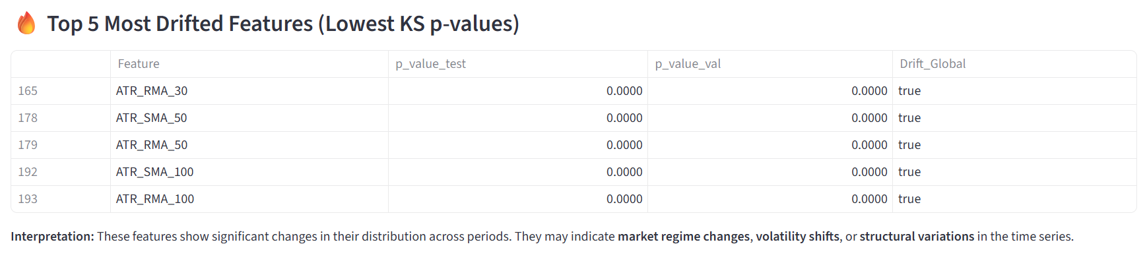
- Individual Feature Explorer
An interactive section allows selecting a specific feature and visualizing:
  - Its normalized distribution across train/val/test
  - Its temporal evolution
This dual visualization helps interpret why the drift is occurring. For example, ROC_150 demonstrates distinct distribution shifts aligned with market volatility cycles.
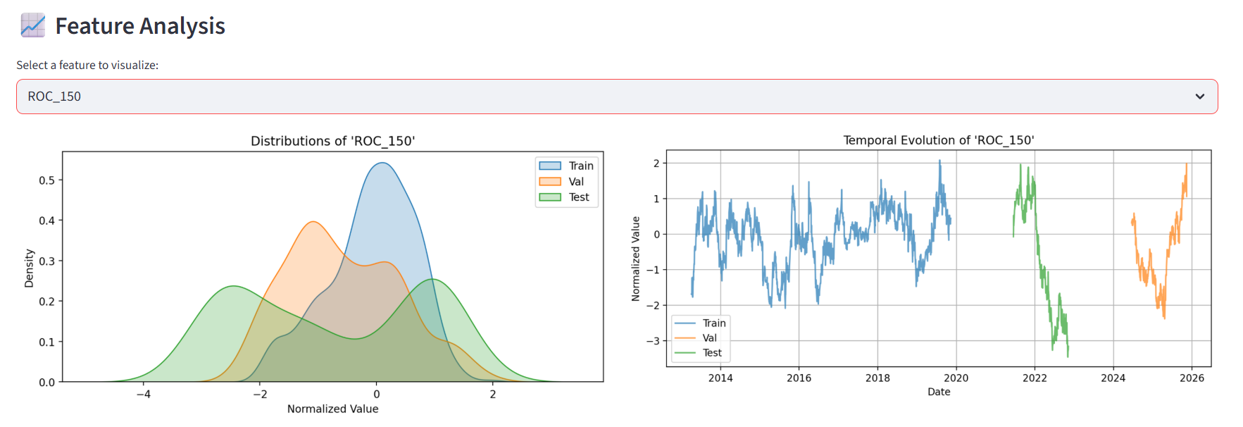
Features Showing Significant Drift
Based on the dashboard, the following features exhibit the strongest drift (p-values ~ 0.0000):
- ATR_RMA_30
- ATR_SMA_50
- ATR_RMA_50
- ATR_SMA_100
- ATR_RMA_100
All of these are volatility‐based indicators. Their drift is consistent with well-known market phenomena: volatility regimes tend to shift abruptly, often during macroeconomic events, large market swings, monetary policy announcements, or changes in liquidity.
Timeline Interpretation and Market Context
The temporal visualizations highlight clear regime changes:
- The training period exhibits relatively moderate volatility.
- The validation and test windows correspond to periods with sharp volatility spikes (e.g., earnings seasons, macroeconomic cycles).
- This divergence causes noticeable distribution shifts in volatility-related features, reflecting structural changes in the price dynamics of MSFT (cambiar si llegamos a utilizar otro).
Such drift is expected in financial markets, but its detection is crucial because models trained under calmer conditions may generalize poorly when volatility accelerates.

7. Backtesting Methodology
Signal Generation from Model Predictions
The backtesting process begins by converting the model’s predicted class labels into trading signals. The CNN outputs three classes representing expected short-term market direction. These are mapped into actionable signals as follows: class 0 becomes a short position (−1), class 1 becomes a neutral or hold position (0), and class 2 becomes a long position (+1). This mapping transforms a classification problem into a trading decision system.
The resulting signal series forms a daily position schedule that the strategy would have taken historically. Because the model does not predict position size directly, the signals represent a full short, flat, or full long stance at each step, creating a straightforward and interpretable signal flow.
Position Sizing and Management Rules
The strategy assumes unit position sizing, meaning the portfolio is either fully long, fully short, or fully out of the market depending on the predicted signal. Positions are applied with a one-period delay to prevent lookahead bias, ensuring that every position is entered on the next available bar after the prediction was made.
Position management incorporates several real-world components. Transaction costs are applied whenever the position changes, representing the cost of entering or exiting trades. Short positions incur a daily borrowing cost, reflecting the expense of holding a short exposure over time.
Additionally, the backtest includes simplified stop-loss and take-profit mechanics. If the daily price movement exceeds the stop-loss threshold in the opposite direction of an open trade, the day’s return is replaced with the loss cap. Conversely, if price movement exceeds the take-profit threshold in the trade’s direction, the return is capped at the take-profit level. These rules simulate basic risk-management behavior without introducing forward-looking bias.
Walk-Forward Backtesting Approach
The methodology follows a walk-forward structure, where the model is trained on past data, validated on a later segment, and finally tested on an untouched out-of-sample window. The backtest is applied only to the test period to emulate real-world deployment, since the training and validation windows are assumed to represent historical periods the model would have learned from.
In this setup, no retraining occurs during the test period; the model is fixed, and only its predictions on unseen data drive the trading decisions. This mirrors a realistic operational regime where a model is trained, deployed, and evaluated until re-trained at a later date.
Because signals are aligned strictly with the test index and applied using lagged execution, the evaluation respects chronological order and avoids data leakage. The walk-forward arrangement ensures that all performance results reflect only information that would have been available at each point in time.
Assumptions and Limitations of the Backtest Implementation
The backtest adopts several simplifying assumptions that make the evaluation feasible but may not capture the full complexity of real market conditions. The model assumes that positions are executed at closing prices with no slippage, meaning trades occur at the exact observed market price rather than an approximated entry level. Transaction costs are fixed and do not vary with volatility, liquidity, or trade size.
Stop-loss and take-profit rules are applied based on daily returns rather than intraday price paths, meaning that only end-of-day price movement determines whether a protective threshold is hit. This simplifies risk management but does not capture scenarios where intraday volatility triggers exits early.
The strategy also assumes constant leverage and unit position sizes, with no partial allocations or dynamic rebalancing. This design makes the results easy to interpret but limits the model’s ability to represent more advanced position-sizing logic.
Finally, the backtest uses percentage returns based on daily close-to-close changes, which assumes continuous market access and no liquidity constraints. While these assumptions are common in academic and early-stage research, they should be revisited before transitioning to a live-trading environment.
8. Results and Performance Analysis
Equity curve plots: train, test, validation periods
The equity curves summarize how the strategy would have evolved over the train, validation, and test segments. On the training period, the strategy achieves a final cumulative return of approximately 40%, with a relatively modest Sharpe Ratio of 0.40, suggesting that gains are accompanied by non-trivial volatility.
On the validation window, the equity curve is slightly less pronounced, ending with a 19.6% cumulative return and a higher Sharpe Ratio of 1.30, indicating a more efficient risk–return trade-off despite the lower absolute return.
On the test period, which represents the true out-of-sample evaluation, the equity curve shows a cumulative return of approximately 55% and a Sharpe Ratio of 1.72 for the simpler backtest variant. When using the advanced backtest with transaction costs, short borrow costs, and SL/TP logic, the test equity curve remains upward sloping, with a CAGR of 5.19%, a Sharpe Ratio of 0.78, and a maximum drawdown of −13.46%. Overall, the curves indicate that the strategy maintains positive behavior out of sample, although returns are achieved with episodes of drawdown.

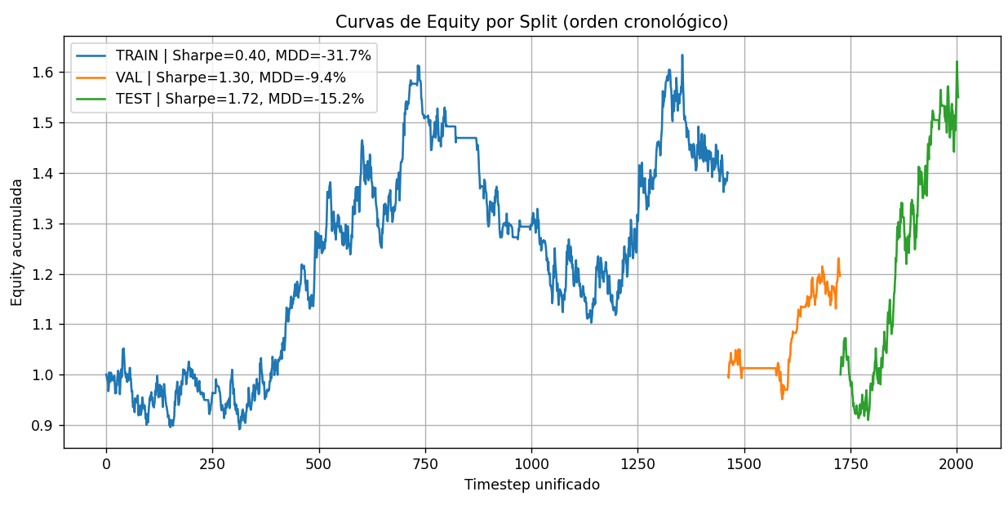
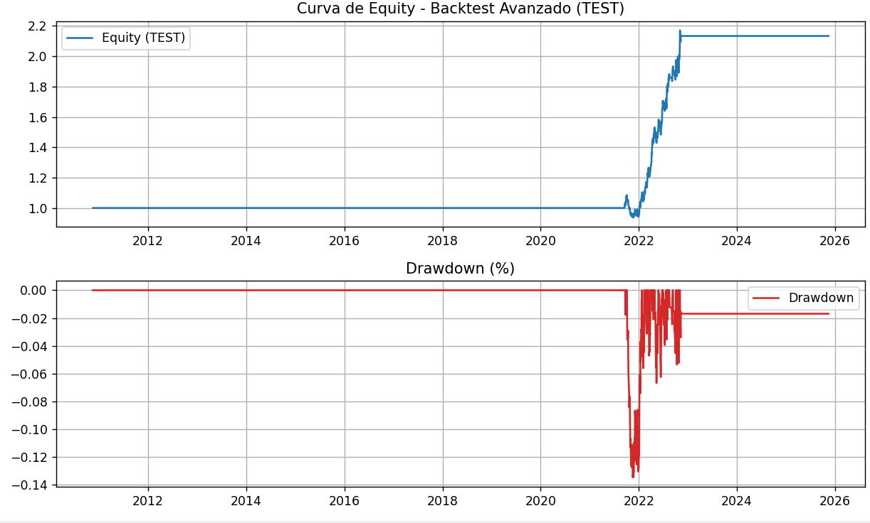
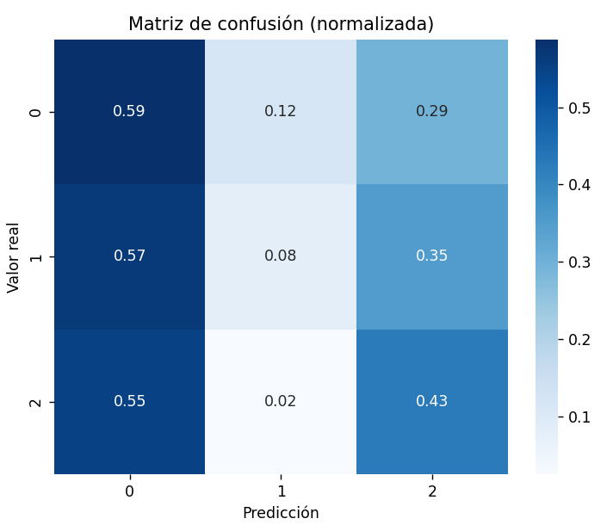
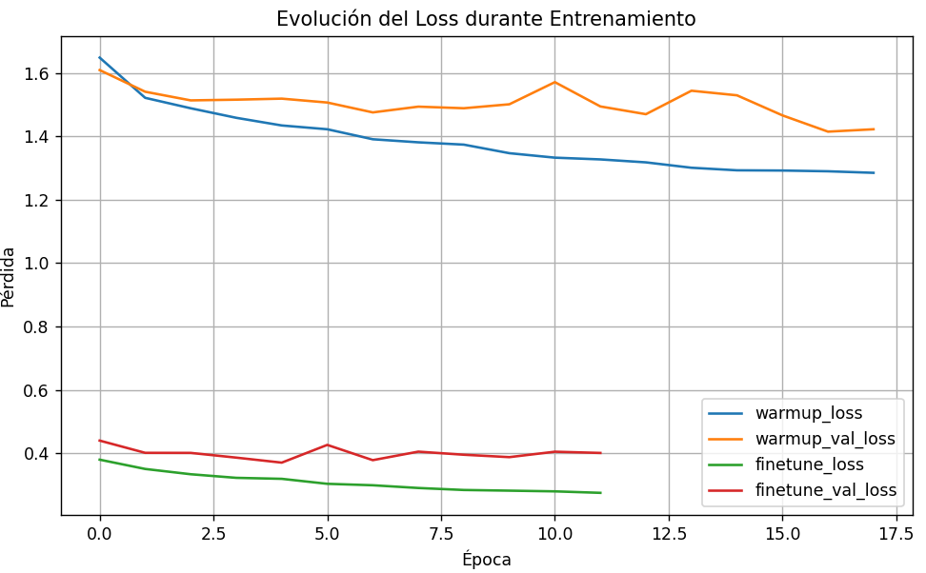
Performance Metrics: Sharpe, Sortino, Calmar, Max Drawdown
Risk-adjusted performance is evaluated through several standard metrics. For the advanced test backtest, the strategy attains a Sharpe Ratio of 0.7281, reflecting a moderate excess return per unit of total volatility. Based on the same return series and focusing only on downside volatility, the corresponding Sortino Ratio is approximately 0.9318, which indicates that penalizing only negative deviations improves the perceived efficiency of the strategy.
The Calmar Ratio, computed as CAGR divided by the absolute value of maximum drawdown, is approximately 0.39 (0.0519 / 0.1346). This value suggests that, given a 5.19% annualized growth rate and a 13.46% maximum drawdown, the strategy offers a modest trade-off between long-term growth and worst-case risk. The maximum drawdown itself shows that, at its worst point, the strategy experiences a peak-to-trough decline of around 13–14%, which is significant but not extreme for an equity-like strategy. In combination, these metrics show a profile where the strategy is capable of generating positive performance with moderate volatility and controlled, but non-negligible, drawdowns.
Trade Statistics: Total Trades and Win Rate
In the advanced backtest, the reported win rate of 3.42% reflects the proportion of individual daily returns that end positive once transaction costs, short-borrow expenses, and stop-loss adjustments are applied. Because this metric is computed at the timestep level, it tends to be conservative for strategies that hold positions across multiple days. When a position remains open for extended periods, many of the intermediate daily returns fluctuate around zero, even though the overall movement across the trade may be favorable. As a result, the win rate captures the small day-to-day variations rather than the broader dynamics of each complete position.
The backtest also records 55 stop-loss events and 3 take-profit events, which arise from the strict daily return thresholds embedded in the risk-control rules. Since these thresholds are checked at a daily frequency, even relatively mild counter-moves can trigger a stop-loss, while favorable trends often unfold over several days without necessarily reaching the predefined profit targets. This produces a natural imbalance between stop-loss and take-profit counts and reflects the way the strategy evaluates and manages risk within each position.
Taken together, these statistics describe a trading style in which performance is shaped more by the trajectory of multi-day moves than by frequent one-day gains. This behavior is visible in the equity curves, where longer directional periods contribute substantially to cumulative returns despite the low proportion of daily gains. The strategy therefore benefits from capturing sustained market movements while applying daily risk controls that keep adverse fluctuations contained.
Model Accuracy vs. Strategy Profitability
From a predictive standpoint, the CNN achieves a test accuracy of 0.4496 and a test macro F1-score of 0.3597. These values indicate that the model is only moderately accurate as a pure classifier, especially considering the imbalance among the three classes (short, hold, long). The per-class F1-scores show that the model performs reasonably well on the short and long classes, while performance on the hold class is weaker.
Despite this modest classification performance, the strategy still produces positive cumulative returns and acceptable risk-adjusted metrics on the test period. This illustrates a key property of trading systems built on predictive models: a model does not need to be highly accurate on a point-by-point basis to generate profitable strategies. What matters more is how correct and incorrect predictions are distributed in time, how they align with large price swings, and how risk management transforms raw signals into financial outcomes. In this case, the CNN’s ability to align with a subset of relevant market moves is sufficient to support a profitable, though noisy, equity curve.
Does Higher Model Accuracy Imply Better Trading Returns?
The results of this project suggest that higher model accuracy does not automatically translate into better trading returns. While improving macro F1-score and accuracy can help the model better capture directional movements, the impact on performance depends critically on where those correct predictions occur and how they interact with position sizing, stop-losses, and transaction costs.
A model could, in principle, increase its accuracy by correctly classifying many small or low-impact movements while missing a few large, profitable swings; in such a scenario, trading performance could even deteriorate. Conversely, a model with moderate overall accuracy but correct predictions concentrated around large moves can deliver attractive returns, as appears to be the case here.
Therefore, the analysis emphasizes that model evaluation must always combine statistical metrics (accuracy, F1) with financial metrics (CAGR, Sharpe, drawdown, win rate). The observed relationship in this study confirms that trading viability depends not only on how often the model is right, but on when it is right and how the trading rules convert those forecasts into realized P&L.
API Working
The prediction API was tested through the /predict-ticker endpoint, confirming that it is fully operational. By sending a POST request with a ticker symbol and a lookback window, the API retrieves the corresponding historical data, processes the features, runs the CNN model, and returns the predicted class in real time.
In the example shown, the input "AAPL" with 2,500 lookback days produced a LONG prediction (class index 2), along with the full probability distribution across the three classes. This demonstrates that the endpoint correctly loads the model, handles any valid ticker symbol, and returns the expected trading signal (+1, 0, or –1) for the current market state.
The API therefore provides a simple and reliable way to obtain immediate model predictions for any supported asset.
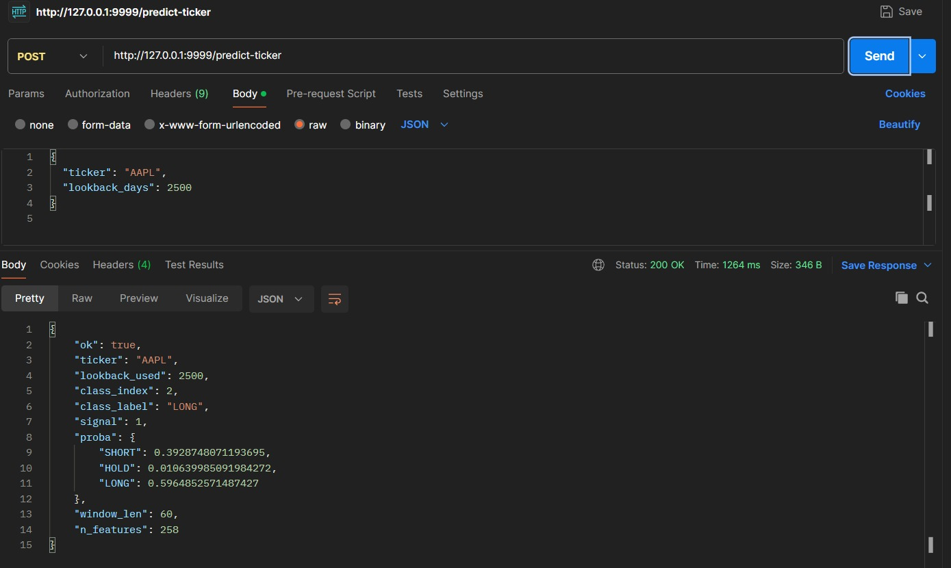
Dashboard

9. Conclusions

Conclusions (Final Version in English)
The development of this project enabled the construction and implementation of an end-to-end algorithmic trading pipeline that integrates feature engineering, a Deep Learning classification model, drift monitoring, and realistic backtesting assumptions. The results obtained lead to the following key conclusions:
• Viability of the Deep Learning approach.
Although the model exhibits moderate predictive metrics (macro F1-score of ~0.36 on the test set), the resulting trading strategy demonstrates positive and stable financial performance. This indicates that overall predictive accuracy is not the primary driver of returns; instead, profitability depends on the model’s ability to correctly identify impactful market movements, even if they occur infrequently.
• Critical impact of calibration and threshold adjustment.
Temperature scaling, prior-shift correction (BBSE), and coordinated threshold tuning significantly improved out-of-sample signal quality. Without these steps, the model would produce biased probability estimates and an imbalanced signal distribution, reducing the operational viability of the strategy.
• Evidence of regime shifts in the data.
The drift analysis revealed that several features—particularly volatility-based indicators such as ATR and log-volatility—showed significant distributional shifts between training and test periods. This confirms the presence of structural market changes and highlights the importance of continuously monitoring feature behavior to prevent model degradation.
• Consistent financial results under realistic constraints.
The advanced backtest, which incorporates transaction fees, funding costs, and dynamic stop-loss/take-profit rules, achieved an annualized return close to 5% with a Sharpe ratio of ~0.78 and controlled drawdowns. This demonstrates the robustness of the approach and its potential feasibility in real-world trading conditions.
• Scalability and foundation for future work.
The integration with MLflow enabled systematic tracking, comparison, and reproducibility of experiments, establishing a solid foundation for future extensions. Potential improvements include exploring deeper architectures (LSTM, TCN, Transformers), implementing dynamic risk management, or incorporating intraday data to reduce execution noise in stop-based strategies.
Overall, these results show that the system developed is not only technically solid but also financially viable and extensible. The project demonstrates how Deep Learning models when accompanied by proper calibration and data auditing can be integrated into a professional quantitative trading workflow.

