**Brush-up Project: Grocery List**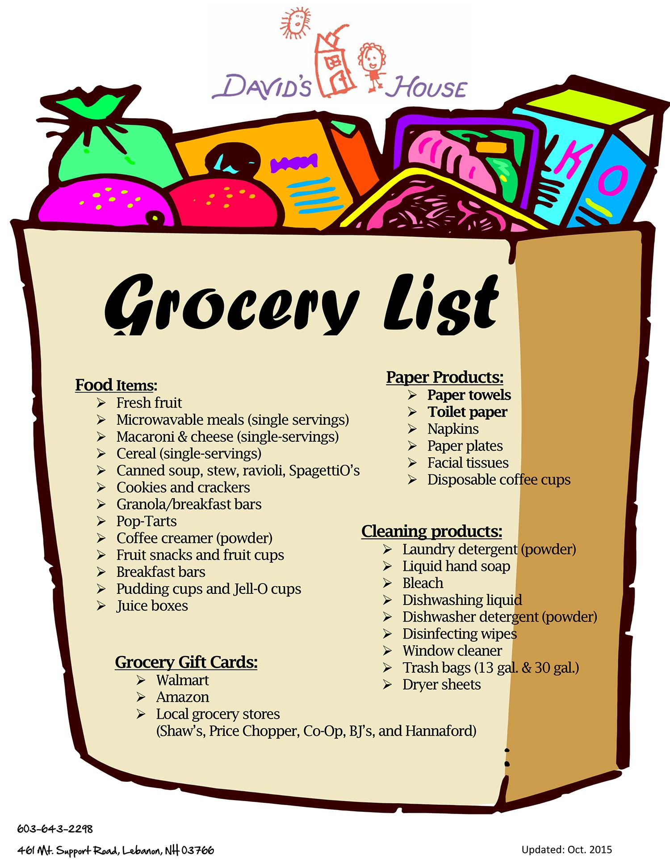

(in groups of 2 students)

Write a class named GroceryList that represents a list of items to buy from the supermarket, and another class named GroceryItemOrder that represents a request to purchase a particular item in a given quantity (example: four boxes of cookies).

The GroceryList class should use an array to store the grocery item orders. Assume that a grocery list will have no more than 10 item orders. The GroceryList class should have an add method that will add a given item order to the list if the list has fewer than 10 items, and a getTotalCost method that will return the total sum cost of all grocery item orders in this list, printed out to the console (formatted nicely! containing name, quantity and total price). It should also have a toString method.

The GroceryItemOrder class should have an item name, a quantity, and a price per unit, all incapsulated, and it should have a constructor setting all these values, and one only setting the name (the default quantity should be one). It should have a getCost method returning the total cost of the item in its given quantity, and a toString method returning a String with the name, quantity, and total cost. All fields should have getter and setter methods.

Make a test class with a main method that instantiates the GroceryList, fills it with GroceryItemOrder objects, and prints it. Test what happens if you try to add a grocery item order when the list is filled.

Extra features:

1. Instead of writing the names of the items when instantiating them in the test class, try to read them from a file. Make a .txt file with a number of grocery names in it, to test it.
2. Make a new version of GroceryList and change the implementation to an ArrayList instead of an array.
3. Refactor GroceryItemOrder class into 2 classes: GroceryProduct which contains item name and unit price) and ItemOrder which holds a reference to a GroceryProduct and a quantity.

If you finish fast: Make more improvements to your program!

CAHL 2018 / TIMA 2020