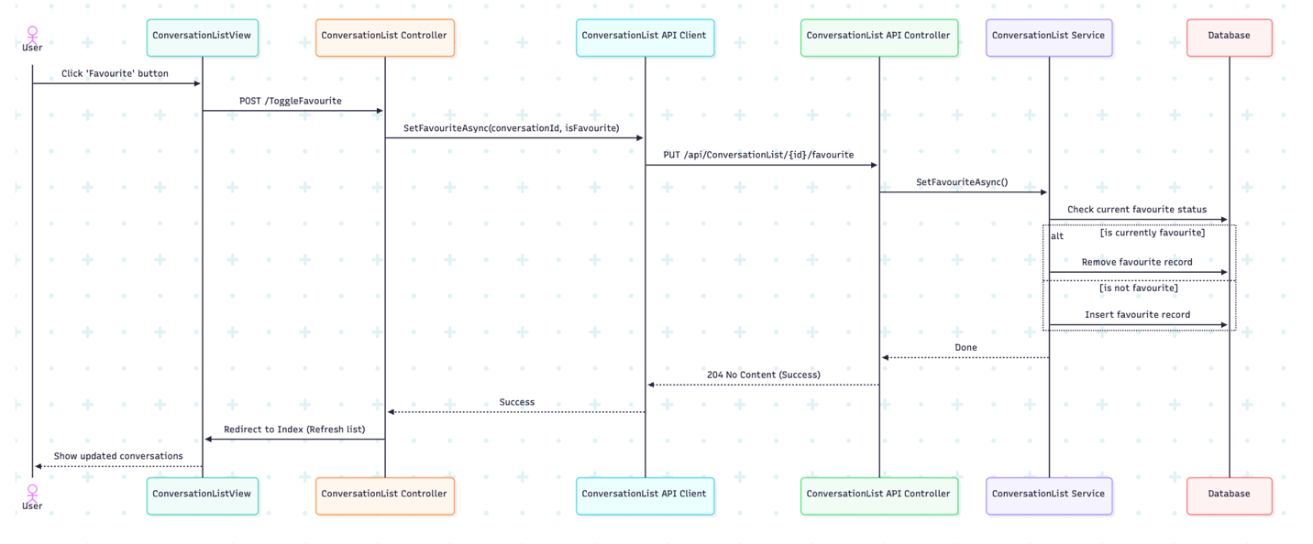

Controller: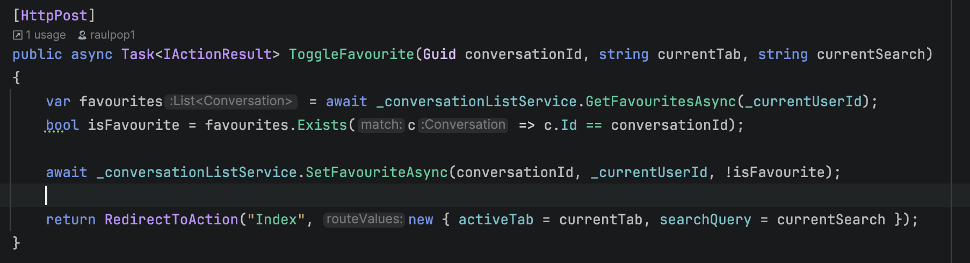
Service:
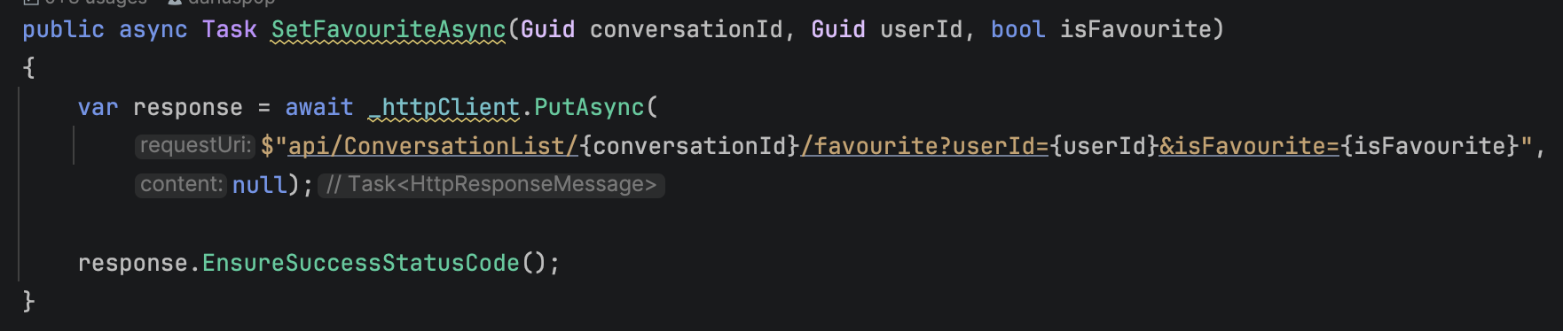
sequenceDiagram
actor A1 as User
participant P1 as ConversationListView
participant P2 as ConversationList Controller
participant P3 as ConversationList API Client
participant P4 as ConversationList API Controller
participant P5 as ConversationList Service
participant P6 as Database

A1->>P1: Click 'Favourite' button
P1->>P2: POST /ToggleFavourite
P2->>P3: SetFavouriteAsync(conversationId, isFavourite)
P3->>P4: PUT /api/ConversationList/{id}/favourite
P4->>P5: SetFavouriteAsync()
P5->>P6: Check current favourite status

alt is currently favourite
P5->>P6: Remove favourite record
else is not favourite
P5->>P6: Insert favourite record
end

P5-->>P4: Done
P4-->>P3: 204 No Content (Success)
P3-->>P2: Success
P2->>P1: Redirect to Index (Refresh list)
P1-->>A1: Show updated conversations

