Modeling of spin-orbital dynamics in a storage ring

Alexander Aksentev1,2*, Yury Senichev2

1 National Research Nuclear University “MEPhI,” Moscow, Russia

2 Forschungszentrul Jülich, Jülich, Germany

* a.aksentev@fz-juelich.de

**Abstract**. Two distinct storage ring designs have been proposed for the deuteron Electric Dipole Moment (dEDM) search experiment: a Frozen Spin, and a Quasi-Frozen Spin ring. The FS-ring allows for the most accurate measurement, but the continuous fulfilment of the FS condition is unrealizable. The QFS design relaxes the condition to only hold on average, at a slight cost of precision. [1] The goal of the present work is to investigate which design is preferable for the attainment of the target precision. This task requires one to model the spin-orbital dynamics of the beam in both rings.

1. The Frozen and Quasi-frozen Spin concepts

There exist two design approaches to the problem of measuring the deuteron Electric Dipole Moment (dEDM) inside a storage ring: the Frozen Spin (FS) lattice, and the Quasi-Frozen Spin (QFS) lattice.

In the FS ring design, the spin of a beam particle is aligned with its momentum at any point in time; this allows the maximization of the useful signal, but requires that the energy of the particle be its so-called “magic energy” – a condition that cannot be fulfilled exactly for an ensemble of particles. Also, in this design, combined E+B field elements in the arcs must be used, which further complicates the construction of such a lattice. The QFS design does not require the continuous fulfillment of the Frozen Spin condition; the cost for this is a slight (on the order of percents) degradation of the EDM signal. It can also be implemented in two versions: one in which the E- and B-field elements are separated, and another in which the E+B elements are located in the straight sections of the lattice. [1]

In order to decide which design solution is preferable for the attainment of the target accuracy (upped bound on the dEDM at 10-24 e·cm) one has to model the spin-orbital dynamics of the beam inside both structures. The present work deals with some problems that are inherent in this enterprise, on the example of an FS lattice design with E+B elements in the arcs.

1. Experiment systematics

In the original BNL proposal, a longitudinally polarized beam is injected in the storage ring, and the EDM is measured by the growth, over a long period, of its vertical polarization component. [2] The spin dynamics of a particle put into an electro-magnetic field are determined by the Thomas-Bargmann-Michel-Telegdi equation:

(1)

where is the anomalous magnetic moment, g the gyromagnetic ratio, the first two terms are due to the Magnetic Dipole Moment (MDM), and the last two to the EDM.

As is readily observed from the above equation, the presence of a parasitic horizontal magnetic, or vertical electric, field caused by the imprecision of accelerator element positioning (specifically, tilts about the optical axis), induces a faking MDM signal in the measurement plane. To solve this problem, a CW/CCW procedure was proposed in Jülich. [3] The idea behind this method is to estimate the net MDM+EDM spin precession frequency when the beam in injected into the ring counter-/clockwise, and then add the results. Since the magnetic field is reversed going from the CW to CCW case, the MDM frequency changes sign, and hence cancels in addition. One requirement of this method, though, is that the MDM frequency must be much higher than the one caused by the EDM; the sensitivity of MDM precession to the element positioning inaccuracy has to be analyzed by simulation.

Another problem encountered in the EDM search is the finite spin coherence time (SCT). Because the beam particles are injected into the ring at different energies and positions, and hence have different orbit lengths, their spins precess at different frequencies; due to this fact the net beam polarization vector dissipates over time. By Taylor-expanding the expressions for the spin tune in the electric and magnetic fields around the value of the reference particle, we arrive at: [3]

(2)

where G6 is a function of G and , is the synchrotron oscillation amplitude of the particle, is the second-order momentum compaction factor, the slip factor, the synchrotron oscillation frequency, and is the orbit lengthening due to betatron motion. The first term in equation (2) is averaged out as a result of synchrotron oscillation; the orbit-lengthening-related decoherence effect is mitigated by the introduction of sextupole fields.

3. ODE integrator

For the analysis of the lattice designs a tracking code was written in python, utilizing a conventional integrator LSODA from Scipy's Integrate package. Major elements used in the construction of a lattice, such as the magnetic dipole, quadrupole, electric cylindrical deflector and Wien filter are implemented, with two ways to simulate element positioning error: 1) via the computation of a tilt matrix, which is applied to the computed field vector at run time (which is the more general, but computationally inefficient approach), and 2) customized tilting of E+B and quadrupole elements. The computation of the right-hand side of the system of ODEs is vectorized, due to the use of Numpy arrays.

## Sensitivity and decoherence tests

In order to analyze the sensitivity of the MDM precession to positioning error, the simulation was set up as follows:

* The E+B elements were tilted about the optical axis, the tilt angles were picked from a normal distribution with zero mean and 10-4 rad standard deviation.
* An ensemble of 1000 initial conditions, taken from a normal distribution with , was tracked through the lattice for 100 turns (for reasons of run time)
* The test statistics (spin precession frequencies in the vertical and horizontal planes) were estimated by

I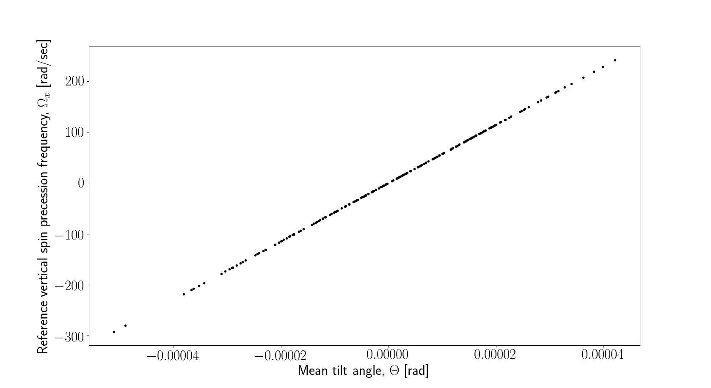llustration 1: Reference particle spin precession frequency in the vertical plane as a function of the average E+B element tilt angle. The average tilt angle is linearly proportional to the net radial magnetic field. Linear dependence is thus in accordance with the T-BMT equation. Slope: 5.72·106 1/sec, intercept 4.19·10-4 rad/sec.

Illustration 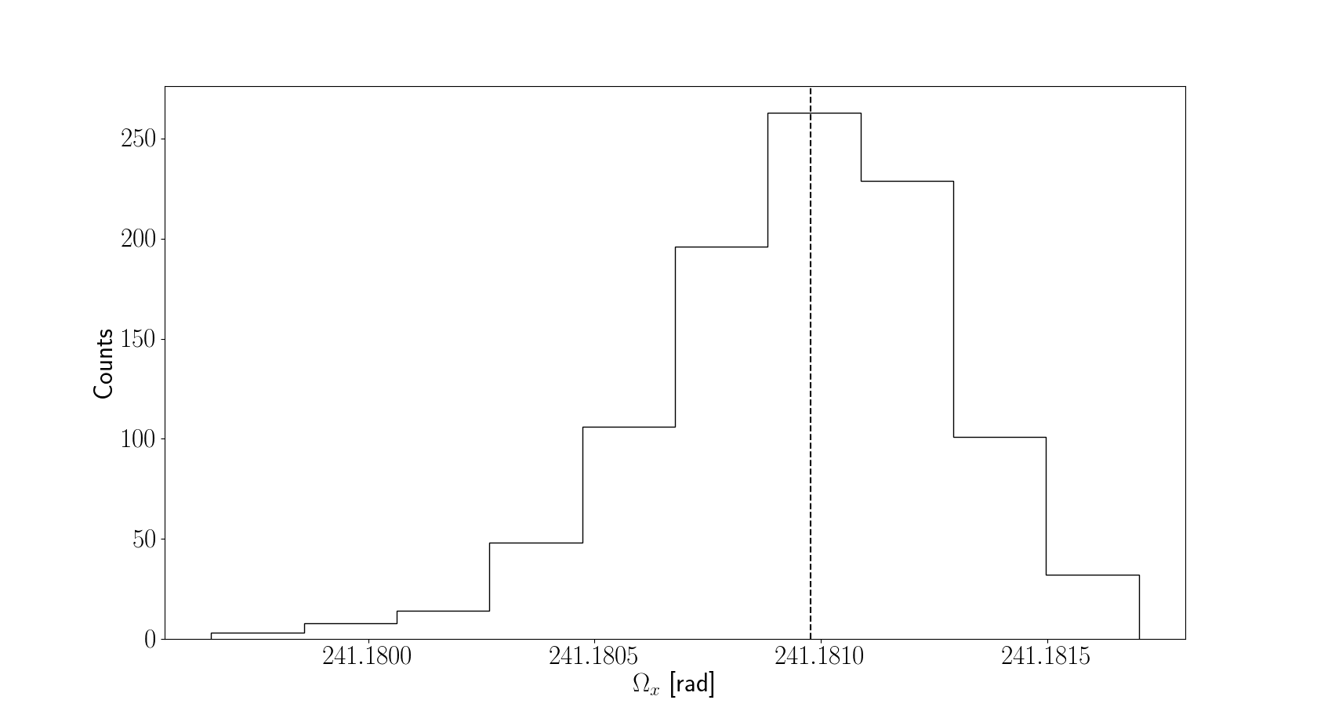2: Decoherence in the vertical plane. Dashed line: frequency of the reference particle. At higher turn numbers this should become a chi-square distribution with the reference frequency being the lowest. This isn't observed here due to the low number of synchrotron oscillations.

Illustration 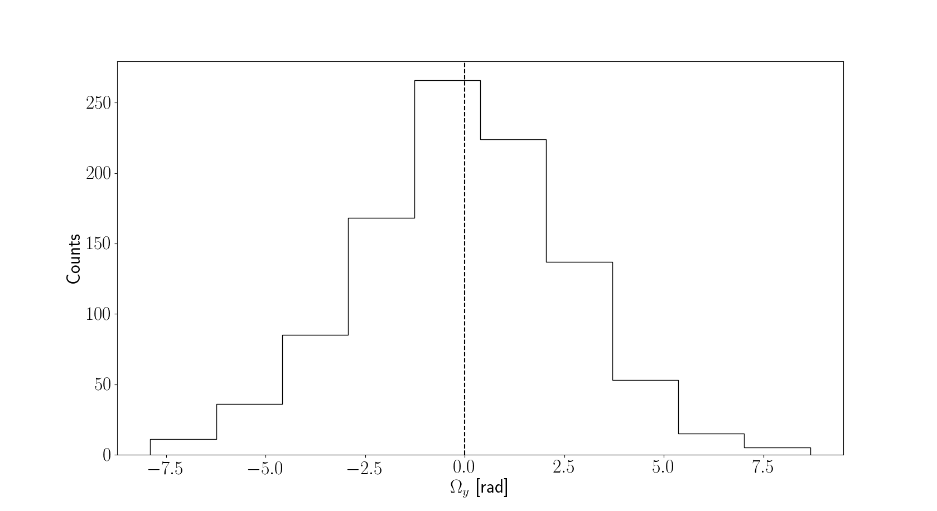3: Decoherence in the horizontal plane. Dashed line: reference particle. It can be observed that the frozen spin condition is fulfiled (reference frequency is zero), but decoherence in this plane is four orders of manitude higher.

## Major problems

As was observed at the end of section 2, the linear decoherence terms vanish as a result of synchrotron oscillations. This averaging out, however, requires a significant number of synchrotron oscillations to have occurred. As the ratio of synchrotron to revolution frequencies is significantly less than unity, any reasonable simulation must track the initial particle ensemble for thousands of revolutions in the accelerator. This poses a significant problem in terms of run time, not only to any interpreted code, but also to any code using conventional integration in general.

As an example, we estimate the run time required for a single decoherence test run, if a Runge-Kutta integrator is used with performance on the level of MSURK89. [4] MSURK89 is an 8-th order, Runge-Kutta-Verner, step-size adaptive integrator, with initial step size calibrated for optimal speed-precision ratio. Use of an 8-th order stepper yields better run times due to fewer required evaluations of the right hand side. That code requires approximately 1.23·10-4 sec per homogenous dipole field, and 6.25·10-4 sec per spherical deflector (tracking was performed for 10 initial conditions simultaneously). An FS lattice design we used in simulations contains 20 E+B cylindrical deflectors, out of 397 elements. MSURK89 would thus take 5.88·10-2 sec/turn to track ten particles through a single realization of the lattice, 20,000 turns would take 1176 seconds, and an ensemble of 1,000 particles would further require 20.4 hours of run time on a 16-core machine. In order to give certainty bounds on the MDM precession frequency, one has to repeat this experiment a reasonable number of times. Unless the code is massively vectorized, using technologies like OpenCL, the use of a conventional integrator for this type of analysis is not a tenable option; use of mapping methods, like COSY INFINITY [4] should be preferred.

References

1. Senichev Y, Andrianov S, Ivanov A, Chekmenev S, Berz M, Valetov E 2015 *Investigation of lattice for deuteron EDM ring*. Proc. ICAP2015 (Shanghai, China).
2. Anastassopoulos D et al. 2008 *AGS Proposal: Search for a permanent electric dipole moment of the deuteron nucleus at the 10 −29 e · cm level.* BNL Report.
3. Senichev Y 2016 *Search for the Charged Particle Electric Dipole Moments in Storage Rings*. Proc. RuPAC2016 (St. Petersburg, Russia).
4. Valetov E 2017 *Field modeling, symplectic tracking, and spin decoherence for EDM and muon G-2 lattices.* Fermilab thesis, pp 156—165.