search for the charged particle electric dipole moments in storage rings
Y. Senichev#, IKP, Forschungszentrum Jülich, Germany
A.Aksentev, National Research Nuclear University “MEPhI”, Russia

Abstract
The idea of searching for the electric dipole moment (EDM) of the proton and the deuteron using polarized beams in a storage ring was originally proposed at Brookhaven National Laboratory (BNL), USA. Currently, the “Jülich Electric Dipole Moment Investigations” (JEDI) collaboration is developing the conceptual design of such a ring specifically for the search of the deuteron electrical dipole moment (dEDM). The idea is that the oscillation of spin due to a possible finite electric dipole moment is separated from the influence of the magnetic dipole moment (MDM), and the behavior of spin indicates the existence of dEDM. In connection with this problem, two questions arise: (i) how to create conditions for maximum growth of the total EDM signal of all particles in the beam bunch, and (ii) how to differentiate the EDM signal from the induced MDM signal. For the design of such a ring, we need to address three major challenges:
- the ring lattice should meet the conditions of beam stability, and it has to have incorporated straight sections to accommodate the accelerating station, equipment for injection and extraction of the beam, a polarimeter, and sextupoles;
- the beam polarization lifetime must be around ~1000 seconds;
- systematic errors have to be minimized to eliminate the induced fake EDM signal.
In my contribution, I will present the current status of the project.
introduction
One of the essential problems of modern physics is the baryon asymmetry of the Universe that represents the prevalence of matter over antimatter [1]. In addition, cosmic detectors, whose purpose is to search for antimatter, PAMELA and AMS haven’t found any significant amount of it in the Universe yet [2]. The development of the new idea that claims one of the reasons for the baryon asymmetry is the breaking of CP invariance, has begun soon after its discovery. A. Sakharov established three necessary conditions for baryogenesis (initial creation of baryons) in 1967 [3]:
• Baryon number violation;
• C-symmetry and CP-symmetry violation;
• Interactions out of thermal equilibrium.
Many theories beyond the SM have been proposed and all of them of so-called "New Physics" are able to remove the difficulties that one meets in the Standard Model, but
__________________
#y.senichev@fz-juelich.de
their experimental confirmation has yet to be found. One of the possible arguments for the breaking of CP-invariance is the existence of non-vanishing electric dipole moments (EDM) of elementary particles.
Currently, the “Jülich Electric Dipole Moment Investigation” (JEDI) collaboration works in two directions: first on the existing accelerator COSY the precursor experiment is carried out to prove the feasibility of EDM measurement using the storage ring [4,5,6], and secondly the conceptual design of the ring specifically for search of the deuteron electrical dipole moment (dEDM) is being developed [7]. At present the RF flipper for installation on COSY ring is progressing successfully. Besides, we have already obtained very important experimental results with precise measurements of the spin precession frequency [4,5] which will allow calibrating the particle energy using the clock-wise and counter clock-wise procedure, and we have reached the longest spin coherence time ~1000 sec in horizontal plane [6].
This article is devoted mainly to the dEDM ring development. For the design of such a ring, we need to address three major challenges:
- the lattice should meet the conditions of stability of motion, minimization of beam loss, and it has to have incorporated straight sections to accommodate the accelerating station, equipment for injection and extraction of beam, a polarimeter, and sextupoles;
- using an RF cavity and a certain number of sextupole families, the beam polarization lifetime must be around ~1000 seconds;
- systematic errors have to be minimized to eliminate the induced fake EDM signal.
Frozen and quasi-frozen spin concepts
In this paper, we will analyze two types of structures: the frozen spin (FS) and the quasi- frozen spin (QFS) lattices described in [7]. The concept of “frozen spin” lattice has been suggested by BNL [8], and it is based on the elements with incorporated electric and magnetic fields in one element, when the spin of the reference particle is always orientated along the momentum. Using this concept, a lot of lattice options for its implementation were proposed for protons and deuteron, in particular by R. Talman [9].
In the “frozen” spin method the main objective is to maximize the EDM signal growth, which is provided by the frozen orientation of spin along the momentum, i.e. by zero spin frequency 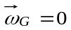 relative to the momentum due to the magnetic dipole moment (hereinafter called MDM precession) in 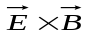 fields:
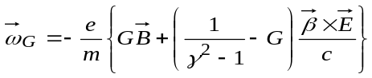, (1)
where 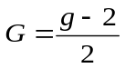 is the anomalous magnetic moment and 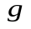 is the gyromagnetic ratio. The expression (1) defines the ratio between electric and magnetic fields in “E+B” elements.
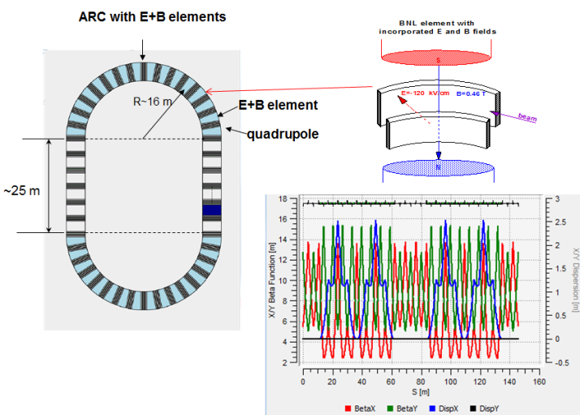
Figure 1: FS lattice with TWISS functions.

We have developed a custom option of FS lattices for the EDM deuteron measurement, which is based on “E + B” elements. The FS lattice has the racetrack shape and contains two arcs and two zero-dispersion straight sections (see fig.1). The TWISS functions show the beam envelope and dispersion along circumference. We have studied the spin-orbital dynamics in this ring with sextupoles, which would allow us to get the spin coherence time of more than 1000 seconds.
Studying the FS structure, we have paid attention to the fact that the frozen spin condition is performed only for the reference particle, and the spin vector of all other particles oscillates relative the frozen direction. But if so, it might not be worth it to strictly fulfill the frozen spin condition even for the reference particle. If the spin oscillates in the horizontal plane with respect to the frozen spin direction with amplitude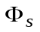, then the EDM growth decreases proportionally to the factor 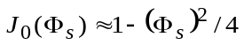. Taking into account that the deuteron’s anomalous magnetic moment 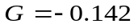 has a small value and the fact that the spin oscillates around the momentum direction within half value of the advanced spin phase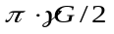 in the magnetic arc, each time returning in the elements with electrical field on the straight sections, it is obvious that the effective contribution to the expected EDM effect is reduced only by a few percent. This allows us to proceed to the concept of quasi-frozen spin QFS [10], where the spin is not frozen with respect to the momentum vector, but continually oscillates around momentum with small amplitude of few degrees.
In case of the quasi-frozen spin lattice, we have two options. In the first option (see fig.2), the electrical and magnetic fields are fully spatially separated in arcs and straight section elements.
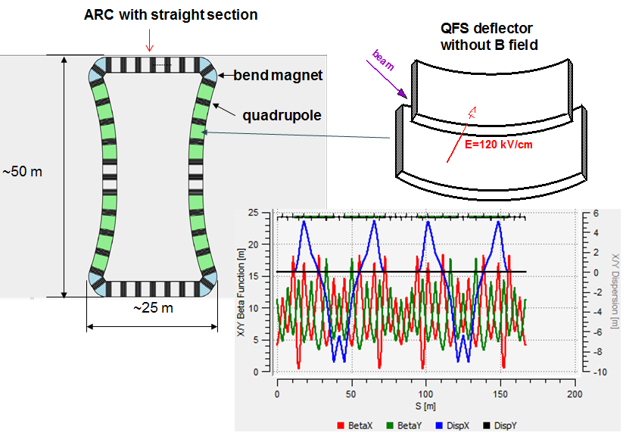
Figure 2: First option of ring lattice based on QFS concept with TWISS.
However, this concept inherits the drawback of cylindrical electrodes, namely the whole set of high-order nonlinearities. Therefore, in second option of QFS lattice we introduced a magnetic field of small value ~100 mT, compensating the Lorentz force of the electric field on arcs (see fig.3). Both QFS lattices consist of two arcs and two straight sections with approximately similar circumference to that of the FS lattice.
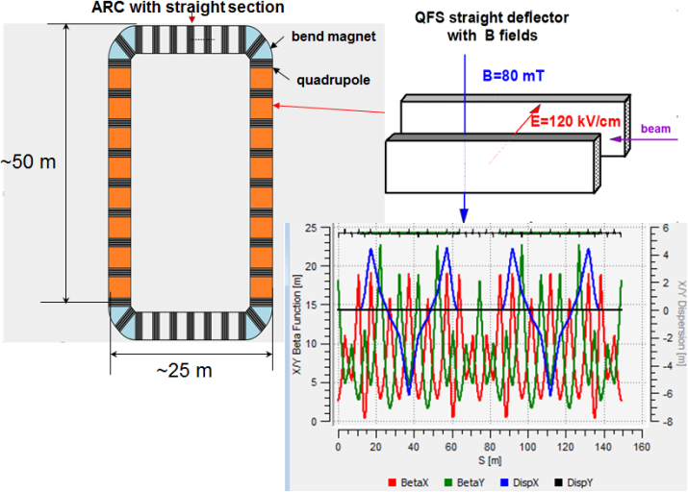
Figure 3: Second option of ring lattice with TWISS functions.
In both cases the lattice includes the straight sections with zero dispersion in the middle of the magnetic arcs for installation of the polarimeter, the beam extraction and injection systems, and the RF cavity.
spin tune decoherence
To discuss the effect of spin decoherence, it is reasonable to consider the spin tune, which is the number of spin oscillations in one revolution of the particle around the ring. Initially, the problem of spin tune decoherence arose due to the requirement of having a maximum EDM signal. For horizontally oriented spin, the spread of spin tune leads to a multi-directional EDM signal for different particles and ultimately to a reduction of the total EDM signal. Later on, this problem gained salience due to understanding the fact that considering systematic errors, in particular due to misalignment of the electric and magnetic elements, spin decoherence can be transferred from the horizontal plane into the vertical plane, where we expect to see the EDM signal, that is, we get the “fake” EDM signal. The latter is a stronger argument than the geometric phase considered in [8], and it puts forward much greater demands on the limitation of the spin tune decoherence.
Now let us briefly mention the main causes of decoherence. Expanding in Taylor series the well-known expression for the spin tune in electric field 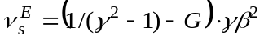and in magnetic field 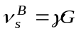 in the vicinity of an arbitrary point 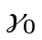
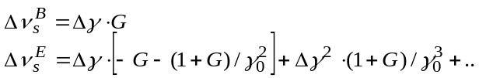 (2)
we see that the spin tune spread 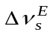 in an electric field has all orders of non-linearity. Obviously, the linear term 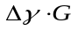 in both fields gives the maximum contribution to the spin tune decoherence, and a simple estimate shows that the spin coherence time is limited to a few milliseconds.
Introduction of the RF cavity allows averaging and practically reducing the linear term contribution to zero. However, it has been shown in [11] that the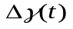deviation follows the expression:
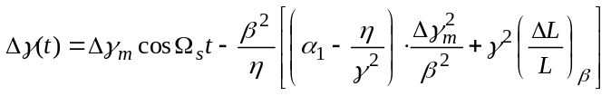(3).
where 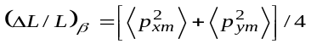 is the orbit lengthening due to the betatron motion with amplitude of transverse momentum deviation in horizontal 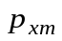 and vertical 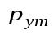 planes, 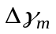 is amplitude of synchrotron oscillation for arbitrary particle, 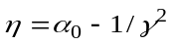 is the slip factor, 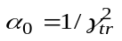 is the first order momentum compaction factor, 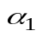 is the second order momentum compaction factor, and 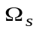is the synchrotron frequency.
Despite that the linear term in (3) is practically reduced to zero with RF, the time independent term and the term proportional to 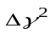 in equation (3) restrict the spin coherence time to a few hundred seconds.
The final step to reduce the spin tune decoherence is based on the sextupoles, which change the orbit length dependent on the momentum deviation and the dispersion [11]. Detailed numerical consideration of decoherence effects [12] has been done using COSY Infinity [13] and MODE code [14].
Systematic errors
Generally, the measurement errors can be divided into two components: random errors and systematic errors. The systematic error is called the error component, which remains constant in repeated measurements and is caused by imperfections of the physical facility. In the EDM ring experiment, the systematic error arises due to the misalignments of electric and magnetic elements in the ring and causes a “fake” EDM signal. The nature of origin being random errors, the misalignments create conditions for systematic errors in EDM experiments. The installation errors (misalignments) are associated with limited capabilities of the geodetic instruments. As is known, the bending magnet (or the electric deflector) can be rotated in three planes. We consider only the rotation around the longitudinal and transverse axis, because the rotation around the vertical axis does not introduce a systematic error. First, let us consider the case of the magnet rotated relative to the longitudinal axis (see Fig.4). Due to such rotation, a horizontal component of
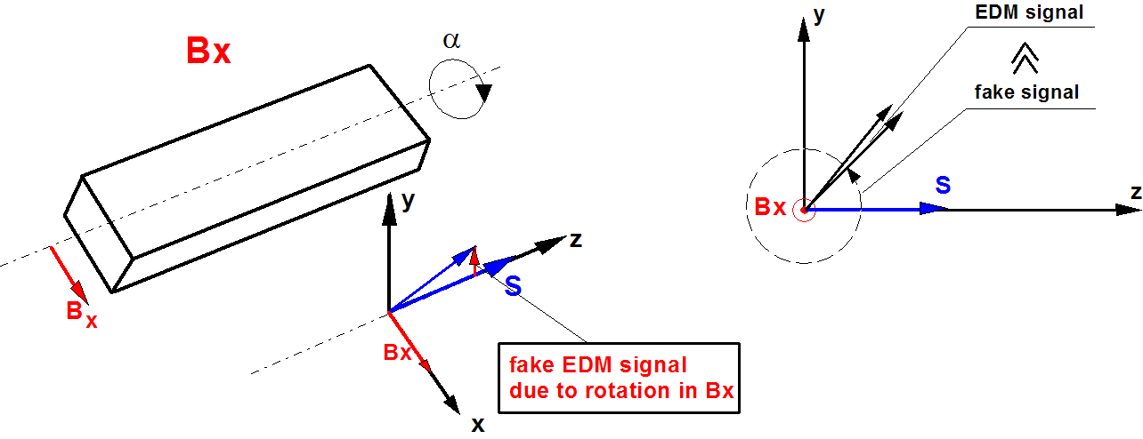
Figure 4: Magnet rotating relative to longitudinal axis.

the magnetic field 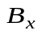 arises and causes the spin rotation 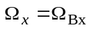 in the same plane where we expect the EDM rotation. To illustrate, let us write the solutions of T-BMT equations with initial condition 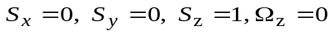and 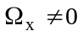 in simplest form:
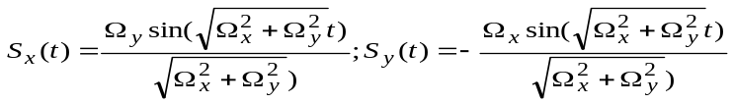.(4)
Taking into account the above, we can present components: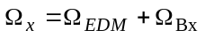and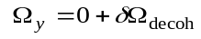, where 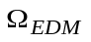is the frequency of spin rotation due to the presence of an EDM, is the horizontal component induced by the magnet rotation (misalignments), and 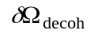 is the spin tune decoherence in the horizontal plane, and it is allowed to reach an rms value of 1 rad for spin coherence time t_{SCT}>1000 sec, that is the rms value of 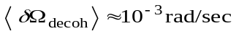.
The magnets are supposed to be installed at the technically realized accuracy of 10μm, which corresponds to the rotation angle of the magnet around the axis of about 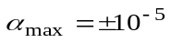rad. Using COSY Infinity [13] and MODE [14], we have calculated the MDM spin rotation due to B_{x}, which is 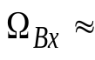3 rad/sec. At the same time, at presumable EDM value of 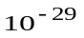e·cm, the EDM rotation should be 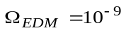rad/sec, that is 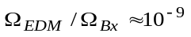, and the expression (4) can be simplified without loss of measurement accuracy of possible signal EDM at the level of 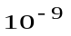:
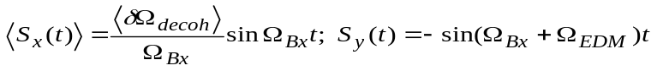. (5)
We can see from the first equation of (5) that the spin decoherence in the horizontal plane is not growing and is stabilized at the level of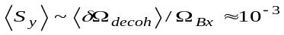. This is a significant positive feature. But to be fair, we should understand that, since 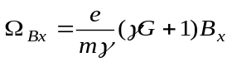, we will now get due to 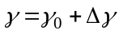 the spin frequency decoherence 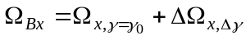in the vertical plane around horizontal axis, which one we can minimize by the same methods (sextupoles, RF) as in horizontal plane. In addition, we are really deprived of ability to measure the accumulated EDM signal by growth of the vertical component of spin suggested in [8], since the spin rotation due to the magnet errors is much faster than due to possibly existing EDM 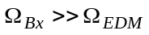. That is 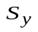reach a maximum for very short time meanwhile the signal EDM does not have time to be accumulated.
Therefore, the only solution is to measure the total frequency 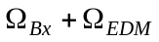, but in order to split out the EDM signal from the sum signal, we need an additional condition. Such a condition is to measure the total spin frequency in the experiment with a counter clock-wise (CCW) direction of the beam 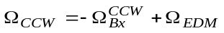 and compare with clock-wise (CW) measurements 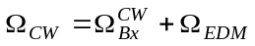. Simultaneously, we must understand that the accuracy of the frequency measurement of 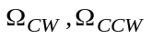 determines the precision of the EDM measurement. In [5], we achieved the precision of the spin frequency measurements that agrees well with the statistical expectation: 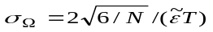where N is the total number of useful events, 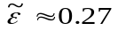 is the oscillation amplitude of measured asymmetry of polarization, and T is the measurement duration. In a 1000 s time interval with an initial detector rate of 5000 s⁻¹, one would expect an error of the spin frequencies of 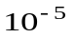rad/sec. Taking into account the average accelerator beamtime of 6000 hours per year, we can reach 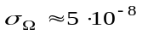rad/sec with one-year statistics. Assuming that we can measure the spin frequencies with such an accuracy, we will be able to determine the EDM signal at the level of 10⁻²⁷ ÷10⁻²⁸ e·cm. The lacking one orders of magnitude can be obtained by the time modulation of the “diamond pellets” target (frequency of following diamonds) and higher detector rate [16]. It would allow having bigger number of useful events in the interval when the polarization asymmetry changes faster and having the smaller statistic errors. Thus, such an approach looks promising.
However, we need to be sure that when the sign of the driven magnetic field 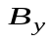 for the CW-CCW is changed, the magnetic field component is restored with the required relative precision of not lower than 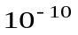. Therefore, we suggest calibrating the field in the magnets using the relation between the beam energy and the spin precession frequency in the horizontal plane, that is, determined by the vertical component . Since the magnet orientation remains unchanged, and the magnets are fed from one power supply, the calibration of will restore the component with the same relative accuracy , which applies to the difference 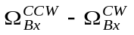as well. Besides, we should mention that the calibration in the horizontal plane does not involve the EDM signal. Thus, this calibration will allow using one-year statistics with a limit of EDM on the level up to 10⁻²⁷ ÷10⁻²⁸ e·cm. Figure 5 shows the results of a numerical simulation of the EDM measurement procedure. We purposely took the initial EDM value 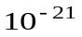 when 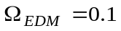rad/sec in order to reduce the duration of the simulation. Then, following the above described procedure, we have “measured” EDM and got EDM=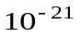. Thus, we have proved the method of EDM measurement.

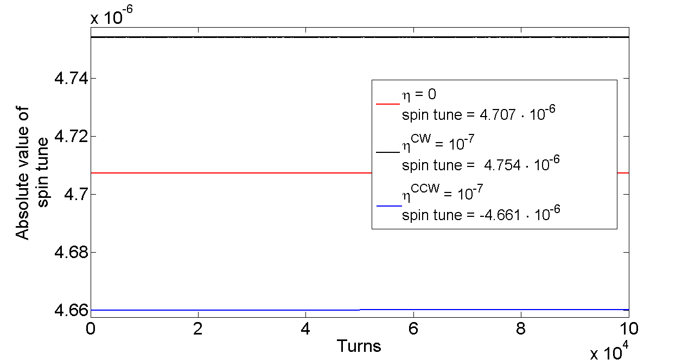
Figure 5: Results of numerical simulation of EDM measurement.
Nevertheless, the fundamental question of how to calibrate the field B_{y} using the spin tune measurement in a horizontal plane, if due to misalignments the spin rotates in the vertical plane with the relatively high frequency of 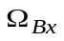~10 rad/sec, remains. To solve this problem, we plan for the calibration mode only to introduce the inhibitory vertical field, for example by means of a horizontal coil. Having inhibited rotation in the vertical plane to the reasonable value of ~0.1 rad/sec and calibrated, we turn off the coil. In this case, we do not need to know the value of the field in the coil.
Up to this point, we have discussed only how to calibrate the magnetic field. But our ring consists of magnetic and electrical elements. Here we rely on the fact that calibrating the magnetic field and taking into account that the electric polarity is not changed and the unique connection of the magnetic field with the electric field for each energy value, we calibrate the electric field as well.
We have to mention that the idea of measuring EDM by introducing a horizontal coil with magnetic field and measuring the spin precession in the vertical plane has been proposed in the wheel concept by I. Koop [17], but it differs from the method considered here. The wheel method uses a special horizontal coil, assuming calibration of the field in the coil by splitting of CW and CCW trajectories and measuring the distance between the separated beams. Besides, in the wheel concept, the issue with the change of field direction in presence of misalignments remained to be unresolved.
Finally, let us consider the case where systematic errors arise due to magnet rotation around the transverse axis, and we get the longitudinal component 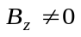. The longitudinal component is not mixed with the EDM signal directly, but it can transform by spin decoherence from the horizontal plane into the vertical plane where we expect an EDM signal. Now, let us suppose that we do not have the systematic errors B_{x}=0 in vertical plane, but B_{z}≠0. The solution of the T-BMT equations with initial condition 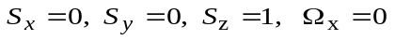 at condition 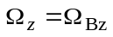, 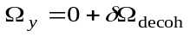 and 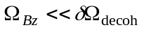is:
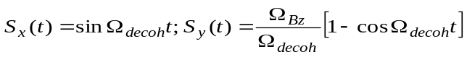. (6)
How to see the fake signal depends on the ratio between 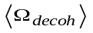and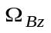. Therefore, the only way is to minimize the longitudinal component of the magnetic field with 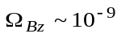 rad/turn, using additional trim coils with the longitudinal magnetic field.
Conclusion
In the paper, we analyzed the frozen and quasi-frozen spin structures, taking into account the effect of spin decoherence and systematic errors. It has been shown how you can measure the EDM in an imperfect ring using achieved the experimental results of spin tune measurement and the beam polarization lifetime of 1000 sec. In the proposed conception we use: the calibration energy in horizontal plane and measurement in vertical plane, the invariability of ratio 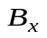to after change of polarity in all elements. These estimates show that the lower limit of detection of presumably existing EDM can be as low as ~10⁻²⁷ ÷10⁻²⁸ e·cm.
References
[1] Canetti L., Drewes M., Shaposhnikov M. (2012). "Matter and Antimatter in the Universe", New Journal of Physics, 14, 095012.
[2] Aguilar M., Alberti G., Alpat B. et al., (2013) "First Result from the Alpha Magnetic Spectrometer on the International Space Station: Precision Measurement of the Positron Fraction in Primary Cosmic Rays of 0.5 - 350 GeV", Phys. Rev. Lett., 110, 141102.
[3] Sakharov A. (1967). "Violation of CP Invariance, C Asymmetry, and Baryon Asymmetry of the Universe", Letters to Jounal of Experimental and Theoretical Physics, 5, 24- 26.
[4] Z. Bagdasarian et al., Measuring the polarization of a rapidly precessing deuteron beam, Phys. Rev. ST Accel. Beams 17, 052803 (2014)
[5] D. Eversmann et al., New method for a continuous determination of the spin tune in storage rings and implications for precision experiments, Phys. Rev. Lett. 115, 094801 (2015)
[6] G. Guidoboni, et al., How to reach a thousand-second in-plane polarization lifetime with 0.97-GeV/c deuterons in a storage ring, Phys. Rev. Lett. 117, 054801, (2016)
[7] Y.Senichev et al., Investigating of lattice for deuteron EDM ring, Proceedings of ICAP 2015, Shanghai, China, pp. 17-19
[8] D. Anastassopoulos et al., “AGS Proposal: Search for a permanent electric dipole moment of the deuteron nucleus at the 10−29 e · cm level”, BNL, 2008.
[9] R.Talman et al., Beam and spin dynamics in electric proton EDM, Proceedings of IPAC2012, New Orleans, Louisiana, USA
[10] Yu.Senichev et al., Quasi-frozen Spin Method for EDM Deuteron Search, Proceedings of IPAC2015, Richmond, VA, USA
[11] Y. Senichev et al., Spin Tune Decoherence Effects in Electro- and Magnetostatic Structures”, Proceedings of IPAC 2013, Shanghai, China, pp. 2579-2581
[12] E. Valetov et al., Search for optimal spin decoherence effect in QFS lattice, these proceedings
[13] M. Berz, “Computational Aspects of Design and Simulation: COSY INFINITY”, NIM A298, (1990).
[14] Ivanov A. et al., (2014), "Matrix Integration of ODEs for Spin-orbit Dynamics Simulation", Proc. of IPAC2014, Dresden, Germany, 400-402.
[15] Yu.Senichev, et al., Systematic Errors Investigation in Frozen and Quasi-Frozen Spin Lattices of Deuteron EDM Ring, Proceedings of IPAC2016, Busan, Korea
[16] I.Keshelashvili, Towards JEDI Polarimetry, XVIth International Workshop in Polarized Sources, Targets, and Polarimetry, PSTP2015, Bochum, Germany
[17] I. Koop et al., Asymmetric Energy Colliding Ion Beams in the EDM Storage Ring, Proceedings of IPAC 2013, Shanghai, China.

