Modeling of CW/CCW
@modeling
Distribute tilt error => Transfer map.
Track/Spin tune/&c => Spin Motion Characteristic (1). // SMC :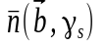 ; see image below.
Reverse injection direction (map).
Track/Spin tune/&c => SPC (2).
Compare SMC (1) & SMC (2) => statistic. // angle 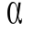 between 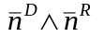 ?
Repeat many times => Statistic distribution.
Analyze the statistic distribution and conclude if/under what constriction of the error distribution we can get it sufficiently narrow.

note 1
- Fix the problem with spin tune not an orbital invariant.

note 2
Every time the beam is injected into the ring, it occupies a different subspace of phase space (call it ). 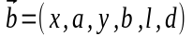Spin tune is, theoretically, a function of the beam position (x,y), momentum spread (dp/p =: d), and kinetic energy (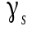); the first two are second order terms, while the kinetic energy dependence is linear. Hence we propose to calibrate the transition between the CW to CCW regimes via adjusting the beam energy .

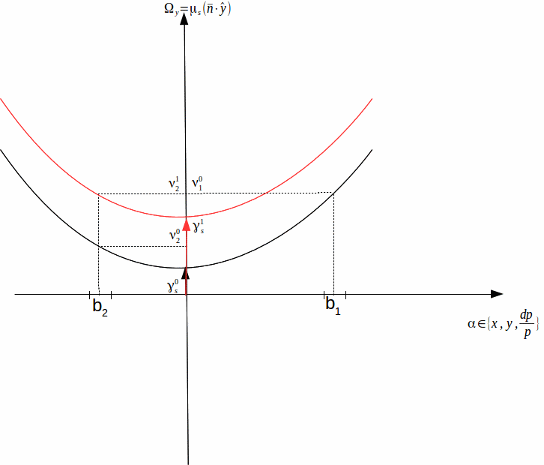
In calibrating, we observe the spin precession in the horizontal plane, i.e. 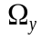. We need to show that (under our conditions)
.
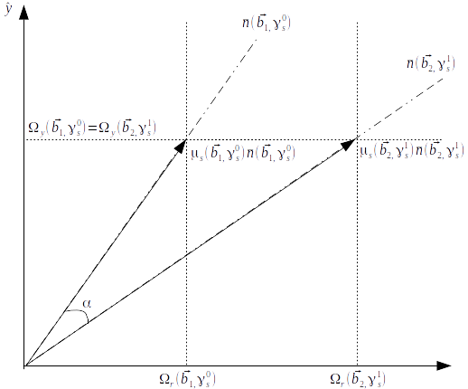
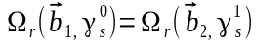 requires the directions 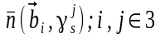 to coincide, as can be observed from the figure above.
Must show that 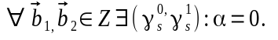

Modeling of Calibration

Turn on solenoid (turn off vertical precession). // Transfer map w/solenoid on
Set By.
Compute 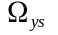. // TSP computes all Omegas; observe 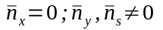
Turn off solenoid (turn on vertical precession). // Transfer map w/solenoid off
Compute 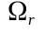. // Observe from TSP 