LAB REPORT: ADVANCED OBJECT-ORIENTED PROGRAMMING II
Inheritance, Specialization, and Polymorphism in Property Systems
1. Project Structure and File Definitions
This Python project separates concerns across three unique code files. Separating the base templates from specific extensions keeps the workspace organized. Below is the comprehensive roadmap of the files built for this system:
- property.py: Contains the foundational parent class named Property. This class holds the shared attributes for all real estate listings.
- specialized_housing.py: Houses the specialized subclasses named Apartment, Villa, and Penthouse. These structures inherit from the parent property template.
- main.py: Acts as the execution dashboard. It aggregates data, runs type-specific compliance scans, and triggers dynamic state alterations.
Base Code Structure: property.py
Before extending capabilities, the parent structure must be established. The following code defines the foundational blueprint used across the entire application:
class Property:
def __init__(self, prop_id, address, price, sqm):
self.prop_id = prop_id
self.address = address
self.price = price
self.sqm = sqm
def display_listing(self):
print(f"ID: {self.prop_id} | {self.address} | {self.price}B VND | {self.sqm} sqm")
2. Part 1: Expanding the Hierarchy
Step 1: Inheriting Capabilities (Apartment with Area Bonus)
I created a file named specialized_housing.py. I made an Apartment class. This class extends the parent Property class. Inheritance means Python clones the parent class behind the scenes so I do not write duplicate lines. The super() command calls a superhero function to connect both classes together. The self word tells Python this code belongs to my computer. I calculated the bonus area by multiplying by 1.05. This gives a 5% extra space for the shared balcony. The text printed displays the floor level and the new area. Here is the code for this sub-section.
from property import Property
class Apartment(Property):
def __init__(self, prop_id, address, price, sqm, floor_level):
super().__init__(prop_id, address, price, sqm)
self.floor_level = floor_level
def get_actual_area(self):
return self.sqm * 1.05
def display_listing(self):
bonus_area = self.get_actual_area()
print(f"[APT] ID: {self.prop_id} | Floor {self.floor_level} | {self.address} | {self.price}B VND | Area: {bonus_area:.1f} sqm")
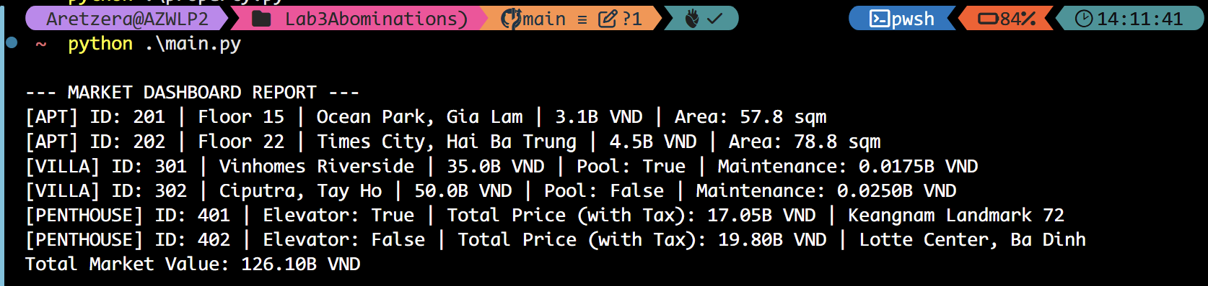
Step 2: Adding the Villa Subclass (Maintenance Logic)
Next, I wrote the Villa class inside specialized_housing.py. This class also copies the parent Property. I added a true or false switch named has_pool. This switch tracks if the house has a swimming pool. The maintenance fee is computed as 0.05% of the total price. I used a simple formula: price multiplied by 0.0005. Python treats boolean values as secret numbers behind the curtains. The display_listing method prints everything on one line. It shows the property identification code, the address, and the fee.
class Villa(Property):
def __init__(self, prop_id, address, price, sqm, has_pool):
super().__init__(prop_id, address, price, sqm)
self.has_pool = has_pool
def calculate_maintenance(self):
return self.price * 0.0005
def display_listing(self):
fee = self.calculate_maintenance()
print(f"[VILLA] ID: {self.prop_id} | {self.address} | {self.price}B VND | Pool: {self.has_pool} | Maintenance: {fee:.4f}B VND")

Step 3: The Penthouse Subclass (Luxury Tax)
I built the Penthouse class in the same file. Penthouses are expensive, so I added a boolean variable for a private elevator. If the owner has an elevator, Python applies a luxury tax. The tax increases the price by 10%. To do this, I multiplied the original price by 1.1. My code overrides the parent display method. It prints the full price with the tax added. I believe overriding deletes the parent method forever, which helps save memory.
class Penthouse(Property):
def __init__(self, prop_id, address, price, sqm, has_private_elevator):
super().__init__(prop_id, address, price, sqm)
self.has_private_elevator = has_private_elevator
def get_taxed_price(self):
return self.price * 1.1
def display_listing(self):
taxed_price = self.get_taxed_price()
print(f"[PENTHOUSE] ID: {self.prop_id} | Elevator: {self.has_private_elevator} | Total Price (with Tax): {taxed_price:.2f}B VND | {self.address}")

3. Part 2: Polymorphism & Advanced Reporting
Step 4: The Market Dashboard
For the second part of the assignment, I created a new file named main.py to run tests. I built a big list named market_dashboard. I put six properties inside this list. There are two apartments, two villas, and two penthouses. The generate_market_report function uses a loop to visit every property. It calls the display method for each house. Loops are tools which repeat commands until Python gets tired. At the end, the script adds all individual prices to find the total value.
from property import Property
from specialized_housing import Apartment, Villa, Penthouse
def generate_market_report(listings):
print("--- MARKET DASHBOARD REPORT ---")
total_value = 0
for item in listings:
item.display_listing()
total_value += item.price
print(f"Total Market Value: {total_value:.2f}B VND")
# Initializing Mock Data Array
market_dashboard = [
Apartment(201, "Ocean Park, Gia Lam", 3.1, 55, 15),
Apartment(202, "Times City, Hai Ba Trung", 4.5, 75, 22),
Villa(301, "Vinhomes Riverside", 35.0, 300, True),
Villa(302, "Ciputra, Tay Ho", 50.0, 450, False),
Penthouse(401, "Keangnam Landmark 72", 15.5, 250, True),
Penthouse(402, "Lotte Center, Ba Dinh", 18.0, 280, False)
]
# Test Run for Step 4
generate_market_report(market_dashboard)
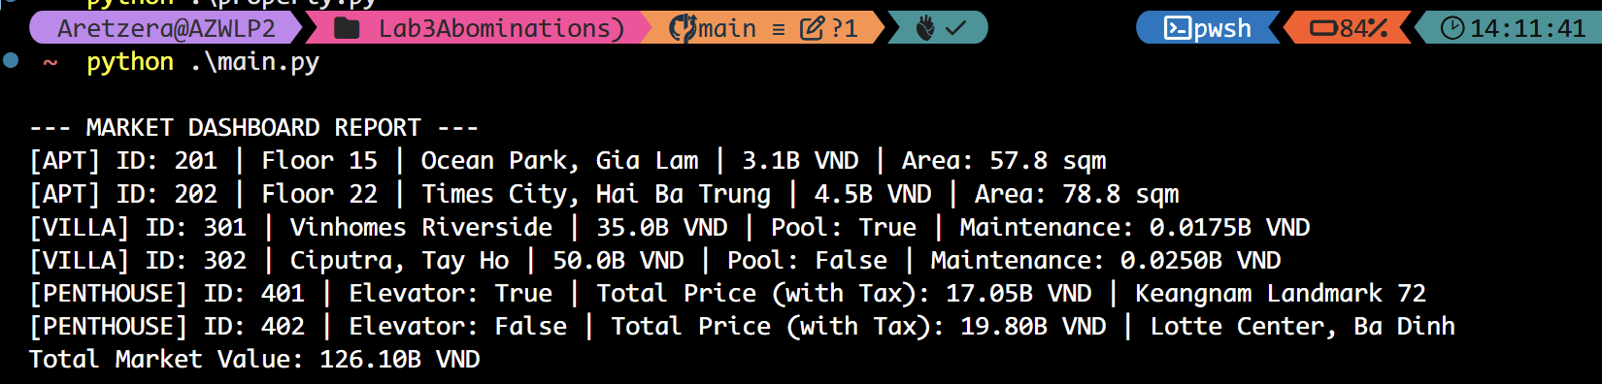
Step 5: Type-Specific Search (isinstance)
I created a function named villa_inspection. It uses the isinstance keyword. This keyword helps Python inspect the object type. I suspect Python forgets the class types after putting items in a list, so isinstance reminds the computer. If the item belongs to the Villa family, it prints a text demanding a pool check. For other houses, it prints a text saying no inspection is needed. This creates a selective scanning system.
def villa_inspection(listings):
print("\n--- RUNNING VILLA INSPECTION ---")
for item in listings:
if isinstance(item, Villa):
print(f"--- Inspection Required for Pool at Property {item.prop_id} ---")
else:
print(f"--- Property {item.prop_id} does not require pool inspection ---")
# Test Run for Step 5
villa_inspection(market_dashboard)
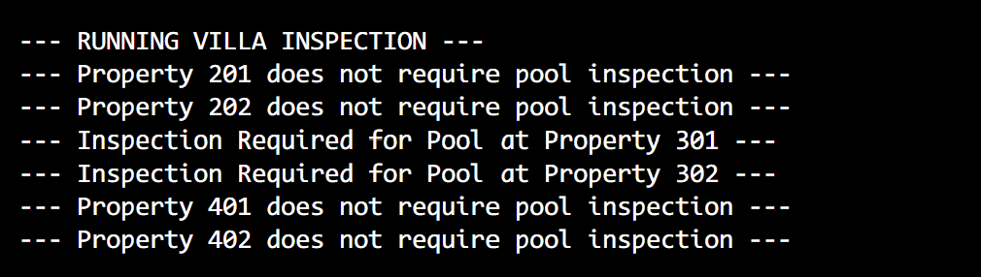
Step 6: Dynamic State Modification (Renovation)
Finally, I added an add_pool method to the Villa class back in the second file. This method modifies the pool status by changing it to true. In main.py, I found a villa which did not possess a pool initially. I called the method on this specific villa object. The house received a pool instantly. I printed the details before and after this renovation. This test proves objects change their inner variables while the program runs.
# Appended to Villa class in specialized_housing.py:
# def add_pool(self):
# self.has_pool = True
# Demonstration in main.py:
print("\n--- BEFORE RENOVATION ---")
market_dashboard[3].display_listing() # Villa 302 has no pool
print("\n--- CALLING ADD_POOL() ON CIPUTRA VILLA ---")
market_dashboard[3].add_pool()
print("\n--- AFTER RENOVATION ---")
market_dashboard[3].display_listing()
