**Little Man Computer**

**Calculator**

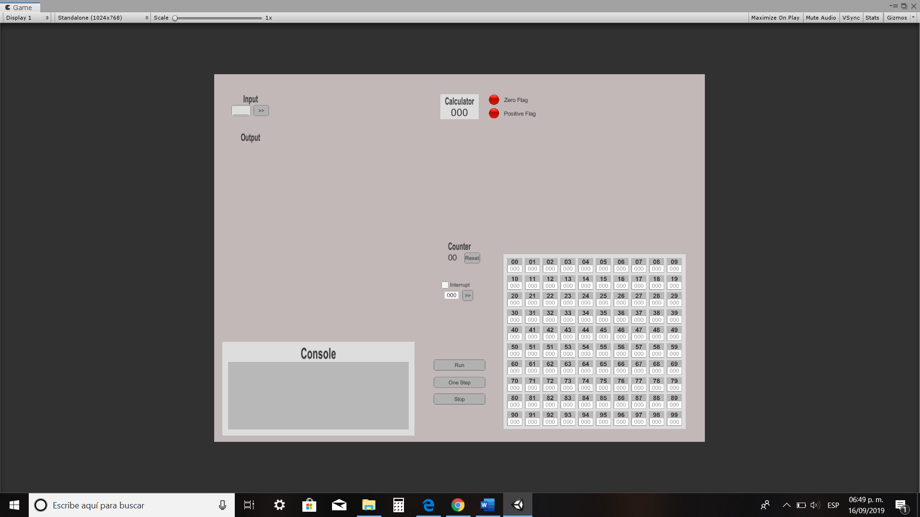

**Zero Flag**

**In-box**

**Positive Flag**

**Out-box**

**Mailboxes**

**Program counter**

**Interrupt Handler**

**Console**

**Options**

* Mailboxes: Each mailbox stores 3 digits, if we want the little man to do something, we need to set the first digit as an operation code and the next ones as a mailbox address.
  + The little man cannot distinguish between operations and numbers.
* Calculator: It shows on the screen the result of the arithmetic operations performed.
  + You can only display three digits on the screen.
* Zero and Positive Flags: They show if the number shown on the screen is positive or zero respectively.
* Input and output: The input section takes 3 digits value given by the user and places it in the calculator, the output section displays on the screen the selected number.
* In the options we can see that the LMC program can be executed in two modes: continuous (only pause for INPUT or OUTPUT) and step by step (a button to execute an instruction per click) and has an option to completely stop the program and restart.
* Console: It is a description of all procedures in execution.
* Counter: Contains the number of the mailbox in which the NEXT instruction is stored, the little man can change this value, usually by incrementing it, but sometimes by replacement.
  + Reset Button: This button functionality is to set the instruction counter to 0.
* Interrupt handler: This section shows the option to create a break for the running program. The interruption will be run by placing the number where the instruction to be followed is placed and once the interruption is over the program will continue.

|  |  |  |
| --- | --- | --- |
| **FORMAT** | **MNEMONIC** | **MEANING** |
| 1xx | ADDxx | Adds the contents of mailbox xx to the calculator display |
| 2xx | SUBxx | Subtracts the contents of mailbox to the calculator display |
| 3xx | STOxx | Stores the calculator value into mailbox xx |
| 4xx | STAxx | Stores the last 2 digits of the calculator value into the address portion of the instruction in mailbox xx |
| 5xx | LOADxx | Loads the contents of mailbox xx into the calculator |
| 6xx | Bxx | This instruction sets the instruction counter to the number xx thus effectively branching to mailbox xx |
| 7xx | BZxx | If the calculator value is zero, the set the instruction counter to the number xx, thus effectively branching to mailbox xx |
| 8xx | BPxx | If the calculator value is positive, the sets the instruction counter to the number xx, thus effectively branching to mailbox xx. NOTE: Zero is considered positive |
| 901 | INPUT | Read a number from the IN basket and key it into the calculator |
| 902 | OUTPUT | Copy the number in the calculator onto a slip of paper and place it into the OUT basket |
| 000 | STOP | Stops the computer – the Little Man resets |