The event viewer library

This document describes the event viewer library which can be used to view timing events of the emBODY using Vision.

Approval History

|  |  |  |  |  |  |  |
| --- | --- | --- | --- | --- | --- | --- |
| Version | Author | | Date | Approved | | Date |
| 0.1 | Accame | RBCS |  |  |  |  |
|  |  |  |  |  |  |  |
|  |  |  |  |  |  |  |

Revision History

|  |  |  |  |
| --- | --- | --- | --- |
| Version | Date | Author | Comments |
| 0.1 | 29 Feb 12 | Accame | First version. |
|  |  |  |  |
|  |  |  |  |
|  |  |  |  |
|  |  |  |  |
|  |  |  |  |

Table of Contents

1 Introduction 1

2 How to configure it 2

3 How to use it 4

# Introduction

The event viewer can be used to view timing events from every software module of the emBODY.

ETC. ETC.

How to configure it

In Vision follow the steps:

1. Include the library and set the include path,
2. In options-target specify the use of RTX,
3. In options-debug use the ULINK-PRO, use the file *eventviewer-stm32-cfg.ini* (or similar w/ correct TRACE* initialisation),
4. In options-debug-ULINKPRO-settings, specify as in figures.

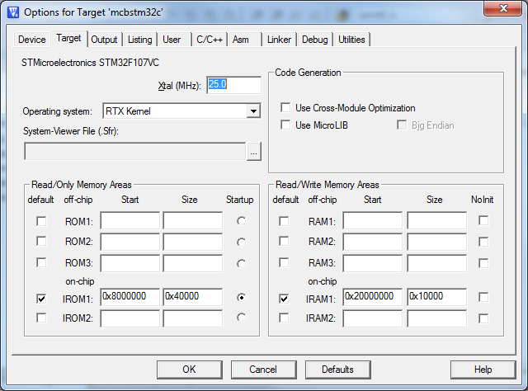

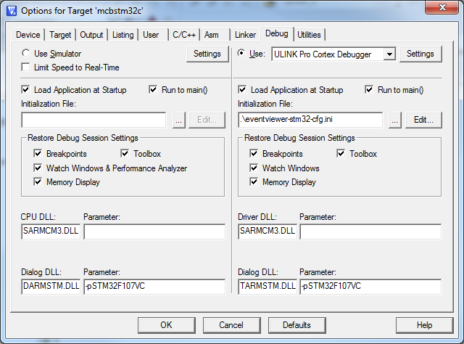

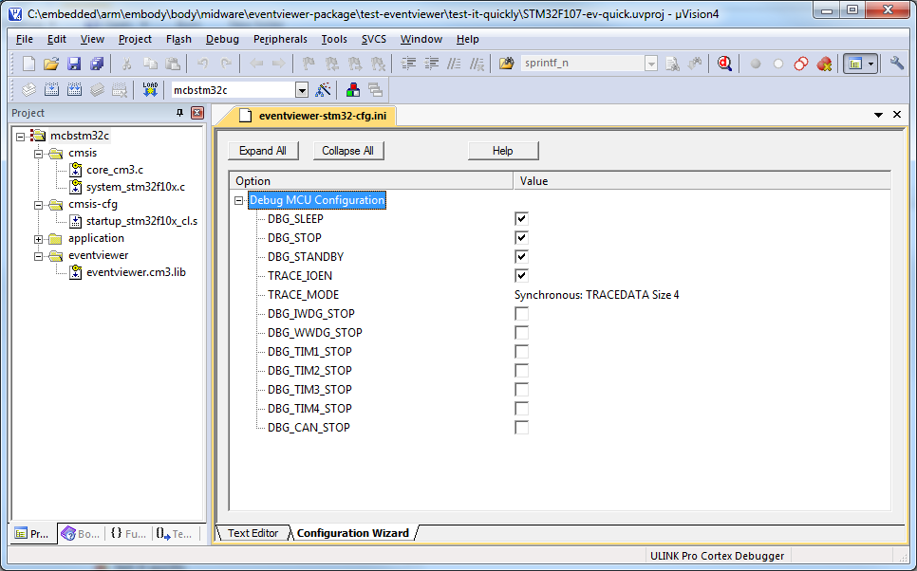

### For CM3

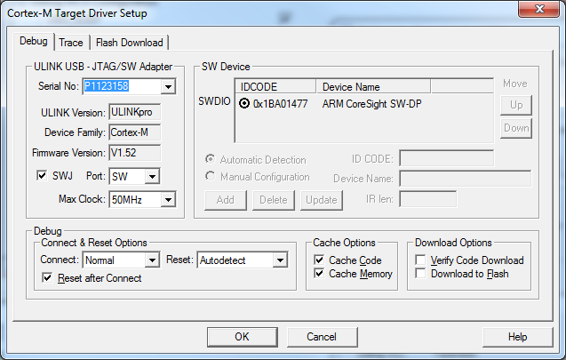

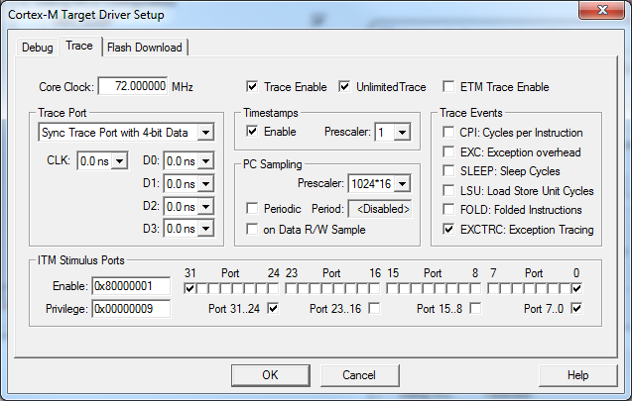

### For CM4

How to use it

Compile, attach the ULINK-pro, run debugger and enable Event Viewer.

