Rules

Arriving and Leaving

The flat has been cleaned for you.  When you leave, please clean, and remove all your rubbish and recycling.

San Sebastian is very humid!

1. Please keep the apartment well-ventilated to discourage mould.  Leave the windows and patio door tilted open at the top, also internal doors to be kept open when possible.  The same please whenever you leave the flat.
2. When temperatures are low and natural ventilation isn't possible, the dehumidifier can be used to reduce humidity in the flat.  It can also be used to dry laundry.  The windows must be shut when you use it, and the tank emptied regularly.  (see photo)

Equipment

The operating instructions for the dehumidifier, washing machine and other appliances etc are available in the apartment - please read before using them.

Awning

If the patio awning is wet, please let it dry before rolling it up.

Floors

Keep the wooden floor dry.  Only use a brush or the vacuum cleaner to clean it.

Smoking

Not in the apartment or building, thank you.

Noise and disturbance

Our neighbours include families with children, as well as elderly people, so please do not make loud or disturbing noises, especially after 10.30 pm.  Barbeques and parties are forbidden.

Heating and hot water

The heating temperature is set by the thermostat above the entry phone.  Turn dial and confirm with a push.

Please inform Alan and Jen, immediately if there are any problems at:

+44 7851631541 (WhatsApp) or [alanandjen1997@gmail.com](mailto:alanandjen1997@gmail.com)

Or our agent Oscar on:

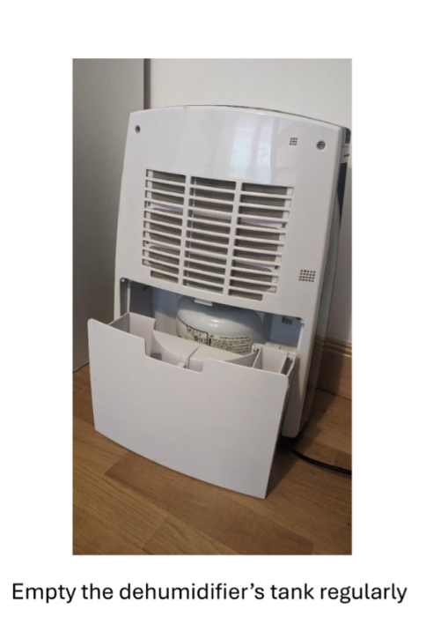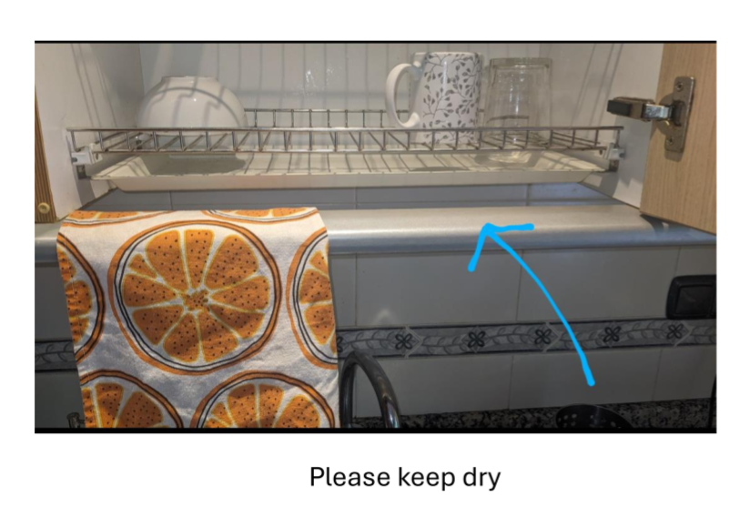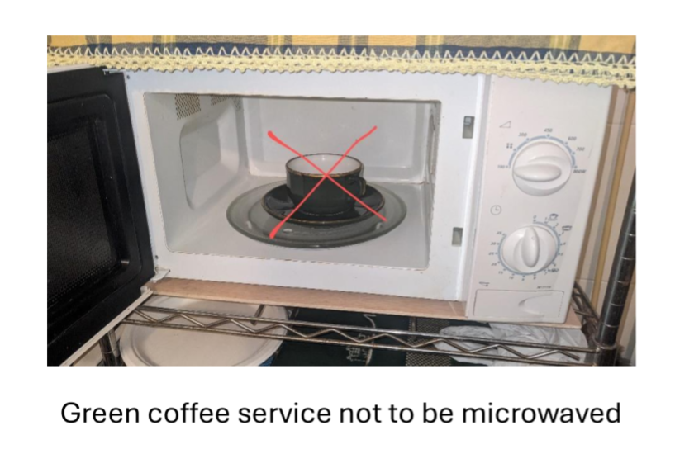+34 610 79 37 48