**Bug Report Template**

|  |  |
| --- | --- |
| ID number | CS-23 |
| Name | Benefit cost is wrongly calculated |
| Reporter | Alejandro Hernandez |
| Submit Date | 09/01/2024 |
| Summary | When my cart contains one item, I am unable to add a second item via the add to cart button on a product page |
| URL | <https://wmxrwq14uc.execute-api.us-east-1.amazonaws.com/Prod/Benefits> |
| Operating System | OS/ Windows |
| Browser | Chrome |
| Environment | Prod |
| Severity | High |
| Assigned to | / |
| Priority | High |

**Description**

The benefit cost is wrongly calculated

**Steps to reproduce**

> Login into paylocity

> Click on Add employee and enter the details with 1 dependet

> Verify the data displayed in the employee table

**Expected result**

The benefit cost is not correct, below we have the business rules:

* The cost of benefits is $1000/year for each employee

* Each dependent incurs a cost of $500/year

Employee cost: 1000/12 = 83.33

Dependent cost: 500/12 = 41.6666667

Cost = 124.996667

**Actual result**

The benefit cost is wrongly calculated:

57.66

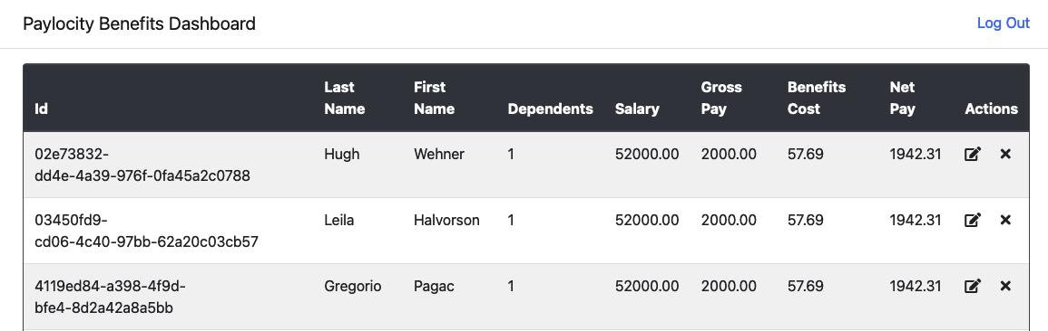

|  |  |
| --- | --- |
| ID number | CS-24 |
| Name | FirstName and LastName fields accept alphanumeric characters |
| Reporter | Alejandro Hernandez |
| Submit Date | 09/01/2024 |
| Summary | When I add or edit an employee, the user is able to enter alphanumeric characters |
| URL | <https://wmxrwq14uc.execute-api.us-east-1.amazonaws.com/Prod/Benefits> |
| Operating System | OS/ Windows |
| Browser | Chrome |
| Environment | Prod |
| Severity | Medium |
| Assigned to | / |
| Priority | High |

**Description**

FirstName and LastName fields accept alphanumeric characters

**Steps to reproduce**

> Login into paylocity

> Click on Add employee and enter a first and last name with alphanumeric characters

> Verify the data displayed in the employee table

> Login into paylocity

> Click on Edit Employee and enter a first and last name with alphanumeric characters

> Verify the data displayed in the employee table

**Expected result**

The user should not be allowed to enter alphanumeric characters in the first and last name fields

**Actual result**

FirstName and LastName fields accept alphanumeric characters

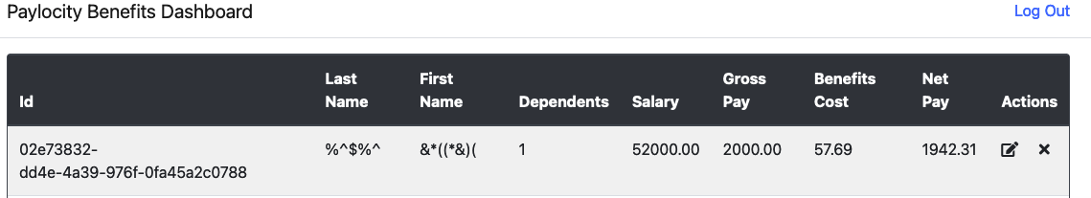

|  |  |
| --- | --- |
| ID number | CS-25 |
| Name | Wrong format for FirstName and LastName fields |
| Reporter | Alejandro Hernandez |
| Submit Date | 09/01/2024 |
| Summary | First and last name fields accept to many spaces and the length limit is big |
| URL | <https://wmxrwq14uc.execute-api.us-east-1.amazonaws.com/Prod/Benefits> |
| Operating System | OS/ Windows |
| Browser | Chrome |
| Environment | Prod |
| Severity | Medium |
| Assigned to | / |
| Priority | Medium |

**Description**

First and last name fields accept to many spaces and the length limit is big

**Steps to reproduce**

> Login into paylocity

> Click on Add employee and enter a first and last name with spaces

> Verify the data displayed in the employee table

> Login into paylocity

> Click on Edit Employee and enter a first and last name with spaces

> Verify the data displayed in the employee table

**Expected result**

Add a rule to limit the characters size and don't allow more than 2 names for first and las name

**Actual result**

First and last name fields accept to many spaces and the length limit is big

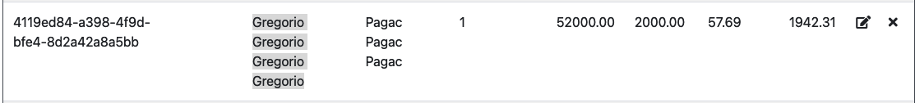

|  |  |
| --- | --- |
| ID number | CS-26 |
| Name | Dependents rule is not correct |
| Reporter | Alejandro Hernandez |
| Submit Date | 09/01/2024 |
| Summary | The dependents limit is 32, but this is not something possible, we should update the limit. |
| URL | <https://wmxrwq14uc.execute-api.us-east-1.amazonaws.com/Prod/Benefits> |
| Operating System | OS/ Windows |
| Browser | Chrome |
| Environment | Prod |
| Severity | low |
| Assigned to | / |
| Priority | low |

**Description**

The dependents limit is 32, but this is not something possible, we should update the limit.

**Steps to reproduce**

> Login into paylocity

> Click on Add employee and enter 32 dependents

> Verify the data displayed in the employee table

> Login into paylocity

> Click on Edit Employee and enter 32 dependents

> Verify the data displayed in the employee table

**Expected result**

Add a rule to limit the number of dependents (Verify with business analyst)

**Actual result**

The dependent limit is big, the limit is 32

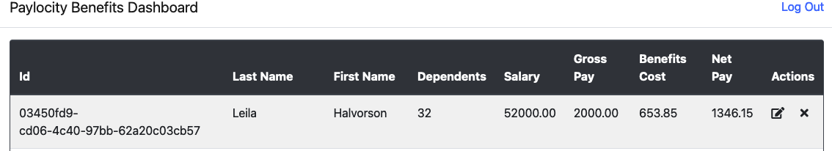

|  |  |
| --- | --- |
| ID number | CS-27 |
| Name | Employees added in wrong order in the table |
| Reporter | Alejandro Hernandez |
| Submit Date | 09/01/2024 |
| Summary | When the user adds an employee, it is not added below the last one, looks like the order is based on the ID |
| URL | <https://wmxrwq14uc.execute-api.us-east-1.amazonaws.com/Prod/Benefits> |
| Operating System | OS/ Windows |
| Browser | Chrome |
| Environment | Prod |
| Severity | low |
| Assigned to | / |
| Priority | low |

**Description**

When the user adds an employee, it is not added below the last one, looks like the order is based on the ID

**Steps to reproduce**

> Login into paylocity

> Click on Add employee details

> Verify the data displayed in the employee table

**Expected result**

New employees should be added below the last one

**Actual result**

When the user adds an employee, it is not added below the last one, looks like the order is based on the ID

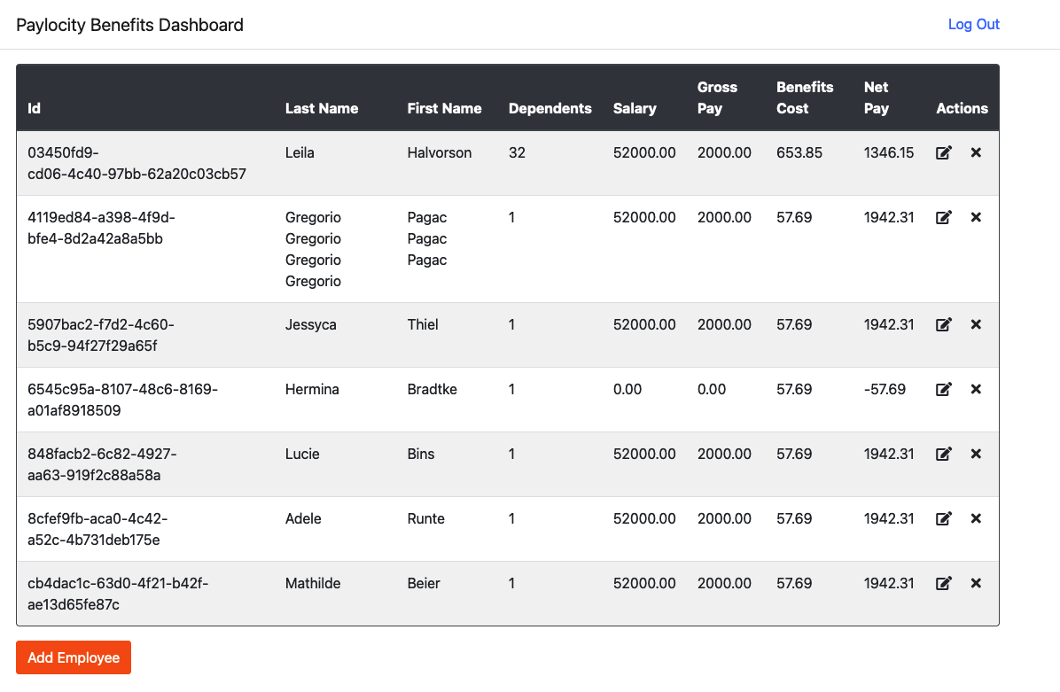

|  |  |
| --- | --- |
| ID number | CS-28 |
| Name | Dashboard is frozen when you are inactive for around 10-15 minutes |
| Reporter | Alejandro Hernandez |
| Submit Date | 09/01/2024 |
| Summary | When the user is inactive for around 10-15 minutes you cannot perform actions like remove, add or update |
| URL | <https://wmxrwq14uc.execute-api.us-east-1.amazonaws.com/Prod/Benefits> |
| Operating System | OS/ Windows |
| Browser | Chrome |
| Environment | Prod |
| Severity | High |
| Assigned to | / |
| Priority | low |

**Description**

When the user is inactive for around 10-15 minutes you cannot perform actions like remove, add or update

**Steps to reproduce**

> Login into paylocity

> Leave the application inactive around 10-15 min

> Click on Add employee, edit or remove

**Expected result**

The user should be able to perform actions or logout automatically due to inactivity

**Actual result**

When the user is inactive for around 10-15 minutes you cannot perform actions like remove, add or update



|  |  |
| --- | --- |
| ID number | CS-28 |
| Name | Blank screen when user enter wrong credentials |
| Reporter | Alejandro Hernandez |
| Submit Date | 09/01/2024 |
| Summary | When the user enters wrong credentials in the login form a blank screen is displayed |
| URL | https://wmxrwq14uc.execute-api.us-east-1.amazonaws.com/Prod/Account/LogIn |
| Operating System | OS/ Windows |
| Browser | Chrome |
| Environment | Prod |
| Severity | Medium |
| Assigned to | / |
| Priority | Medium |

**Description**

When the user enters wrong credentials in the login form a blank screen is displayed

**Steps to reproduce**

> Enter a non-existing username or password

> Click on log in

> A blank screen is displayed

**Expected result**

If the user enters wrong credentials an error message should be displayed

**Actual result**

When the user enters wrong credentials in the login form a blank screen is displayed

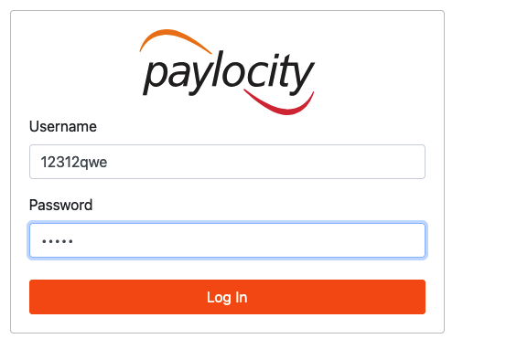

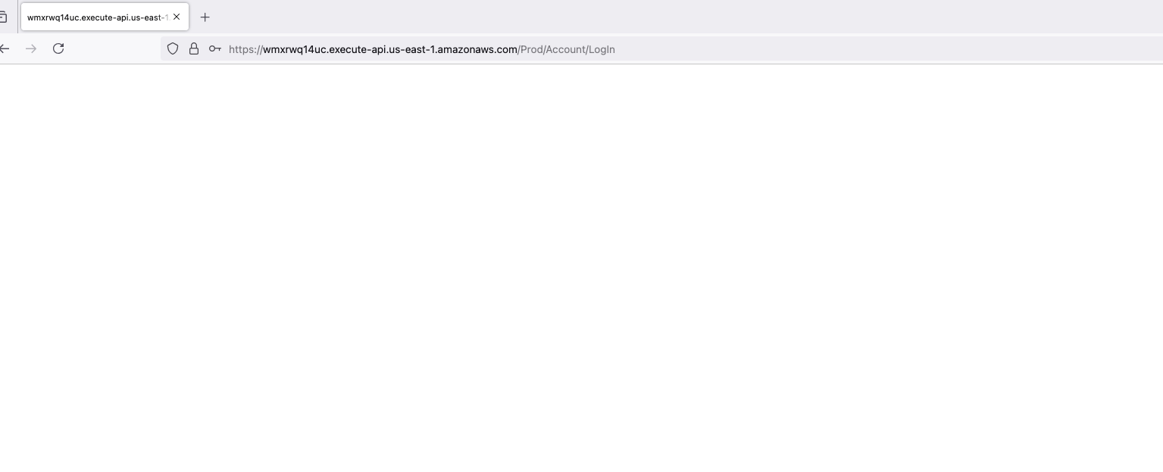

|  |  |
| --- | --- |
| ID number | CS-29 |
| Name | Get employee service showing incorrect response when the employee is removed |
| Reporter | Alejandro Hernandez |
| Submit Date | 09/01/2024 |
| Summary | When the user has an existing user and it is removed from the table, the service get employee is showing a wrong response. |
| URL | https://wmxrwq14uc.execute-api.us-east-1.amazonaws.com/Prod/api/employees/fef6773d-7a80-4660-b6f2-6a5f4dea0923 |
| Operating System | OS/ Windows |
| Browser | Chrome |
| Environment | Prod |
| Severity | low |
| Assigned to | / |
| Priority | low |

**Description**

When the user has an existing user and it is removed from the table, the service get employee is showing a wrong response.

**Steps to reproduce**

> Login into the application

> Add a new employee

> Get the id, remove the employee

> Search the employee through the get employee service

**Expected result**

An error code or message should be displayed when the employee id was removed from the table.

**Actual result**

200 code is displayed, and the body details are blank

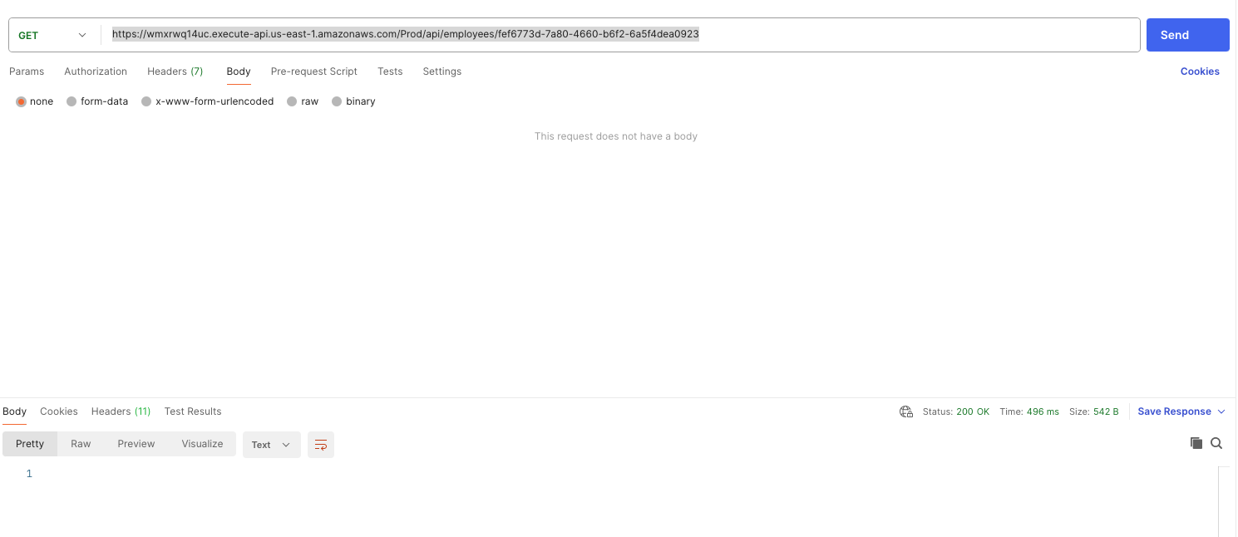

|  |  |
| --- | --- |
| ID number | CS-30 |
| Name | Delete employee service showing incorrect response when the employee is removed |
| Reporter | Alejandro Hernandez |
| Submit Date | 09/01/2024 |
| Summary | When the user has an existing user and it is removed from the table, the service delete employee is showing a wrong response. |
| URL | https://wmxrwq14uc.execute-api.us-east-1.amazonaws.com/Prod/api/employees/fef6773d-7a80-4660-b6f2-6a5f4dea0923 |
| Operating System | OS/ Windows |
| Browser | Chrome |
| Environment | Prod |
| Severity | low |
| Assigned to | / |
| Priority | low |

**Description**

When the user has an existing user and it is removed from the table, the service delete employee is showing a wrong response.

**Steps to reproduce**

> Login into the application

> Add a new employee

> Get the id

> Delete the employee through the service and try to delete the same employee with the service

**Expected result**

An error code or message should be displayed when the employee id was already removed

**Actual result**

200 code is displayed, and the body details are blank when you try to delete more than one time the same user.

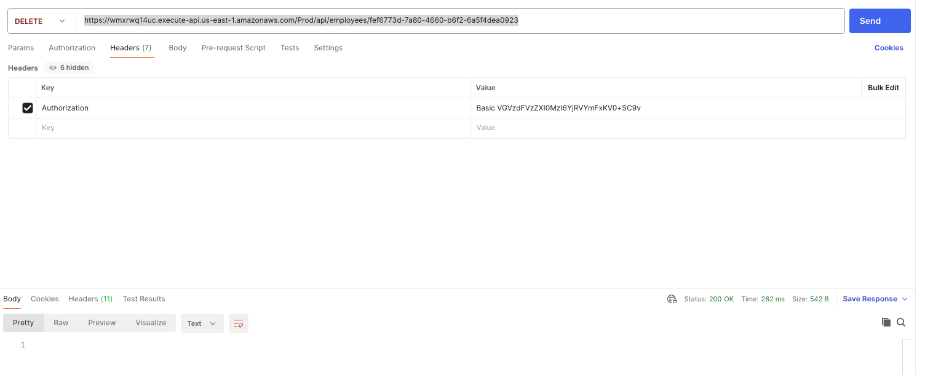

|  |  |
| --- | --- |
| ID number | CS-30 |
| Name | Update service is creating again a deleted user |
| Reporter | Alejandro Hernandez |
| Submit Date | 09/01/2024 |
| Summary | The user is able to add a deleted record through the put request |
| URL | https://wmxrwq14uc.execute-api.us-east-1.amazonaws.com/Prod/api/employees |
| Operating System | OS/ Windows |
| Browser | Chrome |
| Environment | Prod |
| Severity | high |
| Assigned to | / |
| Priority | high |

**Description**

The user is able to add a deleted record through the put request

**Steps to reproduce**

> Login into the application

> Add a new employee

> Get the id

> Delete the employee through the service

> Execute the put request with the same id from the deleted user

**Expected result**

A deleted user should not be able to be updated and added to the table

**Actual result**

200 code is displayed the user is added into the table with incorrect salary.

