1. **What is income tax?[1]?**

Income tax is levied on income obtained by individuals, undivided inheritances[2] and corporations, whether domestic or foreign. The tax year is from January 1 to December 31 (National Assembly of Ecuador, 2004; Presidency of the Republic of Ecuador, 2010).

Individuals, whether they are dependent or not, and whether or not they are obliged to keep accounting records, are obliged to file their annual income tax form.

1. **Under a relationship of dependency**

Article 8 of the Labor Code defines an individual contract as: "(...) an agreement by virtue of which a person undertakes to render lawful and personal services to another or others, under his or her dependence, for a remuneration fixed by agreement, law, collective contract or custom" (National Congress, 2005).

Based on this article, the condition of a dependent relationship refers to the fact that the worker maintains a relationship of subordination to his employer and obedience to the provisions for the development of labor activities.

1. **Taxable income**

They are all those incomes coming from work under a dependency relationship, economic activity, or work and capital that the Tax Administration recognizes to be subject to income tax under the general regime.

The taxable income of individuals under a dependency relationship are: unified monthly remuneration (salary or wage as appropriate), bonuses and profit sharing.

1. **Gross income**

This is all the income received from each of the sources of income identified, whether it comes from the relationship of dependency, from the business economic activity or from capital and work without making any type of discount. In the case of individuals under a dependency relationship, taxable income plus the tenths of remunerations and reserve funds are considered. This income represents the economic capacity that an individual may have.

1. **What is the taxable base?**

In general, the taxable base is constituted by the total ordinary and extraordinary income taxed, minus refunds, discounts, costs, expenses and deductions attributable to such income (National Assembly of Ecuador, 2004).

1. **Taxable income from employment as a dependent employee**

The taxable base of income from employment as a dependent is constituted by the ordinary or extraordinary income subject to tax, minus the value of personal contributions to the Ecuadorian Social Security Institute, except when these are paid by the employer, and cannot be reduced by any rebate or deduction, except for personal expenses (National Assembly of Ecuador, 2004; Presidency of the Republic of Ecuador, 2010).

In other words, the taxable base is taxable income minus personal contributions to the Ecuadorian Social Security Institute and personal expenses.

1. **Taxable base tables**

|  |  |  |  |
| --- | --- | --- | --- |
| **Year 2022 - In dollars** | | | |
| **Basic fraction** | **Excess up to** | **Basic fraction tax** | **% Excess fraction tax** |
| - | 11.310 | 0 | 0% |
| 11.310 | 14.410 | - | 5% |
| 14.410 | 18.010 | 155 | 10% |
| 18.010 | 21.630 | 515 | 12% |
| 21.630 | 31.630 | 949 | 15% |
| 31.630 | 41.630 | 2.449 | 20% |
| 41.630 | 51.630 | 4.449 | 25% |
| 51.630 | 61.630 | 6.949 | 30% |
| 61.630 | 100.000 | 9.949 | 35% |
| 100.000 | En adelante | 23.379 | 37% |

Organic Law on Economic Development and Fiscal Sustainability after the COVID 19

pandemic published in 3S.R.O. 587 of 11/29/2021.

1. **Schedule of Personal Expenses**

The Personal Expenses Schedule must be filed if the deductible personal expenses exceed 50% of the basic fraction of Income Tax deductible for individuals. People working as employees are not required to file an income tax return provided that they work with only one employer and do not project personal expenses, or if they have done so, there are no amounts to be reimbursed.

1. **Personal expenses**

Individuals will enjoy a rebate on income tax caused by their personal expenses, applicable prior to the allocation of tax credits to which they are entitled in accordance with the Law. According to Ecuadorian regulations, taxpayers may deduct their personal expenses in six items for 2022: Health; Education, art and culture; Clothing; Food; Housing; and Domestic tourism.

In order to establish the maximum amount of the deduction indicated in the previous paragraph, the following rules must be observed (National Assembly of Ecuador, 2004; last amendment 2022):

a) If your annual gross income (including exempt income) does not exceed two point thirteen (2.13) basic income tax deductible fractions, the maximum amount of the personal expense allowance will be the result of applying the following formula:

R= L x 20%.

R= personal expense allowance

L= The lesser of the declared personal expenses for the annual tax period and the value of the basic food basket multiplied by seven.

b) If your annual gross income (including exempt income) exceeds two point thirteen (2.13) basic income tax deductions during the tax year:

R= L x 10%.

R= rebate for personal expenses

L= The lesser of the declared personal expenses of the annual fiscal period and the value of the basic basket multiplied by seven.

For the purposes of this calculation, the value of the Basic Family Basket of December of the fiscal year in which the tax is settled will be considered, according to the data published by the National Institute of Statistics and Census.

Personal expenses must be supported by validly issued sales receipts.

In order to quantify personal expenses, those incurred by parents, spouse or common-law partner and dependent children of the taxpayer or his/her spouse or common-law partner may be considered, provided that they do not receive taxable income; however, in any case, VAT and ICE must be excluded from the transactions.

**HOUSING**

* **Lease:** Lease of a single property used for housing.
* **Mortgage loan interest:** Interest on mortgage loans granted by authorized institutions for the expansion, remodeling, restoration, acquisition or construction of a single dwelling used for housing. In this case, the certificates issued by the institution that granted the loan, or the respective debit reflected in the account statements or savings books, will be sufficient evidence.
* **Basic services:** Payments for basic services including water, gas, electricity, conventional telephone and condominium fee of a single property used for housing.
* **Property tax:** Property taxes on a single piece of real estate used for housing.
* **Alimony:** Alimony, duly supported by mediation act or judicial resolution.
* **Other expenses:** Intended for the acquisition, construction, remodeling, remodeling, expansion, improvement and maintenance of a single real estate property. In all the cases indicated in this item and in the previous ones, the expenses will be considered on the basis of a single dwelling.

**EDUCATION, ARTS AND CULTURE**

* **Tuition and pension:** Tuition and pension at all levels of the educational system, initial, basic general education, high school and higher education, as well as tuition, refresher courses, professional training seminars duly approved by the Ministry of Education or Labor when applicable or by the National Council of Higher Education as the case may be.
* **School transportation.**
* **Degree fees.**
* **Payment of interest on educational credits granted by duly authorized institutions.**
* **School supplies and textbooks:** School supplies, textbooks, computer equipment, and didactic materials used in education.
* **Education for persons with disabilities:** Special education services for persons with disabilities, provided by centers and professionals recognized by the competent bodies.
* **Child care and/or development:** Services provided by child care and/or development centers and didactic material for child development.
* **Uniforms:** Uniforms.
* **Live and performing arts:** Dance, theater, opera, mime, circus arts, magic, performance, puppetry and video dance.
* **Fine, visual and applied arts:** Drawing, painting, sculpture, restoration, printmaking, ceramics, non-cosmetic tattooing, mural, photography, video art and installations, pottery, screen printing, carving and illustration.
* **Literary and narrative arts:** Training and instruction in these areas, payment for recitals, shows and live events related to them, as well as payments for the acquisition of books and magazines.
* **Cinematographic and audiovisual arts:** Training and instruction in these areas, payment for exhibitions, shows and audiovisual and cinematographic events.
* **Musical and sound arts:** Training and instruction in these areas, payment for concerts, recitals, musicals and other types of live musical events and shows, as well as payments for the acquisition of musical instruments and accessories for such instruments.
* **Promotion and dissemination of social memory and heritage:** Training and instruction in these areas, payments for tickets and services of memory repositories (museum, archive and library).
* **Handicrafts:** Acquisition of handmade crafts made by artisans qualified by the competent agencies.
* **Alimony:** Alimony, duly supported by mediation or court order.

**HEALTH**

* **Health professional fees:** Fees of physicians and health professionals with a professional degree endorsed by the National Council of Higher Education.
* **Health services:** Health services provided by authorized clinics, hospitals, laboratories and pharmacies.
* **Medicines and others:** Medicines, medical supplies, eyeglasses, orthotics, prostheses and other health accessories.
* **Prepaid medicine and health insurance premium:** Prepaid medicine and health insurance premium in individual and corporate contracts. In cases where these values correspond to a corporate policy and they are deducted from the taxpayer's payment record, this document will be valid to support the corresponding expense.
* **Insurance deductible:** The unreimbursed deductible of the private insurance settlement.
* **Alimony:** Alimony, duly supported by mediation act or judicial resolution.
* **Other expenses:** Related to physical and mental wellbeing, as well as those for the prevention, recovery and rehabilitation of health.

**FOOD**

* **Food:** Purchases of food for human consumption and other natural or artificial products that human beings ingest for subsistence or nutrition.
* **Alimony:** Alimony, duly supported by mediation or judicial resolution.
* **Restaurants:** Purchase of food in prepared food vending centers.

**CLOTHING**

**Clothing:** Expenses incurred for any type of clothing will be considered clothing expenses.

**Alimony:** Alimony, duly supported by mediation or judicial resolution.

**TOURISM**

* **Lodging:** Expenses for tourist lodging within Ecuadorian territory in all its modalities will be considered.
* **Transportation:** Passenger transportation, including air, sea, river and land transportation and rental of vehicles hired or used for domestic tourism within Ecuadorian territory.
* **Food and beverage service:** Gastronomic services in restaurants, bars and similar, where food and/or non-alcoholic beverages are sold for human consumption, acquired by individuals during their tourist activities within Ecuadorian territory.
* **Tourist operation:** Packages, tours, and other tourist services provided by tour operators within Ecuadorian territory.
* **Tourism intermediation:** Tourism service agencies; organization of events, congresses and conventions, within Ecuadorian territory.
* **Amusement parks:** Stable amusement parks will be considered within Ecuadorian territory.
* **Alimony:** Alimony, duly supported by mediation or judicial resolution.

1. **Structure**

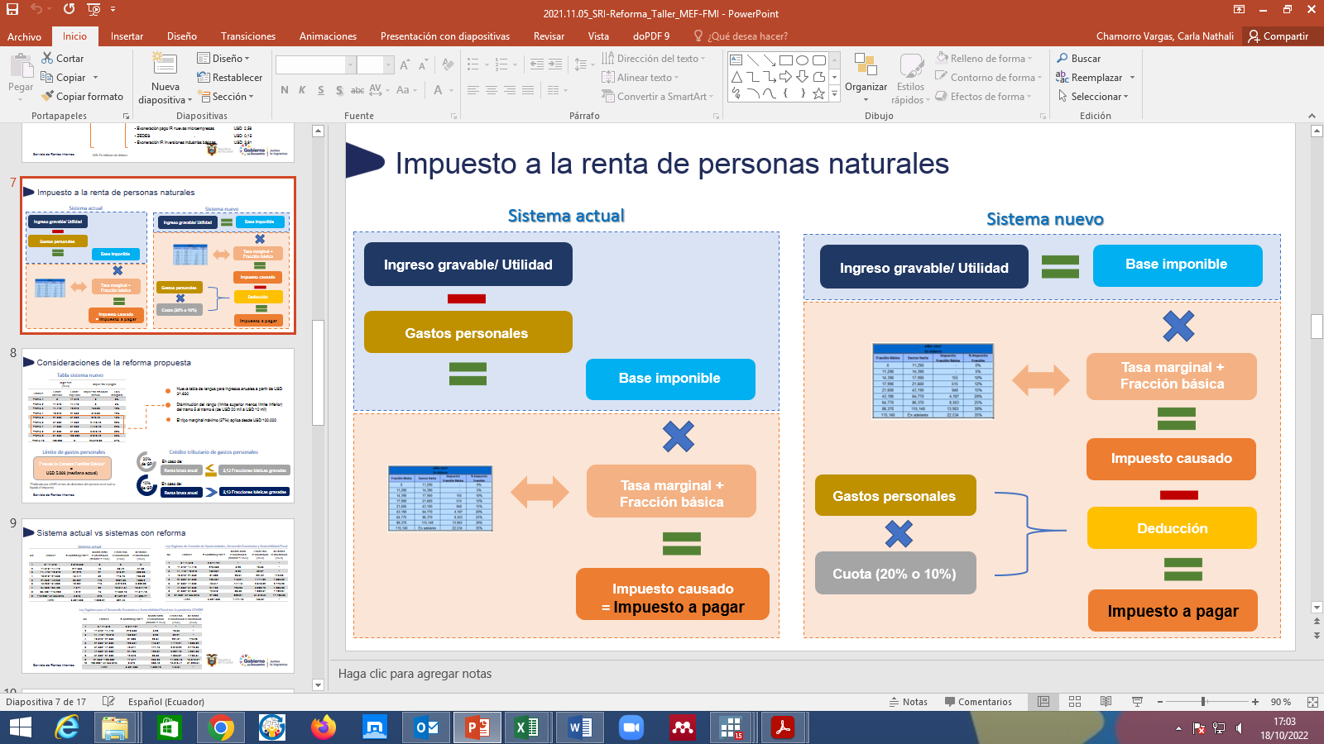

1. **Declaration period**

February to March 2023, according to the ninth digit of the identification card or RUC.

1. **Bibliographical references**

* National Assembly of Ecuador (2004). Law of Internal Tax Regime (Internal Tax Regime Law).
* National Congress (2005). Labor Code (pp. 1-158).
* Presidency of the Republic of Ecuador (2010). Regulations for the application of Law of Internal Tax Regime (Regulation for the Application of the Internal Tax Regime Law) (pp. 1-181).
* Tax Administration Office of Ecuador (Servicio de Rentas Internas) (2021). Declaración: Impuesto a la Renta 2021 (Income Tax Return 2021). https://www.sri.gob.ec/nl/declaracion-impuesto-a-la-renta-2021

1. Article 2 of the Organic Law of Internal Tax Regime and Article 1 of the Regulations of the Law.
2. Undivided inheritances for income tax liquidation are considered as independent economic units, i.e., they are understood and treated as a natural person. They are temporary taxpayers, their existence begins with the death of a natural person and ends when the heirs incorporate in their own estate the inheritance of the deceased (Presidency of the Republic of Ecuador, 2010).