Design
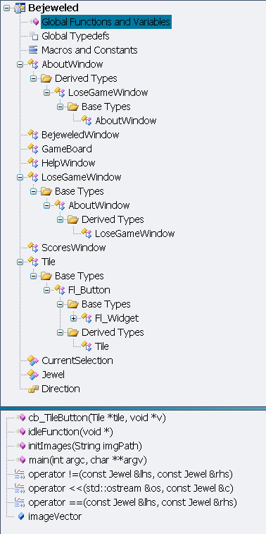
Class View

Global scope:
cb_TileButton(Tile* tile, void* v)
callback function for the tile, tells the program to update itself every time a tile is clicked.

idleFunction(void*)
allows for possible background function while fl::wait() is running. This function found no purpose in the final implementation, but was left for if we decided to use it in future versions.

initImages(String imgPath)
initializes the global imageVector with Fl_GIF_Images that are loaded from the directory listed in imgPath.

main(int argc, char** argv)
starting point of the program. Can be run in two modes – text based or GUI based. Currently it is hardcoded into GUI based (text based is commented out) in future versions we should parse the command line arguments passed to main to determine which mode to run in.

operator!=(const Jewel& lhs, const Jewel& rhs),
operator<<(std::ostream& os, const Jewel& c),
operator==(const Jewel& lhs, const Jewel& rhs):
These are overloaded operator support functions for the jewel class to allow for ease of use.

HelpWindow, ScoresWindow, AboutWindow:
Blank aside from a Fl_Double_Window pointer and constructor which creates the window. Once the window is created FLTK deals with the dangling pointer and invokes the deletion of the widgets on the window and the window itself from the free store for us.

LoseGameWindow: inherits from AboutWindow
All it does is expand the window in its constructor to add a box saying “You Lose”

Direction: an enumeration containing the 4 cardinal directions and an UNKNOWN field for use in our algorithms

CurrentSelection:
A class with static fields and a private constructor (no instances allowed) to help us in logically keeping the current game tile selection out of complete global scope.

Jewel:
A class similar to the Color class that we used in the engineering course but modified for our program, includes an as_Fl_Color() function which returns the color represented in addition to the as_int() function

Tile: inherits from Fl_Button
The class used to represent a game tile in our game. Each tile is unaware of its neighboring tiles and contains information pertaining to itself including its Jewel type, row, column, and marked status (used in removal of tiles in the game). Provides several overloaded constructors for ease of use. The default constructor is meant for text based game play only due to the immutable nature of the row and column property it stores. The callback function cb_TileButton is a friend of this class and is the only function with access to the row and column members.

GameBoard:
The heart of the program. Contains the static constant variables used to control the size of the board and a c-style 2D array that stores the game tiles themselves. Many of the debugging features are built into this class including several display commands and variables to track matches and combos in the game. By far the most important functions in the game are:
findMatches() : marks all gems it finds in a match for removal and returns the number of
gem matches. It calls markGems to mark the tiles for removal
possibleMatches() : returns true immediately when it comes across a possible match
uses possibleMatchGap and possibleMatchPair to help simplify logic
legalMove(int r, int c, Direction dir) : attempts to make the move by checking
findMatches. If findMatches
returns 0 the gems are swapped back and nothing happens.
removeMatches() : removes all marked gems for removal and the column falls to fill in
the holes, new gems fill the top positions.
We made the public functions have as few parameters as possible to allow for ease of use when working with the class as an interface.

BejeweledWindow:
Our major GUI class. contains all the important widgets and a GameBoard object with functions to create support windows. Also contains a newGame function to allow the user to start a new game at any time.

