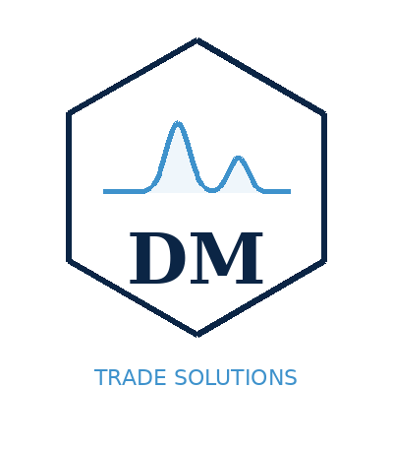 | DM TRADE SOLUTIONS LLC  8 The Green, Ste D, Dover, DE 19901  EIN: 41-3226623  www.dmtrade.solutions  info@dmtrade.solutions | INVOICE

BILL TO:  [Customer Name]  [Address Line 1]  [City, State ZIP]  [Email / Phone] | Invoice #: INV-2026-001  Date: MM/DD/2026  Due Date: Upon Receipt  Payment: Zelle

# | Description | Qty | Unit | Price | Amount
1 | Laboratory equipment / part description | 1 | pcs | $0.00 | $0.00
2 |  |  |  | $0.00 | $0.00
3 |  |  |  | $0.00 | $0.00
4 |  |  |  | $0.00 | $0.00
5 |  |  |  | $0.00 | $0.00
 | Subtotal: | $0.00
 | Tax (0%): | $0.00
 | Shipping: | $0.00
 | TOTAL: | $0.00

PAYMENT INFORMATION
Payment accepted via Zelle to the business account of DM Trade Solutions LLC.
Please reference the invoice number in your Zelle payment memo.

TERMS & CONDITIONS
All sales are final unless otherwise agreed in writing. Equipment sold as-is unless warranty is explicitly stated. Full terms available at www.dmtrade.solutions.

DELIVERY METHOD
[ ] Shipping (tracking # _______________)
[ ] Customer pickup Date: _______________

Thank you for your business!
DM Trade Solutions LLC | www.dmtrade.solutions | info@dmtrade.solutions

