When designing the Unicode Musical Symbols range, Perry Roland elected to develop a scheme for creating complex ornaments using a series of glyphs rather than defining precomposed glyphs for every ornament, as shown below:[1]

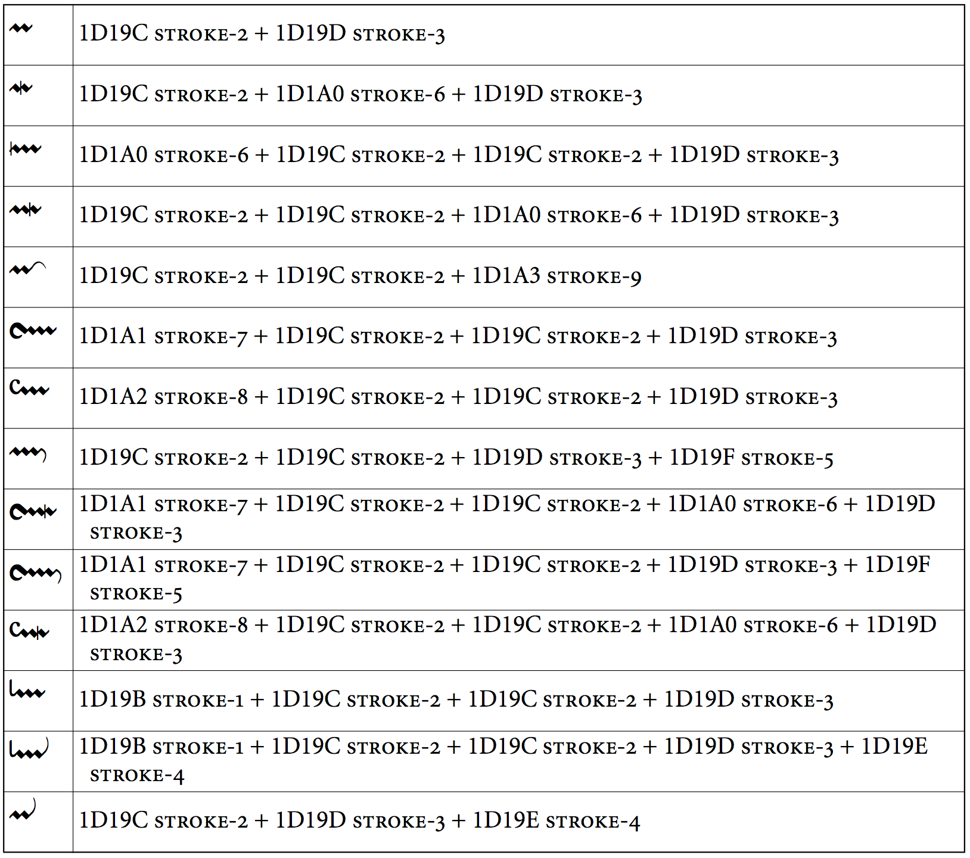

This range expands upon the repertoire of 11 strokes in the Unicode Musical Symbols range.

The side-bearings for the glyphs in this range must be adjusted carefully to ensure correct positioning. (Kerning pairs may also be used.)

Glyphs between ornamentTopLeftConcaveStroke and ornamentBottomLeftConvexStroke are designed to be positioned immediately to the left of and to join seamlessly to ornamentZigZagLineNoRightEnd. ornamentZigZagLineWithRightEnd and glyphs between ornamentTopRightConcaveStroke and ornamentBottomRightConvexStroke are designed to be positioned immediately to the right of and to join seamlessly to ornamentZigZagLineNoRightEnd. ornamentMiddleVerticalStroke should be used immediately to the left of either ornamentZigZagLineNoRightEnd or ornamentZigZagLineWithRightEnd to provide correct positioning of the vertical stroke across the zig-zag line.

1. *Ibid.*, Allen, page 539.