All of the glyphs in this range should have zero width, with all glyphs registered so that they overlay correctly (see examples below).

To construct a fingering chart, first use fingeringOboeChart to produce an empty chart. To add closed, half-closed, quarter-closed or trill keys to the chart, simply add the relevant glyphs at the same position.

The following diagram shows the disposition of keys in the blank chart.

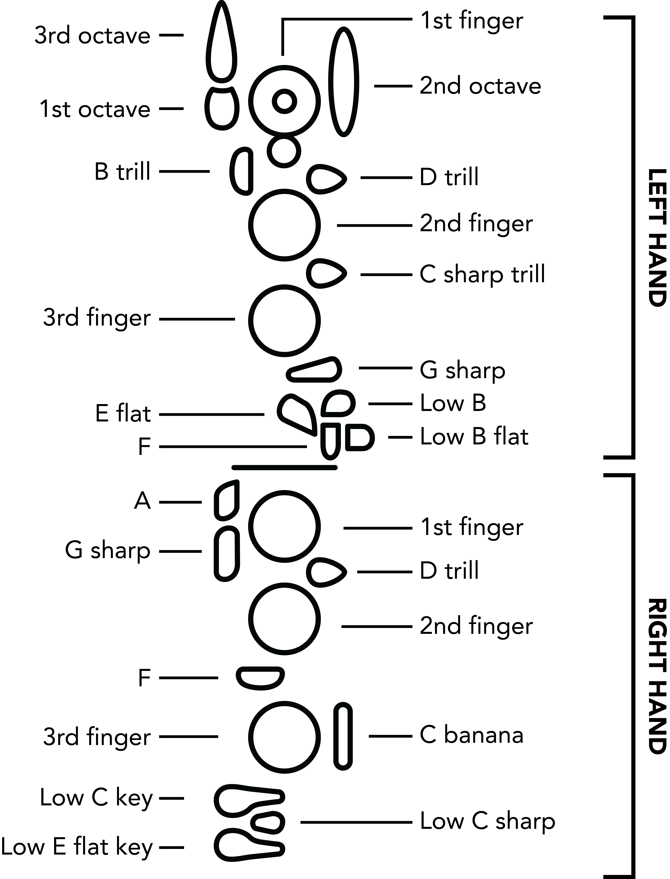

Here are a couple of examples of complete fingering charts. Note that they have been rotated counter-clockwise by 90 degrees:

|  |  |
| --- | --- |
|  | G: fingeringOboeChart, fingeringOboeLH1stFingerClosed, fingeringOboeLH2ndFingerClosed, fingeringOboeLH3rdFingerClosed |
|  | E flat: fingeringOboeChart, fingeringOboeLH1stFingerClosed, fingeringOboeLH2ndFingerClosed, fingeringOboeLH3rdFingerClosed, fingeringOboeLHEFlatClosed, fingeringOboeRH1stFingerClosed, fingeringOboeRH2ndFingerClosed, fingeringOboeRH3rdFingerClosed |