All of the glyphs in this range should have zero width, with all glyphs registered so that they overlay correctly (see examples below).

To construct a fingering chart, first use fingeringSaxChart to produce an empty chart for soprano, alto or tenor saxophone. To add the low A key found on a baritone saxophone, use fingeringSaxBariLowAOpen. To add closed, half-closed, quarter-closed or trill keys to the chart, simply add the relevant glyphs at the same position.

The following diagram shows the disposition of keys in the blank chart.

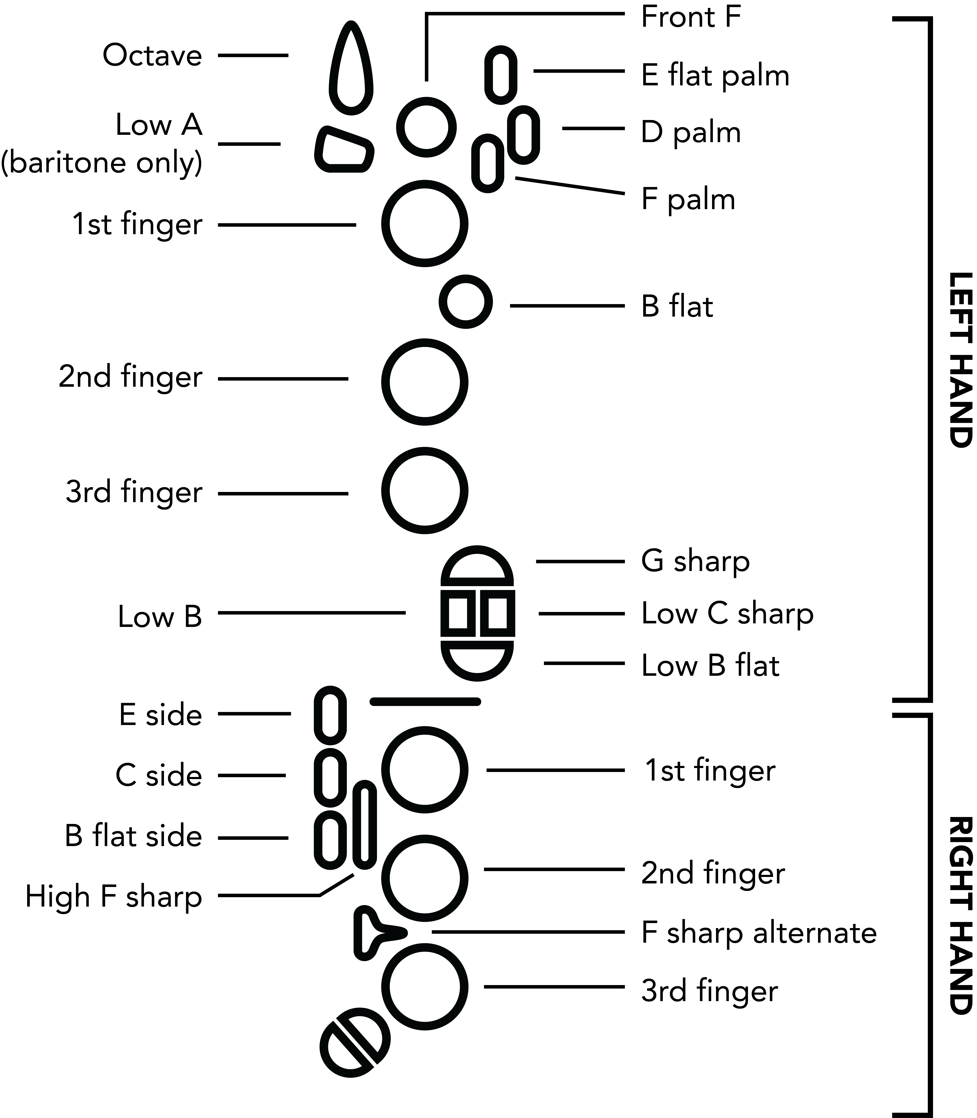

Here are a couple of examples of complete fingering charts. Note that they have been rotated counter-clockwise by 90 degrees:

|  |  |
| --- | --- |
| Macintosh HD:Users:DSpreadbury:Desktop:saxophone-d.png | D: fingeringSaxChart, fingeringSaxLHOctaveClosed, fingeringSaxLH1stFingerClosed, fingeringSaxLH2ndFingerClosed, fingeringSaxLH3rdFingerClosed, fingeringSaxRH1stFingerClosed, fingeringSaxRH2ndFingerClosed, fingeringSaxRH3rdFingerClosed |
|  | F sharp: fingeringSaxChart, fingeringSaxLHOctaveClosed, fingeringSaxLHEFlatPalmClosed, fingeringSaxLHDPalmClosed, fingeringBsnLHFPalmClosed, fingeringSaxRHESideClosed, fingeringBsnRHHighFSharpClosed |