Scoring applications should draw simple note clusters (e.g. noteheadClusterSquareWhite, noteheadClusterRoundBlack) directly using primitives rather than using these glyphs, so that the clusters can be drawn spanning the correct interval.

The combining glyphs for note clusters are designed to allow the creation of clusters of any interval larger than a third, with a scoring application inserting the appropriate number of “middle” segments between a single instance of the “top” and “bottom” segments:

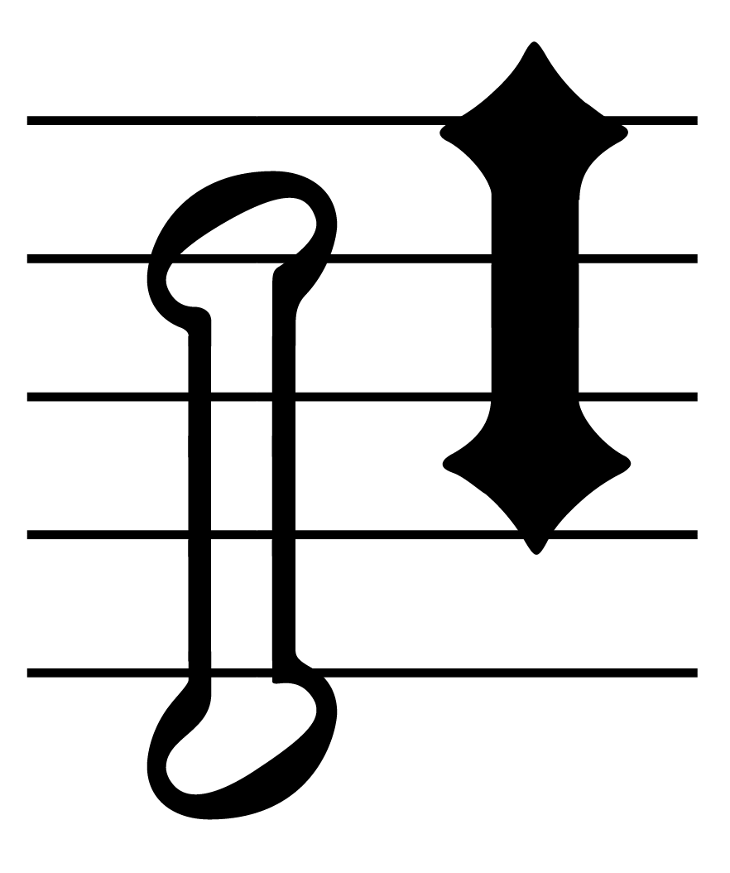

The left-hand cluster is a stack (top to bottom) of 1 x noteheadClusterHalfTop, 3 x noteheadClusterHalfMiddle, 1 x noteheadClusterHalfBottom; the right-hand cluster is 1 x noteheadDiamondClusterBlackTop, 2 x noteheadDiamondClusterBlackMiddle, 1 x noteheadDiamondClusterBlackBottom.

Clusters for intervals of a second or a third are created using a single glyph, e.g. noteheadClusterQuarter2nd. These glyphs are registered such that the lowest pitch in the cluster is centered around y = 0, so to draw correctly, the glyph should be positioned on the staff position corresponding to the lowest note in the cluster.

*See also* the implementation notes for noteheads.